First Approach :Docling
While using Docling for PDF extraction on the Loan Review set, the tool is unable to extract all required data because the PDF content is non-searchable. The text appears to be embedded within images rather than actual text layers, which prevents Docling from parsing it effectively. As a result, image-based content is not being captured during extraction.
screenshot of the issue have been attached for reference.
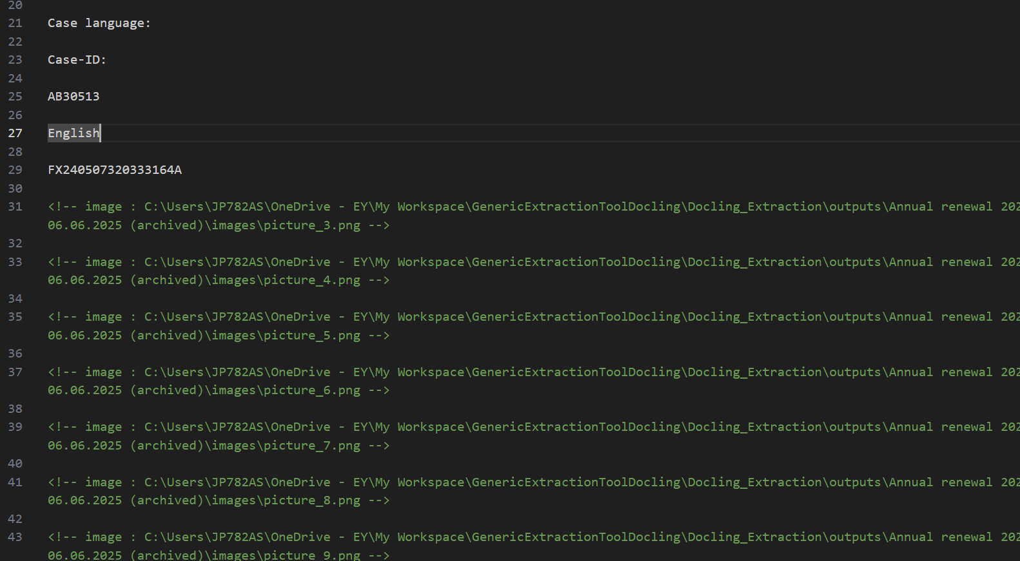
Second Approach :Prebuilt-read
Why Prebuilt-Read Cannot Be Used in the Current ADI Extraction Pipeline
Technical Observation
- attempted to use ADI's Prebuilt-Read model for document text extraction .
Result
- The extracted content was returned in plain text format, without preserving the tabular structure.
- Tables were converted into linear text patterns, making it difficult to:
  - Identify individual cells.
  - Map fields accurately for structured data processing.
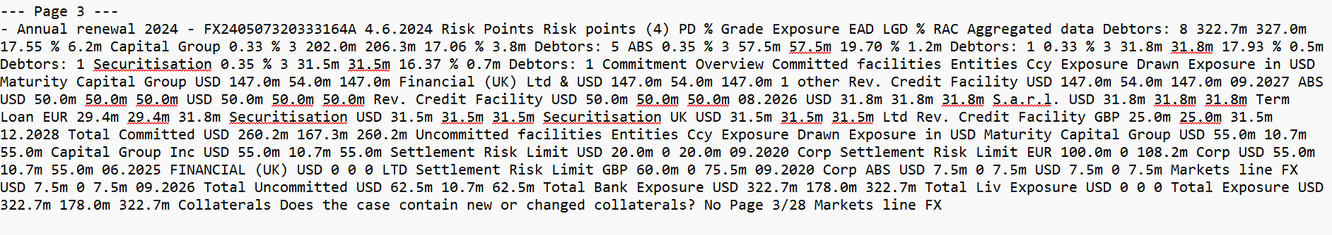
Third Approach: Prebuilt-Layout
- We tested ADI's Prebuilt-Layout model as part of the extraction pipeline.
- Result:
  - Successfully preserved document structure, including tables in proper tabular format.
  - Extracted data is well-organized, making it easier to map fields accurately for structured processing.
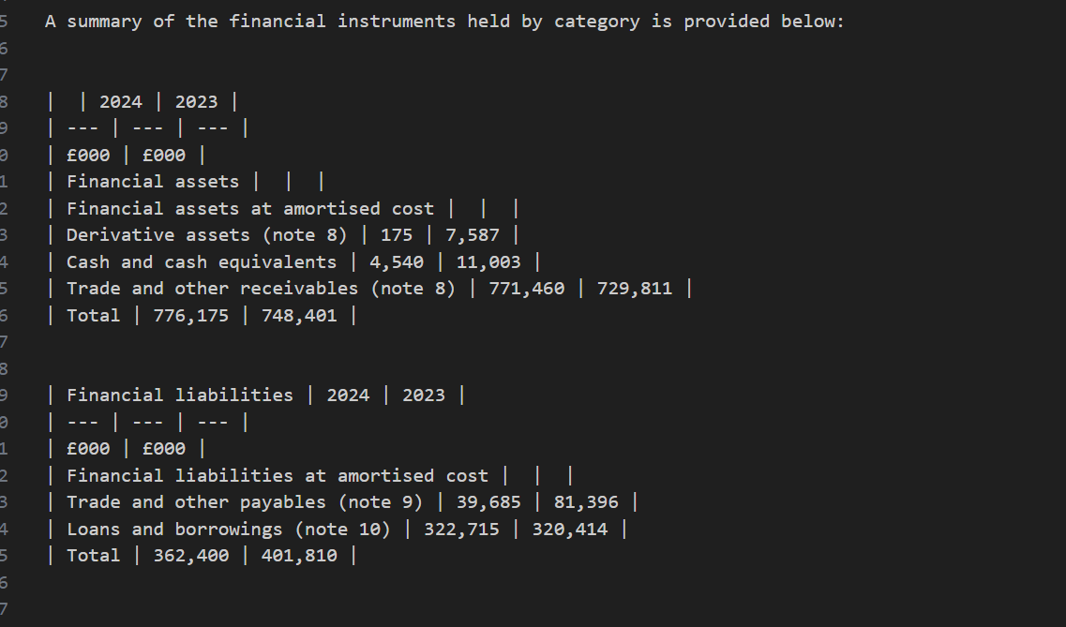
Fourth Aproach : Prebuilt-document
Why Prebuilt-Document Cannot Be Used in the Current ADI Extraction Pipeline
Technical Root Cause: LangChain Integration Incompatibility
- API Parameter Mismatch
  - The prebuilt-document model requires different API parameters and response handling compared to prebuilt-layout.
  - The current pipeline uses LangChain's AzureAIDocumentIntelligenceLoader, which was designed and tested primarily with the prebuilt-layout model.
- Model Purpose Misalignment
  - Prebuilt-document is optimized for general document text extraction and reading order, not for structured data extraction like tables.
  - Prebuilt-layout, on the other hand, is specifically designed to preserve document structure and extract tables, which is a core requirement for the ADI pipeline.

