GLOBAL E-COMMERCE SALES &
PROFITABILITY OPTIMIZATION ANALYTICS
IBM Data Analytics Internship Project
Prepared By: Sanjaya M A
Department: CSE (Artificial Intelligence & Machine Learning)
Institution: Malnad College of Engineering, Hassan
Academic Year: 2026-2027

Brazilian E-Commerce Public Dataset by Olist
Analysis period: 2016-09-04 to 2018-10-17

1. Executive Summary
The project analyzes the Olist Brazilian e-commerce dataset to understand sales performance, freight burden, category mix, regional performance, customer repeat behavior, and delivery-related customer experience. The dataset contains 99,441 orders and 112,650 order-item records.
Across orders with item-level financial records, item revenue is BRL 13,591,643.70 and freight is BRL 2,251,909.54, producing a freight-to-revenue ratio of 16.57%. The project reports a freight-adjusted contribution proxy of BRL 11,339,734.16.
Operationally, 96,478 orders are recorded as delivered. Among delivered orders with valid timing fields, average delivery time is 12.56 days and the late-delivery rate is 8.11%.
Customer retention is a significant analytical area: the repeat-customer rate is 3.12%, while repeat-customer orders represent 6.38% of all orders. The analysis also finds a negative association between delivery delay and review score (Spearman rho -0.176; p < 0.001).
Important limitation: Olist does not provide complete accounting cost information. Therefore, the contribution proxy is not true accounting profit.
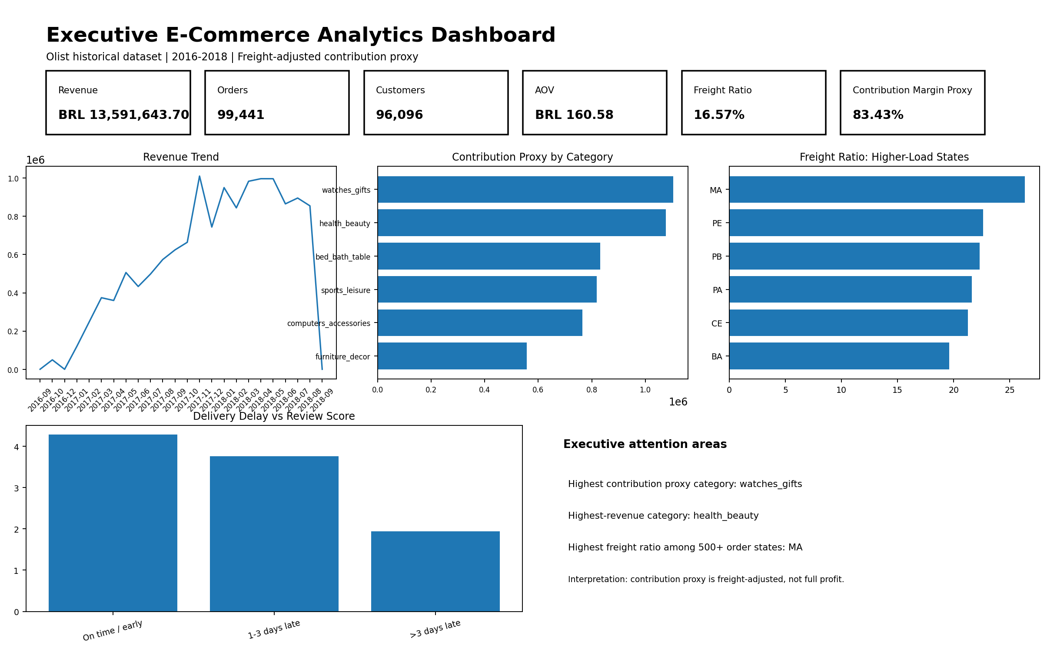
Figure 1. Executive dashboard view generated from the actual Olist data.

2. Introduction
E-commerce analytics requires more than reporting sales volume. The project follows a business-intelligence sequence: KPIs describe what is happening; trends show direction; driver analysis investigates measurable associations; risk and opportunity analysis identifies areas for management attention; and recommendations connect evidence to action.

3. Business Problem
Identify which product categories, customer segments, and geographic regions contribute strongly to sales and freight-adjusted contribution while identifying freight burden, delivery problems, and customer-experience risks.

4. Business Objective
Improve e-commerce resource efficiency and commercial decision-making using evidence from sales, logistics, customer, payment, and review data.

5. Analytics Objectives
- Measure category-level revenue and freight-adjusted contribution.
- Quantify freight burden across customer states.
- Measure delivery duration and late delivery prevalence.
- Examine the association between delivery delay and review scores.
- Measure repeat-customer behavior and customer value.
- Identify evidence-based risks, opportunities, and business actions.

6. Dataset Description
Source: https://www.kaggle.com/datasets/olistbr/brazilian-ecommerce
The uploaded dataset contains 99,441 order records, 112,650 order-item records, 99,441 customer records, 32,951 product records, 103,886 payment records, 99,224 review records, 3,095 seller records, 1,000,163 raw geolocation rows (738,332 after exact-duplicate cleaning), and 71 category translation rows.
Order purchase timestamps span 2016-09-04 to 2018-10-17.

Table 1. Raw Table Inventory
table | rows | columns | exact_duplicate_rows | missing_cells
customers | 99,441 | 5 | 0 | 0
geolocation | 1,000,163 | 5 | 261,831 | 0
items | 112,650 | 7 | 0 | 0
payments | 103,886 | 5 | 0 | 0
reviews | 99,224 | 7 | 0 | 145,903
orders | 99,441 | 8 | 0 | 4,908
products | 32,951 | 9 | 0 | 2,448
sellers | 3,095 | 4 | 0 | 0
translation | 71 | 2 | 0 | 0

7. Data Preparation and Methodology
- Exact duplicate rows were removed without collapsing legitimate multi-item orders.
- Dates were converted using pandas datetime parsing with invalid strings becoming missing values.
- Financial fields were coerced to numeric types; item rows missing price or freight were excluded from contribution calculations.
- Missing product categories were treated as an explicit unknown category rather than fabricated labels.
- Payment data were aggregated to order level and the dominant payment type was selected by recorded payment value.
- Review data were aggregated to order level using the mean available review score; missing reviews were not imputed.
- The order master was built with one row per Olist order. Item-level category analysis was retained separately to avoid double-counting when multi-item orders contain several categories.
- Financial KPIs are based on orders with item-level records because price and freight are stored at item level.

8. Data Dictionary

Table 2. Analytical Data Dictionary
column_name | data_type | description | missing_percentage | analytical_role
order_id | object | Unique order identifier. | 0.000 | Identifier
customer_id | object | Customer identifier for the order record. | 0.000 | Identifier
order_status | object | Current status recorded for the order. | 0.000 | Dimension / Feature
order_purchase_timestamp | datetime64[ns] | Timestamp at which the order was placed. | 0.000 | Dimension / Feature
order_approved_at | datetime64[ns] | Derived analytical field or source attribute. | 0.160 | Dimension / Feature
order_delivered_carrier_date | datetime64[ns] | Derived analytical field or source attribute. | 1.790 | Dimension / Feature
order_delivered_customer_date | datetime64[ns] | Timestamp when the order was delivered to the customer. | 2.980 | Dimension / Feature
order_estimated_delivery_date | datetime64[ns] | Estimated delivery date recorded for the order. | 0.000 | Dimension / Feature
item_revenue | float64 | Sum of item selling prices for the order. | 0.780 | Metric
freight_value | float64 | Sum of item freight charges for the order. | 0.780 | Metric
item_count | float64 | Number of item rows in the order. | 0.780 | Metric
product_count | float64 | Number of distinct products in the order. | 0.780 | Metric
total_order_value | float64 | Item revenue plus freight charges. | 0.780 | Metric
contribution_proxy | float64 | Item revenue minus freight; proxy only, not accounting profit. | 0.780 | Metric
freight_ratio | float64 | Freight divided by item revenue. | 0.780 | Metric
customer_unique_id | object | Customer identifier stable across repeat orders. | 0.000 | Identifier
customer_city | object | Derived analytical field or source attribute. | 0.000 | Dimension / Feature
customer_state | object | Derived analytical field or source attribute. | 0.000 | Dimension / Feature
payment_value | float64 | Total recorded payment value for the order. | 0.000 | Metric
dominant_payment_type | object | Payment type with the greatest aggregated payment value for the order. | 0.000 | Dimension / Feature
review_score | float64 | Average available review score for the order. | 0.770 | Metric
review_count | float64 | Derived analytical field or source attribute. | 0.770 | Metric

9. KPI Analysis

Table 3. Key Performance Indicators
kpi | display_value | definition
Total registered orders | 99,441 | All rows in the Olist orders table.
Orders with item records | 98,666 | Orders with item-level financial records.
Delivered orders | 96,478 | Order status = delivered.
Unique customers | 96,096 | Distinct customer_unique_id.
Total item revenue | BRL 13,591,643.70 | Sum of item selling prices.
Total freight | BRL 2,251,909.54 | Sum of freight_value.
Freight-adjusted contribution proxy | BRL 11,339,734.16 | Item revenue minus freight only; not accounting profit.
Contribution proxy margin | 83.43% | Contribution proxy / item revenue.
Average order value incl. freight | BRL 160.58 | Average total order value among orders with item records.
Freight-to-revenue ratio | 16.57% | Freight / item revenue.
Average delivery days | 12.56 | Delivered orders with valid purchase and delivery dates.
Late delivery rate | 8.11% | Delivered orders delivered after the estimate.
Average review score | 4.09 | Mean of available order-level review scores.
Repeat customer rate | 3.12% | Share of unique customers with more than one order.
Order share from repeat customers | 6.38% | Share of all orders linked to repeat customers.

10. Exploratory Data Analysis
The exploratory stage examines overall sales distribution, category concentration, geographic performance, customer type, delivery delay, payment mix, and monthly trends. The generated charts are included below and are based on the actual uploaded dataset.
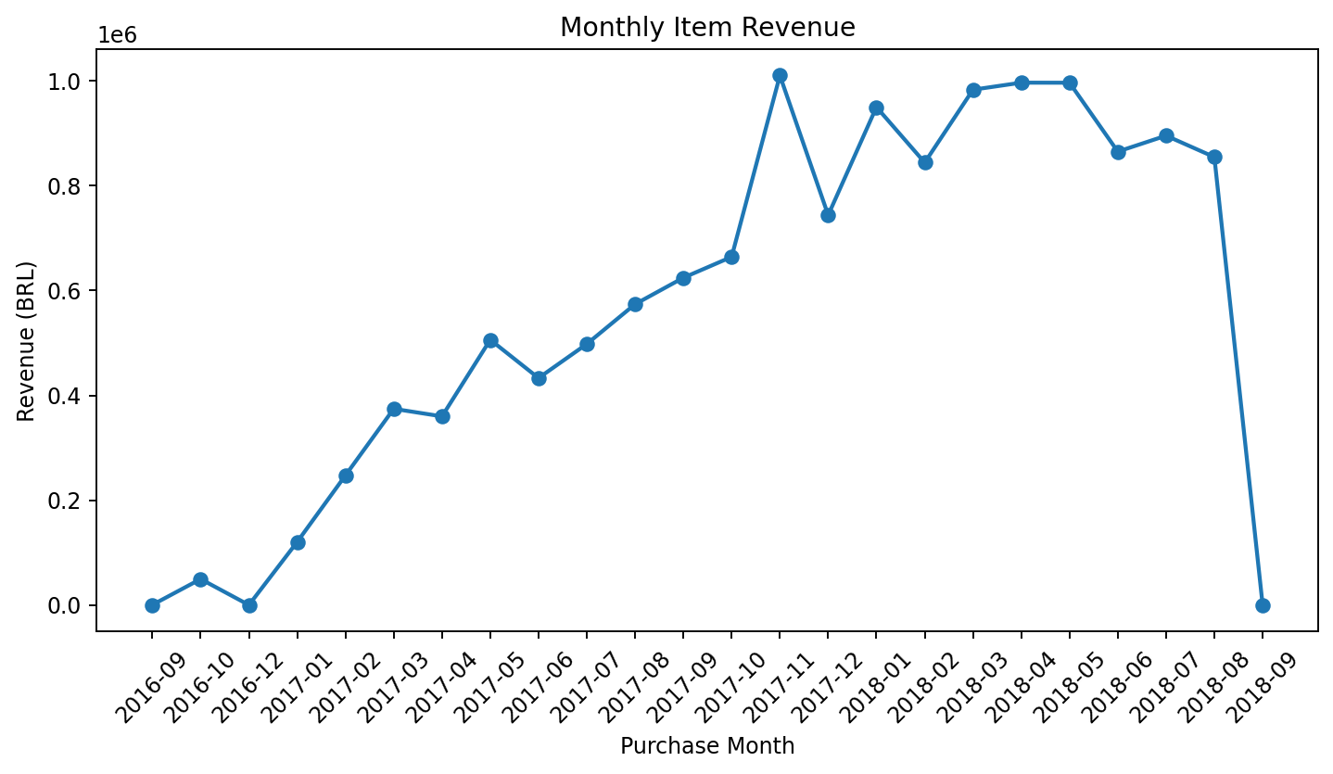
Figure 2. Monthly item revenue trend.
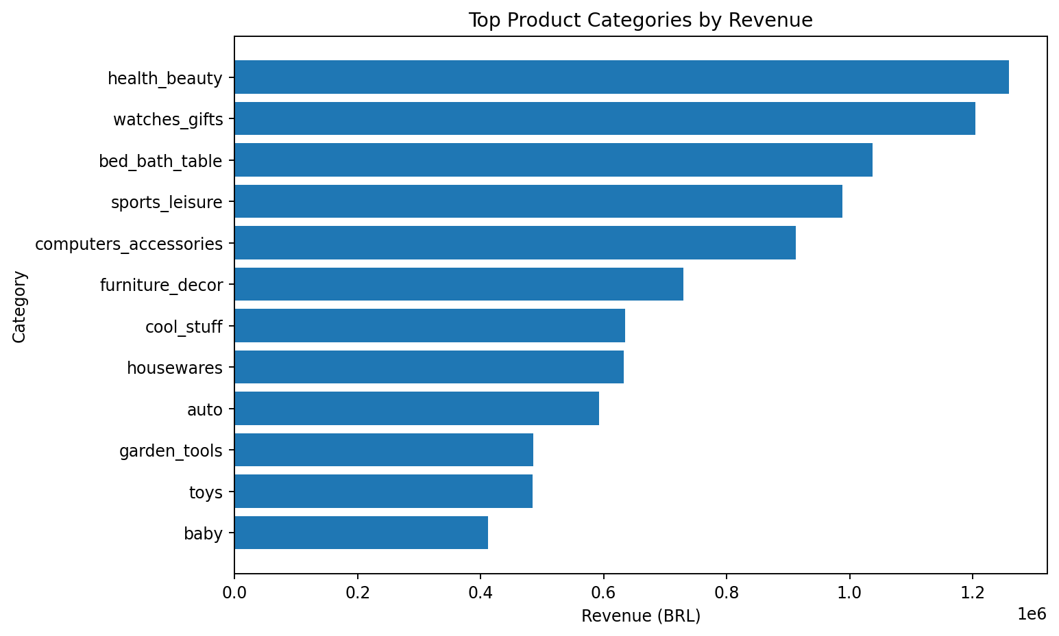
Figure 3. Highest-revenue product categories.
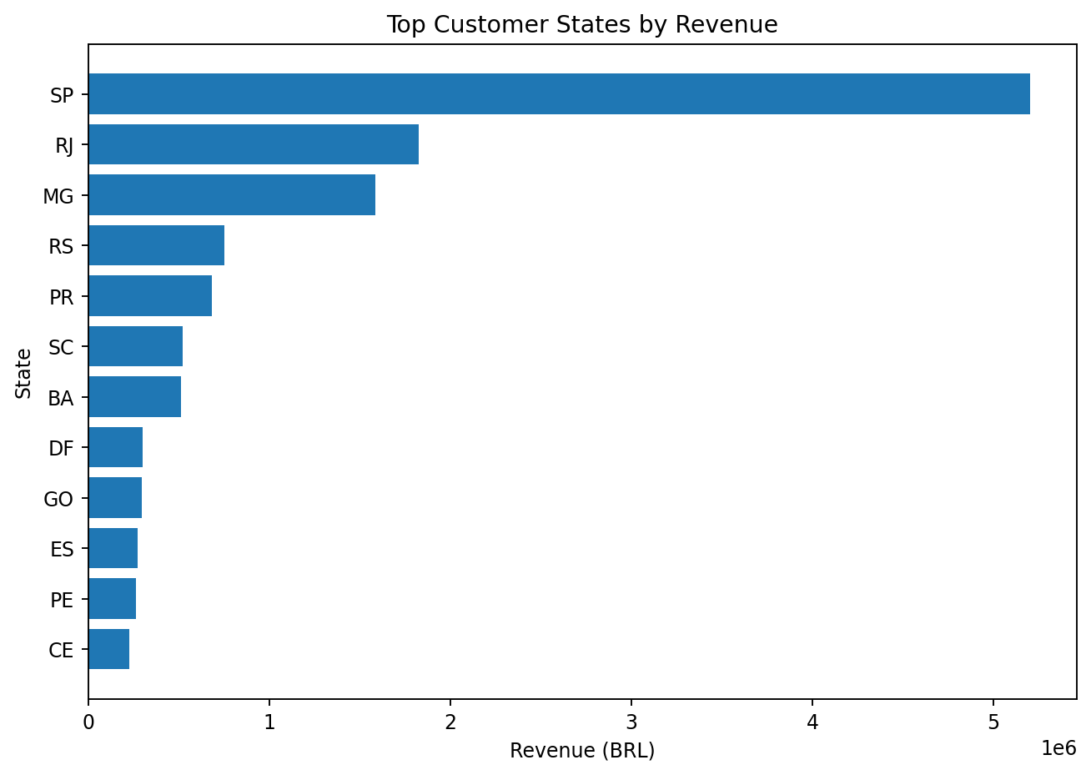
Figure 4. Highest-revenue customer states.

11. Product Category Analysis

Table 4. Top Categories by Revenue
category | items | orders | Revenue (BRL) | Contribution Proxy (BRL) | Freight Ratio | Margin Proxy
health_beauty | 9,670 | 8,836 | 1,258,681 | 1,076,115 | 14.50% | 85.50%
watches_gifts | 5,991 | 5,624 | 1,205,006 | 1,104,470 | 8.34% | 91.66%
bed_bath_table | 11,115 | 9,417 | 1,036,989 | 832,296 | 19.74% | 80.26%
sports_leisure | 8,641 | 7,720 | 988,049 | 819,441 | 17.06% | 82.94%
computers_accessories | 7,827 | 6,689 | 911,954 | 764,636 | 16.15% | 83.85%
furniture_decor | 8,334 | 6,449 | 729,762 | 557,013 | 23.67% | 76.33%
cool_stuff | 3,796 | 3,632 | 635,291 | 551,252 | 13.23% | 86.77%
housewares | 6,964 | 5,884 | 632,249 | 486,100 | 23.12% | 76.88%

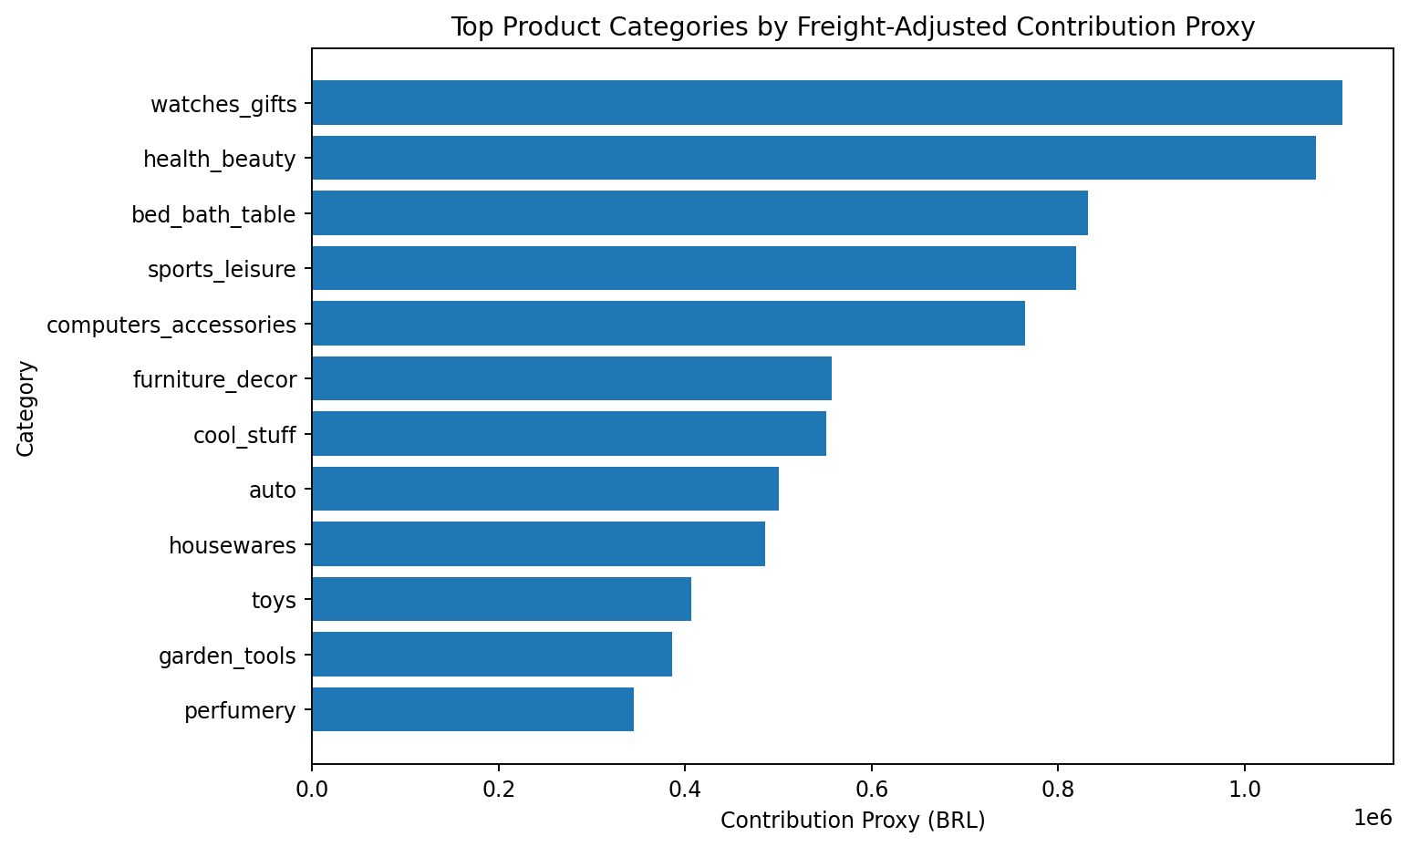
Figure 5. Categories with the largest freight-adjusted contribution proxy.
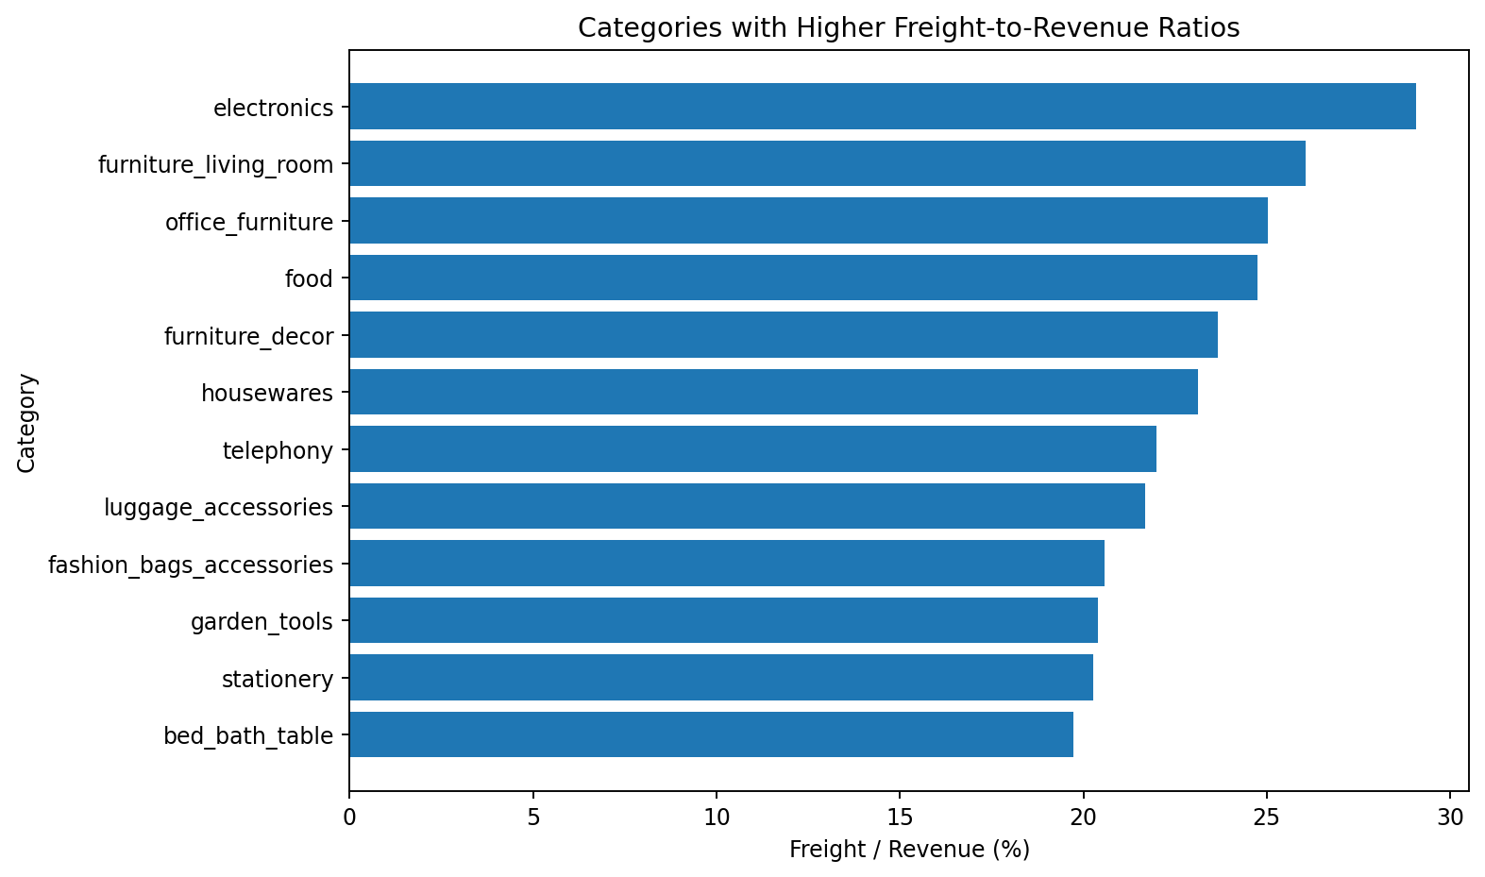
Figure 6. Categories with higher freight-to-revenue ratios among categories with 500+ items.

12. Regional Analysis

Table 5. Regional Performance
customer_state | orders | Revenue (BRL) | Freight Ratio | Late Rate | Avg Review
SP | 41,375 | 5,202,955 | 13.81% | 5.77% | 4.20
RJ | 12,762 | 1,824,093 | 16.75% | 13.04% | 3.89
MG | 11,544 | 1,585,308 | 17.09% | 5.53% | 4.15
RS | 5,432 | 750,304 | 18.06% | 7.03% | 4.15
PR | 4,998 | 683,084 | 17.25% | 4.92% | 4.20
SC | 3,612 | 520,553 | 17.22% | 9.58% | 4.09
BA | 3,358 | 511,350 | 19.59% | 13.61% | 3.88
DF | 2,125 | 302,604 | 16.73% | 6.92% | 4.08
GO | 2,007 | 294,592 | 18.03% | 7.97% | 4.06
ES | 2,025 | 275,037 | 18.09% | 12.05% | 4.05
PE | 1,648 | 262,788 | 22.62% | 10.44% | 4.02
CE | 1,327 | 227,255 | 21.28% | 14.77% | 3.87

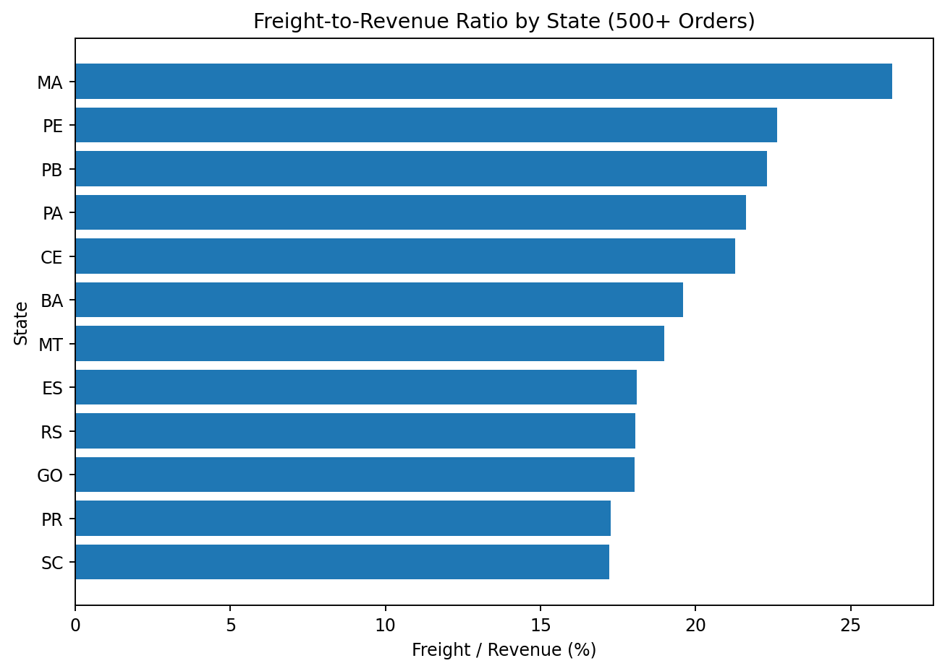
Figure 7. Freight-to-revenue ratio by state for states with at least 500 orders.

13. Customer Analysis

Table 6. Customer Type Summary
customer_type | customers | orders | revenue | contribution_proxy | revenue_per_customer
One-time | 92,507 | 92,507 | 12,828,351.840 | 10,717,596.690 | 138.670
Repeat | 2,913 | 6,159 | 763,291.860 | 622,137.470 | 262.030

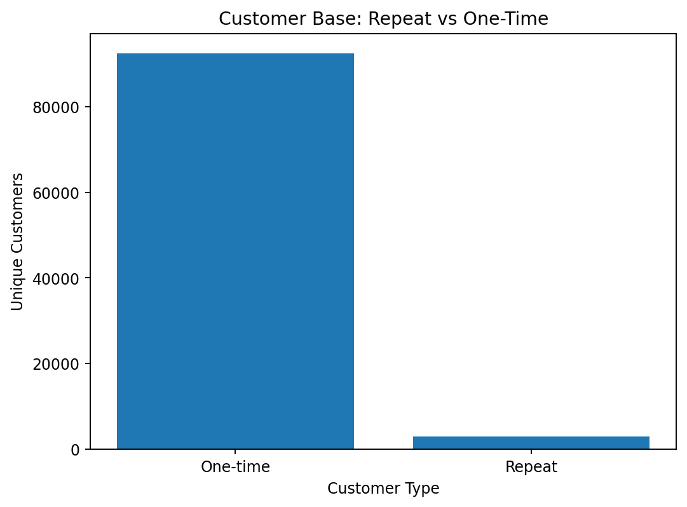
Figure 8. Unique customers by repeat/one-time classification.
Repeat classification uses customer_unique_id and the historical number of orders. The analysis does not label the result as customer lifetime value because the dataset covers a fixed historical period and lacks forward-looking retention information.

14. Delivery Performance and Customer Satisfaction

Table 7. Delivery Delay Groups
delay_group | orders | average_delivery_days | average_delay_days | average_review_score | order_share
On time / early | 88,644 | 10.880 | -13.010 | 4.290 | 91.890
1-3 days late | 2,662 | 21.080 | 1.400 | 3.770 | 2.760
>3 days late | 5,164 | 36.900 | 13.750 | 1.940 | 5.350

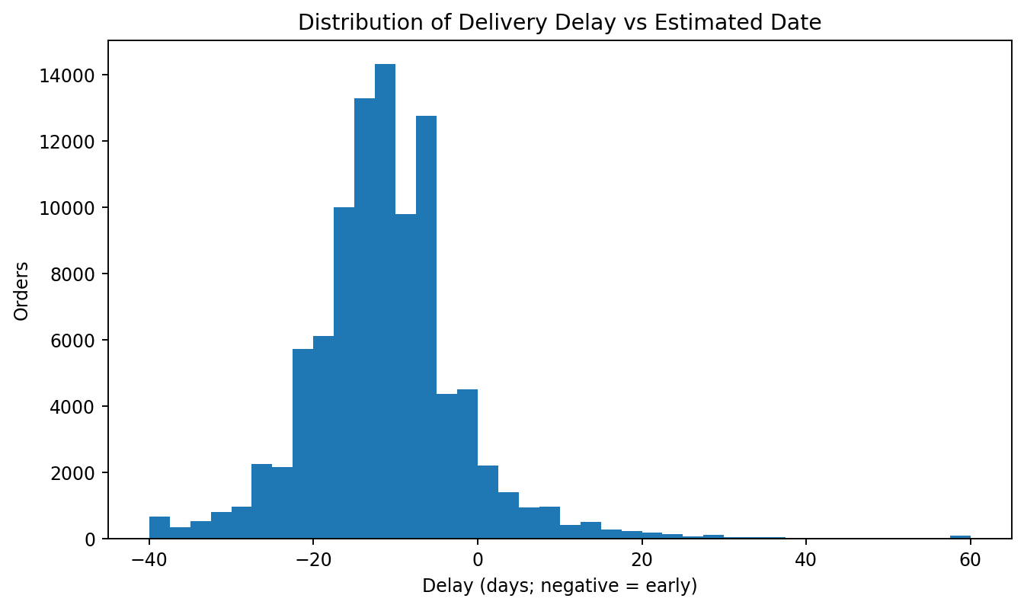
Figure 9. Delivery delay distribution relative to estimated date.
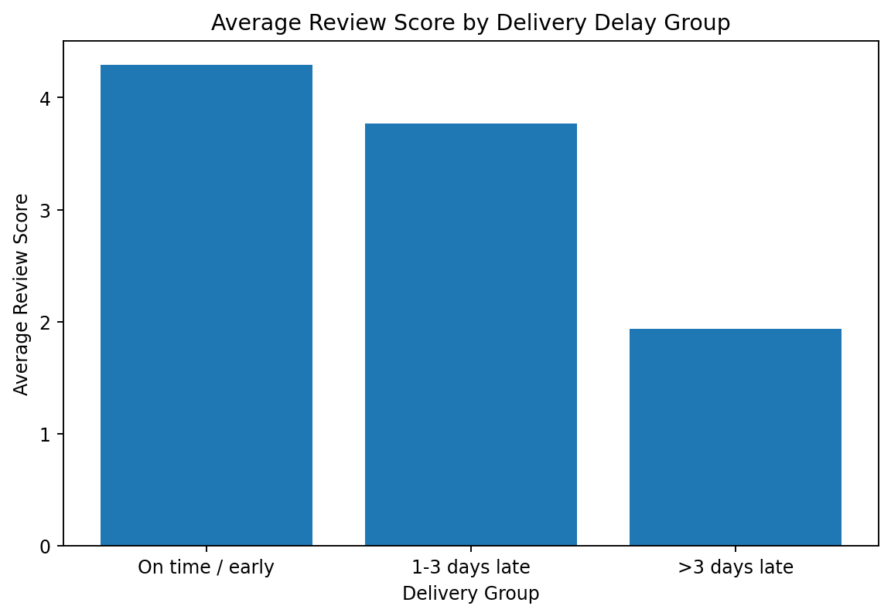
Figure 10. Average review score across delivery-delay groups.
Statistical evidence: Spearman correlation between delivery delay days and review score is -0.176 with p < 0.001. The Mann-Whitney U test comparing review scores for late versus on-time/early orders is also significant (p < 0.001). The direction indicates that larger delays are associated with lower reviews in this dataset; this is association, not causal proof.

15. Trend Analysis
The time series covers the Olist historical period and is strongest from 2017 through 2018; early and final partial months should not be interpreted as complete comparable periods.
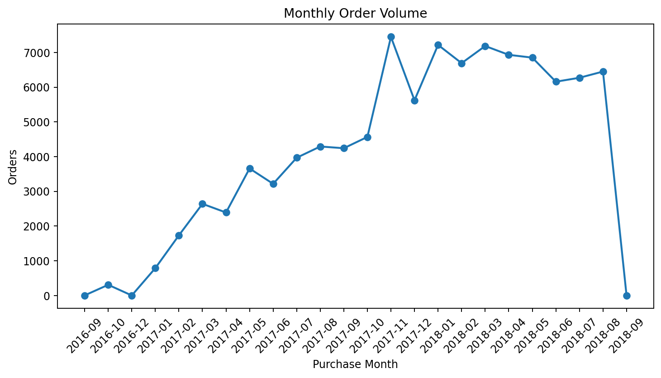
Figure 11. Monthly order volume trend.
The highest-revenue month in the item-level series is 2017-11 with 7,451 orders and BRL 1,010,271.37 in item revenue.

16. Driver Analysis
Driver analysis uses descriptive comparisons and non-parametric/statistical association. The analysis deliberately avoids causal language when the dataset is observational.

Table 8. Selected Spearman Associations
index | item_revenue | freight_value | contribution_proxy | delivery_delay_days | review_score
freight_ratio | -0.785 | 0.103 | -0.867 | -0.046 | -0.031
delivery_delay_days | -0.045 | -0.156 | -0.023 | 1.000 | -0.176
review_score | -0.029 | -0.089 | -0.015 | -0.176 | 1.000

17. Risk Analysis

Table 9. Data-Driven Risk Signals
risk_area | segment | evidence_metric | Evidence Value | context
Category freight burden | electronics | freight_ratio | 0.291 | 2,767 items; BRL 160,246.74 revenue
Category freight burden | furniture_living_room | freight_ratio | 0.261 | 503 items; BRL 68,916.56 revenue
Category freight burden | office_furniture | freight_ratio | 0.250 | 1,691 items; BRL 273,960.70 revenue
Category freight burden | food | freight_ratio | 0.247 | 510 items; BRL 29,393.41 revenue
Category freight burden | furniture_decor | freight_ratio | 0.237 | 8,334 items; BRL 729,762.49 revenue
Category freight burden | housewares | freight_ratio | 0.231 | 6,964 items; BRL 632,248.66 revenue
Category freight burden | telephony | freight_ratio | 0.220 | 4,545 items; BRL 323,667.53 revenue
Category freight burden | luggage_accessories | freight_ratio | 0.217 | 1,092 items; BRL 140,429.98 revenue

Category freight burden — electronics: Freight consumes a higher share of revenue than the overall portfolio average.
Category freight burden — furniture_living_room: Freight consumes a higher share of revenue than the overall portfolio average.
Category freight burden — office_furniture: Freight consumes a higher share of revenue than the overall portfolio average.
Category freight burden — food: Freight consumes a higher share of revenue than the overall portfolio average.
Category freight burden — furniture_decor: Freight consumes a higher share of revenue than the overall portfolio average.
Category freight burden — housewares: Freight consumes a higher share of revenue than the overall portfolio average.
Category freight burden — telephony: Freight consumes a higher share of revenue than the overall portfolio average.
Category freight burden — luggage_accessories: Freight consumes a higher share of revenue than the overall portfolio average.

18. Opportunity Analysis

Table 10. Data-Driven Opportunities
opportunity_area | segment | evidence_metric | Evidence Value | Supporting Value
Category growth / mix | watches_gifts | contribution_proxy | 1,104,470 | 0.917
Category growth / mix | health_beauty | contribution_proxy | 1,076,115 | 0.855
Category growth / mix | bed_bath_table | contribution_proxy | 832,296 | 0.803
Category growth / mix | sports_leisure | contribution_proxy | 819,441 | 0.829
Category growth / mix | computers_accessories | contribution_proxy | 764,636 | 0.838
Category growth / mix | furniture_decor | contribution_proxy | 557,013 | 0.763
Category growth / mix | cool_stuff | contribution_proxy | 551,252 | 0.868
Category growth / mix | auto | contribution_proxy | 500,056 | 0.844

Category growth / mix — watches_gifts: Meaningful category contribution proxy with sufficient observed volume.
Category growth / mix — health_beauty: Meaningful category contribution proxy with sufficient observed volume.
Category growth / mix — bed_bath_table: Meaningful category contribution proxy with sufficient observed volume.
Category growth / mix — sports_leisure: Meaningful category contribution proxy with sufficient observed volume.
Category growth / mix — computers_accessories: Meaningful category contribution proxy with sufficient observed volume.
Category growth / mix — furniture_decor: Meaningful category contribution proxy with sufficient observed volume.
Category growth / mix — cool_stuff: Meaningful category contribution proxy with sufficient observed volume.
Category growth / mix — auto: Meaningful category contribution proxy with sufficient observed volume.

19. Actionable Business Recommendations

Protect and scale strong category economics
Evidence: watches_gifts has the largest contribution proxy (BRL 1,104,469.75).
Recommended action: Review assortment depth, inventory availability and cross-sell opportunities around strong-contribution categories while monitoring freight ratio.
KPI to monitor: Contribution proxy and freight ratio

Investigate freight burden in high-load categories
Evidence: electronics has a freight ratio of 29.07% among categories with 500+ items.
Recommended action: Review shipping lanes, package dimensions, seller fulfillment choices and shipping-price rules for high-load categories.
KPI to monitor: Freight ratio and contribution proxy margin

Prioritize operational review in high-freight regions
Evidence: MA has a freight ratio of 26.35% among states with 500+ orders.
Recommended action: Evaluate carrier mix, regional fulfillment strategy and shipping thresholds before changing customer-facing pricing.
KPI to monitor: Regional freight ratio and late-delivery rate

Use delivery performance as a customer-experience KPI
Evidence: Late deliveries show lower average review scores and a negative Spearman association with review score (-0.176).
Recommended action: Track late-delivery rate by carrier/region/category and create an operational exception process for chronically delayed segments.
KPI to monitor: Late-delivery rate and average review score

Build a second-purchase retention program
Evidence: The repeat-customer rate is 3.12%.
Recommended action: Test post-purchase messaging, category cross-sell and timed second-purchase offers for one-time customers, then measure repeat-order conversion.
KPI to monitor: Repeat customer rate and second-order conversion

20. Dashboard Design
The dashboard is designed for executives and operating managers who need quick answers about sales scale, freight burden, category performance, customer retention, delivery performance, and evidence-based action areas.
Figure 12. Final executive dashboard design.

21. Limitations
- The Olist dataset does not contain full accounting cost data; contribution proxy is therefore not true profit.
- Historical period ends in 2018, so results should not be treated as current market performance.
- Observed associations do not establish causality.
- Customer retention is measured from historical repeat ordering and should not be treated as a forward-looking CLV model.
- Some regions/categories have low volume; sample-size thresholds are used for risk flags where practical.
- Freight value is an observed dataset field; the analysis does not independently verify carrier-level cost allocation.

22. Conclusion
The completed analysis converts the Olist transactional data into a reproducible Business Intelligence workflow. The project combines sales, freight, category, regional, customer and delivery evidence, and translates the observed patterns into measurable management actions. The most important analytical discipline is preserving the distinction between actual dataset evidence and unsupported assumptions, especially for profitability and causal explanations.

23. References
Olist / Kaggle: https://www.kaggle.com/datasets/olistbr/brazilian-ecommerce
Python libraries: pandas, NumPy, Matplotlib, SciPy, python-docx.

24. Appendix — Additional Output Files
The project also creates detailed CSV outputs in outputs/tables/ and report-ready figures in outputs/figures/.

