## WATER QUALITY ANALYSIS

INTRODUCTION :

* About This File
* Feature Description
* Libraries
* Importing The Datasets
* Output

**About This File**

Ppm: parts per million

Μg/L: microgram per litre

Mg/L: milligram per litre



**Feature Description:**

1. **ph**: pH of 1. Water (0 to 14).
2. **Hardness**: Capacity of water to precipitate soap in mg/L
3. **Solids**: Total dissolved solids in ppm.
4. **Chloramines**: Amount of Chloramines in ppm.
5. **Sulfate**: Amount of Sulfates dissolved in mg/L.
6. **Conductivity**: Electrical conductivity of water in μS/cm.

**7. Organic_carbon**: Amount of organic carbon in ppm.

**8. Trihalomethanes**: Amount of Trihalomethanes in

ug./L.

**Libraries**

# Basic Libraries

Import numpy as np

Import pandas as pd

From warnings import filterwarnings

From collections import Counter

# Visualizations Libraries

Import matplotlib.pyplot as plt

Import seaborn as sns

Import plotly

Import plotly.offline as pyo

Import plotly.express as px

Import plotly.graph_objs as go

Pyo.init_notebook_mode()

Import plotly.figure_factory as ff

Import missingno as msno

# Data Pre-processing Libraries

From sklearn.preprocessing import StandardScaler,MinMaxScaler

From sklearn.model_selection import train_test_split

# Modelling Libraries

From sklearn.linear_model import LogisticRegression,RidgeClassifier,SGDClassifier,PassiveAggressiveClassifier

From sklearn.linear_model import Perceptron

From sklearn.svm import SVC,LinearSVC,NuSVC

From sklearn.neighbors import KNeighborsClassifier,NearestCentroid

From sklearn.tree import DecisionTreeClassifier

From sklearn.ensemble import RandomForestClassifier,AdaBoostClassifier,GradientBoostingClassifier

From sklearn.naive_bayes import GaussianNB,BernoulliNB

From sklearn.ensemble import VotingClassifier

# Evaluation & CV Libraries

From sklearn.metrics import precision_score,accuracy_score

from sklearn.model_selection import RandomizedSearchCV,GridSearchCV,RepeatedStratifiedKFold

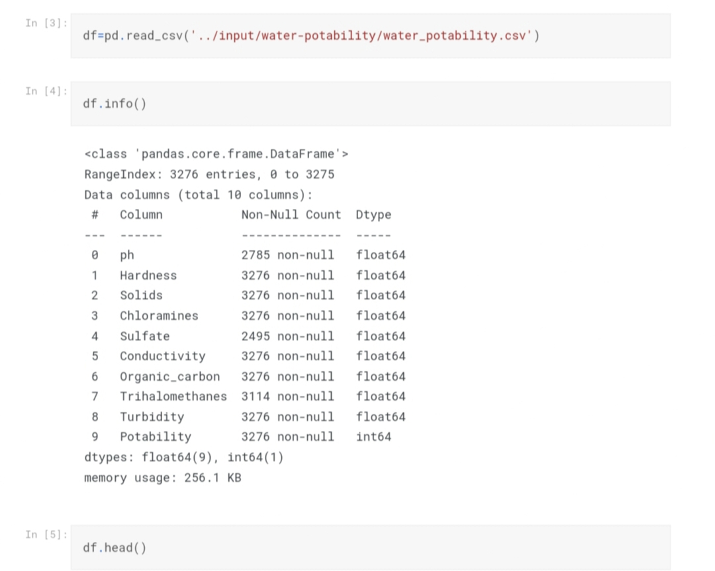**Importing The Datasets**

**Output:**

