Degital Soc Design

Day1:The Main Structure of the Courses in Throey
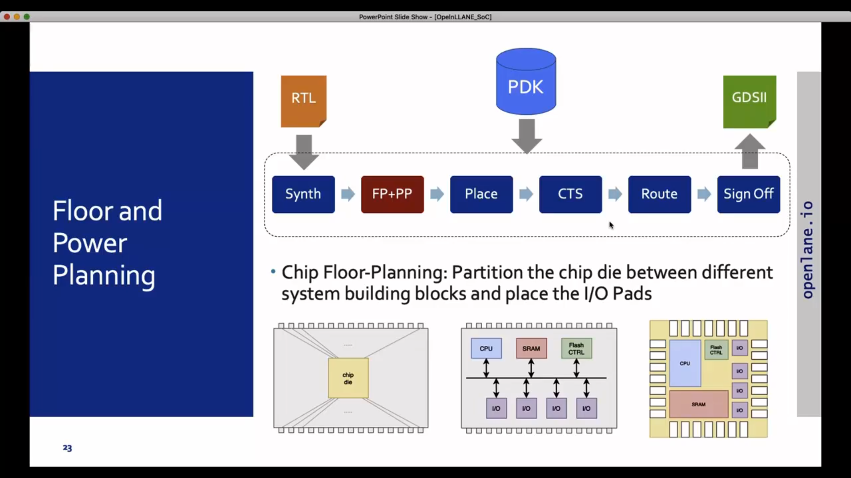
RTL Synthesis:
RTL synthesis involves converting a hardware description language (HDL), such as Verilog or VHDL, into a gate-level representation. This representation comprises flip-flops, standard cells, and interconnected logic gates sourced from a technology library. Synthesis is typically performed using tools like Yosys, with technology mapping accomplished post-synthesis using tools like abc.

Floorplanning :
It involves arranging components in a chip to meet design goals like performance and area utilization. It minimizes wire lengths and signal delays while optimizing power distribution. There are two types: chip-level, which organizes overall components, and macro-level, which details specific blocks. Tools like OpenROAD are used for floorplanning.

Placement:
Determining optimal component locations for performance, power efficiency, and area utilization. OpenROAD used for Global and Detailed Placement.

Clock Tree Synthesis:
Efficient distribution of clock signal with minimal skew, jitter, and power consumption. Done before signal routing using OpenROAD.

Routing:
Establishing physical connections between components using available metal layers. The router leverages specifications from the Process Design Kit (PDK), which defines parameters like thickness and pitch for each metal layer. Sky-130 PDK defines six routing tiers.

Labs: Introduction about the Openlane and its commands

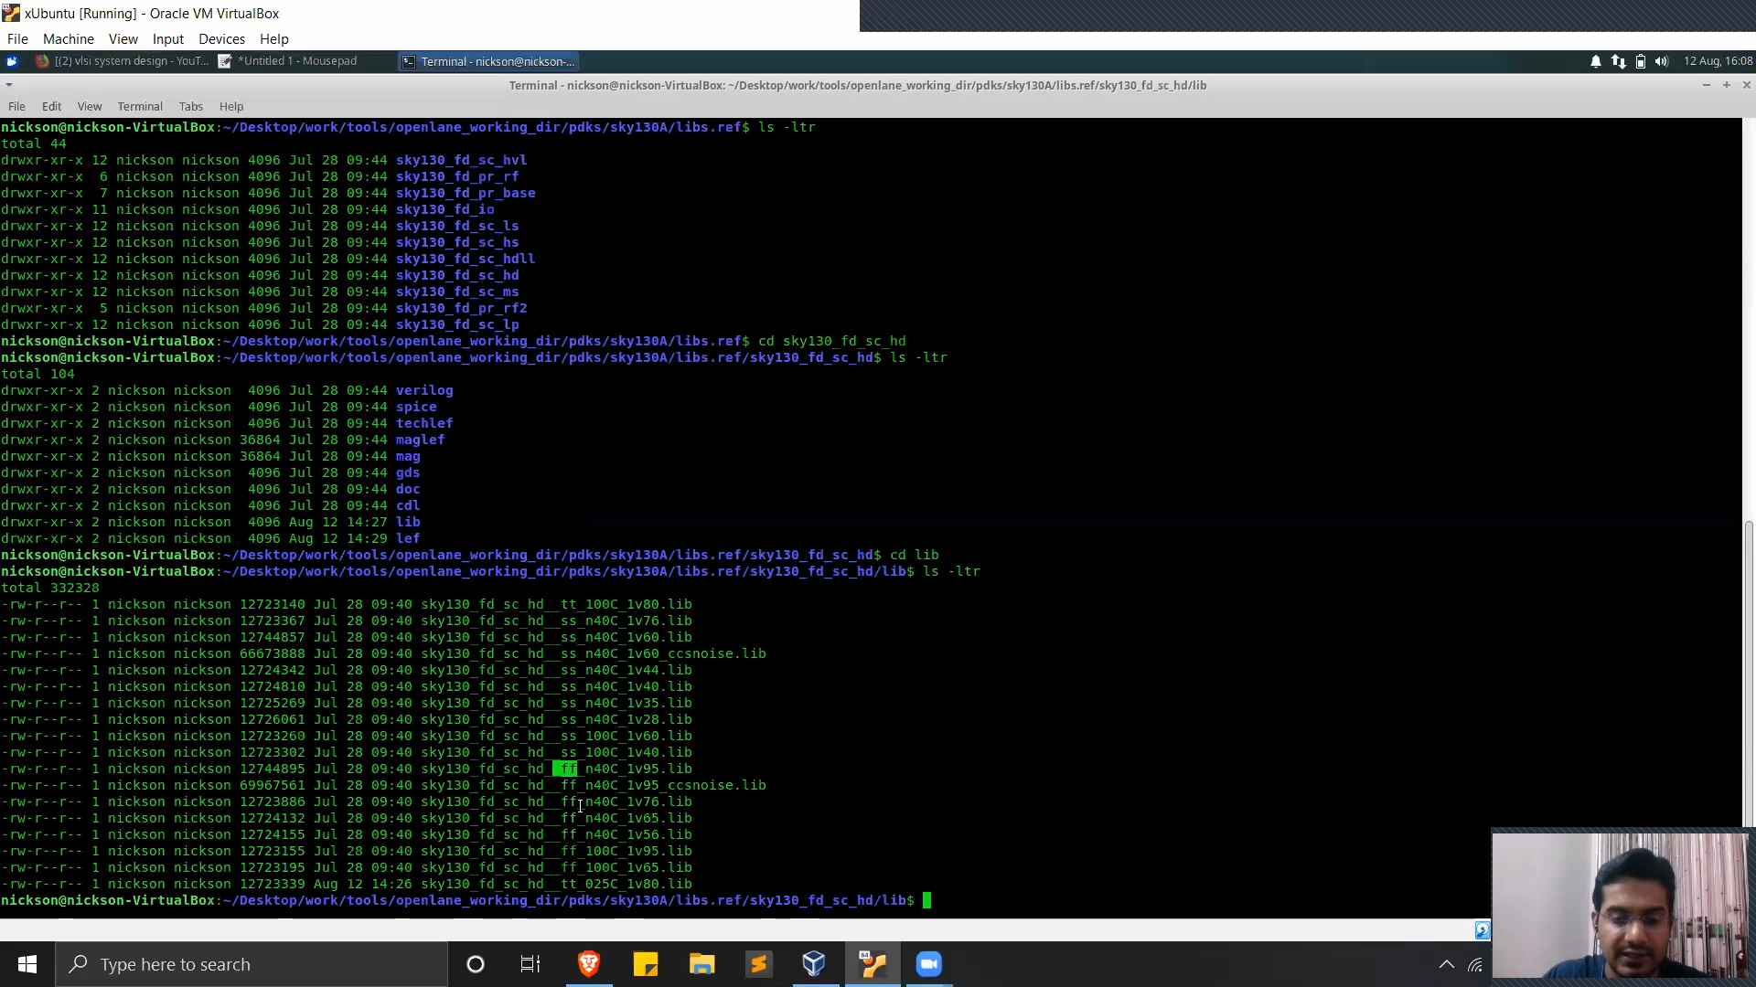

commands to enter Directory:
cd Desktop
cd work/tools
cd openlane_working_dir
cd openlane

After getting into the directory, enter the commands
docker
pwd
ls -ltr
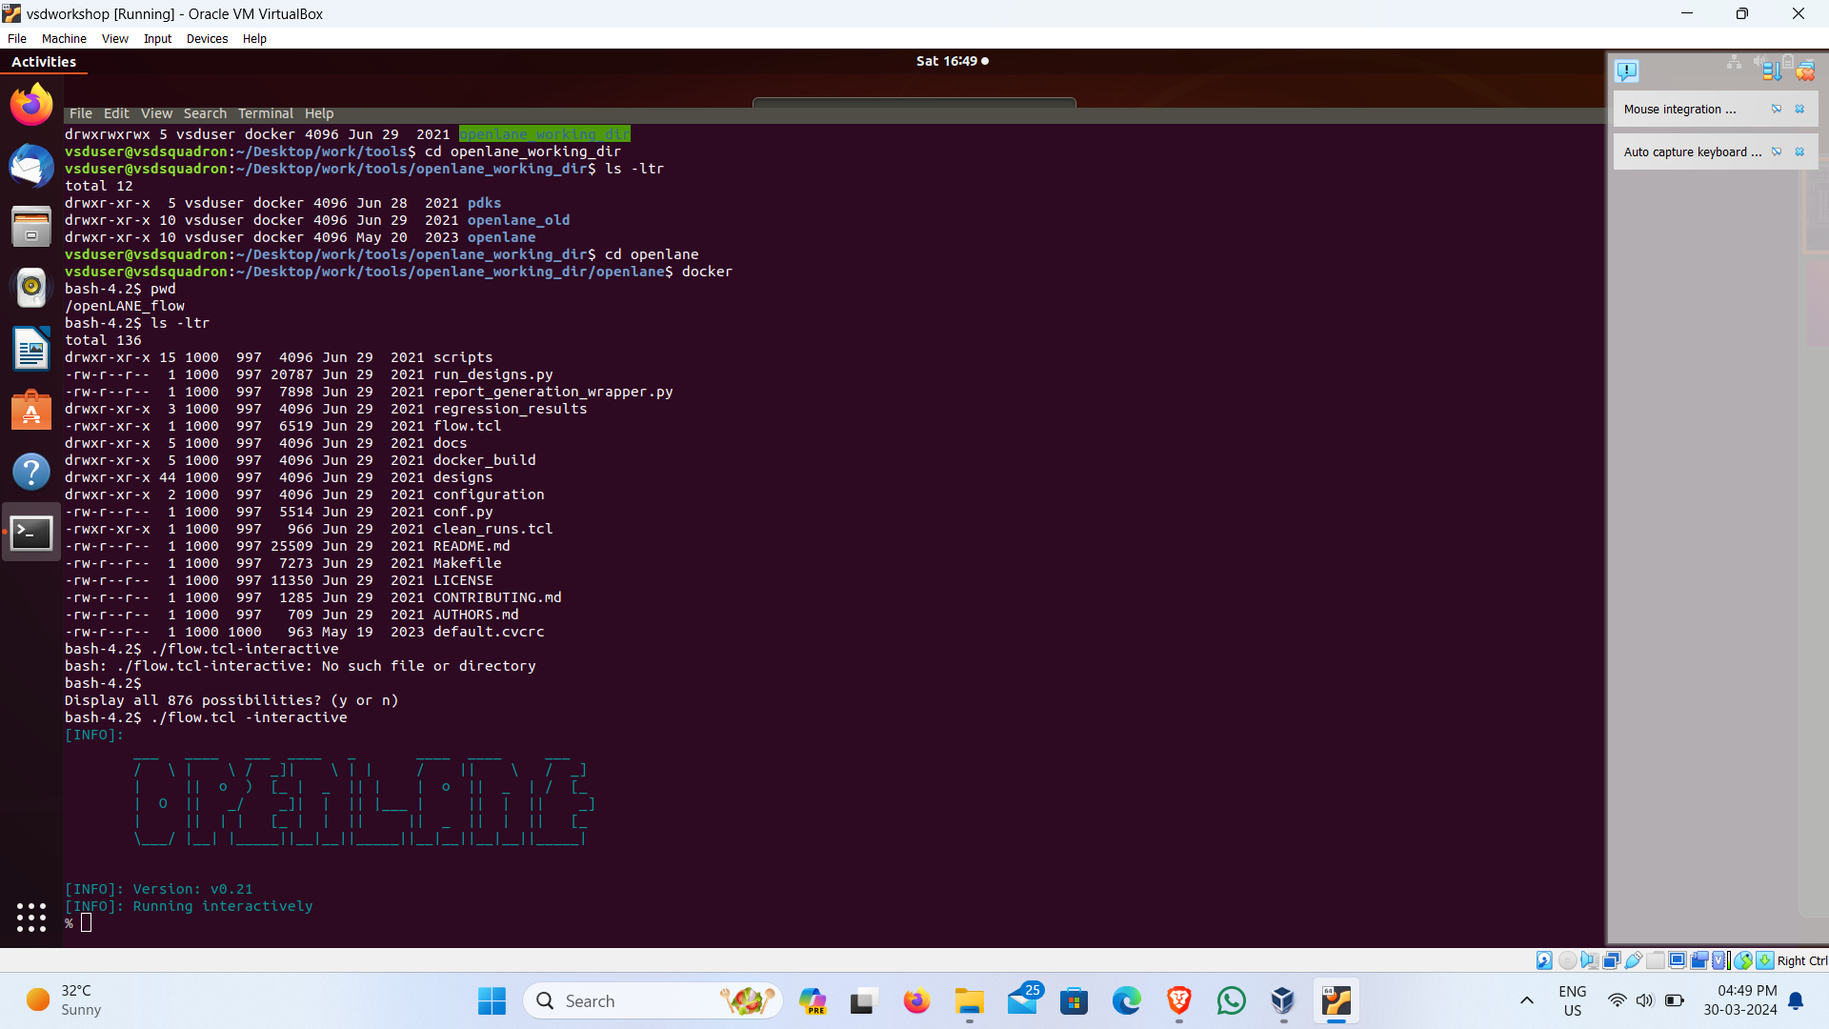
Then to open the openlane in interactive mode,

./flow.tcl -interactive
To prepare the openlane,

package require openlane 0.9
prep - design picorv32a

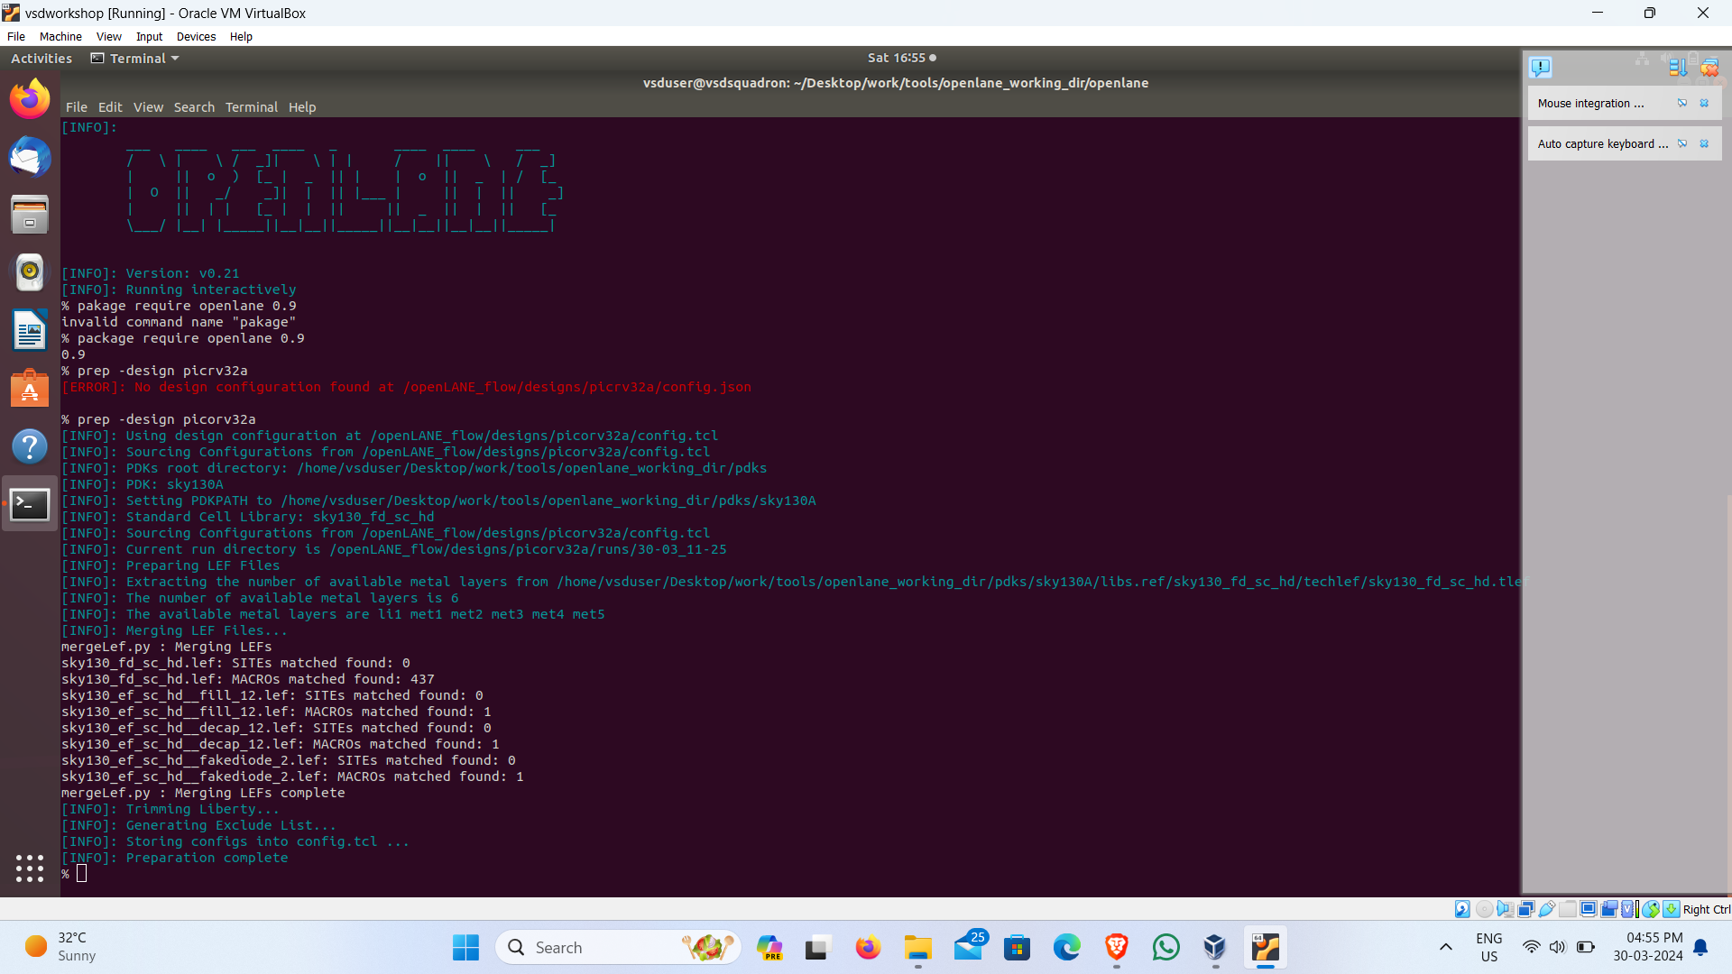

Synthesis:
To run the Synthesis

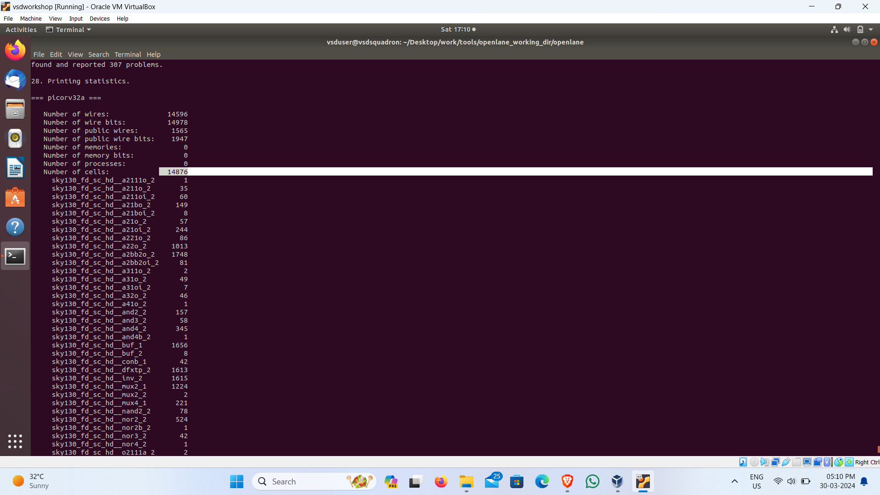
run_synthesis

After Synthesis is completed, the message is shown that the "Synthesis was successful"

This contains all the details about the synthesis of the picorv32a

------------------------------------------------------------------------------------------------------------------------

The number of cells:14876

----------------------------------------------------------------------------------------------------
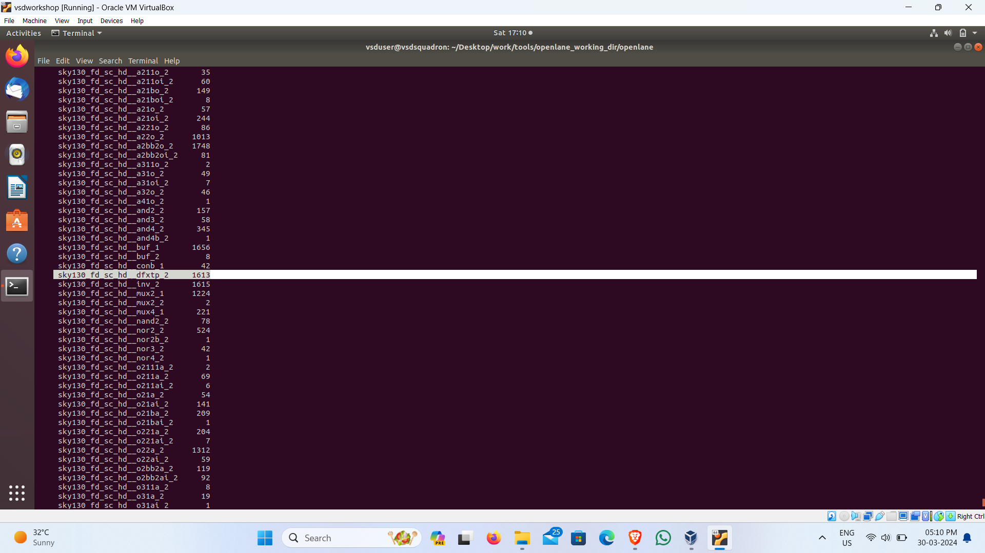
The number fo D flip flop:1613

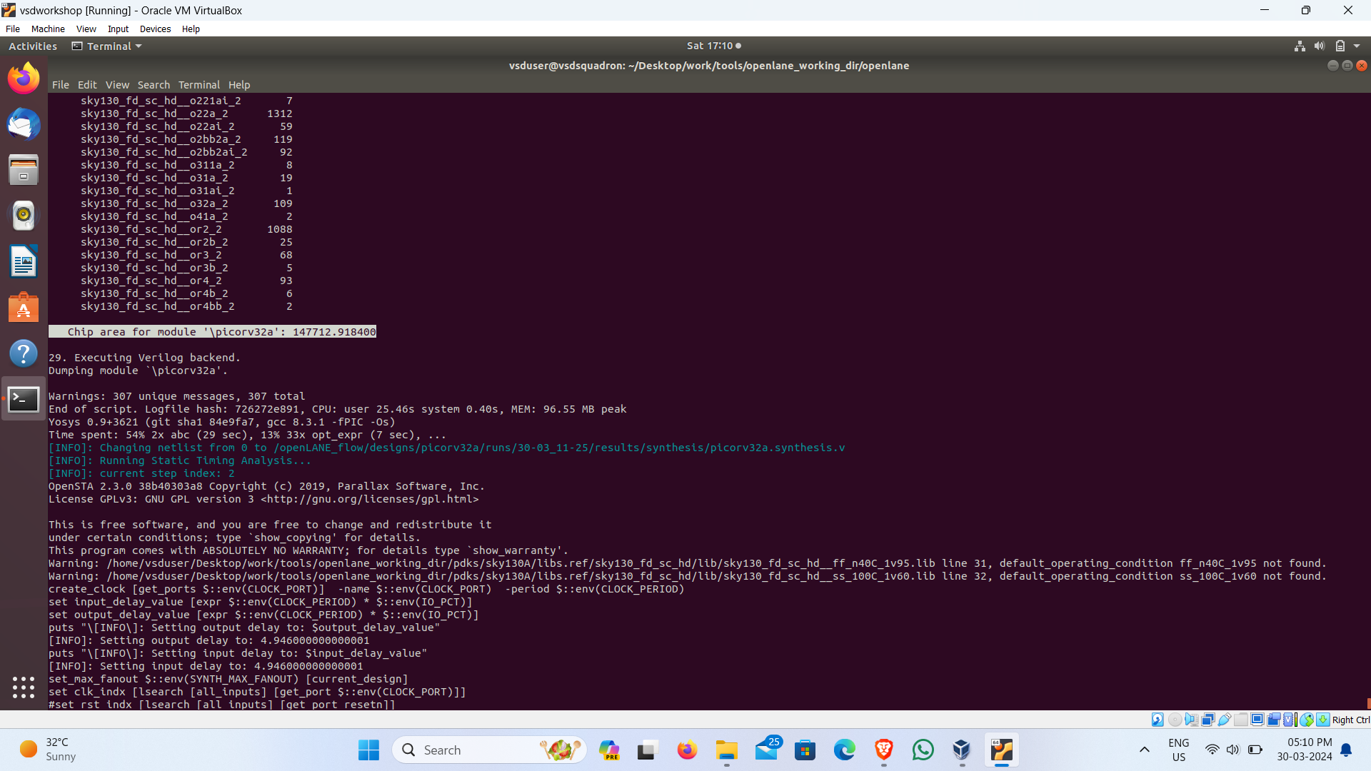
The chip area of the module:147712.918400

----------------------------------------------------------------------------------------------------------

AS for the Assignment to find the Flop ratio. This can be calculated by using the formula:

Flop ratio in (%) = Total No of D-FF
-------------------- X 100
Total No of Cells

= 1613
-------- X 100
14876

Flop ratio = 10.8429685

