**Document that includes a MECE breakdown and outlines the insights that can be drawn from the analysed data provided.**

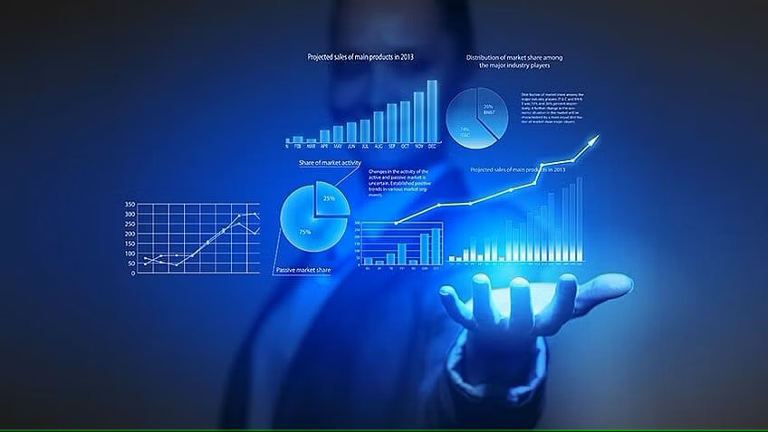

Submitted By

Sanjay Kumar

MECE breakdown of given Olympic Data

1. of regions and continents in the Olympics.

2.Host countries and regions over the years.

3.Regions with limited representation in specific sports.

Regional Diversity

Medal Analysis

1.Distribution of medals (Gold, Silver, Bronze, N/A) in sports.

2.Countries with the highest medal count.

3.Trends in medal distribution across editions and sports.

4.Athletes with the most medals and their sports.

1.Gender distribution of athletes over time.

2.Analysis of athletes' height and weight in different sports.

3.Representation of countries in the Olympics.

4.Countries with the most successful athletes and medallists.

Participants and Representation

1.Number of Olympic Games held over the years.

2.Frequency and distribution of Summer and Winter Olympics.

3.Cities that have hosted multiple editions.

4.Growth in the number of participating countries and athletes.

1.Distribution and categorization of sports (summer and winter).

2.Popular sports and events over time.

3.Gender representation in different sports.

4.Discontinued and newly added sports.

**Sports and Events**

**Historical Trends and Evolution**

Athlete Performance and Records

1.World records set and broken in various sports.

2.Athletes with exceptional performance in multiple Olympics.

3.Athletes with the most Olympic appearances.

1.Athletes who represented multiple countries in different Olympics.

2.Patterns in athletes' transitions from one NOC to another.

3.Impact of nationality changes on athletes' careers.

1.Gender representation in sports and events.

2.Sports open to athletes with disabilities (Paralympics).

3.Efforts to promote inclusivity and diversity in the Games.

Inclusivity and Diversity

Athlete Transitions and Representations