**TRAFFIC MANAGEMENT SYSTEM**

**Problem statement**

Traffic congestion is a pervasive issue in urban areas worldwide, leading to increased travel time, fuel consumption, air pollution, and frustration among commuters. To address this problem, a comprehensive Traffic Management System (TMS) utilizing the Internet of Things (IoT) technology is proposed.

The primary problem to be addressed by the Traffic Management System is as follows:

Traffic Congestion: Urban areas experience frequent traffic congestion due to various factors, including inadequate traffic control, limited infrastructure, and inefficient resource allocation. This congestion leads to substantial economic and environmental costs.

**Problem Solution**

**Real-time Traffic Monitoring:** Developing a network of IoT sensors and cameras placed strategically throughout the road network to continuously monitor traffic flow, vehicle density, and road conditions in real-time.

**Data Aggregation and Analysis:** Collecting and aggregating data from IoT devices, including vehicle counts, speed, and traffic patterns, to analyze traffic congestion hotspots, peak traffic hours, and congestion triggers.

**Dynamic Traffic Control:** Implementing adaptive traffic control systems that adjust traffic signals and routing based on real-time data, enabling efficient traffic flow and reduced congestion.

**Public Awareness:** Providing real-time traffic updates and alternative route suggestions to commuters through mobile apps and electronic signage to encourage the use of less congested routes.

**Emergency Response:** Integrating emergency services and disaster management with the TMS to ensure swift response during accidents or emergencies, minimizing traffic disruptions.

**Environmental Impact Reduction:** Reducing fuel consumption and greenhouse gas emissions by optimizing traffic flow and minimizing idle time in congested areas

**Data Privacy and Security:** Ensuring the privacy and security of collected data, implementing encryption, access control, and strict data handling protocols.

**Scalability and Adaptability:** Designing the system to be scalable to accommodate growth in urban areas and adaptable to changing traffic patterns and technology advancements.

**Cost Efficiency:** Implementing cost-effective IoT devices and traffic control solutions to make the system financially viable for city authorities.

The successful implementation of a Traffic Management System using IoT can lead to a significant reduction in traffic congestion and improved traffic flow, reduced travel times and a decrease in environmental pollution, ultimately enhancing the quality of life in urban areas.

**Enhancement of Traffic safety and mobility on the Road**

**Efficient traffic management system**

Efficient traffic management system is crucial for enhancing safety and mobility on the roads. It involves the use of advanced technologies and strategies to manage traffic flow and reduce congestion.

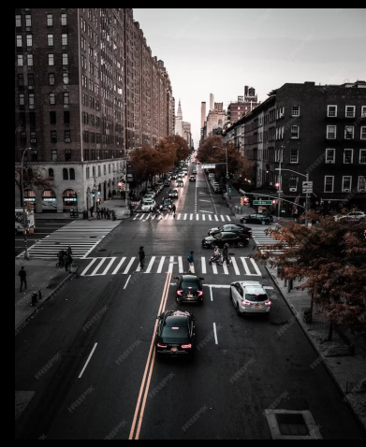

**Traffic Congestion**

Traffic congestion is a major problem in many cities. It leads to increased travel time, air pollution, and fuel consumption.

Efficient traffic management can help reduce congestion and improve the overall traffic flow.

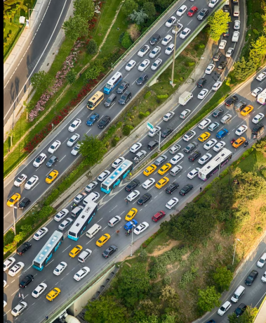

**Intelligent Transportation Systems**

Intelligent transportation systems (ITS) are a key component of efficient traffic management. ITS technologies include traffic sensors, cameras, and real-time data analysis to improve traffic flow and reduce congestion.

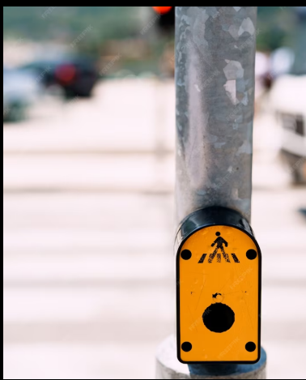

**Road Safety**

Efficient traffic management also plays a critical role in improving road safety. Strategies such as speed limit enforcement, traffic calming measures, and pedestrian safety programs can help reduce the number of accidents on the roads.

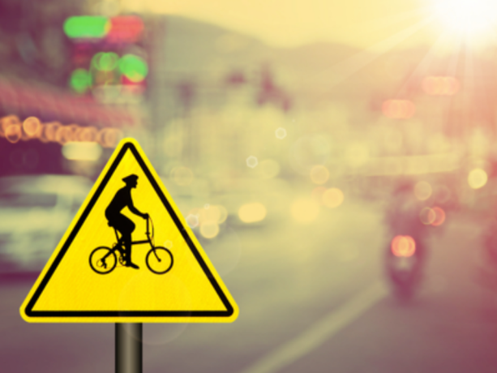

**Public Transportation**

Public transportation is an important part of efficient traffic management. It provides an alternative to driving, reducing the number of cars on the road and easing congestion. Additionally, public transportation can be integrated with ITS technologies to improve its efficiency.

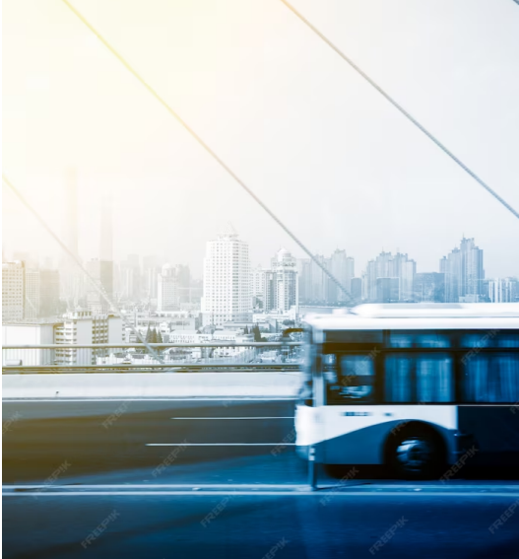

**Conclusion**

In conclusion, efficient traffic management is critical for enhancing safety and mobility on the roads. By leveraging advanced technologies and strategies, we can reduce congestion, improve traffic flow, and make our roads safer for everyone.

**Building up of Traffic management system**

* **STEP 1: Setting up a Hardware**

Connect the sensors, camera, and Arduino to the Raspberry Pi as per their datasheets or manuals. Ensure they're powered properly.

* **STEP 2: Install required libraries and software**

If you're using additional sensors, you might need to install libraries for them. For example, for an ultrasonic sensor, you'd use something like the GPIOZERO library on the Raspberry Pi.

* **STEP 3: Writing an Arduino code**

The Arduino code will handle sensor data and potentially control hardware components like traffic lights.

* **STEP 4: Setting up cloud simulator**

Create an account on a cloud service and set up a project with IoT capabilities.

* **STEP 5: Sending data to cloud from Raspberry Pi**

Use the cloud service's provided libraries or SDKs to send data from the Raspberry Pi to the cloud. This could be sensor data or images captured by the camera.

* **STEP 6: Implementing traffic control logic in cloud**

In the cloud, process the received data (e.g., apply machine learning for object detection). Based on the processed data, decide when to change traffic signals.

* **STEP 7: Sending control signals from cloud to Arduino**

Send control signals from the cloud to the Arduino through the cloud service. This could be done using MQTT or other communication protocols.

**WRITING PYTHON CODE FOR RASPBERRY PI**

* #Sample Python Code for Vehicle Detection using Ultrasonic Sensors:
* import Distance Sensor
* from time import sleep
* sensor = Distance Sensor (echo=17, trigger=4) # Example GPIO pins
* while True:
* distance = sensor. distance * 100 # Convert to cm
* print (f ’Distance: {distance:.2f} cm')
* if distance < 30: # Adjust as needed
* # Vehicle detected, implement traffic control logic here
* pass
* sleep (1)
* # Sample Python Code for Image Processing using Camera:
* python
* from pi Camera import Pi Camera
* from time import sleep
* camera = Pi Camera ()
* def capture_ image (file_ name):
* camera. Start _ preview ()
* sleep (2) # Allow time for the camera to adjust
* camera capture(filename)
* camera. Stop _ preview ()

<!DOCTYPE html>

<html>

<head>

<title>Traffic Management System</title>

</head>

<body>

<header>

<h1>Traffic Management System</h1>

</header>

<nav>

<ul>

<li><a href="#">Home</a></li>

<li><a href="#">Live Traffic Feed</a></li>

<li><a href="#">Traffic Cameras</a></li>

<li><a href="#">Traffic Reports</a></li>

<li><a href="#">Settings</a></li>

</ul>

</nav>

<main>

<section id="live-feed">

<h2>Live Traffic Feed</h2>

<!-- Display live traffic information here -->

</section>

<section id="traffic-cameras">

<h2>Traffic Cameras</h2>

<!-- Display traffic camera feeds and controls here -->

</section>

<section id="traffic-reports">

<h2>Traffic Reports</h2>

<!-- Display traffic reports and statistics here -->

</section>

</main>

<footer>

<p>&copy; 2023 Traffic Management System</p>

</footer>

</body>

</html>

**BLOCK DIAGRAM**

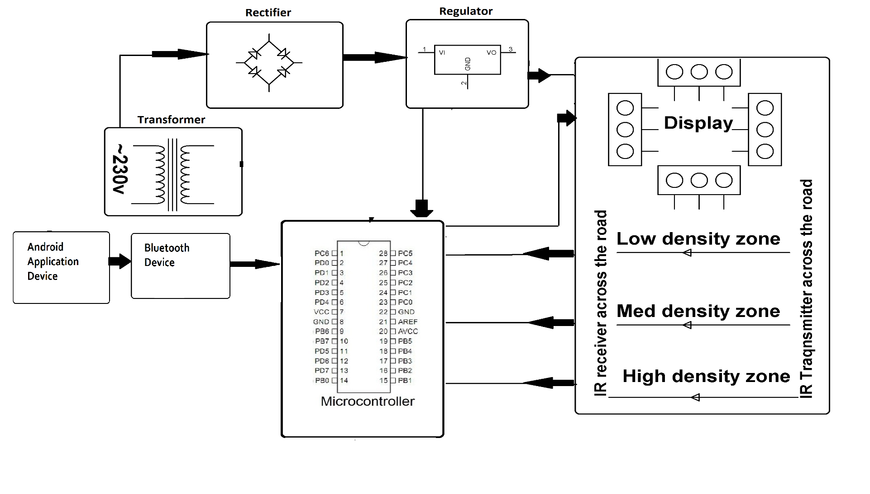

**SCREENSHOTS OF THE IoT DEVICES**

