**BeerWiki**

Hi All,

BeerWiki.zip contains 1 directory and 1 file(ReleaseNotes).

BeerWiki is a website which contains all the information about the Beers.

The website is based on MVC 4.0, developing environment is: Windows 10 with ASP.NET MVC 4 in Visual Studio 2015.

This website is using BreweryDB API for populating the details of Beers in ListPage and detailsPage.

Below are the screenshots of each page with short description on the WebSite.

1. This is Home page which will be open when we deploy the application on IIS or run it through VS.

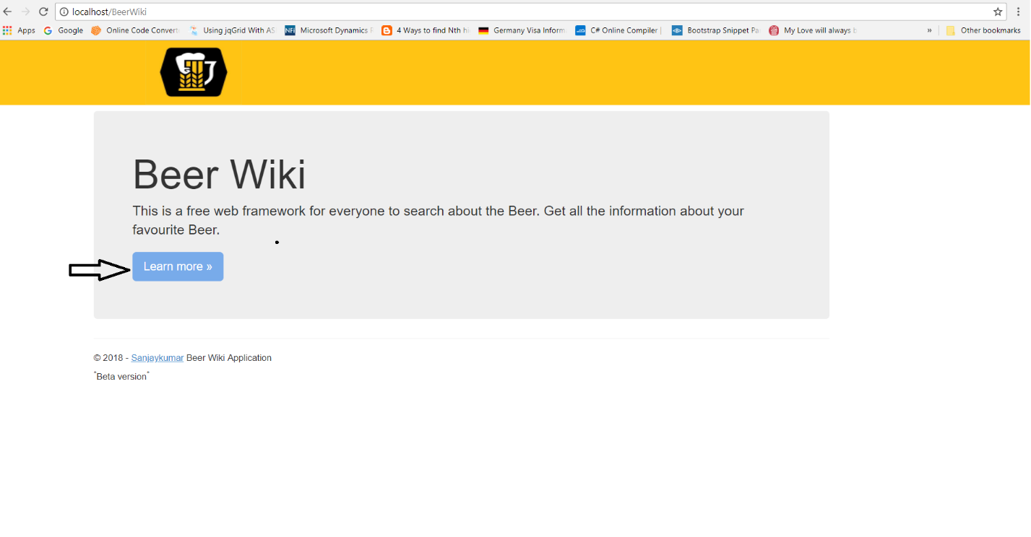

Click on “Learn more” Button which will load next page i.e. BeerList.

1. Below screenshot is of List of beers.

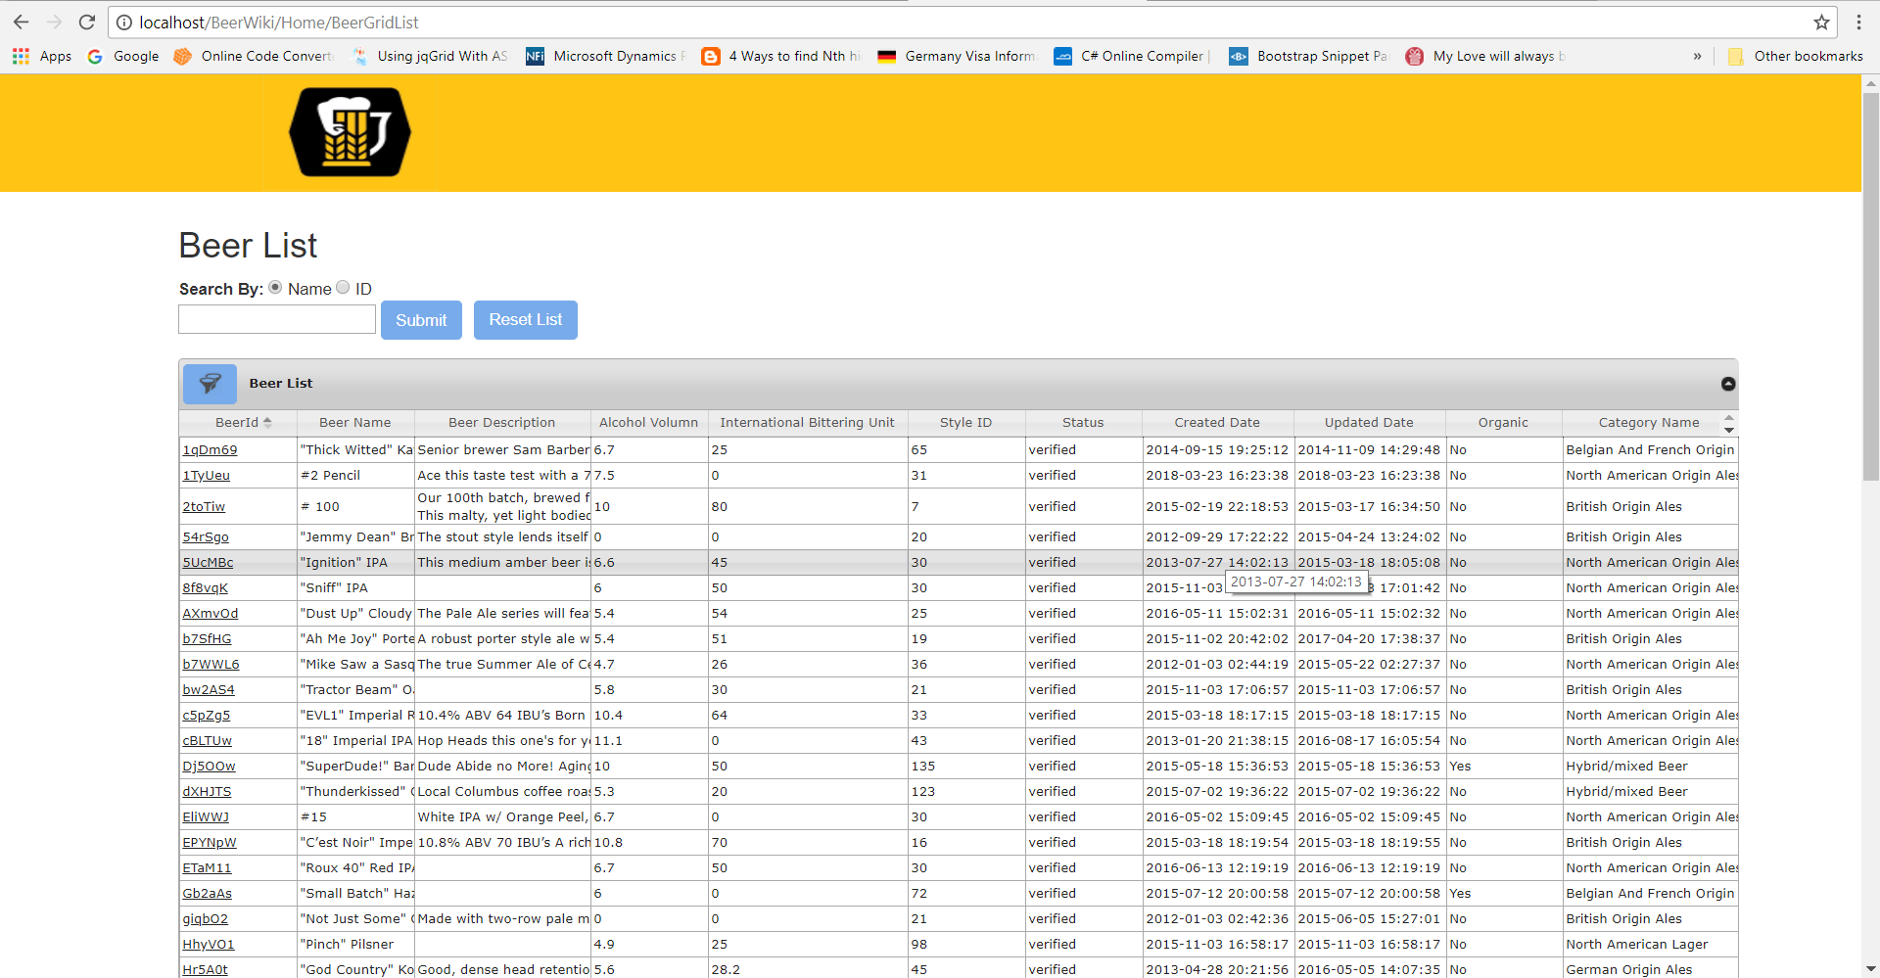

1. This page also has Paging through which we can navigate to another list of Beer.

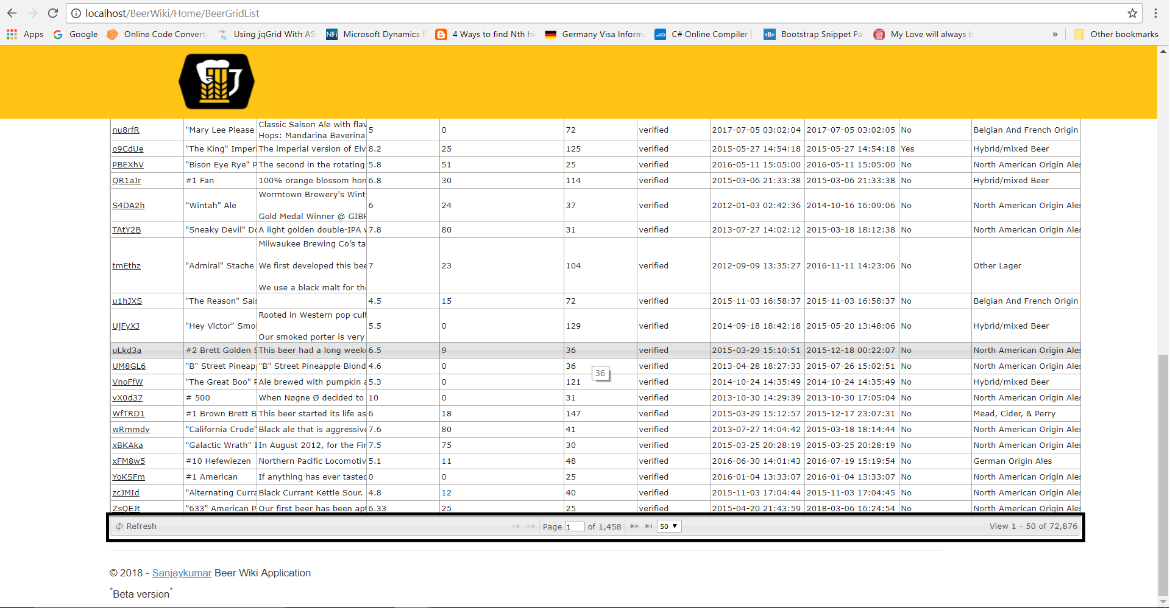

Pagination can be done up to 50 records per page in BETA version.

1. As per requirement I have implemented search functionality for this page by either name or ID.

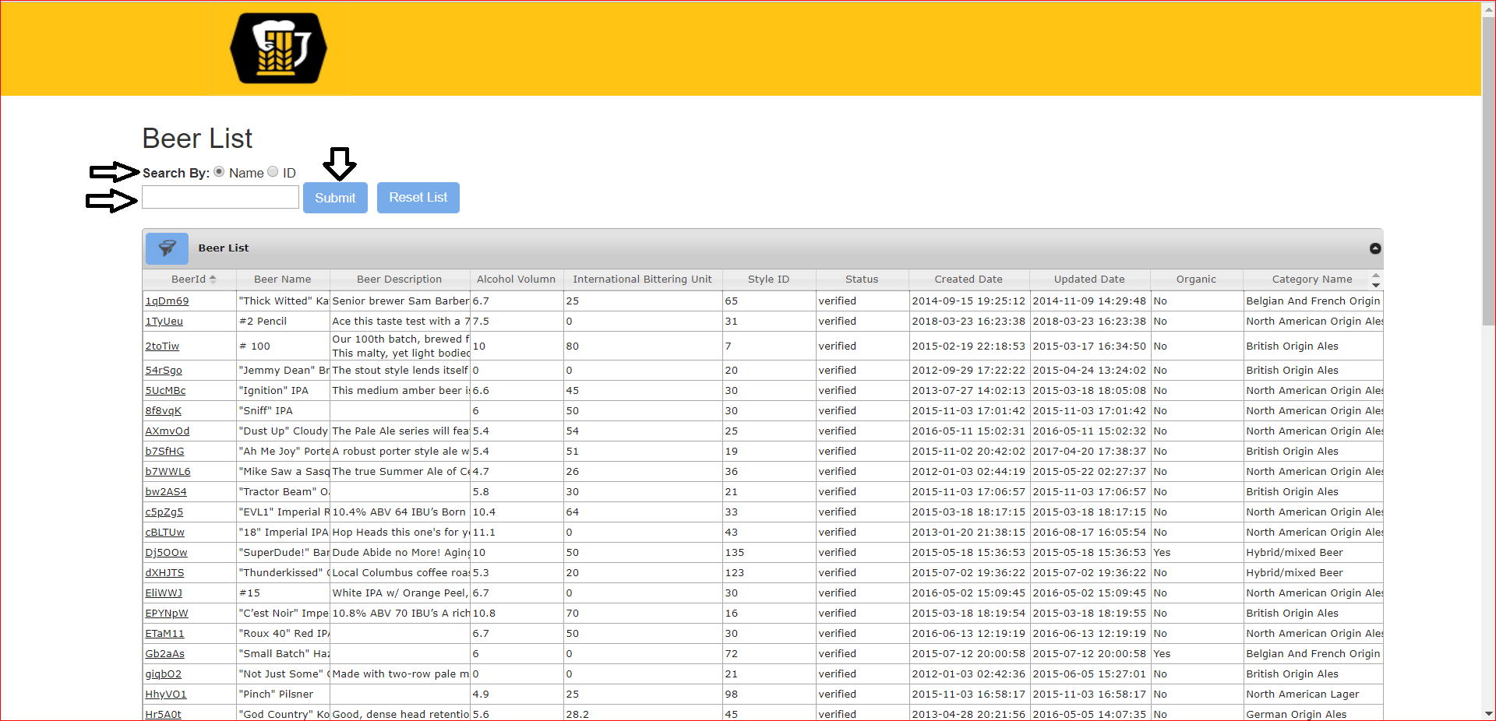

Result will be displayed as below screenshot.

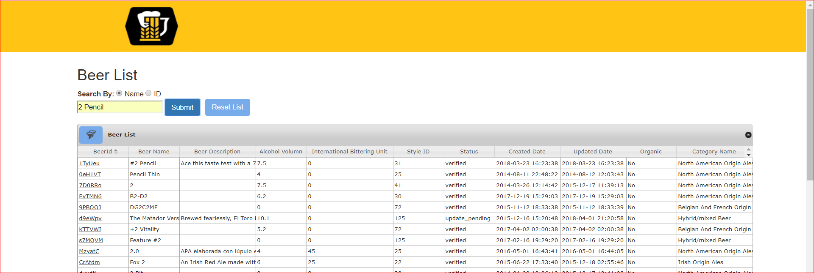

1. You can click on the reset button and reset the list.

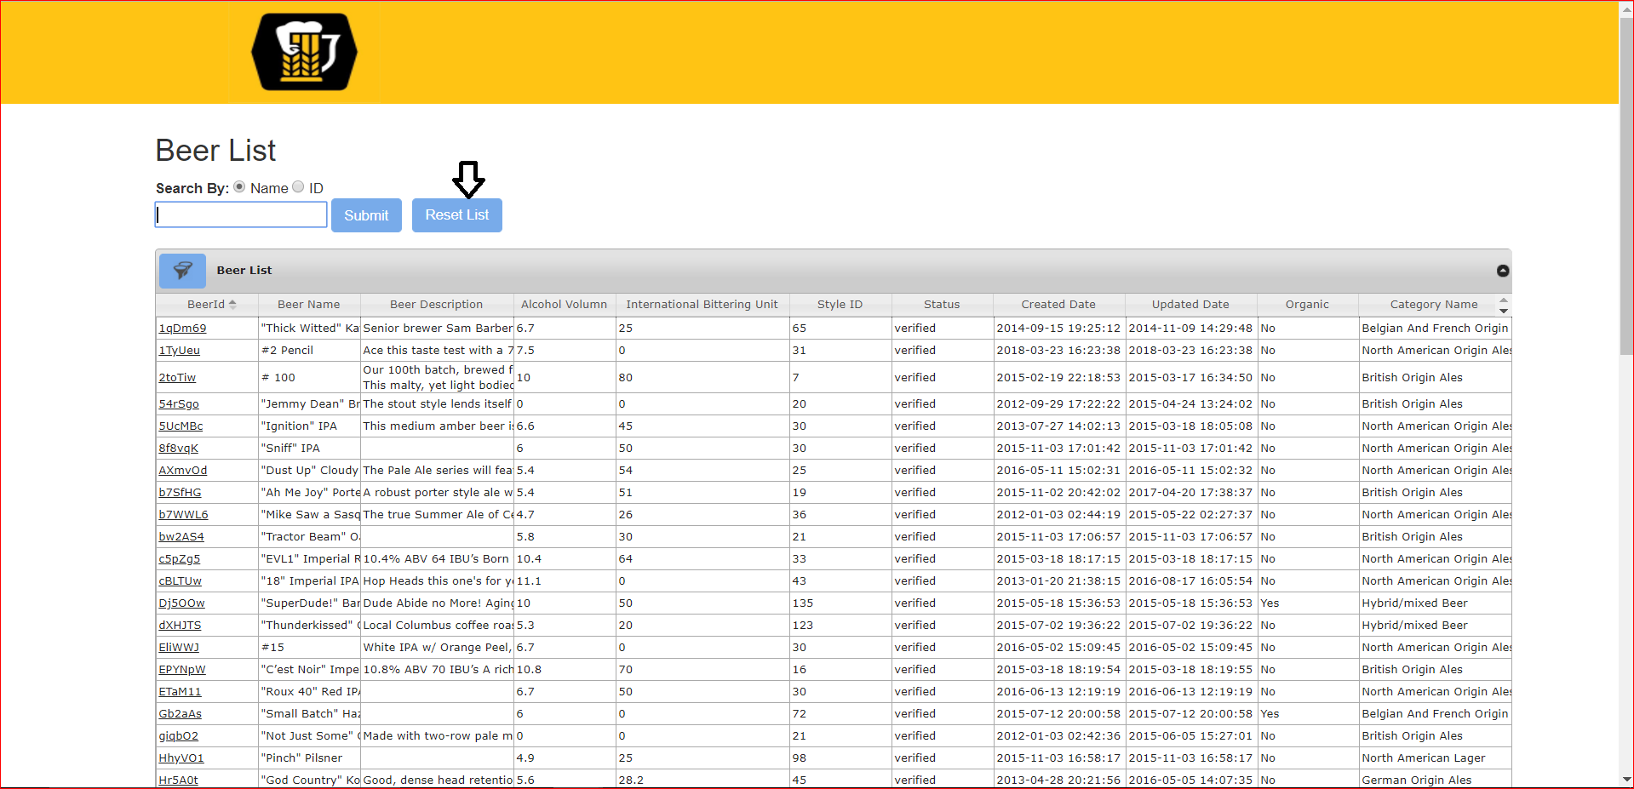

1. Along with search functionality I have given Filter button which will filter the list by several columns together.

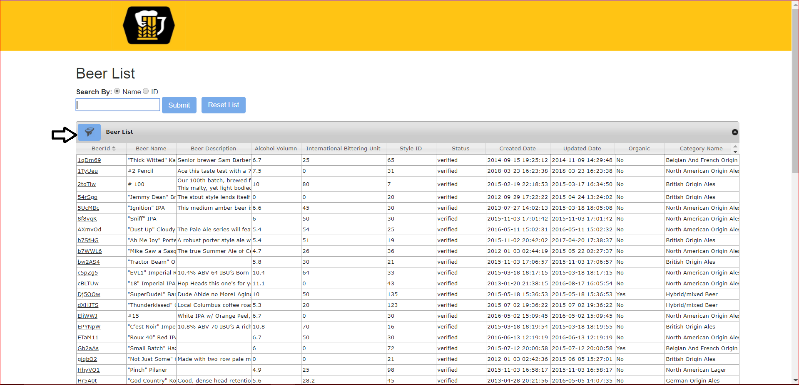

1. Filter can be applied by Ids (10 at a time separated by comma), Name, Status and IsOrganic.

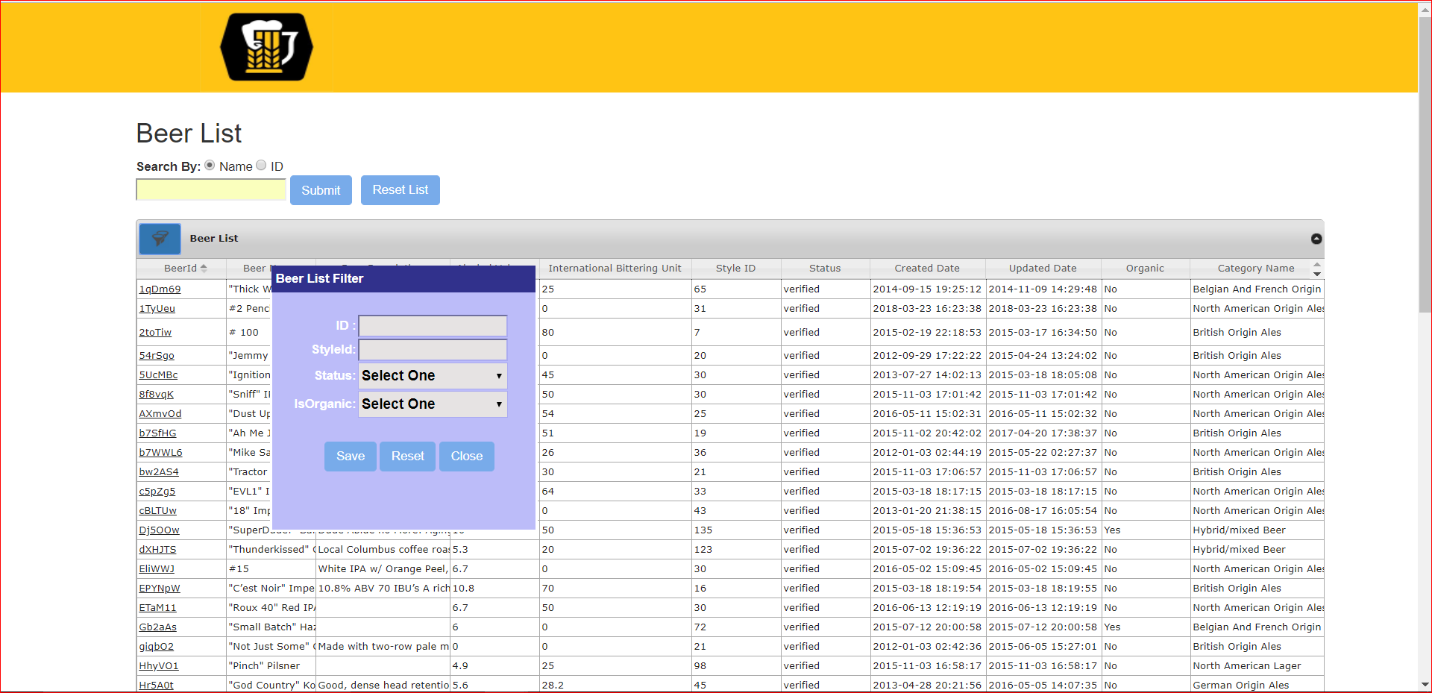

NOTE: Ids and Status cannot be search together in beta version.

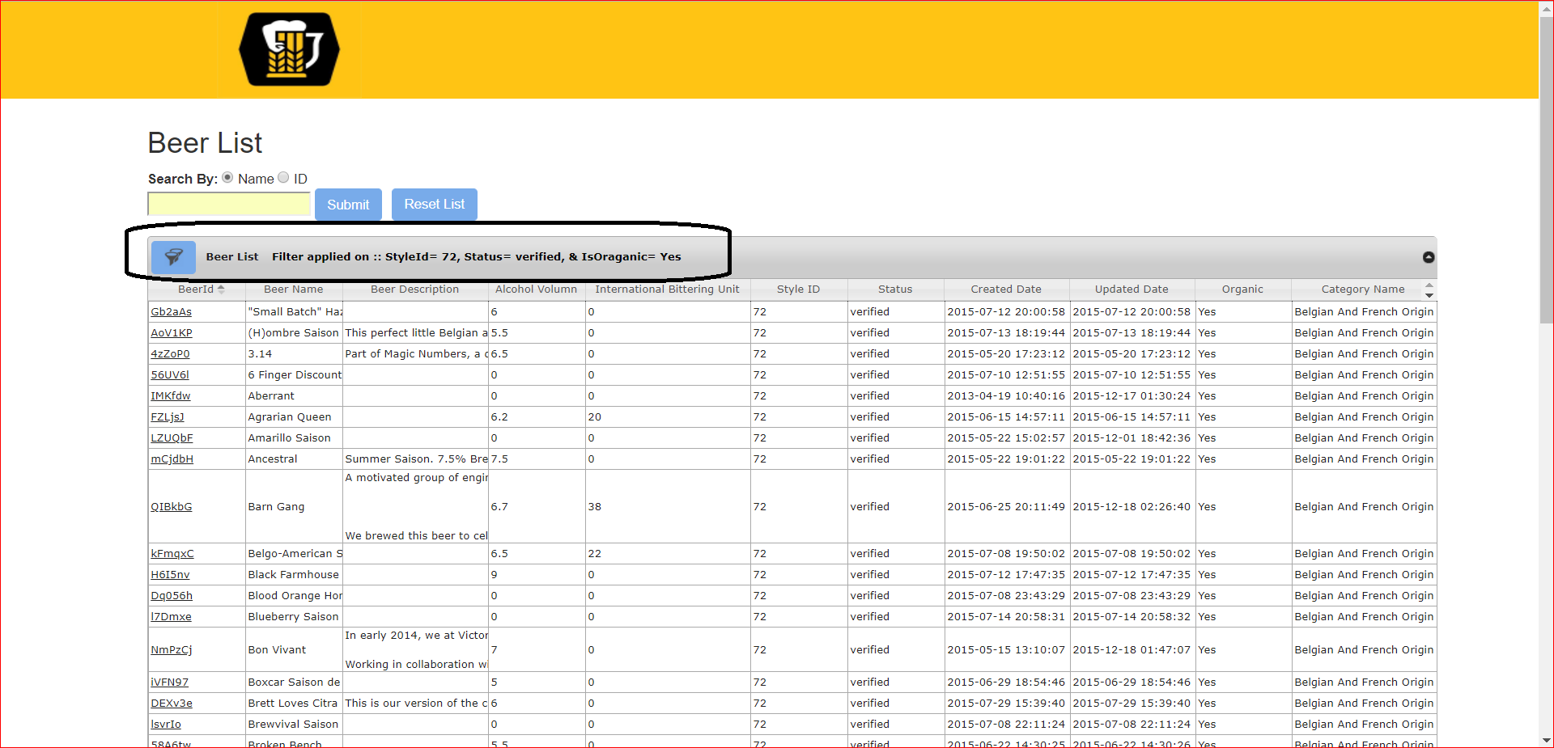

Once you apply the filter you can see the text on header of the Grid List.

1. Each Id in the grid is linked to show the description of the Beer.

The beer with the image will display like below

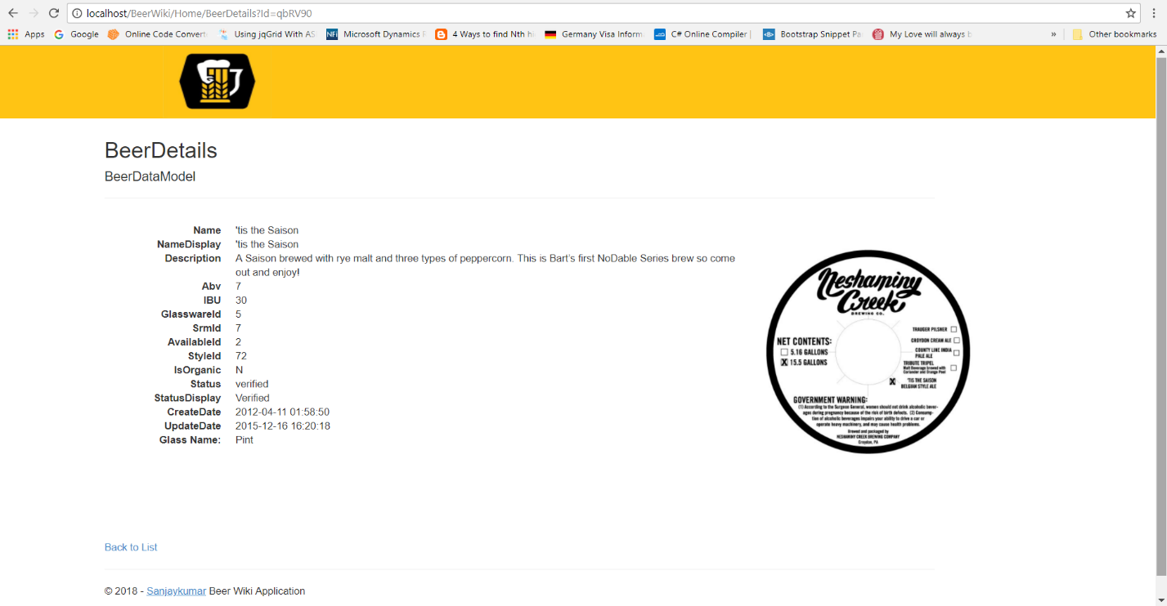

And the beer details which has no image will look like this.

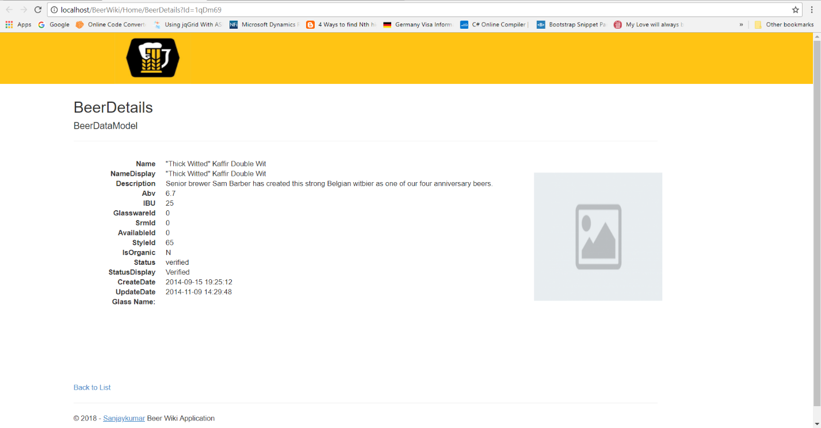

I am open for any questions and discussion.

Warm Regards,

Sanjay

***Disclaimer:***

**API used:** BreweryDB

**MSDN reference**: <https://docs.microsoft.com/en-us/aspnet/mvc/overview/older-versions/getting-started-with-aspnet-mvc4/intro-to-aspnet-mvc-4>

**Know Issues**:

1. As this website is beta version, after adding any filters or search criteria. It will only show first 50 result.

**NOTE:** On initial load the pagination works as expected.