Super Resolution Image Enhancing Extension
In this work as extension we have used FSRCNN (Fast Super-Resolution Convolutional Neural Network) is a deep learning algorithm used for image super-resolution, which is the process of increasing the resolution of a low-resolution (LR) image to produce a high-resolution (HR) image. It's designed to be computationally efficient, making it suitable for real-time applications. FSRCNN achieves high-quality results with minimal computational cost, making it suitable for real-time super-resolution tasks.
To create and differentiate between high quality big image from small size image we are using separate visualization which is showing in below screen
Note: you ask to display image retrieval using similarity score but this calculate already available in code which is showing in below screen
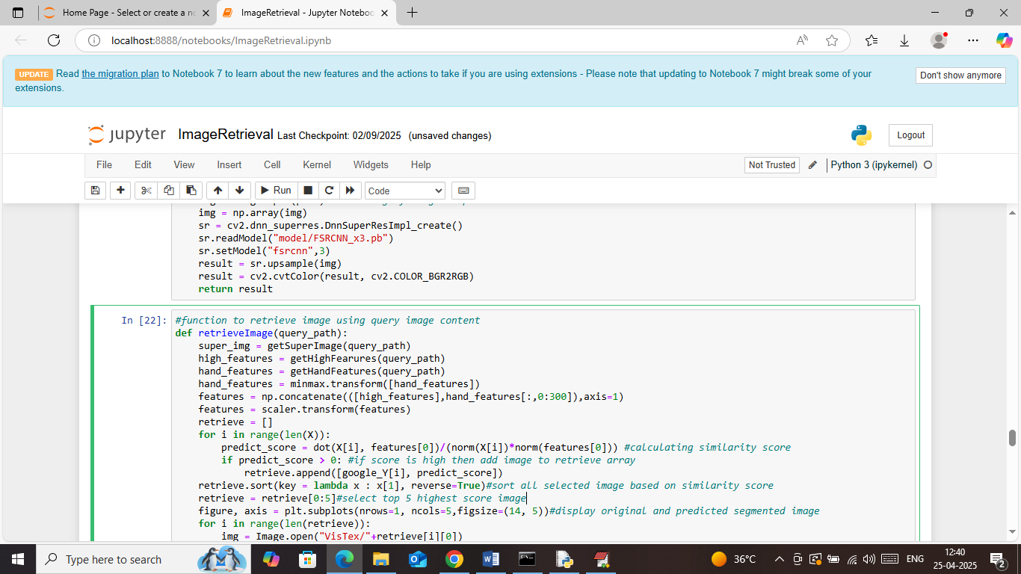
In above screen read blue color comments to know about image retrieval using similarity score.
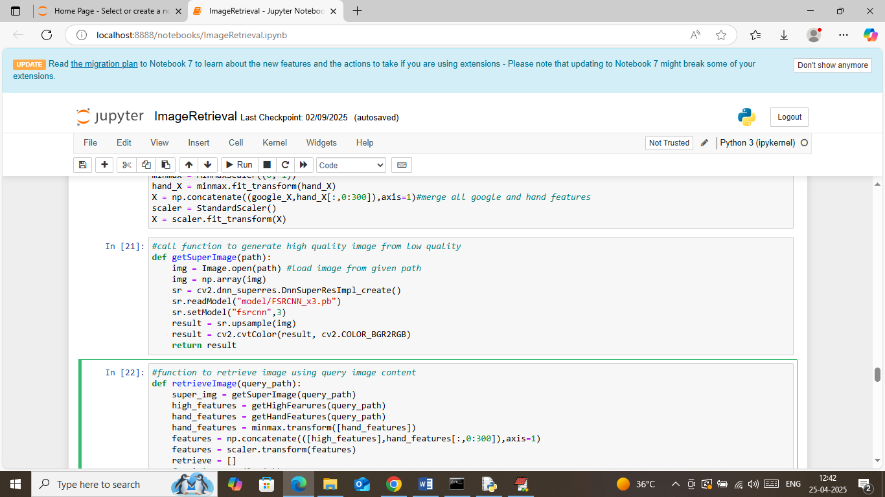
In above screen defining function to generate super resolution from given input image
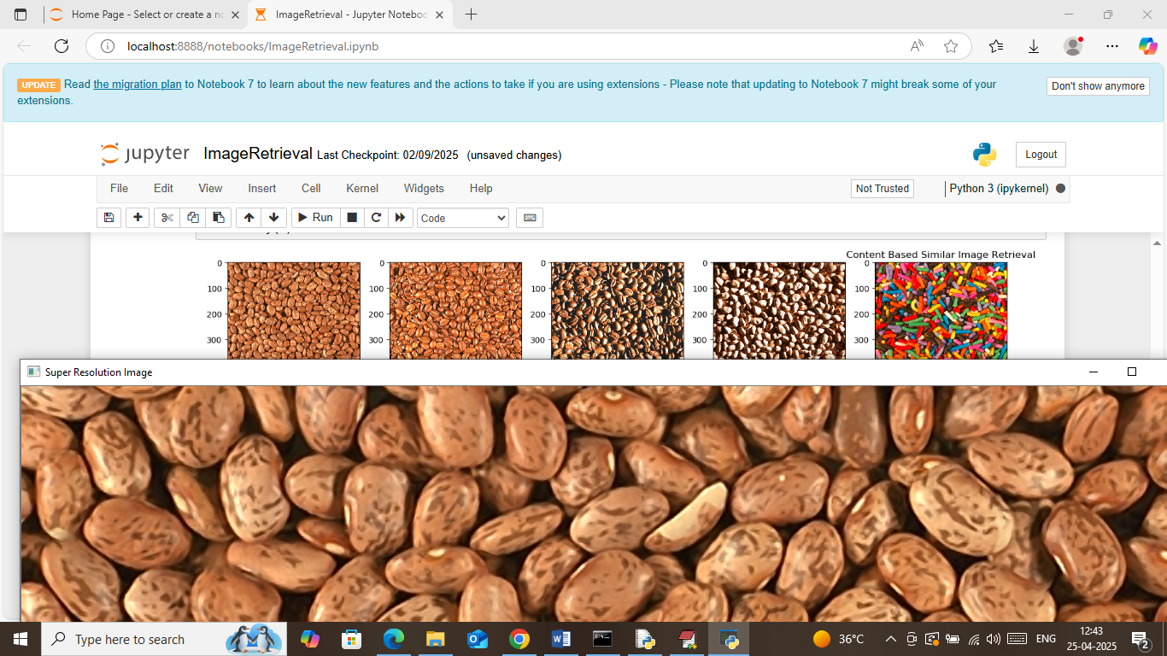
In above screen small 5 images are the top 5 retrieval image and the 6th big image is the super resolution image generated from small input image. In 6th big image can see each pixel having high quality resolution. To run next image block just close above big image and below is another example

Above is another example
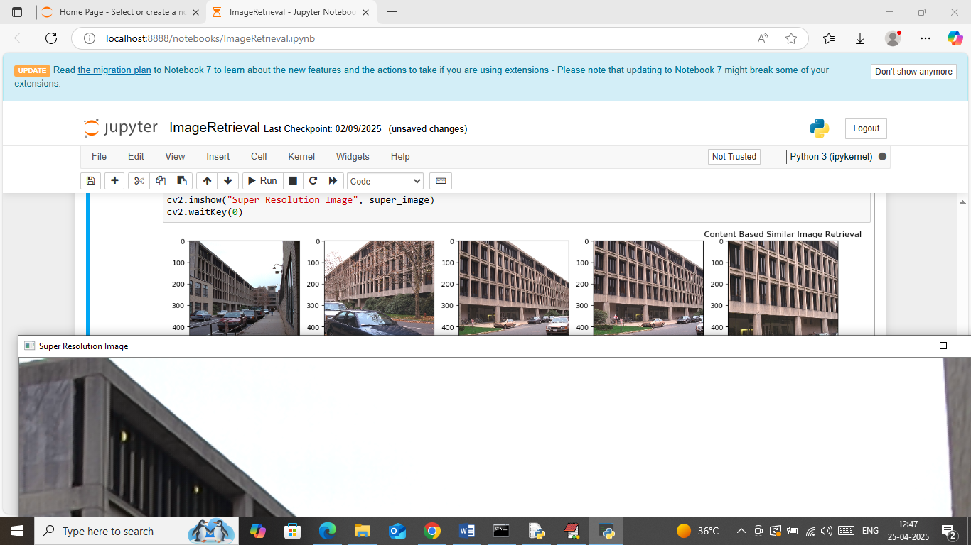
Above is another big size high quality super resolution image
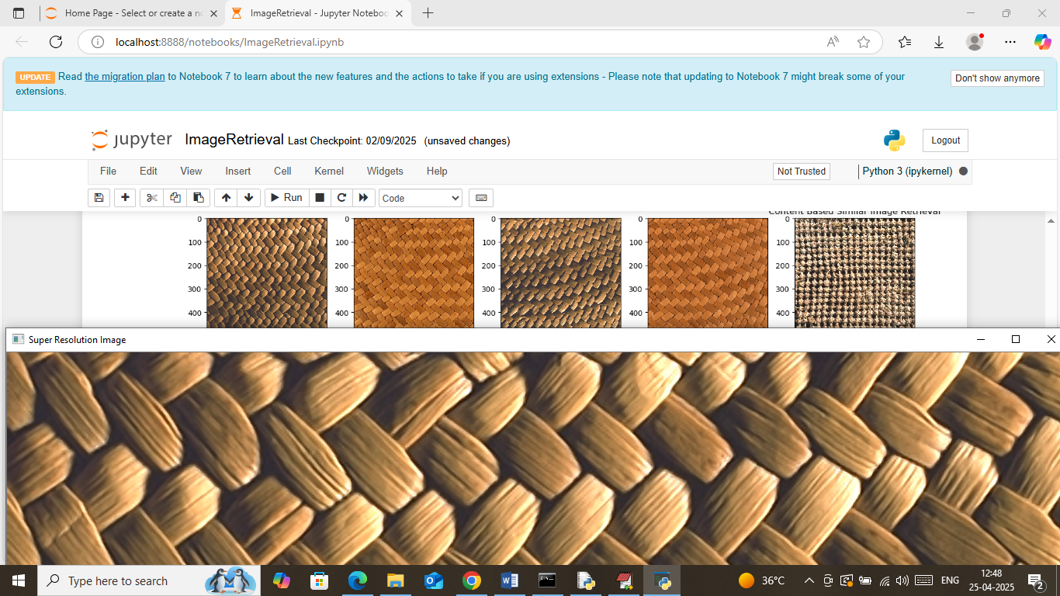
Above is another super resolution example
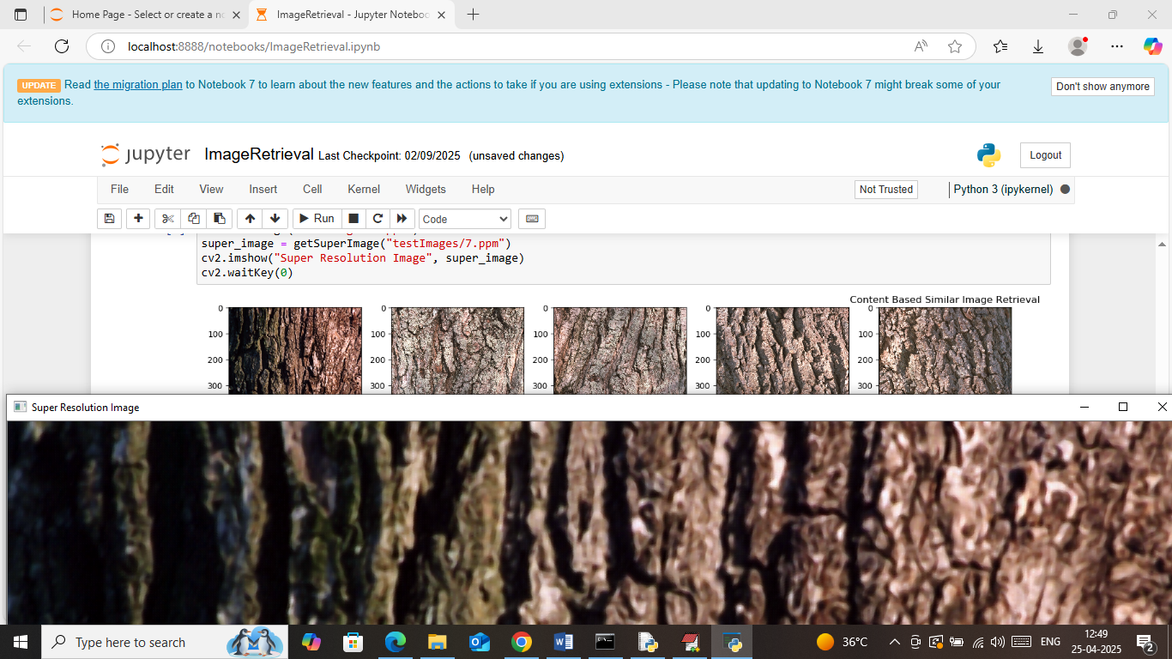
Above is another example

