Content-Based Image Retrieval for Super-Resolution Images using Feature Fusion: Deep Learning & Hand Crafted
In propose paper author combining multiple techniques such as deep learning High level and Hand crafted features extraction from Super Resolution images to retrieve content based similar images. All existing algorithms were utilizing either deep learning or manual hand crafted features extraction technique whose retrieval precision rate is very low. In propose paper author validated propose model with multiple different techniques on different dataset and in all propose model outperform.
In propose paper InceptionV3 GOOGLENET model utilize to extract high level features and then employ hand crafted features extraction techniques called Modified DDBTC, HOG, Integrated channel HSI and GCLM. Both High level and hand crafted features will get concatenated and then employ Vector Similarity search algorithm to retrieve content based similar images.
Author validated propose model with multiple techniques and it’s not possible to implement all so we have utilize GOOGLENET features as existing and combination of GOOGLENET + Hand crafted as propose model. We have trained both existing and propose model on VISTEX and STEX dataset.
Both dataset images are converted to super solution images by employing INTER-CUBIC algorithm.
SCREEN SHOTS we have code this project using JUPYTER notebook and below are the code and output screens with blue colour comments
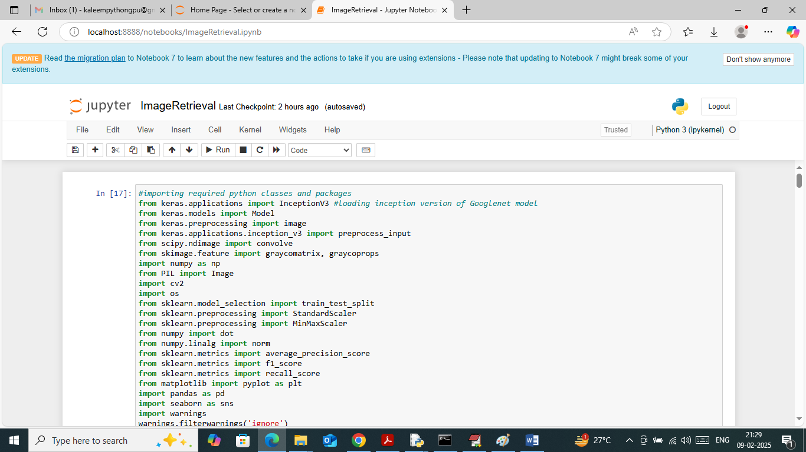
In above screen loading required python classes and packages
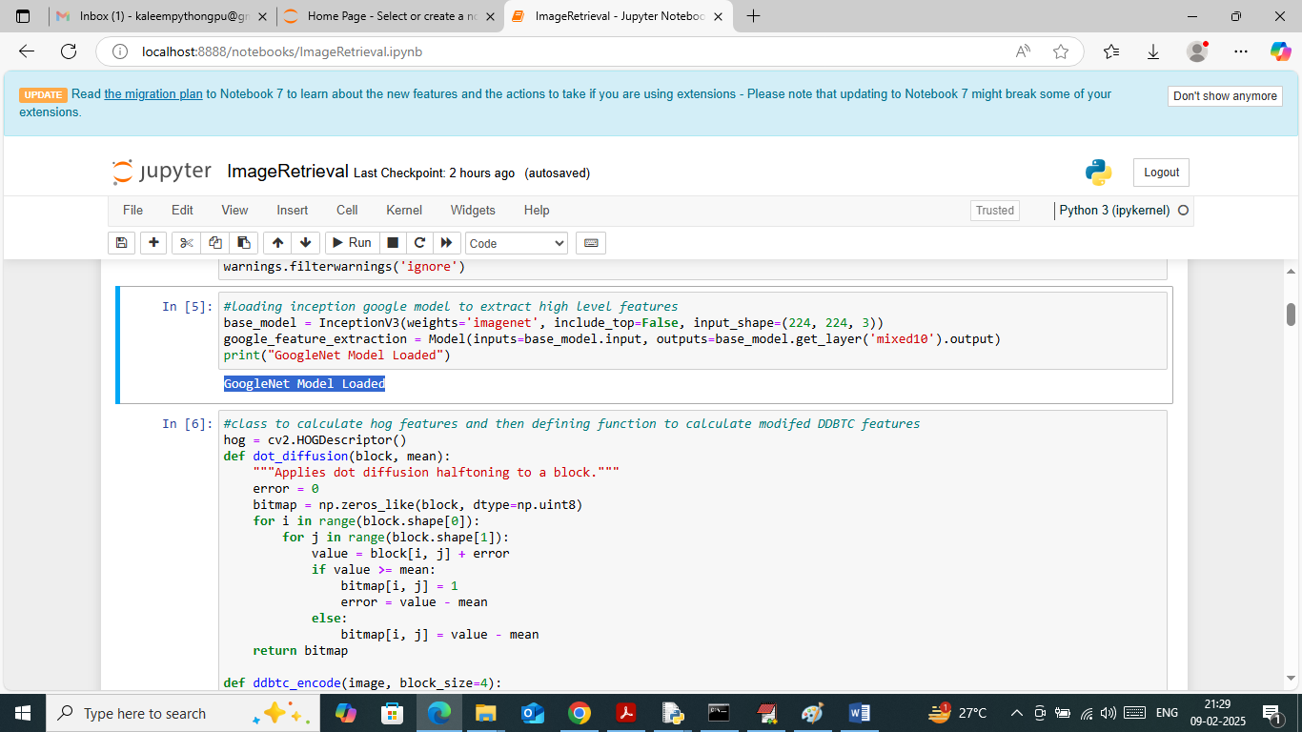
In above screen defining function to load GOOGLENET model and then can see DDBTC function to extract features
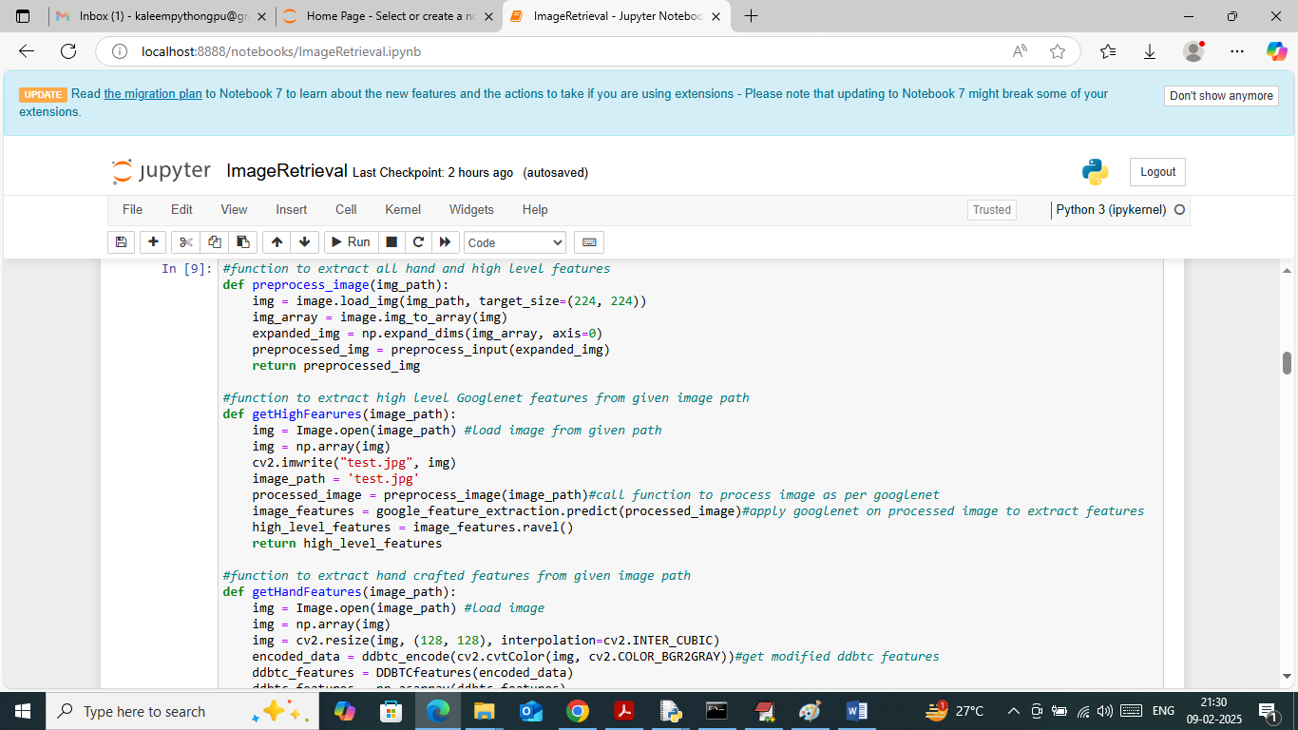
In above screen defining function to extract HIGH and Hand crafted features from given image path
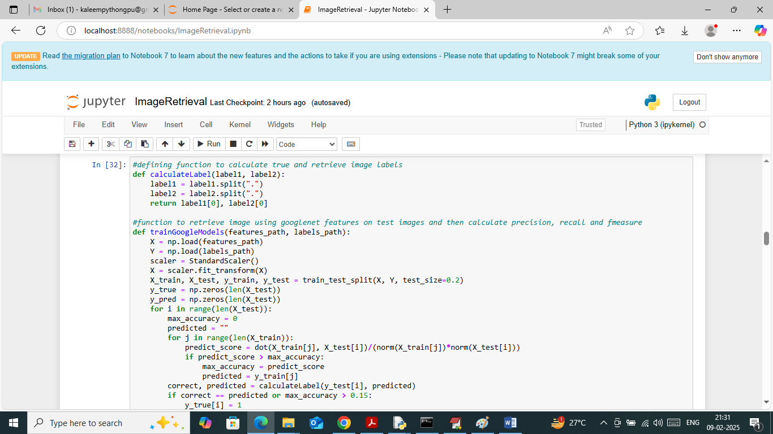
In above screen defining function to train model on Google Net features and then calculate metrics
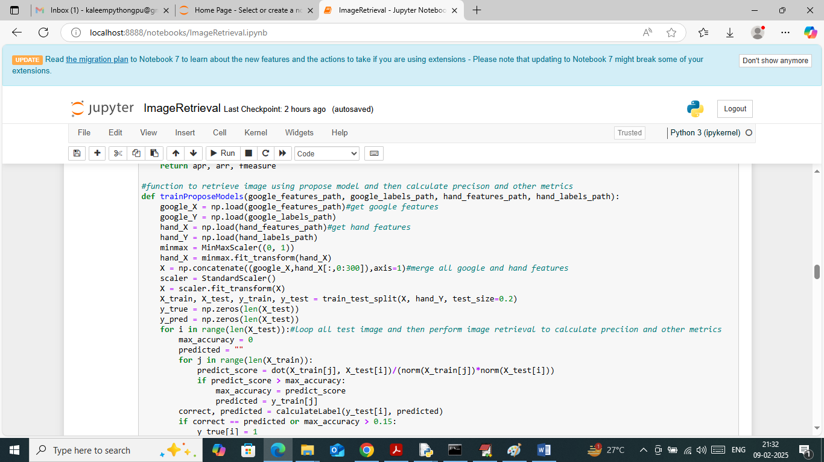
In above screen defining function to train propose model by combining High level and Hand Crafted features and then calculate metrics
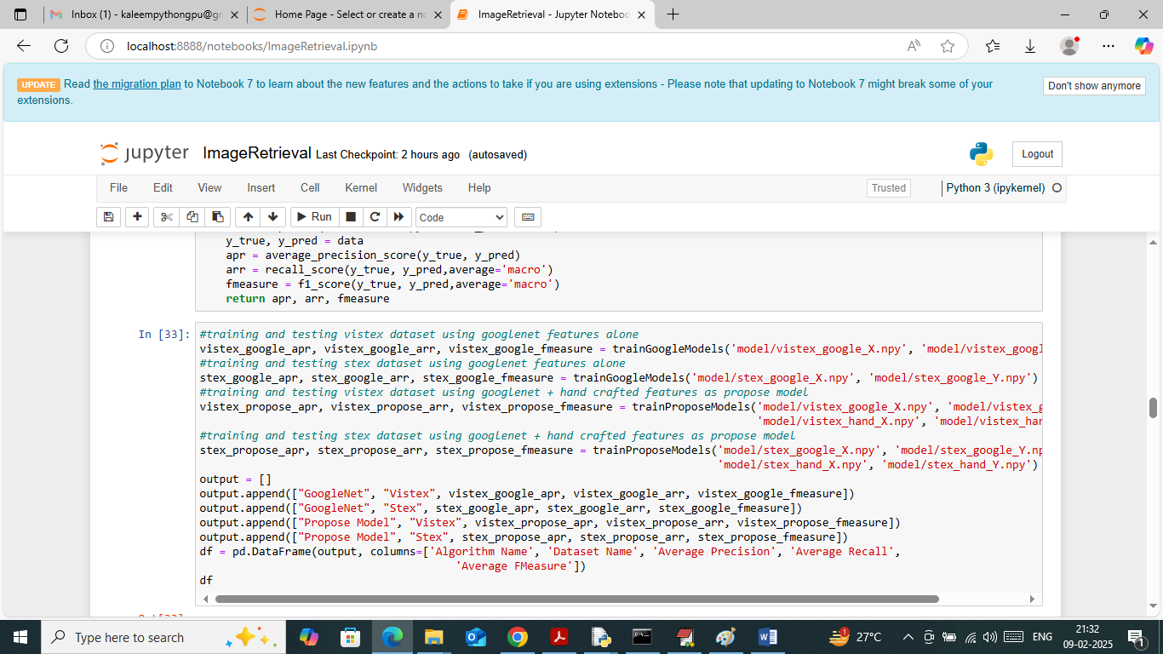
In above screen calling existing and propose algorithm on two different datasets such as VISTEXT and STEX and after training will get below output
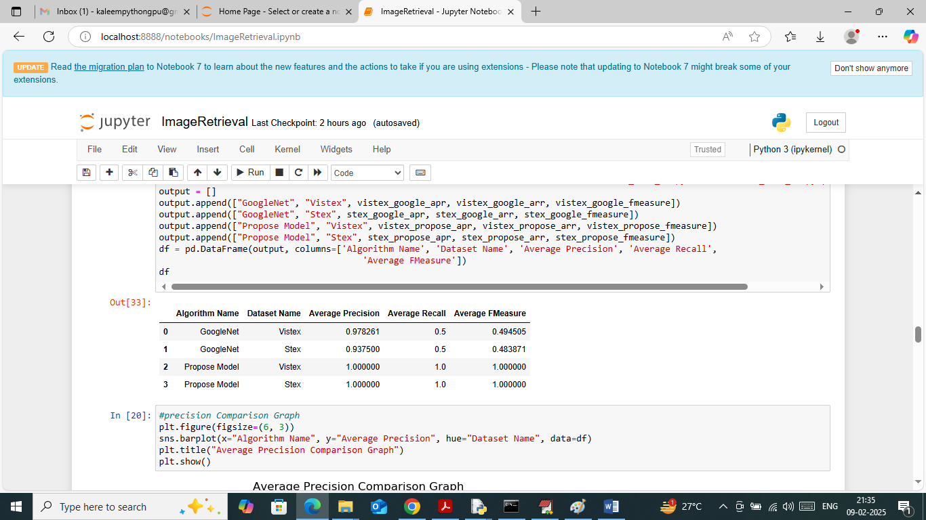
In above screen can see both algorithm performance on both datasets and each algorithm performance is calculated in terms of Precision, Recall and FMEASURE and in both algorithm propose got high precision on both datasets
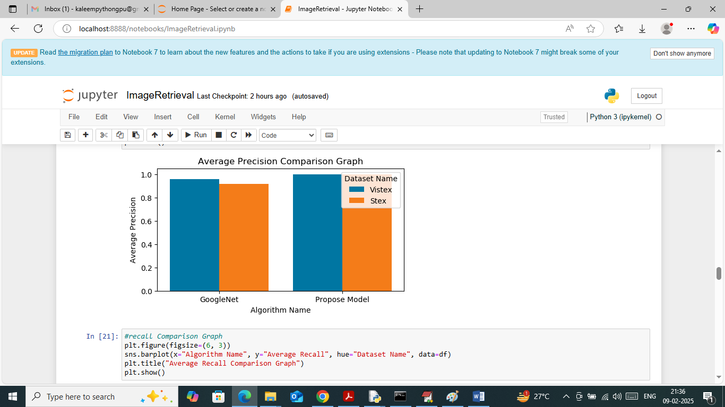
In above screen showing precision comparison graph between both algorithms on both datasets where x-axis represents algorithm names and y-axis represents precision with different colour bars as two datasets
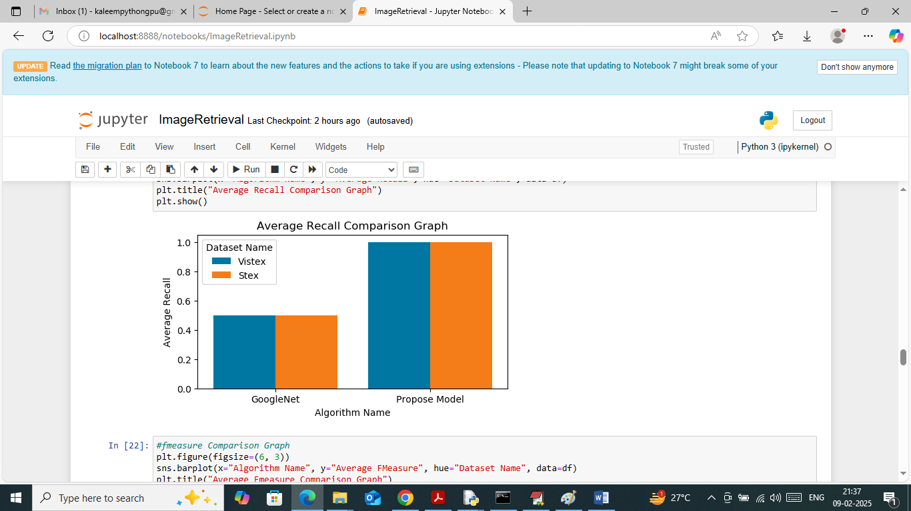
In above screen showing recall comparison graph
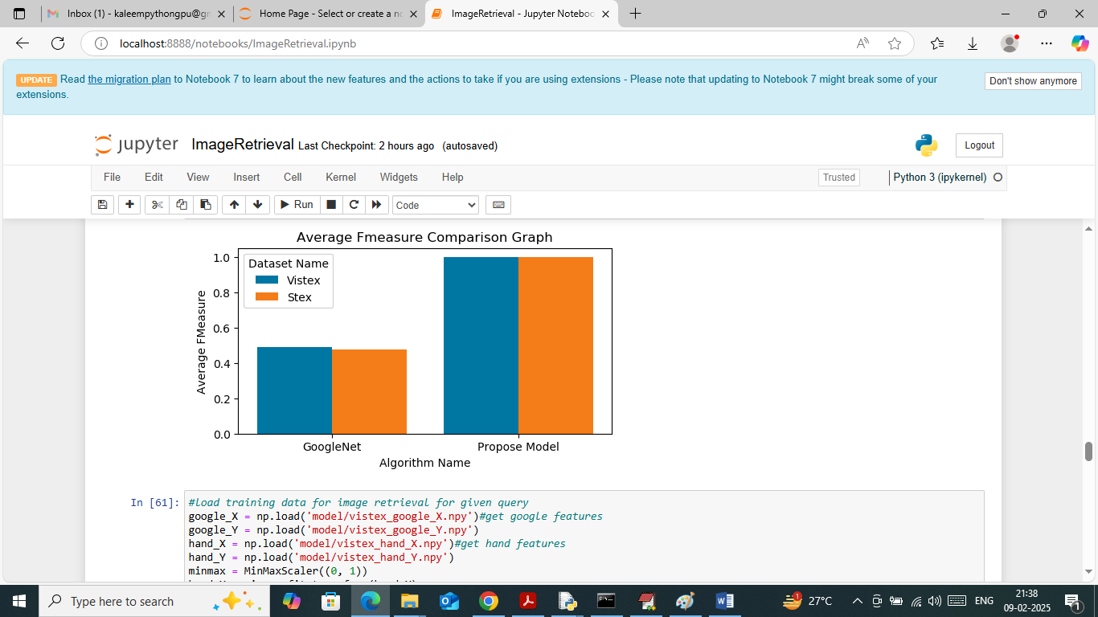
In above screen showing FMEASURE comparison graph
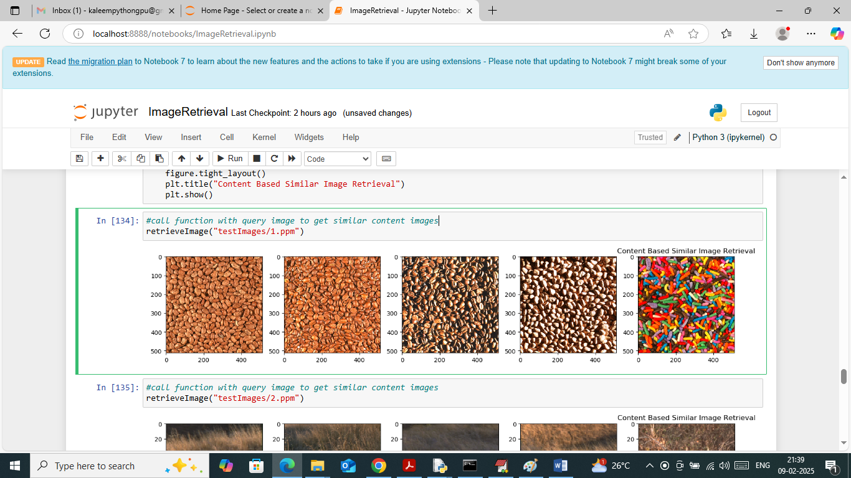
In above screen calling ‘retrieve Image’ function with query image path and then propose algorithm gave top 5 similar retrieval images and similarly you can call above function with different image path to get similar image
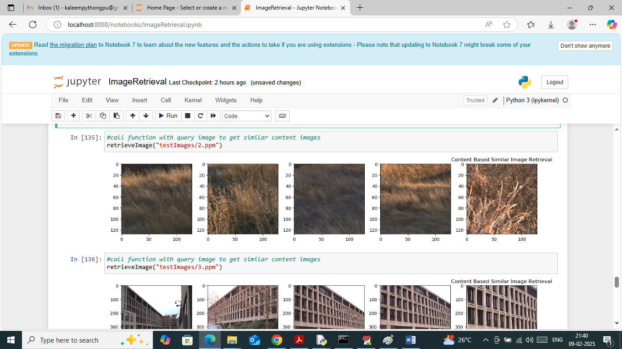
In above screen can see similar content images for given query image
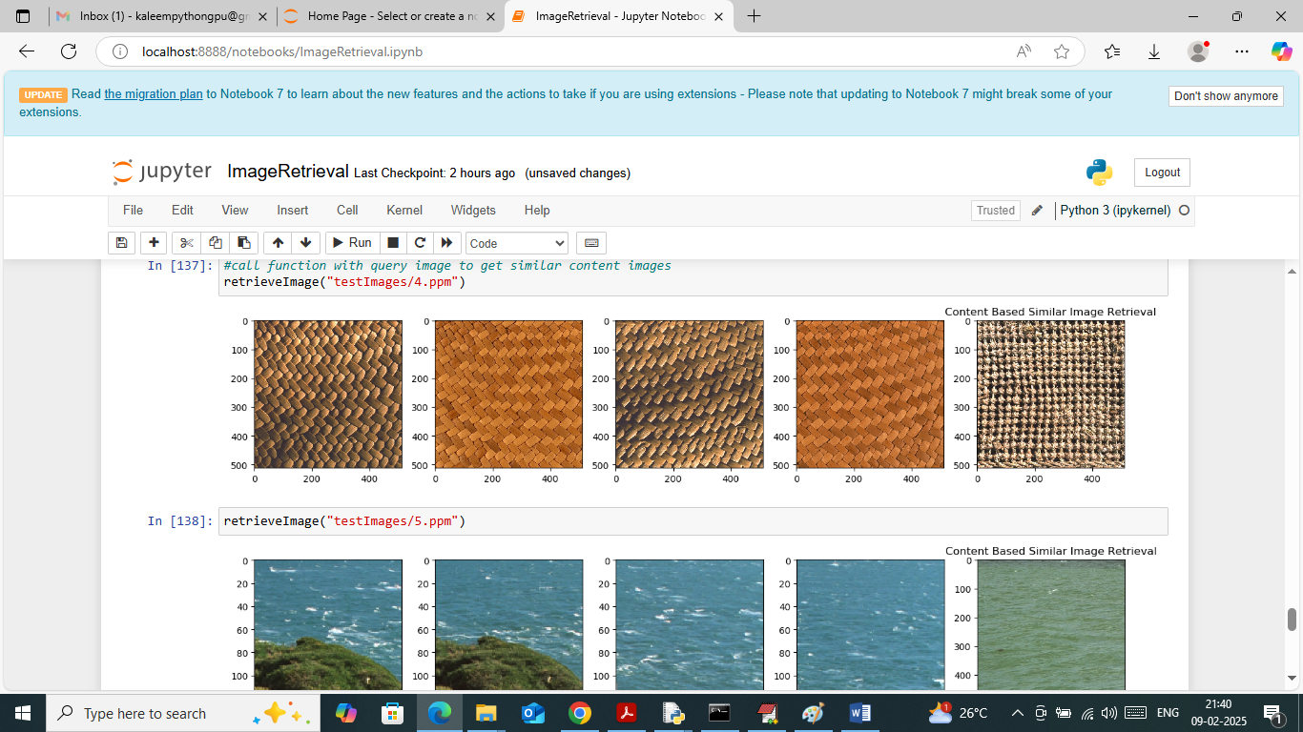
In above screen can see another query example
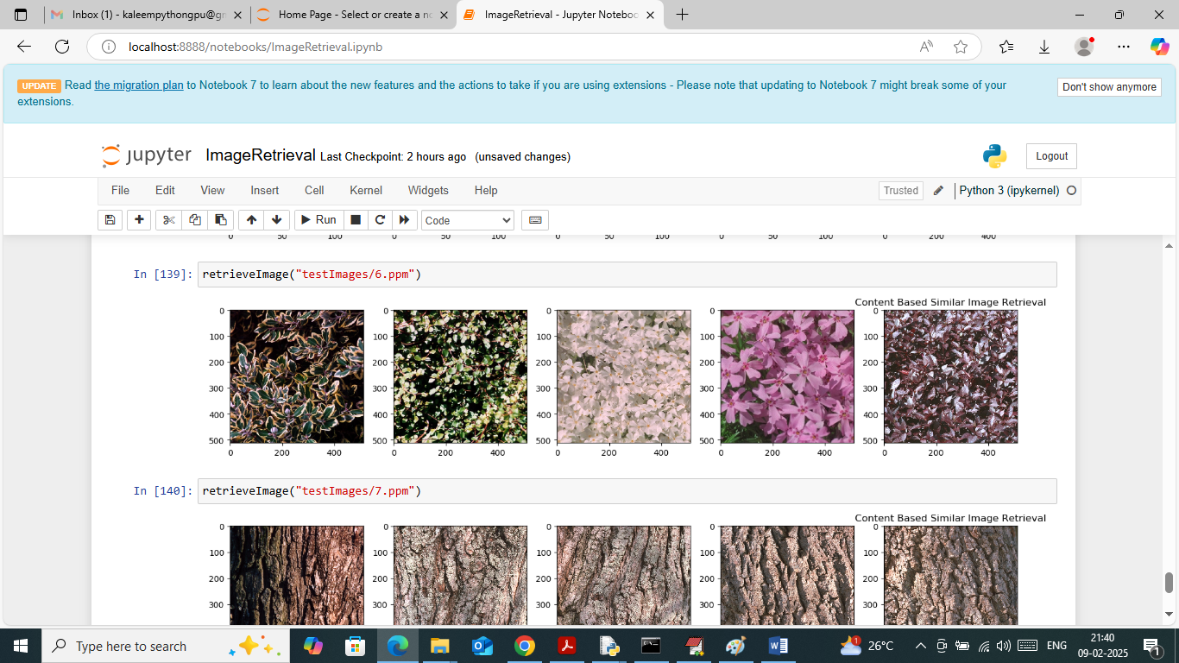
In above screen can see other query example

