PIZZA SALES SQL QUERIES
A.KPI’S
1. Total Revenue
SELECT SUM(total_price) AS Total_Revenue from Sales
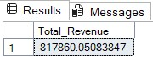

2. Average Order Value
SELECT (SUM(total_price) / COUNT(DISTINCT order_id)) AS Avg_order_Value from Sales

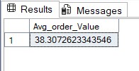

3. Total Pizzas Sold
SELECT SUM(quantity) AS Total_pizza_sold from Sales

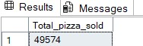

4. Total Orders
SELECT COUNT(DISTINCT order_id) AS Total_Orders from Sales

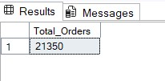

5. Average Pizzas per Order

SELECT CAST(CAST(SUM(quantity) AS DECIMAL(10,2)) /
CAST(COUNT(DISTINCT order_id) AS DECIMAL(10,2)) AS DECIMAL(10,2))
AS Avg_Pizzas_per_order
from sales;

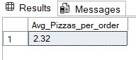

B. Daily Trend for Total Orders

SELECT DATENAME(DW, Order_Date) as order_day, COUNT(Distinct ORDER_ID) as Total_Orders
from sales
Group by DATENAME(DW, Order_Date)

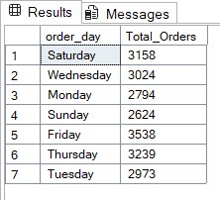

C. Monthly Trend for Orders

Select DATENAME(MONTH, order_date) as Month_Name, COUNT(DISTINCT order_id) as Total_orders
from sales
GROUP BY DATENAME(MONTH, order_date)
order by total_orders desc

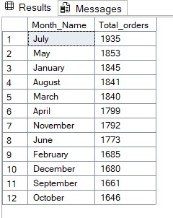

D. % of Sales by Pizza Category

select pizza_category ,sum(total_price) as Total_Sales, sum(Total_price) *100 /
(Select sum(total_price) from sales where month(order_date) = 1) as PCT
from sales
where month(order_date) = 1
group by pizza_category

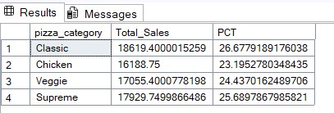

E. % of Sales by Pizza Size

select pizza_size ,cast(sum(total_price) as decimal(10,2)) as Total_Sales, cast(sum(Total_price) *100 /
(Select sum(total_price) from sales where DATEPART(quarter, order_date)=1) as decimal(10,2)) as PCT
from sales
where DATEPART(quarter, order_date)=1
group by pizza_size
order by PCT desc

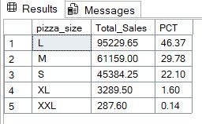

F. Total Pizzas Sold by Pizza Category

Select top 5 pizza_name, sum(total_price) as total_revenue from sales
group by pizza_name
order by total_revenue desc

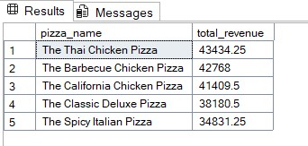

G. Top 5 Pizzas by Revenue

Select top 5 pizza_name, sum(total_price) as total_revenue from sales
group by pizza_name
order by total_revenue asc

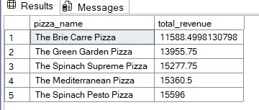

H. Bottom 5 Pizzas by Revenue

Select top 5 pizza_name, sum(quantity) as total_quantity from sales
group by pizza_name
order by total_quantity desc

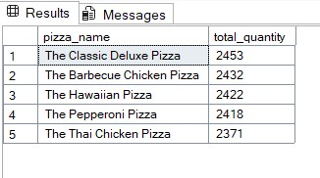
I. Top 5 Pizzas by Quantity

Select top 5 pizza_name, sum(quantity) as total_quantity from sales
group by pizza_name
order by total_quantity asc

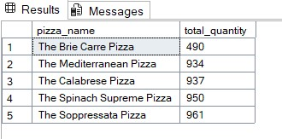

J. Bottom 5 Pizzas by Quantity

Select top 5 pizza_name, count(distinct order_id) as total_orders from sales
group by pizza_name
order by total_orders asc

