5.Develop a system using UML for implementing Online Course Reservation System. This system is

organized by the central management system. The student first browses and selects the desired

course of their choice. The university then checks the availability of the seat if it is available the

student is enrolled for the course.

Collaboration Diagram :

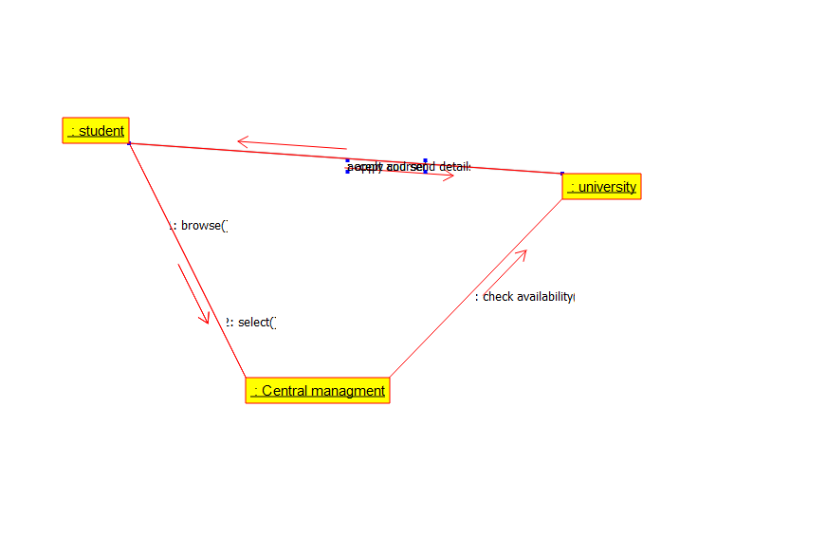

Deployment Diagram :

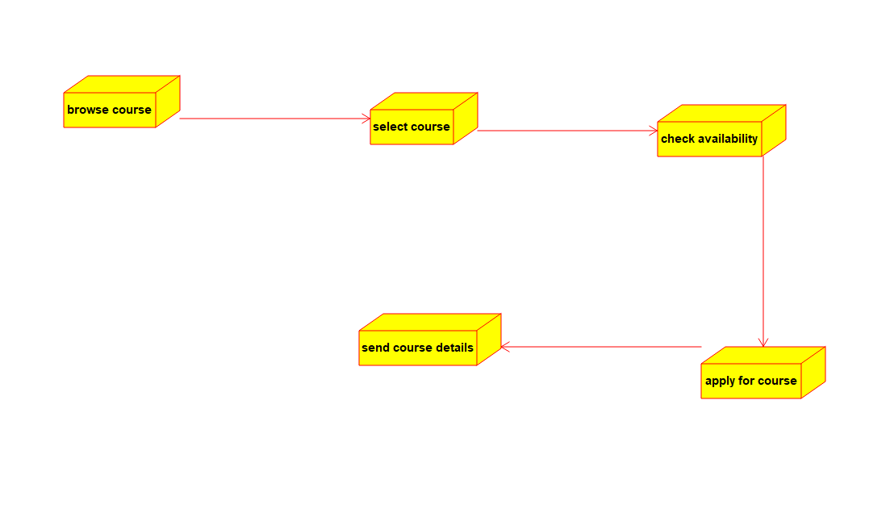

Activity Diagram :

