8. Develop a system using UML for Software Personnel Management System. It should be used to

process the details of a person who works in a software company. The details are to be stored in

the central management system for cross-checking the person’s details.

State Diagram :

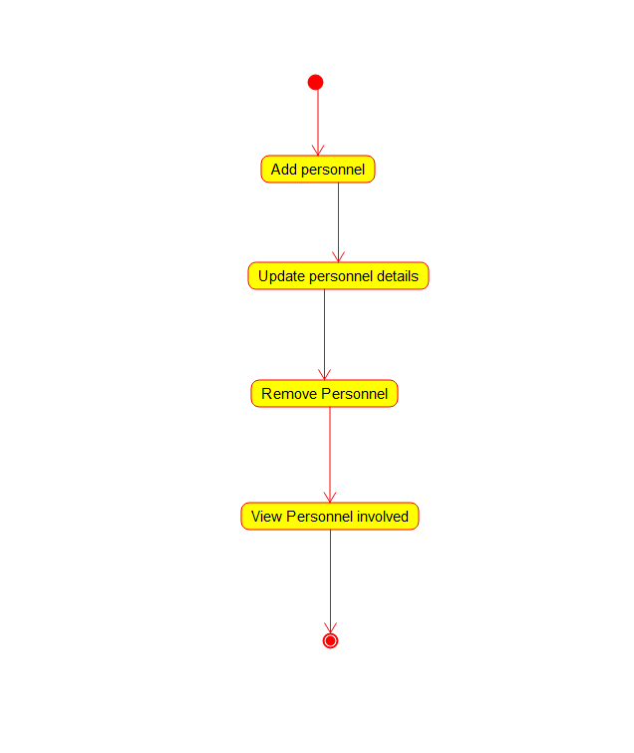

Package Diagram :

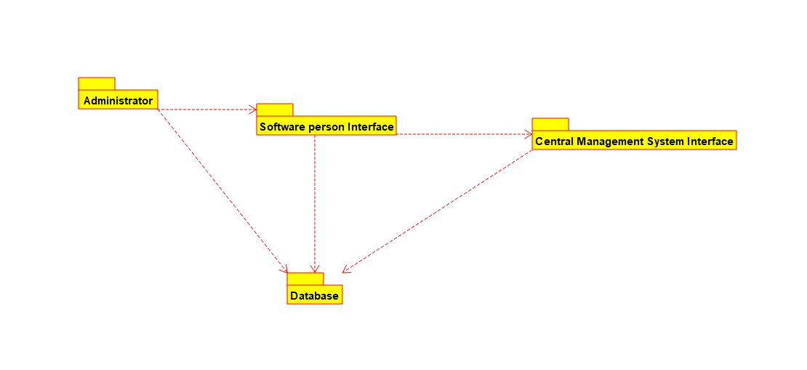

Use Case Diagram :

