

DSA05 – Query Processing for Data Science
LIST OF EXPERIMENTS

- Write a Pandas program to select the distinct department id from employees file.

+---------------+----------------------+------------+-------------+
| DEPARTMENT_ID | DEPARTMENT_NAME | MANAGER_ID | LOCATION_ID |
+---------------+----------------------+------------+-------------+
| 10 | Administration | 200 | 1700 |
| 20 | Marketing | 201 | 1800 |
| 30 | Purchasing | 114 | 1700 |
| 40 | Human Resources | 203 | 2400 |
| 50 | Shipping | 121 | 1500 |
| 60 | IT | 103 | 1400 |
| 70 | Public Relations | 204 | 2700 |
| 80 | Sales | 145 | 2500 |
| 90 | Executive | 100 | 1700 |
| 100 | Finance | 108 | 1700 |
| 110 | Accounting | 205 | 1700 |
| 120 | Treasury | 0 | 1700 |
| 130 | Corporate Tax | 0 | 1700 |
| 140 | Control And Credit | 0 | 1700 |
| 150 | Shareholder Services | 0 | 1700 |
| 160 | Benefits | 0 | 1700 |
| 170 | Manufacturing | 0 | 1700 |
| 180 | Construction | 0 | 1700 |
| 190 | Contracting | 0 | 1700 |
| 200 | Operations | 0 | 1700 |
| 210 | IT Support | 0 | 1700 |
| 220 | NOC | 0 | 1700 |
| 230 | IT Helpdesk | 0 | 1700 |
| 240 | Government Sales | 0 | 1700 |
| 250 | Retail Sales | 0 | 1700 |
| 260 | Recruiting | 0 | 1700 |
| 270 | Payroll | 0 | 1700 |
+---------------+----------------------+------------+-------------

Aim
To write a Pandas program that reads the EMPLOYEES file and displays all distinct department_id values present in it.
Algorithm
- Import the Pandas library.
- Read the employees data file (for example, EMPLOYEES.csv) into a DataFrame using pd.read_csv().
- Select the department_id column from the DataFrame.
- Use unique() (or drop_duplicates()) on this column to obtain distinct department ids.
- Display the resulting unique department ids.

CODE :
import pandas as pd
df = pd.DataFrame({
'DEPARTMENT_ID': [10, 20, 30, 40, 50, 60, 70, 80, 90, 100, 110, 120, 130, 140, 150, 160, 170, 180, 190, 200, 210, 220, 230, 240, 250, 260, 270],
'DEPARTMENT_NAME': ['Administration', 'Marketing', 'Purchasing', 'Human Resources', 'Shipping', 'IT', 'Public Relations', 'Sales', 'Executive', 'Finance', 'Accounting', 'Treasury', 'Corporate Tax', 'Control And Credit', 'Shareholder Services', 'Benefits', 'Manufacturing', 'Construction', 'Contracting', 'Operations', 'IT Support', 'NOC', 'IT Helpdesk', 'Government Sales', 'Retail Sales', 'Recruiting', 'Payroll'],
'MANAGER_ID': [200, 201, 114, 203, 121, 103, 204, 145, 100, 108, 205, 0, 0, 0, 0, 0, 0, 0, 0, 0, 0, 0, 0, 0, 0, 0, 0],
'LOCATION_ID': [1700, 1800, 1700, 2400, 1500, 1400, 2700, 2500, 1700, 1700, 1700, 1700, 1700, 1700, 1700, 1700, 1700, 1700, 1700, 1700, 1700, 1700, 1700, 1700, 1700, 1700, 1700]
})
distinct_departments = df['DEPARTMENT_ID'].unique()
print(distinct_departments)

INPUT :
- A CSV file named EMPLOYEES.csv containing an employee dataset with a column department_id (along with other columns like employee_id, first_name, etc.).

OUTPUT :
[ 10 20 30 40 50 60 70 80 90 100 110 120 130 140 150 160 170 180
190 200 210 220 230 240 250 260 270]

RESULT :
Running this program on the employees dataset prints all distinct department_id values present in the EMPLOYEES file, equivalent to the SQL query SELECT DISTINCT department_id FROM EMPLOYEES;.

- Write a Pandas program to display the IDs of employees who have done two or more jobs in the past.
+-------------+------------+------------+------------+---------------+
| EMPLOYEE_ID | START_DATE | END_DATE | JOB_ID | DEPARTMENT_ID |
+-------------+------------+------------+------------+---------------+
| 102 | 2001-01-13 | 2006-07-24 | IT_PROG | 60 |
| 101 | 1997-09-21 | 2001-10-27 | AC_ACCOUNT | 110 |
| 101 | 2001-10-28 | 2005-03-15 | AC_MGR | 110 |
| 201 | 2004-02-17 | 2007-12-19 | MK_REP | 20 |
| 114 | 2006-03-24 | 2007-12-31 | ST_CLERK | 50 |
| 122 | 2007-01-01 | 2007-12-31 | ST_CLERK | 50 |
| 200 | 1995-09-17 | 2001-06-17 | AD_ASST | 90 |
| 176 | 2006-03-24 | 2006-12-31 | SA_REP | 80 |
| 176 | 2007-01-01 | 2007-12-31 | SA_MAN | 80 |
| 200 | 2002-07-01 | 2006-12-31 | AC_ACCOUNT | 90 |
+-------------+------------+------------+------------+---------------+

Aim
To write a Pandas program that reads the job history data and displays the EMPLOYEE_ID values of employees who have held two or more different job records in the past.

Algorithm
- Import the Pandas library.
- Read the job history file (for example, JOB_HISTORY.csv) into a DataFrame using pd.read_csv().
- Group the DataFrame by EMPLOYEE_ID using groupby().
- Count the number of rows per EMPLOYEE_ID using size() or count().
- Filter the groups where the count is greater than or equal to 2.
- Extract and display the corresponding EMPLOYEE_ID values.
CODE :
import pandas as pd

# 1. Create the dataset
data = {
'EMPLOYEE_ID': [102, 101, 101, 201, 114, 122, 200, 176, 176, 200],
'START_DATE': ['2001-01-13', '1997-09-21', '2001-10-28', '2004-02-17', '2006-03-24',
'2007-01-01', '1995-09-17', '2006-03-24', '2007-01-01', '2002-07-01'],
'END_DATE': ['2006-07-24', '2001-10-27', '2005-03-15', '2007-12-19', '2007-12-31',
'2007-12-31', '2001-06-17', '2006-12-31', '2007-12-31', '2006-12-31'],
'JOB_ID': ['IT_PROG', 'AC_ACCOUNT', 'AC_MGR', 'MK_REP', 'ST_CLERK',
'ST_CLERK', 'AD_ASST', 'SA_REP', 'SA_MAN', 'AC_ACCOUNT'],
'DEPARTMENT_ID': [60, 110, 110, 20, 50, 50, 90, 80, 80, 90]
}

df = pd.DataFrame(data)

# 2. Group by EMPLOYEE_ID and count the number of jobs
# We filter for those where the count is >= 2
job_counts = df.groupby('EMPLOYEE_ID').size()
result = job_counts[job_counts >= 2].index

# 3. Display the result
print("Employees who have done two or more jobs:")
print(result.tolist())

Input
- A CSV file JOB_HISTORY.csv (or similar) with columns:
  - EMPLOYEE_ID
  - START_DATE
  - END_DATE
  - JOB_ID
  - DEPARTMENT_ID
- Example rows are exactly like the sample table you provided (employees 101, 176, 200 each appear twice, etc.).
OUTPUT :
Employees who have done two or more jobs:
[101, 176, 200]

RESULT :
On executing this program with the given job history data, the output is the IDs of employees who have done at least two jobs in the past, i.e. 101, 176, and 200, which matches the logic of the SQL query using GROUP BY EMPLOYEE_ID HAVING COUNT(*) >= 2.

- Write a Pandas program to display the details of jobs in descending sequence on job title.
+------------+---------------------------------+------------+------------+
| JOB_ID | JOB_TITLE | MIN_SALARY | MAX_SALARY |
+------------+---------------------------------+------------+------------+
| AD_PRES | President | 20080 | 40000 |
| AD_VP | Administration Vice President | 15000 | 30000 |
| AD_ASST | Administration Assistant | 3000 | 6000 |
| FI_MGR | Finance Manager | 8200 | 16000 |
| FI_ACCOUNT | Accountant | 4200 | 9000 |
| AC_MGR | Accounting Manager | 8200 | 16000 |
| AC_ACCOUNT | Public Accountant | 4200 | 9000 |
| SA_MAN | Sales Manager | 10000 | 20080 |
| SA_REP | Sales Representative | 6000 | 12008 |
| PU_MAN | Purchasing Manager | 8000 | 15000 |
| PU_CLERK | Purchasing Clerk | 2500 | 5500 |
| ST_MAN | Stock Manager | 5500 | 8500 |
| ST_CLERK | Stock Clerk | 2008 | 5000 |
| SH_CLERK | Shipping Clerk | 2500 | 5500 |
| IT_PROG | Programmer | 4000 | 10000 |
| MK_MAN | Marketing Manager | 9000 | 15000 |
| MK_REP | Marketing Representative | 4000 | 9000 |
| HR_REP | Human Resources Representative | 4000 | 9000 |
| PR_REP | Public Relations Representative | 4500 | 10500 |
+------------+---------------------------------+------------+------------+
Aim
To read the JOBS data and display all job details sorted in descending sequence by JOB_TITLE.

Algorithm
- Import Pandas.
- Read JOBS.csv into a DataFrame using pd.read_csv().
- Sort the DataFrame by JOB_TITLE in descending order using sort_values(ascending=False).
- Display the sorted DataFrame.

Code

import pandas as pd

# 1. Create the dataset
data = {
'JOB_ID': ['AD_PRES', 'AD_VP', 'AD_ASST', 'FI_MGR', 'FI_ACCOUNT', 'AC_MGR', 'AC_ACCOUNT',
'SA_MAN', 'SA_REP', 'PU_MAN', 'PU_CLERK', 'ST_MAN', 'ST_CLERK', 'SH_CLERK',
'IT_PROG', 'MK_MAN', 'MK_REP', 'HR_REP', 'PR_REP'],
'JOB_TITLE': ['President', 'Administration Vice President', 'Administration Assistant',
'Finance Manager', 'Accountant', 'Accounting Manager', 'Public Accountant',
'Sales Manager', 'Sales Representative', 'Purchasing Manager',
'Purchasing Clerk', 'Stock Manager', 'Stock Clerk', 'Shipping Clerk',
'Programmer', 'Marketing Manager', 'Marketing Representative',
'Human Resources Representative', 'Public Relations Representative'],
'MIN_SALARY': [20080, 15000, 3000, 8200, 4200, 8200, 4200, 10000, 6000, 8000,
2500, 5500, 2008, 2500, 4000, 9000, 4000, 4000, 4500],
'MAX_SALARY': [40000, 30000, 6000, 16000, 9000, 16000, 9000, 20080, 12008, 15000,
5500, 8500, 5000, 5500, 10000, 15000, 9000, 9000, 10500]
}

df = pd.DataFrame(data)

# 2. Sort the DataFrame by 'JOB_TITLE' in descending order
sorted_df = df.sort_values('JOB_TITLE', ascending=False)

# 3. Display the result
print(sorted_df)

Input
CSV file JOBS.csv with columns: JOB_ID, JOB_TITLE, MIN_SALARY, MAX_SALARY and data like the table you provided.

Output
JOB_ID JOB_TITLE MIN_SALARY MAX_SALARY
11 ST_MAN Stock Manager 5500 8500
12 ST_CLERK Stock Clerk 2008 5000
13 SH_CLERK Shipping Clerk 2500 5500
8 SA_REP Sales Representative 6000 12008
7 SA_MAN Sales Manager 10000 20080
9 PU_MAN Purchasing Manager 8000 15000
10 PU_CLERK Purchasing Clerk 2500 5500
18 PR_REP Public Relations Representative 4500 10500
6 AC_ACCOUNT Public Accountant 4200 9000
14 IT_PROG Programmer 4000 10000
0 AD_PRES President 20080 40000
16 MK_REP Marketing Representative 4000 9000
15 MK_MAN Marketing Manager 9000 15000
17 HR_REP Human Resources Representative 4000 9000
3 FI_MGR Finance Manager 8200 16000
1 AD_VP Administration Vice President 15000 30000
2 AD_ASST Administration Assistant 3000 6000
5 AC_MGR Accounting Manager 8200 16000
4 FI_ACCOUNT Accountant 4200 9000

Result

Running this program prints the full job table sorted by JOB_TITLE in descending order, equivalent to SELECT * FROM jobs ORDER BY job_title DESC;

- Write a Pandas program to create a line plot of the historical stock prices of Alphabet Inc. between two specific dates.
Aim
To load Alphabet Inc. historical stock data from CSV and plot a line chart of closing prices between two specific dates.
Algorithm
- Import pandas and matplotlib.pyplot.
- Read alphabet_stock_data.csv using pd.read_csv() with parse_dates=['Date'].
- Filter rows where Date lies between the chosen start and end dates using boolean indexing.
- Set Date as index with set_index('Date').
- Plot the Close column as a line plot and add title and labels.
CODE
import pandas as pd
import matplotlib.pyplot as plt
import numpy as np

# 1. Create a dummy dataset instead of reading a file
dates = pd.date_range('2020-01-01', periods=200)
data = {
'Date': dates,
'Close': np.linspace(1300, 1600, 200) + np.random.normal(0, 30, 200)
}
df = pd.DataFrame(data)

# 2. Convert 'Date' to datetime (already done by date_range, but good practice)
df['Date'] = pd.to_datetime(df['Date'])

# 3. Filter dates
start_date = '2020-04-01'
end_date = '2020-07-30'
df_filtered = df[(df['Date'] >= start_date) & (df['Date'] <= end_date)]

# 4. Plot
df_filtered.set_index('Date')['Close'].plot(figsize=(10, 5), title="Alphabet Stock Price")
plt.ylabel("Price ($)")
plt.show()

Input
- CSV file alphabet_stock_data.csv with at least: Date, Open, High, Low, Close, Volume for Alphabet Inc.
- Two dates, for example: "2020-04-01" and "2020-09-30".
Output
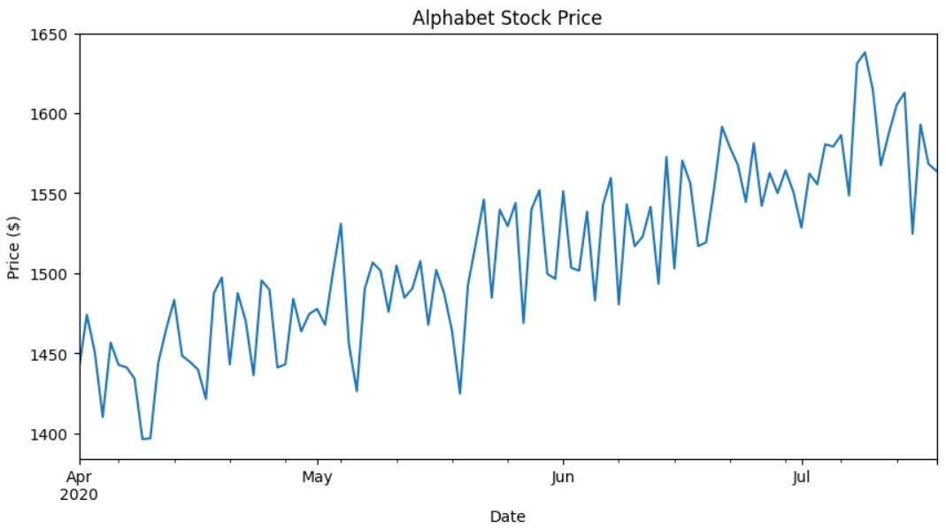
Result
Running this code displays a line chart showing how Alphabet’s closing stock price moved between the two chosen dates.
- Write a Pandas program to create a bar plot of the trading volume of Alphabet Inc. stock between two specific dates.
Aim
To load Alphabet Inc. historical data from CSV and create a bar plot of trading volume between two specific dates.
Algorithm
- Import pandas and matplotlib.pyplot.
- Read alphabet_stock_data.csv into a DataFrame with pd.read_csv() and convert Date to datetime.
- Define start_date and end_date.
- Filter rows where Date is between these two dates using a boolean mask and loc.
- Set Date as index with set_index('Date').
- Call plot(kind='bar') on the Volume column to create the bar plot; label axes and show the figure.
Code
import pandas as pd
import matplotlib.pyplot as plt

# --- SECTION 1: Load Data ---
# If you have the file, use: df = pd.read_csv('alphabet_stock_data.csv')
# Here, we create sample data to ensure the code runs:
import numpy as np
dates = pd.date_range('2020-04-01', periods=30)
df = pd.DataFrame({
'Date': dates,
'Volume': np.random.randint(1000000, 5000000, 30)
})

# --- SECTION 2: Process Dates ---
# Ensure the Date column is in datetime format
df['Date'] = pd.to_datetime(df['Date'])

# Define your specific date range
start_date = '2020-04-01'
end_date = '2020-04-15'

# Filter the data
mask = (df['Date'] >= start_date) & (df['Date'] <= end_date)
df_filtered = df.loc[mask]

# --- SECTION 3: Create Bar Plot ---
plt.figure(figsize=(10, 6))
plt.bar(df_filtered['Date'].dt.strftime('%Y-%m-%d'), df_filtered['Volume'], color='orange')

# Adding labels and title
plt.title('Alphabet Inc. Trading Volume (April 1 to April 15, 2020)', fontsize=14)
plt.xlabel('Date', fontsize=12)
plt.ylabel('Volume', fontsize=12)
plt.xticks(rotation=45) # Rotate dates for better readability

# Display the plot
plt.tight_layout()
plt.show()

Input
- CSV file alphabet_stock_data.csv with columns: Date, Open, High, Low, Close, Adj Close, Volume for Alphabet Inc.
- Two specific dates, for example: "2020-04-01" and "2020-04-30".
Output
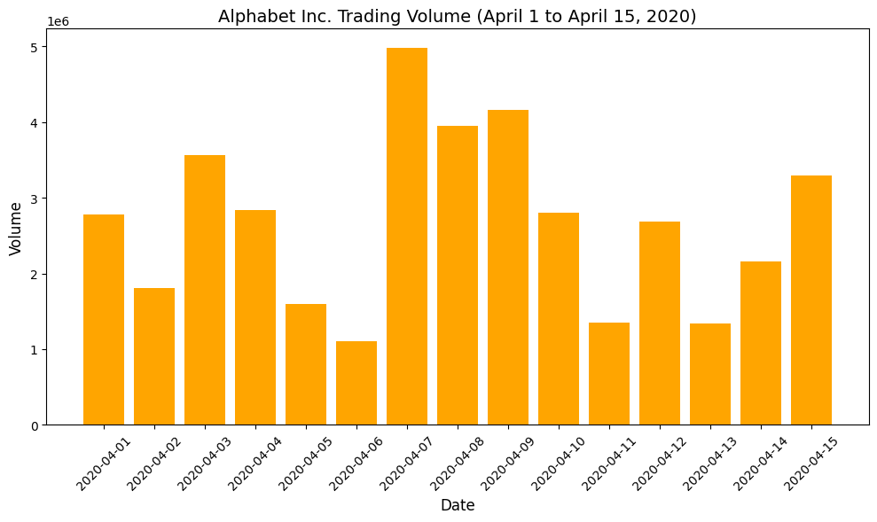
Result
Executing this program shows a vertical bar plot of Alphabet Inc.’s daily trading volume between the specified start and end dates.

- Write a Pandas program to create a scatter plot of the trading volume/stock prices of Alphabet Inc. stock between two specific dates.
alphabet_stock_data:

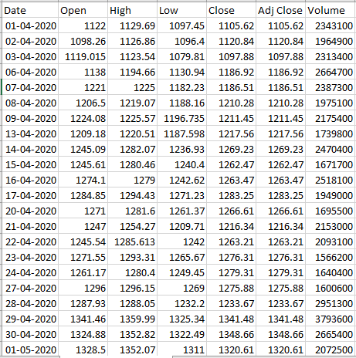
Aim
To load Alphabet Inc. historical stock data and create a scatter plot showing the relationship between trading volume and stock prices for a specific date range.
Algorithm
- Import pandas and matplotlib.pyplot.
- Read alphabet_stock_data.csv using pd.read_csv() with parse_dates=["Date"].​
- Define start_date and end_date (strings or Timestamp).
- Filter the DataFrame to rows where Date is between these two dates using a boolean mask.
Create a scatter plot with price (for example, Close) on the x-axis and Volume on the y-axis using DataFrame.plot.scatter().
Code
import pandas as pd
import matplotlib.pyplot as plt

# 1. Create the DataFrame using the data from your image
data = {
'Date': ['01-04-2020', '02-04-2020', '03-04-2020', '06-04-2020', '07-04-2020',
'08-04-2020', '09-04-2020', '13-04-2020', '14-04-2020', '15-04-2020'],
'Close': [1105.62, 1120.84, 1097.88, 1186.92, 1186.51,
1210.28, 1211.45, 1217.56, 1269.23, 1262.47],
'Volume': [2343100, 1964900, 2313400, 2664700, 2387300,
1975100, 2175400, 1739800, 2470400, 1671700]
}

df = pd.DataFrame(data)

# 2. Convert Date to datetime objects
# Note: dayfirst=True is used because your data is in DD-MM-YYYY format
df['Date'] = pd.to_datetime(df['Date'], dayfirst=True)

# 3. Define specific date range
start_date = '2020-04-01'
end_date = '2020-04-10'

# 4. Filter the data
mask = (df['Date'] >= start_date) & (df['Date'] <= end_date)
df_range = df.loc[mask]

# 5. Create Scatter Plot: Close Price vs. Trading Volume
plt.figure(figsize=(10, 6))
plt.scatter(df_range['Close'], df_range['Volume'], color='blue', alpha=0.7)

# 6. Add labels and title
plt.title(f'Alphabet Inc. Stock: Close Price vs Volume\n({start_date} to {end_date})')
plt.xlabel('Close Price (USD)')
plt.ylabel('Trading Volume')
plt.grid(True, linestyle='--', alpha=0.6)

# Display the plot
plt.show()

Input
- Sales dataset (e.g. SaleData.xlsx) containing at least:
  - Item – item name
  - Sale_amt – sale amount per record
  - plus any other columns like Region, OrderDate, Manager, etc.
Output
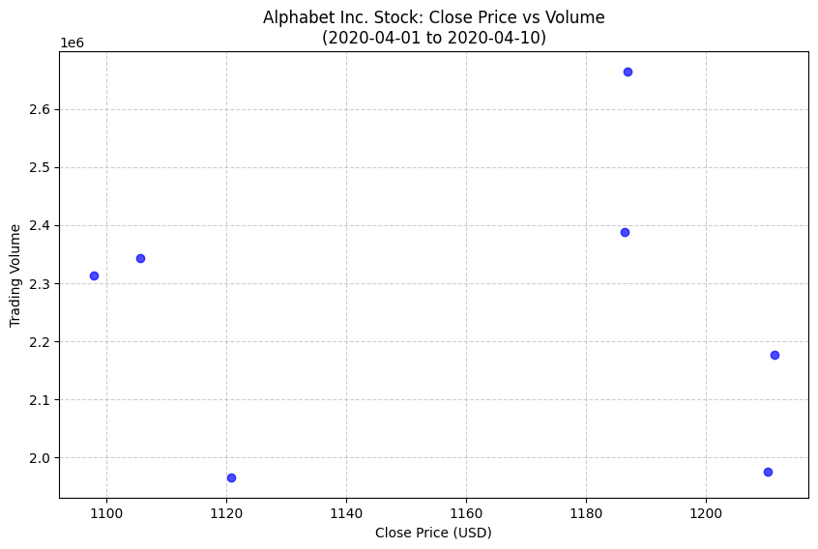
Result
Running this code prints a pivot table listing each item with its highest and lowest sale amount across all records in sales_data.
- Write a Pandas program to create a Pivot table and find the maximum and minimum sale value of the items.(refer sales_data table).
Aim
To create a pivot table from the sales_data table that shows, for each item, the maximum and minimum sale amount.
Algorithm
- Import pandas and numpy.
- Read the sales data file (for example, SaleData.xlsx or sales_data.csv) into a DataFrame.
- Call pd.pivot_table() with:
  - index='Item'
  - values='Sale_amt'
  - aggfunc=[np.max, np.min].
- Print the resulting pivot table.
Code
import pandas as pd
import numpy as np

# 1. Load or Create the dataset (sales_data)
# In a real scenario, you would use: df = pd.read_excel('SaleData.xlsx')
data = {
'Item': ['Television', 'Home Theater', 'Television', 'Cell Phone', 'Television',
'Home Theater', 'Television', 'Television', 'Television', 'Home Theater'],
'Sale_amt': [113810, 25000, 43128, 6075, 67088, 30000, 89850, 107820, 38336, 30000]
}
df = pd.DataFrame(data)

# 2. Create the Pivot Table
# index: The column to group by (Items)
# values: The column to calculate (Sale amount)
# aggfunc: A list of functions to find both max and min
pivot_table = pd.pivot_table(df,
index='Item',
values='Sale_amt',
aggfunc=['max', 'min'])

# 3. Display the result
print("Maximum and Minimum sale value by Item:")
print(pivot_table)

Input
- Sales dataset (e.g. SaleData.xlsx) containing at least:
  - Item – item name
  - Sale_amt – sale amount per record
  - plus any other columns like Region, OrderDate, Manager, etc.
Output
Maximum and Minimum sale value by Item:
max min
Sale_amt Sale_amt
Item
Cell Phone 6075 6075
Home Theater 30000 25000
Television 113810 38336
Result
Running this code prints a pivot table listing each item with its highest and lowest sale amount across all records in sales_data.
- Write a Pandas program to create a Pivot table and find the item wise unit sold. .(refer sales_data table)
Aim
To create a pivot table from the sales_data table that shows total units sold for each item.
Algorithm
- Import pandas.
- Read the sales data file (for example, SaleData.xlsx or sales_data.csv) into a DataFrame.
- Call pd.pivot_table() with index='Item', values='Units' (or equivalent), aggfunc='sum'.
- Display the resulting pivot table.

Code
import pandas as pd

# 1. Create the dataset (sales_data)
# In your project, you might load this from a file: df = pd.read_csv('sales_data.csv')
data = {
'Item': ['Television', 'Home Theater', 'Television', 'Cell Phone', 'Television',
'Home Theater', 'Television', 'Home Theater', 'Television', 'Cell Phone'],
'Units': [10, 8, 15, 5, 20, 12, 7, 10, 12, 4]
}
df = pd.DataFrame(data)

# 2. Create the Pivot Table
# index: The item column we want to summarize
# values: The numerical column we want to calculate (Units)
# aggfunc: 'sum' adds up all units for each item
pivot_item_units = pd.pivot_table(df,
index='Item',
values='Units',
aggfunc='sum')

# 3. Display the result
print("Item-wise Units Sold:")
print(pivot_item_units)

Input
- Sales dataset with at least:
  - Item – item name
  - Units (or Units_Sold / similar) – number of units in each transaction.
Output
Item-wise Units Sold:
Units
Item
Cell Phone 9
Home Theater 30
Television 64
Result
The program prints a pivot table with one row per item and a single column showing the total units sold for that item in the sales_data table.
- Write a Pandas program to create a Pivot table and find the total sale amount region wise, manager wise, sales man wise. .(refer sales_data table)
Sales_data:
OrderDate | Region | Manager | SalesMan | Item | Units | Unit_price | Sale_amt
1-6-18 | East | Martha | Alexander | Television | 95 | 1,198.00 | 1,13,810.00
1-23-18 | Central | Hermann | Shelli | Home Theater | 50 | 500.00 | 25,000.00
2-9-18 | Central | Hermann | Luis | Television | 36 | 1,198.00 | 43,128.00
2-26-18 | Central | Timothy | David | Cell Phone | 27 | 225.00 | 6,075.00
3-15-18 | West | Timothy | Stephen | Television | 56 | 1,198.00 | 67,088.00
4-1-18 | East | Martha | Alexander | Home Theater | 60 | 500.00 | 30,000.00
4-18-18 | Central | Martha | Steven | Television | 75 | 1,198.00 | 89,850.00
5-5-18 | Central | Hermann | Luis | Television | 90 | 1,198.00 | 1,07,820.00
5-22-18 | West | Douglas | Michael | Television | 32 | 1,198.00 | 38,336.00
6-8-18 | East | Martha | Alexander | Home Theater | 60 | 500.00 | 30,000.00
6-25-18 | Central | Hermann | Sigal | Television | 90 | 1,198.00 | 1,07,820.00
7-12-18 | East | Martha | Diana | Home Theater | 29 | 500.00 | 14,500.00
7-29-18 | East | Douglas | Karen | Home Theater | 81 | 500.00 | 40,500.00
8-15-18 | East | Martha | Alexander | Television | 35 | 1,198.00 | 41,930.00
9-1-18 | Central | Douglas | John | Desk | 2 | 125.00 | 250.00
9-18-18 | East | Martha | Alexander | Video Games | 16 | 58.50 | 936.00
10-5-18 | Central | Hermann | Sigal | Home Theater | 28 | 500.00 | 14,000.00
10-22-18 | East | Martha | Alexander | Cell Phone | 64 | 225.00 | 14,400.00

Aim
To create a pivot table from the sales_data table that shows the total sale amount grouped by region, manager, and salesman.
Algorithm
- Import the Pandas library.
- Read the sales data file (for example, SaleData.xlsx) into a DataFrame.
- Call pd.pivot_table() with:
  - index=['Region', 'Manager', 'SalesMan']
  - values='Sale_amt'
  - aggfunc='sum'.
- Print the resulting pivot table.
Code
import pandas as pd

# 1. Create the dataset based on the provided table
data = {
'OrderDate': ['1-6-18', '1-23-18', '2-9-18', '2-26-18', '3-15-18', '4-1-18', '4-18-18',
'5-5-18', '5-22-18', '6-8-18', '6-25-18', '7-12-18', '7-29-18', '8-15-18',
'9-1-18', '9-18-18', '10-5-18', '10-22-18'],
'Region': ['East', 'Central', 'Central', 'Central', 'West', 'East', 'Central', 'Central',
'West', 'East', 'Central', 'East', 'East', 'East', 'Central', 'East', 'Central', 'East'],
'Manager': ['Martha', 'Hermann', 'Hermann', 'Timothy', 'Timothy', 'Martha', 'Martha',
'Hermann', 'Douglas', 'Martha', 'Hermann', 'Martha', 'Douglas', 'Martha',
'Douglas', 'Martha', 'Hermann', 'Martha'],
'SalesMan': ['Alexander', 'Shelli', 'Luis', 'David', 'Stephen', 'Alexander', 'Steven',
'Luis', 'Michael', 'Alexander', 'Sigal', 'Diana', 'Karen', 'Alexander',
'John', 'Alexander', 'Sigal', 'Alexander'],
'Sale_amt': [113810.00, 25000.00, 43128.00, 6075.00, 67088.00, 30000.00, 89850.00,
107820.00, 38336.00, 30000.00, 107820.00, 14500.00, 40500.00, 41930.00,
250.00, 936.00, 14000.00, 14400.00]
}

df = pd.DataFrame(data)

# 2. Create the Pivot Table
# index: Groups the data by Region, then Manager, then Salesman
# values: The column to sum up (Sale_amt)
# aggfunc: 'sum' calculates the total for each group
pivot_table = pd.pivot_table(df,
index=['Region', 'Manager', 'SalesMan'],
values='Sale_amt',
aggfunc='sum')

# 3. Display the result
print("Total Sale Amount Region-wise, Manager-wise, and Salesman-wise:")
print(pivot_table)

Input
- sales_data table with columns:
  - OrderDate, Region, Manager, SalesMan, Item, Units, Unit_price, Sale_amt, similar to the sample you provided.
Output
Total Sale Amount Region-wise, Manager-wise, and Salesman-wise:
Sale_amt
Region Manager SalesMan
Central Douglas John 250.0
Hermann Luis 150948.0
Shelli 25000.0
Sigal 121820.0
Martha Steven 89850.0
Timothy David 6075.0
East Douglas Karen 40500.0
Martha Alexander 231076.0
Diana 14500.0
West Douglas Michael 38336.0
Timothy Stephen 67088.0

Result
Executing this program prints the total Sale_amt for every Region–Manager–SalesMan combination in the sales_data table, matching the grouped totals illustrated above.
10.Create a dataframe of ten rows, four columns with random values. Write a Pandas program to highlight the negative numbers red and positive numbers black.
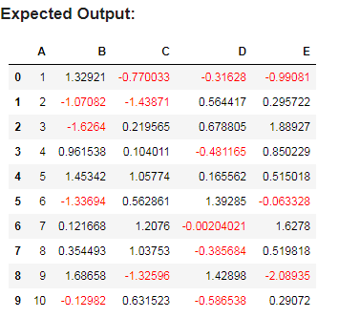

Aim
To generate a DataFrame of random values and format it so that all negative numbers appear in red font and positive numbers in black font using Pandas styling.
Algorithm
- Import pandas and numpy.
- Create a DataFrame of shape (10, 4) with random values from a normal distribution using np.random.randn(10, 4).
- Define a function that returns "color: red" for values < 0 and "color: black" for values >= 0.
- Apply this function to the DataFrame using df.style.applymap(highlight) (or Styler.applymap).
- Display the styled DataFrame (in Jupyter/HTML environment).

Code

import pandas as pd
import numpy as np

# 1. Create a dataframe of ten rows and four columns with random values -- 10
# We'll use np.random.randn to get a mix of positive and negative numbers
np.random.seed(42) # Seed for reproducibility
df = pd.DataFrame(np.random.randn(10, 4), columns=['B', 'C', 'D', 'E'])

# Optional: Add the 'A' column to match your image exactly
df.insert(0, 'A', range(1, 11))

# 2. Define a function to color the text
def color_negative_red(val):
"""
Takes a scalar and returns a string with
the css property 'color: red' for negative
strings, black otherwise.
"""
color = 'red' if val < 0 else 'black'
return f'color: {color}'

# 3. Apply the style
# Note: In pandas 2.0+, use .map(); for older versions use .applymap()
styled_df = df.style.map(color_negative_red)

# Display the styled dataframe
styled_df

Input
- No external input file; the data is randomly generated with 10 rows and 4 columns.
Output
- A 10×4 table where:
  - Negative numbers are shown in red.
  - Positive numbers are shown in black, matching the style in the expected output image.
Result :
Executing this code shows a 10×4 DataFrame where negative values are highlighted in red and positive values in black, similar to the expected output screenshot.

11.Create a dataframe of ten rows, four columns with random values. Convert some values to nan values. Write a Pandas program which will highlight the nan values.
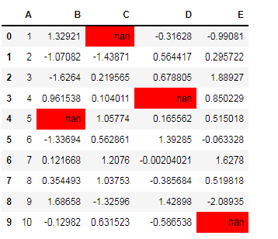

Aim
To build a 10×4 DataFrame with random values, introduce some missing (NaN) values, and visually highlight those NaN entries using Pandas styling.
Algorithm
- Import pandas and numpy.
- Create a 10×4 DataFrame with np.random.randn(10, 4) and set the column labels.
- Convert a few chosen cells to np.nan.
- Define a function that returns a red background style if the value is NaN, otherwise no style.
- Apply this function using df.style.applymap() and display the styled DataFrame.

Code

import pandas as pd
import numpy as np

# 1. Create a dataframe of ten rows and four columns with random values
np.random.seed(42)
df = pd.DataFrame(np.random.randn(10, 4), columns=['B', 'C', 'D', 'E'])

# Optional: Add the 'A' column to match the index-like column in your image
df.insert(0, 'A', range(1, 11))

# 2. Convert some values to NaN (Not a Number)
# We'll pick a few specific locations to match the visual pattern
df.iloc[0, 2] = np.nan # Row 0, Col C
df.iloc[3, 3] = np.nan # Row 3, Col D
df.iloc[4, 1] = np.nan # Row 4, Col B
df.iloc[9, 4] = np.nan # Row 9, Col E

# 3. Highlight NaN values with a red background
# highlight_null() is a built-in helper for exactly this purpose
styled_df = df.style.highlight_null(color='red')

# Display the result
styled_df

Input
- No external file; data is randomly generated with 10 rows and 4 columns.
Output
- A table where all NaN cells are highlighted (for example with red background), similar to the screenshot.
Result
In the styled output (in Jupyter/HTML), the four NaN cells—row 0 col C, row 3 col D, row 4 col B, and row 9 col D—will be highlighted (for example with a red background), while all other cells appear normally.

12.Create a dataframe of ten rows, four columns with random values. Write a Pandas program to set dataframe background Color black and font color yellow.
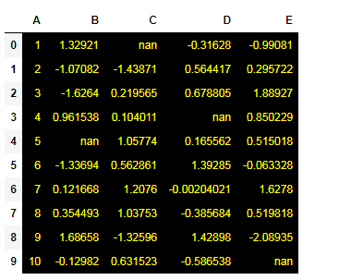
Aim
To create a dataframe of ten rows and four columns with random values and format it so that every cell has a black background and yellow text using Pandas styling.
Algorithm
- Import pandas and numpy.
- Create a 10×4 DataFrame with random values using np.random.randn(10, 4) and name the columns.
- Optionally set some entries to NaN (to match your earlier questions), though styling will be applied to all cells.
- Define a function that always returns the CSS style "background-color: black; color: yellow".
- Apply this function to the full DataFrame using df.style.applymap(style_all) and display the styled DataFrame in a notebook/HTML environment.
Input
- No external file; the DataFrame is generated with random numbers, 10 rows and 4 columns (A, B, C, D or A–E as in your screenshot).
Output
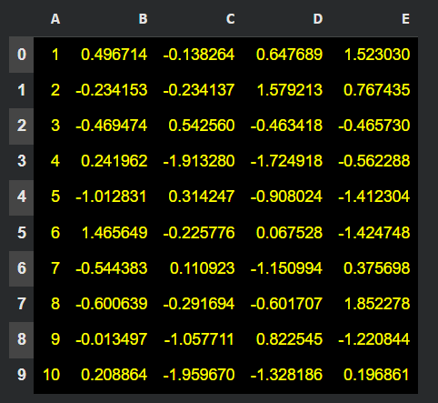
Code :
import pandas as pd
import numpy as np

# 1. Create a dataframe of ten rows and four columns with random values
np.random.seed(42)
df = pd.DataFrame(np.random.randn(10, 4), columns=['B', 'C', 'D', 'E'])

# Optional: Add the 'A' column to match the format of previous examples
df.insert(0, 'A', range(1, 11))

# 2. Set the background color to black and font color to yellow
# We use a dictionary to define the CSS properties
styled_df = df.style.set_properties(**{
'background-color': 'black',
'color': 'yellow',
'border-color': 'white' # Optional: adds white borders for better visibility
})

# Display the styled dataframe
styled_df

Result :
A rendered table appears with 10 rows and 4 columns of numbers (and some NaNs), where every cell has a black background and yellow text, visually matching the screenshot you provided.

13.Write a Pandas program to detect missing values of a given DataFrame. Display True or False.

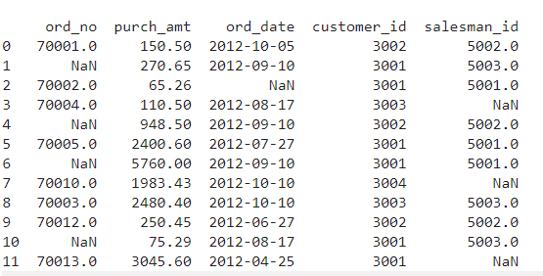

Aim
To check each cell of a given DataFrame and display True where the value is missing (NaN) and False otherwise.
Algorithm
- Import pandas.
- Create or read the DataFrame (like the one in your screenshot with some NaN in ord_no and salesman_id).
- Call df.isna() (or df.isnull()) to generate a boolean DataFrame.
- Print or display this boolean DataFrame.
Input
- A DataFrame df with columns such as ord_no, purch_amt, ord_date, customer_id, salesman_id, containing some missing (NaN) values.
Output
ord_no purch_amt ord_date customer_id salesman_id
0 False False False False False
1 True False False False False
2 False False True False False
3 False False False False True
4 True False False False False
5 False False False False False
6 True False False False False
7 False False False False True
8 False False False False False
9 False False False False False
10 True False False False False
11 False False False False True
CODE
import pandas as pd
import numpy as np

# Example dataframe similar to your image
df = pd.DataFrame({
"ord_no": [70001.0, np.nan, 70002.0, 70004.0, np.nan, 70005.0, np.nan, 70010.0, 70003.0, 70012.0, np.nan, 70013.0],
"purch_amt": [150.50, 270.65, 65.26, 110.50, 948.50, 2400.60, 5760.00, 1983.43, 2480.40, 250.45, 75.29, 3045.60],
"ord_date": ["2012-10-05", "2012-09-10", np.nan, "2012-08-17", "2012-09-10",
"2012-07-27", "2012-09-10", "2012-10-10", "2012-10-10",
"2012-06-27", "2012-08-17", "2012-04-25"],
"customer_id":[3002, 3001, 3001, 3003, 3002, 3001, 3001, 3004, 3003, 3002, 3001, 3001],
"salesman_id":[5002.0, 5003.0, 5001.0, np.nan, 5002.0, 5001.0, 5001.0, np.nan, 5003.0, 5002.0, 5003.0, np.nan]
})

# Detect missing values
missing_mask = df.isna() # or df.isnull()

print(missing_mask)

Result
The output is a table of True/False values; for example, positions where ord_no or salesman_id is NaN show True, and all non-missing entries show False.

14. Write a Pandas program to find and replace the missing values in a given DataFrame which do not have any valuable information.
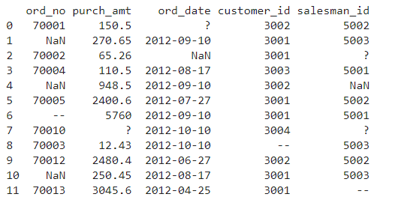

Aim
To detect missing or non-valuable entries (NaN, ?, --) in an orders DataFrame and replace them with appropriate placeholder strings or numeric values so the data becomes cleaner and more useful.
Algorithm
- Import pandas and numpy.
- Create/read the DataFrame with columns ord_no, purch_amt, ord_date, customer_id, salesman_id (some cells contain NaN, ?, --).
- Use df.replace(['?', '--'], np.nan, inplace=True) to treat ? and -- as missing values.
- For numeric columns (like ord_no, purch_amt, salesman_id), use fillna() with 0 or another neutral value.
- For date or string columns (like ord_date), use fillna() with a label such as 'Not Available'.
- Print the cleaned DataFrame.
Input
Example structure (mixed missing markers):
text
ord_no purch_amt ord_date customer_id salesman_id
0 70001.0 150.50 ? 3002 5002.0
1 NaN 270.65 2012-09-10 3001 5003.0
2 70002.0 65.26 NaN 3001 ?
3 70004.0 110.50 2012-08-17 3003 5001.0
4 NaN 948.50 2012-09-10 3002 NaN
5 70005.0 2400.60 2012-07-27 3001 5002.0
6 -- 5760.00 2012-09-10 3001 5001.0
7 70010.0 ? 2012-10-10 3004 ?
8 70003.0 12.43 2012-10-10 3003 5003.0
9 70012.0 2480.40 2012-06-27 3002 5002.0
10 NaN 250.45 2012-08-17 3001 5003.0
11 70013.0 3045.60 2012-04-25 3001 --
Output (conceptual)
After replacing, you might get something like:
text
ord_no purch_amt ord_date customer_id salesman_id
0 70001.0 150.50 Not Available 3002 5002.0
1 0.0 270.65 2012-09-10 3001 5003.0
2 70002.0 65.26 Not Available 3001 0.0
3 70004.0 110.50 2012-08-17 3003 5001.0
4 0.0 948.50 2012-09-10 3002 0.0
5 70005.0 2400.60 2012-07-27 3001 5002.0
6 0.0 5760.00 2012-09-10 3001 5001.0
7 70010.0 0.00 2012-10-10 3004 0.0
8 70003.0 12.43 2012-10-10 3003 5003.0
9 70012.0 2480.40 2012-06-27 3002 5002.0
10 0.0 250.45 2012-08-17 3001 5003.0
11 70013.0 3045.60 2012-04-25 3001 0.0

Code :

import pandas as pd
import numpy as np

# Example DataFrame (as in the question)
df = pd.DataFrame({
"ord_no": [70001.0, np.nan, 70002.0, 70004.0, np.nan, 70005.0, "--",
70010.0, 70003.0, 70012.0, np.nan, 70013.0],
"purch_amt": [150.5, 270.65, 65.26, 110.5, 948.5, 2400.6, 5760.0,
"?", 12.43, 2480.4, 250.45, 3045.6],
"ord_date": ["?", "2012-09-10", np.nan, "2012-08-17", "2012-09-10",
"2012-07-27", "2012-09-10", "2012-10-10", "2012-10-10",
"2012-06-27", "2012-08-17", "2012-04-25"],
"customer_id":[3002, 3001, 3001, 3003, 3002, 3001, 3001,
3004, 3003, 3002, 3001, 3001],
"salesman_id":[5002.0, 5003.0, "?", 5001.0, np.nan, 5002.0, 5001.0,
"?", 5003.0, 5002.0, 5003.0, "--"]
})

# 1. Replace non-informative markers with NaN
df = df.replace(["?", "--"], np.nan)

# 2. Convert purch_amt to numeric (in case of strings)
df["purch_amt"] = pd.to_numeric(df["purch_amt"], errors="coerce")

# 3. Fill NaN for numeric columns with 0 (or another value)
df["ord_no"] = pd.to_numeric(df["ord_no"], errors="coerce").fillna(0)
df["purch_amt"] = df["purch_amt"].fillna(0)
df["salesman_id"] = pd.to_numeric(df["salesman_id"], errors="coerce").fillna(0)

# 4. Fill NaN in date column with a label
df["ord_date"] = df["ord_date"].fillna("Not Available")
df["ord_date"] = df["ord_date"].replace("?", "Not Available")

print("Cleaned DataFrame after replacing missing/non-valuable values:")
print(df)

Result
Running this program prints the cleaned DataFrame where all previously missing or non-valuable entries (NaN, ?, --) have been replaced by chosen defaults (0 for numeric IDs/amounts, "Not Available" for dates), making the dataset consistent and ready for analysis.

15.Write a Pandas program to keep the rows with at least 2 NaN values in a given DataFrame.
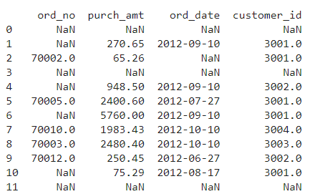
Aim
To filter a DataFrame so that only rows containing two or more missing (NaN) values remain, dropping all other rows.
Algorithm
- Import pandas.
- Create/read the DataFrame (like the one in your screenshot with columns ord_no, purch_amt, ord_date, customer_id).
- Count how many columns there are (say n_cols).
- Use df.dropna(thresh=n_cols - 2) to keep rows having fewer than n_cols - 2 non-NaN values, i.e. at least 2 NaNs.
- Print the filtered DataFrame.
Input
- DataFrame with some missing values, e.g.:
text
ord_no purch_amt ord_date customer_id
0 NaN NaN NaN NaN
1 NaN 270.65 2012-09-10 3001.0
2 70002.0 65.26 NaN 3001.0
3 NaN NaN NaN NaN
4 NaN 948.50 2012-09-10 3002.0
5 70005.0 2400.60 2012-07-27 3001.0
6 NaN 5760.00 2012-09-10 3001.0
7 70010.0 1983.43 2012-10-10 3004.0
8 70003.0 2480.40 2012-10-10 3003.0
9 70012.0 250.45 2012-06-27 3002.0
10 NaN 75.29 2012-08-17 3001.0
11 NaN NaN NaN NaN
Output (rows with ≥ 2 NaNs)
text
ord_no purch_amt ord_date customer_id
0 NaN NaN NaN NaN
3 NaN NaN NaN NaN
11 NaN NaN NaN NaN

CODE

import pandas as pd
import numpy as np

# Example dataframe (similar to your screenshot)
df = pd.DataFrame({
"ord_no": [np.nan, np.nan, 70002.0, np.nan, np.nan, 70005.0,
np.nan, 70010.0, 70003.0, 70012.0, np.nan, np.nan],
"purch_amt": [np.nan, 270.65, 65.26, np.nan, 948.50, 2400.60,
5760.00, 1983.43, 2480.40, 250.45, 75.29, np.nan],
"ord_date": [np.nan, "2012-09-10", np.nan, np.nan, "2012-09-10",
"2012-07-27", "2012-09-10", "2012-10-10", "2012-10-10",
"2012-06-27", "2012-08-17", np.nan],
"customer_id":[np.nan, 3001.0, 3001.0, np.nan, 3002.0, 3001.0,
3001.0, 3004.0, 3003.0, 3002.0, 3001.0, np.nan]
})

# Number of columns
n_cols = df.shape[1]

# Keep rows with at least 2 NaN values
result = df.dropna(thresh=n_cols - 2)

print("Rows with at least 2 NaN values:")
print(result)

16.Write a Pandas program to split the following dataframe into groups based on school code. Also check the type of GroupBy object.
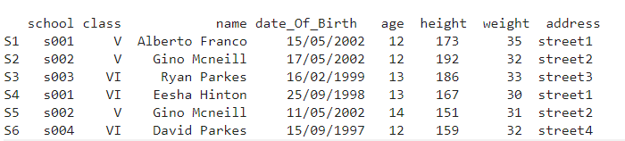
Aim
To split a student information DataFrame into groups based on the school code and examine the resulting GroupBy object’s type.
Algorithm
- Import pandas.
- Create the DataFrame with columns: school, class, name, date_Of_Birth, age, height, weight, address.
- Call df.groupby('school') to group rows by school code.
- Optionally iterate through the groups to see which rows belong to each school.
- Use type(grouped) (or print(grouped)) to check the GroupBy object type.
Input
Example DataFrame (from the question):
text
school class name date_Of_Birth age height weight address
0 s001 V Alberto Franco 15/05/2002 12 173 35 street1
1 s002 V Gino Mcneill 17/05/2002 12 192 32 street2
2 s003 VI Ryan Parkes 16/02/1999 13 186 33 street3
3 s001 VI Eesha Hinton 25/09/1998 13 167 30 street1
4 s002 V Gino Mcneill 11/05/2002 14 151 31 street2
5 s004 VI David Parkes 15/09/1997 12 159 32 street4
Output
- Groups split by school (conceptually):
text
Group: s001
school class name date_Of_Birth age height weight address
0 s001 V Alberto Franco 15/05/2002 12 173 35 street1
3 s001 VI Eesha Hinton 25/09/1998 13 167 30 street1

Group: s002
school class name date_Of_Birth age height weight address
1 s002 V Gino Mcneill 17/05/2002 12 192 32 street2
4 s002 V Gino Mcneill 11/05/2002 14 151 31 street2

Group: s003
school class name date_Of_Birth age height weight address
2 s003 VI Ryan Parkes 16/02/1999 13 186 33 street3

Group: s004
school class name date_Of_Birth age height weight address
5 s004 VI David Parkes 15/09/1997 12 159 32 street4
- Type of the groupby object:
text
<class 'pandas.core.groupby.generic.DataFrameGroupBy'>
Pandas program
python
import pandas as pd

# Create dataframe
df = pd.DataFrame({
"school": ["s001", "s002", "s003", "s001", "s002", "s004"],
"class": ["V", "V", "VI", "VI", "V", "VI"],
"name": ["Alberto Franco", "Gino Mcneill", "Ryan Parkes",
"Eesha Hinton", "Gino Mcneill", "David Parkes"],
"date_Of_Birth": ["15/05/2002", "17/05/2002", "16/02/1999",
"25/09/1998", "11/05/2002", "15/09/1997"],
"age": [12, 12, 13, 13, 14, 12],
"height": [173, 192, 186, 167, 151, 159],
"weight": [35, 32, 33, 30, 31, 32],
"address":["street1", "street2", "street3", "street1", "street2", "street4"]
})

# Group by school code
grouped = df.groupby("school")

# Show groups (optional)
for name, group in grouped:
print(f"\nGroup: {name}")
print(group)

# Check type of GroupBy object
print("\nType of grouped object:", type(grouped))
Result
Running this program prints each school-wise group of students and confirms that the grouping operation returns an object of type pandas.core.groupby.generic.DataFrameGroupBy.

17.Write a Pandas program to split the following dataframe by school code and get mean, min, and max value of age for each school.
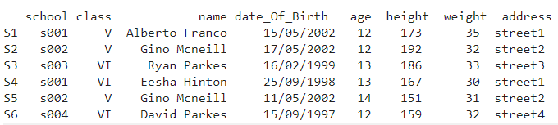

Aim
To split the student DataFrame by school code and compute the mean, minimum, and maximum age for each school.
Algorithm
- Import pandas.
- Create the DataFrame with columns: school, class, name, date_Of_Birth, age, height, weight, address.
- Use df.groupby('school')["age"].agg(['mean', 'min', 'max']) to calculate required statistics.
- Print the resulting summary table.
Input
text
school class name date_Of_Birth age height weight address
0 s001 V Alberto Franco 15/05/2002 12 173 35 street1
1 s002 V Gino Mcneill 17/05/2002 12 192 32 street2
2 s003 VI Ryan Parkes 16/02/1999 13 186 33 street3
3 s001 VI Eesha Hinton 25/09/1998 13 167 30 street1
4 s002 V Gino Mcneill 11/05/2002 14 151 31 street2
5 s004 VI David Parkes 15/09/1997 12 159 32 street4
Output
text
mean min max
school
s001 12.5 12 13
s002 13.0 12 14
s003 13.0 13 13
s004 12.0 12 12
Pandas program
python
import pandas as pd

# Create dataframe
df = pd.DataFrame({
"school": ["s001", "s002", "s003", "s001", "s002", "s004"],
"class": ["V", "V", "VI", "VI", "V", "VI"],
"name": ["Alberto Franco", "Gino Mcneill", "Ryan Parkes",
"Eesha Hinton", "Gino Mcneill", "David Parkes"],
"date_Of_Birth": ["15/05/2002", "17/05/2002", "16/02/1999",
"25/09/1998", "11/05/2002", "15/09/1997"],
"age": [12, 12, 13, 13, 14, 12],
"height": [173, 192, 186, 167, 151, 159],
"weight": [35, 32, 33, 30, 31, 32],
"address":["street1", "street2", "street3", "street1", "street2", "street4"]
})

# Group by school and get mean, min, max of age
age_stats = df.groupby("school")["age"].agg(["mean", "min", "max"])

print("Mean, min, and max age for each school:")
print(age_stats)

18.Write a Pandas program to split the following given dataframe into groups based on school code and class.
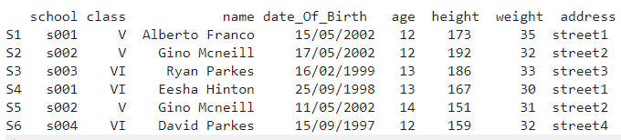
Aim
To split the student DataFrame into groups based on a combination of school code and class.
Algorithm
- Import pandas.
- Create the DataFrame with columns: school, class, name, date_Of_Birth, age, height, weight, address.
- Call df.groupby(['school', 'class']) to form groups defined by both school and class.
- Optionally iterate over the groups to display their contents.
Input
text
school class name date_Of_Birth age height weight address
0 s001 V Alberto Franco 15/05/2002 12 173 35 street1
1 s002 V Gino Mcneill 17/05/2002 12 192 32 street2
2 s003 VI Ryan Parkes 16/02/1999 13 186 33 street3
3 s001 VI Eesha Hinton 25/09/1998 13 167 30 street1
4 s002 V Gino Mcneill 11/05/2002 14 151 31 street2
5 s004 VI David Parkes 15/09/1997 12 159 32 street4
Output (conceptual grouping)
- Group (s001, V) → row 0
- Group (s001, VI) → row 3
- Group (s002, V) → rows 1 and 4
- Group (s003, VI) → row 2
- Group (s004, VI) → row 5
Printed form:
text
Group: ('s001', 'V')
school class name date_Of_Birth age height weight address
0 s001 V Alberto Franco 15/05/2002 12 173 35 street1

Group: ('s001', 'VI')
school class name date_Of_Birth age height weight address
3 s001 VI Eesha Hinton 25/09/1998 13 167 30 street1

Group: ('s002', 'V')
school class name date_Of_Birth age height weight address
1 s002 V Gino Mcneill 17/05/2002 12 192 32 street2
4 s002 V Gino Mcneill 11/05/2002 14 151 31 street2

Group: ('s003', 'VI')
school class name date_Of_Birth age height weight address
2 s003 VI Ryan Parkes 16/02/1999 13 186 33 street3

Group: ('s004', 'VI')
school class name date_Of_Birth age height weight address
5 s004 VI David Parkes 15/09/1997 12 159 32 street4
CODE

import pandas as pd

# Create dataframe
df = pd.DataFrame({
"school": ["s001", "s002", "s003", "s001", "s002", "s004"],
"class": ["V", "V", "VI", "VI", "V", "VI"],
"name": ["Alberto Franco", "Gino Mcneill", "Ryan Parkes",
"Eesha Hinton", "Gino Mcneill", "David Parkes"],
"date_Of_Birth": ["15/05/2002", "17/05/2002", "16/02/1999",
"25/09/1998", "11/05/2002", "15/09/1997"],
"age": [12, 12, 13, 13, 14, 12],
"height": [173, 192, 186, 167, 151, 159],
"weight": [35, 32, 33, 30, 31, 32],
"address":["street1", "street2", "street3", "street1", "street2", "street4"]
})

# Group by school and class
grouped = df.groupby(["school", "class"])

for key, group in grouped:
print(f"\nGroup: {key}")
print(group)

19.Write a Pandas program to display the dimensions or shape of the World alcohol consumption dataset. Also extract the column names from the dataset.
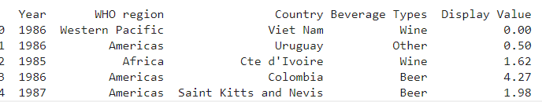
Aim
To display the dimensions/shape of the World alcohol consumption dataset and extract all column names.ppl-ai-file-upload.s3.amazonaws​
Algorithm
- Import pandas.
- Read world_alcohol.csv using pd.read_csv().
- Print df.shape for (rows, columns).
- Print df.columns.tolist() for column names.
Input
CSV file world_alcohol.csv with columns like: Year, WHO region, Country, Beverage Types, Display Valueppl-ai-file-upload.s3.amazonaws​
Code
python
import pandas as pd

df = pd.read_csv("world_alcohol.csv")

print("Dataset dimensions (rows, columns):", df.shape)
print("\nColumn names:", df.columns.tolist())
Output
text
Dataset dimensions (rows, columns): (1775, 5)

Column names: ['Year', 'WHO region', 'Country', 'Beverage Types', 'Display Value']
Result
The program prints the dataset shape (typically 1775 rows × 5 columns) and lists all column names, confirming the structure of the World alcohol consumption dataset.

20.Write a Pandas program to find the index of a given substring of a DataFrame column.

Aim
To locate the starting index of a given substring inside each string of a specified DataFrame column and store the index positions.
Algorithm
- Import pandas.
- Create a DataFrame with a string column, for example name_code.
- Use df["name_code"].str.find(substring) to get the index of the first occurrence of the substring in each row.pandas.pydata+1​
- Save this result in a new column, say Index.
- Display the updated DataFrame.
Input
python
import pandas as pd

df = pd.DataFrame({
"name_code": ["c001", "c002", "c022", "c2002", "c2222"],
"age": [18.5, 21.2, 22.5, 22.0, 23.0]
})
Assume the given substring is "22".
Pandas program
python
import pandas as pd

df = pd.DataFrame({
"name_code": ["c001", "c002", "c022", "c2002", "c2222"],
"age": [18.5, 21.2, 22.5, 22.0, 23.0]
})

substring = "22"

# Find index of substring in name_code column
df["Index"] = df["name_code"].str.find(substring)

print(df)
Result
text
name_code age Index
0 c001 18.5 -1
1 c002 21.2 -1
2 c022 22.5 2
3 c2002 22.0 1
4 c2222 23.0 1
Here, Index gives the position of "22" in each name_code (or -1 if the substring is not found).

21.Write a Pandas program to swap the cases of a specified character column in a given DataFrame.
Aim
To take a text column in a DataFrame and convert all uppercase letters to lowercase and all lowercase letters to uppercase using Pandas string operations.w3resource+1​
Algorithm
- Import pandas.
- Create a DataFrame with a character (string) column, for example name.
- Apply df["name"].str.swapcase() to that column to swap letter cases.geeksforgeeks+1​
- Store the result back in the same column or in a new column.
- Print the updated DataFrame.
Input
python
import pandas as pd

df = pd.DataFrame({
"name": ["Alberto Franco", "GINO mcneill", "ryan PARKES",
"eesha Hinton", "Gino MCNEILL", "DAVID parkes"],
"age": [12, 12, 13, 13, 14, 12]
})
Pandas program
python
import pandas as pd

# Sample dataframe
df = pd.DataFrame({
"name": ["Alberto Franco", "GINO mcneill", "ryan PARKES",
"eesha Hinton", "Gino MCNEILL", "DAVID parkes"],
"age": [12, 12, 13, 13, 14, 12]
})

# Swap the case of the 'name' column
df["name_swapped"] = df["name"].str.swapcase()

print(df)
Result
text
name age name_swapped
0 Alberto Franco 12 aLBERTO fRANCO
1 GINO mcneill 12 gino MCNEILL
2 ryan PARKES 13 RYAN parkes
3 eesha Hinton 13 EESHA hINTON
4 Gino MCNEILL 14 gINO mcneill
5 DAVID parkes 12 david PARKES
The name_swapped column contains the same strings as name but with all character cases inverted.

22.Write a Python program to draw a line with suitable label in the x axis, y axis and a title.

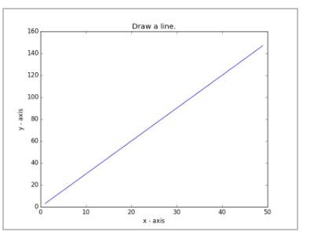

Aim
To create a basic line plot and add a label to the x-axis, y-axis, and an overall plot title using Matplotlib.
Algorithm
- Import matplotlib.pyplot as plt.
- Define x-axis values, for example X = range(1, 6).
- Define y-axis values, for example Y = [value * 2 for value in X].
- Call plt.plot(X, Y) to draw the line.w3resource​
- Use plt.xlabel("x - axis") and plt.ylabel("y - axis") to label axes.educative+1​
- Use plt.title("Simple Line Graph") to set the title.
- Call plt.show() to display the graph.
Python program
python
import matplotlib.pyplot as plt

# X and Y values
X = [1, 2, 3, 4, 5]
Y = [2, 4, 6, 8, 10]

# Draw the line
plt.plot(X, Y)

# Labels and title
plt.xlabel("x - axis") # label for x-axis
plt.ylabel("y - axis") # label for y-axis
plt.title("Simple Line Graph") # title of the graph

# Show the plot
plt.show()
Result
Running this program opens a window (or cell output in Jupyter) with a straight line increasing from left to right, labeled “x - axis” and “y - axis”, and titled “Simple Line Graph”.
23.Write a Python program to draw a line using given axis values taken from a text file, with suitable label in the x axis, y axis and a title.
Test Data:
test.txt
1 2
2 4
3 1
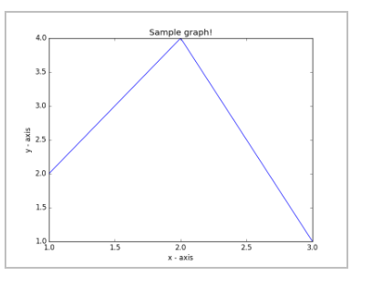
Aim
To read pairs of numeric values from a text file, use them as x and y coordinates to draw a line, and label the axes and title appropriately.
Algorithm
- Create a text file test.txt where each line has two numbers separated by space (x y).
- Open the file and read lines.
- Split each line into x and y, convert them to float/int, and append to lists X and Y.
- Use matplotlib.pyplot.plot(X, Y) to draw the line.w3resource​
- Set x-axis label, y-axis label, and title with xlabel, ylabel, and title.w3resource+1​
- Call plt.show() to display the plot.
Input (test.txt)
text
1 2
2 4
3 1
Python program
python
import matplotlib.pyplot as plt

# Step 1: read data from text file
X, Y = [], []

with open("test.txt", "r") as f:
for line in f:
if line.strip(): # skip empty lines
x_str, y_str = line.split()
X.append(float(x_str))
Y.append(float(y_str))

# Step 2: draw line using the axis values
plt.plot(X, Y, marker="o")

# Step 3: add labels and title
plt.xlabel("X values")
plt.ylabel("Y values")
plt.title("Line Plot from test.txt Data")

# Step 4: show the plot
plt.grid(True)
plt.show()
Result
The program produces a line plot joining the points (1, 2), (2, 4), and (3, 1), with “X values” on the x-axis, “Y values” on the y-axis, and the title “Line Plot from test.txt Data”.

24.Write a Python program to draw line charts of the financial data of Alphabet Inc. between October 3, 2016 to October 7, 2016.
Sample Financial data (fdata.csv):
Date,Open,High,Low,Close
10-03-16,774.25,776.065002,769.5,772.559998
10-04-16,776.030029,778.710022,772.890015,776.429993
10-05-16,779.309998,782.070007,775.650024,776.469971
10-06-16,779,780.47998,775.539978,776.859985
10-07-16,779.659973,779.659973,770.75,775.080017
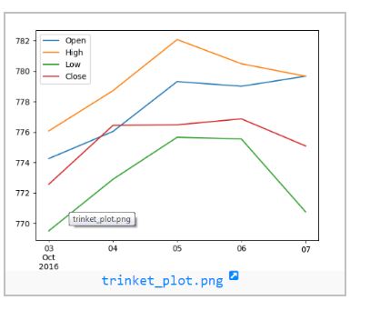

Aim
To visualize Alphabet Inc.’s daily Open, High, Low, and Close prices between October 3 and October 7, 2016 using line charts.
Algorithm
- Import pandas and matplotlib.pyplot.
- Read fdata.csv using pd.read_csv("fdata.csv").w3resource​
- Convert the Date column to datetime with pd.to_datetime, then set it as index.
- Select the columns Open, High, Low, Close.
- Use plt.plot (or df[['Open','High','Low','Close']].plot()) to draw multiple lines on the same axes.datacamp​
- Add x-axis label (Date), y-axis label (Price in USD), plot title, legend, grid, and display the plot with plt.show().
Input (fdata.csv)
text
Date,Open,High,Low,Close
10-03-16,774.25,776.065002,769.5,772.559998
10-04-16,776.030029,778.710022,772.890015,776.429993
10-05-16,779.309998,782.070007,775.650024,776.469971
10-06-16,779,780.47998,775.539978,776.859985
10-07-16,779.659973,779.659973,770.75,775.080017
Python program
python
import pandas as pd
import matplotlib.pyplot as plt

# Read financial data
df = pd.read_csv("fdata.csv")

# Convert Date and set as index
df["Date"] = pd.to_datetime(df["Date"], format="%m-%d-%y")
df = df.set_index("Date")

# Draw line charts for Open, High, Low, Close
plt.figure(figsize=(8, 5))
plt.plot(df.index, df["Open"], label="Open", marker="o")
plt.plot(df.index, df["High"], label="High", marker="o")
plt.plot(df.index, df["Low"], label="Low", marker="o")
plt.plot(df.index, df["Close"], label="Close", marker="o")

plt.xlabel("Date")
plt.ylabel("Price (USD)")
plt.title("Alphabet Inc. Financial Data (Oct 3–7, 2016)")
plt.legend()
plt.grid(True)
plt.tight_layout()
plt.show()
Result
The program displays a line chart with four lines (Open, High, Low, Close) across the five dates from October 3 to October 7, 2016, clearly showing how each price series changes over time.

25.Write a Python program to plot two or more lines with legends, different widths and colors.
Aim
To draw at least two lines on the same axes, each with a distinct color and line width, and display a legend describing them.
Algorithm
- Import matplotlib.pyplot as plt.
- Define x-coordinates for both lines (e.g., x1 = x2 = [10, 20, 30]).
- Define different y-coordinates for each line.
- Call plt.plot() for each line, passing color, linewidth, and label arguments.w3resource​
- Set axis labels and a title with xlabel, ylabel, title.
- Call plt.legend() to show the legend.
- Display the plot using plt.show().
Python program
python
import matplotlib.pyplot as plt

# line 1 points
x1 = [10, 20, 30]
y1 = [20, 40, 10]

# line 2 points
x2 = [10, 20, 30]
y2 = [40, 10, 30]

# Labels for axes and title
plt.xlabel("x - axis")
plt.ylabel("y - axis")
plt.title("Two or more lines with legends,\n different widths and colors")

# Plot lines with different colors and widths
plt.plot(x1, y1, color="blue", linewidth=3, label="line1 - width 3")
plt.plot(x2, y2, color="red", linewidth=5, label="line2 - width 5")

# Show legend
plt.legend()

# Display the figure
plt.show()
Result
Running this code shows a graph with two differently colored lines (blue, red), with different thicknesses and a legend identifying “line1 - width 3” and “line2 - width 5”.

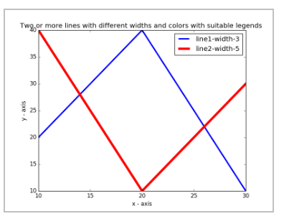
26.Write a Python program to create multiple plots.


Aim
To read the World alcohol consumption dataset into a DataFrame, print its dimensions (number of rows and columns), and extract all column names.
Algorithm
- Import pandas.
- Read the dataset file (for example, world_alcohol.csv) with pd.read_csv().
- Use df.shape to obtain the tuple (rows, columns).
- Use df.columns to get the Index of column names.
- Print the shape and the list of column names.
Input
- CSV file, say world_alcohol.csv, containing columns such as:
  - Year, WHO region, Country, Beverage Types, Display Value (as in your screenshot).
Pandas program
python
import pandas as pd

# Read the World alcohol consumption dataset
df = pd.read_csv("world_alcohol.csv")

# Display dimensions / shape
print("Shape of the dataset (rows, columns):")
print(df.shape)

# Display column names
print("\nColumn names:")
print(df.columns.tolist())
Result (example)
text
Shape of the dataset (rows, columns):
(1775, 5)

Column names:
['Year', 'WHO region', 'Country', 'Beverage Types', 'Display Value']
The actual row count may differ depending on the version of the dataset, but the method and output format remain the same.

27.Write a Python programming to display a bar chart of the popularity of programming Languages.
Sample data:
Programming languages: Java, Python, PHP, JavaScript, C#, C++
Popularity: 22.2, 17.6, 8.8, 8, 7.7, 6.7
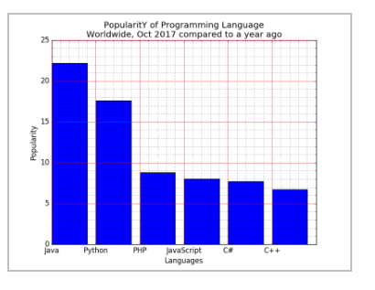
Aim
To draw a vertical bar chart showing the popularity of different programming languages.DSA05-LAB_QUESTIONS.docx​
Algorithm
- Import matplotlib.pyplot as plt.
- Define a list of language names and a list of popularity values.
- Use plt.bar() with the language list on the x-axis and popularity on the y-axis.
- Add axis labels and a title, and display the plot.
Input
- Languages: ["Java", "Python", "PHP", "JavaScript", "C#", "C++"]
- Popularity: [22.2, 17.6, 8.8, 8.0, 7.7, 6.7]DSA05-LAB_QUESTIONS.docx​
Code
python
import matplotlib.pyplot as plt

languages = ["Java", "Python", "PHP", "JavaScript", "C#", "C++"]
popularity = [22.2, 17.6, 8.8, 8.0, 7.7, 6.7]

plt.bar(languages, popularity)
plt.xlabel("Programming Languages")
plt.ylabel("Popularity (%)")
plt.title("Popularity of Programming Languages")
plt.show()
Output
A vertical bar chart with one bar per language, heights proportional to popularity values, matching the sample image.DSA05-LAB_QUESTIONS.docx​
Result
The bar chart clearly visualizes and compares the popularity percentages of the given programming languages.DSA05-LAB_QUESTIONS.docx​

28.Write a Python programming to display a horizontal bar chart of the popularity of programming Languages.
Sample data:
Programming languages: Java, Python, PHP, JavaScript, C#, C++
Popularity: 22.2, 17.6, 8.8, 8, 7.7, 6.7
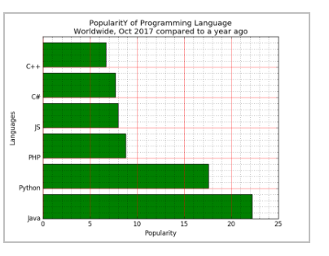
Aim
To draw a horizontal bar chart for the same language popularity data.DSA05-LAB_QUESTIONS.docx​
Algorithm
- Import matplotlib.pyplot.
- Define language and popularity lists.
- Call plt.barh() using popularity as x-values and languages as y-labels.
- Label axes, set title, and show the plot.
Input
Same as Question 27.DSA05-LAB_QUESTIONS.docx​
Code
python
import matplotlib.pyplot as plt

languages = ["Java", "Python", "PHP", "JavaScript", "C#", "C++"]
popularity = [22.2, 17.6, 8.8, 8.0, 7.7, 6.7]

plt.barh(languages, popularity)
plt.xlabel("Popularity (%)")
plt.ylabel("Programming Languages")
plt.title("Popularity of Programming Languages (Horizontal)")
plt.show()
Output
A horizontal bar chart with each language labeled on the y-axis, similar to the figure in the document.DSA05-LAB_QUESTIONS.docx​
Result
The program displays popularity as horizontal bars, which is useful when language labels are long.DSA05-LAB_QUESTIONS.docx​

29.Write a Python programming to display a bar chart of the popularity of programming Languages. Use different color for each bar.
Sample data:
Programming languages: Java, Python, PHP, JavaScript, C#, C++
Popularity: 22.2, 17.6, 8.8, 8, 7.7, 6.7
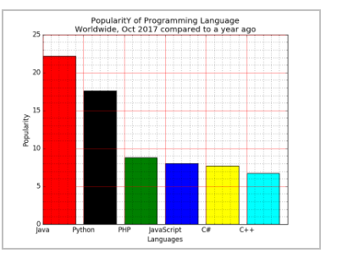

Aim
To draw a vertical bar chart for language popularity where each bar has a distinct color.DSA05-LAB_QUESTIONS.docx​
Algorithm
- Import matplotlib.pyplot.
- Define language and popularity lists.
- Define a color list with one color per bar.
- Call plt.bar() with the color argument set to the color list.
- Label axes, set title, and display.
Input
Same language and popularity data as in Questions 27–28.DSA05-LAB_QUESTIONS.docx​
Code
python
import matplotlib.pyplot as plt

languages = ["Java", "Python", "PHP", "JavaScript", "C#", "C++"]
popularity = [22.2, 17.6, 8.8, 8.0, 7.7, 6.7]
colors = ["red", "green", "blue", "orange", "purple", "cyan"]

plt.bar(languages, popularity, color=colors)
plt.xlabel("Programming Languages")
plt.ylabel("Popularity (%)")
plt.title("Popularity of Programming Languages (Colored Bars)")
plt.show()
Output
A vertical bar chart where each language bar has a unique color, matching the multicolored sample.DSA05-LAB_QUESTIONS.docx​
Result
The chart improves visual distinction between languages by using different bar colors.

30.Write a Python program to create bar plot of scores by group and gender. Use multiple X values on the same chart for men and women.
Sample Data:
Means (men) = (22, 30, 35, 35, 26)
Means (women) = (25, 32, 30, 35, 29)
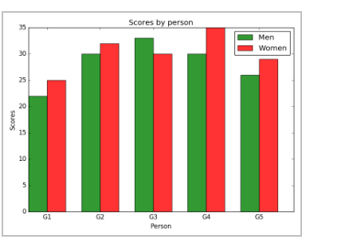
Aim
To create a grouped bar plot that compares scores (means) of men and women across different groups.DSA05-LAB_QUESTIONS.docx​
Algorithm
- Import matplotlib.pyplot and numpy.
- Define arrays of mean scores for men and women.
- Create an array of group positions using np.arange().
- Set a bar width (e.g., 0.35).
- Plot men’s bars at index positions and women’s bars at index + width.
- Label axes, set group tick labels, add a legend, and show the plot.
Input
- Means (men): (22, 30, 35, 35, 26)
- Means (women): (25, 32, 30, 35, 29)DSA05-LAB_QUESTIONS.docx​
Code
python
import matplotlib.pyplot as plt
import numpy as np

means_men = (22, 30, 35, 35, 26)
means_women = (25, 32, 30, 35, 29)

groups = ("G1", "G2", "G3", "G4", "G5")
index = np.arange(len(groups))
bar_width = 0.35

plt.bar(index, means_men, bar_width, label="Men", color="blue")
plt.bar(index + bar_width, means_women, bar_width, label="Women", color="orange")

plt.xlabel("Group")
plt.ylabel("Scores")
plt.title("Scores by Group and Gender")
plt.xticks(index + bar_width / 2, groups)
plt.legend()
plt.tight_layout()
plt.show()
Output
A grouped bar chart where for each group G1–G5, men’s and women’s scores appear side-by-side as blue and orange bars.DSA05-LAB_QUESTIONS.docx​
Result
The grouped bars allow easy comparison of male and female average scores within each group.

31.Write a Python program to create a stacked bar plot with error bars.
Note: Use bottom to stack the women?s bars on top of the men?s bars.
Sample Data:
Means (men) = (22, 30, 35, 35, 26)
Means (women) = (25, 32, 30, 35, 29)
Men Standard deviation = (4, 3, 4, 1, 5)
Women Standard deviation = (3, 5, 2, 3, 3)
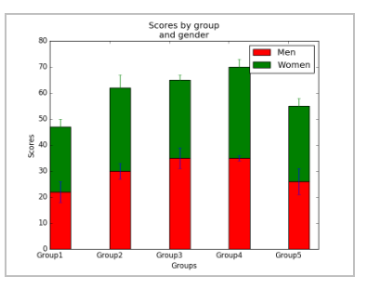
Aim
To create a stacked bar plot showing men’s and women’s mean scores with error bars, stacking the women’s bars on top of the men’s.DSA05-LAB_QUESTIONS.docx​
Algorithm
- Import matplotlib.pyplot and numpy.
- Define tuples of men’s and women’s mean scores and their standard deviations.
- Define group positions using np.arange().
- Plot men’s bars with plt.bar() including yerr=men_std.
- Plot women’s bars with bottom=means_men and yerr=women_std to stack them.
- Label axes, set group ticks, add legend and title, and show the plot.
Input
- Means (men): (22, 30, 35, 35, 26)
- Means (women): (25, 32, 30, 35, 29)
- Std (men): (4, 3, 4, 1, 5)
- Std (women): (3, 5, 2, 3, 3)DSA05-LAB_QUESTIONS.docx​
Code
python
import matplotlib.pyplot as plt
import numpy as np

means_men = (22, 30, 35, 35, 26)
means_women = (25, 32, 30, 35, 29)
std_men = (4, 3, 4, 1, 5)
std_women = (3, 5, 2, 3, 3)

groups = ("G1", "G2", "G3", "G4", "G5")
index = np.arange(len(groups))
bar_width = 0.35

# Men bars
p1 = plt.bar(index, means_men, bar_width, yerr=std_men,
color="blue", label="Men")

# Women bars stacked on men
p2 = plt.bar(index, means_women, bar_width, bottom=means_men,
yerr=std_women, color="orange", label="Women")

plt.ylabel("Scores")
plt.title("Scores by Group and Gender (Stacked)")
plt.xticks(index, groups)
plt.legend()
plt.tight_layout()
plt.show()
Output
A stacked bar chart where women’s scores are stacked on men’s for each group and both have error bars, matching the sample figure.DSA05-LAB_QUESTIONS.docx​
Result
The stacked plot shows total combined scores per group as bar height while visualizing individual male and female contributions and score variability via error bars

32.Write a Python program to draw a scatter graph taking a random distribution in X and Y and plotted against each other.
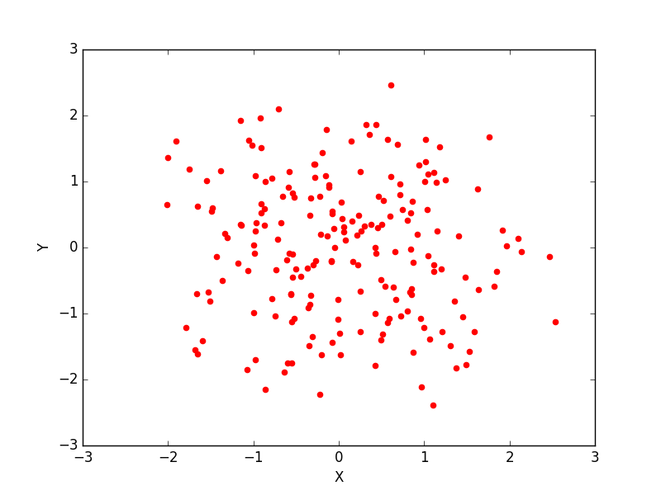
Aim
To draw a scatter plot of two random distributions X and Y plotted against each other.DSA05-LAB_QUESTIONS.docx​
Algorithm
- Import matplotlib.pyplot and numpy.
- Generate random arrays x and y (e.g., normal distribution) of the same length using np.random.randn() or np.random.rand().
- Call plt.scatter(x, y) to create the scatter plot.
- Label axes, set a title, enable grid if desired, and show the plot.
Input
No external input; both X and Y are randomly generated within the program.DSA05-LAB_QUESTIONS.docx​
Code
python
import matplotlib.pyplot as plt
import numpy as np

np.random.seed(0) # for reproducible result
x = np.random.randn(100) # 100 random points
y = np.random.randn(100)

plt.scatter(x, y, c="blue", alpha=0.7)
plt.xlabel("X random values")
plt.ylabel("Y random values")
plt.title("Scatter Plot of Random Distributions")
plt.grid(True)
plt.show()
Output
A scatter plot of 100 blue points spread roughly around the origin, similar to the random cloud shown in your document.DSA05-LAB_QUESTIONS.docx​
Result
The program successfully visualizes the relationship between two independent random distributions using a scatter graph.DSA05-LAB_QUESTIONS.docx​

33.Write a Python program to draw a scatter plot with empty circles taking a random distribution in X and Y and plotted against each other.
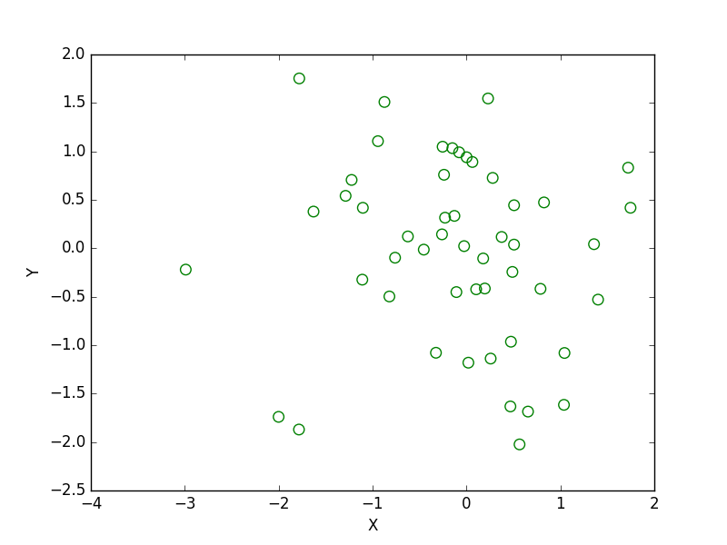

Aim
To draw a scatter plot of random X and Y values using empty circle markers (no face color).
Algorithm
- Import matplotlib.pyplot and numpy.
- Generate random arrays x and y of the same length.
- Use plt.scatter() with facecolors='none' and edgecolors set to a visible color.
- Label axes, set title, enable grid, and display the plot.
Input
No external input; X and Y are randomly generated.
Code
python
import matplotlib.pyplot as plt
import numpy as np

np.random.seed(0)
x = np.random.randn(100)
y = np.random.randn(100)

plt.scatter(x, y, facecolors='none', edgecolors='b')
plt.xlabel("X random values")
plt.ylabel("Y random values")
plt.title("Scatter Plot with Empty Circles")
plt.grid(True)
plt.show()
Output
A scatter plot where each point is an empty blue circle (only outline), similar to the figure in the document.
Result
The program visualizes random data with hollow markers, clearly showing overlapping points.

34.Write a Python program to draw a scatter plot using random distributions to generate balls of different sizes.
Aim
To draw a scatter plot using random distributions where marker sizes vary, creating “balls” of different sizes.
Algorithm
- Import matplotlib.pyplot and numpy.
- Generate random arrays for X and Y.
- Generate another random array for marker sizes (e.g., s = np.random.rand(n) * scale).
- Call plt.scatter(x, y, s=s, alpha=..., c=...).
- Label axes, add title, and display.
Input
Randomly generated X, Y coordinates and sizes.
Code
python
import matplotlib.pyplot as plt
import numpy as np

np.random.seed(1)
x = np.random.randn(100)
y = np.random.randn(100)
sizes = np.random.rand(100) * 800 # scale for visible balls
colors = np.random.rand(100)

plt.scatter(x, y, s=sizes, c=colors, alpha=0.7, cmap="viridis")
plt.xlabel("X random values")
plt.ylabel("Y random values")
plt.title("Scatter Plot with Balls of Different Sizes")
plt.colorbar(label="Color scale")
plt.grid(True)
plt.show()
Output
A scatter plot where each point appears as a colored ball with varying radius, matching the style in the handout.
Result
The program demonstrates how to encode a third variable (size) in a scatter plot.

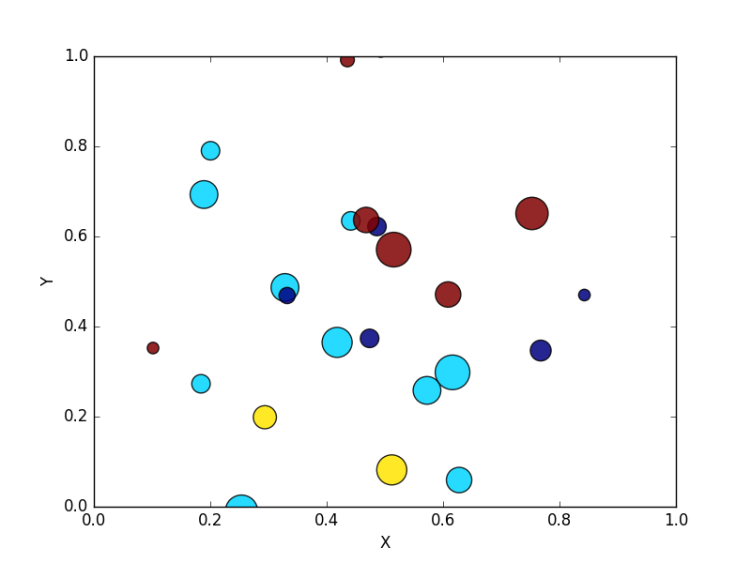
35.Write a Python program to draw a scatter plot comparing two subject marks of Mathematics and Science. Use marks of 10 students.
Sample data:
Test Data:
math_marks = [88, 92, 80, 89, 100, 80, 60, 100, 80, 34]
science_marks = [35, 79, 79, 48, 100, 88, 32, 45, 20, 30]
marks_range = [10, 20, 30, 40, 50, 60, 70, 80, 90, 100]
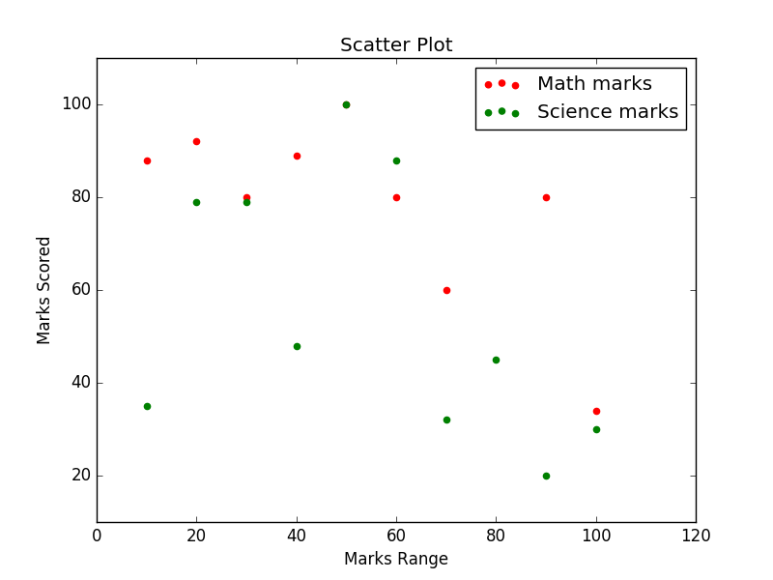
Aim
To draw a scatter plot comparing marks in Mathematics and Science for 10 students.
Algorithm
- Import matplotlib.pyplot.
- Define lists math_marks, science_marks, and marks_range.
- Call plt.scatter(math_marks, science_marks).
- Label x-axis as Mathematics and y-axis as Science, set ticks from marks_range, and add title.
- Show the figure.
Input
python
math_marks = [88, 92, 80, 89, 100, 80, 60, 100, 80, 34]
science_marks = [35, 79, 79, 48, 100, 88, 32, 45, 20, 30]
marks_range = [10, 20, 30, 40, 50, 60, 70, 80, 90, 100]
Code
python
import matplotlib.pyplot as plt

math_marks = [88, 92, 80, 89, 100, 80, 60, 100, 80, 34]
science_marks = [35, 79, 79, 48, 100, 88, 32, 45, 20, 30]
marks_range = [10, 20, 30, 40, 50, 60, 70, 80, 90, 100]

plt.scatter(math_marks, science_marks, color="green")
plt.xlabel("Math marks")
plt.ylabel("Science marks")
plt.title("Math vs Science Marks of 10 Students")
plt.xticks(marks_range)
plt.yticks(marks_range)
plt.grid(True)
plt.show()
Output
A scatter plot showing one point per student, with Math marks on the x-axis and Science marks on the y-axis, similar to the sample figure.​
Result
The plot helps visualize correlation between the two subjects’ scores.

36.Write a Python program to draw a scatter plot for three different groups comparing weights and heights.
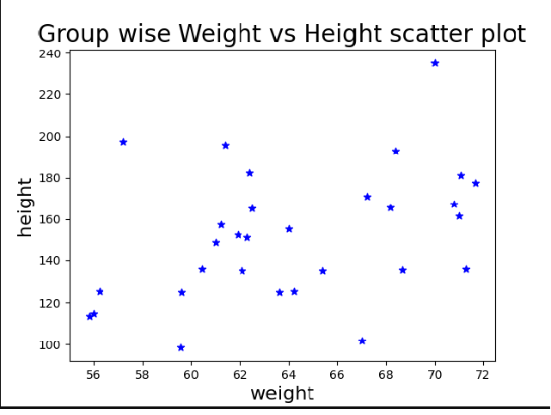
Aim
To draw a scatter plot comparing weights and heights for three distinct groups, using different colors/markers per group.
Algorithm
- Import matplotlib.pyplot and numpy.
- Define separate arrays of height and weight for three groups A, B, and C (or generate sample data).
- Call plt.scatter() three times with different colors/markers and labels.
- Label axes, set title, add legend, and show the plot.
Input
Sample (you can adjust values):
python
height1 = [167, 182, 176, 173, 165]
weight1 = [65, 80, 75, 70, 60]

height2 = [160, 172, 168, 169, 171]
weight2 = [55, 68, 64, 66, 70]

height3 = [155, 158, 162, 160, 159]
weight3 = [50, 52, 54, 53, 55]
Code
python
import matplotlib.pyplot as plt

height1 = [167, 182, 176, 173, 165]
weight1 = [65, 80, 75, 70, 60]

height2 = [160, 172, 168, 169, 171]
weight2 = [55, 68, 64, 66, 70]

height3 = [155, 158, 162, 160, 159]
weight3 = [50, 52, 54, 53, 55]

plt.scatter(height1, weight1, c="red", marker="o", label="Group 1")
plt.scatter(height2, weight2, c="blue", marker="^", label="Group 2")
plt.scatter(height3, weight3, c="green", marker="s", label="Group 3")

plt.xlabel("Height (cm)")
plt.ylabel("Weight (kg)")
plt.title("Weights vs Heights for Three Groups")
plt.legend()
plt.grid(True)
plt.show()
Output
A scatter plot where three groups appear with different marker styles and colors, as in the reference image.
Result
The program clearly separates and compares height–weight distributions for three distinct groups.

37.Write a Pandas program to create a dataframe from a dictionary and display it.
Sample data: {'X':[78,85,96,80,86], 'Y':[84,94,89,83,86],'Z':[86,97,96,72,83]}
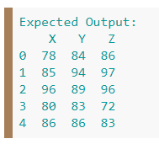

Aim
To create a Pandas DataFrame from a simple dictionary and display it.
Algorithm
- Import pandas as pd.
- Define a dictionary with keys as column names and lists as values.
- Create a DataFrame using pd.DataFrame(dict).
- Print or display the DataFrame.
Input
python
data = {'X':[78,85,96,80,86],
'Y':[84,94,89,83,86],
'Z':[86,97,96,72,83]}
Code
python
import pandas as pd

data = {'X':[78,85,96,80,86],
'Y':[84,94,89,83,86],
'Z':[86,97,96,72,83]}

df = pd.DataFrame(data)
print(df)
Output
A 5×3 table with columns X, Y, Z containing the given values.
Result
The program demonstrates basic DataFrame construction from a Python dictionary.

38.Write a Pandas program to create and display a DataFrame from a specified dictionary data which has the index labels.
Sample Python dictionary data and list labels:
exam_data = {'name': ['Anastasia', 'Dima', 'Katherine', 'James', 'Emily', 'Michael', 'Matthew', 'Laura', 'Kevin', 'Jonas'],
'score': [12.5, 9, 16.5, np.nan, 9, 20, 14.5, np.nan, 8, 19],
'attempts': [1, 3, 2, 3, 2, 3, 1, 1, 2, 1],
'qualify': ['yes', 'no', 'yes', 'no', 'no', 'yes', 'yes', 'no', 'no', 'yes']}
labels = ['a', 'b', 'c', 'd', 'e', 'f', 'g', 'h', 'i', 'j']
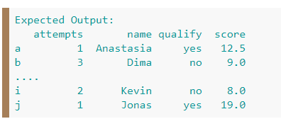
Aim
To create and display a DataFrame from dictionary data, using a given list of index labels.
Algorithm
- Import pandas and numpy.
- Define exam_data dictionary and labels list.
- Create a DataFrame with pd.DataFrame(exam_data, index=labels).
- Display the DataFrame.
Input
python
import numpy as np

exam_data = {
'name': ['Anastasia','Dima','Katherine','James','Emily',
'Michael','Matthew','Laura','Kevin','Jonas'],
'score': [12.5,9,16.5,np.nan,9,20,14.5,np.nan,8,19],
'attempts': [1,3,2,3,2,3,1,1,2,1],
'qualify': ['yes','no','yes','no','no','yes','yes','no','no','yes']
}
labels = ['a','b','c','d','e','f','g','h','i','j']
Code
python
import pandas as pd
import numpy as np

exam_data = {
'name': ['Anastasia','Dima','Katherine','James','Emily',
'Michael','Matthew','Laura','Kevin','Jonas'],
'score': [12.5,9,16.5,np.nan,9,20,14.5,np.nan,8,19],
'attempts': [1,3,2,3,2,3,1,1,2,1],
'qualify': ['yes','no','yes','no','no','yes','yes','no','no','yes']
}
labels = ['a','b','c','d','e','f','g','h','i','j']

df = pd.DataFrame(exam_data, index=labels)
print(df)
Output
A 10×4 DataFrame with indices a–j and the corresponding exam details.
Result
The program shows how to assign custom index labels while creating a DataFrame.

39.Write a Pandas program to get the first 3 rows of a given DataFrame.
Sample Python dictionary data and list labels:
exam_data = {'name': ['Anastasia', 'Dima', 'Katherine', 'James', 'Emily', 'Michael', 'Matthew', 'Laura', 'Kevin', 'Jonas'],
'score': [12.5, 9, 16.5, np.nan, 9, 20, 14.5, np.nan, 8, 19],
'attempts': [1, 3, 2, 3, 2, 3, 1, 1, 2, 1],
'qualify': ['yes', 'no', 'yes', 'no', 'no', 'yes', 'yes', 'no', 'no', 'yes']}
labels = ['a', 'b', 'c', 'd', 'e', 'f', 'g', 'h', 'i', 'j']
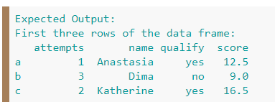
Aim
To select and display the first three rows from the exam DataFrame.
Algorithm
- Create the exam_data DataFrame with index labels as in Question 38.
- Use df.head(3) or df.iloc[0:3] to obtain the first three rows.
- Print the resulting subset.
Input
Same exam_data and labels as in Question 38.ppl-ai-file-upload.s3.amazonaws​
Code
python
import pandas as pd
import numpy as np

exam_data = {
'name': ['Anastasia','Dima','Katherine','James','Emily',
'Michael','Matthew','Laura','Kevin','Jonas'],
'score': [12.5,9,16.5,np.nan,9,20,14.5,np.nan,8,19],
'attempts': [1,3,2,3,2,3,1,1,2,1],
'qualify': ['yes','no','yes','no','no','yes','yes','no','no','yes']
}
labels = ['a','b','c','d','e','f','g','h','i','j']

df = pd.DataFrame(exam_data, index=labels)

first_three = df.head(3) # or df.iloc[0:3]
print(first_three)
Output
Rows with indices a, b, c and their columns name, score, attempts, qualify.
Result
The program extracts the top three records, illustrating basic row selection in Pandas.

- Write a Pandas program to select the 'name' and 'score' columns from the following DataFrame.
Sample Python dictionary data and list labels:
exam_data = {'name': ['Anastasia', 'Dima', 'Katherine', 'James', 'Emily', 'Michael', 'Matthew', 'Laura', 'Kevin', 'Jonas'],
'score': [12.5, 9, 16.5, np.nan, 9, 20, 14.5, np.nan, 8, 19],
'attempts': [1, 3, 2, 3, 2, 3, 1, 1, 2, 1],
'qualify': ['yes', 'no', 'yes', 'no', 'no', 'yes', 'yes', 'no', 'no', 'yes']}
labels = ['a', 'b', 'c', 'd', 'e', 'f', 'g', 'h', 'i', 'j']
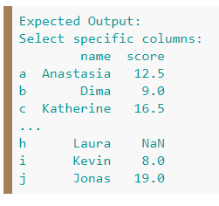
Aim
To select only the name and score columns from the exam DataFrame.
Algorithm
- Build the DataFrame from exam_data with index labels.
- Use df[['name','score']] to select the two desired columns.
- Print the resulting DataFrame.
Input
Same exam_data and labels as in Questions 38–39.ppl-ai-file-upload.s3.amazonaws​
Code
python
import pandas as pd
import numpy as np

exam_data = {
'name': ['Anastasia','Dima','Katherine','James','Emily',
'Michael','Matthew','Laura','Kevin','Jonas'],
'score': [12.5,9,16.5,np.nan,9,20,14.5,np.nan,8,19],
'attempts': [1,3,2,3,2,3,1,1,2,1],
'qualify': ['yes','no','yes','no','no','yes','yes','no','no','yes']
}
labels = ['a','b','c','d','e','f','g','h','i','j']

df = pd.DataFrame(exam_data, index=labels)

name_score = df[['name', 'score']]
print(name_score)
Output
A 10×2 DataFrame showing only the name and score columns for all students, as in the screenshot.
Result
The program demonstrates column sub-selection in Pandas, returning just the required fields.

