AI-Based Heart Disease Prediction Using Python
Damaries Ongole, Iman Parwaiz Sayeda, and Sanjeev Koushik Sennam Setty
University of the Cumberlands
PhDAI-733: Residency Project Day 1
Najam Hassan
November 6, 2026

Introduction and Problem Framing
For this residency project, our team selected a healthcare problem with a practical question: Can routinely collected patient information help identify patterns associated with heart disease? Clinicians consider several measurements together, including age, chest pain, blood pressure, cholesterol, and exercise-test findings. We explored whether a Python-based classification model could combine these features to support preliminary risk assessment. The intended users are clinicians considering additional evaluation and healthcare administrators planning diagnostic resources.
We defined the outcome as a binary classification variable in the team-provided dataset: 1 denotes the positive heart disease class and 0 the negative class. We prioritized recall to reduce missed positives, while also reporting precision, accuracy, F1-score, and ROC-AUC. This is an educational proof of concept, not a validated diagnostic system.

Dataset Exploration and Preprocessing

Dataset and Exploratory Analysis
The analysis used a team-provided heart.csv file described as a processed version of the UCI Heart Disease (Cleveland) dataset (Janosi et al., 1989). It contained 303 rows, 13 predictor variables, and one target column. Predictors included demographic characteristics, blood pressure, cholesterol, chest pain, electrocardiogram measures, and exercise-test results. Using pandas and NumPy, we examined data types, missing values, duplicate rows, summary statistics, and outcome distribution.
In this processed file, no missing values were reported. One exact duplicate was removed, leaving 302 records: 164 (54.3%) in the positive class and 138 (45.7%) in the negative class. Ages ranged from 29 to 77 years, with a mean of approximately 54.4 years. We used Matplotlib and Seaborn to visualize the outcome distribution, correlations, and selected features (see Figure 1). Higher values such as cholesterol and ST depression were retained because an extreme measurement alone is not sufficient evidence of a data-entry error. The original UCI data can contain missing values; the zero-missing finding applies only to our processed file.
Exploratory analysis showed that the two outcome groups differed on several measures. On average, records in the positive class were younger (52.6 vs. 56.6 years), reached a higher maximum heart rate (158.4 vs. 139.1), and had a lower ST depression value (oldpeak; 0.59 vs. 1.59) than records in the negative class. The predictors most strongly correlated with the target were chest pain type (r = .43), maximum heart rate achieved (r = .42), the slope of the peak exercise ST segment (r = .34), exercise-induced angina (r = -.44), oldpeak (r = -.43), and the number of major vessels colored by fluoroscopy (r = -.41). These patterns are associations within this sample; we used them to guide modeling rather than to draw clinical conclusions.
Figure 1
Outcome Distribution and Correlation Heatmap
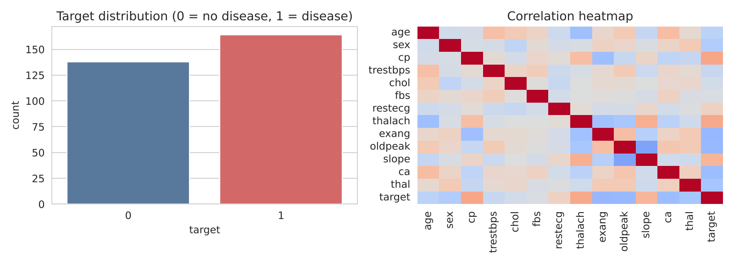
Note. Left: counts of records without (0) and with (1) heart disease. Right: pairwise correlations among all variables, from the analysis of the processed heart.csv file.

Preprocessing Decisions
We one-hot encoded eight categorical predictors (sex, cp, fbs, restecg, exang, slope, ca, and thal) and standardized five numerical predictors (age, trestbps, chol, thalach, and oldpeak). We then created a stratified 75/25 train-test split, producing 226 training records and 76 test records (random_state = 42). Encoding and scaling were implemented inside a scikit-learn Pipeline, so transformations were learned from the training data rather than the held-out test set.

Initial Model Development and Evaluation
We trained Logistic Regression as an interpretable baseline and Random Forest to examine whether a nonlinear ensemble would improve classification. Both models underwent five-fold cross-validation on the training data and evaluation on the same held-out test set. We also tuned Random Forest using GridSearchCV. The reported test results are summarized in Table 1; tuning did not improve performance.
Table 1
Held-Out Test-Set Model Performance (n = 76)
Model | Accuracy | Precision | Recall | F1 | ROC-AUC
Logistic Regression | 0.803 | 0.783 | 0.878 | 0.828 | 0.895
Random Forest | 0.750 | 0.739 | 0.829 | 0.782 | 0.879
Tuned Random Forest | 0.737 | 0.723 | 0.829 | 0.773 | 0.861
Note. Results are from the team's Python analysis (scikit-learn) using the processed heart.csv file described above.
Logistic Regression performed best on this test split, achieving 80.3% accuracy and 87.8% recall. Among 41 positive-class test records, it identified 36 and missed five; it also produced 10 false positives among 35 negative-class records. Random Forest missed seven positive cases. Although recall is important in this setting, a reduction in missed cases must be weighed against additional false alerts. The small test set means that a difference of only a few predictions can noticeably change the reported metrics; these results cannot establish clinical effectiveness.
Future work should assess classification thresholds, error trade-offs, calibration, subgroup fairness, and performance on larger datasets. Any clinical application would require external validation, privacy safeguards, and clinician oversight.
Model errors in this setting carry real consequences. A false negative can delay diagnosis and treatment for a patient who has heart disease, which is why this project prioritized recall, while a false positive can lead to anxiety and additional testing for a healthy patient. Fairness also requires attention: the dataset was collected in the 1980s at a single site in Cleveland and contains mostly male patients (207 of 303 records, 68.3%), so performance may not generalize equally across sex, age, or ethnic groups, and subgroup evaluation is needed before any wider use. The file used here is a de-identified public dataset, but any real deployment would need strict privacy safeguards for patient data. In practice, a model like this could support preliminary risk assessment in a clinic, helping clinicians decide which patients should receive further evaluation first. It is a decision support tool, not a diagnosis, and it would require external validation on larger, current, and more diverse data, along with clinician oversight, before use with real patients.

Team Collaboration Process
The team assigned complementary responsibilities: Damaries Ongole, exploration and visualization; Iman Parwaiz Sayeda, preprocessing and evaluation; and Sanjeev Koushik Sennam Setty, problem framing, modeling, and documentation. Key decisions, including removing the duplicate record, using a stratified split, and prioritizing recall, were agreed on by the full team before they were applied.
We worked in a shared Google Colab notebook so every member could run and review the same code, and we used GitHub for version control. The team's repository (github.com/SanjeeKoushik/residency-project-day1) holds the analysis code, this report, and the team kickoff slides, and all three members were added as collaborators with edit access. Before finalizing this report, we re-ran the full notebook in Google Colab and confirmed that the model results matched the values reported here.

References
Janosi, A., Steinbrunn, W., Pfisterer, M., & Detrano, R. (1989). Heart disease [Data set]. UCI Machine Learning Repository. https://doi.org/10.24432/C52P4X

