Model Optimization, Real-World Impact, and Ethical Evaluation of an AI-Based Heart Disease Predictor
Damaries Ongole, Iman Parwaiz Sayeda, and Sanjeev Koushik Sennam Setty
University of the Cumberlands
PhDAI-733: Residency Project Day 2
Najam Hassan
November 7, 2026

Hyperparameter Tuning
In Day 1 we trained a Logistic Regression and a Random Forest baseline on the processed UCI Heart Disease (Cleveland) data (Janosi et al., 1989), which contained 302 records after removing one duplicate, using a stratified 75/25 split (226 training and 76 test records). To refine both models we used GridSearchCV with five-fold stratified cross-validation on the training set only, scoring each setting by ROC-AUC, so the test set stayed untouched until the final evaluation. Scaling and encoding remained inside the scikit-learn pipeline, so each fold was preprocessed separately. Table 1 summarizes the search.
Table 1
Hyperparameter Search Results
Model | Settings searched | Best settings | CV ROC-AUC
Logistic Regression | 12 (C values × L1/L2 penalty) | C = 0.3, L2 penalty | 0.912
Random Forest | 48 (trees, depth, leaf size, split size) | 100 trees, depth 10, 3 per leaf, 2 per split | 0.918
Note. Results are from five-fold stratified cross-validation on the 226 training records.
The two tuned models were nearly tied in cross-validation (.912 vs. .918). We therefore selected the Random Forest on the basis of cross-validation alone and did not use test results to choose a model. We then tuned the decision threshold using cross-validated predictions on the training data. Lowering the threshold from 0.50 to 0.40 raised cross-validated recall from .862 to .919, while precision decreased from .876 to .785. Because a missed diagnosis is more costly than an additional follow-up test, we adopted a threshold of 0.40 for the final model.

Final Model Evaluation
Table 2 compares the baseline, tuned, and final models on the held-out test set (76 records, 41 with heart disease). The final model identified 37 of the 41 positive-class records (recall = .902) and missed four, while producing 15 false positives among the 35 negative-class records. Relative to the default 0.50 threshold, it found two additional positive cases at the cost of three additional false alerts. The ROC curves and the confusion matrix of the final model are shown in Figure 1.
Table 2
Test-Set Performance of Baseline, Tuned, and Final Models (n = 76)
Model | Accuracy | Precision | Recall | F1 | ROC-AUC
Baseline Logistic Regression | 0.803 | 0.783 | 0.878 | 0.828 | 0.895
Baseline Random Forest | 0.750 | 0.739 | 0.829 | 0.782 | 0.879
Tuned Logistic Regression | 0.816 | 0.800 | 0.878 | 0.837 | 0.895
Tuned Random Forest (0.50) | 0.763 | 0.745 | 0.854 | 0.795 | 0.889
Final: Tuned Random Forest (0.40) | 0.750 | 0.712 | 0.902 | 0.796 | 0.889
Note. Thresholds are shown in parentheses. The final model was selected using cross-validation on the training data, not the test set.
Figure 1
ROC Curves and Confusion Matrix of the Final Model
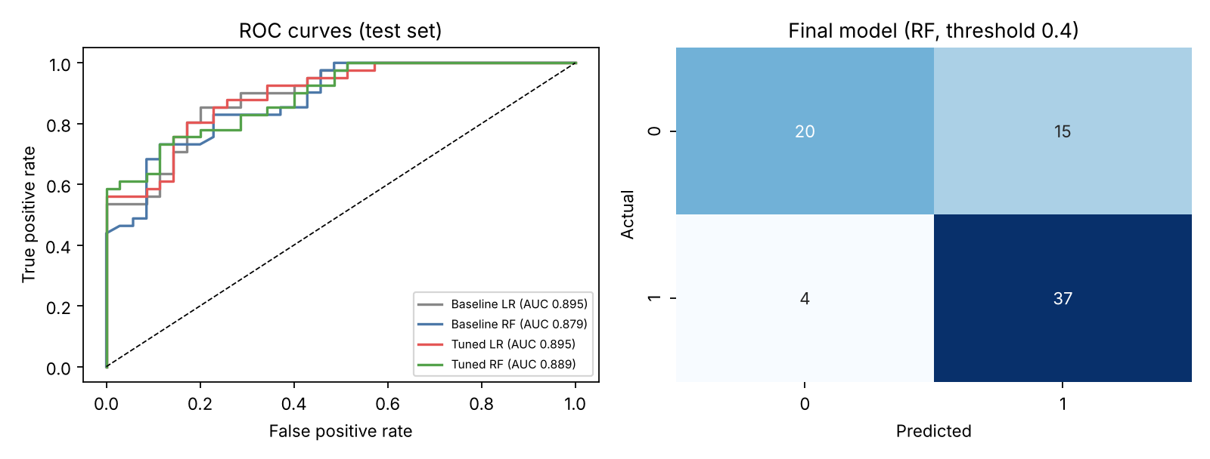
Note. Left: ROC curves of the baseline and tuned models on the test set. Right: confusion matrix of the final Random Forest at a threshold of 0.40.
Tuning improved both models only modestly (for example, Random Forest ROC-AUC rose from .879 to .889), and the tuned Logistic Regression had slightly higher test accuracy than the final model (.816 vs. .750). With only 76 test records, a difference of a few predictions can change these values, and both models reached a ROC-AUC near .89, so the simpler and more interpretable Logistic Regression remains a reasonable alternative. The most important features in the final Random Forest were the thalassemia result (thal), chest pain type (cp), ST depression (oldpeak), maximum heart rate (thalach), and the number of major vessels (ca). These agree with the strongest correlations found during exploration in Day 1, which suggests that the model relies on clinically sensible signals.

Ethical Considerations
Model errors in this setting carry real consequences. A false negative can delay diagnosis and treatment, while a false positive can cause anxiety and unnecessary testing, so the threshold is a clinical decision as well as a statistical one. Fairness also requires attention. The data were collected in the 1980s at a single site and contain mostly male patients (207 of 303 records, 68.3%), and the positive-class rate differs sharply between the two sex groups in the file (about 45% vs. 75%), so the sample may not represent the wider population. Table 3 shows how the final model performed for subgroups of the test set.
Table 3
Final Model Performance by Subgroup
Subgroup (test set) | n | Accuracy | Recall
Sex = 0 | 26 | 0.885 | 1.000
Sex = 1 | 50 | 0.680 | 0.800
Age under 55 | 38 | 0.868 | 0.962
Age 55 and over | 38 | 0.632 | 0.800
Note. Results use the final Random Forest at a threshold of 0.40. Subgroups are small, so estimates are noisy.
Performance was clearly weaker for patients aged 55 and older than for younger patients, and accuracy was lower for the larger sex group (sex = 1). Because the subgroups are small, these estimates are uncertain, but the gaps are large enough to investigate before any real use. Possible steps include collecting more data from older patients and additional sites, monitoring recall and false-negative rates by group, and considering group-specific thresholds only after clinical review. For transparency, the model would report a risk score together with its most influential features so that a clinician can see what drives a prediction, and the clinician would remain responsible for the decision. The file used here is a de-identified public dataset, but any real deployment would require strict privacy safeguards, such as HIPAA-compliant access controls, for patient data.

Real-World Application
We envision the model as a triage aid in a cardiology or primary-care clinic. After intake, the 13 routine measurements already collected for a patient would be passed to the saved scikit-learn pipeline, which returns a risk score. Patients scoring above 0.40 would be flagged so that clinicians can prioritize them for further evaluation, such as stress testing or cardiology referral, while the clinician still reviews every case. Patients would benefit from earlier attention if they are at higher risk, clinicians would have a consistent second opinion when time is limited, and administrators could schedule limited diagnostic capacity more effectively.
The threshold lets a clinic match the tool to its capacity. On our test set, the 0.40 threshold would flag 52 of 76 patients, including 37 of the 41 with heart disease, whereas a 0.50 threshold would flag 47 and capture 35. A clinic with ample follow-up capacity could favor the lower threshold, while a clinic with limited capacity might accept more missed cases in exchange for fewer referrals, a trade-off that clinicians should decide.
A responsible rollout would begin by running the model in the background (“shadow mode”) and comparing its scores with clinicians’ decisions without affecting care. The model would then be validated on local patient data, because our data are older and come from one site, and it would be monitored after launch for changes in the input data, recall by sex and age group, and the need for retraining. Risks include over-reliance on the score (automation bias), shifts in the patient population, and medical-device regulation. For these reasons the model is a decision-support tool, not a diagnosis, and it would require external validation on larger, current, and more diverse data, along with clinician oversight, before use with real patients.

Final Thoughts and Conclusion
This project built an end-to-end Python workflow that predicts heart disease from routine patient data. Tuning and threshold selection raised recall to .902 on the test set, with a ROC-AUC of about .89, and the most important features agreed with what our exploration showed. The main lessons were that careful validation matters (we kept the test set separate and chose the model using cross-validation), that metrics should reflect the cost of different mistakes, and that overall accuracy can hide weaker performance for specific groups. The main limitations are the small, older, single-site sample and the subgroup gaps we found. Next steps are testing on larger and more diverse data, completing a fairness review with clinicians, and piloting the model in shadow mode before any use in patient care.

References
Janosi, A., Steinbrunn, W., Pfisterer, M., & Detrano, R. (1989). Heart disease [Data set]. UCI Machine Learning Repository. https://doi.org/10.24432/C52P4X

