Residency Project Day 1: Data Preprocessing and Initial Model Development
Real-World AI-Driven Analytics Solution Using Python
Team: Damaries Ongole, Iman Parwaiz Sayeda, Sanjeev Koushik Sennam Setty

1. Introduction and Problem Framing
Cardiovascular disease is one of the leading causes of death worldwide, and identifying high-risk patients early helps clinicians prioritize testing and treatment. Our team acted as an analytics group supporting a hospital care-management department. The stakeholders are clinicians, who need a transparent risk signal, and administrators, who need to allocate diagnostic resources efficiently.
Business question: Can routinely collected patient attributes (age, sex, chest pain type, blood pressure, cholesterol, and exercise test results) predict whether a patient has heart disease? We framed this as a supervised binary classification problem using the UCI Heart Disease (Cleveland) dataset, where the target is 1 for heart disease present and 0 for absent.
Success criteria: Because a missed diagnosis is more costly than a false alarm, we prioritized recall for the disease class alongside accuracy and ROC-AUC. The model is intended only as decision support, never as a replacement for clinical judgment, and ethical limits are discussed in Section 3.

2. Dataset Exploration and Preprocessing
Overview. The dataset has 303 patient records, 13 predictors, and one binary target. Predictors include age, sex, chest pain type (cp), resting blood pressure (trestbps), cholesterol (chol), fasting blood sugar (fbs), resting ECG (restecg), maximum heart rate (thalach), exercise-induced angina (exang), ST depression (oldpeak), slope, number of major vessels (ca), and thalassemia result (thal). There were no missing values, and one exact duplicate record was removed, leaving 302 records. Patients ranged from 29 to 77 years old (mean 54.4).
Exploration. The classes are fairly balanced: 164 patients (54.3%) have heart disease and 138 (45.7%) do not, so accuracy is a reasonable metric and no resampling was needed. The strongest correlations with the target were positive for chest pain type (0.43), maximum heart rate (0.42), and slope (0.34), and negative for exercise-induced angina (-0.44), ST depression (-0.43), and number of vessels (-0.41). Patients with heart disease tended to reach a higher maximum heart rate and show lower ST depression. In this sample the disease rate was 75.0% for female patients (sex = 0) versus 44.7% for male patients, which is a reminder that the sample is small and not necessarily representative. Cholesterol (up to 564) and ST depression (up to 6.2) contain extreme values, but they are clinically plausible, so we kept them.
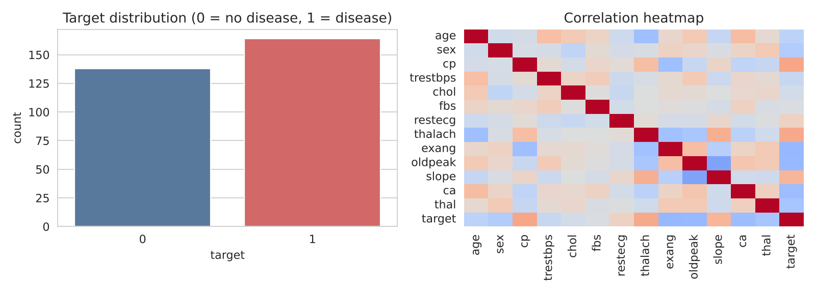
Figure 1. Target distribution and feature correlation heatmap.
Preprocessing steps.
- Cleaning: checked for missing values (none) and removed one duplicate record with drop_duplicates().
- Encoding: one-hot encoded the categorical variables (sex, cp, fbs, restecg, exang, slope, ca, thal).
- Scaling: standardized the numeric variables (age, trestbps, chol, thalach, oldpeak) with StandardScaler.
- Split: 75/25 stratified train/test split (226 training and 76 test records, random_state = 42). Scaling and encoding were fitted inside a scikit-learn Pipeline on the training data only, so no test information leaked into training.

3. Initial Model Development
We trained a Logistic Regression baseline, chosen for interpretability, and a Random Forest classifier to test whether non-linear patterns help. Both were evaluated with 5-fold cross-validation on the training set and on the held-out test set. We then tuned the Random Forest with GridSearchCV (n_estimators of 100 or 200, max_depth of 10, 20, or None; 3-fold CV). The best settings were max_depth = 10 and n_estimators = 100.
Model | Accuracy | Precision | Recall | F1 | ROC-AUC
Logistic Regression | 0.803 | 0.783 | 0.878 | 0.828 | 0.895
Random Forest (default) | 0.750 | 0.739 | 0.829 | 0.782 | 0.879
Random Forest (tuned) | 0.737 | 0.723 | 0.829 | 0.773 | 0.861
Table 1. Performance on the held-out test set (n = 76).
Logistic Regression performed best on the test set, with 80.3% accuracy, 87.8% recall, and an ROC-AUC of 0.895. It missed 5 of 41 patients with disease (false negatives) and raised 10 false alarms among 35 patients without disease. Cross-validated ROC-AUC was nearly identical for the two models (0.909 for Logistic Regression and 0.914 for Random Forest), and tuning did not improve test results. With only 76 test records, differences of a few patients can swing these numbers, so we treat the models as comparable and prefer Logistic Regression for its transparency. The most influential features were chest pain type, thal, number of vessels (ca), ST depression, and maximum heart rate.
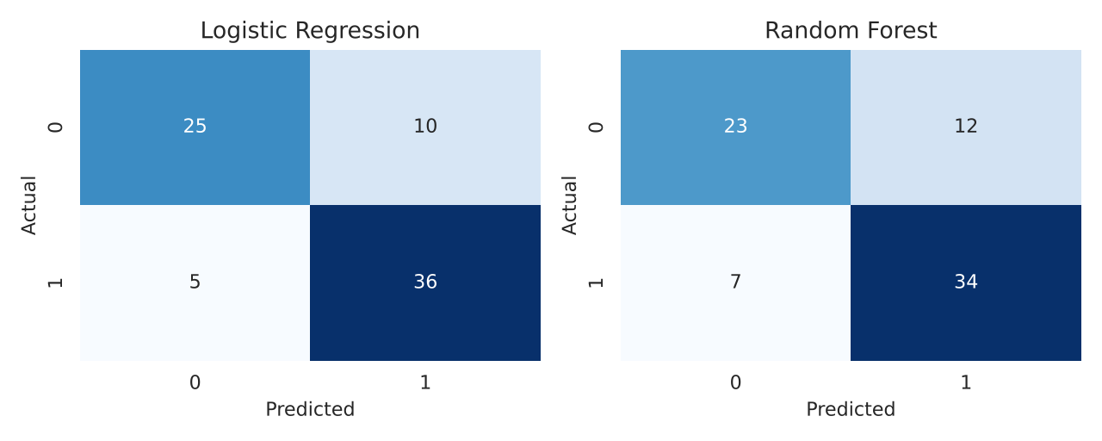
Figure 2. Confusion matrices on the test set.
Limitations and ethical considerations. The data comes from a single clinic with 302 records, so results may not generalize and the model could under-perform for groups that are under-represented. Before any real use we would compare recall and false-negative rates by sex and age group, keep the model interpretable, and handle patient data under HIPAA-compliant controls. Next steps include threshold tuning to raise recall, fairness checks by subgroup, and validation on a larger dataset.

4. Team Collaboration Process
We used a shared Google Colab notebook for coding and a GitHub repository for version control, with one branch per task and a teammate reviewing each pull request before merging. Roles were divided as follows: problem framing, documentation, and modeling (Sanjeev Koushik Sennam Setty), exploration and visualization (Damaries Ongole), and preprocessing and evaluation (Iman Parwaiz Sayeda). We held short check-ins to agree on key decisions, such as removing the duplicate record, using a stratified split, and prioritizing recall, and recorded them in the repository README. The main challenge was keeping notebook versions in sync, which we solved by committing frequently and agreeing on a single main notebook.

