APEX SOLUTIONS
NETWORK DESIGN REPORT

Prepared by: Sanjeel Shrestha
IT Graduate | Networking & Cybersecurity
Sydney, NSW, Australia
May 2026

Tools: Cisco Packet Tracer | Cisco Portfolio Project

1. Introduction
This network is the network infrastructure of Apex Solutions that has separated the access to different categories of users like the staff, management and guests. VLANs ensure each group of users is isolated from one another, preventing unauthorized access between departments. There are three VLANs — 10, 20 and 99 — representing Staff, Guest and Management respectively, with Management being VLAN 99 specifically to avoid accidental access.

2. Network Topology
The network consists of one Cisco 2911 router (Apex-Router), two Cisco 2960 switches (Switch-Staff and Switch-Guest), and seven end devices. The router connects to both switches via GigabitEthernet ports and handles inter-VLAN routing through subinterfaces.

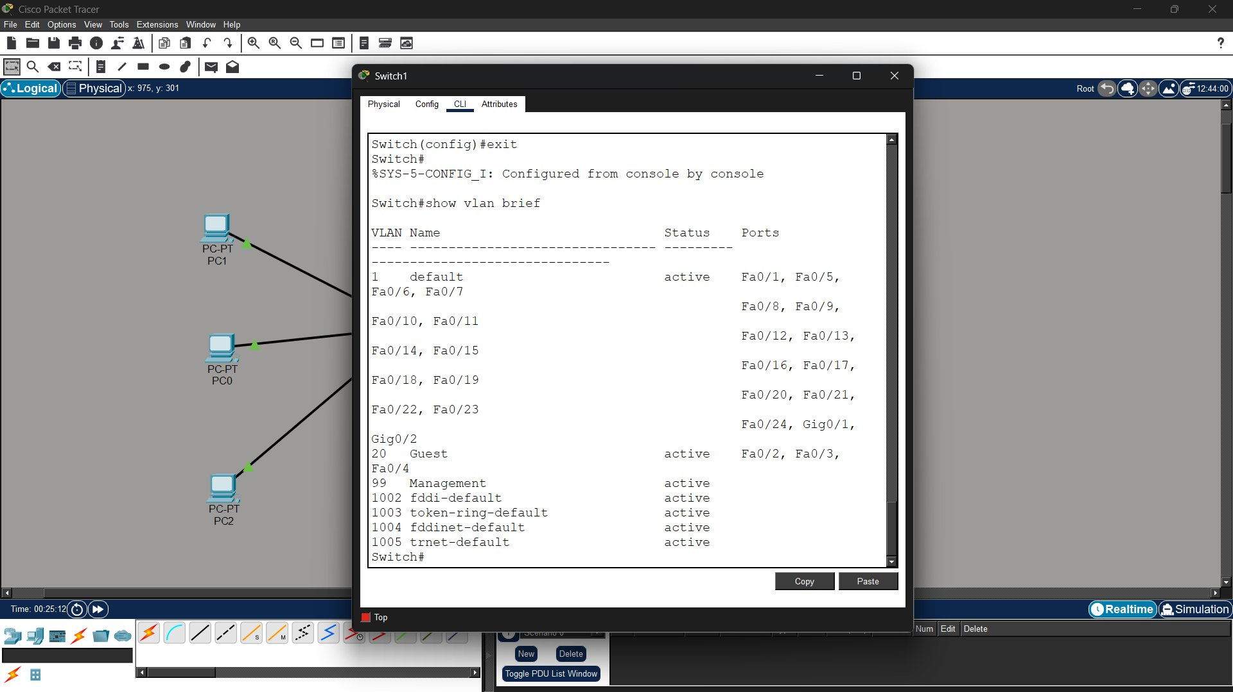
Figure 1 — Apex Solutions Network Topology in Cisco Packet Tracer

3. IP Addressing Table

Device | VLAN | IP Address | Subnet Mask | Default Gateway
Apex-Router Gig0/0.10 | 10 | 192.168.10.1 | 255.255.255.0 | —
Apex-Router Gig0/0.99 | 99 | 192.168.99.1 | 255.255.255.0 | —
Apex-Router Gig0/1.20 | 20 | 192.168.20.1 | 255.255.255.0 | —
Staff-PC1 | 10 | 192.168.10.2 | 255.255.255.0 | 192.168.10.1
Staff-PC2 | 10 | 192.168.10.3 | 255.255.255.0 | 192.168.10.1
Staff-PC3 | 10 | 192.168.10.4 | 255.255.255.0 | 192.168.10.1
Management-PC | 99 | 192.168.99.2 | 255.255.255.0 | 192.168.99.1
Guest-PC1 | 20 | 192.168.20.2 | 255.255.255.0 | 192.168.20.1
Guest-PC2 | 20 | 192.168.20.3 | 255.255.255.0 | 192.168.20.1
Guest-PC3 | 20 | 192.168.20.4 | 255.255.255.0 | 192.168.20.1

4. VLAN Configuration

4.1 VLAN Assignments

VLAN ID | Name | Switch | Ports Assigned
10 | Staff | Switch-Staff | Fa0/2, Fa0/3, Fa0/4
99 | Management | Switch-Staff | Fa0/5
20 | Guest | Switch-Guest | Fa0/2, Fa0/3, Fa0/4

4.2 Trunk Ports

Switch | Trunk Port | Connected To | VLANs Allowed
Switch-Staff | Fa0/1 | Apex-Router Gig0/0 | 10, 99
Switch-Guest | Fa0/1 | Apex-Router Gig0/1 | 20

5. Device Configuration

5.1 Switch-Staff Configuration
Switch-Staff was configured with VLAN 10 (Staff) and VLAN 99 (Management). Ports Fa0/2–Fa0/4 were assigned to VLAN 10 as access ports. Port Fa0/5 was assigned to VLAN 99. Port Fa0/1 was configured as a trunk port to carry all VLANs to the router.

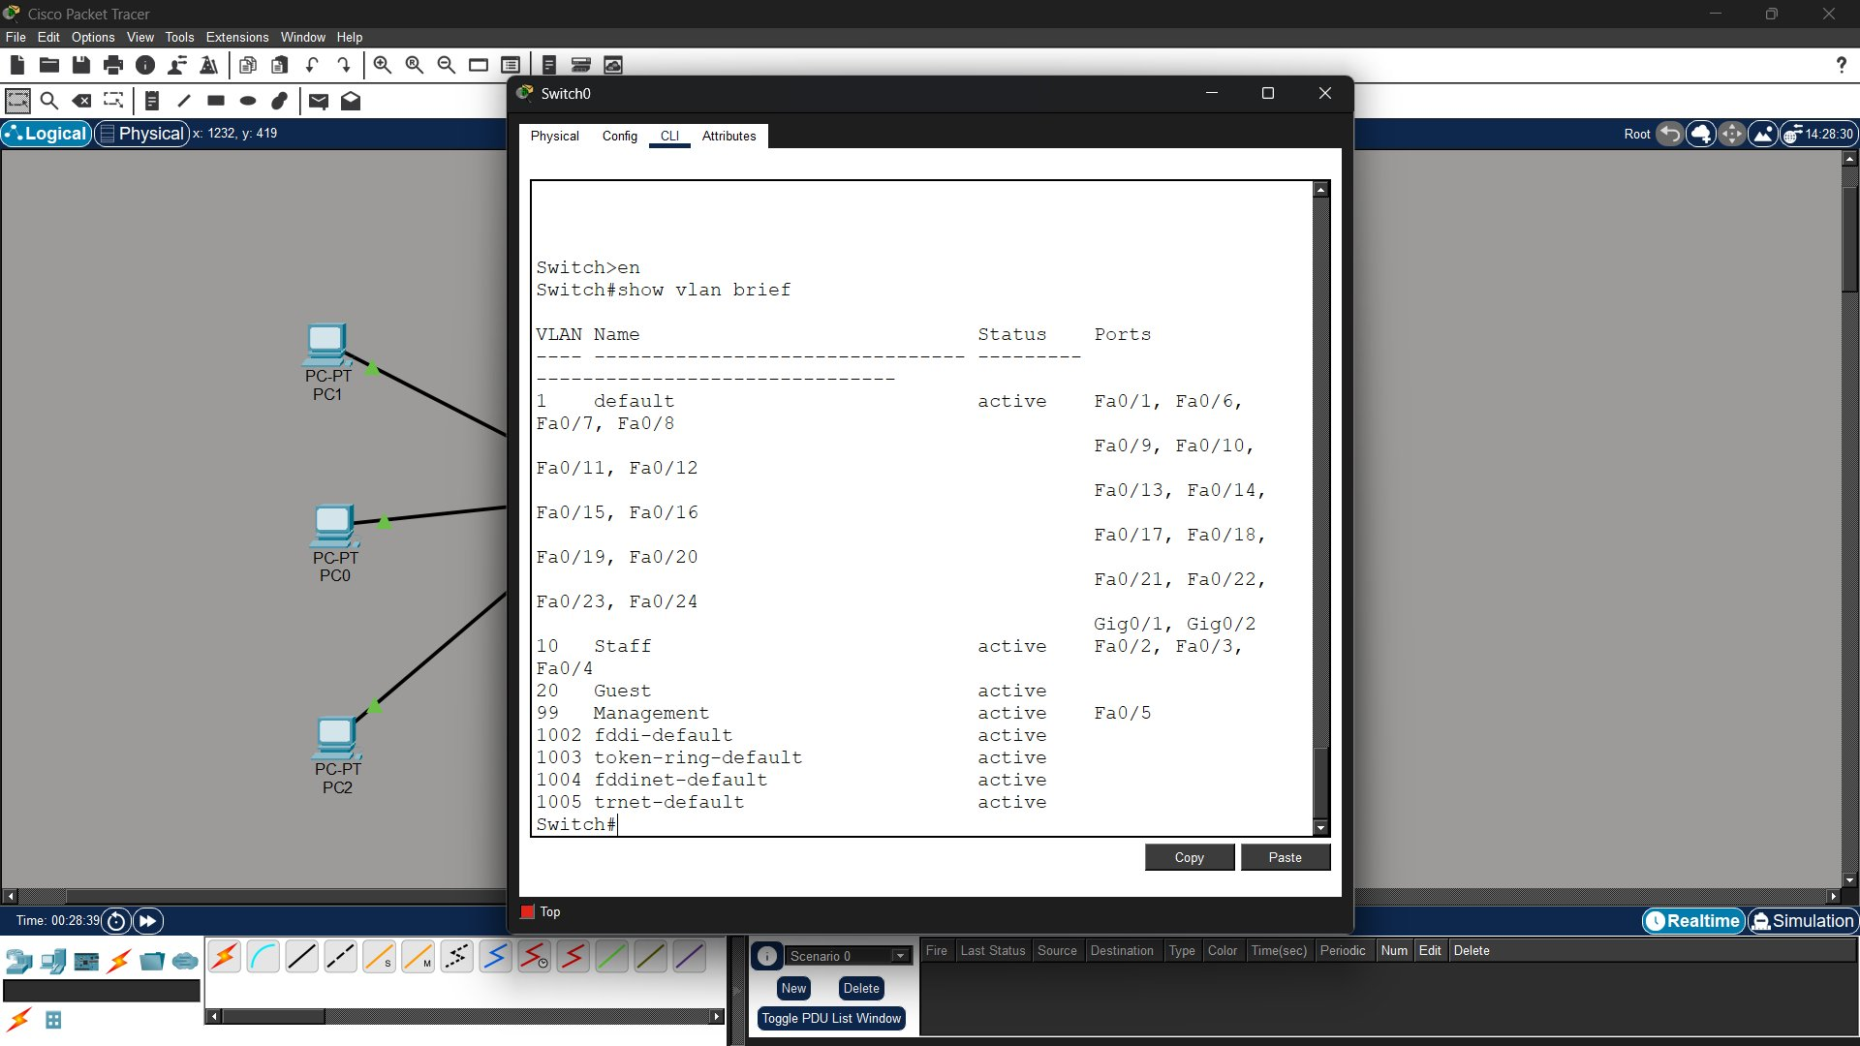
Figure 2 — Switch-Staff VLAN configuration commands
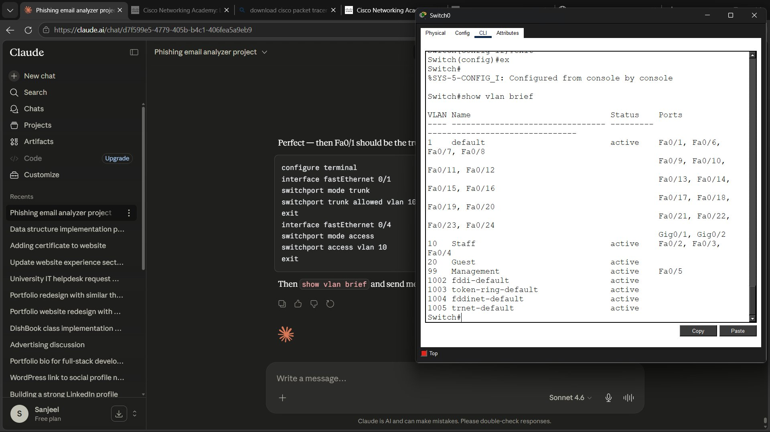
Figure 3 — Switch-Staff show vlan brief output

5.2 Switch-Guest Configuration
Switch-Guest was configured with VLAN 20 (Guest). Ports Fa0/2–Fa0/4 were assigned to VLAN 20 as access ports. Port Fa0/1 was configured as a trunk port to the router.

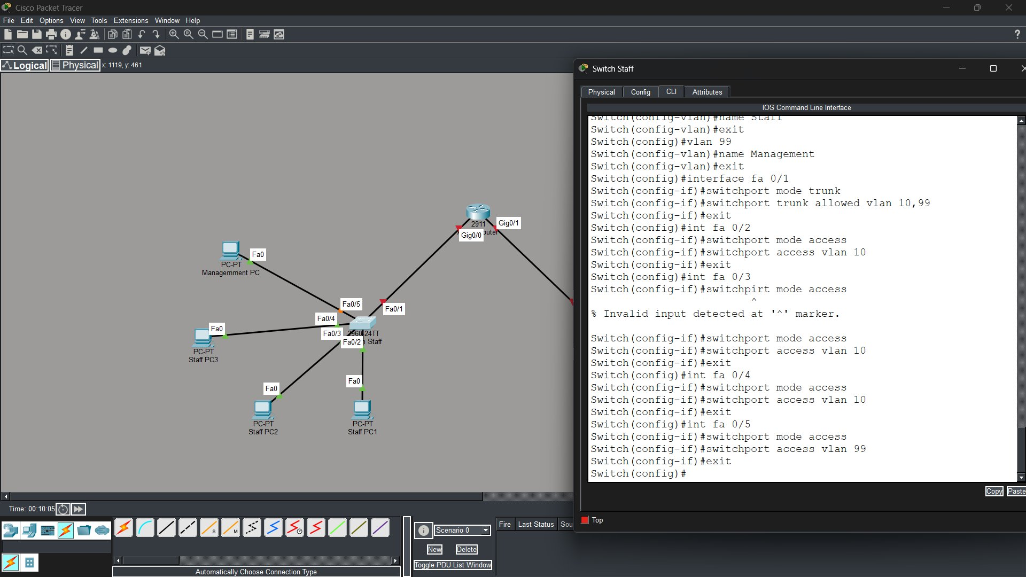
Figure 4 — Switch-Guest VLAN configuration commands
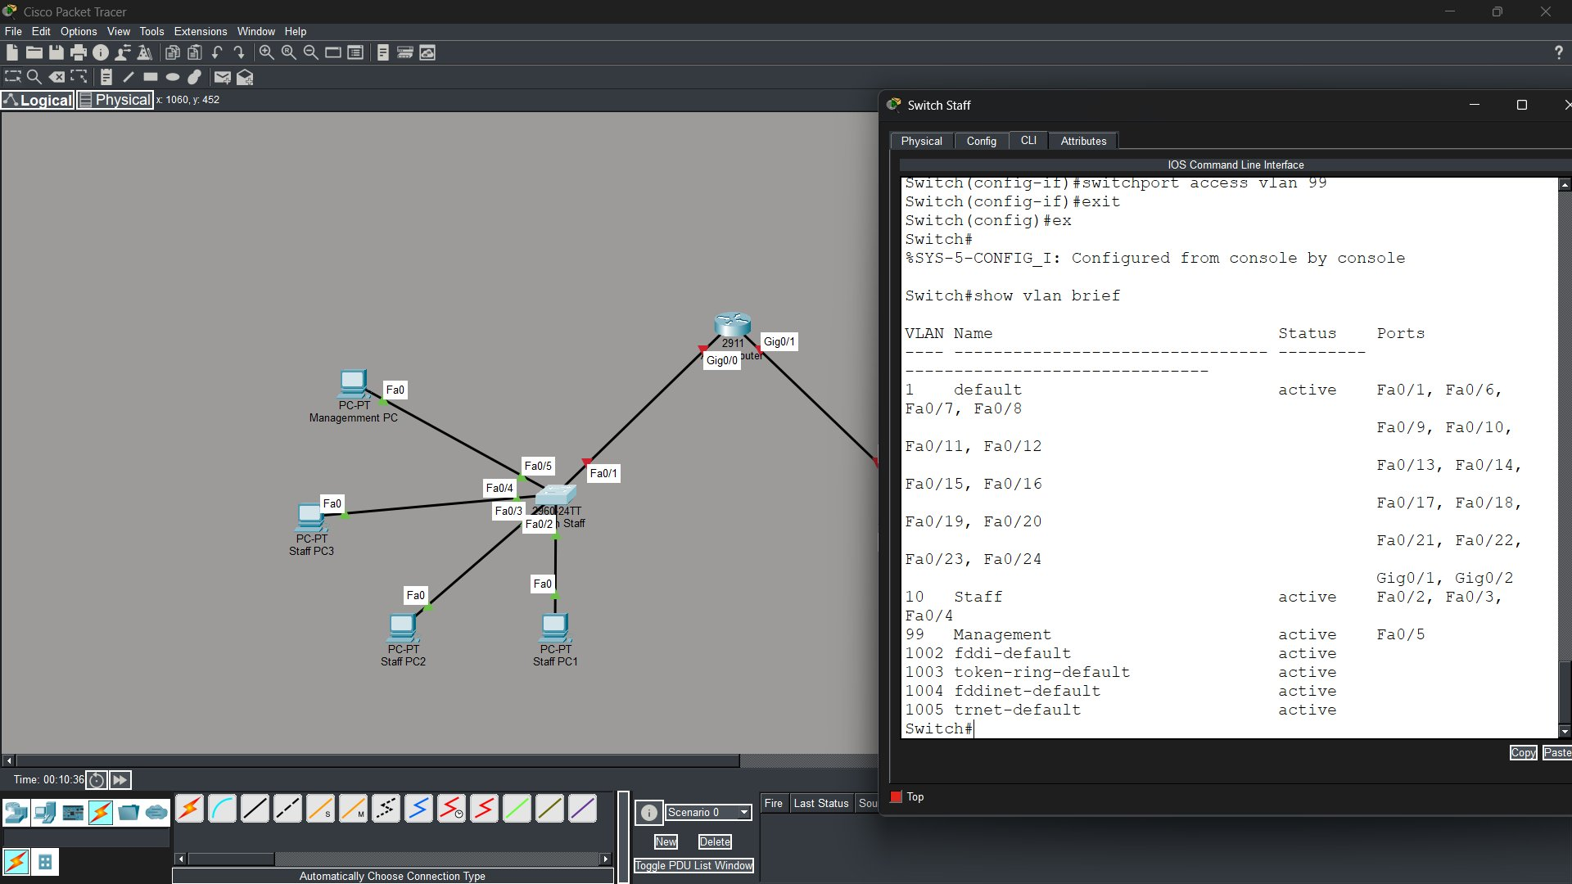
Figure 5 — Switch-Guest show vlan brief output

5.3 Apex-Router Configuration
The router was configured with subinterfaces on Gig0/0 for VLANs 10 and 99, and on Gig0/1 for VLAN 20. Each subinterface was assigned an IP address to serve as the default gateway for its respective VLAN. encapsulation dot1Q was used to tag VLAN traffic on each subinterface.

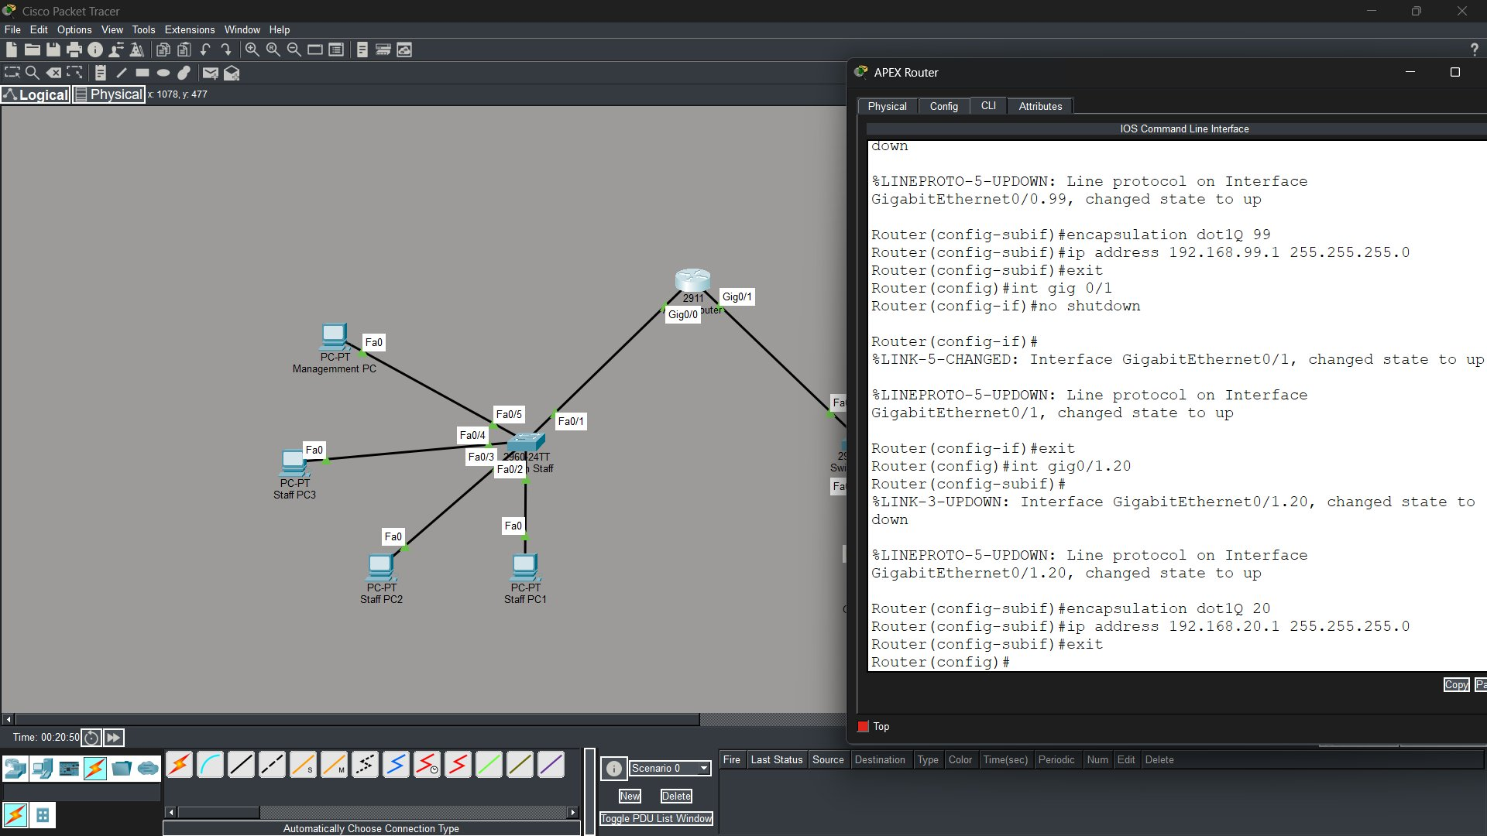
Figure 6 — Apex-Router subinterface configuration
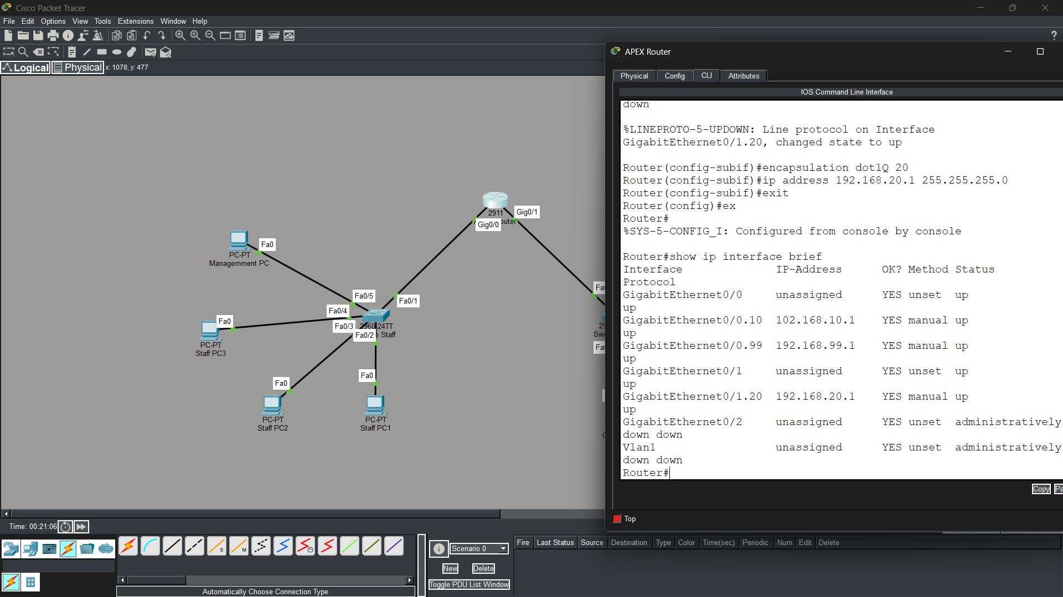
Figure 7 — Apex-Router show ip interface brief output

6. Testing Results
Connectivity was verified using ICMP ping tests between devices across all VLANs. The 25% packet loss on some tests is expected and is caused by the ARP resolution process on the first packet — all subsequent packets were successful.

✓ Staff-PC1 → Staff Gateway (192.168.10.1): 4/4 packets received — 0% loss
✓ Staff-PC1 → Guest-PC1 (192.168.20.2): 3/4 packets received — 25% loss (ARP)
✓ Staff-PC1 → Management-PC (192.168.99.2): 3/4 packets received — 25% loss (ARP)
✓ Guest-PC1 → Management-PC (192.168.99.2): 4/4 packets received — 0% loss
✓ Guest-PC1 → Staff-PC1 (192.168.10.2): 4/4 packets received — 0% loss

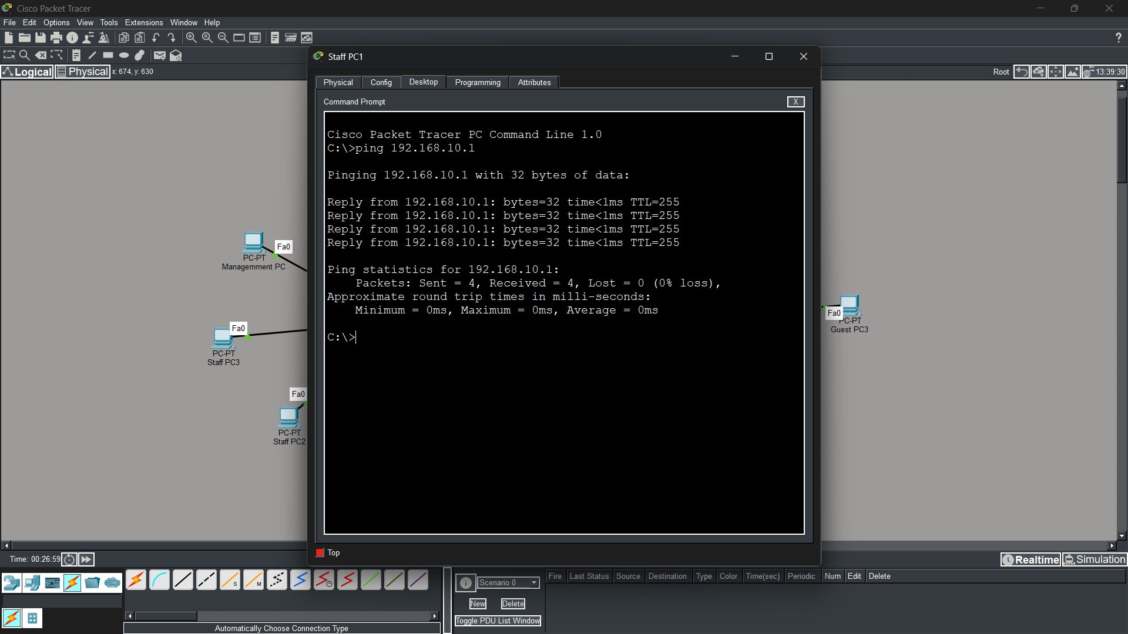
Figure 8 — Staff-PC1 pinging the Staff gateway successfully
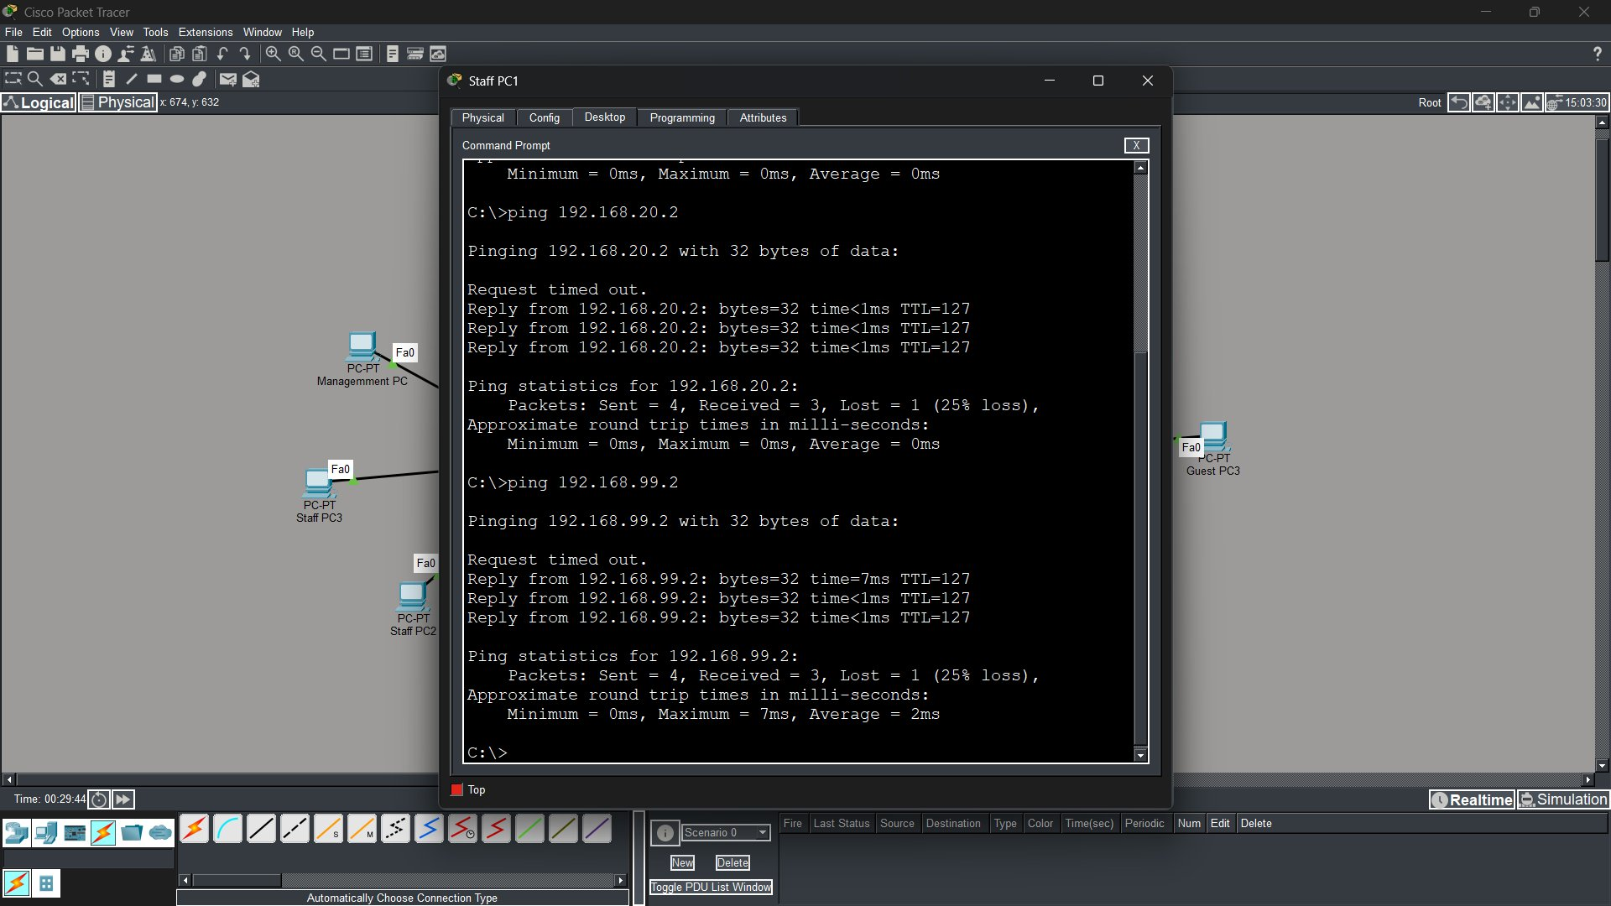
Figure 9 — Inter-VLAN ping results showing successful routing

7. Conclusion
A network infrastructure with two switches, one router, three Staff PCs, three Guest PCs and one Management PC was successfully built and configured in Cisco Packet Tracer. VLANs ensured the prevention of unauthorized access between different categories of users, with each group isolated to its own network segment. In the future, a firewall can be added to further control traffic between VLANs, and internet connectivity can be provided to all users through the router.

