Experiment 1: DATA PROFILING AND QUALITY ASSESSMENT

Aim: To perform data profiling and assess data quality by identifying missing, inconsistent, and incorrect data.

Problem Definition: To perform data profiling and assess the quality of data in three different datasets by examining their structure, statistical characteristics, completeness, consistency, and correctness. Identify and analyze data quality issues such as missing values, duplicate records, inconsistent formats, invalid values, and potential outliers, and present a comparative summary of the findings.

Students shall:
- Select any three datasets from suitable sources.
- Perform data profiling for each dataset, including:
  - Number of records and attributes
○ Data types of attributes
○ Descriptive/statistical summary
○ Unique and duplicate values
○ Missing-value analysis
- Assess the data quality by identifying:
  - Missing data
○ Inconsistent data formats or representations
○ Incorrect or invalid values
○ Duplicate records
○ Potential outliers or anomalous values
- Compare the data quality of the three datasets based on the observations obtained.
- Present the profiling results using tables
- Summarize the major data quality issues identified and suggest which dataset presented the highest quality.

THEORY: In today’s data-driven world, organizations rely heavily on data for decision-making, research, business intelligence, and the development of machine learning and artificial intelligence applications. However, the usefulness of any analysis depends largely on the quality of the underlying data. Data that contains missing values, duplicate records, inconsistent formats, incorrect values, or unusual observations can produce misleading results and affect the reliability of decisions. Therefore, before performing detailed analysis, it is important to understand and evaluate the quality of the available data. This process is known as data profiling and data quality assessment. Data profiling is the systematic process of examining a dataset to understand its structure, content, and characteristics. It provides an initial overview of the data and helps analysts determine whether the dataset is suitable for further analysis. Data profiling generally involves examining the number of records and attributes, data types, unique values, missing values, duplicate records, statistical measures, and the distribution of the data.
For example, consider a student dataset containing information such as Student ID, Name, Age, Department, and Marks. Data profiling would determine how many students are present, what data types are associated with each attribute, how many different departments are represented, whether any student records are duplicated, and whether values such as age and marks fall within reasonable ranges.
A basic statistical summary can provide important information about numerical attributes. Measures such as mean, median, minimum, maximum, standard deviation, and quartiles help describe the central tendency and spread of the data. For categorical attributes, frequency counts and the number of unique categories provide useful information about the distribution of values.
Data profiling can therefore be considered the first step toward understanding a dataset. It helps answer questions such as: What does the dataset contain? How large is it? What types of variables are present? Are there missing or duplicate values? Are the values distributed as expected?
While data profiling helps us understand the characteristics of data, data quality assessment focuses on determining whether the data is reliable and suitable for its intended purpose. Data quality is commonly evaluated using dimensions such as completeness, accuracy, consistency, validity, uniqueness, and timeliness.
Completeness refers to the availability of all required information. A dataset containing many missing values has poor completeness. For example, if the age of several students is not recorded, the dataset is incomplete with respect to the Age attribute.
Accuracy refers to whether the values correctly represent the real-world information they are intended to describe. For example, if a student's actual mark is 78 but the dataset records it as 87, the value is inaccurate. Determining accuracy may sometimes require comparison with a trusted external source. Consistency refers to uniformity in the representation of data. For instance, a Gender attribute may contain values such as Male, M, male, and MALE. Although these values may represent the same category, they are represented differently. Similarly, dates may be stored as 12/05/2025, 2025-05-12, and May 12, 2025. Such inconsistencies can make data processing and analysis more difficult.
Validity refers to whether a value conforms to predefined rules or constraints. For example, if an Age attribute contains values such as -10 or 250, these values are likely to be invalid. Similarly, if marks are expected to range from 0 to 100, a value of 105 violates the expected constraint.
Uniqueness refers to whether records that are expected to be unique actually are unique. Duplicate records can occur because of repeated data entry, data integration, or errors during data collection. Such duplicates can distort statistical analysis by giving excessive weight to repeated observations. Timeliness refers to whether the data is sufficiently current for its intended use. Data may be accurate but no longer useful if it is outdated. For example, an old customer address may have been correct when recorded but may not represent the customer's current information.

Missing data is one of the most common data-quality problems. A missing value may be represented by a blank cell, NULL, NaN, or another special symbol. Missing values may occur because information was not collected, a user failed to provide it, or data was lost during processing.

The extent of missing data can be assessed by calculating both the number and percentage of missing values. A high percentage of missing values in an important attribute may significantly affect subsequent analysis.
Missing values should not always be removed automatically. Depending on the nature of the dataset, they may be handled by removing records, replacing values using statistical measures such as mean, median, or mode, or applying more sophisticated imputation techniques. The appropriate approach depends on the context and the importance of the attribute.

Duplicate records occur when the same observation appears multiple times in a dataset. For example, if a student with Student ID 101 appears twice with exactly the same information, one of the records may be a duplicate.
Duplicates can arise during data entry, data integration, or the merging of multiple datasets. They can affect statistical calculations and machine-learning models by causing certain observations to be counted more than once.
However, it is important to distinguish between true duplicates and legitimate repeated observations. A dataset containing multiple transactions from the same customer, for example, does not necessarily contain duplicate records.

Inconsistencies occur when the same type of information is represented using different formats or conventions. These problems are particularly common in categorical and textual data. For example, a City attribute might contain: Pune, pune, PUNE, and Poona. Similarly, a gender attribute might contain: Male, M, male, and MALE.
Although some of these values may represent the same category, their inconsistent representation can lead to incorrect frequency counts and analysis. Data standardization can be used to convert such values into a common representation.
Inconsistencies may also occur in units of measurement, date formats, currency formats, spelling, capitalization, and coding schemes. Identifying these problems is an important part of data-quality assessment.

Incorrect or invalid values are another important data-quality concern. Such values can be identified by applying domain knowledge and predefined constraints. For example, an Age attribute containing -5 is clearly suspicious, while an examination Marks attribute containing 150 is invalid if the maximum possible mark is 100. Similarly, a percentage cannot normally be greater than 100 or less than 0.
Validation rules can be established for different attributes based on their meaning. These rules can include acceptable ranges, permitted categories, required formats, and relationships between attributes.
It is important to recognize that an unusual value is not automatically an incorrect value. For example, a very high salary may be an outlier but could still be genuine. Therefore, suspicious observations should be investigated before they are removed or modified.
An outlier is an observation that differs substantially from the majority of observations. Outliers may occur because of measurement errors, incorrect data entry, unusual events, or genuine variation in the population.

PROGRAM:
Import pandas as pd
Import numpy as np
Datasets={“Employee Attrition”:”Employee_Attrition.csv”,”Retail Sales”:”retail_sales_dataset.csv”,”Student”:”student_data.csv”}
Data={name:pd.read_csv(file) for name,file in datasets.items()}
For name,df in data.items():
Print(“=”*55)
Print(name)
Print(“=”*55)
Print(“\n1. Records and Attributes”)
Print(“Records:”,len(df),”Attributes:”,len(df.columns))
Print(“\n2. Data Types”)
Types=df.dtypes.astype(str).value_counts()
Print(“Numeric:”,types.get(“int64”,0)+types.get(“float64”,0),”Categorical:”,types.get(“object”,0))
Print(“\n3. Statistical Summary”)
If name==”Employee Attrition”:
Cols=[“Age”,”MonthlyIncome”,”TotalWorkingYears”,”YearsAtCompany”]
Elif name==”Retail Sales”:
Cols=[“Age”,”Quantity”,”Price per Unit”,”Total Amount”]
Else:
Cols=[“age”,”absences”,”G1”,”G2”,”G3”]
Print(df[cols].describe().round(2).to_string())
Print(“\n4. Unique Values”)
Unique=df.nunique()
Print(“Minimum:”,int(unique.min()),”Maximum:”,int(unique.max()),”Average:”,round(unique.mean(),2))
Print(“\n5. Missing Values”)
Print(“Total Missing:”,int(df.isnull().sum().sum()))
Print(“\n6. Duplicate Records”)
Print(“Duplicates:”,int(df.duplicated().sum()))
Print(“\n7. Potential Outliers”)
Found=False
For col in df.select_dtypes(include=np.number):
Q1,q3=df[col].quantile([.25,.75])
Iqr=q3-q1
N=int(((df[col]<q1-1.5*iqr)|(df[col]>q3+1.5*iqr)).sum())
If n:
Print(col,”:”,n)
Found=True
If not found:
Print(“None”)
Print(“\n8. Incorrect Values”)
Checks={}
If name==”Employee Attrition”:
Checks={
“Age”L(df[“Age”]<18)|(df[“Age”]>100)).sum(),
“PercentSalaryHike”L(df[“PercentSalaryHike”]<0)|(df[“PercentSalaryHike”]>100)).sum(),
“EmployeeCount”Ldf[“EmployeeCount”]!=1).sum(),
“StandardHours”Ldf[“StandardHours”]!=80).sum(),
“YearsAtCompany > TotalWorkingYears”Ldf[“YearsAtCompany”]>df[“TotalWorkingYears”]).sum()
}
Elif name==”Retail Sales”:
Checks={
“Age”L(df[“Age”]<0)|(df[“Age”]>120)).sum(),
“Quantity”Ldf[“Quantity”]<=0).sum(),
“Price per Unit”Ldf[“Price per Unit”]<0).sum(),
“Total Amount”Ldf[“Total Amount”]!=df[“Quantity”]*df[“Price per Unit”]).sum(),
“Invalid Date”:pd.to_datetime(df[“Date”],errors=”coerce”).isna().sum()
}
Else:
Checks={
“Age”L(df[“age”]<15)|(df[“age”]>25)).sum(),
“Medu”L(df[“Medu”]<0)|(df[“Medu”]>4)).sum(),
“Fedu”L(df[“Fedu”]<0)|(df[“Fedu”]>4)).sum(),
“G1”L(df[“G1”]<0)|(df[“G1”]>20)).sum(),
“G2”L(df[“G2”]<0)|(df[“G2”]>20)).sum(),
“G3”L(df[“G3”]<0)|(df[“G3”]>20)).sum(),
“Absences”Ldf[“absences”]<0).sum()
}
Found=False
For col,n in checks.items():
N=int(n)
If n:
Print(col,”:”,n)
Found=True
If not found:
Print(“None”)
Print(“\n9. Inconsistent Values”)
Checks={}
If name==”Employee Attrition”:
Checks={
“Attrition”:set(df[“Attrition”].dropna().unique())-{“Yes”,”No”},
“Gender”:set(df[“Gender”].dropna().unique())-{“Male”,”Female”},
“OverTime”:set(df[“OverTime”].dropna().unique())-{“Yes”,”No”}
}
Elif name==”Retail Sales”:
Checks={
“Gender”:set(df[“Gender”].dropna().unique())-{“Male”,”Female”},
“Product Category”:set(df[“Product Category”].dropna().unique())-{“Beauty”,”Clothing”,”Electronics”}
}
Else:
Checks={
“school”:set(df[“school”].dropna().unique())-{“GP”,”MS”},
“sex”:set(df[“sex”].dropna().unique())-{“F”,”M”},
“address”:set(df[“address”].dropna().unique())-{“U”,”R”}
}
Found=False
For col,vals in checks.items():
If vals:
Print(col,”:”,”, “.join(map(str,vals)))
Found=True
If not found:
Print(“None”)
Print(“\n”+”=”*55)
Print(“DATA QUALITY COMPARISON”)
Print(“=”*55)
Result=[]
For name,df in data.items():
Result.append([name,len(df),len(df.columns),int(df.isnull().sum().sum()),int(df.duplicated().sum())])
Print(pd.DataFrame(result,columns=[“Dataset”,”Records”,”Attributes”,”Missing”,”Duplicates”]).to_string(index=False))

OUTPUT:
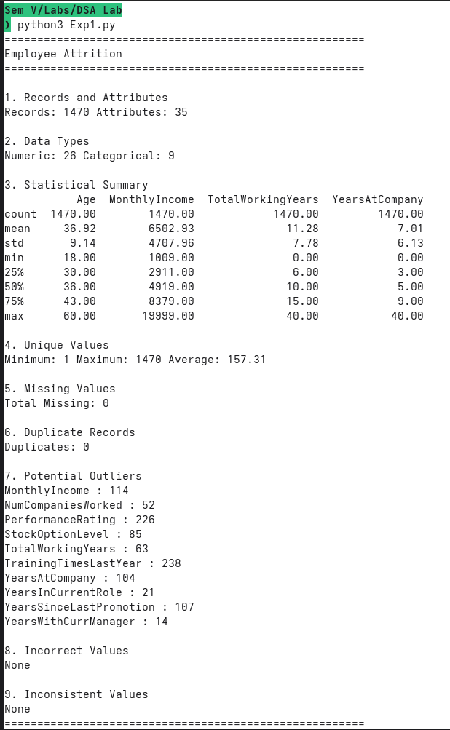
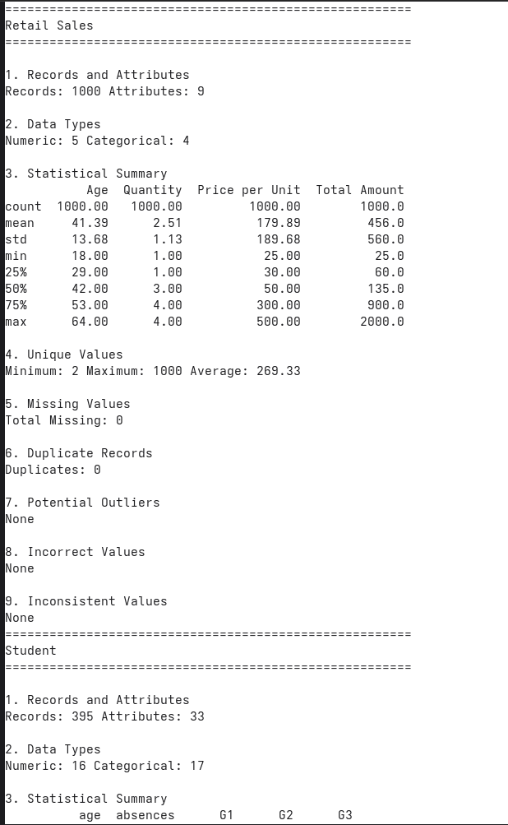
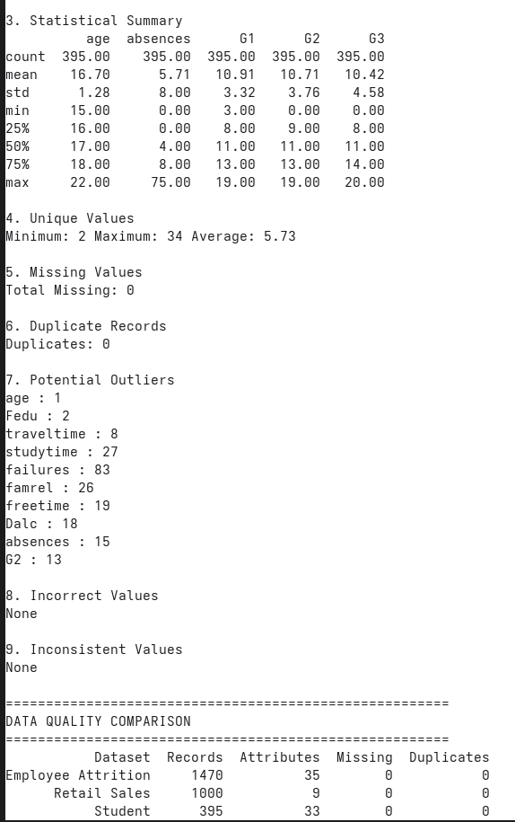

RESULTS:
The data profiling was successfully performed on the Employee Attrition, Retail Sales, and Student datasets. The analysis examined the number of records and attributes, data types, statistical summaries, unique values, missing values, duplicate records, potential outliers, incorrect values, and inconsistent values.

- Completeness: All three datasets contained 0 missing values. This indicates that the selected datasets were complete with respect to the fields examined.

- Consistency and Uniqueness: The Employee Attrition, Retail Sales, and Student datasets contained 0 duplicate records. No inconsistent categorical values were detected in the selected fields, and no incorrect or invalid values were identified using the defined validation rules.

- Outlier Identification: The IQR-based analysis detected potential numerical outliers in the Employee Attrition and Student datasets. Employee Attrition showed potential outliers in several numerical attributes, while Student also contained potential outliers in attributes such as age, failures, absences, and G2. The Retail Sales dataset showed no potential outliers.

- Comparative Summary: Based on missing values, duplicates, incorrect values, inconsistent values, and potential outliers, the Retail Sales dataset demonstrated the highest overall data quality among the three datasets because it contained no detected data-quality issues under the applied checks. Employee Attrition and Student required comparatively more attention due to the presence of potential outliers.

CONCLUSION:
Data profiling and data quality assessment were successfully performed on the Employee Attrition, Retail Sales, and Student datasets. All three datasets had no missing values, duplicate records, incorrect values, or detected inconsistencies. The Retail Sales dataset showed the highest overall data quality, while Employee Attrition and Student contained potential numerical outliers that may require further investigation.

