BPM (Business process management tools)

Camunda example

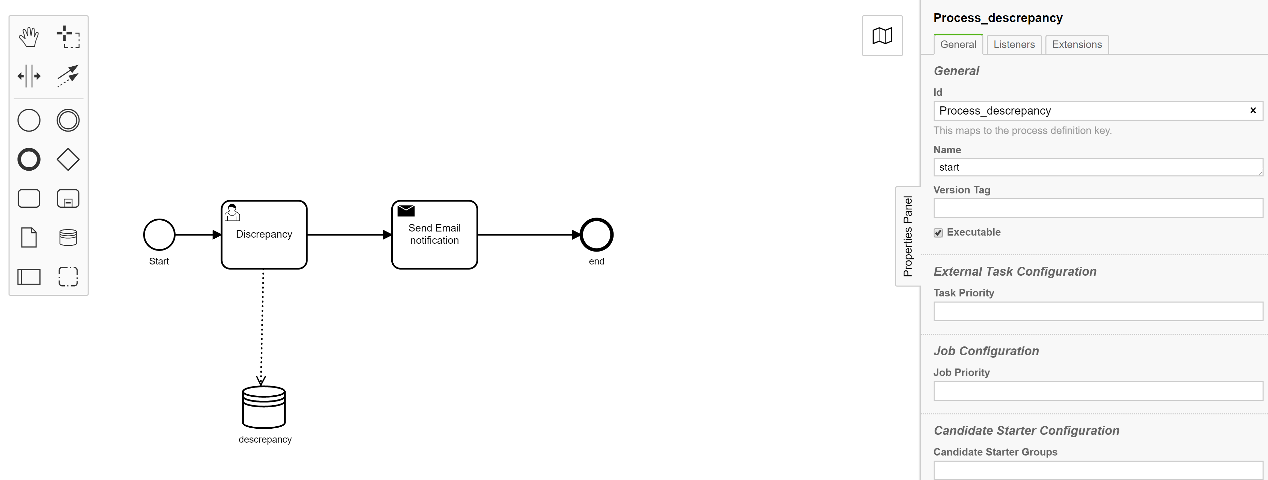

View to user

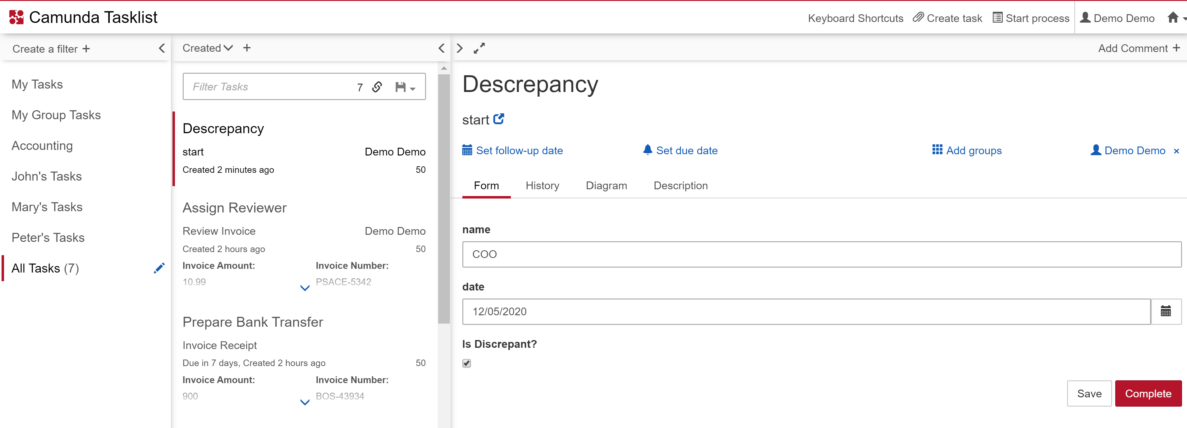

Database snapshot

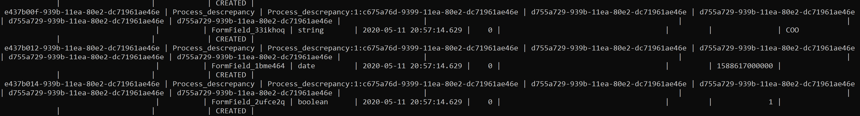

Pros:

1. The Camunda Modeler is very easy to learn and provides various options to
2. Setting the platform and configuring databases is fast
3. Ability to create user, service and manual tasks
4. The process can be initiated using camunda ui or can be called from rest apis exposed
5. Easy external java service integrations
6. Available and used in SG and open source

Cons:

1. The default ui only allows user to create small forms as input to process.
2. Custom and complex forms have to be developed and given as input to services modelled in platform
3. Services modelled in process are usually developed outside the platform and linked inside the model. The Modelling UI does allow to add scripts or expressions to be provided in UI. But this is only helpful for simple service creations
4. All the process data(all different types) gets stored by default in a single table. It is assumed that there would be connectors to external systems to store all data
5. Doesn’t provide visualization on data, only process visualization is possible. Opensource visualization and report generation tools can be used for this.