

School of Electronics Engineering (SENSE)
B. Tech – Electronics & Communication Engineering
DIGITAL ASSIGNMENT – 1
3×3 Convolution Engine Using Nine Parallel 16×16 Multipliers and an Adder Tree

Submitted by

Madhan Kumar V-23BEC1129
Sanjeev Mohan-23BEC1234
Mithil Arasu B-23BEC1246
Umesh S-23BEC1210

1. Theory and Diagram

1.1 3×3 Image Convolution
Convolution is a fundamental operation in digital image processing used for filtering operations such as blurring, sharpening, edge detection and embossing. In a 3×3 convolution, a small 3×3 window of the image, called the pixel patch P, is multiplied element-wise with a 3×3 filter kernel K, and the resulting nine products are summed to produce a single output pixel Y. The kernel is slid over the entire image to compute the complete filtered output; this implementation computes the result for one 3×3 patch position.

1.2 Mathematical Equation
The 3×3 convolution operation implemented in this design is expressed as:
Y = Σ Σ K(i,j) × P(i,j), i = 0 to 2, j = 0 to 2
Here, P(i,j) represents the pixel intensity at row i and column j of the 3×3 image patch, and K(i,j) represents the corresponding kernel (filter) coefficient at the same position. The output Y is the weighted sum of all nine pixel–kernel products, i.e. the convolution result for that patch.

1.3 Role of the Nine Parallel Multipliers
The design instantiates nine independent signed 16-bit × 16-bit multipliers (m00 through m22), one for each pixel–kernel pair (p00×k00, p01×k01, p02×k02, p10×k10, p11×k11, p12×k12, p20×k20, p21×k21 and p22×k22). Because all nine multiplications are combinational and operate simultaneously on the registered pixel and kernel values, the entire multiplication stage completes in parallel rather than sequentially, which is the key to a single-cycle convolution result once the operands are loaded. Each product is a signed 32-bit value since it is the product of two signed 16-bit operands.

1.4 Adder Tree
The nine partial products are combined using a multi-level adder tree rather than a straight sequential accumulation, so that the addition delay grows logarithmically with the number of terms instead of linearly. As implemented in the RTL, eight of the nine products (m00, m01, m02, m10, m11, m12, m20, m21) are combined in a balanced three-level binary tree:
• Level 1: s0 = m00+m01, s1 = m02+m10, s2 = m11+m12, s3 = m20+m21
• Level 2: t0 = s0+s1, t1 = s2+s3
• Level 3: u0 = t0+t1
The ninth product, m22, is then added to u0 (with appropriate sign extension) in a final adder to produce the 36-bit signed convolution_result. Bit widths are progressively widened at each addition stage (from 33 bits after level 1 up to the final 36-bit result) to safely accommodate growth in the sum without overflow.

1.5 Input Loading and Addressing
Pixel and kernel values are loaded serially into the design through a single shared 16-bit data_in bus, using the 5-bit addr bus to select the destination register and the load_en signal to enable the write. On every rising edge of clk, if load_en is asserted, the value on data_in is latched into the register selected by addr: addresses 0 to 8 correspond to the nine pixel registers (p00–p22), and addresses 9 to 17 correspond to the nine kernel registers (k00–k22). This serial loading scheme reduces the number of top-level input pins compared to loading all eighteen values in parallel.

1.6 Control Signals
• clk — system clock; all sequential elements (pixel/kernel registers and the output register) update on its rising edge.
• rst — synchronous, active-high reset. When asserted, all pixel registers, kernel registers, the output register y and the done flag are cleared to zero.
• load_en — active-high load enable; when high, the value on data_in is written into the pixel/kernel register selected by addr on the next rising clock edge.
• addr — 5-bit address selecting which pixel or kernel register is being loaded (0–8 for pixels, 9–17 for kernel coefficients).
• data_in — signed 16-bit data bus carrying the pixel or kernel value to be loaded.
• start — when asserted, triggers the convolution computation; the combinationally-computed convolution_result is registered into y on the next clock edge.
• y — signed 36-bit registered output holding the convolution result.
• done — pulses high for one clock cycle immediately after a start pulse, indicating that y holds a valid result.

1.7 Architecture Diagram
Figure 1 shows the RTL schematic of the convolution engine as generated from the synthesized design. It shows the nine parallel multiplier blocks (Mult0–Mult8) fed by the pixel and kernel registers, followed by the adder-tree stages (Add0–Add7) that combine the partial products, and the final registered output y with the done flag.
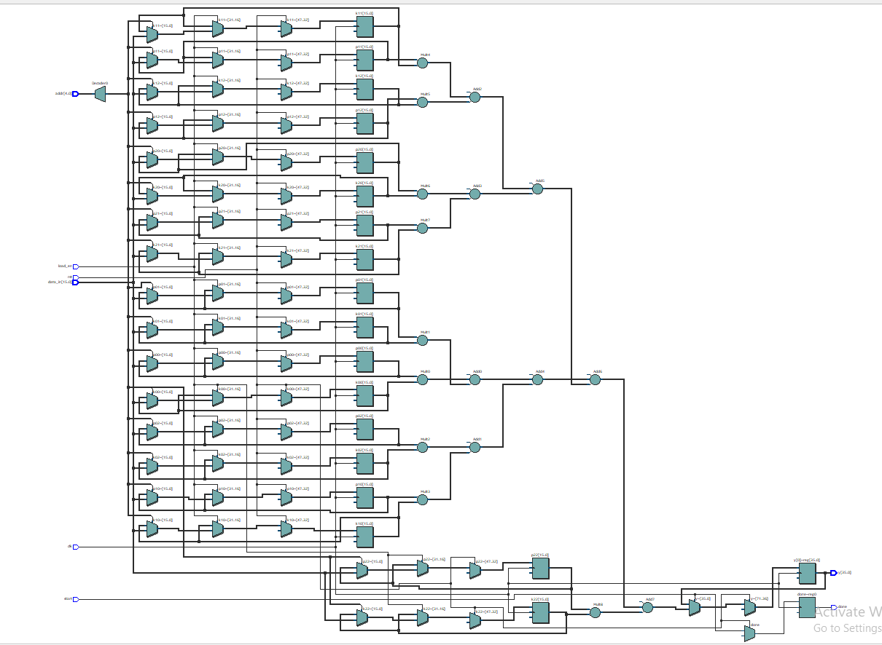
Figure 1. Convolution Engine Architecture (RTL Schematic)

2. Verilog Code
The RTL design conv.v implements the convolution engine described in Section 1. It consists of a synchronous load block that latches pixel and kernel values based on addr and load_en, nine parallel signed multipliers, a three-level adder tree combining eight of the nine products, a final adder that incorporates the ninth product (m22), and an output register that captures the result and asserts done when start is pulsed. The complete, unmodified source code is given below.
module conv (

input clk,
input rst,
input load_en,
input [4:0] addr,
input signed [15:0] data_in,

input start,

output reg signed [35:0] y,
output reg done

);

reg signed [15:0] p00, p01, p02;
reg signed [15:0] p10, p11, p12;
reg signed [15:0] p20, p21, p22;

reg signed [15:0] k00, k01, k02;
reg signed [15:0] k10, k11, k12;
reg signed [15:0] k20, k21, k22;

always @(posedge clk) begin

if (rst) begin

p00 <= 0;
p01 <= 0;
p02 <= 0;
p10 <= 0;
p11 <= 0;
p12 <= 0;
p20 <= 0;
p21 <= 0;
p22 <= 0;

k00 <= 0;
k01 <= 0;
k02 <= 0;
k10 <= 0;
k11 <= 0;
k12 <= 0;
k20 <= 0;
k21 <= 0;
k22 <= 0;

end

else if (load_en) begin

case (addr)

5'd0: p00 <= data_in;
5'd1: p01 <= data_in;
5'd2: p02 <= data_in;

5'd3: p10 <= data_in;
5'd4: p11 <= data_in;
5'd5: p12 <= data_in;

5'd6: p20 <= data_in;
5'd7: p21 <= data_in;
5'd8: p22 <= data_in;

5'd9: k00 <= data_in;
5'd10: k01 <= data_in;
5'd11: k02 <= data_in;

5'd12: k10 <= data_in;
5'd13: k11 <= data_in;
5'd14: k12 <= data_in;

5'd15: k20 <= data_in;
5'd16: k21 <= data_in;
5'd17: k22 <= data_in;

default: begin
end

endcase

end

end

wire signed [31:0] m00, m01, m02;
wire signed [31:0] m10, m11, m12;
wire signed [31:0] m20, m21, m22;

assign m00 = p00 * k00;
assign m01 = p01 * k01;
assign m02 = p02 * k02;

assign m10 = p10 * k10;
assign m11 = p11 * k11;
assign m12 = p12 * k12;

assign m20 = p20 * k20;
assign m21 = p21 * k21;
assign m22 = p22 * k22;

wire signed [32:0] s0, s1, s2, s3;

assign s0 = m00 + m01;
assign s1 = m02 + m10;
assign s2 = m11 + m12;
assign s3 = m20 + m21;

wire signed [33:0] t0, t1;

assign t0 = s0 + s1;
assign t1 = s2 + s3;

wire signed [34:0] u0;

assign u0 = t0 + t1;

wire signed [35:0] convolution_result;

assign convolution_result =
{u0[34], u0} +
{{4{m22[31]}}, m22};

always @(posedge clk) begin

if (rst) begin

y <= 0;
done <= 0;

end

else begin

done <= 0;

if (start) begin

y <= convolution_result;
done <= 1;

end

end

end

endmodule

3. Testbench / Verilog Code
The testbench tb_conv.v instantiates the conv module as the Device Under Test (DUT) and verifies its functionality using five convolution test cases corresponding to standard image-processing kernels. A 100 MHz clock is generated using a forever block that toggles clk every 5 ns. Two reusable tasks drive the DUT: load_value(address, value), which loads a single pixel or kernel register by driving addr, data_in and a one-cycle load_en pulse; and run_convolution(), which pulses start for one clock cycle and then waits for the done signal to go high before returning.
The test sequence first applies a synchronous reset, then loads a common fixed 3×3 image (10, 20, 30 / 40, 50, 60 / 70, 80, 90) into the pixel registers. For each of the five test cases (Identity Filter, Blur Filter, Edge Detection, Sharpening and Emboss), the corresponding kernel coefficients are loaded into the kernel registers, run_convolution() is invoked, and the resulting y output is compared against a pre-computed expected value using the !== operator. Each mismatch increments an errors counter, and the pass/fail status of each test is printed to the simulation console using $display statements. After all five tests, the total error count and an overall PASS/FAIL result are printed. A VCD waveform dump (conv_5tests.vcd) is also generated for waveform inspection. The complete, unmodified testbench source code is given below.
`timescale 1ns/1ps

module tb_conv;

reg clk;
reg rst;

initial begin
clk = 1'b0;
forever #5 clk = ~clk;
end

reg load_en;
reg [4:0] addr;
reg signed [15:0] data_in;

reg start;

wire signed [35:0] y;
wire done;

integer errors;

conv DUT (
.clk (clk),
.rst (rst),
.load_en (load_en),
.addr (addr),
.data_in (data_in),
.start (start),
.y (y),
.done (done)
);

initial begin
$dumpfile("conv_5tests.vcd");
$dumpvars(0, tb_conv);
end

task load_value;

input [4:0] address;
input signed [15:0] value;

begin
@(negedge clk);

addr = address;
data_in = value;
load_en = 1'b1;

@(posedge clk);

#1;

load_en = 1'b0;
end

endtask

task run_convolution;

begin
@(negedge clk);

start = 1'b1;

@(posedge clk);

#1;

start = 1'b0;

wait(done == 1'b1);

#1;
end

endtask

initial begin

errors = 0;

rst = 1'b1;
load_en = 1'b0;
start = 1'b0;
addr = 5'd0;
data_in = 16'sd0;

repeat(2)
@(posedge clk);

#1;

rst = 1'b0;

load_value(5'd0, 16'sd10);
load_value(5'd1, 16'sd20);
load_value(5'd2, 16'sd30);

load_value(5'd3, 16'sd40);
load_value(5'd4, 16'sd50);
load_value(5'd5, 16'sd60);

load_value(5'd6, 16'sd70);
load_value(5'd7, 16'sd80);
load_value(5'd8, 16'sd90);

load_value(5'd9, 16'sd0);
load_value(5'd10, 16'sd0);
load_value(5'd11, 16'sd0);

load_value(5'd12, 16'sd0);
load_value(5'd13, 16'sd1);
load_value(5'd14, 16'sd0);

load_value(5'd15, 16'sd0);
load_value(5'd16, 16'sd0);
load_value(5'd17, 16'sd0);

run_convolution();

$display("--------------------------------------------");
$display("TEST 1 : IDENTITY FILTER");
$display("Expected = 50");
$display("Output = %0d", y);

if (y !== 36'sd50) begin
errors = errors + 1;
$display("STATUS = FAIL");
end
else begin
$display("STATUS = PASS");
end

load_value(5'd9, 16'sd1);
load_value(5'd10, 16'sd1);
load_value(5'd11, 16'sd1);

load_value(5'd12, 16'sd1);
load_value(5'd13, 16'sd1);
load_value(5'd14, 16'sd1);

load_value(5'd15, 16'sd1);
load_value(5'd16, 16'sd1);
load_value(5'd17, 16'sd1);

run_convolution();

$display("--------------------------------------------");
$display("TEST 2 : BLUR FILTER");
$display("Expected = 450");
$display("Output = %0d", y);

if (y !== 36'sd450) begin
errors = errors + 1;
$display("STATUS = FAIL");
end
else begin
$display("STATUS = PASS");
end

load_value(5'd9, -16'sd1);
load_value(5'd10, -16'sd1);
load_value(5'd11, -16'sd1);

load_value(5'd12, -16'sd1);
load_value(5'd13, 16'sd8);
load_value(5'd14, -16'sd1);

load_value(5'd15, -16'sd1);
load_value(5'd16, -16'sd1);
load_value(5'd17, -16'sd1);

run_convolution();

$display("--------------------------------------------");
$display("TEST 3 : EDGE DETECTION");
$display("Expected = 0");
$display("Output = %0d", y);

if (y !== 36'sd0) begin
errors = errors + 1;
$display("STATUS = FAIL");
end
else begin
$display("STATUS = PASS");
end

load_value(5'd9, 16'sd0);
load_value(5'd10, -16'sd1);
load_value(5'd11, 16'sd0);

load_value(5'd12, -16'sd1);
load_value(5'd13, 16'sd5);
load_value(5'd14, -16'sd1);

load_value(5'd15, 16'sd0);
load_value(5'd16, -16'sd1);
load_value(5'd17, 16'sd0);

run_convolution();

$display("--------------------------------------------");
$display("TEST 4 : SHARPENING");
$display("Expected = 50");
$display("Output = %0d", y);

if (y !== 36'sd50) begin
errors = errors + 1;
$display("STATUS = FAIL");
end
else begin
$display("STATUS = PASS");
end

load_value(5'd9, -16'sd2);
load_value(5'd10, -16'sd1);
load_value(5'd11, 16'sd0);

load_value(5'd12, -16'sd1);
load_value(5'd13, 16'sd1);
load_value(5'd14, 16'sd1);

load_value(5'd15, 16'sd0);
load_value(5'd16, 16'sd1);
load_value(5'd17, 16'sd2);

run_convolution();

$display("--------------------------------------------");
$display("TEST 5 : EMBOSS");
$display("Expected = 290");
$display("Output = %0d", y);

if (y !== 36'sd290) begin
errors = errors + 1;
$display("STATUS = FAIL");
end
else begin
$display("STATUS = PASS");
end

$display("--------------------------------------------");
$display("ALL TEST CASES COMPLETED");
$display("Total Errors = %0d", errors);

if (errors == 0)
$display("FINAL RESULT = PASS");
else
$display("FINAL RESULT = FAIL");

$display("--------------------------------------------");

#20;

$finish;

end

endmodule

4. Simulated Results (Waveforms)

4.1 Simulation Waveform
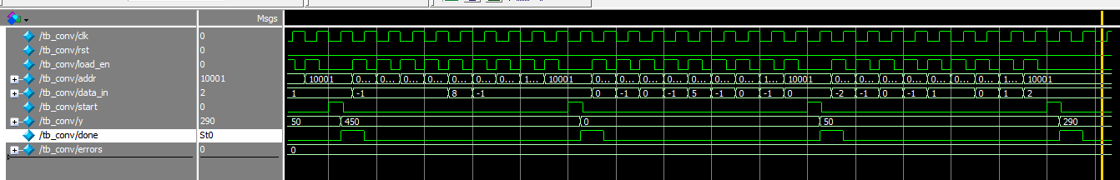
Figure 2 shows the ModelSim/QuestaSim simulation waveform for tb_conv, captured over the full run covering all five test cases.

Figure 2. Simulation Waveform (tb_conv)
The important signals visible in the waveform are:
• clk — the free-running system clock driving all sequential logic.
• rst — synchronous reset; held low during normal operation shown in the capture.
• load_en — pulses high briefly for each register load operation (pixels and kernel coefficients).
• addr — steps through the register addresses (e.g. 5'b10001 = 17, the last kernel address) as each value is loaded.
• data_in — carries the pixel/kernel value being loaded for the current addr, including negative kernel coefficients such as -1.
• start — pulses high for one clock cycle to trigger each convolution computation.
• y — updates to the registered convolution result after each start pulse; the waveform shows the sequence of results 50, 450, 0, 50 and 290 corresponding to the five test cases.
• done — pulses high for one clock cycle immediately after each result is ready in y.
• errors — remains at 0 throughout the simulation, confirming that every test case matched its expected value.

4.2 Console / Output Log
Figure 3 shows the $display output printed to the simulation console for all five test cases.
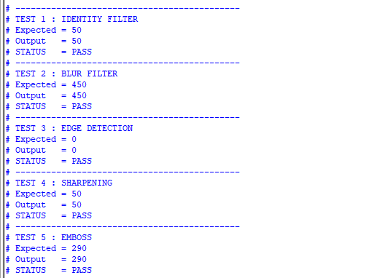
Figure 3. Simulation Console Output

4.3 Test Case Summary
Table 1 summarizes all five test cases exactly as reported in the testbench source and confirmed by the simulation console log and waveform capture.
Test | Filter / Kernel | Kernel Coefficients (row-wise) | Expected Y | Actual Y | Status
1 | Identity Filter | 0 0 0 / 0 1 0 / 0 0 0 | 50 | 50 | PASS
2 | Blur Filter | 1 1 1 / 1 1 1 / 1 1 1 | 450 | 450 | PASS
3 | Edge Detection | -1 -1 -1 / -1 8 -1 / -1 -1 -1 | 0 | 0 | PASS
4 | Sharpening | 0 -1 0 / -1 5 -1 / 0 -1 0 | 50 | 50 | PASS
5 | Emboss | -2 -1 0 / -1 1 1 / 0 1 2 | 290 | 290 | PASS

Table 1. Summary of Test Cases, Expected vs. Actual Output
All five test cases (Identity Filter, Blur Filter, Edge Detection, Sharpening and Emboss) produced an actual output that exactly matched the expected value, and each was individually reported as PASS in the console log, with the errors signal remaining at 0 throughout the simulation.

5. Synthesis Report (Area, Power, Delay)
The design was synthesized and analyzed using Quartus Prime 21.1.0 (Build 842, SJ Lite Edition) targeting the Cyclone V device 5CSXFC6D6F31C6.

5.1 Power Analysis
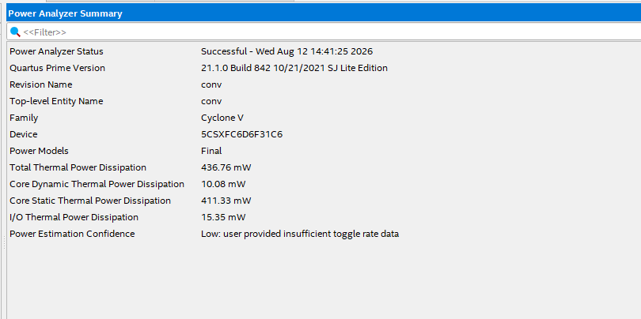
Figure 4. Quartus Power Analyzer Summary
Parameter | Reported Value
Power Analyzer Status | Successful
Revision / Top-level Entity | conv
Family / Device | Cyclone V / 5CSXFC6D6F31C6
Power Model | Final
Total Thermal Power Dissipation | 436.76 mW
Core Dynamic Thermal Power Dissipation | 10.08 mW
Core Static Thermal Power Dissipation | 411.33 mW
I/O Thermal Power Dissipation | 15.35 mW
Power Estimation Confidence | Low (user provided insufficient toggle-rate data)

Table 2. Power Analysis Summary
Total power dissipation is dominated by core static (leakage) power (411.33 mW) rather than dynamic switching power (10.08 mW), which is consistent with the low power-estimation confidence reported by Quartus, since accurate dynamic power figures require real toggle-rate (activity) data from a simulation testbench, which was not supplied to the Power Analyzer for this run.

5.2 Timing Analysis — Fmax
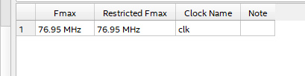
Figure 5. Fmax Summary
Clock | Fmax | Restricted Fmax
clk | 76.95 MHz | 76.95 MHz

Table 3. Maximum Operating Frequency
Fmax represents the highest frequency at which the design's clk domain can operate while still meeting all setup timing requirements; the Restricted Fmax additionally accounts for any I/O or design restrictions and is equal to the Fmax here.

5.3 Setup Timing
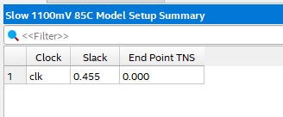
Figure 6. Setup Timing Summary (Slow 1100 mV 85°C Model)
Clock | Setup Slack | End Point TNS
clk | 0.455 ns | 0.000

Table 4. Setup Timing Summary
A positive setup slack of 0.455 ns indicates that data arrives at the destination register at least 0.455 ns before the capturing clock edge, so all setup-timing requirements are met with margin to spare under the slow 1100 mV, 85°C corner. The Total Negative Slack (TNS) of 0.000 confirms there are no setup violations anywhere in the clk domain.

5.4 Hold Timing
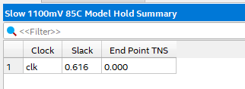
Figure 7. Hold Timing Summary (Slow 1100 mV 85°C Model)
Clock | Hold Slack | End Point TNS
clk | 0.616 ns | 0.000

Table 5. Hold Timing Summary
A positive hold slack of 0.616 ns confirms that data at each destination register remains stable long enough after the active clock edge to satisfy the register's hold-time requirement, with zero Total Negative Slack, i.e. no hold violations.

6. Conclusion
A 3×3 convolution engine was designed and verified in Verilog HDL. The architecture uses nine parallel signed 16×16 multipliers to compute all pixel–kernel products of a 3×3 image patch simultaneously, followed by a multi-level adder tree (a three-level balanced tree for eight of the nine products plus a final add for the ninth) that combines the partial products into a single 36-bit signed convolution result. Pixel and kernel values are loaded through a shared data bus using an address-based load mechanism (load_en, addr, data_in), and the computation is triggered by a start pulse, with the registered output y and a done flag indicating completion.
The design was functionally verified using a self-checking testbench (tb_conv.v) covering five standard image-processing kernels: Identity Filter, Blur Filter, Edge Detection, Sharpening and Emboss. All five test cases produced outputs that exactly matched their expected values (50, 450, 0, 50 and 290 respectively), each independently reported as PASS in the simulation console log and confirmed by the waveform capture, with the errors counter remaining at zero throughout the run.
Synthesis and timing analysis using Quartus Prime 21.1.0 on a Cyclone V device (5CSXFC6D6F31C6) reported a maximum operating frequency (Fmax) of 76.95 MHz for the clk domain, with a positive setup slack of 0.455 ns and a positive hold slack of 0.616 ns (both with zero Total Negative Slack), indicating that the design meets timing under the Slow 1100 mV, 85°C corner. The Power Analyzer reported a total thermal power dissipation of 436.76 mW, dominated by core static power (411.33 mW), with the estimation flagged as low-confidence due to the absence of toggle-rate data. Area/resource utilization figures were not available in the supplied reports.
Overall, the implemented convolution engine meets its functional requirements, with all test cases passing and positive timing margins reported at the analyzed corner.
7. Reference
[1] K. Mohammad and S. S. Agaian, “Efficient FPGA Implementation of Convolution,” Proc. IEEE International Conference on Systems, Man and Cybernetics (SMC), San Antonio, TX, USA, 2009, pp. 3560–3565
[2] J. M. Ramírez, E. Morales Flores, J. Martínez-Carballido, R. Enriquez-Caldera, V. Alarcón-Aquino, and D. Báez-López, “An FPGA-Based Architecture for Linear and Morphological Image Filtering,” Proc. 20th International Conference on Electronics, Communications and Computers (CONIELECOMP), 2010
[3] C. S. Wallace, "A suggestion for a fast multiplier," IEEE Transactions on Electronic Computers, vol. EC-13, no. 1, pp. 14–17, Feb. 1964.
[4] M. Kalbasi and H. Nikmehr, “A Fine-Grained Pipelined 2-D Convolver for High-Performance Applications,” IEEE Transactions on Circuits and Systems II: Express Briefs, vol. 66, no. 1, pp. 146–150, 2019
[5] L. Ioannou, A. Al-Dujaili, and S. A. Fahmy, “High Throughput Spatial Convolution Filters on FPGAs,” IEEE Transactions on Very Large Scale Integration (VLSI) Systems, vol. 28, no. 6, pp. 1392–1402, Jun. 2020

