Reinforcement Learning Final Project
An Actor-Critic Agent for a Custom Block-Centering Control Task
Sanjeev Ranjan
MS Internet of Things — Drexel University

1. Project Overview
This project implements an actor-critic reinforcement-learning agent that controls the horizontal motion of a block sliding on a flat, damped surface. At each time step the agent chooses one of three discrete force actions — push left, push right, or apply no force — and its objective is to learn a control policy that keeps the block near the center of the track (position x = 0) with low velocity.
As required, the environment is built entirely from closed-form Newtonian equations of motion rather than a standard benchmark such as OpenAI Gym. The agent, its neural-network function approximators, the temporal-difference update, and the policy-gradient update are all implemented from scratch in NumPy so that each required reinforcement-learning concept is explicit and inspectable in the source code.
The four concepts the assignment asks us to demonstrate map onto the implementation as follows: continuous state spaces (the real-valued state [position, velocity]), function approximation (two multilayer-perceptron networks), temporal-difference learning (the critic trained on a one-step TD target), and policy gradients (the actor updated with the score-function estimator using the TD error as the advantage).

2. Environment Formulation (Markov Decision Process)

2.1 State, Action, and Dynamics
State (continuous): s = [x, v], where x is the block’s position (m) and v is its velocity (m/s). This is a genuinely continuous state space — no discretization or table is used.
Action (discrete): a ∈ {0, 1, 2}, mapping to applied forces {−F, 0, +F}. A discrete action space with a continuous state is exactly the regime actor-critic policy-gradient methods are designed for.
The continuous-time dynamics follow Newton’s second law with a viscous (velocity-proportional) damping term that opposes motion:
m · ẍ = F_action − c · ẋ
We integrate these equations with a stable semi-implicit (symplectic) Euler scheme, which updates velocity before position:
a = (F_action − c · v) / m
v_next = v + a · dt
x_next = x + v_next · dt
Because the environment is defined purely by these closed-form equations, the full transition model is known and deterministic; the agent, however, is never given the equations and must learn its policy purely from sampled (state, action, reward, next-state) experience.

2.2 Reward Function
To express the goal “keep the block near the center,” we use a quadratic regulator-style cost (making the task a discrete-action analogue of the classic Linear-Quadratic Regulator):
r = −( x² + w_v · v² + w_u · (F_action / F)² )
The reward is largest (closest to zero) when the block sits at the center, moving slowly, while using little control effort. An episode terminates after 200 steps, or earlier with an additional penalty if the block escapes the region |x| > 2.4 m. The velocity and control-effort terms discourage high-speed overshoot and excessive chattering of the discrete force.

3. The Actor-Critic Method
Actor-critic methods combine two complementary ideas. The actor is a parameterized policy π(a | s) that selects actions; the critic is a learned value function V(s) that evaluates how good states are. The critic supplies a low-variance learning signal (the temporal-difference error) that the actor uses to improve its policy. Both are represented with function approximators because the state space is continuous.

3.1 Function Approximation
Two independent one-hidden-layer multilayer perceptrons (MLPs) with 64 tanh units are used:
- Actor network: maps the state to three logits, passed through a softmax to give the policy π(a | s), a probability distribution over the three actions.
- Critic network: maps the state to a single scalar value estimate V(s).
Both networks take the normalized continuous state as input. Forward and backward passes (including the tanh derivative and the softmax/cross-entropy gradient) are written explicitly, and a small from-scratch Adam optimizer is used for stable updates. Inputs are normalized to roughly [−1, 1], which substantially improves training stability without altering the physics.

3.2 Temporal-Difference Learning (the Critic)
After observing a transition (s, a, r, s′), the critic forms a one-step TD(0) target and the corresponding TD error:
TD target: y = r + γ · V(s′) · (1 − done)
TD error : δ = y − V(s)
The critic is trained to minimize the squared TD error δ² using the standard semi-gradient update (the target y is treated as fixed). This is bootstrapping: the value estimate at one state is updated toward an estimate built from the next state, the defining feature of temporal-difference learning.

3.3 Policy Gradient (the Actor)
The actor is improved using the policy-gradient (score-function) estimator. The TD error δ serves as an advantage estimate — a baseline-subtracted measure of whether the chosen action did better or worse than the critic expected:
∇J ≈ δ · ∇ log π(a | s)
When δ > 0 (the action led to a better-than-expected outcome) the update increases the probability of that action; when δ < 0 it decreases it. The gradient of −log π(a | s) with respect to the actor’s output logits has the convenient closed form (π − one-hot(a)), which is computed directly and back-propagated through the network. An entropy bonus (β = 0.01) is added to the actor objective to encourage exploration and prevent premature convergence to a deterministic policy.
Combining these, the per-transition actor-critic update minimizes:
critic_loss = δ²
actor_loss = − log π(a | s) · δ − β · H(π(· | s))

4. Experimental Setup
The agent was trained online for 1500 episodes, performing one actor-critic update per environment step. The full configuration is summarized below.
Component / Hyperparameter | Value
Mass m | 1.0 kg
Damping coefficient c | 0.30 N·s/m
Force magnitude F | 10.0 N (actions: −F, 0, +F)
Time step dt | 0.05 s
Position bound x_max | 2.4 m (episode fails beyond this)
Max steps / episode | 200
Reward weights (w_v, w_u) | 0.10 (velocity), 0.01 (control)
Discount factor γ | 0.99
Hidden units (per network) | 64, tanh activation
Actor learning rate | 2 × 10⁻³ (Adam)
Critic learning rate | 5 × 10⁻³ (Adam)
Entropy bonus β | 0.01
Training episodes | 1500

5. Results

5.1 Learning Curve
The average return over the first 100 episodes was about −43.6, improving to about −2.2 over the final 100 episodes — roughly a twenty-fold reduction in accumulated cost. Under a greedy (deterministic) policy, the trained agent scored −2.40 ± 1.04 across 50 evaluation episodes, completing all 200 steps without the block escaping the track.
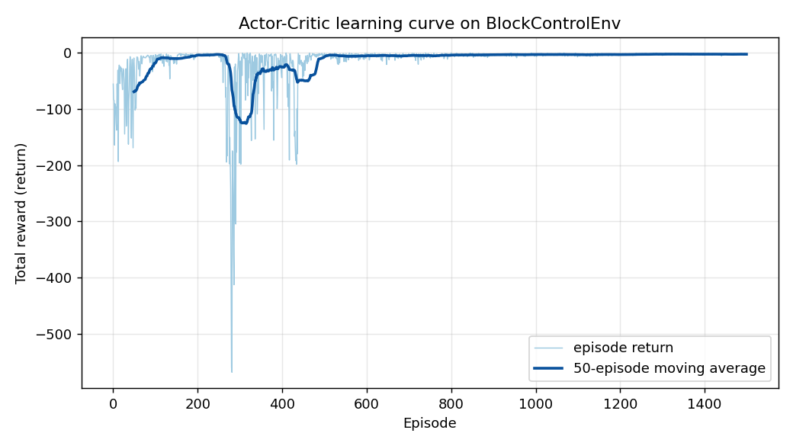
Figure 1. Episode return versus training episode. The bold line is a 50-episode moving average. After an early transient the agent converges to near-optimal control.
The curve shows a characteristic transient instability between roughly episodes 280 and 450, where the moving average temporarily worsens before recovering. This is a well-known property of fully online (single-step, unbatched) actor-critic learning: the policy-gradient estimate from a single transition is high-variance, and a few large updates can briefly destabilize an otherwise-improving policy. The agent recovers on its own and remains stable for the final ~1000 episodes.

5.2 Closed-Loop Behavior
Figure 2 contrasts a single episode under the untrained (random) policy with one under the trained greedy policy. The random policy lets the block accelerate away and leave the track within about 1.5 seconds. The trained policy instead drives the block to the center and holds it there — position and velocity both stay near zero for the full 10-second horizon, with only a small, quickly-corrected disturbance.
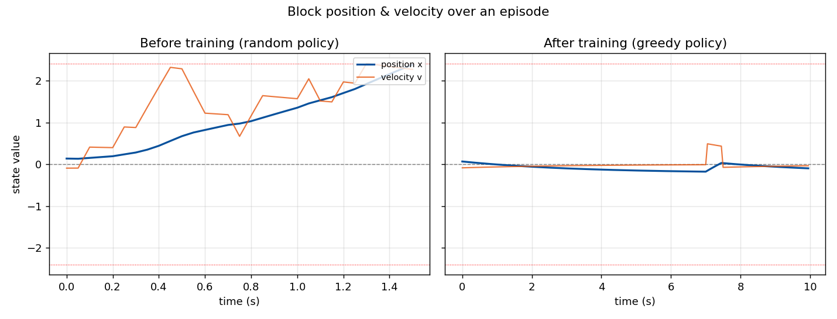
Figure 2. Block position (blue) and velocity (orange) over one episode. Left: random policy (block escapes). Right: trained policy (block stays centered for the full horizon).

5.3 Learned Value Function and Policy
Because the function approximators generalize over the continuous state space, we can visualize what the agent learned across all of state space, not just the states it visited. Figure 3 (left) shows the critic’s value function V(s): it peaks at the center with low velocity and decreases smoothly toward the boundaries, exactly the shape implied by the quadratic reward.
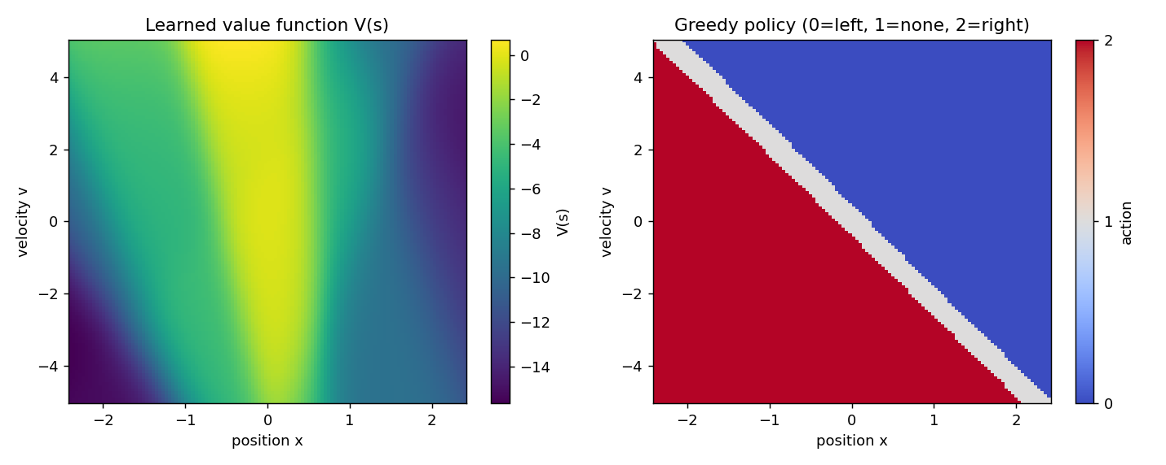
Figure 3. Left: learned value function V(s) over the continuous state. Right: the greedy policy, which forms a near-linear switching surface in the position-velocity plane.
Figure 3 (right) shows the greedy action at each state and reveals the most striking result: the agent independently discovered a near-linear switching law in the position-velocity phase plane. When the weighted sum of position and velocity is positive (the block is to the right or moving right), it pushes left; when negative, it pushes right; and a thin “no force” band runs along the switching line. This is precisely the bang-bang / sliding-mode control structure that optimal control theory predicts for a damped double-integrator regulator — learned purely from reward, with no model given to the agent.

6. Discussion
The results confirm that the actor-critic agent successfully solved the custom control task and, more importantly, that it did so by learning an interpretable and theoretically-motivated policy. The agreement between the learned switching surface and the known optimal-control structure is strong evidence that the function approximation, TD learning, and policy-gradient components are all working correctly together.
The main practical limitation observed was the variance of the online policy gradient, visible as the mid-training instability in Figure 1. Standard mitigations — collecting short batches of transitions before each update, using n-step or generalized-advantage estimation for the advantage term, or annealing the learning rates — would smooth the learning curve further. The entropy bonus already helps by keeping exploration alive long enough to find the switching policy rather than collapsing to a suboptimal deterministic one early on.

7. Code Structure and How to Run
- block_env.py — the custom environment: closed-form Newtonian dynamics, reward, and reset/step interface (no Gym).
- actor_critic.py — the from-scratch MLP function approximators, the Adam optimizer, and the actor-critic update (TD error + policy gradient).
- train.py — the training loop, greedy evaluation, and the code that generates all three figures.
To reproduce the results, run the training script (Python 3 with NumPy and Matplotlib):
python train.py
This trains the agent for 1500 episodes, prints periodic progress, reports the greedy-evaluation score, and saves the three figures used in this report.

8. Conclusion
An actor-critic agent was implemented from scratch and applied to a custom, closed-form block-centering control task. The agent learned to keep the block near the center, improving its average return roughly twenty-fold and converging to a policy that mirrors the optimal switching-control law for a damped double integrator. The project demonstrates, in explicit and inspectable code, the four target concepts — continuous state spaces, function approximation, temporal-difference learning, and policy gradients — working together in a single learning system.

