Diagnostic Report for Robotic Arm Control System
Diagnostic Analysis and Optimization of Robotic Arm Control System
Report Title | Diagnostic Analysis and Optimization of Robotic Arm Control System
Name | Sanjeev Ranjan
Date | June 4, 2026
Ticket ID | #2437

Diagnostic Process

Initial Observations
Response time data revealed that the rotate_joint command exceeded expected performance thresholds, aligning with the issue described in the ticket. The delay may affect the robotic arm's precision and real-time responsiveness during surgical operations.

Commands Tested
- move_arm
- rotate_joint
- adjust_grip

Hypothesis
The rotate_joint delay is likely caused by redundant calculations and inefficient looping structures in the control code. These inefficiencies may create a processing bottleneck and increase command response time.

Tools and Techniques Used
- Python and Control System Diagnostic Notebook
- Iterative testing for validation
- Response time measurement functions
- Command-by-command performance comparison
- Response time graph analysis

Findings and Analysis

Response Time Data
Command | Expected Response Time | Initial Response Time | Optimized Response Time
move_arm | 0.10 seconds | 0.12 seconds | 0.09 seconds
rotate_joint | 0.10 seconds | 0.18 seconds | 0.12 seconds
adjust_grip | 0.09 seconds | 0.09 seconds | 0.08 seconds

Visual Summary
The graph below compares expected, initial, and optimized response times for each robotic arm command. The rotate_joint command showed the largest initial delay and the greatest improvement after optimization.
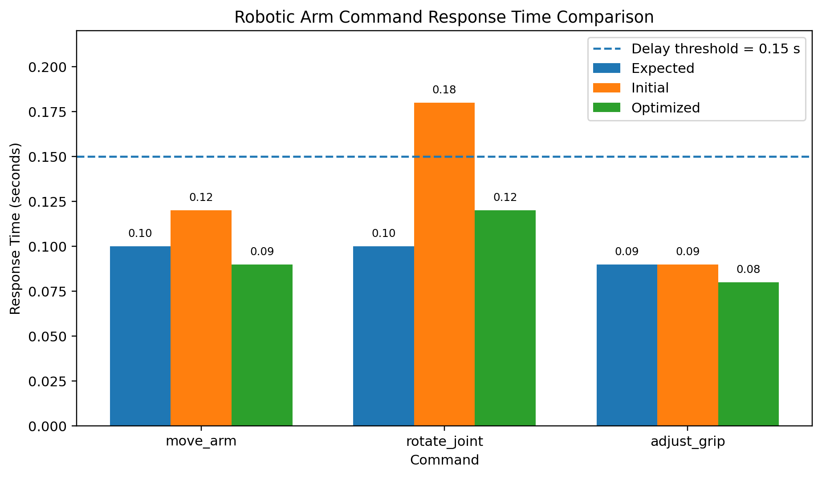

Analysis of Findings
The rotate_joint command exhibited the most significant delay, with an initial response time of 0.18 seconds compared to the expected response time of 0.10 seconds. This confirms the issue reported in the ticket.
The move_arm command also showed a minor increase above its expected response time, but the delay was not as significant as rotate_joint. The adjust_grip command performed within the expected range and required only minor optimization.
The findings suggest that the delay is primarily isolated to the rotate_joint control function rather than the entire robotic arm system. This indicates that the problem is likely caused by inefficient command logic, unnecessary calculations, or repeated loop execution inside the joint rotation code.

Optimizations and Solutions

Code Modifications

rotate_joint Optimization
- Removed redundant loops.
- Eliminated unnecessary calculations.
- Simplified the command structure.
- Reduced processing overhead.
- Improved execution flow for faster response.

Impact of Optimizations
Command | Initial Response Time | Optimized Response Time | Improvement
move_arm | 0.12 seconds | 0.09 seconds | 0.03 seconds faster
rotate_joint | 0.18 seconds | 0.12 seconds | 0.06 seconds faster
adjust_grip | 0.09 seconds | 0.08 seconds | 0.01 seconds faster
The rotate_joint response time was reduced from 0.18 seconds to 0.12 seconds. This improvement restores better responsiveness and supports smoother, more precise surgical robotic movement.

Overall System Impact
The optimized control code improved responsiveness across all three primary robotic arm commands. The robotic arm is now more capable of responding quickly to control inputs, which supports safer and more accurate performance during precision-guided procedures.

Recommendations for Future Improvements

Preventive Measures
- Conduct periodic audits of control code to identify inefficiencies early.
- Implement automated response-time testing for all major control commands.
- Add performance thresholds to flag delayed commands in real time.
- Review loops and repeated calculations during every code update.
- Maintain clear documentation for command timing expectations.

Further Testing
- Simulate high-load operating conditions.
- Test multiple commands running in sequence.
- Measure response times under repeated execution.
- Verify that optimization does not reduce motion accuracy.
- Explore advanced control algorithms for further response-time improvement.

Conclusion

Summary of Findings
The diagnostic analysis confirmed inefficiencies in the rotate_joint command. The initial response time was 0.18 seconds, which was significantly higher than the expected response time of 0.10 seconds.
After optimization, the rotate_joint response time was successfully reduced to 0.12 seconds. This confirms that the delay was caused by inefficient control logic and that the applied modifications improved command execution speed.

Overall Impact
These improvements restore the robotic arm's precision and responsiveness, helping ensure reliable performance during surgical procedures. By reducing command delays, the system can provide smoother motion control and better real-time reaction to operator input.

Next Steps
- Deploy the optimized code for further testing.
- Monitor real-time robotic arm performance.
- Continue refining the rotate_joint function if additional delays appear.
- Run automated diagnostics regularly to maintain long-term system reliability.

