AI Powered Trading
User Guide
Every screen explained, with the steps to get things done
Version: October 2026
For: anyone using the app to plan, test and practise NIFTY 50 and BANKNIFTY options trades.
About the pictures: all screenshots use the fake demo account "Priya Nair" and fake test data. The numbers you see on your own screen will differ.

Careful: This is an educational research tool. It places no real orders, and nothing it shows is financial advice. Prices come from loaded datasets (fake or historical), not from the live market.

Contents
1. What the app does, and a 5-minute quick start
2. Key ideas in plain words (glossary and experience levels)
3. The screens: Login, Layout, Dashboard, Strategy Desk, Backtest, Paper Trading, Profit & Loss, Knowledge Base, Settings & Models
4. Step-by-step recipes for common jobs
5. How the numbers are worked out
6. Troubleshooting and FAQ
7. Limits and safety
Appendix: sources used for the explanations

1. What the app does
You describe a trade in your own words, for example the index, the expiry, how much you can lose on one trade and what you hope to make. A team of AI agents then researches the idea (from a knowledge base and recent market news), designs a rule-based strategy, verifies it, backtests it on historical option candles and reviews its risk. You get a trade plan with reasons, which you can paper-trade with virtual money. If you ever trade for real, you place the orders yourself in your own broker app.

What it is not
- Not a broker: no order ever leaves the app.
- Not live: paper trading replays a loaded dataset with a clock, it does not stream live prices.
- Not advice: the plans are research output built on past or fake data.

Quick start (about 5 minutes)
- Log in (or create an account). Pick your experience level: Beginner, Advanced or Expert.
- Open Strategy Desk. Type what you want, for example: "BANKNIFTY monthly expiry, use EMA with RSI, capital 2 lakh, max loss 5000, target 12000".
- Choose the Underlying and, if you like, the Expiry from the dropdown. Check the Model (pick a real model if the default says mock).
- Press Generate strategy and wait one to two minutes while the five steps on the right turn green.
- Read the AI recommendation in the middle: the contract, lots, stop, target, the reasons and when to trade.
- Press Paper trade CE or Paper trade PE to practise the plan with virtual money, or Open full backtest results to study how it did on past data.
- Use Paper Trading to move the replayed market forward and watch your position, and Profit & Loss to review how you did on a day or over a range.
Tip: New to options? Read section 2 first. It takes five minutes and explains every word the screens use.

2. Key ideas in plain words
Word | What it means here
Underlying | The index the option is based on. This app supports NIFTY (Nifty 50) and BANKNIFTY (Nifty Bank).
Option, CE and PE | A contract that gives the right, not the duty, to trade the underlying at a fixed price. CE (call) gains when the index rises, PE (put) gains when it falls. This app only buys options, so the most you can lose on a trade is the premium you paid.
Strike | The fixed price of the contract, for example 25900 or 60500.
Premium | The price of one option. It has two parts: intrinsic value (what it would be worth if exercised now) and time value (the chance it becomes valuable before expiry).
Lot and lot size | Options trade in fixed bundles. 1 lot = lot size units (NIFTY 65, BANKNIFTY 30 at the time of writing). Cost of one lot = premium x lot size. The exchange changes lot sizes now and then, so check before real trading.
Expiry: weekly and monthly | The day the contract ends. Index options settle in cash. A month's last expiry is the monthly one, the others are weekly. An exchange holiday can move an expiry to an earlier day, so the app shows the exchange's own list.
ATM, ITM, OTM | ATM: the strike is about equal to the index (at the money). ITM: a call with a strike below the index, or a put above it (in the money, dearer). OTM: the opposite (out of the money, cheaper, needs a bigger move).
Stop loss | An automatic exit if the premium falls by a set percentage from your entry. It limits the loss on a trade.
Target | An automatic exit if the premium rises by a set percentage. It books the profit.
Square-off | A forced exit at a set time (15:15 here) so an intraday trade is not carried overnight.
Candle and timeframe | One bar of price data. A 5-minute candle summarises five minutes (open, high, low, close). The app reads prices candle by candle.
Backtest | Running a strategy's rules over past data to see what it would have done. Useful, but past results do not promise future ones.
Paper trading | Practising with virtual money. In this app the market is a dataset replayed by a clock.
Equity, cash | Cash: virtual money not tied up in positions. Equity: cash plus the current value of open positions.
Realised and unrealised P&L | Realised: profit or loss of trades already closed. Unrealised: paper profit or loss of positions still open.
Win rate | Share of trades that made money.
Profit factor | Total of winning trades divided by the total of losing trades. Above 1 means winners outweighed losers.
Drawdown | How far your running profit fell from its highest point. A measure of how painful the bad patches were.
Expectancy | Average profit or loss per trade.
Sharpe | Return compared with how bumpy it was. Higher is smoother. It needs many trading days to mean much.

Experience levels
Your level is set at sign-up and can be changed any time in Settings & Models. It changes how the agents explain things and which safety guardrails apply. The numbers themselves never depend on the level.
Level | How the agents talk and plan | Guardrails added to your plan
Beginner | Plain words, each term explained, simple strategies with one or two indicators, conservative stops. | A note appears if your max loss is above 2% of capital. At most 3 trades a day are allowed.
Advanced | Normal depth. A few indicators together are fine, trade-offs mentioned briefly. | A note appears if your max loss is above 5% of capital.
Expert | Short and technical, no basics. Talks about sensitivity to parameters and market regimes. | A note appears if your max loss is above 10% of capital.

3. The screens
Every screen below follows the same pattern: what it is for, what you see, how to do the common tasks, and what to watch out for. The sidebar on the left of the app takes you between screens.

3.1 Login and Create account
Use it to: sign in, or make a new account. You need to be logged in to see anything else. Your strategies, backtests, runs and paper account belong to you; other users cannot see them.
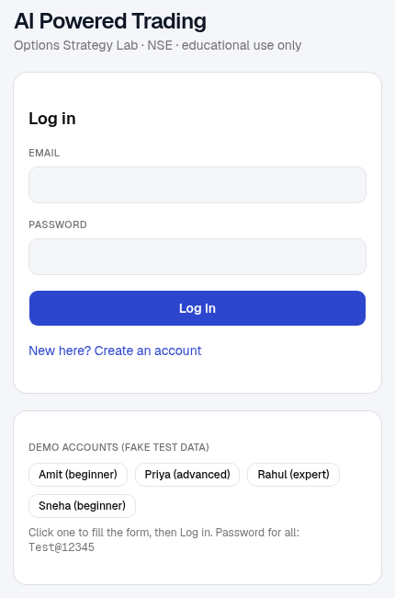 | What you see  - Email and Password boxes and the Log in button.  - New here? Create an account switches the form to sign-up (see below).  - Demo accounts (fake test data): one-click buttons that fill the form for the practice users. All use the password shown. These exist only for local testing.

How to log in
- Type your email and password, or press a demo account button.
- Press Log in. You land on the Dashboard.
- Press Log out (bottom of the sidebar, or in Settings) when you are done.

How to create an account
- Press New here? Create an account.
- Enter your name, email and a password of at least 8 characters.
- Choose your experience level: Beginner, Advanced or Expert.
- Press Create account. You are logged in straight away.
Note: A login lasts about a week, then you are sent back to this screen. Eight wrong passwords for one email within ten minutes lock that email for the rest of that window. If sign-up says "Registration is disabled", ask whoever runs the app for an account.

3.2 The layout: sidebar and top bar
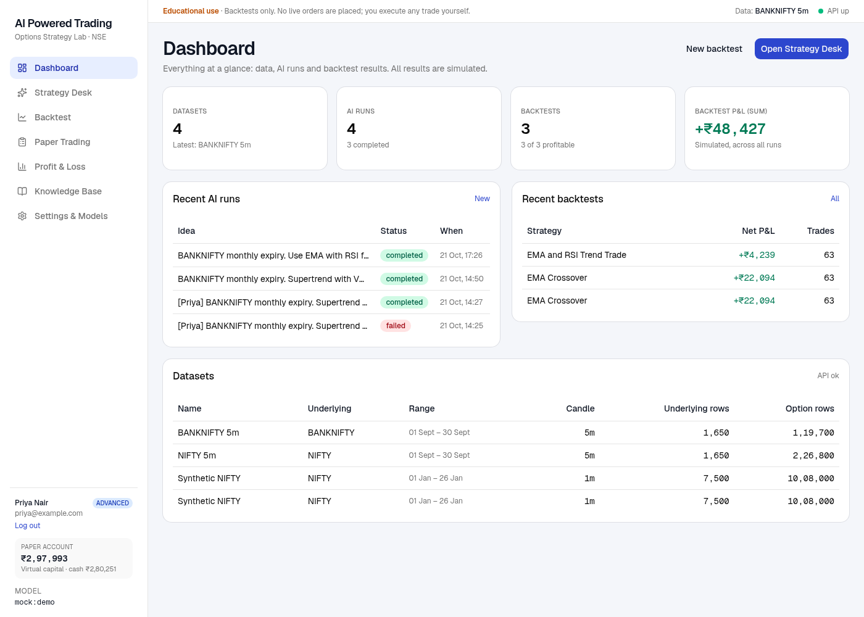
The sidebar (left) and top bar (top) appear on every screen after login.
Part | What it does
Sidebar menu | Dashboard, Strategy Desk, Backtest, Paper Trading, Profit & Loss, Knowledge Base, Settings & Models. The current screen is highlighted.
User card | Your name, your level (Beginner, Advanced or Expert) and email, and Log out.
Paper account box | Your virtual equity (large) and cash. Click it to open Paper Trading. It updates when you trade.
Model | The AI model used when you do not choose one yourself. mock:demo is an offline stand-in with scripted answers, not a real model.
Top bar notice | A reminder that this is educational and sends no real orders.
Top bar status | Data: the newest dataset loaded. API: a green dot means the app's server is up, red means it cannot be reached, amber means a part of it is struggling.

3.3 Dashboard
Use it to: see everything at a glance and jump back into earlier work.
Part | What it shows
Four cards | Datasets loaded (and the latest), AI runs (and how many completed), Backtests (and how many were profitable), Backtest P&L (sum) across all your backtests.
Recent AI runs | Your latest Strategy Desk runs with their status (completed, running, failed). Click the idea to reopen that run in the Strategy Desk with its plan.
Recent backtests | Latest backtests with net profit and number of trades. Click a strategy name to open its full results.
Datasets | The market data you can test on: name, index, date range, candle size and how many rows it holds.
Buttons | Open Strategy Desk to start a new plan; New backtest to test a built-in strategy directly.

How to
- Reopen an earlier plan: click its idea under Recent AI runs.
- See why a run failed: open it; the pipeline panel shows which step failed and why.
- No datasets? The Backtest and Paper Trading screens need market data. Ask whoever runs the app to load a NIFTY or BANKNIFTY dataset with option candles, or create a small fake one from New backtest.

3.4 Strategy Desk
Use it to: get a complete trade plan from a plain-language request. This is the main screen. It has three panels that you read left to right: Ask the agents (step 1), AI recommendation (step 2) and Agent pipeline (step 3).
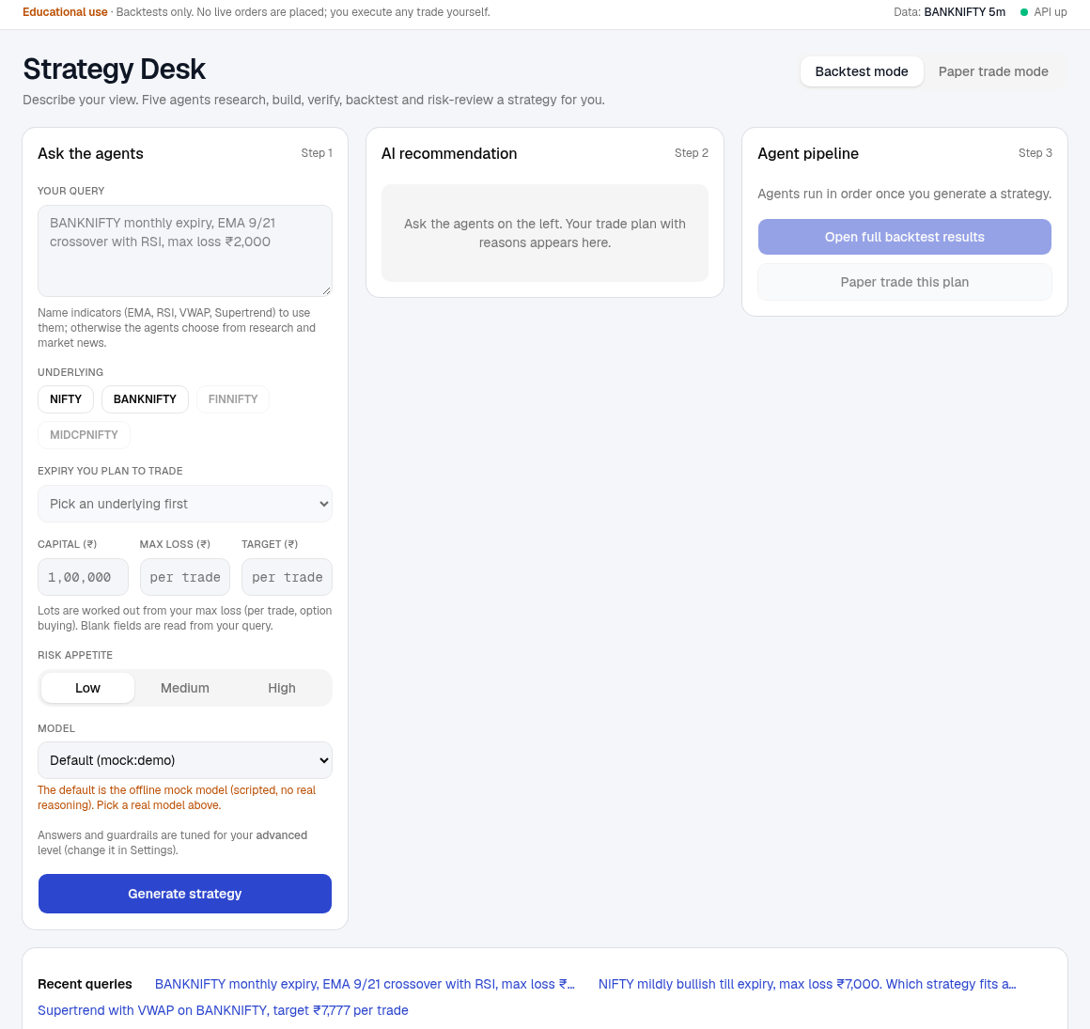
The Strategy Desk when you first open it: the form on the left, empty panels on the right.
Note: The top-right switch shows Backtest mode. Paper trade mode is a shortcut to the Paper Trading screen.

Panel 1: Ask the agents
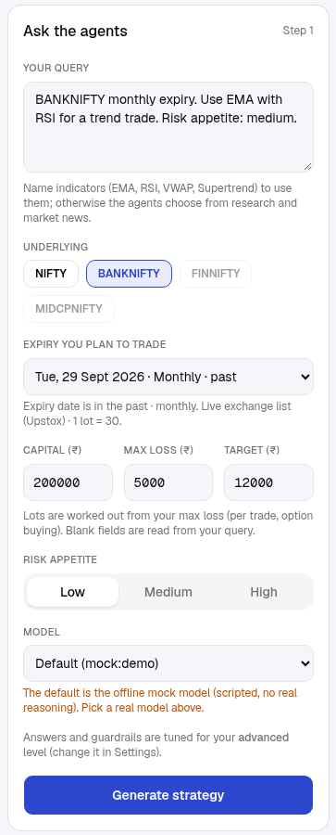
  Field | What to enter
  Your query | Describe the trade in your own words (English, Hindi or Hinglish).
  Underlying | NIFTY or BANKNIFTY. FINNIFTY and MIDCPNIFTY are greyed out: not supported yet.
  Expiry | Pick from the live exchange list. It shows weekly or monthly, days left and the lot size. Leave blank and the agents use your query or the nearest expiry.
  Capital | Your trading money in rupees.
  Max loss | The most you accept losing on one trade, in rupees.
  Target | The profit you hope for on one trade, in rupees.
  Risk appetite | Low, Medium or High. Added to your request as a hint.
  Model | Which AI to use. Pick a real model when the default says mock.

A line under the form reminds you that answers and guardrails follow your level. Recent queries at the bottom of the screen are saved in your browser; click one to reuse it.

How to write a good query
Say this | Why it helps
The index and the expiry | "BANKNIFTY monthly expiry" tells the agents which contract family to design for.
Your limits as numbers | "capital 2 lakh, max loss 5000, target 12000". The app turns them into lots, stop and target. Say "per trade" so it is clear.
Indicators, if you have a favourite | "Use EMA with RSI", "Supertrend with VWAP". If you name none, the agents choose from the research and market news and explain why.
Direction or style, if any | "mildly bullish", "trend trade", "avoid trading near close".

Weak query | Better query
make profit in banknifty | BANKNIFTY monthly expiry. EMA 9/21 crossover with RSI filter. Capital 2 lakh, max loss 5000 per trade, target 12000.
good strategy | NIFTY weekly expiry, mildly bullish, Supertrend with VWAP, max loss 3000 per trade.
Tip: Blank Capital, Max loss and Target boxes are read from your query. A value you type in a box always wins over the query. The app also fills the boxes with what it understood, so you can see and correct it.

How to generate a plan
- Write your query and pick the Underlying (or mention it in the query).
- Optionally pick the Expiry, and fill Capital, Max loss and Target.
- Choose Risk appetite and the Model.
- Press Generate strategy. The button shows "Agents are working...". Do not close the page; it takes one to two minutes.
- When all five steps on the right show a green tick, read the middle panel.
Note: If the box under the form turns amber with notes, the app could not tell something (for example whether your amounts are per trade or per day). Read the notes and correct the boxes.

Panel 2: AI recommendation
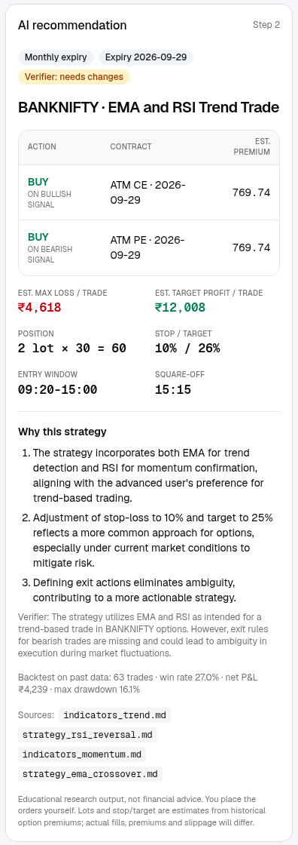 | Reading the plan, top to bottom  - Badges: weekly or monthly expiry, the expiry date, and the verifier's verdict (approved, needs changes or rejected).  - Title: the index and the strategy name.  - Action table: BUY, on a bullish signal buy a CE, on a bearish signal buy a PE. Contract shows how the strike is chosen (for example ATM) and the expiry. Est. premium is the price estimated from the data.  - Est. max loss / trade and Est. target profit / trade: what a stop-out or a target hit would roughly cost or earn, in rupees.  - Position: lots x lot size = quantity.  - Stop / target: percentages of the premium you paid.  - Entry window and square-off: the hours the plan may enter, and the forced exit time.  - Why this strategy: the reasons for each choice. When to trade: when it enters and when it stays out.  - Backtest line: how the rules did on past data.  - Sources: the knowledge-base notes the research used.

What the verifier's verdict means
Verdict | What to do
Approved | The checker found no serious problem with the rules, risk settings or fit with your request. You can go on to paper trading or study the backtest.
Needs changes | The checker found issues it could not fully fix after up to two revision rounds. Read the pipeline panel's note and the plan's reasons, then either run again with a clearer query or treat the plan with extra caution.
Rejected | The strategy does not do what you asked or cannot work. Rephrase and generate again.
Careful: A profitable backtest is not proof of an edge. Check the number of trades and the drawdown, not only the profit. Fake or very short data can show wins by luck.

Panel 3: Agent pipeline
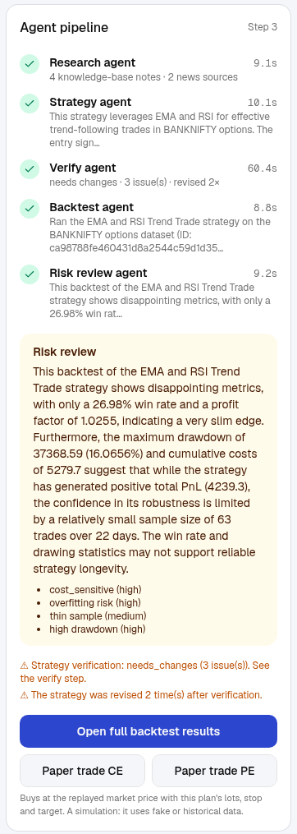 | The five steps  - Research: reads the knowledge base and recent market news.  - Strategy: writes the rules and the reasons.  - Verify: checks the strategy; if it is not approved it is sent back for up to two revisions.  - Backtest: runs the approved rules on past data.  - Risk review: points out weaknesses such as few trades, high costs or a large drawdown.  Each step shows its time. A yellow Risk review box lists the main risks. Orange warning lines tell you if the plan was revised.  Buttons  - Open full backtest results: the complete results screen (section 3.5).  - Paper trade CE / PE: opens a paper position that follows the plan. Only the sides the plan actually buys are offered. If the plan says to sell an option, paper trading cannot follow it (it only buys).

How to paper-trade a plan
- Generate a plan and read it.
- Press Paper trade CE (for the bullish side) or Paper trade PE (bearish side).
- You land on Paper Trading. The plan's contract is now an open position with the plan's lots, stop, target and square-off time.
- Move the market forward with the clock buttons and watch what happens.
Note: Asking general questions ("what is theta decay?") is supported by the system's back end, but the Strategy Desk box does not have a question mode yet. Anything you type here is treated as a request to build a strategy.

3.5 Backtest: list, New backtest and Results
Use it to: test a built-in strategy yourself, and study how any strategy behaved on past data. AI plans from the Strategy Desk also appear here.

The backtest list
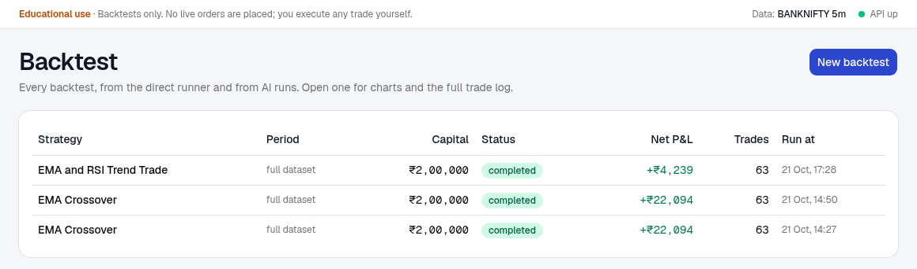
Every backtest you ran, from here and from AI plans.
Columns: Strategy, Period ("full dataset" or the dates you chose), Capital, Status, Net P&L after brokerage, slippage and taxes, Trades and when it was run. Click a strategy name to open its results.

New backtest
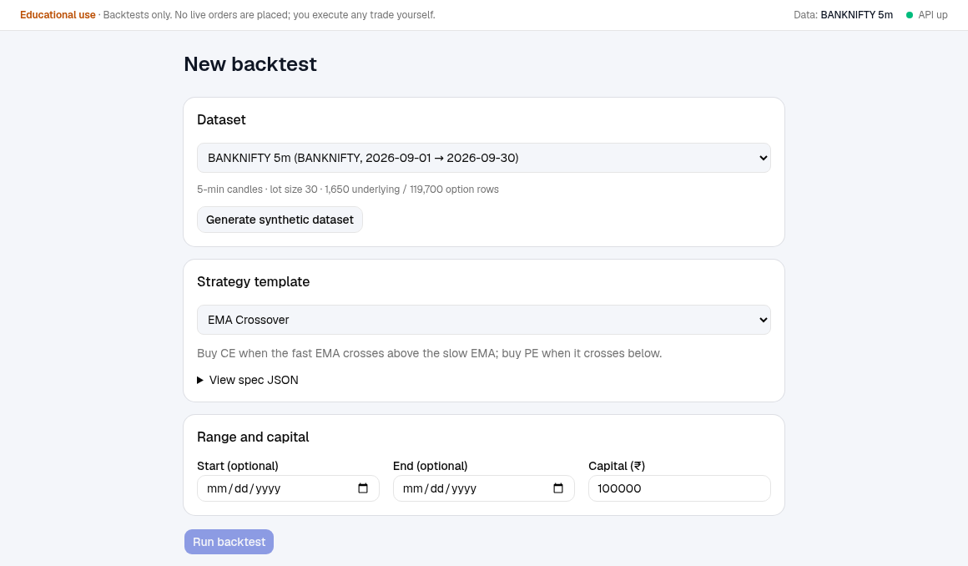
Choose data, a strategy and a period, then run.
- Press New backtest (top right of the list).
- Dataset: choose the market data. The line below it tells you the candle size, lot size and number of rows.
- Strategy template: choose EMA Crossover or RSI Reversal. A sentence explains it; View spec JSON shows the exact rules.
- Range and capital: leave Start and End blank to use the whole dataset, or set dates inside the data. Set your Capital.
- Press Run backtest. You go straight to the results.
Tip: No dataset? Press Generate synthetic dataset to make a small fake NIFTY dataset to practise on. Results on fake data say nothing about real markets.

Results
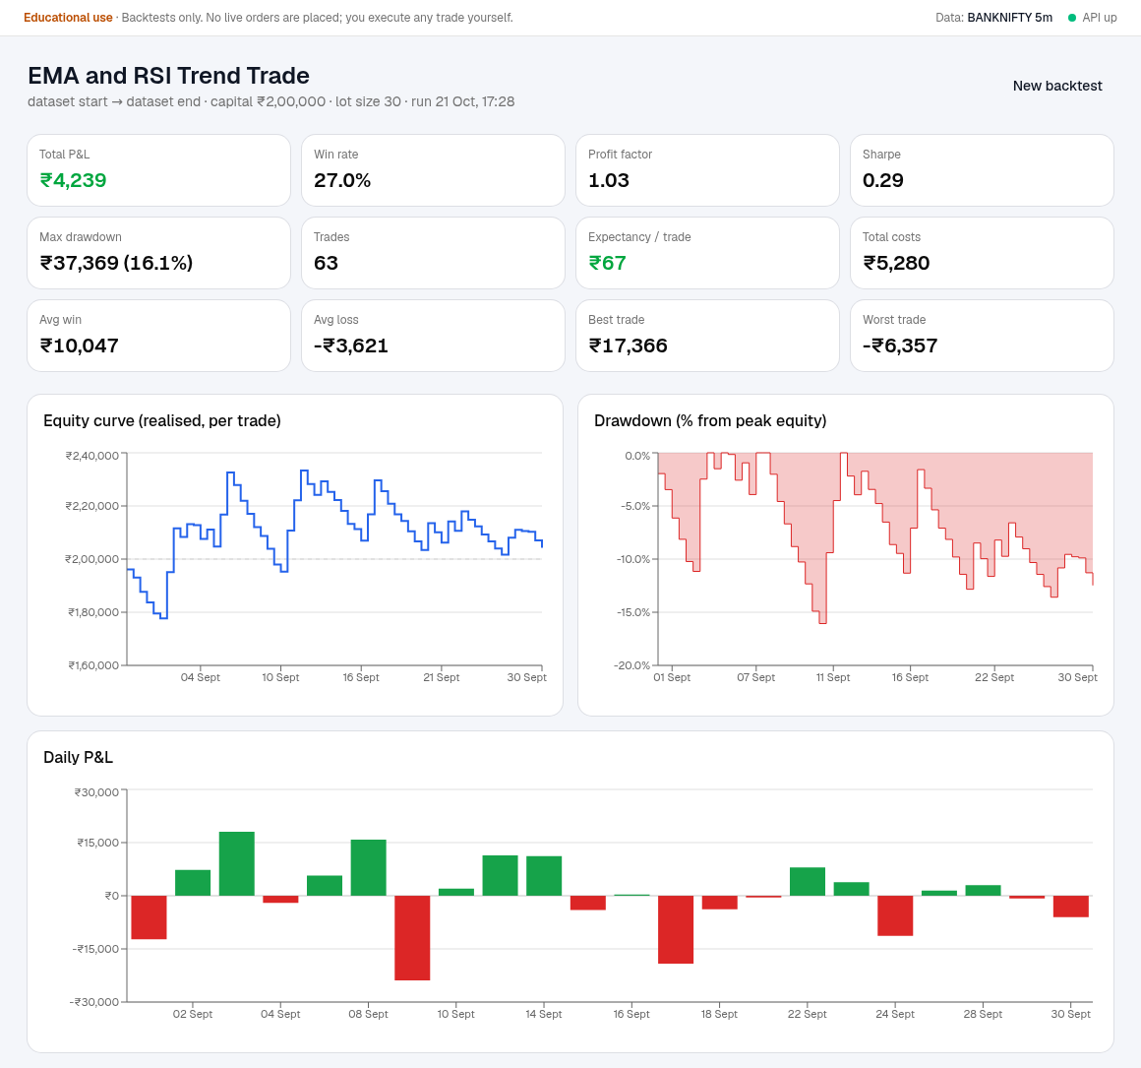
Results: twelve numbers on top, then three charts.
Card | Meaning
Total P&L | Net profit or loss after all costs.
Win rate | Share of trades that made money.
Profit factor | Winning trades' total divided by losing trades' total. Above 1 is better.
Sharpe | Return per unit of bumpiness (needs many days to mean much).
Max drawdown | The biggest fall from a peak, in rupees and as a percentage.
Trades | How many trades the rules took. Very few trades means the result is weak evidence.
Expectancy / trade | Average profit or loss per trade.
Total costs | Brokerage and taxes paid over the whole test.
Avg win, Avg loss, Best trade, Worst trade | The size of typical and extreme trades.

- Equity curve: your money after each closed trade. It should drift up without huge dips.
- Drawdown: how far below the previous peak you were, in percent.
- Daily P&L: each day's result as green or red bars.
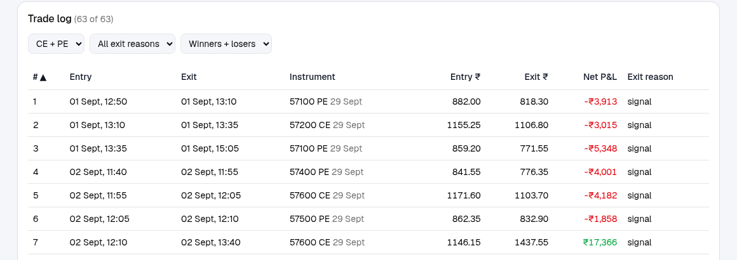
The trade log. Use the three drop-downs to filter and click a column heading to sort.
- Trade log: every trade with entry and exit time, instrument (strike, CE or PE, expiry), prices, net profit and the exit reason (signal, stop_loss, target, square_off).
- Use the drop-downs to show only CE or PE, only one exit reason, or only winners or losers. Click a heading to sort.
- Skipped events (when shown) lists signals the engine could not trade, for example no option price at that time.

3.6 Paper Trading
Use it to: practise buying and selling options with virtual money. There is no live feed: a market clock replays a dataset, and you decide when time moves on.
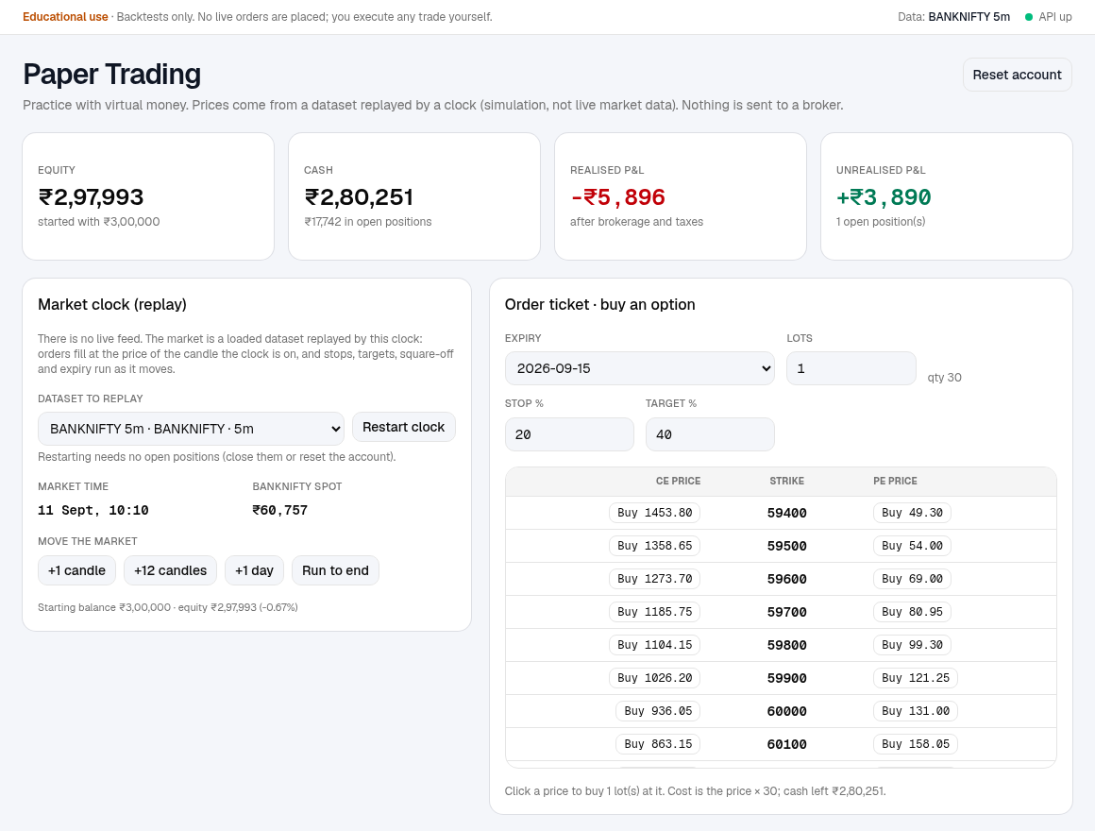
Top half: your balance, the market clock and the order ticket.
Part | What it does
Four cards | Equity (cash plus open positions), Cash, Realised P&L (closed trades, after costs) and Unrealised P&L (open positions).
Market clock | Choose the dataset to replay and press Start clock (or Restart clock). It shows the market time and the index spot. +1 candle, +12 candles, +1 day and Run to end move the market forward.
Order ticket | Pick an expiry, set lots, stop % and target %, then click a Buy price in the option chain: CE prices on the left, PE prices on the right, the strike in the middle. The at-the-money row is highlighted.
Reset account | Top right. Deletes all positions, orders and trades, and sets the starting balance you type.
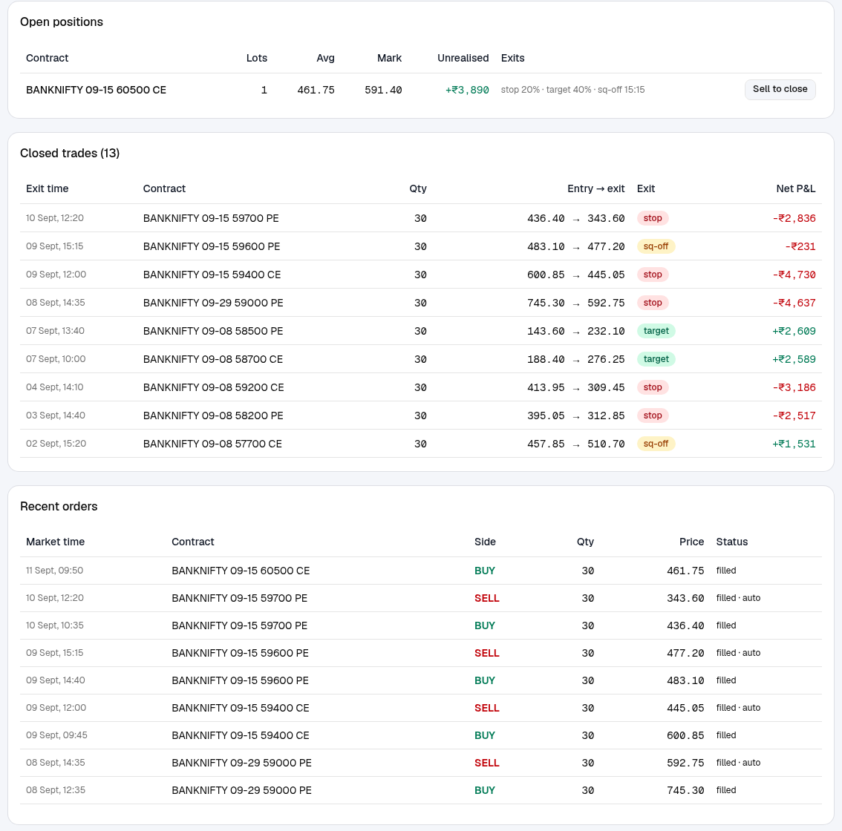
Bottom half: open positions, closed trades and the order history.
Table | What it shows
Open positions | Contract, lots, average price you paid, current mark price, unrealised profit and the exit rules (stop, target, square-off time). Sell to close sells the position at the current market price.
Closed trades | Exit time, contract, quantity, entry price to exit price, why it closed (manual, stop, target, sq-off or expiry) and net profit after costs. Hover the profit to see gross and costs.
Recent orders | Every buy and sell with its market time, price and status (filled, rejected, or an automatic exit).

How to place and manage a paper trade
- Under Market clock, pick a dataset and press Start clock. The clock starts a few days before the end of the data so there is room to move forward.
- In the Order ticket, choose an expiry. Only expiries that have prices at the market time are listed.
- Set lots, and the stop % and target % you want (defaults 20 and 40).
- Click the Buy price of the CE or PE you want. The position appears under Open positions, and cash drops by price x quantity.
- Press +1 candle, +12 candles or +1 day to move the market. If a stop, target, square-off or expiry is hit, the position closes by itself and a yellow banner tells you.
- Or press Sell to close at any time to close by hand.
- Open Profit & Loss to review the result.

The rules of the simulation
- Buy only. You buy options and sell them to close. Selling to open is rejected.
- Fill price: the price of the candle the clock is on. Real fills have slippage and delays; these do not.
- Exit order on each candle: expiry first, then stop, then target, then square-off time.
- Costs: taken when a trade closes: Rs 20 brokerage for each of the two legs plus 0.05% of the turnover. Cash always moves by exactly the trade's net profit.
- Not enough cash: the order is rejected and noted in Recent orders.
- One dataset at a time: to replay a different dataset or restart the clock, close your positions or reset the account.
Careful: The replayed data may be fake. Practise the mechanics (orders, stops, sizing, review), not the strategy's profits.

3.7 Profit & Loss
Use it to: see how much you made or lost on one day or over a range of dates.
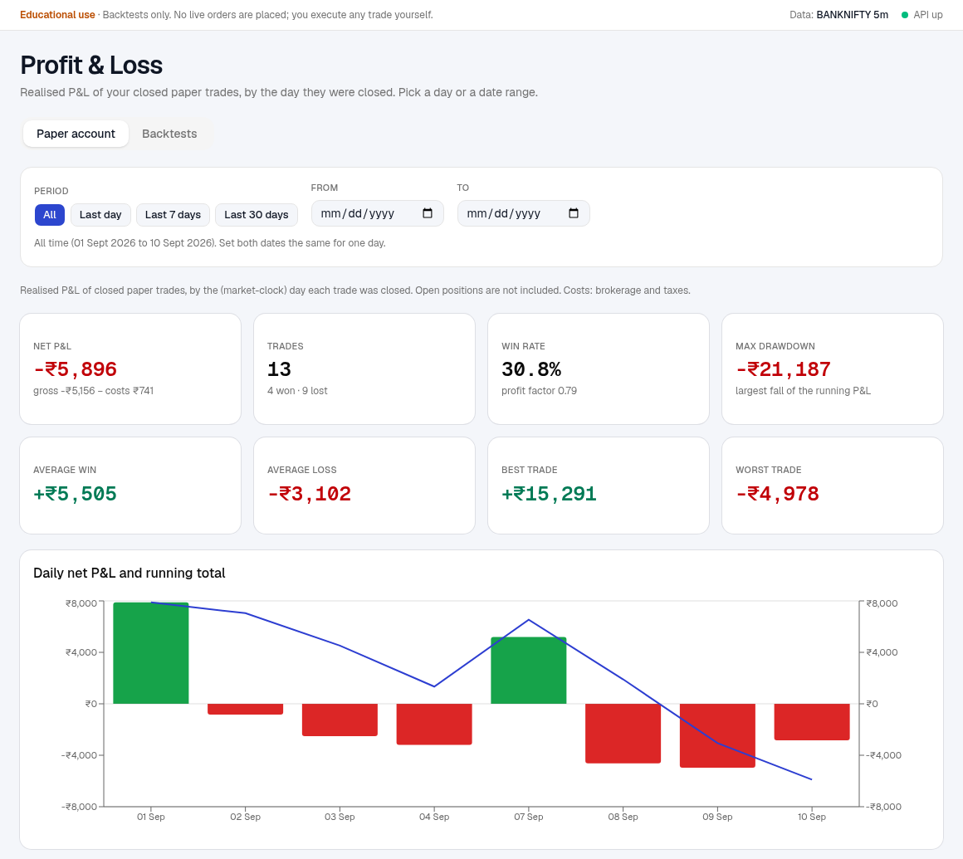
Profit & Loss: choose a period at the top, read the cards and chart below.

Choosing the dates
Control | How it works
Tabs | Paper account: realised P&L of your closed paper trades. Backtests: the P&L of your backtests, filtered by the day each was run.
Presets | All, Last day, Last 7 days, Last 30 days. They count back from the most recent day that has data.
From and To | Pick any two dates. Set both to the same date for a single day.
Click a day | In the By day table, click a row to show only that day.

How to see one day, or a range
- Open Profit & Loss and stay on the Paper account tab.
- For one day: type the same date in From and To, or click that day in the By day table.
- For a range: set From and To, or press a preset such as Last 7 days.
- To go back to everything, press All.
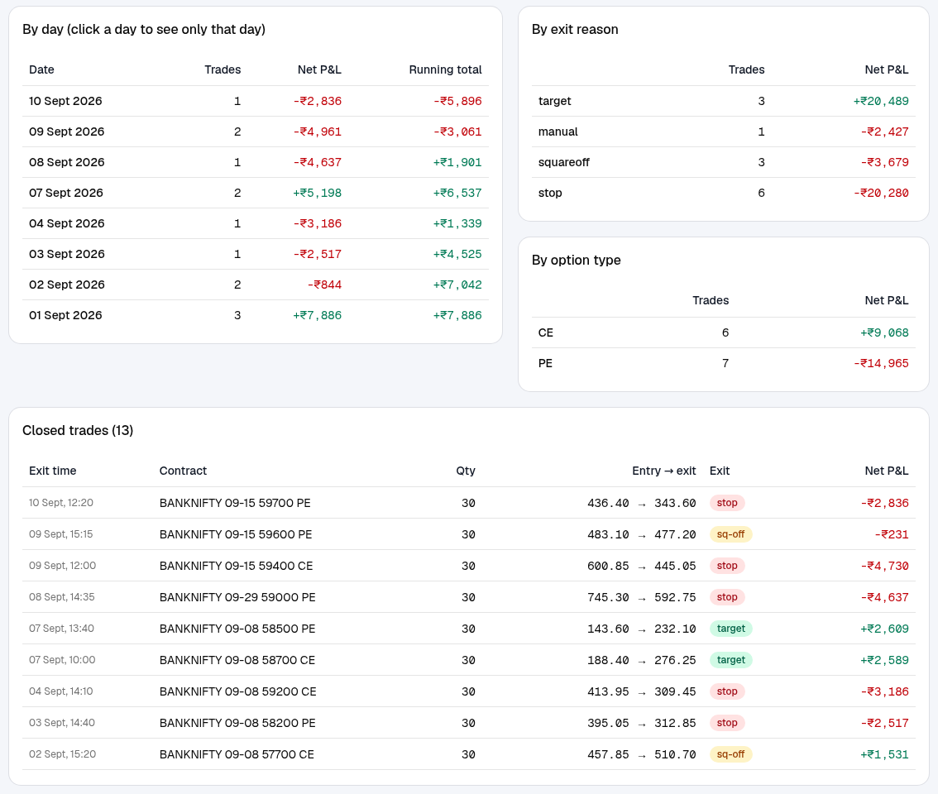
Lower half: the day-by-day table, breakdowns, and the closed trades in the period.
Part | What it tells you
Net P&L card | Profit or loss after costs for the period, with the gross figure and the costs underneath.
Trades, Win rate | How many trades, how many won or lost, and the profit factor.
Max drawdown | The largest fall of your running profit inside the period.
Average win and loss, Best and Worst trade | The size of typical and extreme trades.
Chart | Bars: each day's net profit (green) or loss (red). Blue line: the running total.
By exit reason | Which kinds of exit made or lost money (target, stop, square-off, manual, expiry).
By option type | How your CE trades compared with your PE trades.
Closed trades | Every trade in the period.
Note: Only closed trades count. Open positions are shown on Paper Trading. Dates are market-clock days, that is the day inside the replayed data when the trade closed, not today's calendar date.

3.8 Knowledge Base
Use it to: see, search and add to the notes the research agent reads. Better notes lead to better-grounded plans.
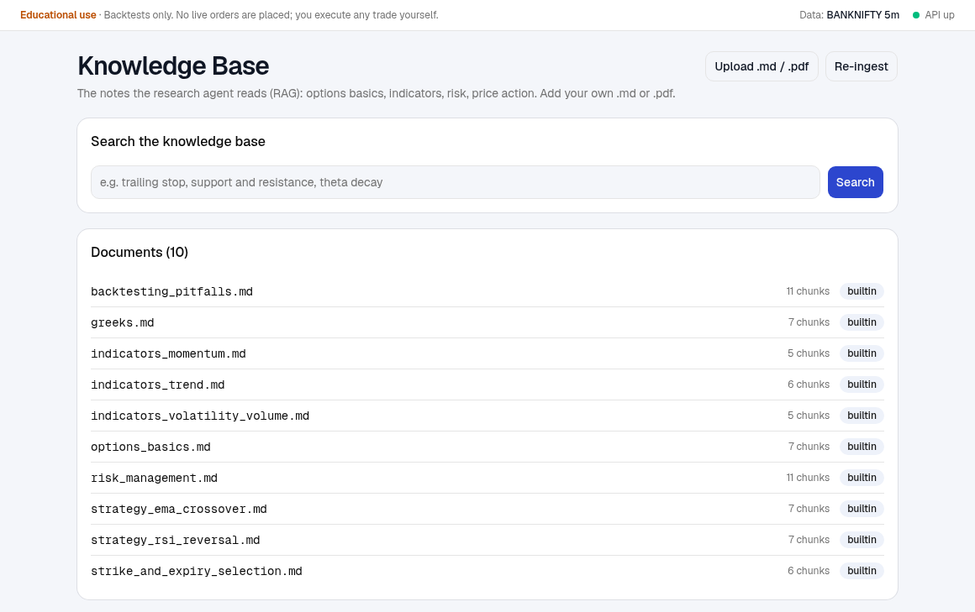
Search the notes at the top; the list below shows every document and how many pieces it was cut into.
Part | What it does
Search box | Type a topic (for example "trailing stop" or "theta decay") and press Search. You see the matching passages, the file and heading they came from, and a relevance score.
Documents list | Each note file with its number of chunks and a badge: builtin (shipped with the app) or uploaded (yours).
Upload .md / .pdf | Add your own notes as a Markdown or PDF file.
Re-ingest | Re-reads all notes and refreshes the search index. Use it if a document seems missing or out of date.

How to add your own notes
- Prepare a short .md or .pdf file about one topic, with clear headings.
- Press Upload .md / .pdf and choose the file. A green message confirms how many chunks were added.
- Search for a phrase from your note to check it is found.
- Generate a new plan; the research may now cite your file under Sources.
Tip: Write notes the way you would explain a rule to a friend: one idea per heading, with an example. Do not paste secrets or personal data.

3.9 Settings & Models
Use it to: change your experience level and see which AI models and services the app is using.
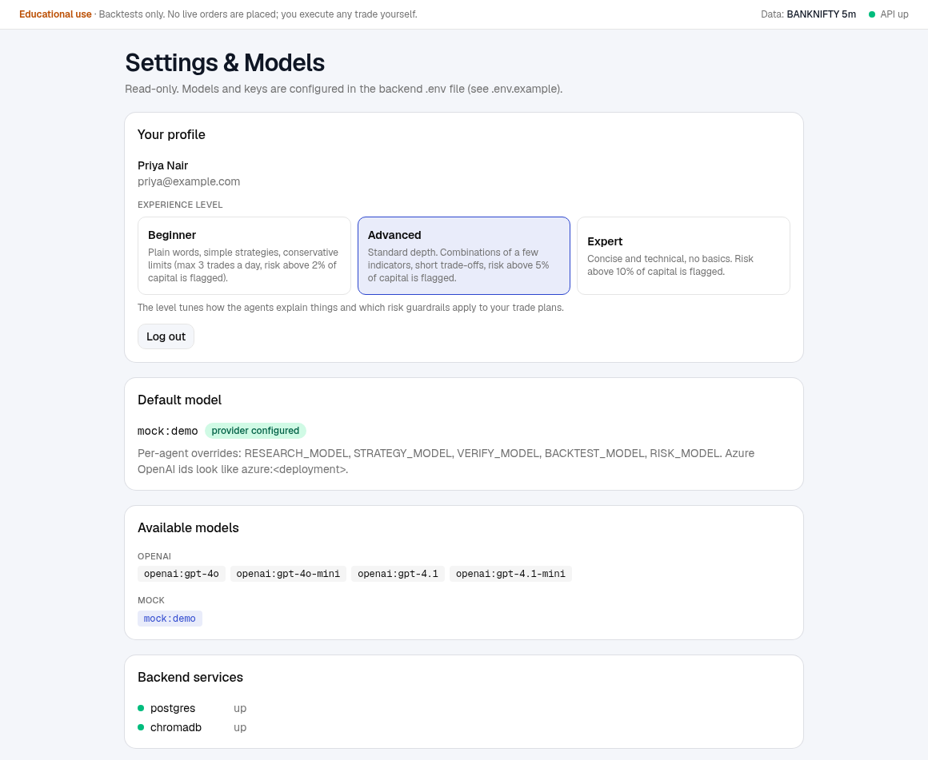
Settings: your profile and level on top, then the models and services.
Part | What it does
Your profile | Your name and email. Click Beginner, Advanced or Expert to change your level straight away. Log out is here too.
Default model | The model used when you do not pick one on the Strategy Desk, and whether its provider is set up.
Available models | Every model you can choose, grouped by provider. The default is highlighted.
Backend services | Whether the database and the search store are running.
Note: Models and keys are not changed here; whoever runs the app sets them in its configuration. If no real model is available you can only use the offline demo model.

4. Step-by-step recipes

A. From an idea to a paper trade
- Strategy Desk: write your query with the index, expiry and limits. Pick a real model. Press Generate strategy.
- Read AI recommendation. Check the verdict, the lots, the stop and target, and the reasons.
- Read the Risk review box in the pipeline panel. Note any red flags such as few trades or a big drawdown.
- Press Open full backtest results and look at the equity curve, drawdown and trade count.
- Happy to practise it? Go back and press Paper trade CE or Paper trade PE.
- On Paper Trading, press +12 candles a few times and watch the position.
- When it closes, open Profit & Loss and look at the day.

B. Test a strategy idea you already have
- Backtest > New backtest. Choose the dataset and the closest template (EMA Crossover or RSI Reversal).
- Set the dates and capital. Press Run backtest.
- Study the cards and charts. Filter the Trade log by exit reason to see where it loses.
- For a custom idea (your own indicators and limits), use the Strategy Desk and name the indicators in your query.

C. Review how you did last week
- Open Profit & Loss, Paper account tab.
- Press Last 7 days (or set From and To).
- Read the Net P&L and Win rate cards, then By exit reason: if most losses are stops, your stops may be too tight for the option.
- Click a bad day in By day and read its trades.

D. Start over with clean virtual money
- Open Paper Trading and press Reset account.
- Type the starting balance and confirm. Positions, orders and trades are deleted.
- Press Start clock again and choose a dataset.

E. Teach the research agent something new
- Open Knowledge Base.
- Upload a short .md or .pdf note.
- Search for it, then generate a plan on a related topic.

5. How the numbers are worked out
The AI writes the rules and the reasons. All numbers are worked out by ordinary program code, not by the AI, so they can be checked.

Lots, stop and target from your rupee limits
The app estimates the option's entry premium from the data (the typical at-the-money price at the first candle of the entry window). Then:
- Lots = your max loss divided by (premium x lot size x stop %), rounded down.
- Target % = your target profit divided by (lots x lot size x premium), as a percentage.
- If even one lot would lose more than your limit, the stop is tightened so that one lot fits, and a note says so.
Note: Worked example (BANKNIFTY, lot size 30). Max loss Rs 5,000 per trade, target Rs 12,000. Estimated premium Rs 769.74 and a 10% stop: one lot would lose 30 x 769.74 x 10% = Rs 2,309, so 2 lots fit (Rs 4,618, under Rs 5,000). For the target: 12,000 / (2 x 30 x 769.74) = 26%. That gives the plan you saw: 2 lots x 30 = 60, stop 10%, target 26%.

Why the plan can differ from what you typed
- Lots are whole numbers and are rounded down, so the real loss is a little below your limit and the real target a little off.
- The premium is an estimate from past data; real prices will differ.
- A Beginner profile adds a 3-trades-a-day cap and a risk note above 2% of capital.
- If the strategy has no stop, the app uses 20% before sizing.

Paper trading costs
Each closed trade pays 2 x Rs 20 brokerage plus 0.05% of (entry value + exit value). Example: buy 60 units at 400 and sell at 500 = gross Rs 6,000. Costs = 40 + 0.05% x (24,000 + 30,000) = Rs 67. Net = Rs 5,933.

6. Troubleshooting and FAQ
What you see | What it means and what to do
"Please log in again." or you are sent to the login screen | Your login ended (it lasts about a week, or you logged out elsewhere). Log in again.
"Invalid email or password" | Check both. The message is the same for a wrong email and a wrong password on purpose. After eight wrong tries within ten minutes the email is locked for a while.
"Describe your view or trade first." | The query box is empty. Type a request.
"Pick an underlying (NIFTY or BANKNIFTY)..." | Click NIFTY or BANKNIFTY, or mention it in your query.
"No BANKNIFTY dataset with option candles; load one first" | There is no market data for that index. Ask whoever runs the app to load a dataset.
"Provider ... is not configured" | The chosen model's service is not set up. Pick another model in the Model box, or ask for the key to be added.
Model box warns that the default is the offline mock model | Answers will be scripted and shallow. Choose a real model such as an OpenAI model for real reasoning.
Verifier says "needs changes" | The checker still saw issues after two revisions. Read the reasons, rephrase the query with clearer rules, or use the plan cautiously.
A step failed in the pipeline | Open the run from the Dashboard and read the red message under the step. Often running again fixes a temporary model error.
Backtest shows 0 trades or empty charts | The rules never triggered in that period, or the period is too short. Use a longer range or different rules.
"Start the market clock first: choose a dataset to replay" | On Paper Trading, pick a dataset and press Start clock.
"Insufficient cash: this order needs Rs ..." | Fewer lots, a cheaper option (further out of the money), or Reset account for a fresh balance.
"... is not an available expiry at the market time" | That expiry has no prices yet at the current market time. Pick one from the dropdown or move the market on.
"That contract has no price at the market time" | Pick another strike or move the clock.
"You hold N lot(s); selling to open is not supported" | Paper trading only sells what you already hold. Use Sell to close with up to your lots.
"Close your open positions (or reset the account) before ..." | You cannot restart the clock or switch dataset while positions are open. Close them or reset.
"The plan says 'sell PE': selling to open is not supported" | This plan sells options. Paper trading follows only plans that buy.
Expiry in the dropdown says "past" | The plan's expiry date has gone by in real time. It is still valid for replayed data, but for a real trade you would pick a current expiry.
The page shows an error box after an update | Refresh with Ctrl+Shift+R. If it stays, tell whoever runs the app.

FAQ
Is this real money? No. Paper trading uses virtual money, and the app cannot place real orders.
Are the prices live? No. They come from loaded datasets, fake or historical, replayed by a clock.
Why does my balance change when I do not trade? It does not. Your equity changes when the market clock moves and your open positions gain or lose value.
Can I sell an option I do not own? Not yet. Paper trading is buy-and-sell-to-close only.
Can two people share one account? Each person should have their own login. Strategies, backtests, runs and the paper account are private to each user.
How do I change my level? Settings & Models > Your profile > click a level.

7. Limits and safety
- Educational only. The app and its plans are research tools, not investment advice, and never promise profit.
- Data limits. Backtests and paper trading use the data you have loaded. Fake data has no real market behaviour. Real historical option data may be limited (for example only recent expiries from some providers).
- Estimates. Premiums, lots and costs are estimates. Real fills have slippage, delays and different charges.
- Lot sizes and expiry days change. Check them with the exchange or your broker before any real trade.
- One-direction practice. Only buying options is simulated, so spreads and selling strategies are not practised here.
- Your account. Use a strong password. Demo accounts and their shared password exist only for local testing and should be switched off anywhere else.
- In India, offering virtual trading to the public is regulated; the regulator has warned about unauthorised virtual-trading apps. Get proper advice before offering this app to others.

Appendix: sources used for the explanations
The wording of the glossary and the structure of this guide drew on the following public pages. They were checked in October 2026; details such as lot sizes and tax rates change, so verify them on the official sites.
- Zerodha Varsity: moneyness (ATM, ITM, OTM) and premium
- INDmoney: key F&O terms (lot size, strike price, premium)
- Wright Research: ITM vs ATM vs OTM options
- Zerodha Support: what happens at expiry for index options
- Wright Research: what is paper trading in India
- Strike.money: paper trading, how it works and its limits
- Docsie: user guides organised by task
- Avaya documentation standards: using screenshots

