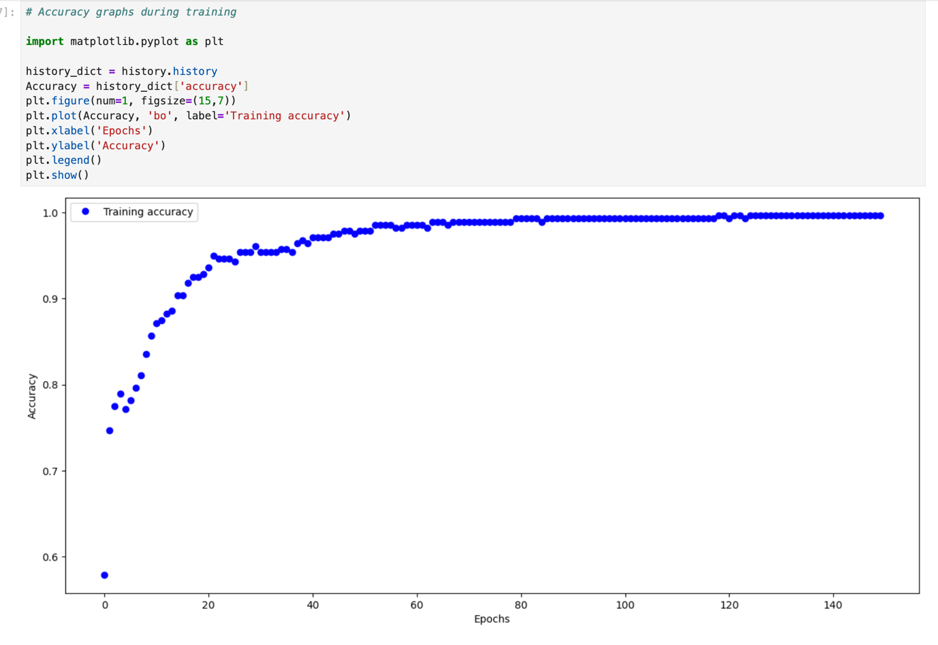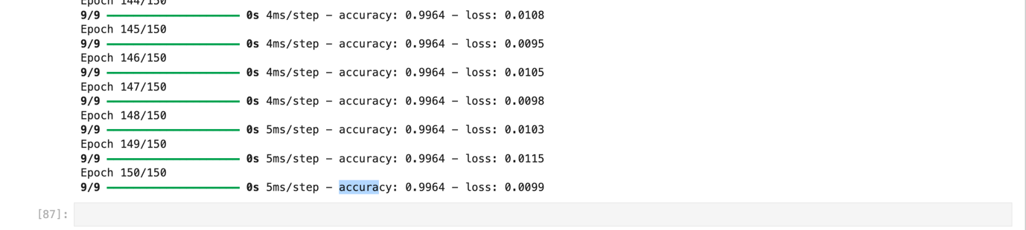
Final Accuracy: 0.996

Step 1: Input Calculation
Given:
$$x_{1}=\left(\frac{SID}{8964879}\right)⋅23 \\ x_{2}=\left(\frac{SID}{8964879}\right)⋅32 \\ x_{3}=\left(\frac{SID}{8964879}\right)⋅56 \\ x_{4}=\left(\frac{SID}{8964879}\right)⋅48$$
SID = 2456952
$$\frac{SID}{8964879}=\frac{2456952}{8964879}≈0.2740641564$$
Now compute inputs:
$$x_{1}=0.2740641564×23≈6.3035 \\ x_{2}=0.2740641564×32≈8.7701 \\ x_{3}=0.2740641564×56≈15.3476 \\ x_{4}=0.2740641564×48≈13.1551$$Sum of inputs:
$$S=x_{1}+x_{2}+x_{3}+x_{4}≈43.5762$$

Step 2: Hidden Layer 1 (h1, h2)
Weights:
$$w_{1}…w_{8}=0.2$$Both neurons receive the same weighted sum:
$$z_{h1}=0.2(x_{1}+x_{2}+x_{3}+x_{4})=0.2S \\ z_{h1}=0.2×43.5762=8.7152$$ReLU activation:
$$h_{1}=max⁡(0,z_{h1})=8.7152$$Similarly:
$$h_{2}=8.7152$$Step 3: Hidden Layer 2 (h3, h4)
Weights:
$$w_{9},w_{10},w_{11},w_{12}=0.1 \\ z_{h3}=0.1h_{1}+0.1h_{2} \\ z_{h3}=0.1(8.7152)+0.1(8.7152) \\ z_{h3}=1.7430$$
ReLU:
$$h_{3}=max⁡(0,1.7430)=1.7430$$
Similarly:
$$h_{4}=1.7430$$

Step 4: Output Layer (Sigmoid)
Weights:
$$w_{13},w_{14},w_{15},w_{16}=0.3$$
Bias:
$$b=0.5$$

Output O1
$$z_{o1}=0.3h_{3}+0.3h_{4}+0.5 \\ z_{o1}=0.3(1.7430)+0.3(1.7430)+0.5 \\ z_{o1}=1.5458$$Sigmoid:
$$O1=σ(z_{o1})=\frac{1}{1+e^{-z_{o1}}} \\ O1=\frac{1}{1+e^{-1.5458}}≈0.8243$$Output O2
Same calculation:
$$z_{o2}=1.5458 \\ O2=σ(1.5458)≈0.8243$$

Answer
$$\boxed{O1≈0.8243} \\ \boxed{O2≈0.8243}$$

