**TECH CONATIVE – ASSIGNMENT**

1. *ChatGPT*

PROMPT: “A busy and realistic scene inside the New York Stock Exchange (NYSE) trading floor. The room is filled with traders and people engaged in conversation, standing near circular desks ( Focus a bit closer on one circular desk) filled with multiple monitors displaying stock market data. Large electronic displays with 'NYSE' logos are placed prominently throughout the space. American flags are hanging using a rod from the ceiling and there are 2 hanging flags on both sides and one hanging flag straight end of the picture. All flags are hung using white rods, and the floor has a wooden finish. The architecture of the building includes high ceilings with visible metal beams and a large glass window façade at the back, letting in natural light. Make the flags hanging using rods. And focus the table on the center with a perfect straight vertical view. No angled images. The environment is bustling with activity, capturing a financial and business atmosphere. Generate a "realistic image" based on the following environment envisioned. ”

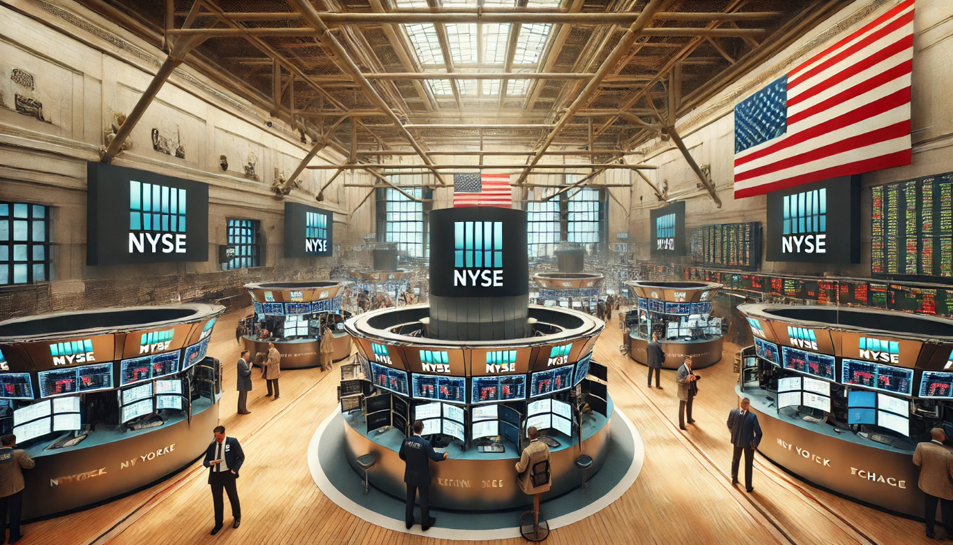

[*https://www.freepik.com/pikaso/ai-image-generator*](https://www.freepik.com/pikaso/ai-image-generator)

PROMPT 2: “A busy and realistic scene inside the New York Stock Exchange NYSE trading floor. The room is filled with people engaged in conversation, standing near the center large circular desk. Focus a bit closer on one circular desk filled with multiple monitors displaying stock market data. Large electronic displays with 'NYSE' logos are placed prominently throughout the space. One American flag iis hanging using a rod from the ceiling on the left wall and One American flag on the right wall symmetrically and one flag hanging at the straight end of the picture. All flags are hung using white rods, and the floor has a wooden finish. The architecture of the building includes high ceilings with visible metal beams and a large glass window façade at the back, letting in natural light. Focus on the center with a perfect straight vertical view. The environment is bustling with activity, capturing a financial and business atmosphere. Generate a colorful 'realistic image' of "45 degree drone view" of the environment envisioned. 45 degree Drone view with people too”

