**HW_Lect_2_1**

**a)**

|  |  |  |  |
| --- | --- | --- | --- |
| Overall | Potential | Weak Foot | Skill Moves |
| 94 | 94 | 4 | 4 |
| 94 | 94 | 4 | 5 |
| 92 | 93 | 5 | 5 |
| 91 | 93 | 3 | 1 |
| 91 | 92 | 5 | 4 |
| 91 | 91 | 4 | 4 |
| 91 | 91 | 4 | 4 |
| 91 | 91 | 4 | 3 |
| 91 | 91 | 3 | 3 |
| 90 | 93 | 3 | 1 |
| 90 | 90 | 4 | 4 |
| 90 | 90 | 5 | 3 |
| 90 | 90 | 3 | 2 |
| 90 | 90 | 2 | 4 |
| 89 | 90 | 3 | 2 |
| 89 | 94 | 3 | 4 |
| 89 | 91 | 4 | 3 |
| 89 | 90 | 3 | 4 |
| 89 | 92 | 4 | 1 |
| 89 | 90 | 2 | 1 |
| 89 | 89 | 3 | 3 |
| 89 | 89 | 4 | 3 |
| 89 | 89 | 4 | 1 |
| 89 | 89 | 4 | 4 |
| 89 | 89 | 3 | 2 |
| 88 | 95 | 4 | 5 |
| 88 | 89 | 3 | 4 |
| 88 | 90 | 3 | 2 |
| 88 | 89 | 3 | 4 |
| 88 | 88 | 3 | 4 |
| 88 | 91 | 3 | 4 |
| 88 | 91 | 5 | 4 |
| 88 | 89 | 4 | 5 |
| 88 | 88 | 4 | 4 |

This is only an excerpt of my data. I didn’t think it was necessary to print out the thousands of data points I used to construct my histogram.

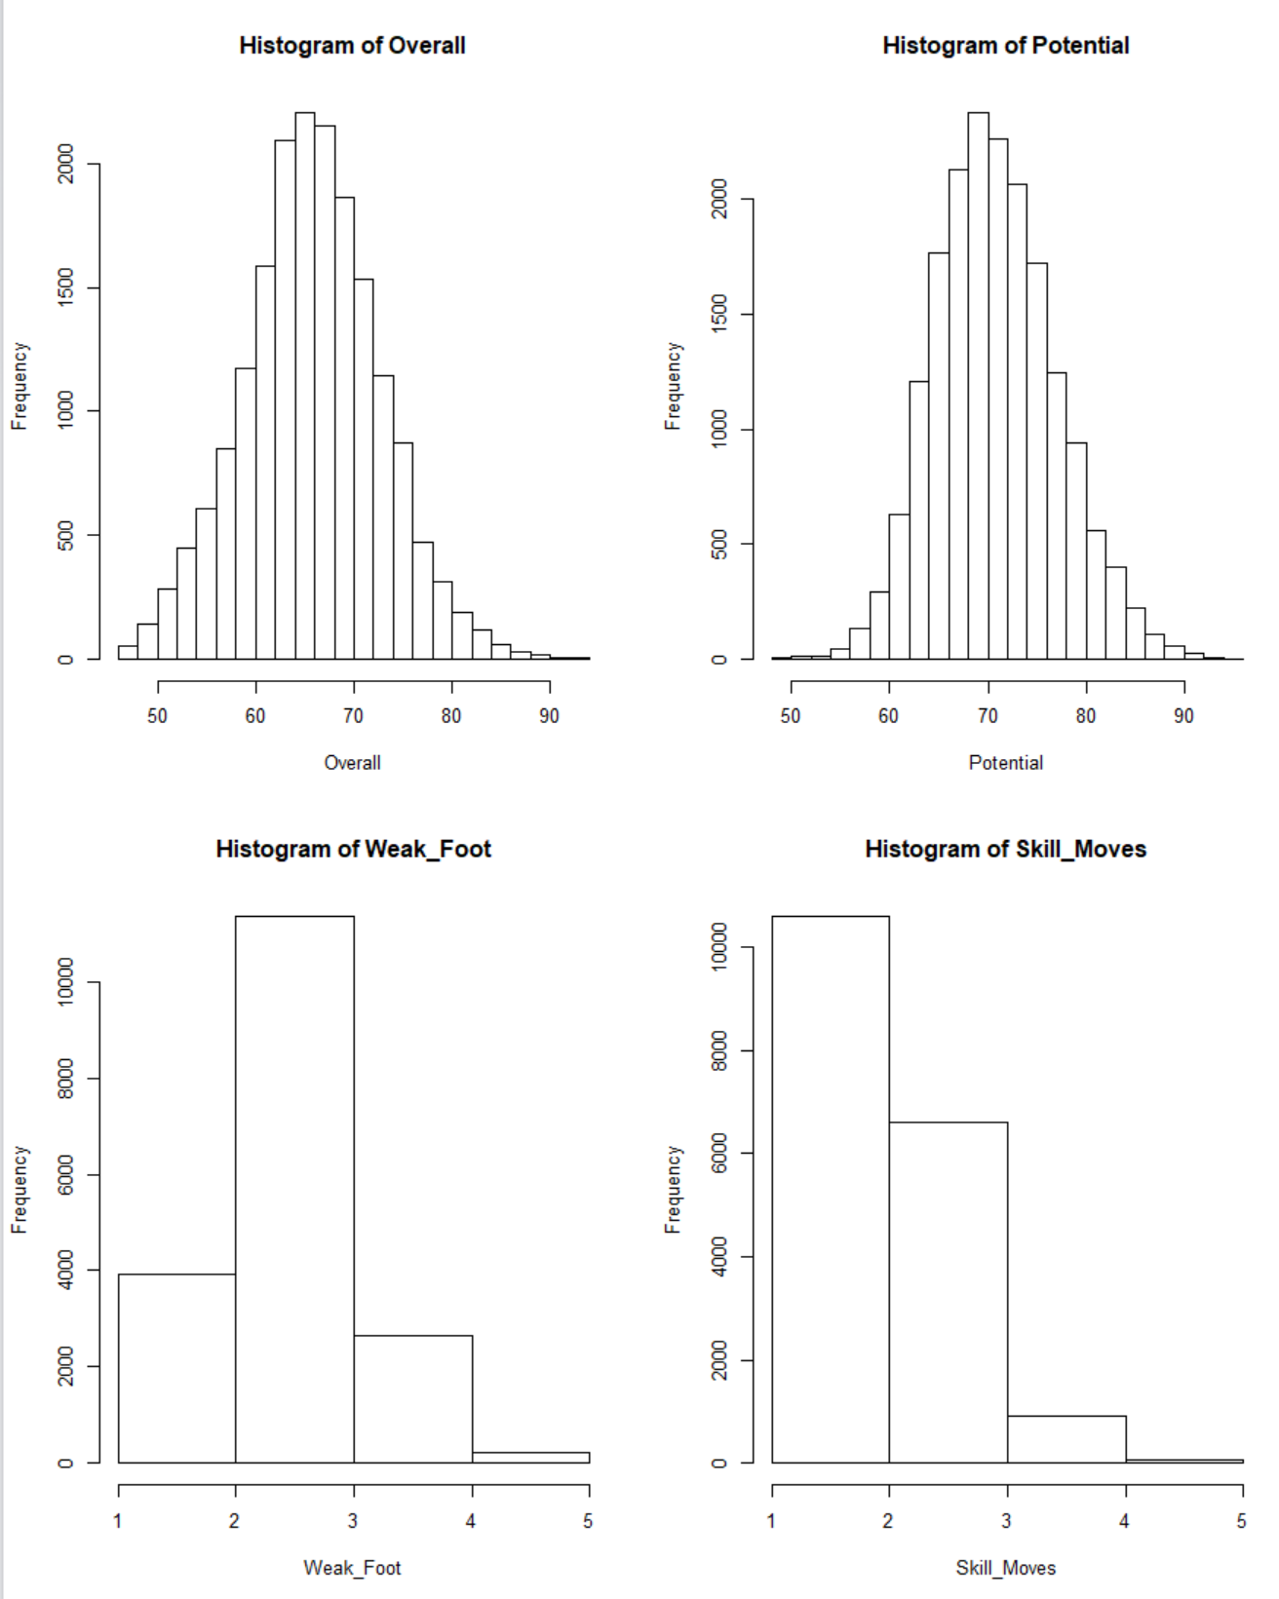**b)**

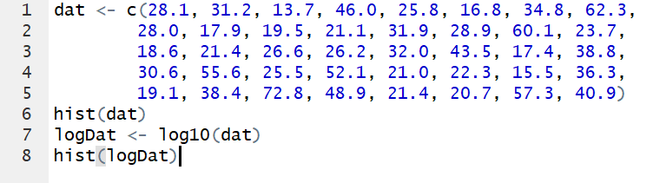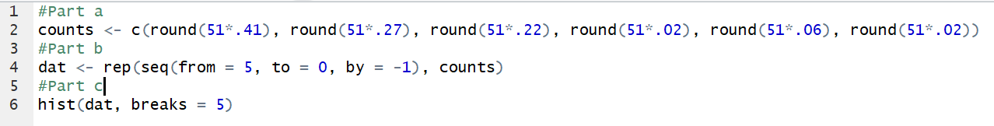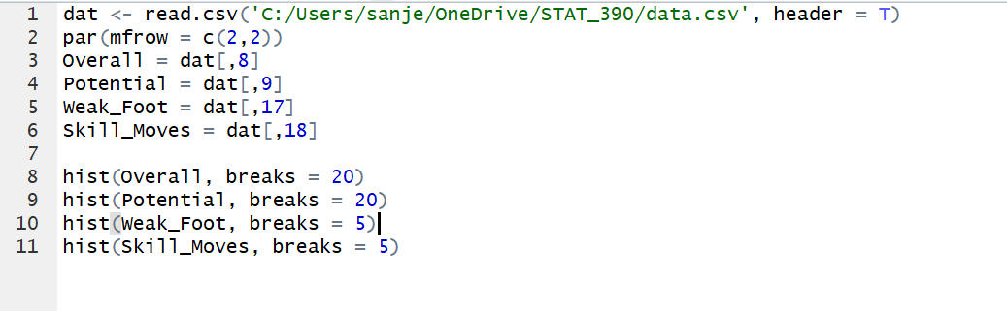**HW_Lect_2_2**

**1.16**

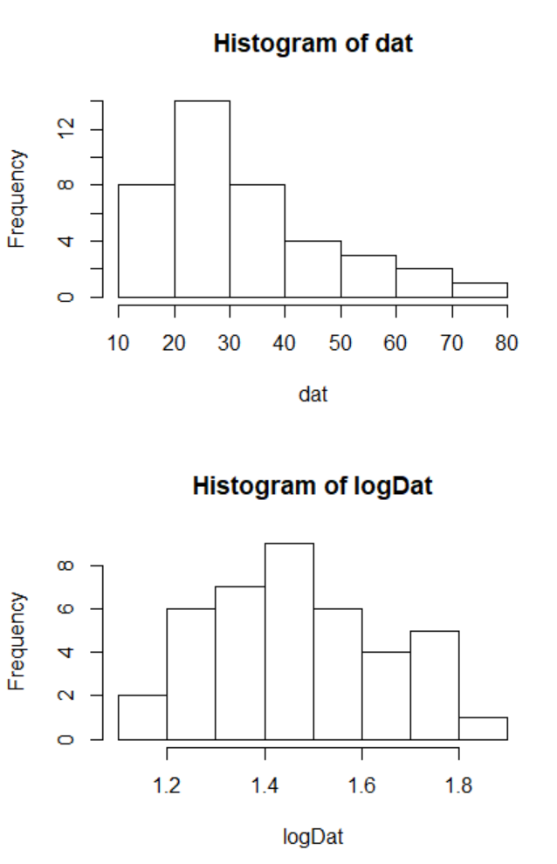

This transformation causes the histogram to be less skewed and more symmetric.