**HW 3**

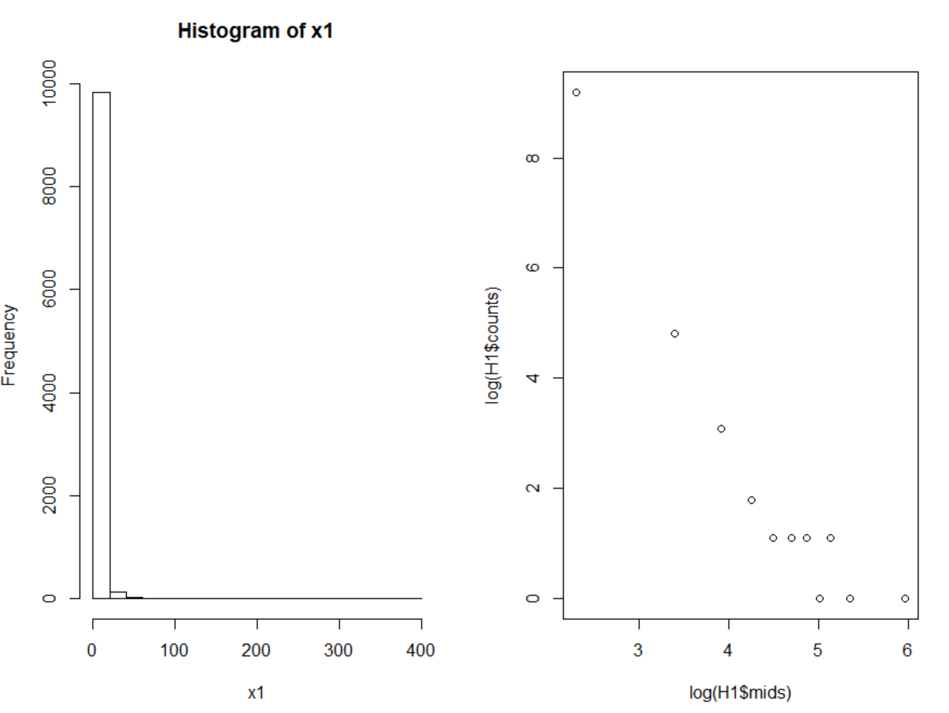**HW_Lec3_3**

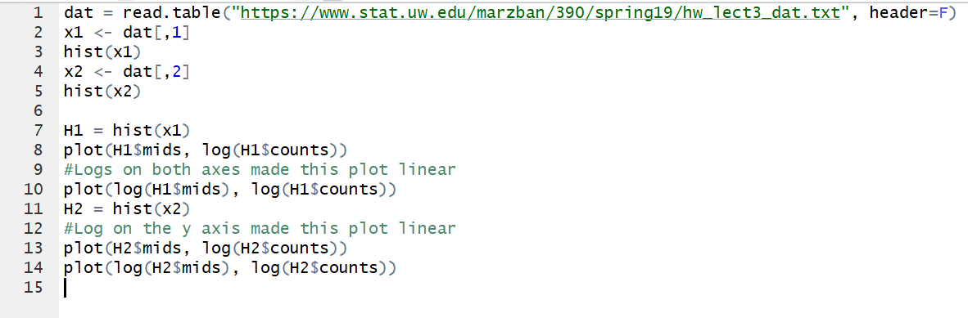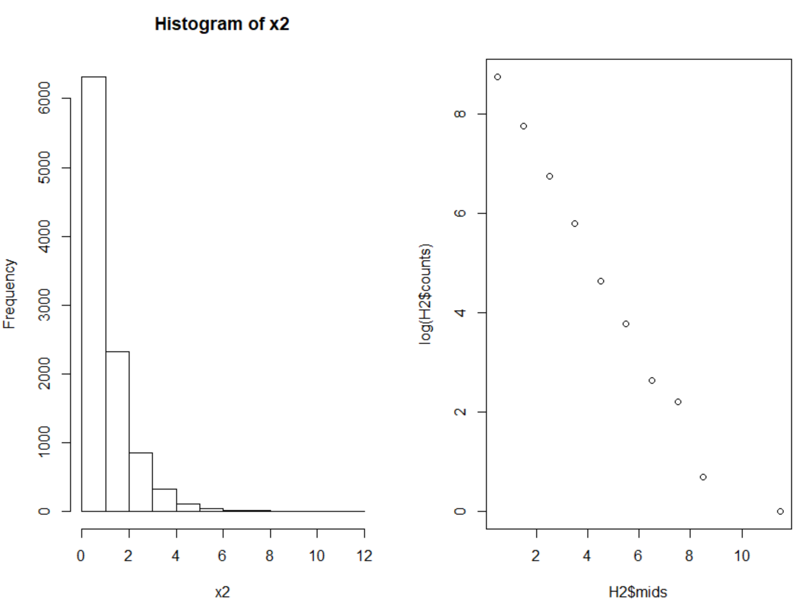

The first column is the power law and the second column is exponential. This is because the second plot became linear when both axes were logarithmic whereas the first column only needed the y axis to be logarithmic.