**HW 6**

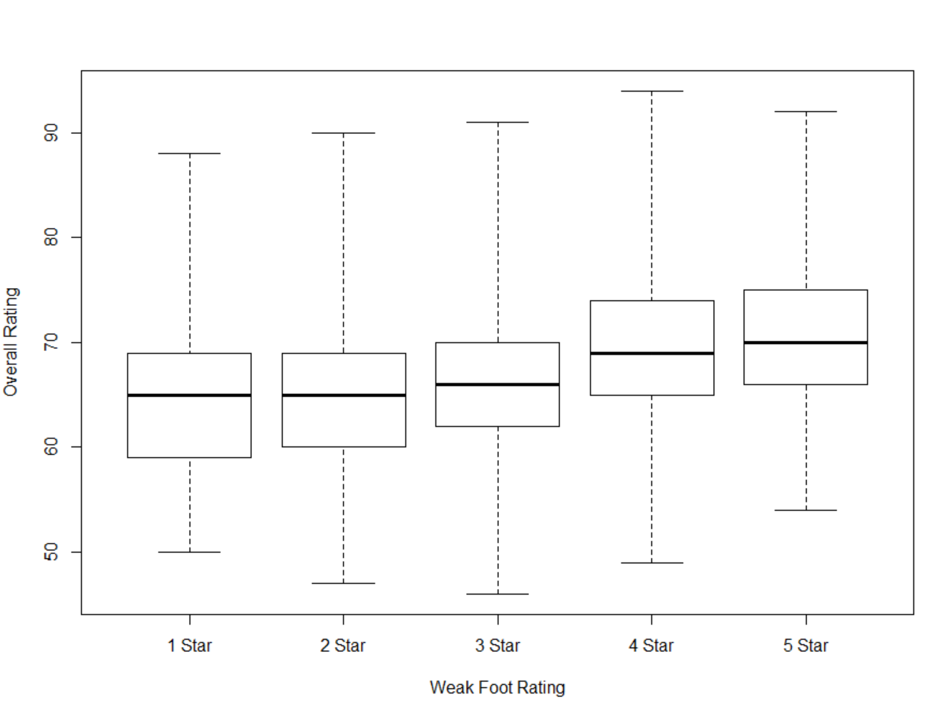Lect6-4

FIFA is a video game where you can play as real soccer teams. Each player has an overall rating ranging from about 40 to 95 (the continuous variable) and a rating for their weaker foot, which can have 1, 2, 3, 4, or 5 stars (the discrete variable). Since there’s a lot of overlap between these boxplots its hard to draw any conclusions. I would have expected to see players with higher ratings for their weak foot to have higher overall ratings, but the presence of heavy overlap does not support this hypothesis.