**HW-Lect10-2**

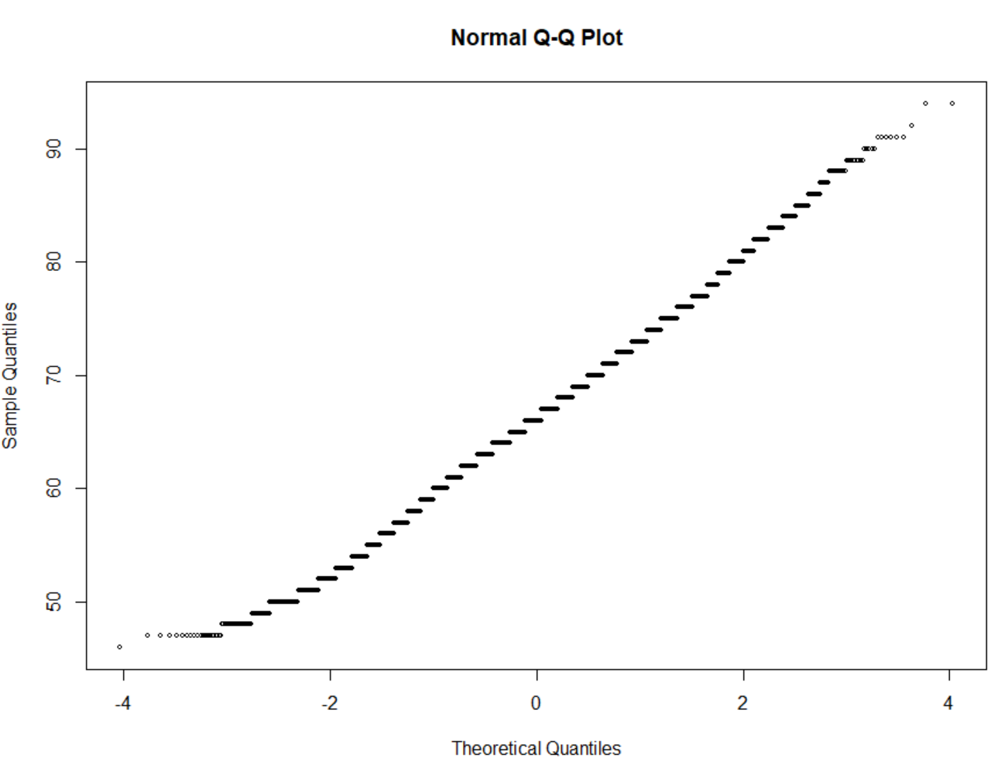

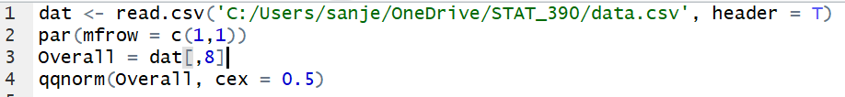

Since my Q-Q Plot looks like a straight diagonal line, I can assume that my data comes from a normal distribution. The fact that my data is a straight line means that it has a direct linear relationship with the theoretical quantiles from the normal distribution.