HW 9 Stat 390

**hw-lect27-1**

HW 27

#a

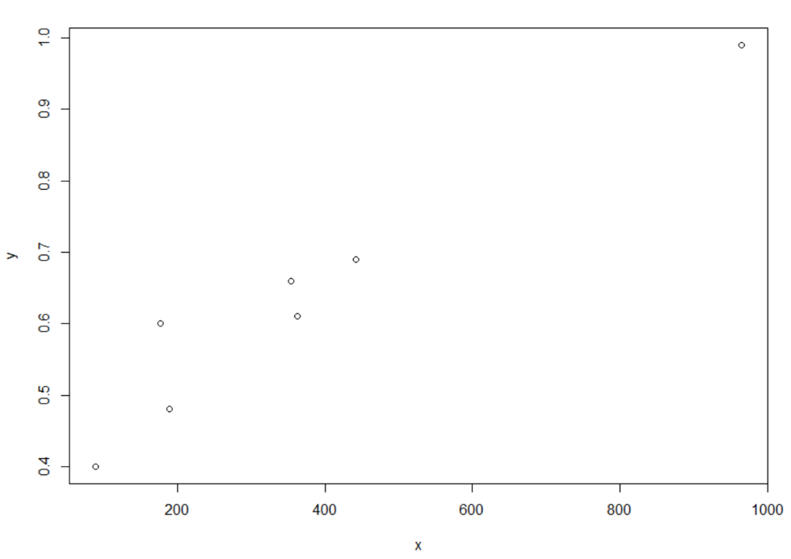

#b

The point estimate of the beta coefficient is 0.0006211. This means that on average a change of 1 unit in x results in a change of 0.0006211 in the predicted value of y.

#c

The typical error for the regression line is 0.05405.

Code used:

