|  |  |  |  |  |
| --- | --- | --- | --- | --- |
| SKILLS EVALUATION SHEET | | | | |
| **Candidate Name:** | | SHAIK SADIK | | |
| **On Bench resource / Sourced externally** | | Bench | | |
| **Total Experience:** | | 2.8years | | |
| **Relevant Experience:** | | 2.8Years | | |
| **Notice Period:** | | NA | | |
| **Candidate available to Join Qualcomm by date DD/MM/YYYY** | | Immediate | | |
|  | | | | |
| **Qualcomm Inputs** | | **Supplier Inputs** | | |
| **Skills possessed by the candidate to perform the role efficiently** | **Mandatory**  **/ Optional** | **Name of Projects in which the skills were used (add rows if necessary)** | **No: of months worked in each Project** | **Description of work done using the skills & Rating (0-5) (5 -**  **High,0- - Low)** |
| C & Embedded C | Mandatory | Smart weather monitoring system | 3 | 4 |
| Python | Mandatory | Automation Development | 18 | 3.5 |
| Validation | Mandatory | Post Silicon Validation | 12 | 4 |

**SHAIK SADIK** 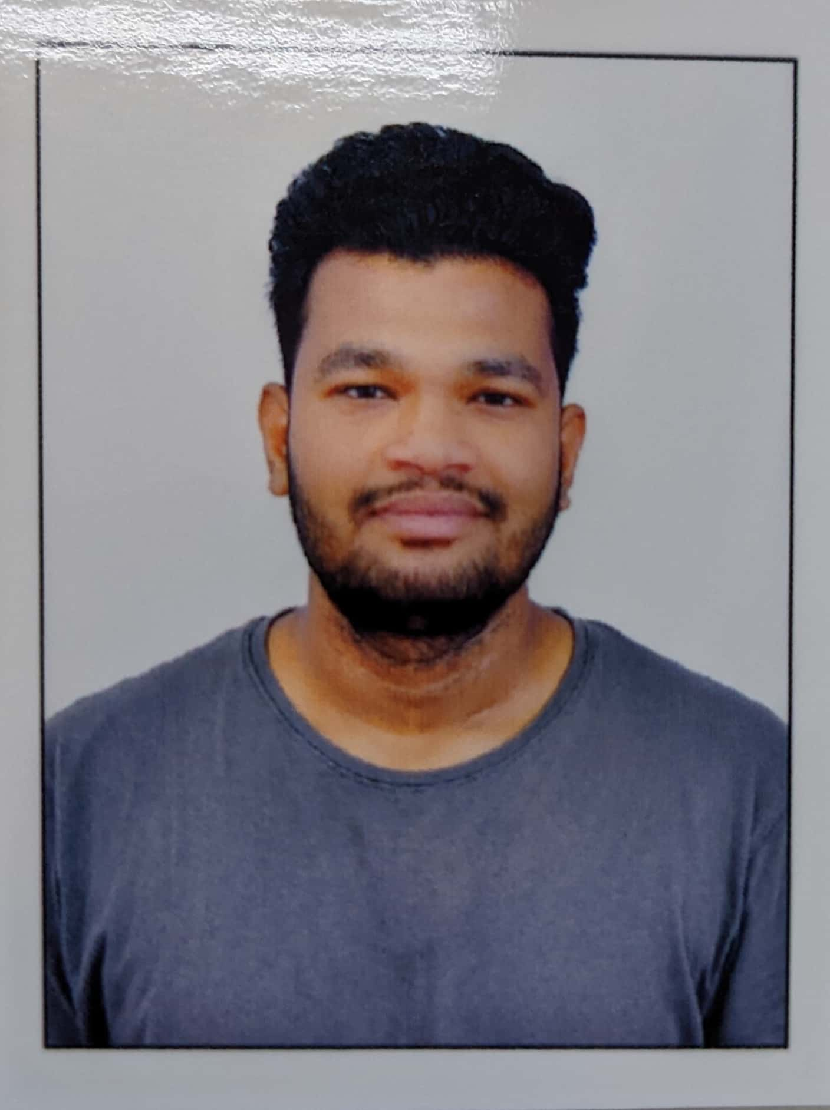

**Mobile No: 7032504606**

**Gmail ID: reshusadik3018@gmail.com**

**Address: Kondapur,Hyderabad,500032**

# CAREER OBJECTIVE

To be associated with organization that provides scope to update skills in accordance with latest technology and to be part of team which dynamically works towards the growth of organization and provide job satisfaction.

# EXPERIENCE SUMMARY

**Mirafra Software Technologies Pvt Ltd (Client-AMD)**.

**Hyderabad**

**Role:** Software Engineer 1 DEC 2022 - PRESENT

**Project title:** Device Model and Timing Support engineer at AMD

**Project description:**

* Playing a crucial part in the capture of FPGA devices, such as providing software support for FPGA.
* Performed FPGA Timing capture to facilitate timing support on Vivado software.
* Developed some of the tasks using python which will reduce the manual work.
* Debugged the script related issues and tool related issues.
* Developed multiple checks for the flow which will error out if data is wrong.
* Submitted multiple Speedfiles, timing related files in perforce.
* Given timing and package support for more than 10 devices.
* Worked on spliting of orginal flow into 2 parts which will reduce the execution time and memory

**L&T Technology Services , Bangalore:**

**Role: Post Silicon Validation Engineer**

**Duration: Sep 2021-2022**

**Team:** BKC post silicon validation team

**Platform:** Working on Eaglestream Serverplatform.

**OS used for validation:** Windows 10 & 11 ,Linux Environment.

**Tools Used:** BMC, Putty, PTU, IPMI, Banino, USB blaster, ITP

**Defect Cycle Management:** Intel HSD

* Responsible for installing OS using different methods and flashing IFWI, BMC, and CPLD using the banino method and dediprog.
* Experienced working on RASP systems and internal systems too.
* Setting up HOST and SUT with open associates.
* Experienced in loop execution.
* Execution on different domains like BIOS, Ucode, and SPS.
* Execution of Automated scripts and analyzing and debugging the logs if any issues are found.
* System level failure analysis to root cause the failures.
* Experience of running test cases by using jenkins.
* Experience on changing hardware like silicon,dims,pch .

# EMPLOYMENT

Working as Software Engineer-I in Mirafra Software Technologies Pvt Ltd at Hyderabad since Dec 2022 to till date.

Worked as a Post Silicon Validation Engineer in L&T technology from Sep 2021 - 2022.

# TECHNICAL PROFICIENCY & TOOLS

**Languages**  : Python, OOPS, C, Embedded C, Perforce, Cron ,Pandas

**Protocols used**  : I2C, UART, SPI

**Embedded Boards and tools:** FPGA, Zynq

**Operating System**  : Windows, Linux

**Other Tools**  : Hands-on experience with applications like BMC web console, Raritan, Spider View, Glasgow, JIRA, HSD, and Putty. Dediprog, Banino board, ladybird programmer, Quarts prime, and ITP knowledge on setting BMC IP both dynamically and statically

# EDUCATION

## B. Tech (ECE) 2016-2020

Sri Venkateswara Engineering College, Suraypet with 7.0 CGPA

# DECLARATION

I, Shaik Sadik, hereby declare that all the above written particulars are true to the best of my knowledge and belief.

Hyderabad Shaik Sadik