PRODUCT REQUIREMENTS DOCUMENT
Course Registration & Feedback Management System
Object-Oriented Programming through Java – Project-Based Learning (PBL)
Project | Course Registration & Feedback Management System (CRFMS)
Course | Object-Oriented Programming through Java (PBL)
Prepared by | [Student name / team members]
Roll number(s) | [Roll number(s)]
Project guide | [Guide name]
Institution | [College / department]
Document version | 1.1
Date | 05 October 2026
Status | Draft for guide review

Fill in the bracketed fields before submission. Defaults and limits marked as proposals can be changed to match your institution’s rules.

Contents
1. Introduction and Overview
1.1 Purpose of This Document
1.2 Understanding the Project in Plain English
1.3 Problem Statement
1.4 Vision and Goals
1.5 Project Objectives
1.6 Scope
1.7 Assumptions, Constraints and Dependencies
1.8 Success Criteria
2. Users, Roles and Permissions
2.1 User Roles
2.2 Illustrative Personas
2.3 Permission Matrix
3. Object-Oriented Concepts Used in This Project
3.1 Why This Project Suits an OOP Course
3.2 Start Here: Classes and Objects
3.3 The Four Pillars of OOP, Explained with CRFMS
3.4 Concept Map: Where Each Idea Appears
4. Functional Requirements
4.1 How to Read the Requirements
4.2 Module Overview
4.3 Authentication and Security (AUTH)
4.4 User Management (USR)
4.5 Course Management (CRS)
4.6 Course Registration (REG)
4.7 Feedback Management (FBK)
4.8 Reports (RPT)
4.9 System Settings (SET)
4.10 Data Management and Logging (DAT)
4.11 General Behaviour (GEN)
4.12 Business Rules
4.13 Input Validation Rules
5. User Stories and Use Cases
5.1 Use Case Overview
5.2 User Stories
5.3 Detailed Use Case Specifications
6. Non-Functional Requirements
7. System Design
7.1 Architecture: Four Layers
7.2 Package and Folder Structure
7.3 Class Design
7.4 Interfaces (DAOs) and Services
7.5 Data Storage Design
7.6 Registration Flow
7.7 Design Patterns Used
7.8 Exception Handling Design
7.9 Security Design
8. User Interface Design (Console)
8.1 Design Principles
8.2 Menu Structure
8.3 Sample Screens
8.4 Message Standards
8.5 Optional Graphical Interface (Release 3)
14. Advanced Feature Pack (Release 4)
14.1 Purpose and Honest Framing
14.2 Feature Catalogue (28 Features)
14.3 Detailed Requirements
14.4 New Business Rules
14.5 Doubt Bot Design
14.6 Teaching Feedback Design
14.7 Faculty Improvement Engine Design
14.8 Class Design for the New Features
14.9 Data and Permissions
14.10 Screen Additions
14.11 Additional Test Cases
14.12 What Has Been Verified
14.13 Plan, Effort and Risks for Release 4
14.14 Optional Upgrades Beyond This PRD
Appendix E: Extended Database Schema (Advanced Features, Optional)
9. Technology, Tools and Development Standards
9.1 Technology Stack
9.2 Coding Standards
9.3 Version Control Practice
9.4 Build and Run (without any build tool)
9.5 Sample Data for Demo and Testing
10. Testing and Quality Plan
10.1 Test Strategy
10.2 Unit Test Example
10.3 System Test Cases
10.4 What Has Already Been Verified
10.5 Requirement-to-Test Traceability
10.6 Code Review Checklist
10.7 Defect Log Template
11. Project Plan, Milestones and Risks
11.1 Suggested Eight-Week Plan
11.2 Milestones
11.3 Team Roles (if working in a group)
11.4 Risk Register
11.5 Decisions to Confirm with Your Guide
12. Deliverables, Demo and Evaluation Preparation
12.1 Deliverables Checklist
12.2 Demo Script (about 10 minutes)
12.3 Self-Evaluation Rubric
13. Future Enhancements and Closing Notes
13.1 Future Enhancements
13.2 Final Advice
Appendix A: Glossary
Appendix B: Output of the Verification Run
Appendix C: Relational Database Schema (Optional, Release 3)
Appendix D: Viva Preparation Questions
Appendix F: Document Control

1. Introduction and Overview

1.1 Purpose of This Document
This Product Requirements Document (PRD) is the complete blueprint for the Course Registration & Feedback Management System (CRFMS), your Object-Oriented Programming through Java project-based learning (PBL) project. A PRD answers three questions before any code is written:
- What are we building? (the features and the rules they follow)
- Who is it for? (the people who will use it and what each of them is allowed to do)
- How will we know it works? (tests and measurable success criteria)
The readers of this document are you (the developer or team), your project guide, and the evaluators. It is written so that someone who has never written a line of Java can still follow the whole story.
Beginner tip: Every Java or OOP term is explained in plain words where it first appears, and Appendix A is a glossary you can return to at any time. If a word looks unfamiliar, check there first.

How this document is organised
Sections | What you will find | Why it matters
1 – 3 | The big picture: what the system is, who uses it, and which OOP ideas it demonstrates. | Makes sure everybody understands the topic the same way.
4 – 6 | Exact requirements: features, business rules, user stories, use cases, quality targets. | The checklist you will build against and be tested against.
7 – 8 | Design: layers, classes, data files, database, flows, security and screens. | Turns requirements into a structure you can code.
9 – 10 | Tools, coding standards, and the full testing plan with test cases. | Keeps the work consistent and proves it works.
11 – 13 | Week-by-week plan, risks, deliverables, demo script and future ideas. | Helps you finish on time and present well.
14 | Advanced Feature Pack (Release 4): doubt bot, multi-type teaching feedback, faculty improvement suggestions and 25 more features. | Makes the project stand out; built only after the core is working.
Appendices | Glossary, verified sample Java code, SQL schemas, viva questions. | Quick reference while coding and preparing.

1.2 Understanding the Project in Plain English
Imagine a college where, every term, students must choose the subjects (called courses) they will study. Each course has a limited number of seats, belongs to a teacher (called faculty), and carries a number of credits. Today the choosing is often done on paper or in spreadsheets, which is slow and easy to get wrong.
CRFMS is a Java program that replaces that paper work. Its name tells you its two jobs:
- Course Registration – students pick and drop courses, and the program instantly checks the rules (is registration open, is there a free seat, is the student already in this course, will the total credits stay within the limit).
- Feedback Management – after attending a course, students rate it and leave a comment. Faculty and the admin see averages and anonymous comments, so teaching can improve.
Three kinds of people use the system: the Admin (sets everything up and controls the rules), Faculty (teach the courses and read the feedback), and Students (register and give feedback).

A day in the life of the system
Step | Who | What happens
1 | Admin | Logs in, adds faculty, students and courses, sets the credit limit and opens the registration window.
2 | Student | Logs in and browses the course catalogue. Each course shows its credits, faculty and how many seats are left.
3 | Student | Registers for a course. The system checks every rule at once and either confirms the registration or explains exactly why it was refused.
4 | Student | Changes their mind: drops one course and registers for another while the window is still open.
5 | Faculty | After registration closes, opens a course and sees the list of enrolled students.
6 | Admin and Students | At the end of the term the admin opens the feedback window. Students rate their registered courses (1 to 5 on four criteria) and add an optional comment.
7 | Faculty and Admin | Read averages and anonymous comments; the admin also generates enrolment and rating reports and exports them.
Note: CRFMS is deliberately a console (text-menu) application that stores data in files. This keeps the focus on object-oriented design rather than on screens or databases. A graphical interface (Swing) and a real database (JDBC) are planned as optional upgrades, and the design makes them easy to add later (see Sections 7 and 13).

1.3 Problem Statement
In many colleges, course registration and course feedback are handled with paper forms, spreadsheets or chat groups. These manual methods cause avoidable problems:
- Errors and duplicates – the same student can be entered twice for a course, or a class can end up with more students than seats.
- No live information – students cannot see how many seats are left, so they may choose a course that is already full.
- Heavy administrative work – staff re-type forms, count seats by hand and update lists after every change.
- Inconsistent rules – limits such as the maximum credits per term depend on someone remembering to check them.
- Slow, hard-to-use feedback – paper feedback must be collected, counted and summarised by hand, so results arrive late or never.
- Weak privacy – students hesitate to be honest when feedback is not clearly anonymous.
CRFMS addresses these problems by moving the process into a program that enforces the rules automatically, keeps one trusted copy of the data, and summarises feedback instantly.

1.4 Vision and Goals
Vision: A simple, reliable and fair registration-and-feedback tool whose code is also a clean, well-structured example of object-oriented design in Java.
- Remove registration errors by making it impossible to break a rule through the program.
- Give students instant, accurate information (seats left, credits used, what they have registered).
- Give faculty and the admin useful, anonymous feedback summaries.
- Produce code that is well organised, tested and easy for you to explain confidently in your viva.

1.5 Project Objectives
ID | Objective | How it will be checked
O1 | Provide a complete role-based system for Admin, Faculty and Student, each with their own menu. | Demo: log in as each role; each one sees only its own menu and data.
O2 | Enforce all registration rules automatically (window open, seat available, no duplicate, credit limit). | Test cases TC-13 to TC-21 pass.
O3 | Collect structured, anonymous feedback (ratings and comments) and summarise it. | Test cases TC-22 to TC-27 pass; sample report produced.
O4 | Save all data permanently and reload it when the program starts. | Test cases TC-29 and TC-30 pass.
O5 | Demonstrate OOP: classes and objects, encapsulation, inheritance, polymorphism, abstraction, interfaces, exceptions, collections and file I/O. | Concept map in Section 3.4 is filled with real class names; viva demonstration.
O6 | Deliver professional artefacts: PRD, UML design, source code, test report, project report, presentation. | Deliverables checklist in Section 12 is complete.
O7 | Close the feedback loop: give students a doubt assistant and detailed teaching feedback, and give faculty rule-based improvement suggestions (Section 14). | Wave 1 test cases TC-35 to TC-39, TC-44 to TC-54 pass; demo of the full loop.

1.6 Scope

In scope
Area | Included in CRFMS
Accounts and security | Login and logout, role-based menus, password change, salted password hashing, temporary lock after repeated wrong passwords.
User management | Admin adds, views, searches, updates and deactivates students and faculty.
Course management | Admin adds, updates, deactivates courses and assigns faculty; everyone can browse and search the catalogue.
Registration | Register, drop, view registrations and total credits; rule checking; registration window and credit limit controlled by Admin.
Feedback | Four-criteria rating plus comment per registered course; edit while the feedback window is open; anonymous summaries for faculty and admin.
Reports | Enrolment, student summary, feedback summary, faculty ratings, low-rated courses; export to CSV.
Data and logging | File-based persistence, safe saving, audit log of important actions.

Out of scope
- Web or mobile applications, and any network or multi-user access at the same time.
- Fee payment, grades or results, attendance, hostel or library features.
- E-mail or SMS notifications, and single sign-on with other systems.
- Student self-sign-up (accounts are created by the Admin so that nobody can create a fake account).
- Prerequisite checking (future enhancement, Section 13). Waiting lists, timetable clash checks, a doubt assistant and teaching-feedback analytics are not in Release 1; they are specified as the optional Release 4 in Section 14.

Release plan
The scope is split into four releases so that you always have a working project, even if time runs short. Priorities use the MoSCoW scale: Must (project fails without it), Should (important, include if at all possible), Could (nice to have).
Release | Contents | Priority
Release 1 – Core (MVP) | Console application; file storage; login and roles; user, course, registration and feedback modules; all business rules; basic enrolment and feedback reports. | Must
Release 2 – Enhanced | Account lock-out, password reset by Admin, audit log, search and filters, CSV export, pending-feedback list, backup export. | Should
Release 3 – Stretch | Swing graphical interface, optional JDBC database storage. | Could
Release 4 – Advanced Feature Pack | 28 extra features (Section 14): doubt bot with escalation to faculty, ten-category teaching feedback with quick-tags and suggestions, faculty improvement suggestions, action plans, waiting list, timetable, notifications and more. Build in three waves; start only after Release 1 passes. | Should

1.7 Assumptions, Constraints and Dependencies

Assumptions
- The program runs on one computer for one user at a time (no simultaneous users).
- Only one academic term is active at a time; a new term is started by adding new course records.
- Course codes are unique and are never reused for a different subject.
- The Admin creates all accounts and gives each user an initial password, which the user must change at first login.
- A JDK (Java Development Kit) is installed on the computer used for development and for the demo.

Constraints
- Fixed academic deadline for the PBL submission (the plan in Section 11 is a suggestion; adjust it to your real dates).
- Only core Java libraries are used (plus JUnit for testing); no paid tools or external servers.
- The project must clearly demonstrate the OOP concepts taught in the course.

Dependencies
- JDK 17 or newer (the sample code in this document was compiled and run on JDK 21).
- A code editor or IDE (VS Code, IntelliJ IDEA Community, Eclipse or NetBeans).
- Optional: JUnit 5 for unit tests, Git for version control, MySQL or SQLite plus a JDBC driver for Release 3.

1.8 Success Criteria
The project is considered successful when all of the following are true:
- 100% of the Must requirements in Section 4 are implemented and demonstrated.
- All test cases in Section 10 marked Must pass, and invalid input never crashes the program.
- Data entered in one run is still present in the next run.
- At least one clear, explainable example exists in the code for each OOP concept in Section 3.4.
- The deliverables in Section 12 are complete and the live demo runs from start to finish without fixing code on the spot.

2. Users, Roles and Permissions

2.1 User Roles
Role | Who they are | Main goals | Typical tasks
Admin | Academic office staff or system administrator. | Keep data correct, control the rules, and monitor results. | - Create and manage users and courses  - Open or close registration and feedback windows  - Set the credit limit  - Generate and export reports
Faculty | Teachers who are assigned to courses. | Know who is enrolled and understand how students rate the course. | - View own courses and rosters  - View feedback averages and anonymous comments for own courses
Student | Learners who register for courses. | Choose a valid set of courses quickly and give honest feedback. | - Browse and search courses  - Register and drop courses  - Submit or edit feedback

2.2 Illustrative Personas
Personas are short, made-up profiles that help a design team keep real users in mind. These three are illustrative examples, not real people.
Persona | Needs | Frustration today | How CRFMS helps
The Student | Pick a valid timetable quickly and see exactly what is registered. | Finds out late that a course is full or that the credit limit was exceeded. | Live seat count and instant rule checks with clear messages.
The Faculty member | Know the class size and hear honest opinions. | Paper feedback is slow to collect and rarely summarised. | Roster on demand and instant anonymous averages and comments.
The Admin | Control registration periods and keep data consistent. | Re-types forms, counts seats by hand, fixes duplicates. | Central control panel, automatic rule enforcement and one-click reports.

2.3 Permission Matrix
The matrix below defines who may do what. These permissions are enforced in the service layer (Section 7), not only by hiding menu options, so a mistake in the screen code can never grant access by accident.
Feature | Admin | Faculty | Student
Log in, log out, change own password | Yes | Yes | Yes
Create, update and deactivate students and faculty | Yes | No | No
Reset another user's password | Yes | No | No
Add, update and deactivate courses; assign faculty | Yes | No | No
Browse and search the course catalogue | Yes | Yes | Yes
Register for and drop courses | No | No | Yes (own)
View own registrations and total credits | No | No | Yes (own)
View the list of students enrolled in a course | All courses | Own courses | No
Open or close registration; set credit limit | Yes | No | No
Open or close the feedback window | Yes | No | No
Submit or edit feedback | No | No | Own, registered courses
View feedback averages and anonymous comments | All courses | Own courses | No
Generate and export reports | Yes | No | No

3. Object-Oriented Concepts Used in This Project

3.1 Why This Project Suits an OOP Course
Object-oriented programming (OOP) is a way of writing programs by modelling real-world things as objects that have data and behaviour. A college has natural objects: students, faculty, courses, registrations and feedback forms. Because these things already exist in the real world, it is easy to see why each class exists, what data it holds and what it should be able to do. That makes CRFMS a good project for showing every major OOP idea with realistic examples.

3.2 Start Here: Classes and Objects
A class is a blueprint. It describes what every thing of that kind has (its fields, such as a course code and a title) and what it can do (its methods, such as checking whether a seat is free). An object is one real thing built from that blueprint.
Think of a printed registration form. The blank form is the class; each filled-in form with a student's details is an object. Many objects can be made from one class, and each object keeps its own values.
Course c1 = new Course("CS101", "Java Basics", 4, 60);
Course c2 = new Course("CS102", "Databases", 4, 30);

System.out.println(c1.seatsLeft()); // prints 60
System.out.println(c2.getTitle()); // prints Databases
Reading the first line from left to right:
- Course c1 creates a variable named c1 that can refer to a Course object.
- new Course(...) builds a new object from the blueprint by running a special method called the constructor, which sets the starting values (code, title, credits, capacity).
- c1.seatsLeft() asks that particular object to run its seatsLeft method. The dot means “use something belonging to this object”.
Note: The Course shown here is simplified so the idea is easy to see. The full class used in the project (Section 7.3) has a few more fields, such as the faculty and the timetable slot.

3.3 The Four Pillars of OOP, Explained with CRFMS

Encapsulation – protect the data
Encapsulation means keeping a class's data private and allowing it to be changed only through the class's own methods. The class acts like an ATM: you can ask for money, but you cannot reach into the vault.
- Course keeps enrolledCount private. Only addStudent() and removeStudent() change it, and addStudent() refuses to go beyond the capacity. No other part of the program can overfill a course by mistake.
- User keeps the password hash private and offers only verifyPassword(...); the hash itself is never handed out to other classes or printed.

Inheritance – reuse what already exists
Inheritance lets one class reuse and extend another when there is an “is-a” relationship. A Student is a User; so is a Faculty member and an Admin.
- Student, Faculty and Admin all extend User, so the shared fields (id, name, email, password data) are written once in User instead of three times.
- Each subclass adds only what is special: a student has a roll number and semester; a faculty member has an employee id and designation.
- The same idea is used for errors: every custom exception extends AppException.

Polymorphism – one call, many behaviours
Polymorphism (“many forms”) means the same method call can behave differently depending on the actual object. The program holds a User reference, calls showMenu(), and Java automatically runs the Student, Faculty or Admin version.
- Overriding: showMenu() and getRole() are declared in User and implemented differently in each subclass. One login routine works for all three roles.
- Overloading: CourseService has search(String keyword) and search(int semester) – same name, different parameters.
- Interfaces: the service layer talks to a CourseDAO reference; it does not matter whether the object behind it is FileCourseDAO or a future database version.
- Reports: every report class implements one Report interface, so a single method can print or export any report.

Abstraction – show what, hide how
Abstraction means exposing only what a user of a class needs and hiding the details. In Java it is achieved with abstract classes and interfaces.
- User is an abstract class: you cannot create a plain User, only a Student, Faculty or Admin. It declares showMenu() without a body and forces every subclass to supply one.
- CourseDAO is an interface: it lists the actions (save, findById, findAll, update) but not how they are done. The services call these actions without knowing whether data lives in a file or a database.

3.4 Concept Map: Where Each Idea Appears
Use this table as a checklist while coding and as a cheat sheet in your viva. For each concept, write the real class name from your final code in the last column.
# | Concept | In plain words | Where it appears in CRFMS
1 | Class and object | A blueprint and a real thing built from it. | Course, Student, Registration, Feedback and their objects.
2 | Constructor | Special method that builds an object and sets its starting values. | new Student(...); super(...) call in subclass constructors.
3 | Encapsulation and access modifiers | private, protected, public decide who can see or change what. | Private fields with getters and validated setters in every model class.
4 | Inheritance | A class reuses and extends another (is-a). | User → Student, Faculty, Admin; AppException → specific exceptions.
5 | Method overriding | A subclass replaces a parent method with its own version. | getRole(), showMenu(), toString().
6 | Method overloading | Same method name, different parameter lists. | CourseService.search(String) and search(int).
7 | Polymorphism | One reference type, many real behaviours. | User references; Report and DAO interface references.
8 | Abstract class | A partly finished class that cannot be instantiated. | User.
9 | Interface | A contract listing methods a class must provide. | UserDAO, CourseDAO, RegistrationDAO, FeedbackDAO, Report.
10 | static and final | static belongs to the class; final cannot be changed. | Constants (maximum comment length), AppConfig.getInstance(), utility methods.
11 | this and super | this is the current object; super is its parent part. | Constructors and setters in the model classes.
12 | Packages | Folders that group related classes. | model, dao, service, exception, util, ui, config.
13 | Exception handling | try/catch/finally, throw, throws, custom exceptions. | CourseFullException, DuplicateRegistrationException, and others (Section 7.8).
14 | Collections | Ready-made containers: lists, maps, sets. | ArrayList<Course>, HashMap<String, Course> for lookup by code, HashSet for duplicate checks.
15 | Generics | Containers that remember the type they hold. | List<Registration>, Map<String, User>.
16 | Enums | A fixed set of named values. | Role, RegistrationStatus; the built-in DayOfWeek.
17 | equals, hashCode, toString | Methods every object inherits from Object. | Course.equals compares by course code.
18 | Strings, regex and parsing | Working with text and converting it to numbers. | InputValidator (patterns), Integer.parseInt for menu choices.
19 | Date and time API | Safe date and time classes. | LocalDate, LocalTime in Registration, Feedback, Course.
20 | File I/O | Reading and writing files. | FileXxxDAO classes, Properties for settings, audit log.
21 | Console input and output | Reading the keyboard with Scanner. | All menu classes in the ui package.
22 | Design patterns | Proven solutions to common design problems. | DAO, Singleton (AppConfig), Factory (UserFactory).
23 | Sorting with Comparable / Comparator | Telling Java how to order objects. | Sorting courses by code and reports by rating.
24 | Optional: lambdas and streams | Short code for filtering and summarising lists. | Averages in FeedbackService. Use only once you are comfortable with loops.
25 | Optional: JDBC | Java's standard way to talk to a database. | Release 3: JdbcXxxDAO classes.
Note: Multithreading is not used in this project because it is a single-user console program. If your syllabus requires it, a natural place to add it is a background auto-save or backup task.

4. Functional Requirements

4.1 How to Read the Requirements
- Each requirement has an ID such as FR-REG-02. FR means functional requirement and the middle part is the module (AUTH, USR, CRS, REG, FBK, RPT, SET, DAT, GEN).
- The word shall means the requirement is mandatory for the priority shown.
- Priority uses MoSCoW: Must (core), Should (important), Could (nice to have).
- Every requirement is testable. The test cases in Section 10 refer back to these IDs.

4.2 Module Overview
Module | Code | Purpose | Main classes
Authentication and Security | AUTH | Log in and out, password rules, lock-out. | AuthService, PasswordUtil, User
User Management | USR | Create and maintain students, faculty and admins. | UserService, UserDAO, UserFactory
Course Management | CRS | Maintain and browse the course catalogue. | CourseService, CourseDAO, Course
Course Registration | REG | Register, drop and view registrations; enforce rules. | RegistrationService, RegistrationDAO, Registration
Feedback Management | FBK | Collect, store and summarise course feedback. | FeedbackService, FeedbackDAO, Feedback
Reports | RPT | Produce and export management reports. | ReportService, Report and its implementations
System Settings | SET | Registration and feedback windows, credit limit. | SettingsService, AppConfig
Data Management and Logging | DAT | Save, load, back up and audit data. | FileXxxDAO classes, FileUtil, AuditLogger
General Behaviour | GEN | Input handling and user experience rules. | ui package, InputValidator, ConsoleHelper

4.3 Authentication and Security (AUTH)
ID | Requirement | Priority
FR-AUTH-01 | The system shall let a user log in with a User ID and a password. | Must
FR-AUTH-02 | After login, the system shall show the menu for the user's role (Admin, Faculty or Student) and no other menu. | Must
FR-AUTH-03 | Passwords shall never be stored or displayed in plain text; they shall be stored as a salted hash (see Section 7.9). | Must
FR-AUTH-04 | A user shall be able to change their own password by giving the old password and a new password that meets the password policy. | Must
FR-AUTH-05 | The system shall refuse login for deactivated accounts. | Must
FR-AUTH-06 | Every failed login shall show the same generic message (“Invalid user ID or password”) so that an attacker cannot tell which part was wrong. | Should
FR-AUTH-07 | After 3 consecutive failed logins for the same User ID, the account shall be locked for 5 minutes (kept in memory; cleared when the program restarts). | Should
FR-AUTH-08 | On the first run, the system shall create a default Admin account whose password must be changed at first login. | Should
FR-AUTH-09 | The Admin shall be able to reset any user's password to a temporary one; the user must change it at the next login. | Should
FR-AUTH-10 | Logging out shall return to the login screen without closing the program. | Must
Note: Password policy (proposed): 8 to 64 characters, at least one letter and one digit, and not the same as the User ID.

4.4 User Management (USR)
ID | Requirement | Priority
FR-USR-01 | The Admin shall be able to add a student with: User ID, name, e-mail, roll number, department, semester and an initial password. | Must
FR-USR-02 | The Admin shall be able to add a faculty member with: User ID, name, e-mail, employee ID, department, designation and an initial password. | Must
FR-USR-03 | User ID, e-mail, roll number and employee ID shall each be unique. A User ID cannot be changed after creation. | Must
FR-USR-04 | The Admin shall be able to list users by role and search them by ID, name or department. | Must
FR-USR-05 | The Admin shall be able to update a user's name, e-mail, department, and semester (student) or designation (faculty). | Must
FR-USR-06 | The Admin shall be able to deactivate and reactivate a user. Accounts are never deleted, so history is preserved. | Should
FR-USR-07 | Any user shall be able to view their own profile. | Should
FR-USR-08 | The system shall not allow the last active Admin to be deactivated. | Should

4.5 Course Management (CRS)
ID | Requirement | Priority
FR-CRS-01 | The Admin shall be able to add a course with: course code, title, credits, capacity, semester, faculty, and optionally a day and time slot. | Must
FR-CRS-02 | The Admin shall be able to update course details. Capacity cannot be reduced below the current number of enrolled students. | Must
FR-CRS-03 | The Admin shall be able to deactivate a course (no new registrations; existing registrations remain). A course that has any registration record cannot be deleted. | Must
FR-CRS-04 | The Admin shall be able to assign or change the faculty of a course; the faculty member must exist and be active. | Must
FR-CRS-05 | All logged-in users shall be able to view the catalogue of active courses showing code, title, credits, semester, faculty name, capacity and seats left. | Must
FR-CRS-06 | Users shall be able to search or filter the catalogue by keyword (code or title), by semester, or by faculty. | Should
FR-CRS-07 | A faculty member shall be able to view the courses assigned to them. | Must

4.6 Course Registration (REG)
ID | Requirement | Priority
FR-REG-01 | A student shall be able to register for an active course by entering its course code. | Must
FR-REG-02 | Before saving, the system shall check in this order: registration window open, course exists and is active, student not already registered, credit limit not exceeded, (optional) no timetable clash, seat available. If any check fails, nothing is saved and a specific message is shown. | Must
FR-REG-03 | On success, the system shall show a confirmation with registration ID, course, credits, total credits used and seats left. | Must
FR-REG-04 | A student shall be able to drop a registered course while the registration window is open. The seat is released and the record is kept with status DROPPED. | Must
FR-REG-05 | A student who dropped a course may register for it again while the window is open; the old record is reactivated instead of creating a duplicate. | Must
FR-REG-06 | A student shall be able to view their active registrations with total credits used and credits remaining. | Must
FR-REG-07 | A faculty member shall be able to view the roster (user ID, name, roll number) of each of their own courses; the Admin may view any roster. | Must
FR-REG-08 | The system shall refuse a registration whose day and time overlap another active registration of the same student (timetable clash). | Could
FR-REG-09 | The Admin shall be able to register or drop a student on their behalf; the action is recorded in the audit log. | Could
The order of checks in FR-REG-02 is shown as a flowchart in Section 7.6.

4.7 Feedback Management (FBK)
ID | Requirement | Priority
FR-FBK-01 | A student shall be able to give feedback only for a course in which their registration status is REGISTERED. | Must
FR-FBK-02 | The feedback form shall collect four ratings, each a whole number from 1 (poor) to 5 (excellent): Course Content, Teaching Quality, Learning Materials and Assessment Fairness; plus an optional comment of up to 300 characters. | Must
FR-FBK-03 | There shall be at most one feedback record per student per course. The student may edit it while the feedback window is open. | Must
FR-FBK-04 | Feedback may be submitted or edited only while the feedback window is open (controlled by the Admin). | Must
FR-FBK-05 | A faculty member shall see, for their own courses only, the number of responses, the average of each criterion, the overall average and the comments. Student identity shall never be shown. | Must
FR-FBK-06 | The Admin shall see the same summaries for all courses and faculty. | Must
FR-FBK-07 | A student shall be able to see which of their registered courses still need feedback. | Should
FR-FBK-08 | If a course has fewer than a minimum number of responses (default 3, configurable), the faculty view shall show only the response count, not averages or comments, to protect anonymity. | Could
Note: The overall rating of one feedback record is the average of its four criterion ratings. The overall average of a course is the average of those overall ratings across all responses.

4.8 Reports (RPT)
ID | Requirement | Priority
FR-RPT-01 | Enrolment report: for each course show code, title, faculty, capacity, enrolled, seats left and fill percentage. | Must
FR-RPT-02 | Student registration summary: for a chosen student list the registered courses and the total credits. | Should
FR-RPT-03 | Feedback summary report: for each course show responses, the average of each criterion and the overall average. | Must
FR-RPT-04 | Faculty rating report: for each faculty member show the average overall rating across all of their courses. | Should
FR-RPT-05 | Low-rated courses report: list courses whose overall average is below a threshold (default 3.0, configurable by the Admin). | Should
FR-RPT-06 | Any report shall be exportable to a CSV file in the exports folder. | Should

4.9 System Settings (SET)
ID | Requirement | Priority
FR-SET-01 | The Admin shall be able to open and close the registration window. | Must
FR-SET-02 | The Admin shall be able to set the maximum credits a student may register for in the term. | Must
FR-SET-03 | The Admin shall be able to open and close the feedback window. | Must
FR-SET-04 | The Admin shall be able to set the low-rating threshold and the minimum-responses threshold. | Should
FR-SET-05 | Settings shall be saved in settings.properties and reloaded when the program starts. | Must
Important: The default maximum of credits per term is a configurable value. This document proposes 24 only as a starting value. Use the rule followed by your own institution when you finalise it.

4.10 Data Management and Logging (DAT)
ID | Requirement | Priority
FR-DAT-01 | All users, courses, registrations, feedback and settings shall be stored permanently. | Must
FR-DAT-02 | Data shall be loaded when the program starts, and every successful change shall be saved immediately (write-through). | Must
FR-DAT-03 | Saving shall be safe: data is written to a temporary file and then moved over the real file, so a crash cannot leave a half-written file. | Should
FR-DAT-04 | If a data file is missing, the system shall create it. If a line cannot be read, the system shall report the line number, skip it, keep a .bak copy of the original file, and continue without crashing. | Must
FR-DAT-05 | The Admin shall be able to export a backup copy of all data files into a time-stamped folder. | Should
FR-DAT-06 | The system shall append important events to an audit log: logins (success and failure), password changes, registrations, drops, feedback submissions and Admin changes. Passwords are never logged. | Should
FR-DAT-07 | Enrolled counts per course shall be recomputed from registration records at start-up so that the numbers can never disagree with the records. | Must

4.11 General Behaviour (GEN)
ID | Requirement | Priority
FR-GEN-01 | Every input shall be validated. Invalid input shall produce a clear message and a new prompt, never a crash. | Must
FR-GEN-02 | Menus shall accept numbers only. Non-numeric input shall show a message and redisplay the menu. | Must
FR-GEN-03 | Important actions (drop a course, deactivate a user or course) shall ask for confirmation (Y/N). | Should
FR-GEN-04 | Every menu shall offer option 0 to go back or log out. | Must
FR-GEN-05 | Unexpected errors shall be caught at the top level, written to the audit log, and shown as a friendly message. | Must
FR-GEN-06 | Dates shall be displayed in the format dd-MMM-yyyy (for example 04-Oct-2026). | Could

4.12 Business Rules
Business rules are the “laws” of the system. They are enforced inside the service layer, so they hold no matter which screen is used.
ID | Rule | Enforced by
BR-01 | Registration is allowed only while the registration window is open. | RegistrationService
BR-02 | A course cannot have more active registrations than its capacity. | Course.addStudent()
BR-03 | A student can have only one active registration for a given course. | RegistrationService
BR-04 | A student's total active credits cannot exceed the maximum-credits setting. | RegistrationService
BR-05 | Only active users may log in or register; only active courses accept new registrations. | AuthService, RegistrationService
BR-06 | Dropping a course is allowed only while the registration window is open. | RegistrationService
BR-07 | Feedback is allowed only for courses in which the student's registration status is REGISTERED. | FeedbackService
BR-08 | There is one feedback record per student per course; editing replaces its ratings and comment. | FeedbackService
BR-09 | Each rating must be a whole number from 1 to 5. | Feedback, InputValidator
BR-10 | Feedback is anonymous in every view: the student's ID is stored only for integrity checks and is never displayed. | FeedbackService, ReportService
BR-11 | A course's capacity cannot be reduced below its current enrolment. | CourseService
BR-12 | Users and courses that have history are never deleted, only deactivated. | UserService, CourseService
BR-13 | IDs (user, course, registration, feedback) are unique and cannot be changed after creation. | Services and DAOs
BR-14 | Faculty may see only their own courses; students may see only their own data. | All services (role checks)
BR-15 | A dropped registration that is registered again is reactivated (same record, status back to REGISTERED). | RegistrationService
BR-16 | The last active Admin cannot be deactivated. | UserService

4.13 Input Validation Rules
Field | Rule | Example
User ID | 4 to 20 characters: letters, digits or underscore; must start with a letter. | stu2026a
Name | 2 to 60 characters: letters, spaces, dots, hyphens and apostrophes. | A. Sample-Name
E-mail | Must match a basic e-mail pattern. | name@example.com
Password | 8 to 64 characters, at least one letter and one digit, not equal to the User ID. | Learn2026x
Roll number / Employee ID | 3 to 20 characters: letters, digits or hyphen. | R-1042
Department | 2 to 50 characters, not empty. | Computer Engineering
Semester | Whole number 1 to 12. | 3
Course code | 2 to 4 uppercase letters followed by 3 digits. | CS101
Course title | 3 to 100 characters. | Java Basics
Credits | Whole number 1 to 6. | 4
Capacity | Whole number 1 to 200. | 60
Day and time slot | Day is MON to SUN; times are HH:mm in 24-hour format; end time is after start time. | MON 10:00-11:00
Rating | Whole number 1 to 5. | 4
Comment | 0 to 300 characters. The | character and line breaks are replaced by a space (they would break the data file format). | Clear explanations.
Menu choice | A whole number that is one of the listed options. | 2
Note: The numeric limits (credits, capacity, semester) are proposed defaults. Change them in one place (constants in InputValidator) if your institution uses different values.

5. User Stories and Use Cases

5.1 Use Case Overview
A use case describes one goal a user wants to achieve with the system. The diagram below groups them by role. In addition to the use cases shown, every role can log in and out, change its own password and browse and search the course catalogue.
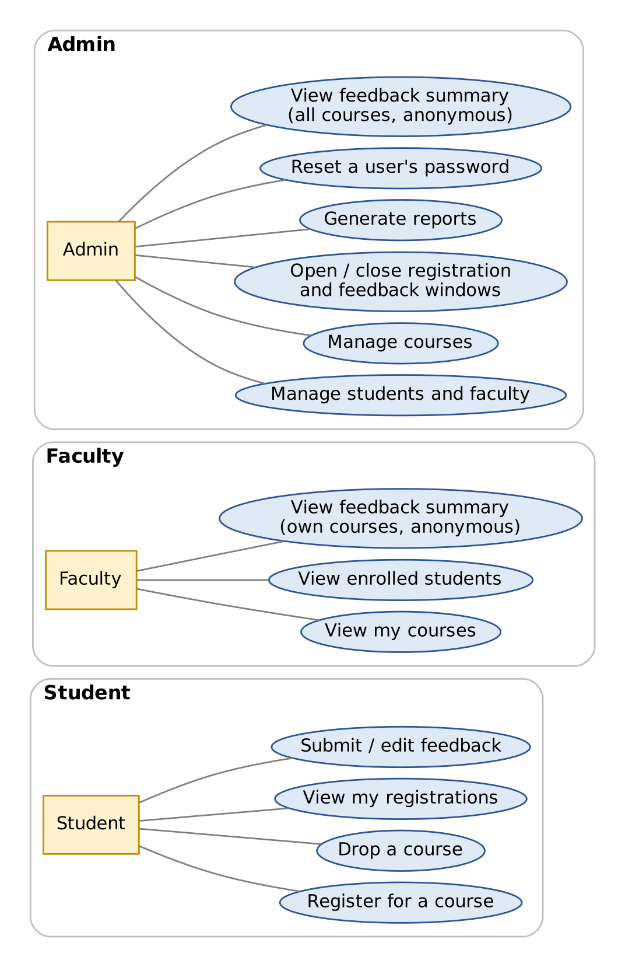
Figure 1: Use cases by role (common actions are listed in the text above)

5.2 User Stories
A user story states a need in one sentence: “As a (role), I want (goal), so that (benefit).” The acceptance criteria say how we will know the story is done.
ID | User story | Acceptance criteria | Priority
US-01 | As a user, I want to log in with my ID and password so that I can use the features for my role. | - Valid details open the menu for my role.  - Wrong details show one generic error.  - A deactivated account is refused. | Must
US-02 | As a user, I want to change my password so that my account stays secure. | - Old password is required.  - New password must meet the policy.  - A success message is shown. | Must
US-03 | As an admin, I want to add students and faculty so that they can use the system. | - All fields are validated.  - Duplicate IDs or e-mails are rejected.  - The new user can log in and must change the initial password. | Must
US-04 | As an admin, I want to add and edit courses so that the catalogue is correct. | - Code, credits and capacity follow the validation rules.  - Capacity cannot drop below current enrolment.  - A faculty member must be assigned. | Must
US-05 | As an admin, I want to open or close registration and set the credit limit so that I control the registration period. | - Closing the window blocks new registrations and drops.  - The new limit applies to the next registration attempt. | Must
US-06 | As a student, I want to browse and search courses with the seats left so that I can choose wisely. | - Only active courses are listed.  - Seats left are correct and up to date. | Must
US-07 | As a student, I want to register for a course and be told at once if I cannot, with the reason, so that I can fix the problem. | - Each rule failure shows its own message.  - Nothing is saved when a rule fails.  - Success shows a confirmation. | Must
US-08 | As a student, I want to drop a course while registration is open so that I can change my choices. | - The seat becomes free immediately.  - Dropping after the window closes is refused. | Must
US-09 | As a student, I want to see my registered courses and total credits so that I know where I stand. | - Lists active registrations only.  - Shows credits used and remaining. | Must
US-10 | As a faculty member, I want to see the students enrolled in my courses so that I know my class. | - I can open only my own courses.  - The list shows ID, name and roll number. | Must
US-11 | As an admin, I want to open the feedback window so that students can rate their courses at the right time. | - Feedback is refused while the window is closed. | Must
US-12 | As a student, I want to rate my registered courses and add a comment so that my opinion is heard. | - Four ratings from 1 to 5 plus an optional comment.  - Only registered courses are allowed.  - I can edit my feedback while the window is open. | Must
US-13 | As a faculty member, I want to see average ratings and anonymous comments for my courses so that I can improve. | - Averages are mathematically correct.  - No student identity is visible. | Must
US-14 | As an admin, I want enrolment and rating reports that I can export so that I can review the term. | - Reports match the stored data.  - Export creates a CSV file. | Should
US-15 | As an admin, I want to reset a forgotten password so that users are not locked out. | - A temporary password is set.  - The user must change it at next login. | Should
US-16 | As an admin, I want all data saved automatically so that nothing is lost when the program closes. | - Data from one run is present in the next run.  - A damaged file does not crash the program. | Must

5.3 Detailed Use Case Specifications
The six use cases below are the most important ones. They are written in the standard format: who, what must be true before, the normal steps, what can go wrong, and what is true afterwards.

UC-01 Log in
Actor | Any user (Student, Faculty, Admin)
Goal | Enter the system and reach the menu for the user's role.
Preconditions | The program is running at the login screen. The user has an account created by the Admin.
Main flow | 1. The user chooses Login.  2. The system asks for User ID and password.  3. The system finds the user, checks the account is active and not locked, and verifies the password hash.  4. The system records a successful login in the audit log.  5. The system shows the menu for the user's role (calls showMenu()).  6. If the account is flagged “must change password”, the system forces a password change first.
Alternate and error flows | - 3a. Unknown ID or wrong password: show “Invalid user ID or password”, count the failure.  - 3b. Three consecutive failures: lock the account for 5 minutes and say so.  - 3c. Account deactivated: show “This account is not active. Contact the Admin.”
Postcondition | A user session exists for exactly one user. Passwords are never stored in plain text or logged.
Related requirements | FR-AUTH-01 to FR-AUTH-10

UC-02 Register for a Course
Actor | Student
Goal | Enrol in a course while following every rule.
Preconditions | The student is logged in. The registration window is open.
Main flow | 1. The student chooses Register for a Course and views the catalogue.  2. The student enters a course code.  3. RegistrationService.register() checks the rules in order (window, course exists and active, not already registered, credit limit, optional clash, seat free).  4. The course's enrolled count increases and a Registration record (status REGISTERED) is saved.  5. The audit log records the action.  6. The system shows a confirmation with registration ID, credits used and seats left.
Alternate and error flows | - Window closed: RegistrationClosedException.  - Unknown or inactive course: ResourceNotFoundException.  - Already registered: DuplicateRegistrationException.  - Over the credit limit: CreditLimitExceededException.  - Timetable clash (stretch): ScheduleClashException.  - No seat left: CourseFullException.  In every failure case the message is shown and nothing is saved.
Postcondition | Exactly one active registration exists for this student and course, and enrolment never exceeds capacity.
Related requirements | FR-REG-01 to FR-REG-06, FR-REG-08; BR-01 to BR-06, BR-15

UC-03 Drop a Course
Actor | Student
Goal | Leave a course that is no longer wanted.
Preconditions | The student is logged in, the registration window is open, and the student has an active registration for the course.
Main flow | 1. The student chooses Drop a Course and sees their registrations.  2. The student selects a course code and confirms (Y/N).  3. The system sets the registration status to DROPPED and the drop date.  4. The course's enrolled count decreases by one.  5. The action is saved and written to the audit log.
Alternate and error flows | - Window closed: refused with RegistrationClosedException.  - No active registration for that course: ResourceNotFoundException.  - Student answers N: nothing changes.
Postcondition | The seat is free again; the registration record remains with status DROPPED.
Related requirements | FR-REG-04, FR-REG-05; BR-06, BR-15

UC-04 Submit Feedback
Actor | Student
Goal | Rate a registered course and leave an optional comment.
Preconditions | The student is logged in, the feedback window is open, and the student's registration for the course has status REGISTERED.
Main flow | 1. The student chooses Submit Feedback and sees the courses that still need feedback.  2. The student selects a course.  3. The system asks for four ratings (1 to 5) and an optional comment.  4. Each input is validated; invalid values are asked again.  5. FeedbackService saves the feedback and the audit log records the action.  6. The system confirms that feedback was recorded.
Alternate and error flows | - Course not registered or dropped: FeedbackNotAllowedException.  - Window closed: FeedbackNotAllowedException with a window message.  - Feedback already exists: the system offers to edit it instead of creating a second one.
Postcondition | At most one feedback record exists for this student and course; the student's identity is never shown in any view.
Related requirements | FR-FBK-01 to FR-FBK-04, FR-FBK-07; BR-07 to BR-10

UC-05 View Feedback Summary (Faculty)
Actor | Faculty (the Admin has a similar use case for all courses)
Goal | Understand how students rate a course taught by the faculty member.
Preconditions | The faculty member is logged in and has at least one assigned course.
Main flow | 1. The faculty member chooses View Feedback Summary.  2. The system lists only the faculty member's own courses.  3. The faculty member selects a course.  4. The system shows the number of responses, the average of each criterion, the overall average and the comments, without student names.
Alternate and error flows | - Course belongs to someone else: AccessDeniedException.  - No responses yet: the system shows “No feedback received yet.”  - Fewer responses than the minimum (stretch): only the response count is shown.
Postcondition | No data is changed. Student identity remains hidden.
Related requirements | FR-FBK-05, FR-FBK-06, FR-FBK-08; BR-10, BR-14

UC-06 Add a Course
Actor | Admin
Goal | Add a new course to the catalogue.
Preconditions | The Admin is logged in. At least one active faculty member exists.
Main flow | 1. The Admin chooses Manage Courses, then Add Course.  2. The system asks for code, title, credits, capacity, semester, faculty and an optional time slot.  3. Each value is validated; invalid values are asked again.  4. CourseService checks that the code is not already used and the faculty member exists and is active.  5. The course is saved and the action is written to the audit log.  6. The system confirms the new course.
Alternate and error flows | - Duplicate course code: DuplicateResourceException.  - Faculty not found or inactive: ResourceNotFoundException.  - Invalid value: ValidationException and the field is asked again.
Postcondition | The course appears in the catalogue with all seats free.
Related requirements | FR-CRS-01, FR-CRS-04; BR-13

6. Non-Functional Requirements
Non-functional requirements describe how well the system must work rather than what it does. The numeric targets are design targets for this academic project; they can be checked on an ordinary laptop.
ID | Category | Requirement | How it is verified
NFR-PERF-01 | Performance | Start-up loading of up to 1,000 users, 200 courses and 10,000 registrations shall take no more than 3 seconds. Each menu action shall respond within 1 second. | Time the program with generated sample data.
NFR-USAB-01 | Usability | A first-time user shall be able to register for a course by following the on-screen prompts only. Menus use consistent numbering and 0 always means back or logout. | Walkthrough with two or three classmates.
NFR-USAB-02 | Usability | Messages shall use plain language and tell the user what to do next. | Review of the message list (Section 7.8).
NFR-REL-01 | Reliability | No keyboard input shall crash the program. Unexpected errors are caught, logged and shown as a friendly message. | TC-31 and exploratory testing.
NFR-REL-02 | Data integrity | Files are saved safely (temporary file then replace). Enrolled counts are recomputed at start-up. | TC-29 and TC-30.
NFR-SEC-01 | Security | Passwords are stored as salted hashes. PBKDF2WithHmacSHA256 from the Java standard library is recommended; SHA-256 with a random salt is the minimum. Passwords are never printed or logged. | Inspect users.csv and the audit log.
NFR-SEC-02 | Security | Access control is checked in the service layer for every operation, not only in the menus. | TC-27 and code review.
NFR-SEC-03 | Security | Input is sanitised so that the file delimiter and line breaks cannot be injected into data files. | Test with | and line breaks in text fields.
NFR-MAINT-01 | Maintainability | Naming follows Java conventions (PascalCase classes, camelCase methods and variables, UPPER_SNAKE_CASE constants). Every public class and method has a Javadoc comment. Methods are short (guideline: under about 40 lines). No copy-pasted blocks. | Code review checklist (Section 10.6).
NFR-MAINT-02 | Maintainability | The UI never touches files; DAOs contain no business rules; services contain no System.out or Scanner code. | Code review and package dependency check.
NFR-PORT-01 | Portability | The program runs on Windows, Linux and macOS with JDK 17 or newer. File paths are built with Path and Paths, not typed with fixed separators. | Run on at least two operating systems if possible.
NFR-TEST-01 | Testability | Services receive their DAOs through the constructor so that tests can use in-memory fake DAOs. Every business rule has at least one passing and one failing test. | Test report.
NFR-EXT-01 | Extensibility | Adding database storage requires only new DAO classes; services and screens stay unchanged. | Design review.
NFR-DOC-01 | Documentation | A README explains set-up and run steps. UML diagrams match the final code. | Deliverables checklist.
NFR-ENC-01 | Compatibility | All source and data files use UTF-8 encoding. | Open files in two different editors.

7. System Design

7.1 Architecture: Four Layers
A well-designed program is split into layers, like the floors of a building. Each layer has one job and may talk only to the layer directly below it. This is called a layered architecture, and it is the reason you can change one part of the program (for example, replace files with a database) without rewriting everything else.
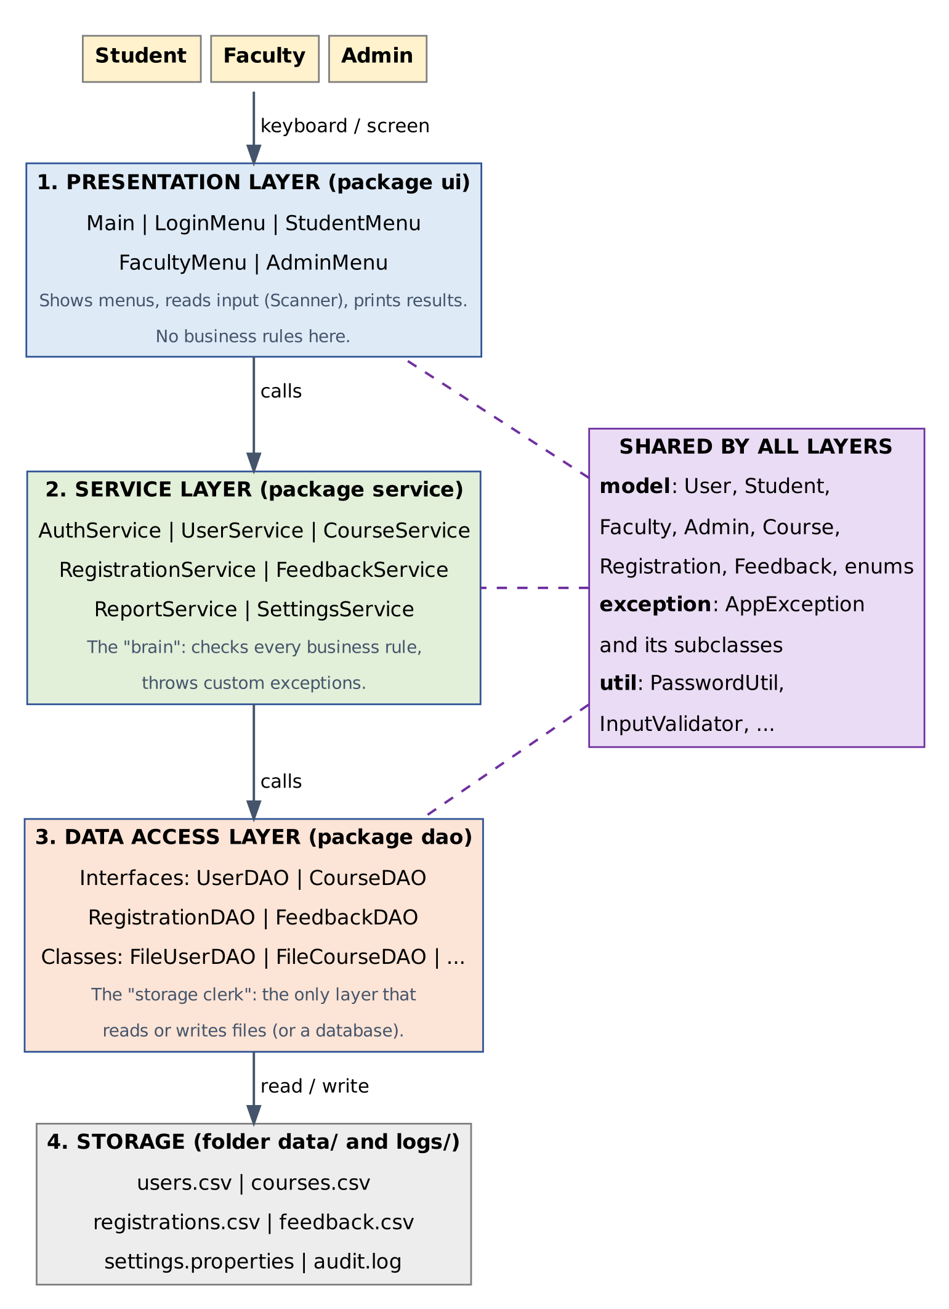
Figure 2: Layered architecture of CRFMS
Layer | Package | Its one job | Must NOT do
Presentation | ui | Show menus, read keyboard input, print results and error messages. | Contain business rules or touch files.
Service | service | Apply the business rules (Section 4.12), check permissions, coordinate DAOs, throw custom exceptions. | Print to the screen or read from the keyboard.
Data access | dao | Read and write data in files (later: a database) and turn text lines into objects and back. | Decide whether an action is allowed.
Storage | data/, logs/ | Hold the CSV files, settings file and audit log. | (It is only data.)
Shared | model, exception, util, config | Classes used by every layer: entities, exceptions, helpers, enums. | Depend on the layers above them.
Beginner tip: Think of a restaurant. The menu card and waiter are the presentation layer, the chef who follows the recipe rules is the service layer, the storeroom keeper is the data access layer, and the storeroom shelves are the storage. A waiter never cooks and a chef never walks into the storeroom of another restaurant.

7.2 Package and Folder Structure
Create the project exactly like this. Each Java package maps to a folder, and the data, logs and exports folders are created automatically by the program when missing.
CRFMS/
|-- src/
| |-- config/
| | |-- AppConfig.java (Singleton: settings in memory)
| |-- model/
| | |-- User.java (abstract)
| | |-- Student.java Faculty.java Admin.java
| | |-- Course.java Registration.java Feedback.java
| | |-- Role.java RegistrationStatus.java (enums)
| |-- exception/
| | |-- AppException.java and its subclasses (Section 7.8)
| |-- dao/
| | |-- UserDAO.java CourseDAO.java RegistrationDAO.java FeedbackDAO.java
| | |-- file/
| | |-- FileUserDAO.java FileCourseDAO.java
| | |-- FileRegistrationDAO.java FileFeedbackDAO.java
| |-- service/
| | |-- AuthService.java UserService.java CourseService.java
| | |-- RegistrationService.java FeedbackService.java
| | |-- ReportService.java SettingsService.java
| |-- report/
| | |-- Report.java (interface) EnrolmentReport.java
| | |-- FeedbackSummaryReport.java FacultyRatingReport.java
| |-- util/
| | |-- PasswordUtil.java FileUtil.java InputValidator.java
| | |-- AuditLogger.java ConsoleHelper.java UserFactory.java
| |-- ui/
| | |-- Main.java LoginMenu.java
| | |-- StudentMenu.java FacultyMenu.java AdminMenu.java
|-- test/ (JUnit tests, mirror of src)
|-- data/ users.csv courses.csv registrations.csv feedback.csv
| settings.properties
|-- logs/ audit.log
|-- exports/ (CSV reports and backups)
|-- README.md
Note: In real Java files the first line is a package statement such as package model;. Code snippets in this document leave it out so they can be compiled as a single test file (that is how they were verified).

7.3 Class Design

7.3.1 The user hierarchy (inheritance)
User is an abstract parent that holds everything common to all accounts. Student, Faculty and Admin extend it. Role is an enum with exactly three values, so the program can never contain a role such as “Studnet” by typing mistake.
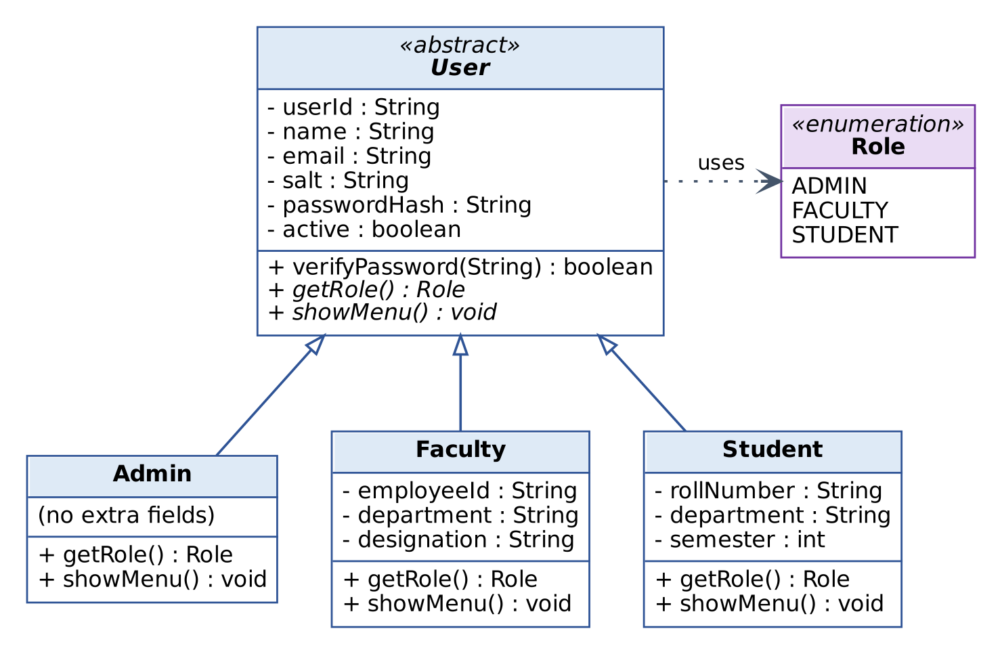
Figure 3: Inheritance: User and its three subclasses (hollow arrowheads mean “is a”)
Here is the beginning of the abstract parent class and one subclass. Read the comments; they explain each new keyword.
abstract class User { // abstract: cannot do new User(...)
private final String userId; // final: set once, never changed
private String name;
private String email;
private boolean active = true;

protected User(String userId, String name, String email) {
this.userId = userId; // this = the object being built
this.name = name;
this.email = email;
}

public String getUserId() { return userId; } // getter: read-only access
public String getName() { return name; }

public void setName(String name) { // setter: validates first
if (name == null || name.trim().isEmpty()) {
throw new IllegalArgumentException("Name cannot be empty");
}
this.name = name.trim();
}

public abstract Role getRole(); // no body: every subclass MUST write one
public abstract void showMenu();

@Override
public String toString() { return getRole() + " " + userId + " - " + name; }
}

class Student extends User { // extends = inherits from User
private final String rollNumber;
private int semester;

public Student(String userId, String name, String email,
String rollNumber, int semester) {
super(userId, name, email); // super = run the parent constructor
this.rollNumber = rollNumber;
this.semester = semester;
}

@Override public Role getRole() { return Role.STUDENT; }

@Override
public void showMenu() {
System.out.println("1. View Courses 2. Register 3. Drop 4. Feedback 0. Logout");
}
}
Beginner tip: Keywords in this snippet. private means only this class can touch the field. protected means this class and its subclasses can. final means the value cannot change after it is set. abstract means “incomplete on purpose”. @Override tells the compiler “I am replacing a parent method”; if you misspell the name, the compiler warns you.
The full class in your project also stores the salt, the password hash and the “must change password” flag, and offers verifyPassword(String) (Section 7.9). Those fields were left out of the snippet above only to keep it short.

7.3.2 The domain classes
The remaining entity classes describe the things the system manages. Notice that Registration and Feedback store the IDs of the student and course (not the whole objects). This keeps the data files simple, and the services look up the full objects when needed.
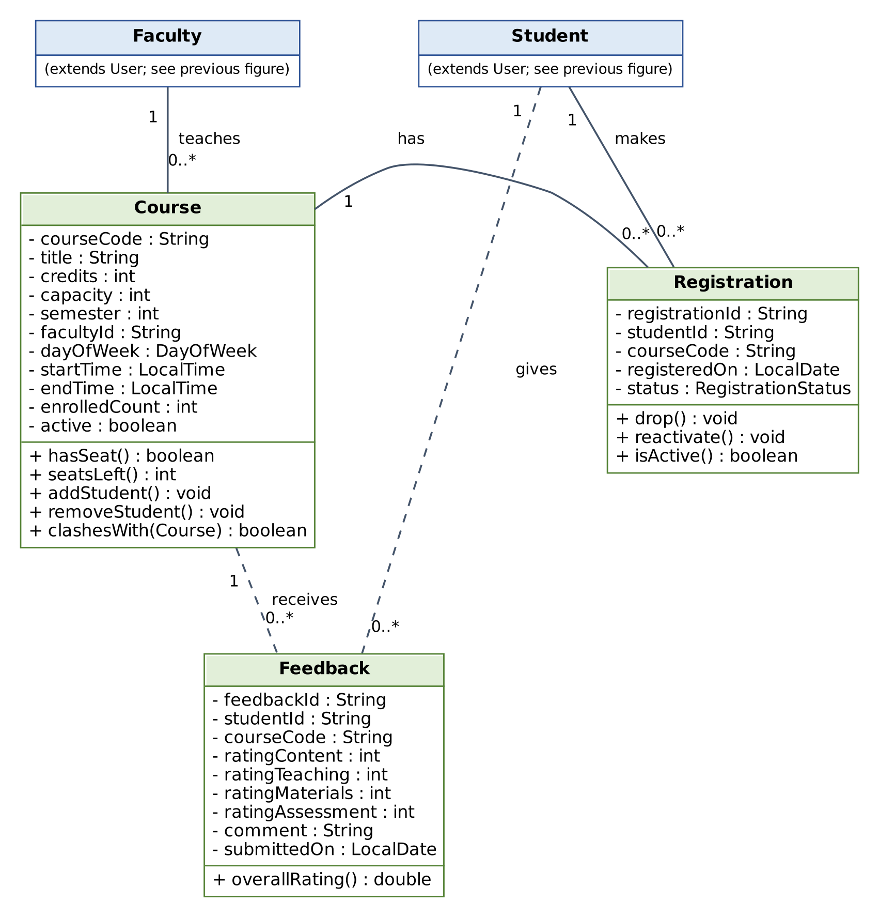
Figure 4: Domain classes and how they relate (solid line = one-to-many, dashed = feedback link)
Class | Responsibility | Key rules it protects
Course | Holds course details and the seat count. | enrolledCount stays between 0 and capacity; addStudent() throws CourseFullException when full.
Registration | Links one student to one course with a status and dates. | Status is only REGISTERED or DROPPED; drop() and reactivate() change it safely.
Feedback | Four ratings and a comment from one student for one course. | Every rating is 1 to 5; comment is at most 300 characters; overallRating() is the average of the four.
Role, RegistrationStatus | Enums: fixed lists of allowed values. | Nothing outside the list can be stored.
The Course class is the best example of encapsulation in the project. Study how the private count can be changed only through two guarded methods:
class Course {
private final String courseCode;
private String title;
private int credits;
private int capacity;
private int enrolledCount;

public Course(String courseCode, String title, int credits, int capacity) {
this.courseCode = courseCode;
this.title = title;
this.credits = credits;
this.capacity = capacity;
}

public int seatsLeft() { return capacity - enrolledCount; }
public boolean hasSeat() { return enrolledCount < capacity; }

public void addStudent() throws CourseFullException {
if (!hasSeat()) {
throw new CourseFullException(courseCode); // refuse: course is full
}
enrolledCount++;
}

public void removeStudent() {
if (enrolledCount > 0) {
enrolledCount--;
}
}

// Two Course objects with the same code are treated as the same course.
@Override
public boolean equals(Object other) {
if (this == other) return true;
if (!(other instanceof Course)) return false;
return courseCode.equals(((Course) other).courseCode);
}

@Override
public int hashCode() { return courseCode.hashCode(); }
}
Note: equals and hashCode must always be written together. Collections such as HashSet and HashMap rely on both to decide whether two objects are “the same”. Getters, the time-slot fields and clashesWith(Course) are omitted here for brevity.

7.4 Interfaces (DAOs) and Services

7.4.1 Data Access Objects
A DAO (Data Access Object) is a class that hides how data is stored. First you write an interface, which is only a list of method names, and then one or more classes that implement it. Services use the interface, so they never know (or care) whether the data lives in a CSV file or a database.
interface CourseDAO {
void save(Course course) throws AppException;
Course findById(String courseCode) throws ResourceNotFoundException;
List<Course> findAll();
void update(Course course) throws AppException;
}

interface RegistrationDAO {
void save(Registration registration) throws AppException;
boolean existsActive(String studentId, String courseCode);
List<Registration> findActiveByStudent(String studentId);
String nextId(); // produces REG-000001, REG-000002, ...
}
The planned DAO methods are summarised below. The two interfaces shown above were compiled and tested; the others follow the same pattern.
Interface | Main methods | File implementation reads/writes
UserDAO | save, findById, findByEmail, findAll, findByRole, update, existsById | data/users.csv
CourseDAO | save, findById, findAll, findByFaculty, update | data/courses.csv
RegistrationDAO | save, findById, find, findActiveByStudent, findActiveByCourse, existsActive, update, nextId | data/registrations.csv
FeedbackDAO | save, update, findByStudentAndCourse, findByCourse, findAll, nextId | data/feedback.csv
Inside each FileXxxDAO the data is kept in memory in a collection (for example a HashMap<String, Course> for quick lookup by code). The file is read once when the program starts and rewritten after every change, using the safe-save helper in Section 7.5.3.

7.4.2 Services
Services contain the business logic. Each service receives the DAOs it needs through its constructor. This is called dependency injection and it makes testing easy: in a test you simply pass in small fake DAOs that keep data in memory.
Service | Responsibilities | Examples of methods
AuthService | Login, logout, lock-out counting, password change and reset. | login, changePassword, resetPassword
UserService | Create, update, search, activate and deactivate users; uniqueness checks. | addStudent, addFaculty, search, setActive
CourseService | Create, update, search and deactivate courses; faculty checks. | addCourse, updateCourse, search(String), search(int)
RegistrationService | Register, drop, view, roster; all registration rules. | register, drop, viewMyRegistrations, roster
FeedbackService | Submit and edit feedback; compute averages; protect anonymity. | submit, pendingFor, summaryForCourse
ReportService | Build reports and export them to CSV. | enrolmentReport, exportCsv
SettingsService | Open and close windows; credit limit; thresholds. | setRegistrationOpen, setMaxCredits
Below is the heart of the project: the method that registers a student. It reads like the rule list in Section 4.12, which is exactly the point. It was compiled and tested with every failing case (closed window, missing course, duplicate, credit limit, full course).
class RegistrationService {
private final CourseDAO courseDao;
private final RegistrationDAO registrationDao;
private final AppConfig config = AppConfig.getInstance();

public RegistrationService(CourseDAO courseDao, RegistrationDAO registrationDao) {
this.courseDao = courseDao;
this.registrationDao = registrationDao;
}

public Registration register(String studentId, String courseCode)
throws AppException {
// Rule 1: the registration window must be open
if (!config.isRegistrationOpen()) {
throw new RegistrationClosedException();
}
// Rule 2: the course must exist
Course course = courseDao.findById(courseCode);

// Rule 3: no duplicate registration
if (registrationDao.existsActive(studentId, courseCode)) {
throw new DuplicateRegistrationException(courseCode);
}
// Rule 4: total credits must stay within the limit
int creditsUsed = 0;
for (Registration r : registrationDao.findActiveByStudent(studentId)) {
creditsUsed += courseDao.findById(r.getCourseCode()).getCredits();
}
if (creditsUsed + course.getCredits() > config.getMaxCredits()) {
throw new CreditLimitExceededException(config.getMaxCredits());
}
// Rule 5: a seat must be free (addStudent throws CourseFullException)
course.addStudent();
courseDao.update(course);

Registration reg = new Registration(registrationDao.nextId(),
studentId, courseCode, LocalDate.now());
registrationDao.save(reg);
return reg;
}
}
Important: The final project version must also (a) check that the course is active and the student is an active Student (BR-05), (b) reactivate a previously dropped registration instead of creating a new one (BR-15), and (c) write to the audit log. These lines were left out of the snippet to keep it readable.

7.5 Data Storage Design

7.5.1 File format (Release 1)
Release 1 stores data in plain text files, one record per line, with fields separated by the pipe character |. A pipe is used instead of a comma because names and comments often contain commas. The first line of each file is a header, which the program skips when loading. Text fields are sanitised so that | and line breaks cannot appear inside them (see Section 4.13).
File | Fields in order (separated by |)
users.csv | userId, role, name, email, salt, passwordHash, active, mustChangePwd, roll_or_employeeId, department, semester_or_designation
courses.csv | courseCode, title, credits, capacity, semester, facultyId, dayOfWeek, startTime, endTime, active
registrations.csv | registrationId, studentId, courseCode, registeredOn, status, droppedOn
feedback.csv | feedbackId, studentId, courseCode, ratingContent, ratingTeaching, ratingMaterials, ratingAssessment, comment, submittedOn
settings.properties | registrationOpen, feedbackOpen, maxCredits, lowRatingThreshold, minResponses (standard Java Properties format)
logs/audit.log | Appended text lines: timestamp, user ID, action, result.
An illustrative course record and registration record look like this (sample values only):
CS101|Java Basics|4|60|3|F-101|MON|10:00|11:00|true
REG-000001|S-1001|CS101|2026-10-04|REGISTERED|
enrolledCount is not stored in courses.csv. It is calculated from the registration records every time the program starts (FR-DAT-07), so the number can never become out of step with the real records.

7.5.2 Entity-relationship design (optional database)
If you build Release 3, the same data is stored in database tables. The design below uses one table per entity. A primary key (PK) uniquely identifies each row; a foreign key (FK) points to a row in another table and stops you from entering, for example, a registration for a course that does not exist. The UNIQUE (student_id, course_code) rule in registration and feedback is the database version of business rules BR-03 and BR-08.
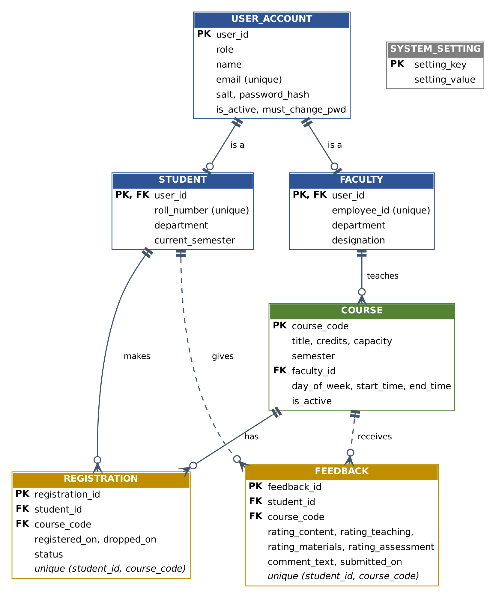
Figure 5: Entity-relationship diagram (crow's foot on the “many” side)
The complete schema is in Appendix C. It was run on SQLite to confirm that the tables are created, the relationships are accepted, and that a duplicate registration and a rating of 6 are both rejected.

7.5.3 Safe saving and loading helpers
To avoid corrupting a file if the program stops halfway through a write, data is first written to a temporary file and then moved over the real file in one step. This helper was compiled and tested (it also returns an empty list if the file does not exist yet, which is how a first run behaves).
import java.io.IOException;
import java.nio.charset.StandardCharsets;
import java.nio.file.Files;
import java.nio.file.Path;
import java.nio.file.StandardCopyOption;
import java.util.List;

public final class FileUtil {
private FileUtil() { }

/** Writes all lines to a temporary file first, then swaps it in. */
public static void writeAtomic(Path target, List<String> lines) throws IOException {
Path parent = target.toAbsolutePath().getParent();
Files.createDirectories(parent);
Path temp = parent.resolve(target.getFileName() + ".tmp");
Files.write(temp, lines, StandardCharsets.UTF_8);
try {
Files.move(temp, target,
StandardCopyOption.REPLACE_EXISTING, StandardCopyOption.ATOMIC_MOVE);
} catch (java.nio.file.AtomicMoveNotSupportedException e) {
Files.move(temp, target, StandardCopyOption.REPLACE_EXISTING);
}
}

public static List<String> readAll(Path file) throws IOException {
if (!Files.exists(file)) {
return List.of();
}
return Files.readAllLines(file, StandardCharsets.UTF_8);
}
}

7.6 Registration Flow
The flowchart shows the exact order of the checks inside register(). Cheap checks come first and the seat check comes last, so the system never reserves a seat for a registration that would be refused for another reason.
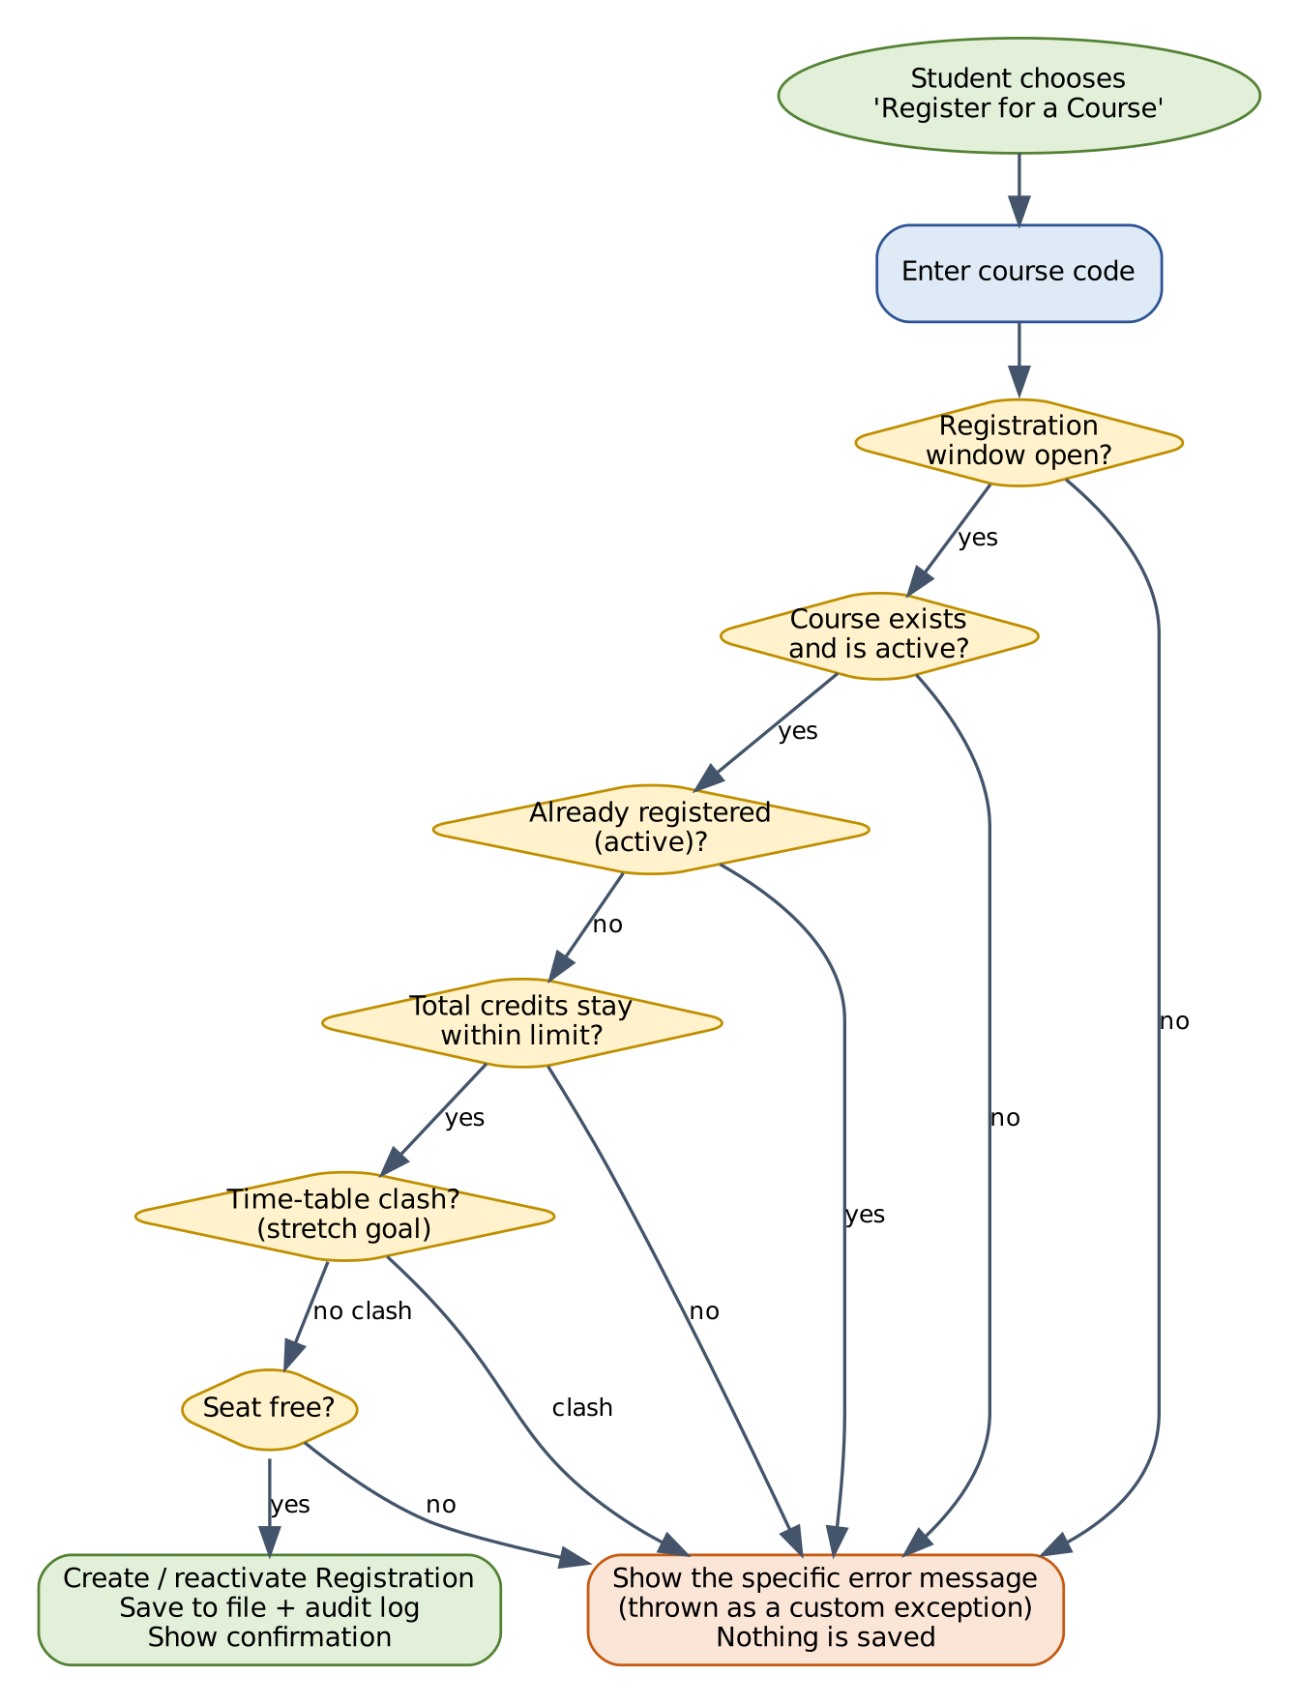
Figure 6: Registration decision flow (any “refuse” branch ends with an error message and nothing saved)

Sequence of calls
This is what happens, step by step, when a student chooses “Register” (it shows the layers cooperating):
# | Who | Does what
1 | StudentMenu (ui) | Asks for the course code, calls registrationService.register(studentId, code) inside a try block.
2 | RegistrationService | Runs the rule checks; asks CourseDAO and RegistrationDAO for the data it needs.
3 | Course | addStudent() increases the seat count, or throws CourseFullException.
4 | CourseDAO, RegistrationDAO | Save the changed course and the new registration (safe save to files).
5 | AuditLogger | Appends a line to audit.log.
6 | StudentMenu (ui) | Prints the confirmation, or, in the catch block, prints the exception message.

7.7 Design Patterns Used
A design pattern is a named, proven way of solving a common design problem. Using a few of them correctly (and being able to explain why) earns more credit than using many without understanding.
Pattern | Problem it solves | Where it is used
DAO | Keeps storage details out of business code so storage can be swapped. | CourseDAO, UserDAO, etc., with FileXxxDAO implementations.
Singleton | Exactly one shared object is needed (the current settings). | AppConfig.getInstance() – private constructor and one static instance.
Factory | Creating the right kind of object without the caller knowing the details. | UserFactory.create(role, ...) builds a Student, Faculty or Admin.
Layered architecture | Separates responsibilities so each part is simple. | ui → service → dao (Section 7.1).
Dependency injection | Makes classes easy to test by passing in their helpers. | Services receive DAOs in their constructors.
The Singleton used by the registration code above looks like this:
class AppConfig {
private static final AppConfig INSTANCE = new AppConfig(); // the only one
private boolean registrationOpen = true;
private int maxCredits = 24;

private AppConfig() { } // private: nobody else can call new
public static AppConfig getInstance() { return INSTANCE; }

public boolean isRegistrationOpen() { return registrationOpen; }
public void setRegistrationOpen(boolean open) { registrationOpen = open; }
public int getMaxCredits() { return maxCredits; }
public void setMaxCredits(int max) { maxCredits = max; }
}
Note: In the final project, AppConfig also loads its values from settings.properties when the program starts and saves them when the Admin changes them (FR-SET-05). The value 24 above is only a starting default.

7.8 Exception Handling Design
An exception is Java's way of saying “something went wrong, stop what you are doing”. Instead of returning confusing error codes, a method throws an exception, and the caller catches it and decides what to tell the user. CRFMS defines its own exception classes so that every problem has a clear name and a friendly message.
class AppException extends Exception { // parent of all our exceptions
public AppException(String message) { super(message); }
}

class CourseFullException extends AppException {
public CourseFullException(String courseCode) {
super("Course " + courseCode + " is full. No seats are left.");
}
}

// How the menu uses them:
try {
Registration r = registrationService.register(studentId, code);
System.out.println("Registered. ID: " + r.getRegistrationId());
} catch (AppException e) {
System.out.println("Could not register: " + e.getMessage()); // friendly text
} catch (Exception e) {
AuditLogger.error(e); // unexpected
System.out.println("Something went wrong. Please try again.");
}
Beginner tip: try means “attempt this”. catch means “if this specific problem happens, do this instead”. Put the most specific catch first and the general Exception last. throws in a method signature warns callers that the method may throw that exception.
Exception | Thrown when | Message shown to the user
AuthenticationException | Wrong ID or password, inactive or locked account. | Invalid user ID or password. (locked: Too many attempts. Try again later.)
AccessDeniedException | A user tries something their role does not allow. | You are not allowed to do this.
ValidationException | An input value breaks a rule in Section 4.13. | (field-specific text, for example “Credits must be from 1 to 6.”)
DuplicateResourceException | An ID, e-mail, roll number or course code already exists. | That ID already exists.
ResourceNotFoundException | A user, course or registration is not found. | (item) was not found.
RegistrationClosedException | Register or drop while the window is closed. | Registration is currently closed.
DuplicateRegistrationException | Already actively registered for the course. | You are already registered for (code).
CreditLimitExceededException | Total credits would exceed the maximum. | This would exceed the maximum of (n) credits.
ScheduleClashException (stretch) | Time slot overlaps another registration. | This course clashes with (code).
CourseFullException | No seats are left. | Course (code) is full. No seats are left.
FeedbackNotAllowedException | Course not registered, or feedback window closed. | Feedback is not allowed for this course right now.
DataAccessException | A file cannot be read or written. | A data error occurred. Please contact the Admin.
All exceptions inherit from AppException, so the menu can handle every expected problem with one catch (AppException e) block.

7.9 Security Design

Password storage
A password must never be saved as typed. If a file with plain passwords is copied, every account is lost. Instead, CRFMS saves a hash: the result of a one-way mathematical function that cannot be turned back into the password. Each user also gets a random salt, so two users with the same password still have different hashes, and ready-made lookup tables are useless.
At login the program hashes what the user typed (with the stored salt) and compares it with the stored hash. The helper below uses PBKDF2 with SHA-256 from the standard Java library. It was compiled and tested: the correct password matched, a wrong one did not, and two generated salts differed.
import java.security.MessageDigest;
import java.security.NoSuchAlgorithmException;
import java.security.SecureRandom;
import java.security.spec.InvalidKeySpecException;
import java.util.Base64;
import javax.crypto.SecretKeyFactory;
import javax.crypto.spec.PBEKeySpec;

public final class PasswordUtil {
private static final int ITERATIONS = 120_000;
private static final int KEY_BITS = 256;

private PasswordUtil() { } // utility class: nobody should create an object

/** Creates a random salt (a random "pinch" added before hashing). */
public static String newSalt() {
byte[] salt = new byte[16];
new SecureRandom().nextBytes(salt);
return Base64.getEncoder().encodeToString(salt);
}

/** Turns a password plus its salt into a one-way hash string. */
public static String hash(String password, String saltBase64) {
try {
PBEKeySpec spec = new PBEKeySpec(password.toCharArray(),
Base64.getDecoder().decode(saltBase64), ITERATIONS, KEY_BITS);
SecretKeyFactory f = SecretKeyFactory.getInstance("PBKDF2WithHmacSHA256");
return Base64.getEncoder().encodeToString(f.generateSecret(spec).getEncoded());
} catch (NoSuchAlgorithmException | InvalidKeySpecException e) {
throw new IllegalStateException("Password hashing is not available", e);
}
}

/** Checks a typed password against the stored salt and hash. */
public static boolean matches(String password, String saltBase64, String storedHash) {
byte[] a = hash(password, saltBase64).getBytes();
byte[] b = storedHash.getBytes();
return MessageDigest.isEqual(a, b); // constant-time comparison
}
}
Important: Password hashing protects stored passwords from being read. It does not make a console program safe against someone who can edit the data files on the same computer, which is why the Admin account should be protected and the data folder kept private. Say this honestly in your viva instead of claiming the system is “fully secure”.

Other security measures
Measure | How it is done
Role checks | Every service method that is restricted checks the role of the acting user and throws AccessDeniedException if it is not allowed. Hiding a menu item is never the only protection.
Input sanitising | The | delimiter and line breaks are removed from text fields so users cannot corrupt or forge records.
Generic login errors | The message is the same whether the ID or the password was wrong.
Lock-out | Three wrong passwords lock the User ID for five minutes (kept in memory).
Forced password change | The default Admin and any reset or newly created account must change the password at first login.
Audit log | Important events are recorded without passwords or hashes.
Least information | Feedback views never contain student IDs or names.
Passwords typed into a console are visible on screen with Scanner. If you want them hidden, use System.console().readPassword() when it is available (it returns null inside some IDE consoles, so keep a fallback).

8. User Interface Design (Console)

8.1 Design Principles
- Numbered menus – the user types a number and presses Enter. Option 0 always means back or logout.
- Same layout everywhere – a title line, a numbered list, then a prompt. Users learn it once.
- Tell the user what happened – every action ends with a confirmation or a clear reason it failed.
- Never crash on bad input – all input goes through ConsoleHelper methods such as readInt(prompt, min, max), which repeat the prompt until the value is valid.
- Confirm risky actions – dropping a course or deactivating a record asks “Are you sure? (Y/N)”.

8.2 Menu Structure
Role | Main menu | Sub-menus
Before login | 1. Login  0. Exit | –
Student | 1. Browse / search courses  2. Register for a course  3. Drop a course  4. My registrations  5. Submit / edit feedback  6. My profile and change password  0. Logout | Search: by keyword, by semester, by faculty.
Faculty | 1. My courses  2. Students in a course  3. Feedback summary  4. Browse courses  5. My profile and change password  0. Logout | –
Admin | 1. Manage students  2. Manage faculty  3. Manage courses  4. Settings (windows, credit limit)  5. Reports  6. Feedback summaries  7. Backup and logs  8. Change password  0. Logout | Manage menus: add, list, search, update, activate/deactivate, reset password.
The user-visible screens below are text mock-ups to guide System.out output. All names and values are made-up samples.

8.3 Sample Screens

Login
==========================================
COURSE REGISTRATION & FEEDBACK SYSTEM
==========================================
1. Login
0. Exit
Enter choice: 1
User ID : stu2026a
Password: ********

Welcome, Sample Student (STUDENT).

Course catalogue
------------------------ COURSES ------------------------
Code Title Cr Sem Faculty Seats
CS101 Java Basics 4 3 Sample Faculty 59/60
CS102 Databases 4 3 Sample Faculty 30/30
CS103 Networks 3 3 Another Faculty 0/45 FULL
----------------------------------------------------------

Register for a course – success and failure
Enter course code to register (0 to cancel): CS101
Registered successfully.
Registration ID : REG-000001
Course : CS101 - Java Basics (4 credits)
Credits used : 4 of 24
Seats left : 59

Enter course code to register (0 to cancel): CS103
Could not register: Course CS103 is full. No seats are left.

Feedback form
Courses awaiting your feedback:
1. CS101 - Java Basics
Select a course (0 to cancel): 1
Rate from 1 (poor) to 5 (excellent).
Course content : 4
Teaching quality : 5
Learning materials : 4
Assessment fairness : 3
Comment (optional, max 300 characters): Clear explanations.
Thank you. Your feedback has been recorded anonymously.

Feedback summary (faculty view)
CS101 - Java Basics Responses: 4
--------------------------------------------------
Course content : 4.25
Teaching quality : 4.50
Learning materials : 4.00
Assessment fairness : 3.50
OVERALL : 4.06
Comments:
- Clear explanations.
- More practice problems please.
Note: The numbers on these mock-up screens are illustrative only and are not real survey results.

8.4 Message Standards
Type | Style | Example
Success | Start with what happened, then the key details. | Registered successfully. Registration ID: REG-000001
Rule failure | Say what is wrong and, when possible, what to do. | This would exceed the maximum of 24 credits. Drop a course first.
Invalid input | Name the field and the allowed range, then ask again. | Credits must be from 1 to 6. Try again:
Confirmation | Ask a yes/no question; default is No. | Drop CS101? (Y/N):
Unexpected error | Friendly text for the user, full details in the log. | Something went wrong. Please try again.

8.5 Optional Graphical Interface (Release 3)
If time allows, the same services can be given a Swing window instead of text menus: a login form, a table of courses (JTable), buttons for Register and Drop, and a feedback dialog with five-star radio buttons. Because the screens call only the service layer, the business code does not change. The project is complete without this step.

9. Technology, Tools and Development Standards

9.1 Technology Stack
Item | Choice | Notes
Language | Java (JDK 17 or newer) | Sample code in this document was compiled and run on JDK 21.
Editor / IDE | VS Code with Java extensions, IntelliJ IDEA Community, Eclipse or NetBeans | Use whichever you are comfortable with.
Build | Plain javac and java commands (Section 9.4); Maven or Gradle optional | Start simple; add a build tool only if your guide requires it.
Testing | JUnit 5 | Add as a library in the IDE or through Maven/Gradle.
Data storage | Text files (Release 1); SQLite or MySQL through JDBC (Release 3, optional) | Only the DAO classes change when you move to a database.
Version control | Git with a free hosting account | Commit small and often; each commit has a clear message.
Diagrams | draw.io, PlantUML, Graphviz or any UML tool | The diagrams in this PRD can be used as a starting point.
Documentation | Word or PDF for reports; Javadoc for code | Generate Javadoc with javadoc -d docs src/**/*.java (adjust for your folder layout).

9.2 Coding Standards
Topic | Standard
Names | Classes PascalCase (RegistrationService); methods and variables camelCase (seatsLeft); constants UPPER_SNAKE_CASE (MAX_COMMENT_LENGTH); packages all lower-case (service).
Names that explain | Prefer creditsUsed to cu. A reader should understand a name without a comment.
Formatting | 4 spaces per indent level, one statement per line, braces always used (even for one-line if), lines under about 100 characters.
Comments | Javadoc (/** ... */) on every public class and method: what it does, parameters, what it returns, what it throws. Use ordinary comments only to explain why, not what.
Methods | One method does one thing; aim for under about 40 lines; avoid more than 4 parameters.
Access | Fields are private by default. Make something public only when another class truly needs it.
Constants | No “magic numbers”. Write MAX_RATING = 5 once and reuse it.
Errors | Never leave a catch block empty. Either handle the problem, log it, or re-throw it.
Layers | No System.out or Scanner outside ui. No business rules in dao or ui. No file code outside dao and util.
Duplication | If you copy and paste the same block twice, move it into a method.

9.3 Version Control Practice
- Create the repository on day one and commit the empty package structure.
- Use short branches such as feature/registration and merge them after the tests pass (a team project needs this; for a solo project one main branch is fine).
- Commit messages are written as an instruction: Add duplicate registration check.
- Do not commit the data folder with real or realistic personal data, and never commit passwords.
- Tag the final submitted version, for example v1.0.

9.4 Build and Run (without any build tool)
From the project folder (the one that contains src), compile every source file into an out folder and then start the program. The commands below are for a Linux or macOS terminal; on Windows use the same commands in PowerShell or Command Prompt but replace the file-listing part as described.
# 1. Create the output folder and compile all .java files
mkdir -p out
javac -d out $(find src -name "*.java")

# 2. Run the program (Main is in package ui, so its full name is ui.Main)
java -cp out ui.Main
Note: On Windows, list the files first with dir /s /b src\*.java > sources.txt and compile with javac -d out @sources.txt. If you use an IDE, simply press Run; the IDE does these steps for you. Remember to set the working directory to the project folder so that the data and logs folders are created in the right place.

9.5 Sample Data for Demo and Testing
Prepare a small set of invented records so that demos and tests are repeatable. All values below are made up for testing and do not describe real people.
Kind | Suggested sample data
Admin | 1 default Admin account (password must be changed at first login).
Faculty | 3 faculty members, each with 1 to 3 courses.
Students | 10 students across 2 semesters; one student left with no registrations.
Courses | 6 to 8 courses with credits 2 to 4; one with capacity 2 (to demonstrate FULL quickly); one inactive course.
Registrations | Enough to make one student sit exactly at the credit limit and one course become full.
Feedback | At least 4 responses on one course (so averages and the minimum-responses rule can be shown).

10. Testing and Quality Plan

10.1 Test Strategy
Level | What is tested | How | Who/when
Unit tests | One class or method in isolation (for example Course.addStudent, InputValidator, PasswordUtil). | JUnit 5, with fake in-memory DAOs for services. | Developer, while coding each class.
Integration tests | Several classes together (service + file DAO + files). | Run a scenario against temporary test files. | Developer, after each module.
System / acceptance tests | Whole program through the menus using the test cases in Section 10.3. | Manual execution with a results table. | Whole team, before each release.
Exploratory tests | Try to break the program with strange input. | Empty lines, letters in number fields, very long text, the | character. | Everyone, before the demo.
Regression tests | Re-run earlier tests after changes. | Re-run all unit tests and the Must test cases. | Before every commit to main (unit) and every release (all).

10.2 Unit Test Example
A unit test is a tiny program that calls your code with chosen inputs and checks the result. This example (JUnit 5 style) checks the seat rules of Course.
import static org.junit.jupiter.api.Assertions.*;
import org.junit.jupiter.api.Test;

class CourseTest {

@Test
void seatsLeftDropsWhenStudentAdded() throws Exception {
Course c = new Course("CS101", "Java Basics", 4, 2);
c.addStudent();
assertEquals(1, c.seatsLeft());
}

@Test
void addingBeyondCapacityThrows() throws Exception {
Course c = new Course("CS101", "Java Basics", 4, 1);
c.addStudent();
assertThrows(CourseFullException.class, c::addStudent);
}
}
Note: This JUnit example needs the JUnit 5 library, which was not available in the environment used to prepare this document, so it was not executed here. The same rules were checked with a plain-Java test driver (Appendix B), whose results are real. The c::addStudent notation is a *method reference*, a short way to pass a method to assertThrows.

10.3 System Test Cases
Each case lists the starting situation, what to do, and what you must see. Test data is illustrative; choose any equivalent values. Mark each case Pass or Fail in your test report and record the date and the tester's name.
ID | Req. | Steps | Test data | Expected result | Priority
TC-01 | FR-AUTH-01, 02 | Log in once as each of Admin, Faculty and Student. | Valid ID and password for each role | Each user sees only the menu for their own role. | Must
TC-02 | FR-AUTH-06 | Log in with a correct ID and a wrong password. | Valid ID, wrong password | Message “Invalid user ID or password”; no menu. | Must
TC-03 | FR-AUTH-06 | Log in with an ID that does not exist. | Unknown ID | The same message as TC-02 (does not reveal which part was wrong). | Should
TC-04 | FR-AUTH-05 | Deactivate a user, then try to log in as that user. | Deactivated account | Login refused with an inactive-account message. | Must
TC-05 | FR-AUTH-07 | Enter a wrong password three times in a row. | Same ID, 3 wrong passwords | Account locked for 5 minutes; a correct password is also refused during the lock. | Should
TC-06 | FR-AUTH-04 | Change password with a weak new password, then a valid one. | “abc”, then “Learn2026x” | Weak password rejected with the reason; valid password accepted; old password stops working. | Must
TC-07 | FR-USR-01 | Admin adds a student with valid details. | Valid sample student | Student saved; can log in and must change the initial password. | Must
TC-08 | FR-USR-03 | Add a second user with an existing ID, then with an existing e-mail. | Duplicate ID; duplicate e-mail | Both rejected with a duplicate message; nothing saved. | Must
TC-09 | FR-GEN-01, §4.13 | Enter invalid values in each field in turn. | Empty name; e-mail without @; semester 15 | Each is rejected with a field-specific message and asked again. | Must
TC-10 | FR-CRS-01 | Admin adds a course with valid details. | Valid sample course | Course appears in the catalogue with all seats free. | Must
TC-11 | FR-CRS-01, BR-13 | Add a course with an existing code. | Duplicate course code | Rejected; existing course unchanged. | Must
TC-12 | FR-CRS-02, BR-11 | Reduce capacity below the current number enrolled. | Enrolled 5, new capacity 3 | Rejected with an explanatory message. | Must
TC-13 | FR-REG-01, 03 | Student registers for an open course with seats. | Valid course code | Confirmation with registration ID, credits used and seats left; seats left drops by 1. | Must
TC-14 | BR-01, BR-06 | Close the registration window; try to register and to drop. | Window closed | Both refused with “Registration is currently closed.” | Must
TC-15 | FR-REG-02 | Register for a course code that does not exist or is inactive. | “ZZ999”; inactive course | “was not found” style message; nothing saved. | Must
TC-16 | BR-03 | Register again for a course already registered. | Same course twice | Rejected as duplicate; seats left unchanged. | Must
TC-17 | BR-04 | Register until total credits equal the limit exactly. | Limit 8; two 4-credit courses | Second registration is accepted (limit is inclusive). | Must
TC-18 | BR-04 | Try to register one more course that would pass the limit. | Limit 8; third 4-credit course | Rejected with the credit-limit message; nothing saved. | Must
TC-19 | BR-02 | Fill a course to capacity, then register one more student. | Capacity 2; third student | Third student rejected with “full” message; enrolment stays at capacity. | Must
TC-20 | FR-REG-04 | Student drops a registered course; check seat count and list. | Registered course | Status becomes DROPPED; seat is free; course absent from active list. | Must
TC-21 | FR-REG-05, BR-15 | Register again for the course dropped in TC-20. | Same course | Accepted; the old record is reactivated (no second record for the pair). | Must
TC-22 | FR-FBK-01, 02 | With feedback window open, submit valid feedback for a registered course. | Ratings 4,5,4,3; short comment | Feedback saved; confirmation shown; course leaves the pending list. | Must
TC-23 | FR-FBK-01, BR-07 | Try feedback for a course not registered, then for a dropped one. | Unregistered course; dropped course | Both refused with the not-allowed message. | Must
TC-24 | FR-FBK-04 | Close the feedback window; try to submit. | Window closed | Refused with a window message. | Must
TC-25 | BR-09 | Enter ratings outside the allowed range. | 0, 6, “abc” | Each rejected and asked again; nothing saved. | Must
TC-26 | FR-FBK-03, BR-08 | Submit feedback twice for the same course (second time as edit). | New ratings | Only one record exists; it now holds the new ratings. | Must
TC-27 | FR-FBK-05, BR-10, BR-14 | Faculty opens feedback for own course, then tries another faculty's course. | Own course; other's course | Own course: averages and comments, no student identity. Other course: access denied. | Must
TC-28 | FR-RPT-01, 03, 06 | Generate the enrolment and feedback reports; export to CSV; compare to the data. | Sample data set | Figures match the stored data (check at least two by hand); CSV file is created and opens correctly. | Should
TC-29 | FR-DAT-01, 02 | Make changes, exit, restart the program. | Any registration and feedback | All data still present after restart. | Must
TC-30 | FR-DAT-04 | Delete a data file; separately, damage one line in another file; start the program. | Missing file; broken line | Missing file is recreated; broken line is reported with its line number and skipped; a .bak copy exists; no crash. | Must
TC-31 | FR-GEN-01, 02 | Type letters, empty lines and very large numbers at menus and prompts. | “abc”, empty, 99999999999 | Friendly message every time; program never crashes. | Must
TC-32 | NFR-SEC-03 | Enter | and a line break inside a comment and a name. | “a|b” in comment | Characters replaced; the file still loads correctly after restart. | Should
TC-33 | FR-DAT-07 | Edit a registration status in the file by hand, restart, view seat counts. | One extra REGISTERED record | Seats left reflect the records in the file, not an old stored number. | Should
TC-34 | BR-16, FR-USR-08 | Try to deactivate the only active Admin. | Single Admin | Refused with an explanation. | Should

10.4 What Has Already Been Verified
To avoid presenting untested material, the code samples in this document were checked before inclusion:
Item | How it was checked | Result
Model classes, exceptions, DAO interfaces, AppConfig, RegistrationService (Sections 7.3 – 7.7) | Compiled with javac -Xlint:all and exercised by a plain-Java test driver covering a successful registration, duplicate, credit limit (limit set to 8), full course, missing course and closed window; also polymorphic showMenu() and Course.equals/hashCode. | Compiled; all 8 checks and the polymorphism demonstration produced the expected output. The compiler printed only warnings about a missing serialVersionUID in the exception classes, which can be ignored in this project.
PasswordUtil (Section 7.9) | Compiled; correct password, wrong password and two generated salts tested. | Correct password matched, wrong one did not, salts differed.
FileUtil (Section 7.5.3) | Compiled; wrote two lines, read them back, checked that no .tmp file remained, and read a missing file. | All as expected; missing file returns an empty list.
SQL schema (Appendix C) | Executed on SQLite 3.45; inserted valid rows; tried a duplicate registration and a rating of 6. | Valid rows accepted; duplicate and out-of-range values rejected by constraints.
Important: The sample code is a foundation, not the finished project. File DAOs, remaining services, the menus, InputValidator, audit logging and JUnit tests still have to be written by you; that is the purpose of the plan in Section 11. Whatever you build must be tested by you too.

10.5 Requirement-to-Test Traceability
Module | Requirements | Test cases
Authentication | FR-AUTH-01 to 10 | TC-01 to TC-06
Users | FR-USR-01 to 08 | TC-07, TC-08, TC-09, TC-34
Courses | FR-CRS-01 to 07 | TC-10, TC-11, TC-12
Registration | FR-REG-01 to 09; BR-01 to 06, BR-15 | TC-13 to TC-21
Feedback | FR-FBK-01 to 08; BR-07 to 10 | TC-22 to TC-27
Reports | FR-RPT-01 to 06 | TC-28
Data and general | FR-DAT-01 to 07; FR-GEN-01 to 06 | TC-29 to TC-33
Requirements for which you have not yet written a test case (for example FR-USR-06 and FR-SET-04) should be added to your own test report when you implement them. A requirement without a test is not finished.

10.6 Code Review Checklist
 | Check
[ ] | Every field is private; getters/setters validate where needed.
[ ] | No business rule appears in ui or dao; no System.out in service or dao.
[ ] | Each custom exception has a clear name and message and extends AppException.
[ ] | No empty catch blocks; resources (files) are closed or opened with try-with-resources.
[ ] | equals and hashCode are overridden together where objects are stored in sets/maps.
[ ] | No magic numbers; no duplicated blocks; methods are short.
[ ] | All public classes and methods have Javadoc.
[ ] | Passwords never appear in output, logs or the repository.
[ ] | All Must test cases pass after the final change.

10.7 Defect Log Template
Defect ID | Test case | What happened | Severity (High/Med/Low) | Status | Fixed in
D-01 |  |  |  | Open
D-02 |  |  |  | Open

11. Project Plan, Milestones and Risks

11.1 Suggested Eight-Week Plan
This is a suggested plan for a typical eight-week PBL schedule. Compress or stretch it to match your real submission date. For a team, the “Owner” column can be filled with names; for a solo project, the same order still works. Always have a working program at the end of every week.
Week | Goals | Outputs (definition of done)
1 | Understand the topic; finish this PRD; set up the project and repository; create the package structure. | Approved PRD; empty project builds; repository created.
2 | Write the model package (User hierarchy, Course, Registration, Feedback, enums) and the exception classes. Draw UML. | Classes compile; a small main creates objects and prints them; UML class diagram done.
3 | Write util (PasswordUtil, FileUtil, InputValidator, ConsoleHelper) and the file DAOs for users and courses. | Users and courses survive restart; unit tests for validators and password helper.
4 | Write AuthService, UserService, CourseService, login menu and Admin menus for users and courses. | Login works for three roles; Admin can manage users and courses.
5 | Write registration and settings: RegistrationService, SettingsService, registration DAO, Student menu. | TC-13 to TC-21 pass. Release 1 core for registration complete.
6 | Write feedback and reports: FeedbackService, feedback DAO, reports, Faculty menu, CSV export. | TC-22 to TC-28 pass. Release 1 complete.
7 | Release 2 items: lock-out, audit log, backup, search/filters. Full test round; fix defects; polish messages. | All Must and Should test cases pass; test report filled in.
8 | Finish documentation (project report, README, UML); rehearse demo; optional stretch features; final tag. | Deliverables checklist (Section 12) complete; demo rehearsed twice.

11.2 Milestones
Milestone | Target | Evidence
M1 – Design approved | End of week 1 | This PRD reviewed by guide.
M2 – Model and storage working | End of week 3 | Demo of objects saved and reloaded.
M3 – Release 1 feature complete | End of week 6 | All Must test cases pass.
M4 – Release 2 and test round | End of week 7 | Test report with results.
M5 – Final submission and demo | Week 8 | Deliverables checklist and live demo.

11.3 Team Roles (if working in a group)
Role | Main responsibility
Project lead / integrator | Repository, merging, build, planning, keeping the demo working.
Model and data developer | model, dao, util (files, hashing, validation).
Service developer | service classes, business rules, exceptions, unit tests.
UI and documentation developer | ui menus, messages, README, report and UML diagrams.
Tester (shared) | Test cases, test data, defect log. Everyone should test someone else's work.
If you are working alone, treat these as hats you wear in turn, and keep the same discipline: finish the model before the services, and the services before the screens.

11.4 Risk Register
ID | Risk | Likelihood | Impact | Prevention / response
R1 | Scope too big for the time. | High | High | Build Release 1 first. Treat Release 2 and 3 as optional. Cut stretch items without guilt.
R2 | Weak understanding of an OOP concept, causing confusion in viva. | Medium | High | Use the concept map (Section 3.4) and viva questions (Appendix D) weekly; explain each class aloud.
R3 | Data files corrupted or lost. | Medium | High | Safe-save helper; backup export; keep sample data in Git.
R4 | Business rules coded in the wrong layer, so they are duplicated or skipped. | Medium | Medium | Follow the layer rules in Section 7.1; review with the checklist in Section 10.6.
R5 | Late testing finds big defects. | Medium | High | Write unit tests while coding; run Must test cases at the end of weeks 5, 6 and 7.
R6 | Team member unavailable. | Medium | Medium | Pair on important classes; keep notes in the repository.
R7 | Requirements change late (for example the guide adds a rule). | Medium | Medium | Keep rules in service classes and settings; change one place only.
R8 | Demo fails on a different computer. | Low | High | Rehearse on the demo computer; carry a jar or compiled out folder plus sample data; have a backup screen recording.

11.5 Decisions to Confirm with Your Guide
This PRD makes sensible assumptions, but a few choices depend on your institution or syllabus. Ask your guide and write the answer next to each:
# | Question | Default used in this PRD | Answer
1 | Is a database (JDBC) required, or are files acceptable? | Files for Release 1; JDBC optional
2 | Must the application have a graphical interface? | Console menus; Swing optional
3 | What is the maximum credits per term at your institution? | Configurable, default 24
4 | Are timetable clashes required? | Stretch goal (FR-REG-08)
5 | Should students be able to register for any semester or only their own? | Any active course (simple); optional filter by semester
6 | Is multithreading, networking or JDBC explicitly in your syllabus for this project? | Not used (noted in Section 3.4)
7 | What documents and format are required for submission? | See Section 12.1

12. Deliverables, Demo and Evaluation Preparation

12.1 Deliverables Checklist
 | Deliverable | Contents
[ ] | Source code | Complete project with the package structure in Section 7.2; compiles without errors.
[ ] | README | What the program does, how to compile and run, default Admin login, folder layout.
[ ] | PRD (this document) | Updated if requirements changed during development.
[ ] | UML diagrams | Use case, class (matching the final code), ER (if database), sequence for registration.
[ ] | Test report | Section 10.3 table filled with actual results, defect log, date and tester.
[ ] | Project report | Introduction, requirements summary, design, implementation highlights, testing, limitations and future work, conclusion.
[ ] | Sample data | The invented demo data set from Section 9.5.
[ ] | Presentation slides | 8 to 12 slides: problem, solution, architecture, OOP concepts, demo screenshots, testing, learning.
[ ] | Executable package | Compiled out folder or a runnable jar, plus the data folder with sample data.

12.2 Demo Script (about 10 minutes)
Rehearse this order. It tells a story and shows each important rule working and failing correctly.
Min | Step | What to show and say
0–1 | Introduce | The problem (paper registration) and the three roles. One slide.
1–2 | Architecture | Show Figure 2 (the architecture diagram) and say: “UI never touches files; services hold the rules; DAOs hide storage.”
2–3 | Admin | Log in as Admin; add a course with capacity 2; show settings (window open, credit limit).
3–6 | Student | Browse courses; register successfully; try a duplicate; fill the capacity-2 course and show the FULL message; exceed the credit limit; drop and re-register.
6–7 | Admin | Close the registration window and show that registration is now refused.
7–8 | Feedback | Open the feedback window; submit feedback as a student; try again to show edit-not-duplicate.
8–9 | Faculty | Log in as Faculty; show the roster and the anonymous summary; show access denied for another faculty's course.
9–10 | Persistence and code | Exit and restart to show data is saved; open Course.java and User.java to point at encapsulation, inheritance and polymorphism.

12.3 Self-Evaluation Rubric
Evaluation schemes differ, so use this only as a self-check and replace it with your own rubric if your institution gives one.
Area | Strong work looks like
Requirements and design | Clear scope, correct diagrams, design matches the final code.
OOP usage | Every concept in Section 3.4 appears naturally (not forced) and can be explained.
Functionality | All Must features work; rules cannot be bypassed; errors are handled gracefully.
Code quality | Readable names, short methods, Javadoc, no duplication, correct layering.
Testing | Test cases executed and recorded, with unit tests for the key rules.
Documentation and presentation | Clear README and report; confident, honest demo that also mentions limitations.

13. Future Enhancements and Closing Notes

13.1 Future Enhancements
Idea | What it adds | Effort
Database storage with JDBC | Real tables, faster queries, multiple users; only new DAO classes are needed. | Medium
Swing graphical interface | Windows, tables and buttons instead of text menus. | Medium
Waiting list | Specified in Section 14 (F24); Release 4. | Medium
Prerequisites | A course can require other courses to be completed first. | Medium
Timetable view and clash detection | Specified in Section 14 (F25); Release 4. | Medium
E-mail notifications | Confirmation and reminder messages through JavaMail. | Medium
Web version | Spring Boot REST API with a browser front end. | High
Analytics | Trends of ratings over terms; charts in reports. | Medium
Multi-term support | Archive a term and start the next one with a clean registration list. | Medium

13.2 Final Advice
- Finish a small thing completely before starting a big thing. A working Release 1 earns more than an unfinished Release 3.
- Understand every line you submit. Type the sample code yourself, run it, then change it and see what breaks. That is the fastest way to learn.
- Be honest in the viva. Say what works, what is simple on purpose (files, console), and how you would improve it. Honest limits are respected.
- Keep this PRD alive. When you change a rule or feature, change it here too.

14. Advanced Feature Pack (Release 4)

14.1 Purpose and Honest Framing
The core system (Sections 1 to 13) registers students and collects a single end-of-term rating. This section adds 28 advanced features that turn it from a record-keeping tool into a small teaching-quality and student-support system. Three of the ideas come directly from your brief:
- Doubt Bot – students ask doubts about a course; the bot answers from stored answers only, and unanswered doubts go to the faculty and are saved.
- Teaching feedback in many types – explanation, examples, board use, individual doubt guidance, “could not understand”, “voice not clear” and more, with ratings and typed suggestions.
- Faculty improvement suggestions – when a teacher logs in, they see their ratings and get advice such as “speak a little louder” or “add examples”, generated from the students' ratings and comments.
The remaining 25 features support these three ideas (for example, the bot learns from faculty answers, and faculty can track whether their changes helped) or make the registration side smarter (waiting list, timetable, recommendations).
Be honest about what it is: Please read before promising anything in your viva. The “bot” in this PRD is a keyword-matching FAQ assistant, not artificial intelligence. It cannot understand meaning or write new answers; it finds the stored question whose important words overlap most with the student's doubt. Likewise, the improvement “suggestions” come from rules (for example, if the Examples average is below 3.5, show the advice about examples). This is honest, explainable and fully implementable in core Java, and it is exactly what an OOP project should demonstrate.
If you later want smarter behaviour, Section 14.14 lists optional upgrades (such as calling an AI service), but the project is complete and strong without them.

What makes this version different
Typical registration project | CRFMS with the Advanced Feature Pack
Only add, view and delete records. | Closes the loop: students give detailed feedback, faculty receive concrete advice, then see whether their changes improved the ratings.
One overall star rating per course. | Ten teaching-skill categories, quick-tags and typed suggestions, collected during the term, not only at the end.
Student doubts handled outside the system. | A doubt assistant that answers instantly where it can, escalates where it cannot, and grows smarter as faculty answers are saved.
Rules hard-coded in the program. | Suggestion rules stored in an admin-editable rule book, so advice can be changed without changing code.
No privacy design. | Minimum-response thresholds, anonymous doubts and comment moderation protect students.

14.2 Feature Catalogue (28 Features)
Priorities here apply inside Release 4: Must features form the minimum Release 4 (they implement your three requested ideas), Should features add depth, Could features are polish. Do Release 1 completely before starting any of this.

A. Doubt Support (8 features)
ID | Feature | Who | What it does | Priority
F01 | Smart Doubt Bot | Student | Student picks a course and types a doubt. The bot cleans the text, compares it with stored FAQ questions of that course (and general ones) and shows the best stored answer if it is similar enough. | Must
F02 | Auto-escalation to faculty | Student, Faculty | If no stored answer is similar enough, the doubt is saved as a ticket (status OPEN) and routed to the faculty teaching that course. | Must
F03 | Faculty doubt inbox | Faculty | Faculty see open doubts for their courses, newest or oldest first, type an answer, and the ticket becomes ANSWERED. | Must
F04 | Bot learns from faculty | Faculty | When answering, faculty can tick “Add to FAQ”. The question and answer become a new FAQ entry, so the same doubt is answered instantly next time. | Should
F05 | Doubt tracking and notice | Student | Student sees the status of every doubt (BOT_ANSWERED, OPEN, ANSWERED, CLOSED) and gets an inbox notice when faculty answer. | Should
F06 | “Was this helpful?” check | Student | After a bot answer the student answers Y/N. N escalates the doubt to the faculty and counts against that FAQ entry, helping faculty spot weak answers. | Should
F07 | Anonymous doubts | Student | A student can tick “ask anonymously”; the faculty never sees who asked. Shy students are more likely to ask. | Could
F08 | Doubt analytics and alerts | Faculty, Admin | Most-asked topics (common words in doubts), FAQ entries with many unhelpful votes, and doubts unanswered for more than 3 days. | Could

B. Teaching Feedback (6 features)
ID | Feature | Who | What it does | Priority
F09 | Ten teaching categories | Student | Rate 1 to 5 on: Explanation, Use of examples, Use of board, Individual doubt guidance, Concept clarity, Voice clarity, Pace, Interaction, Punctuality, Learning materials. A category can be skipped (N/A). | Must
F10 | Quick-tags | Student | Tap ready-made tags such as “Could not understand”, “Voice not clear”, “Need more examples”, “Great examples”, “Helped me individually” (up to 5). | Must
F11 | Typed suggestion box | Student | Free-text suggestion (up to 300 characters) shown to faculty without the student's identity. | Must
F12 | Mid-term pulse feedback | Student, Admin | Admin defines feedback periods (WEEK-3, MID-TERM, END-TERM). Students can give feedback once per period so teachers get early warning, not just end-of-term results. | Should
F13 | Comment moderation | Admin | Typed comments containing words from an admin-managed blocked-word list are held for admin review instead of being shown to the faculty. | Should
F14 | Comment keyword summary | Faculty | The most frequent meaningful words in the typed suggestions and a simple positive / negative / neutral count based on a small word list (see Section 14.7.3). | Could

C. Faculty Growth (6 features)
ID | Feature | Who | What it does | Priority
F15 | Faculty performance dashboard | Faculty | On login the teacher sees the average of each category per course, the overall average, response counts, and the trend across feedback periods. | Must
F16 | Smart improvement suggestions | Faculty | A rule engine turns low averages and frequent tags into plain advice (“students find it hard to hear you; speak a little louder”). Most serious problem first. | Must
F17 | Admin-editable rule book | Admin | Rules (category, limit, advice text) are stored in a file. The Admin can add, edit or switch off rules without changing the Java code. | Should
F18 | Improvement action plan | Faculty | The teacher can save any suggestion as an action and mark it PLANNED, IN_PROGRESS, DONE or DISMISSED. | Should
F19 | Impact check | Faculty | After the next feedback period the system compares the new average with the old one for each action's category and shows “improved by 0.6” or “no change”. | Could
F20 | Strength badges and benchmark | Faculty | Categories with a high average earn a badge (for example “Great with examples”). The teacher also sees the anonymous department average per category for comparison. | Could

D. Student and Admin Experience (8 features)
ID | Feature | Who | What it does | Priority
F21 | Course ratings in the catalogue | Student | Catalogue shows each course's overall rating and a “Top rated” tag, only once the minimum number of responses is reached. | Should
F22 | Course recommendations | Student | “Courses for you”: active courses in the student's department and semester range with seats left, not yet registered, sorted by rating. | Could
F23 | Notification inbox | All roles | In-app messages for events: doubt answered, waiting-list seat offered, new announcement, new suggestions available. | Should
F24 | Waiting list with auto-enrol | Student | A student can join the waiting list of a full course. When a seat is freed, the first student in line is registered automatically if all registration rules still pass. | Should
F25 | Timetable view and clash check | Student | Weekly timetable of the student's registered courses; registration is refused if two courses overlap (this promotes FR-REG-08 to a full feature). | Should
F26 | Course resources | Faculty, Student | Faculty add titles with links or short notes for a course; registered students can read them. | Could
F27 | Course announcements | Faculty, Student | Faculty post short announcements for a course; registered students see them and get a notification. | Could
F28 | Teaching-quality overview and early alerts | Admin | Admin sees all courses ranked by overall rating, courses below the alert threshold, the doubt backlog, and faculty with open improvement actions. Totals only; no student names. | Should

14.3 Detailed Requirements

14.3.1 Doubt support
ID | Requirement | Priority
FR-DBT-01 | A student shall be able to ask a doubt for a course in which the student has an active registration, by choosing the course and typing the text (5 to 500 characters). | Must
FR-DBT-02 | The bot shall answer only from stored FAQ entries of that course or marked ALL. It shall never invent an answer. | Must
FR-DBT-03 | A match shall require at least two shared meaningful words (one if the doubt has a single meaningful word) and a score at or above the minimum score (default 0.5, configurable). | Must
FR-DBT-04 | If no entry qualifies, the system shall save the doubt as a ticket with status OPEN and tell the student it has been sent to the faculty. | Must
FR-DBT-05 | The faculty of the course shall see OPEN doubts in an inbox and shall be able to answer them. Answering sets the status to ANSWERED and records the date. | Must
FR-DBT-06 | When answering, faculty may choose “Add to FAQ”; the system shall then create an FAQ entry (course, question, answer, keywords) immediately available to the bot. | Should
FR-DBT-07 | After a bot answer, the system shall ask “Was this helpful? (Y/N)”. Y closes the doubt as BOT_ANSWERED and adds a helpful vote; N adds an unhelpful vote and escalates the doubt. | Should
FR-DBT-08 | A student shall be able to view their doubts with status and answers, and close an ANSWERED doubt. | Should
FR-DBT-09 | If the student chooses anonymous, no faculty view or report shall show the student's ID or name. | Could
FR-DBT-10 | The faculty shall be able to see, for their courses, the most frequent words in doubts and FAQ entries whose unhelpful votes are higher than their helpful votes. | Could
FR-DBT-11 | The Admin shall be able to add, edit and deactivate FAQ entries for any course or for ALL; faculty may manage entries of their own courses. | Must
FR-DBT-12 | The system shall flag doubts that remain OPEN for more than 3 days to the faculty and the Admin. | Could

14.3.2 Teaching feedback
ID | Requirement | Priority
FR-TFB-01 | A student shall be able to submit teaching feedback for a registered course in each open feedback period (one submission per student, course and period). | Must
FR-TFB-02 | The form shall contain the ten categories of Section 14.6.1, each rated 1 to 5 or skipped; at least four shall be rated. | Must
FR-TFB-03 | The student may choose up to five quick-tags from the fixed list in Section 14.6.2. | Must
FR-TFB-04 | The student may add a typed suggestion of up to 300 characters. | Must
FR-TFB-05 | The Admin shall be able to create, open and close feedback periods (for example WEEK-3, MID-TERM, END-TERM). | Should
FR-TFB-06 | A student may edit their submission while its period is open. | Should
FR-TFB-07 | Typed text containing a blocked word shall be saved as HELD and not shown to faculty until the Admin approves or rejects it. | Should
FR-TFB-08 | The system shall list for a student the courses and periods that still need feedback. | Should

14.3.3 Faculty growth
ID | Requirement | Priority
FR-FPI-01 | After login, a faculty member shall be able to open a dashboard with, for each of their courses and each period: response count, average per category, overall average, tag counts and anonymous typed suggestions. | Must
FR-FPI-02 | If a course-period has fewer responses than the minimum (default 3), the dashboard shall show only the response count. | Must
FR-FPI-03 | The suggestion engine shall evaluate every active rule against the course-period statistics and show the advice of every rule that fires, most serious first. | Must
FR-FPI-04 | The engine shall also list strengths: categories whose average is at or above the strength limit (default 4.3). | Should
FR-FPI-05 | The Admin shall be able to add, edit and switch off suggestion rules; every change is written to the audit log. | Should
FR-FPI-06 | A faculty member shall be able to save a suggestion as an improvement action and change its status. | Should
FR-FPI-07 | For an action in a category, the system shall show the change in that category's average between the period when the action was created and the latest period. | Could
FR-FPI-08 | The dashboard shall show the anonymous average of the same category across the faculty member's department when at least three faculty members have enough responses. | Could
FR-FPI-09 | Suggestions shall be labelled as guidance based on student opinion, and shall never be used by the system to rank, penalise or reward a faculty member automatically. | Must

14.3.4 Student and admin experience
ID | Requirement | Priority
FR-STX-01 | The catalogue shall show a course's overall rating and “Top rated” (default: overall average at or above 4.3) only when the minimum number of responses is reached. | Should
FR-STX-02 | “Courses for you” shall list courses meeting the rules of feature F22 with a one-line reason for each. | Could
FR-STX-03 | Every user shall have an inbox with unread count; a message can be marked read. | Should
FR-STX-04 | A student shall be able to join the waiting list of a full, active course, leave it, and see their position. | Should
FR-STX-05 | When a seat becomes free, the first waiting student shall be registered if every registration rule passes, and notified; otherwise the next student is tried and the first is notified of the reason. | Should
FR-STX-06 | The system shall refuse a registration whose day and time overlap an active registration of the same student and shall name the clashing course. | Should
FR-STX-07 | A student shall see a weekly timetable (Monday to Sunday) of registered courses. | Should
FR-STX-08 | Faculty shall be able to add resources and post announcements for their own courses; only registered students and the Admin can read them. | Could
FR-STX-09 | The Admin shall see the overview of feature F28 with totals and no student identity. | Should

14.4 New Business Rules
ID | Rule
BR-17 | The Doubt Bot answers only from stored FAQ entries and never generates new answers.
BR-18 | A bot answer needs at least two shared meaningful words (or one for a one-word doubt) and a score of at least the minimum score.
BR-19 | FAQ entries are scoped: an entry applies to its own course or to ALL courses.
BR-20 | A doubt with no match, or whose bot answer was marked not helpful, is escalated to the faculty of that course.
BR-21 | For anonymous doubts the student's ID is stored only for integrity and is hidden in every view and report.
BR-22 | Teaching feedback is allowed only for courses with a REGISTERED registration, once per student, course and period, while the period is open.
BR-23 | Each category rating is a whole number 1 to 5 or skipped; at least four categories must be rated; at most five tags.
BR-24 | Typed suggestions are at most 300 characters, sanitised for the file delimiter and checked against the blocked-word list.
BR-25 | No teaching result, suggestion or comment is shown to a faculty member until the course-period has at least the minimum number of responses (default 3).
BR-26 | Suggestions are visible only to the faculty member who teaches the course and to the Admin; students never see them.
BR-27 | Suggestions are guidance only and are not used to rank or penalise anybody automatically.
BR-28 | The waiting list is first-in, first-out; auto-enrolment re-checks all registration rules (BR-01 to BR-05 and the timetable rule).
BR-29 | Timetable clash: two active registrations of one student may not overlap on the same day.
BR-30 | Any change to the rule book, FAQ moderation or blocked-word list is written to the audit log.

14.5 Doubt Bot Design

14.5.1 How the bot works (step by step)
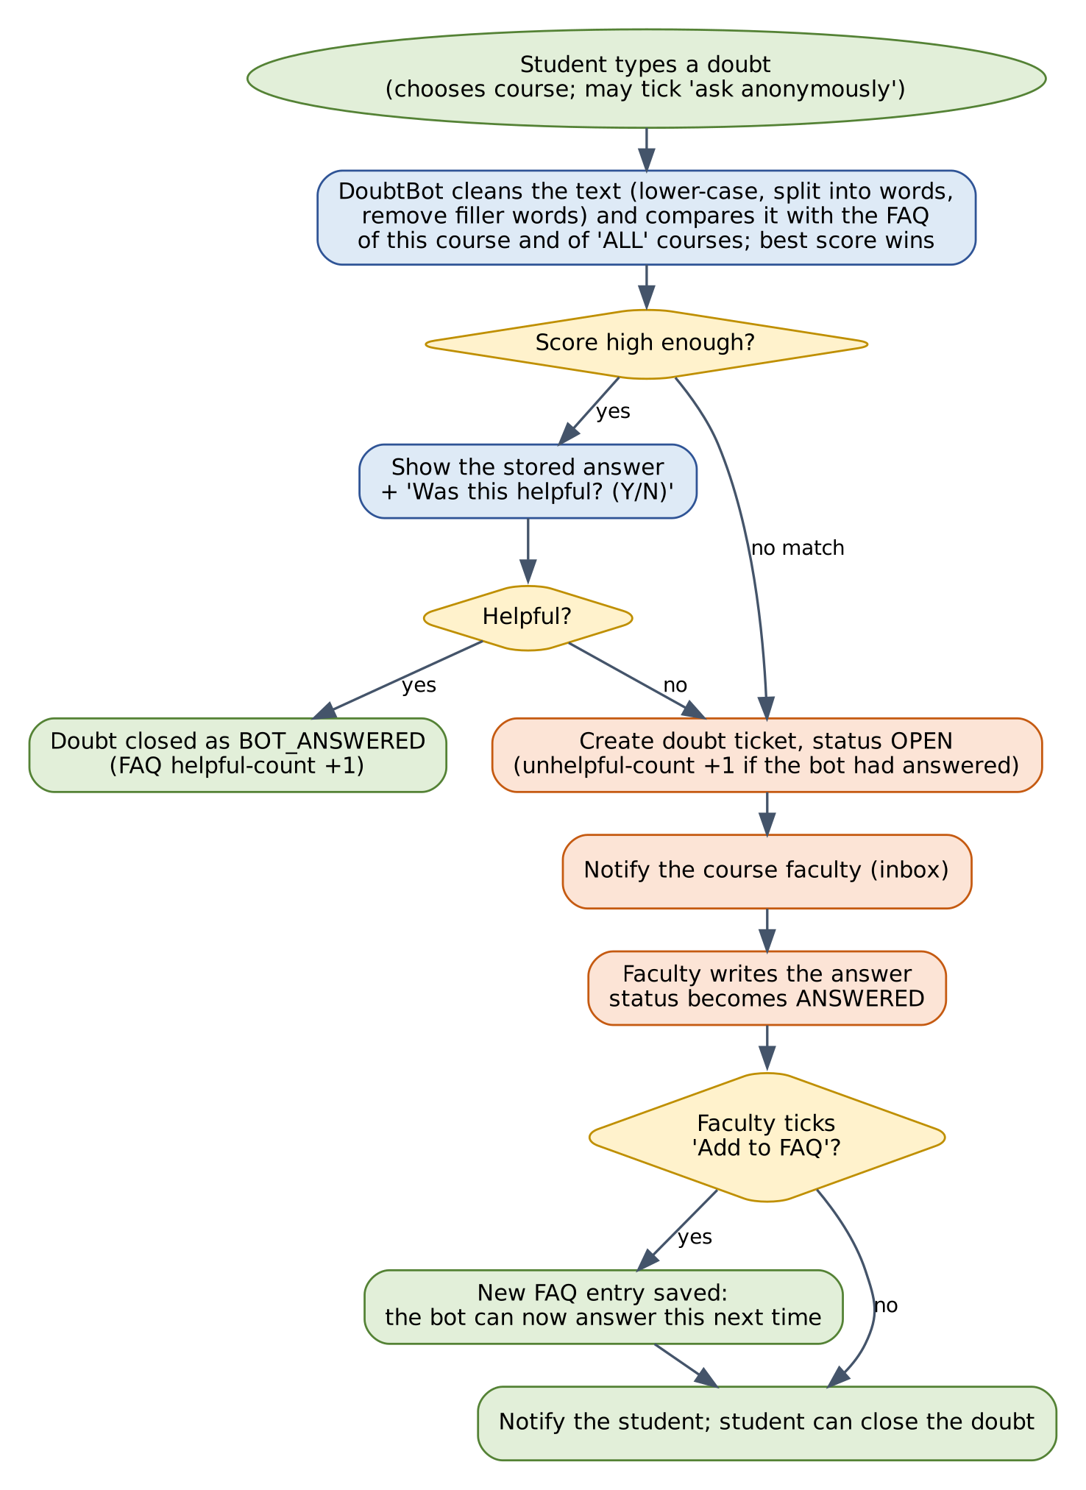
Figure 7: Doubt flow: answer from the FAQ if possible, otherwise escalate, then learn from the faculty answer
The matching idea is simple enough to explain in one minute, which is a strength for your viva:
- Clean the text (tokenise). Convert the doubt to lower case, split it into words, and throw away tiny words and filler words such as “the”, “is”, “how”, “what”. These filler words are called stop words. “What is the difference between an abstract class and an interface?” becomes the set {difference, abstract, class, interface}.
- Compare with each FAQ entry. Every FAQ entry already has its own cleaned word set (its question plus extra keywords added by the faculty).
- Score. Count how many of the student's words appear in the entry. Score = shared words ÷ number of words in the student's doubt. A score of 1.0 means every word of the doubt was found.
- Decide. Take the entry with the highest score. If it has at least two shared words and a score of at least 0.5, show its answer. Otherwise there is no match and the doubt goes to the faculty.
Beginner tip: A Set in Java is a collection that holds each item only once and can quickly tell you whether an item is inside it (contains). That is perfect for comparing words. The program uses Set<String> for the cleaned words.
This is the code that was compiled and tested (the FaqEntry and BotAnswer helper classes only store data and are in the verified source):
class DoubtBot {
private static final Set<String> STOP_WORDS = new HashSet<>(Arrays.asList(
"a", "an", "the", "is", "are", "was", "to", "of", "in", "on", "for", "and", "or",
"do", "does", "how", "what", "why", "can", "i", "me", "my", "we", "you", "it",
"please", "tell", "about", "with", "between", "this", "that"));

private final List<FaqEntry> faq = new ArrayList<>();
private final double minScore;

public DoubtBot(double minScore) { this.minScore = minScore; }

public void add(FaqEntry entry) { faq.add(entry); }

/** Lower-case the text, split into words, drop stop words and tiny words. */
public static Set<String> tokenize(String text) {
Set<String> out = new LinkedHashSet<>();
for (String w : text.toLowerCase().split("[^a-z0-9]+")) {
if (w.length() >= 2 && !STOP_WORDS.contains(w)) {
out.add(w);
}
}
return out;
}

/** Returns the best FAQ answer, or empty if nothing is similar enough. */
public Optional<BotAnswer> ask(String courseCode, String doubt) {
Set<String> q = tokenize(doubt);
if (q.isEmpty()) return Optional.empty();
BotAnswer best = null;
for (FaqEntry e : faq) {
if (!e.getCourseCode().equals("ALL") && !e.getCourseCode().equals(courseCode)) continue;
int overlap = 0;
for (String t : q) if (e.getTokens().contains(t)) overlap++;
double score = (double) overlap / q.size(); // how much of the doubt is covered
boolean enough = overlap >= 2 || (q.size() == 1 && overlap == 1);
if (enough && score >= minScore && (best == null || score > best.getScore())) {
best = new BotAnswer(e, score);
}
}
return Optional.ofNullable(best);
}
}

14.5.2 Starter FAQ content
The bot is only as good as its FAQ. Before the demo, prepare 15 to 25 FAQ entries. Faculty and Admin can add more, and F04 adds entries automatically from answered doubts. Examples of the kind of entries (replace with your real syllabus content):
Course | Stored question | Extra keywords
ALL | How do I drop a registered course? | unregister remove withdraw
ALL | Where can I see how many credits I have used? | credit limit total
Your Java course | What is the difference between an abstract class and an interface? | abstract interface difference
Your Java course | Why do we override equals and hashCode together? | equals hashcode override
Your database course | What is a primary key? | primary key unique row

14.5.3 Verified behaviour
The code above was run with sample FAQ entries. A reworded doubt matched, a general FAQ matched, an entry of another course was correctly ignored, and unrelated or empty doubts were escalated:
PASS matches wording variation
PASS matches a general FAQ
PASS course scoping: CS102 FAQ not shown in CS101
PASS unrelated doubt escalates
PASS empty doubt escalates
best match score 0.80 -> An abstract class can hold fields and code; ...

14.5.4 Known limits (say these in your viva)
- It matches words, not meaning. “Why is my class not extensible?” will not match an entry about “inheritance” unless the keywords include both.
- Spelling mistakes reduce the score. A possible improvement is to ignore small spelling differences.
- It cannot answer a doubt nobody has answered before; that is exactly why escalation and “learn from faculty” exist.
- The minimum score (0.5) is a starting point. Test with real doubts from classmates and adjust it.

14.6 Teaching Feedback Design

14.6.1 Ten categories
# | Category (enum name) | What the student rates
1 | Explanation (EXPLANATION) | How clearly the teacher explains the topic.
2 | Use of examples (EXAMPLES) | Whether examples are given and help understanding.
3 | Use of board (BOARD_USAGE) | Writing and drawing on the board / slides while teaching.
4 | Individual doubt guidance (DOUBT_GUIDANCE) | Help given to individual students who have doubts.
5 | Concept clarity (CONCEPT_CLARITY) | Whether the student understood the concepts.
6 | Voice clarity (VOICE_CLARITY) | Whether the voice is loud and clear enough to follow.
7 | Pace of teaching (PACE) | Not too fast and not too slow (3 is ideal; the form says 1 = far too fast/slow, 5 = just right).
8 | Interaction (INTERACTION) | Questions, discussion and involvement of students.
9 | Punctuality (PUNCTUALITY) | Starts and ends the class on time.
10 | Learning materials (MATERIALS) | Notes, slides and references provided.

14.6.2 Quick-tags
Tags are chosen from a fixed list (an enum or list in the program), so they can be counted reliably. Suggested list; adapt freely:
Needs attention | Strengths
- Could not understand  - Voice not clear  - Too fast  - Too slow  - Need more examples  - Board writing not visible  - Doubts not addressed  - Too much theory | - Great examples  - Clear voice  - Helped me individually  - Good pace  - Very interactive  - Good notes and materials

14.6.3 Periods
Feedback is collected per period (a label such as WEEK-3, MID-TERM, END-TERM). The Admin opens and closes periods. This replaces the single window of Release 1 for teaching feedback. The original 1 to 5 course feedback of Section 4.7 can stay as the simple end-of-term rating.

14.7 Faculty Improvement Engine Design

14.7.1 How suggestions are produced
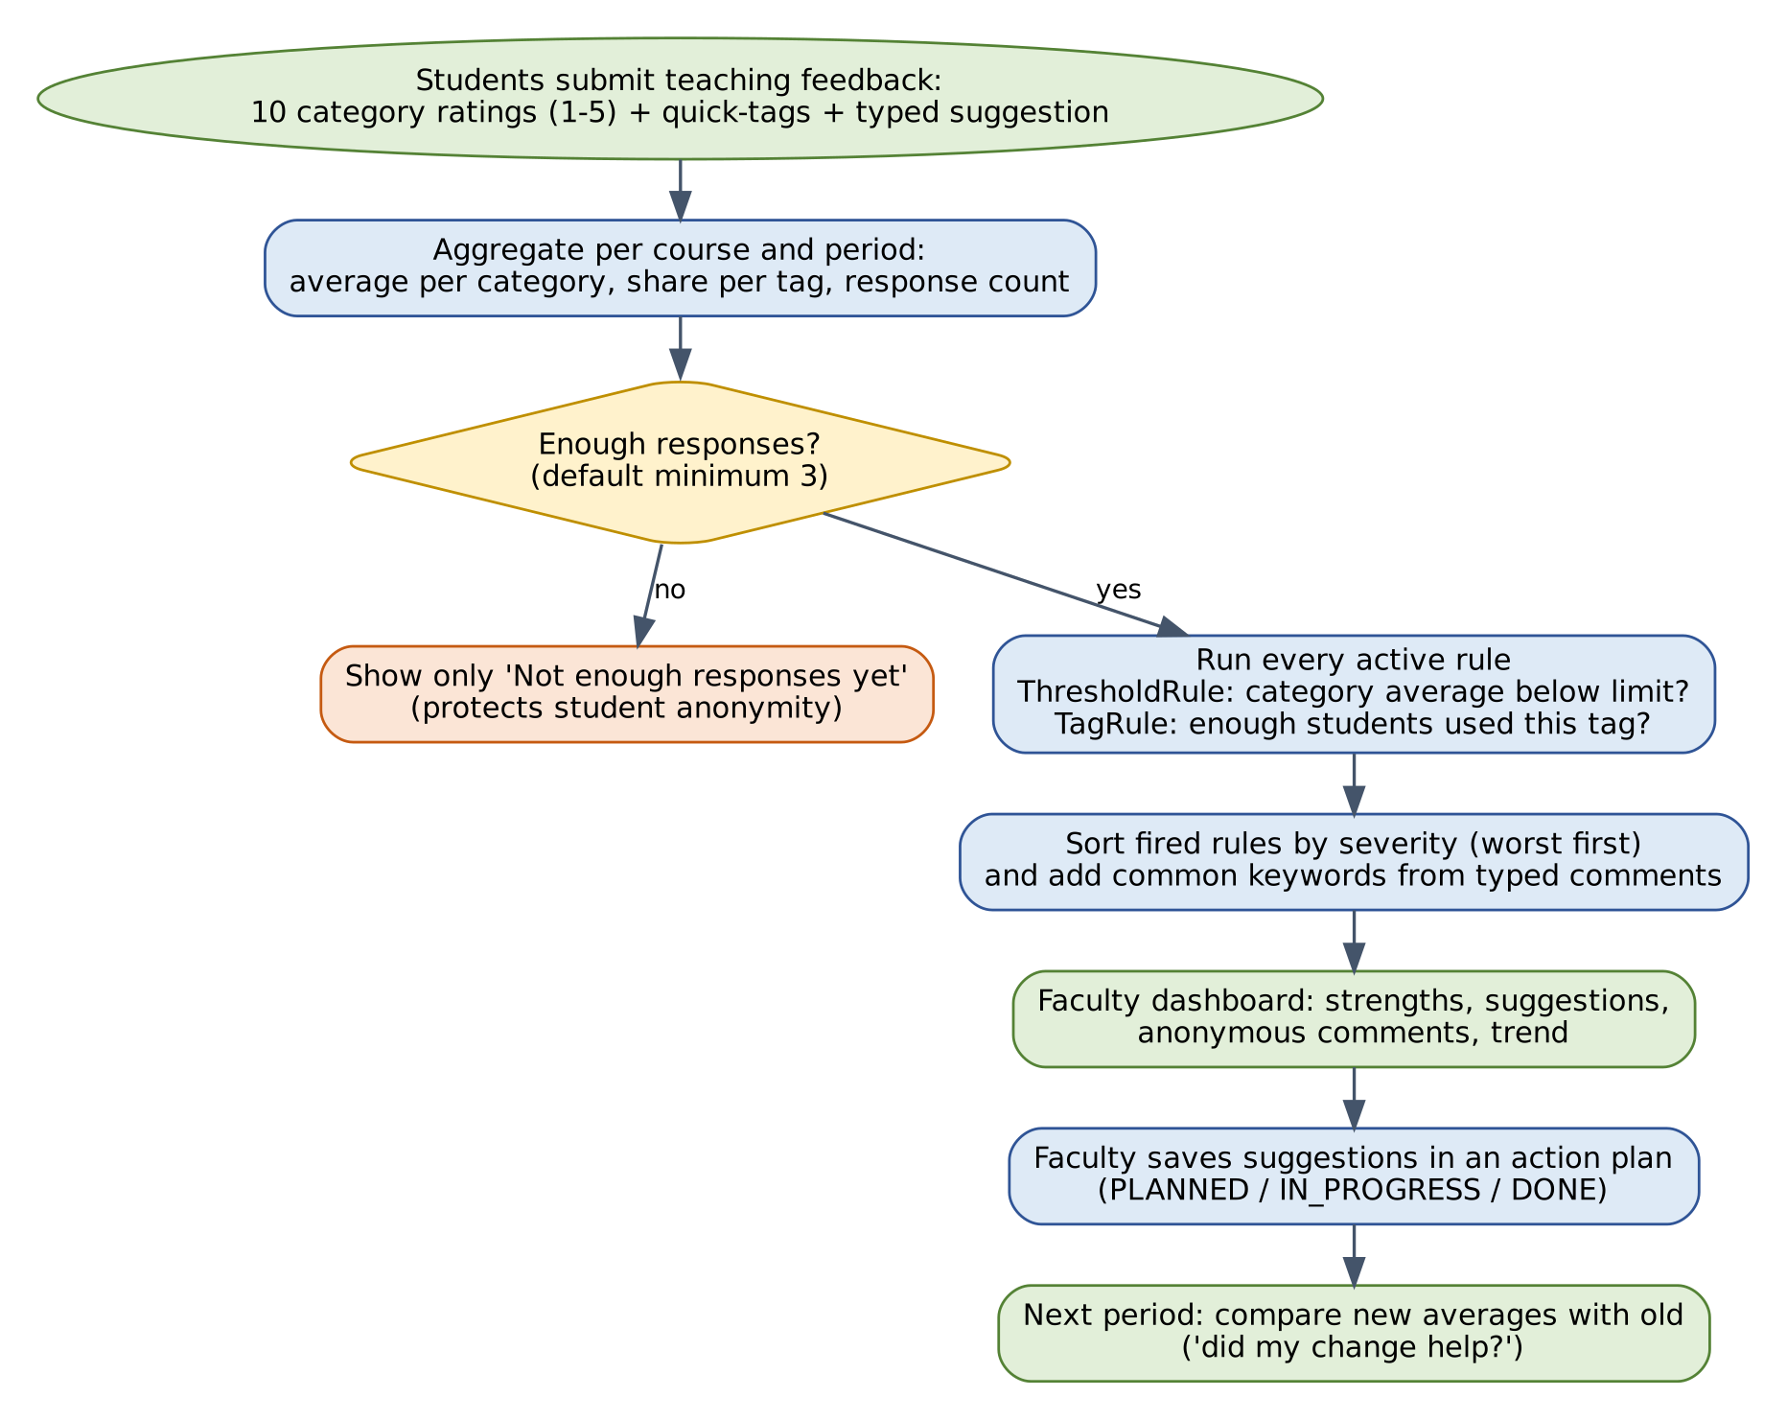
Figure 8: From ratings to suggestions: aggregate, protect anonymity, apply rules, act, compare
The design uses an interface so that new kinds of rule can be added without touching the engine. This is polymorphism in a practical, easy-to-explain form: the engine holds a list of SuggestionRule objects and simply calls evaluate(...) on each; every rule class decides for itself whether to fire.
interface SuggestionRule {
Optional<Suggestion> evaluate(CategoryStats stats);
}

/** Fires when the average of one category is below a threshold. */
class ThresholdRule implements SuggestionRule {
private final FeedbackCategory category; private final double threshold; private final String advice;
public ThresholdRule(FeedbackCategory category, double threshold, String advice) {
this.category = category; this.threshold = threshold; this.advice = advice;
}
@Override
public Optional<Suggestion> evaluate(CategoryStats s) {
double avg = s.average(category);
if (avg > 0 && avg < threshold) {
return Optional.of(new Suggestion(category.getLabel(), advice, threshold - avg));
}
return Optional.empty();
}
}

/** Fires when enough students used a quick-tag such as "voice not clear". */
class TagRule implements SuggestionRule {
private final String tag; private final double minShare; private final String advice;
public TagRule(String tag, double minShare, String advice) {
this.tag = tag; this.minShare = minShare; this.advice = advice;
}
@Override
public Optional<Suggestion> evaluate(CategoryStats s) {
double share = s.tagShare(tag);
return share >= minShare
? Optional.of(new Suggestion("Students reported: " + tag, advice, share))
: Optional.empty();
}
}

class SuggestionEngine {
private final List<SuggestionRule> rules = new ArrayList<>();
private final int minResponses;
public SuggestionEngine(int minResponses) { this.minResponses = minResponses; }
public void addRule(SuggestionRule r) { rules.add(r); }

public List<Suggestion> suggest(CategoryStats stats) {
List<Suggestion> out = new ArrayList<>();
if (stats.getResponses() < minResponses) return out; // protect anonymity
for (SuggestionRule r : rules) r.evaluate(stats).ifPresent(out::add);
out.sort((a, b) -> Double.compare(b.getSeverity(), a.getSeverity())); // worst first
return out;
}
}

14.7.2 Starter rule book (proposed defaults)
These rules cover your examples (“speak louder”, “add examples”). Thresholds are starting values to tune with real feedback; they are stored in the rule book, not hard-coded.
# | Type | Condition | Advice shown to the faculty
1 | Threshold | Voice clarity average below 3.5 | Students find it hard to hear you clearly. Speak a little louder and check from the back row that everyone can hear.
2 | Threshold | Use of examples below 3.5 | Students want more examples. Add one or two worked examples for every new concept.
3 | Threshold | Concept clarity below 3.5 | Many students are not grasping the concepts. Re-explain difficult topics in simpler steps and recap at the end of each class.
4 | Threshold | Explanation below 3.5 | Try breaking each topic into small steps and relate it to something familiar before using technical terms.
5 | Threshold | Use of board below 3.5 | Write key points and diagrams on the board or slides while you explain, and make sure the writing is large enough to read.
6 | Threshold | Individual doubt guidance below 3.5 | Some students feel their doubts are not addressed. Keep five minutes at the end of class for questions or announce doubt-clearing times.
7 | Threshold | Pace below 3.0 | Students find the pace unsuitable. Pause after each concept and ask a quick question to check how the class is following.
8 | Threshold | Interaction below 3.5 | Ask short questions during class and invite students to answer or explain to a neighbour.
9 | Threshold | Punctuality below 3.5 | Try to start and finish on time; students notice delays.
10 | Threshold | Learning materials below 3.5 | Share notes, slides or reference links before or after each class.
11 | Tag | 40% or more used “Could not understand” | A large share of the class could not follow. Pause more often and use simpler examples.
12 | Tag | 30% or more used “Voice not clear” | Several students reported voice problems. Check microphone or seating, and speak louder.
13 | Tag | 30% or more used “Need more examples” | Students asked explicitly for more examples. Add real-life or code examples to each topic.
14 | Tag | 30% or more used “Doubts not addressed” | Make doubt time visible: announce it, or use the Doubt Bot inbox regularly.

14.7.3 Worked example
Sample (made-up) statistics for one course-period with 10 responses: Examples average 2.4, Voice clarity 3.1, Board 4.2, Explanation 4.0, and 5 of 10 students used the tag “Could not understand”. The engine produced exactly this output when run (Voice clarity fires at 3.5, tag rule at 40%):
[1.10] Use of examples: Add one or two worked examples for every new concept.
[0.50] Students reported: Could not understand: Pause after each concept and ask a quick question ...
[0.40] Voice clarity: Speak a little louder and check from the back row that everyone can hear.
PASS 3 suggestions fire (examples, voice, tag), board does not
PASS worst problem listed first
PASS too few responses -> no suggestions (anonymity)
Numbers in brackets are the severity: for a threshold rule, how far below the limit the average is (3.5 − 2.4 = 1.10); for a tag rule, the share of students (5 of 10 = 0.50). Sorting by severity puts the biggest problem first. With only 2 responses the engine returned nothing, which protects students from being identified in a tiny group.

14.7.4 Using typed suggestions
Typed suggestions are shown to faculty as anonymous comments (after moderation). Two simple, explainable helpers add value without AI:
- Keyword count (F14): clean each comment like the bot does, then count how often each word appears and show the top ten. If “voice” and “loud” appear in many comments, the teacher sees it immediately.
- Simple sentiment count: keep two small word lists in a file (for example positive: good, clear, helpful, great; negative: confusing, fast, slow, boring, unclear). Count comments with more positive words, more negative words, or a tie. Present it as a rough indicator, never as a verdict.
Note: Both helpers are word counting only. They will not understand sarcasm or negation (“not good”). Mention that limitation if asked.

14.8 Class Design for the New Features
The new classes follow the same layered structure as before: model classes, DAOs, services and menus. The figures show the main new classes; helper and DAO classes follow the existing pattern.
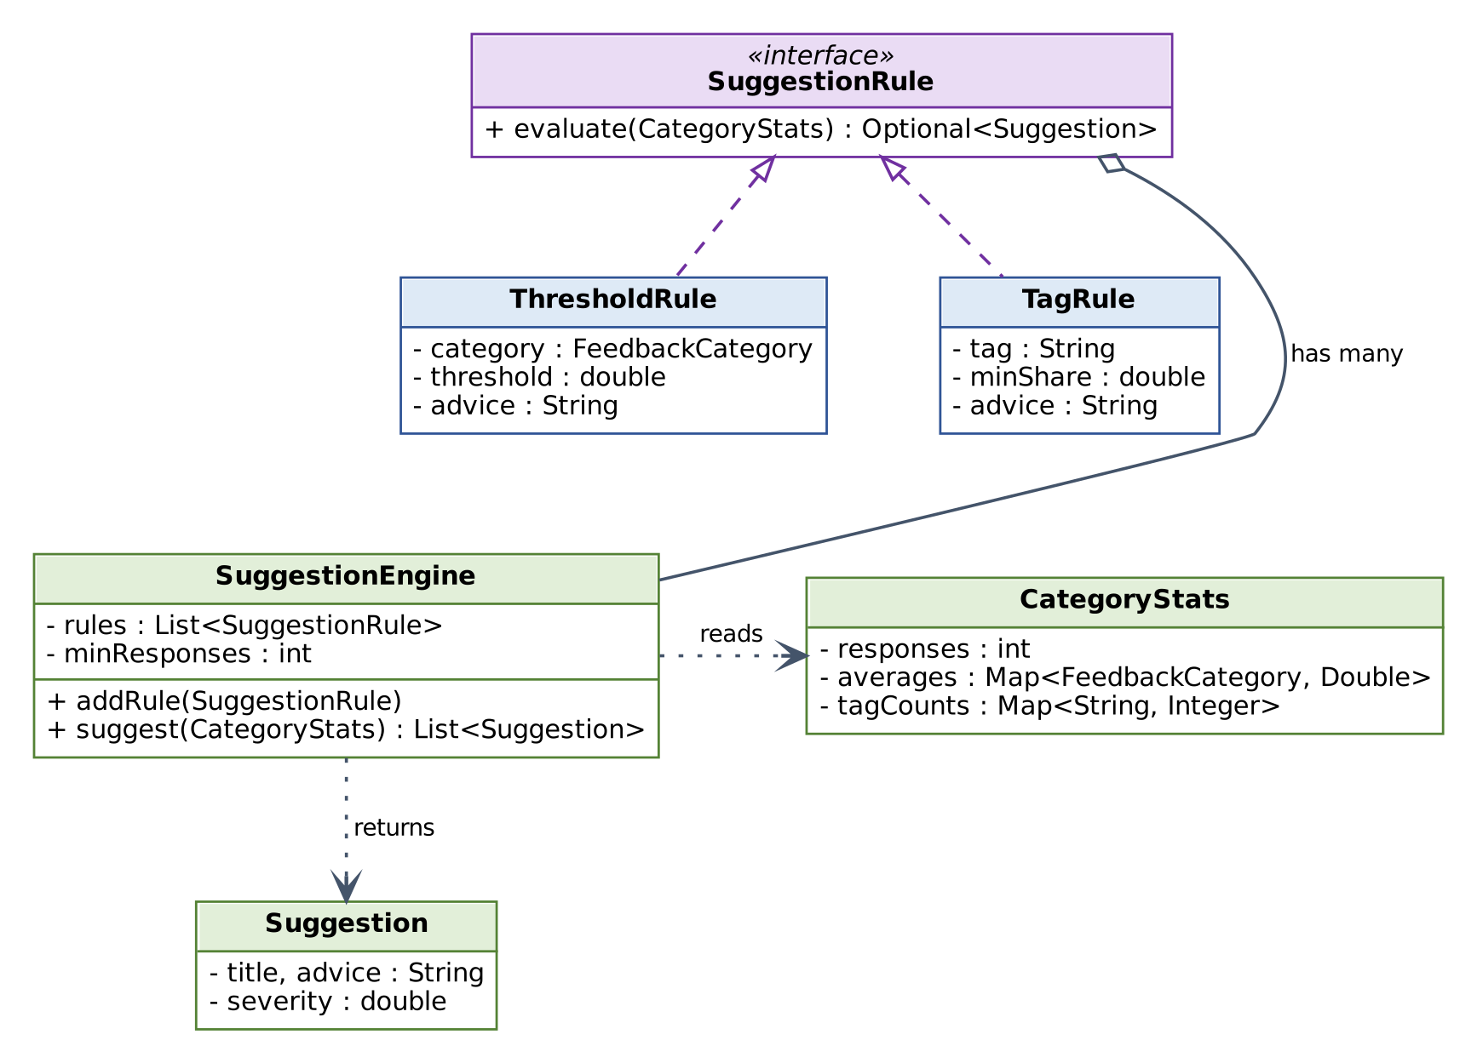
Figure 9: Suggestion engine: one interface, two rule classes (dashed hollow arrows mean “implements”)
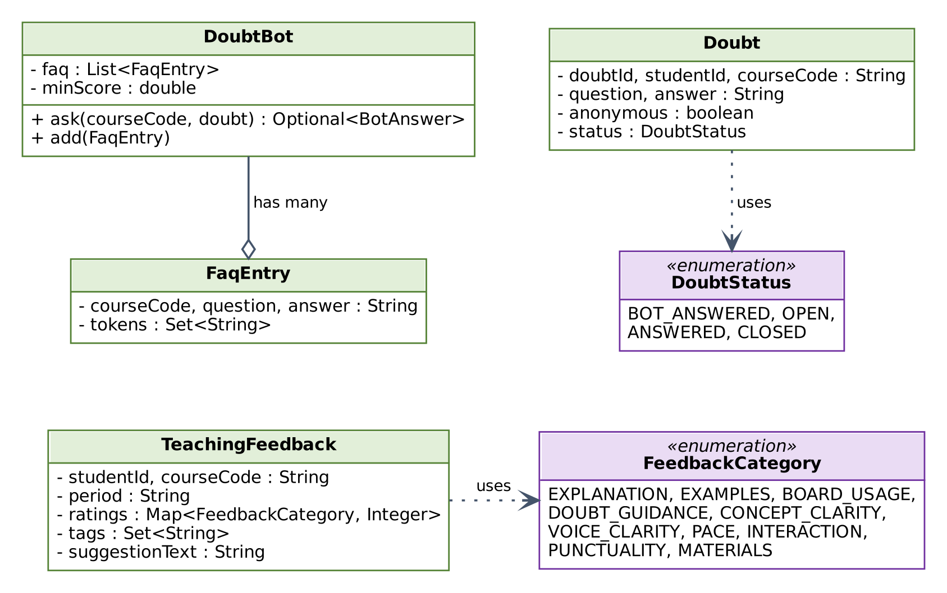
Figure 10: Doubt and teaching-feedback model classes
Layer | New classes (suggested)
model | FaqEntry, Doubt, DoubtStatus (enum), TeachingFeedback, FeedbackCategory (enum), FeedbackPeriod, ImprovementAction, ActionStatus (enum), Notification, Announcement, ResourceItem, WaitlistEntry
dao (+ file implementations) | FaqDAO, DoubtDAO, TeachingFeedbackDAO, SuggestionRuleDAO, ActionDAO, NotificationDAO, AnnouncementDAO, ResourceDAO, WaitlistDAO, PeriodDAO
bot (new package) | DoubtBot, BotAnswer, TextTokenizer
engine (new package) | SuggestionRule (interface), ThresholdRule, TagRule, SuggestionEngine, CategoryStats, Suggestion, StatsCalculator, CommentAnalyzer
service | DoubtService, TeachingFeedbackService, FacultyInsightService, NotificationService, WaitlistService, TimetableService, RecommendationService, AnnouncementService, ResourceService, QualityOverviewService
ui | DoubtMenu, TeachingFeedbackMenu, FacultyDashboardMenu, InboxMenu, TimetableMenu, plus new options in the existing Student, Faculty and Admin menus
Beginner tip: Concepts you will practise here: interfaces and polymorphism (SuggestionRule), enums with fields (FeedbackCategory), EnumMap and HashMap (statistics), Set and Optional (the bot), List.sort with a comparator (severity), packages, and dependency injection (engine receives its rules). All of them are in the concept map of Section 3.4 and appear naturally in this feature pack.

14.9 Data and Permissions

14.9.1 New data files
File | Fields (separated by |)
faq.csv | faqId, courseCode (or ALL), question, answer, keywords, helpfulVotes, unhelpfulVotes, active
doubts.csv | doubtId, studentId, courseCode, question, anonymous, status, answer, answeredBy, askedOn, answeredOn
periods.csv | periodLabel, open (true/false), opensOn, closesOn
teaching_feedback.csv | tfId, studentId, courseCode, periodLabel, ratings (ten values, 0 = skipped), tags (separated by ;), suggestion, moderation (OK / HELD / REJECTED), submittedOn
suggestion_rules.csv | ruleId, type (THRESHOLD / TAG), target, limit, advice, active
actions.csv | actionId, facultyId, courseCode, category, baseAverage, suggestion, status, createdOn, updatedOn
notifications.csv | notificationId, userId, message, createdOn, read
announcements.csv, resources.csv | announcement / resource records per course (see Appendix E for fields)
waitlist.csv | studentId, courseCode, joinedOn
blocked_words.txt, sentiment_words.txt | One word per line, edited by the Admin
For the optional database version, the equivalent tables are in Appendix E. They were created and tested on SQLite together with the base schema (18 tables in total).

14.9.2 Permissions for the new features
Feature | Admin | Faculty | Student
Ask a doubt; view own doubts | No | No | Own, registered courses
Answer doubts; add to FAQ | Edit FAQ only | Own courses | No
Manage FAQ entries | All courses | Own courses | No
Submit teaching feedback | No | No | Own, registered courses
Open / close feedback periods; moderate comments | Yes | No | No
View faculty dashboard and suggestions | All faculty | Own courses | No
Manage suggestion rule book | Yes | No | No
Improvement action plan | View only | Own | No
Course ratings in catalogue; recommendations | Yes | Ratings only | Yes
Waiting list; timetable | View | No | Own
Announcements and resources | View | Own courses (write) | Registered courses (read)
Teaching-quality overview and alerts | Yes | No | No

14.10 Screen Additions
Add these options to the existing menus (numbers are examples):
Role | New menu options
Student | - Ask a Doubt / My Doubts  - Give Teaching Feedback  - My Timetable  - Waiting List  - Courses for You  - Announcements and Resources  - Inbox (n unread)
Faculty | - My Dashboard and Suggestions  - Doubt Inbox  - FAQ for My Courses  - My Action Plan  - Post Announcement / Add Resource  - Inbox (n unread)
Admin | - Feedback Periods  - Moderate Comments  - Rule Book  - Manage FAQ (all courses)  - Teaching-Quality Overview  - Blocked and Sentiment Words

Sample screens (made-up values)
---------------- ASK A DOUBT ----------------
Course: CS101 - Java Basics
Type your doubt: difference of abstract class and interface?
Ask anonymously? (Y/N): N

Bot answer (match 80%):
An abstract class can hold fields and code; an interface lists methods a class
promises to provide.
Was this helpful? (Y/N): N

Sorry about that. Your doubt has been sent to Sample Faculty.
Doubt ID: D-000012 Status: OPEN
-------- MY DASHBOARD: CS101 - Java Basics (MID-TERM) --------
Responses: 10
Explanation 4.0 | Examples 2.4 | Board 4.2 | Voice 3.1 | Pace 3.6
Overall: 3.5 (department average: 3.9)

STRENGTHS
* Use of board (4.2)

SUGGESTIONS FOR YOU (most important first)
1. Use of examples: Add one or two worked examples for every new concept.
2. 50% of students: Could not understand - Pause after each concept and ask a
quick question to check understanding.
3. Voice clarity: Speak a little louder and check from the back row.

Add a suggestion to my action plan? (number, 0 = no): 1
Note: These screens are illustrative mock-ups with invented numbers. Real output must come from real feedback in your data files.

14.11 Additional Test Cases
These continue the numbering of Section 10.3. Run the Must cases for every feature you implement.
ID | Req. | Steps | Test data | Expected result | Priority
TC-35 | FR-DBT-01, 02, 03 | Ask a doubt worded differently from a stored FAQ question. | “difference of abstract class and interface?” | Stored answer shown; no ticket created. | Must
TC-36 | FR-DBT-04 | Ask a doubt unrelated to any FAQ. | “when does the cafeteria open” | Ticket saved as OPEN; student told it was sent to the faculty. | Must
TC-37 | BR-19 | Ask a doubt that matches only the FAQ of another course. | Doubt for course A matching course B FAQ | No match; ticket created. | Must
TC-38 | FR-DBT-01 | Try to ask a doubt for a course the student is not registered in. | Unregistered course | Refused with a clear message. | Must
TC-39 | FR-DBT-05 | Faculty opens inbox and answers a ticket. | One open doubt | Status ANSWERED; answer stored with date; only own-course doubts visible. | Must
TC-40 | FR-DBT-06 | Answer with “Add to FAQ”, then ask the same doubt again as a student. | Same question twice | Second time the bot answers instantly; no new ticket. | Should
TC-41 | FR-DBT-07 | After a bot answer, reply N. | Any matched doubt | Ticket created; unhelpful count of that FAQ increased. | Should
TC-42 | FR-DBT-09, BR-21 | Ask anonymously; faculty opens the inbox and reports. | Anonymous doubt | No student ID or name appears anywhere in faculty or admin views. | Could
TC-43 | FR-DBT-12 | Leave a doubt OPEN beyond 3 days (change the date in the test file). | Old open doubt | Doubt is flagged to faculty and Admin. | Could
TC-44 | FR-TFB-01, 02 | Submit teaching feedback rating all ten categories. | Valid ratings | Saved; course/period leaves the pending list. | Must
TC-45 | BR-23 | Rate only three categories; separately rate a category 6. | 3 ratings; value 6 | Both rejected with clear messages. | Must
TC-46 | FR-TFB-03 | Choose six tags. | 6 tags | Rejected: at most five tags. | Must
TC-47 | BR-22 | Submit feedback twice for the same course and period; then for a dropped course. | Duplicate; dropped course | Duplicate becomes an edit (one record); dropped course refused. | Must
TC-48 | FR-TFB-05 | Close the period and try to submit. | Closed period | Refused with a period-closed message. | Must
TC-49 | FR-TFB-07, F13 | Type a comment containing a blocked word. | Blocked word in comment | Saved as HELD; not visible to faculty until Admin approves. | Should
TC-50 | FR-FPI-02, BR-25 | Faculty opens dashboard with only 2 responses. | 2 responses | Only the count is shown; no averages, comments or suggestions. | Must
TC-51 | FR-FPI-01 | Faculty opens dashboard with 10 responses; compare averages with a hand calculation. | Sample data | Averages match the hand calculation for at least three categories. | Must
TC-52 | FR-FPI-03 | Use data with Examples average 2.4 and Voice 3.1. | Section 14.7.3 data | Suggestions about examples and voice shown, examples first. | Must
TC-53 | FR-FPI-03 | Use data where all averages are 4.5 and no tags are used. | High ratings | No improvement suggestions; strengths listed. | Must
TC-54 | BR-26 | Faculty opens another teacher's course dashboard; student tries the dashboard. | Other course; student account | Access denied in both cases. | Must
TC-55 | FR-FPI-05 | Admin changes a threshold in the rule book, then reopens a faculty dashboard. | Voice limit 3.0 | Voice suggestion no longer fires for average 3.1; change appears in audit log. | Should
TC-56 | FR-FPI-06 | Faculty saves a suggestion to the action plan and changes its status. | One action | Action saved; status changes persist after restart. | Should
TC-57 | FR-FPI-07 | Create action, add a later period with higher averages. | Examples 2.4 then 3.2 | Impact shows an improvement of 0.8 for that category. | Could
TC-58 | FR-STX-01 | Open the catalogue for a course with 2 responses and one with 8. | Different response counts | Rating hidden for the first, shown for the second. | Should
TC-59 | FR-STX-03 | Trigger a notification (answer a doubt); log in as the student. | Answered doubt | Inbox shows 1 unread; reading it clears the count. | Should
TC-60 | FR-STX-04, 05 | Fill a course, join the waiting list as student B, then student A drops. | Capacity 1 | B is registered automatically and notified. | Should
TC-61 | BR-28 | Same as TC-60, but B is at the credit limit. | B at limit | B is skipped and told why; next student in line is tried. | Should
TC-62 | FR-STX-06, BR-29 | Register for two courses with overlapping time slots. | MON 10:00-11:00 and MON 10:30-11:30 | Second refused; message names the clashing course. | Should
TC-63 | FR-STX-08 | Faculty posts an announcement; a registered and an unregistered student check. | One announcement | Registered student sees it with a notification; unregistered student does not. | Could
TC-64 | FR-STX-09 | Admin opens the teaching-quality overview. | Sample data | Courses ranked; low-rated courses flagged; no student names anywhere. | Should

14.12 What Has Been Verified
Item | How it was checked | Result
DoubtBot (Section 14.5) | Compiled with javac -Xlint:all; five behaviours tested (wording variation, general FAQ, course scoping, unrelated doubt, empty doubt). | All five passed.
Suggestion engine and rules (Section 14.7) | Compiled; tested with sample statistics: which rules fire, ordering by severity, and the minimum-response guard. | All three checks passed; output shown in Section 14.7.3.
Extended SQL (Appendix E) | Run on SQLite 3.45 after the base schema (18 tables). A rating of 7, a duplicate period feedback and an invalid doubt status were attempted. | All three invalid inserts were rejected.
The remaining parts of the feature pack (DAOs, services, menus, notifications, waiting list, timetable, recommendations) are specifications for you to implement and test.

14.13 Plan, Effort and Risks for Release 4
Release 4 is extra. Start it only when Release 1 passes all Must test cases. Suggested extension of the plan in Section 11 (weeks 9 to 12), in three waves so you can stop at any wave and still have a coherent project:
Wave | Features | Why this order | Suggested time
Wave 1 – Your three ideas | F01, F02, F03, F09, F10, F11, F15, F16 | Delivers the doubt bot, multi-type feedback and faculty suggestions. This alone makes the project stand out. | About 3 weeks
Wave 2 – Depth | F04, F05, F06, F12, F13, F17, F18, F21, F23, F24, F25, F28 | Makes the loop complete: learning bot, mid-term feedback, rule book, action plan, notices, waiting list, timetable, admin overview. | About 2 weeks
Wave 3 – Polish | F07, F08, F14, F19, F20, F22, F26, F27 | Nice-to-have features; add only if time remains. | As time allows
Risk | Prevention
Too many features, none finished. | Do Wave 1 completely, test it, then decide. A smaller number of well-tested features scores higher than many half-built ones.
Bot answers feel weak because the FAQ is small. | Prepare 20+ real FAQ entries from your own syllabus before the demo; use F04 to grow it.
Suggestions seem generic. | Tune thresholds with sample data and keep advice sentences specific and polite.
Students fear being identified. | Keep the minimum-response rule, anonymous doubts and moderation; show them in the demo.
Evaluators ask “is this AI?” | Answer honestly: it is rule-based and explainable. Explain what the rules are and how they could be extended (Section 14.14).

14.14 Optional Upgrades Beyond This PRD
- Smarter matching: ignore small spelling differences, treat word forms alike (“registering” = “register”), or weight rare words more heavily than common ones.
- AI service for doubts: call an external language-model service when no FAQ matches, and let faculty review the saved answer. This needs internet access, an account and careful handling of cost and privacy, so keep it optional and clearly labelled as AI-generated.
- Charts: trend graphs of category averages using a Java charting library or exported CSV.
- Email notifications in place of in-app messages.

Appendix A: Glossary
Plain-language meanings of the terms used in this document.
Term | Meaning
Abstract class | A class that cannot be created directly and may contain methods without a body that subclasses must supply (User).
Abstraction | Showing what something does while hiding how it does it.
Access modifier | public, protected, private: keywords deciding who may use a field or method.
Audit log | A file that records important events (who did what and when).
Class | A blueprint describing the fields and methods of a kind of object.
Collection | A ready-made container for many objects, such as ArrayList, HashSet and HashMap.
Constructor | A special method that runs when an object is created and sets its starting values.
CSV | Comma-separated values: a plain text file with one record per line. This project uses a pipe | instead of a comma.
DAO | Data Access Object: a class that reads and writes stored data so other classes do not have to.
Dependency injection | Giving a class the helpers it needs (through its constructor) instead of letting it create them.
Encapsulation | Keeping data private and exposing only safe methods to use it.
Enum | A type with a fixed list of named values, such as Role.ADMIN.
Exception | An object that signals a problem; thrown by a method and caught by its caller.
Factory | A design pattern: one method that decides which kind of object to create.
Field | A variable that belongs to an object and stores its data.
final | A keyword meaning the value cannot be changed after it is set.
Foreign key (FK) | A database column that must match a primary key in another table.
Generics | Writing List<Course> so a collection knows exactly what type it holds.
Hash | A one-way scrambled form of a value; used to store passwords safely.
Inheritance | A class reusing and extending another class (“is-a”).
Interface | A list of methods a class promises to provide; says what, not how.
JDBC | Java Database Connectivity: Java's standard way of talking to a database.
JDK | Java Development Kit: the tools needed to compile and run Java programs.
JUnit | A library for writing automated tests in Java.
Javadoc | Special comments (/** ... */) from which documentation pages can be generated.
Layered architecture | Splitting a program into layers with one job each (ui, service, dao).
Method | A named block of code that does a task; belongs to a class.
MoSCoW | Priority scale: Must, Should, Could (and Won't for now).
Object | One real thing created from a class, with its own values.
Overloading | Several methods with the same name but different parameters.
Overriding | A subclass replacing a method it inherited with its own version.
Package | A folder-like group of related classes.
Polymorphism | One method call or reference behaving differently depending on the real object.
Primary key (PK) | A value that uniquely identifies each record in a table or file.
PRD | Product Requirements Document: describes what a product must do and why.
Salt | Random extra data mixed into a password before hashing so equal passwords give different hashes.
Singleton | A design pattern that allows exactly one object of a class.
static | A keyword meaning something belongs to the class itself, not to any single object.
super / this | super refers to the parent class part; this refers to the current object.
UML | Unified Modeling Language: a standard way to draw designs (class, use case, sequence diagrams).
UTF-8 | A text encoding that can store letters of all languages.
Escalation | Passing a problem to a person who can solve it, such as sending an unanswered doubt to the faculty.
Keyword matching | Finding the stored text that shares the most important words with a new text; no real understanding is involved.
Moderation | Checking user-written text before it is shown to others.
Optional | A Java box that holds either a value or nothing (Optional<BotAnswer>), used instead of returning null.
Rule engine | A part of the program that checks a list of simple if-then rules and collects the advice of those that apply.
Sentiment | Whether a piece of text sounds positive, negative or neutral.
Set | A collection that stores each item only once and can quickly check if an item is present.
Stop words | Very common words (the, is, how) removed before matching because they carry little meaning.
Threshold | A limit value; for example, advice is shown when an average falls below 3.5.
Tokenise | Split text into separate words (tokens) so they can be compared.
Waiting list | A first-in, first-out queue of students for a course that is full.

Appendix B: Output of the Verification Run
This is the real output printed by the plain-Java test driver used to check the sample classes in Sections 7.3 to 7.7 (course capacity of 2 for CS101, credit limit set to 8, sample users with made-up names):
PASS happy path creates registration REG-000001
PASS seat count drops
PASS duplicate rejected: You are already registered for CS101.
PASS credit limit rejected: This would exceed the maximum of 8 credits.
PASS full course rejected: Course CS101 is full. No seats are left.
PASS missing course rejected: Course ZZ999 was not found.
PASS closed window rejected: Registration is currently closed.
STUDENT S1 - Test Student 1
1. View Courses 2. Register 3. Drop 4. Feedback 0. Logout
FACULTY F1 - Test Faculty 1
1. My Courses 2. Enrolled Students 3. Feedback Summary 0. Logout
PASS equals/hashCode by course code
ALL OK
Notice the last two blocks: the same call u.showMenu() printed a different menu for a Student and a Faculty object. That is polymorphism in action.

Appendix C: Relational Database Schema (Optional, Release 3)
Portable SQL that was executed successfully on SQLite 3.45 (it uses only common data types so that it can also be adapted for MySQL). Boolean flags are stored as 0/1 integers and times as HH:mm text for portability.
-- CRFMS optional relational schema (portable SQL: MySQL / SQLite compatible)
CREATE TABLE user_account (
user_id VARCHAR(20) PRIMARY KEY,
role VARCHAR(10) NOT NULL CHECK (role IN ('ADMIN','FACULTY','STUDENT')),
name VARCHAR(100) NOT NULL,
email VARCHAR(100) NOT NULL UNIQUE,
salt VARCHAR(64) NOT NULL,
password_hash VARCHAR(128) NOT NULL,
is_active INT NOT NULL DEFAULT 1 CHECK (is_active IN (0,1)),
must_change_pwd INT NOT NULL DEFAULT 1 CHECK (must_change_pwd IN (0,1))
);

CREATE TABLE student (
user_id VARCHAR(20) PRIMARY KEY,
roll_number VARCHAR(20) NOT NULL UNIQUE,
department VARCHAR(50) NOT NULL,
current_semester INT NOT NULL CHECK (current_semester BETWEEN 1 AND 12),
FOREIGN KEY (user_id) REFERENCES user_account(user_id)
);

CREATE TABLE faculty (
user_id VARCHAR(20) PRIMARY KEY,
employee_id VARCHAR(20) NOT NULL UNIQUE,
department VARCHAR(50) NOT NULL,
designation VARCHAR(50),
FOREIGN KEY (user_id) REFERENCES user_account(user_id)
);

CREATE TABLE course (
course_code VARCHAR(10) PRIMARY KEY,
title VARCHAR(100) NOT NULL,
credits INT NOT NULL CHECK (credits BETWEEN 1 AND 6),
capacity INT NOT NULL CHECK (capacity BETWEEN 1 AND 200),
semester INT NOT NULL CHECK (semester BETWEEN 1 AND 12),
faculty_id VARCHAR(20) NOT NULL,
day_of_week VARCHAR(9),
start_time VARCHAR(5),
end_time VARCHAR(5),
is_active INT NOT NULL DEFAULT 1 CHECK (is_active IN (0,1)),
FOREIGN KEY (faculty_id) REFERENCES faculty(user_id)
);

CREATE TABLE registration (
registration_id VARCHAR(12) PRIMARY KEY,
student_id VARCHAR(20) NOT NULL,
course_code VARCHAR(10) NOT NULL,
registered_on DATE NOT NULL,
status VARCHAR(10) NOT NULL CHECK (status IN ('REGISTERED','DROPPED')),
dropped_on DATE,
UNIQUE (student_id, course_code),
FOREIGN KEY (student_id) REFERENCES student(user_id),
FOREIGN KEY (course_code) REFERENCES course(course_code)
);

CREATE TABLE feedback (
feedback_id VARCHAR(12) PRIMARY KEY,
student_id VARCHAR(20) NOT NULL,
course_code VARCHAR(10) NOT NULL,
rating_content INT NOT NULL CHECK (rating_content BETWEEN 1 AND 5),
rating_teaching INT NOT NULL CHECK (rating_teaching BETWEEN 1 AND 5),
rating_materials INT NOT NULL CHECK (rating_materials BETWEEN 1 AND 5),
rating_assessment INT NOT NULL CHECK (rating_assessment BETWEEN 1 AND 5),
comment_text VARCHAR(300),
submitted_on DATE NOT NULL,
UNIQUE (student_id, course_code),
FOREIGN KEY (student_id) REFERENCES student(user_id),
FOREIGN KEY (course_code) REFERENCES course(course_code)
);

CREATE TABLE system_setting (
setting_key VARCHAR(40) PRIMARY KEY,
setting_value VARCHAR(100) NOT NULL
);

Appendix D: Viva Preparation Questions
Practise answering these aloud, pointing at your own code. Short, honest answers are best.
# | Question | Where to find your answer
1 | What is the difference between a class and an object? Show one of each in your project. | Section 3.2; Course and new Course(...).
2 | Why is User abstract? What would go wrong if it were not? | Section 3.3, 7.3.1.
3 | Explain encapsulation using Course.enrolledCount. | Section 7.3.2.
4 | What is the difference between overriding and overloading? Give one example of each. | Section 3.4 (rows 5 and 6).
5 | How does user.showMenu() know which menu to print? | Section 3.3 (polymorphism), Appendix B.
6 | What is an interface and why do your services use CourseDAO instead of FileCourseDAO? | Section 7.4.1.
7 | Why do you use custom exceptions? What is the difference between throw and throws? | Section 7.8.
8 | Why must equals and hashCode be overridden together? | Section 7.3.2 note.
9 | Which collections do you use and why HashMap for courses? | Section 3.4 (row 14), 7.4.1.
10 | How do you store passwords and why not as plain text? | Section 7.9.
11 | Where is each business rule enforced and why not in the menu? | Sections 4.12, 7.1.
12 | What is a design pattern? Which ones did you use? | Section 7.7.
13 | How would you change the project to use a database? | Sections 7.4.1, 7.5.2, 13.1.
14 | How do you stop a course from being overbooked? | Section 7.3.2 and 7.4.2.
15 | How did you test your project? Show a failing and a passing case. | Section 10.
16 | What are the limitations of your project? | Section 1.6, 13.1, and the warning in 7.9.
17 | Is your doubt bot artificial intelligence? How does it find an answer? | Section 14.1 and 14.5.
18 | What happens when the bot cannot answer a doubt? | Section 14.5.1 (escalation) and BR-20.
19 | Why is SuggestionRule an interface? How would you add a new kind of rule? | Section 14.7.1.
20 | How do you protect students when the faculty can see feedback? | BR-25, BR-26, Sections 14.3.3 and 14.4.
21 | How are suggestions produced from ratings? Show a worked example. | Section 14.7.2 and 14.7.3.
22 | Why are the suggestion rules stored in a file and not written in the code? | F17 and Section 14.9.1.

Appendix E: Extended Database Schema (Advanced Features, Optional)
Run after the base schema of Appendix C. Together they create 18 tables. The script was executed on SQLite 3.45 and the constraints (rating range, one feedback per period, valid doubt status) were confirmed to reject bad data.
-- CRFMS advanced feature tables (run after the base schema)
CREATE TABLE faq_entry (
faq_id VARCHAR(12) PRIMARY KEY,
course_code VARCHAR(10) NOT NULL, -- 'ALL' = every course
question VARCHAR(300) NOT NULL,
answer VARCHAR(1000) NOT NULL,
keywords VARCHAR(200),
helpful_votes INT NOT NULL DEFAULT 0,
unhelpful_votes INT NOT NULL DEFAULT 0
);

CREATE TABLE doubt (
doubt_id VARCHAR(12) PRIMARY KEY,
student_id VARCHAR(20) NOT NULL,
course_code VARCHAR(10) NOT NULL,
question VARCHAR(500) NOT NULL,
is_anonymous INT NOT NULL DEFAULT 0 CHECK (is_anonymous IN (0,1)),
status VARCHAR(10) NOT NULL CHECK (status IN ('BOT_ANSWERED','OPEN','ANSWERED','CLOSED')),
answer VARCHAR(1000),
answered_by VARCHAR(20),
asked_on DATE NOT NULL,
answered_on DATE,
FOREIGN KEY (student_id) REFERENCES student(user_id),
FOREIGN KEY (course_code) REFERENCES course(course_code),
FOREIGN KEY (answered_by) REFERENCES faculty(user_id)
);

CREATE TABLE teaching_feedback (
tf_id VARCHAR(12) PRIMARY KEY,
student_id VARCHAR(20) NOT NULL,
course_code VARCHAR(10) NOT NULL,
period_label VARCHAR(20) NOT NULL, -- e.g. WEEK-3 or END-TERM
suggestion VARCHAR(300),
submitted_on DATE NOT NULL,
UNIQUE (student_id, course_code, period_label),
FOREIGN KEY (student_id) REFERENCES student(user_id),
FOREIGN KEY (course_code) REFERENCES course(course_code)
);

CREATE TABLE teaching_rating (
tf_id VARCHAR(12) NOT NULL,
category VARCHAR(20) NOT NULL,
rating INT NOT NULL CHECK (rating BETWEEN 1 AND 5),
PRIMARY KEY (tf_id, category),
FOREIGN KEY (tf_id) REFERENCES teaching_feedback(tf_id)
);

CREATE TABLE teaching_tag (
tf_id VARCHAR(12) NOT NULL,
tag VARCHAR(40) NOT NULL,
PRIMARY KEY (tf_id, tag),
FOREIGN KEY (tf_id) REFERENCES teaching_feedback(tf_id)
);

CREATE TABLE suggestion_rule (
rule_id VARCHAR(12) PRIMARY KEY,
rule_type VARCHAR(10) NOT NULL CHECK (rule_type IN ('THRESHOLD','TAG')),
target VARCHAR(40) NOT NULL, -- category name or tag text
limit_value REAL NOT NULL, -- average below this, or tag share at/above this
advice VARCHAR(300) NOT NULL,
is_active INT NOT NULL DEFAULT 1 CHECK (is_active IN (0,1))
);

CREATE TABLE improvement_action (
action_id VARCHAR(12) PRIMARY KEY,
faculty_id VARCHAR(20) NOT NULL,
course_code VARCHAR(10) NOT NULL,
suggestion VARCHAR(300) NOT NULL,
status VARCHAR(12) NOT NULL CHECK (status IN ('PLANNED','IN_PROGRESS','DONE','DISMISSED')),
created_on DATE NOT NULL,
updated_on DATE,
FOREIGN KEY (faculty_id) REFERENCES faculty(user_id),
FOREIGN KEY (course_code) REFERENCES course(course_code)
);

CREATE TABLE announcement (
announcement_id VARCHAR(12) PRIMARY KEY,
course_code VARCHAR(10) NOT NULL,
faculty_id VARCHAR(20) NOT NULL,
title VARCHAR(100) NOT NULL,
body VARCHAR(500) NOT NULL,
posted_on DATE NOT NULL,
FOREIGN KEY (course_code) REFERENCES course(course_code),
FOREIGN KEY (faculty_id) REFERENCES faculty(user_id)
);

CREATE TABLE resource_item (
resource_id VARCHAR(12) PRIMARY KEY,
course_code VARCHAR(10) NOT NULL,
title VARCHAR(100) NOT NULL,
link_or_note VARCHAR(300) NOT NULL,
added_on DATE NOT NULL,
FOREIGN KEY (course_code) REFERENCES course(course_code)
);

CREATE TABLE waitlist (
student_id VARCHAR(20) NOT NULL,
course_code VARCHAR(10) NOT NULL,
joined_on DATE NOT NULL,
PRIMARY KEY (student_id, course_code),
FOREIGN KEY (student_id) REFERENCES student(user_id),
FOREIGN KEY (course_code) REFERENCES course(course_code)
);

CREATE TABLE notification (
notification_id VARCHAR(12) PRIMARY KEY,
user_id VARCHAR(20) NOT NULL,
message VARCHAR(300) NOT NULL,
created_on DATE NOT NULL,
is_read INT NOT NULL DEFAULT 0 CHECK (is_read IN (0,1)),
FOREIGN KEY (user_id) REFERENCES user_account(user_id)
);

Appendix F: Document Control
Version | Date | Change
1.0 | 05-Oct-2026 | First complete version of the PRD.
1.1 | 05-Oct-2026 | Added Section 14 (Advanced Feature Pack, 28 features), Appendix E (extended schema), test cases TC-35 to TC-64, glossary and viva additions; updated scope, objectives and release plan.

This PRD is a proposed specification prepared for a student learning project. Items marked as defaults or proposals (limits, thresholds, lock-out time, plan duration) can and should be adjusted to your institution's rules and your guide's instructions.

