Linux Basic Commands Assignment
Name: Sanjeevi Rajenderan
Course: Linux Administration
Date: 19-02-2026

- Creating and Renaming Files/Directories
Create a directory
mkdir test_dir
Explanation:
This command creates a new directory named test_dir in the current location.
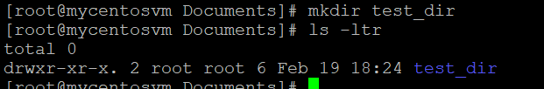

Create an empty file inside test_dir
touch test_dir/example.txt
Explanation:
Creates an empty file named example.txt inside the directory test_dir.
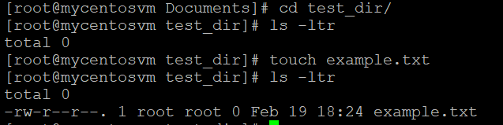
Rename the file
mv test_dir/example.txt test_dir/renamed_example.txt
Explanation:
Renames example.txt to renamed_example.txt using the mv command.
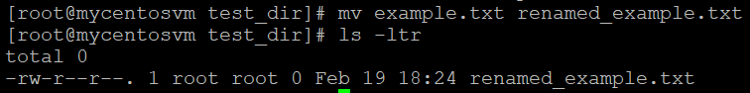
- Viewing File Contents
Display entire file
cat /etc/passwd
Explanation:
Displays the complete contents of the /etc/passwd file.
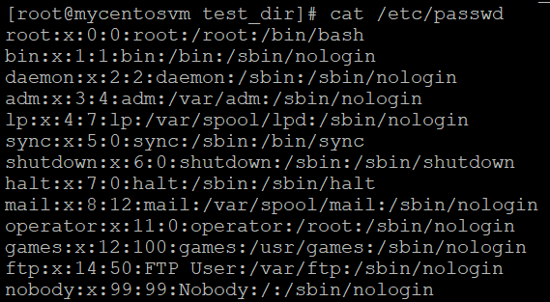
Display first 5 lines
head -5 /etc/passwd
Explanation:
Shows only the first 5 lines of the file.
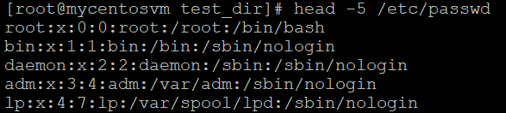
Display last 5 lines
tail -5 /etc/passwd
Explanation:
Shows the last 5 lines of the file.
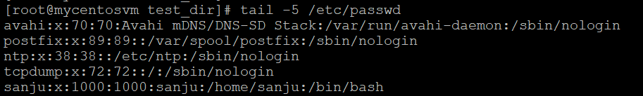
- Searching for Patterns
Search for "root"
grep root /etc/passwd
Explanation:
Searches and displays lines containing the word root.
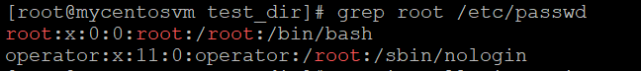

- Zipping and Unzipping
Install zip & unzip
yum install zip unzip -y
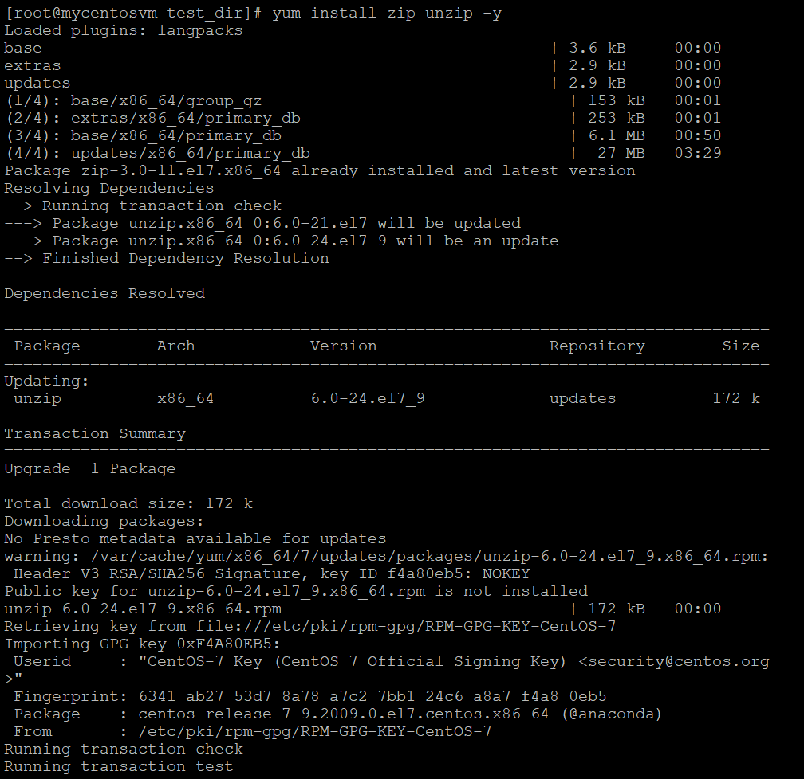

Compress directory
zip -r test_dir.zip test_dir
Explanation:
Compresses the test_dir directory into test_dir.zip.
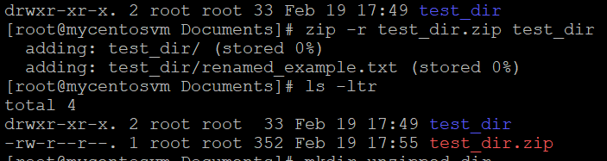
Unzip into new directory
mkdir unzipped_dir
unzip test_dir.zip -d unzipped_dir
Explanation:
Extracts the zip file into a new directory called unzipped_dir.
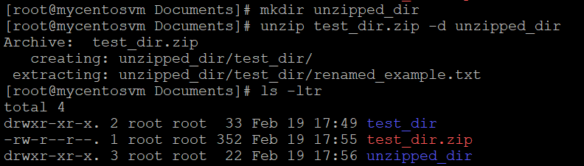
- Downloading Files
Download using wget
wget https://example.com/sample.txt
Explanation:
Downloads a file from the given URL into the current directory.
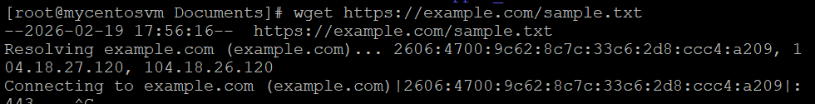
- Changing Permissions
Create file
touch secure.txt
Make read-only for everyone
chmod 444 secure.txt
Explanation:
Sets read-only permission for:
- Owner
- Group
- Others
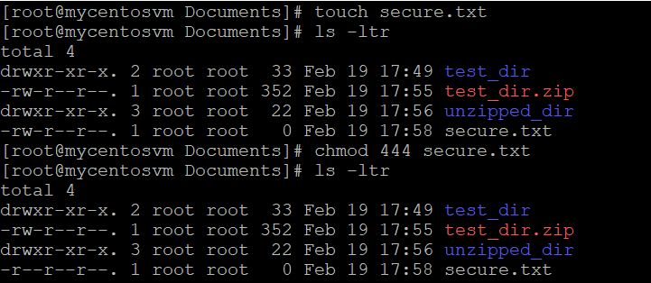
- Working with Environment Variables
Set environment variable
export MY_VAR="Hello, Linux!"
Verify variable
echo $MY_VAR
Explanation:
Creates a temporary environment variable available for the current session.
