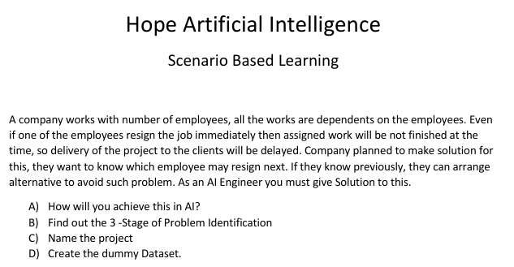

**A)How will you achieve this in AI?**

**Gather historical data of employees** who have resigned in the past, as well as data of current employees, Behavior data also Job-related Information 🡪Job role, department, salary, years in the company, performance evaluations, promotions, etc.

**B) Find out the 3 -Stage of Problem Identification**

Stage 1 : **Machine Learning** (Because data set we have it in excel sheet which is in terms of numbers)

Stage 2: **Supervision** (Because we have input & output)

Stage 3: **Classification** (Because we have to categories the employs who is going to resign the job)

**C) Name the Project**

Proactive resignation predictor and delegate the work

**D) Dummy Dataset**

|  |  |  |  |  |  |  |
| --- | --- | --- | --- | --- | --- | --- |
| Employee ID | Age | Department | Experience | Salary | Avg Hours/Day | Resigned (Target) |
| 10026 | 25 | IT | 5 | 60000 | 8 | 0 |
| 10068 | 49 | HR | 8 | 42000 | 5 | 0 |
| 10069 | 55 | Sales | 10 | 44000 | 12 | 1 |

Based on the above factors it will influences an employ decision to resign. The final label is Resigned or not using 1 and 0 output.

By training an AI model on such a dataset, the company can predict which employees are at risk of resigning and take preventive measures.