SMART AUTOMATED GATE CONTROL AND ACCESS MONITORING SYSTEM USING IOT, SENSORS, AND FULL-STACK TECHNOLOGIES
A PROJECT REPORT
Submitted by
[CANDIDATE NAME(S)]
in partial fulfilment of the requirements for the award of the degree
of
BACHELOR OF ENGINEERING / BACHELOR OF TECHNOLOGY
in
[BRANCH OF STUDY]
KGiSL INSTITUTE OF TECHNOLOGY
ANNA UNIVERSITY: CHENNAI 600 025
[MONTH AND YEAR]

KGiSL INSTITUTE OF TECHNOLOGY
BONAFIDE CERTIFICATE
Certified that this project report entitled “Smart Automated Gate Control And Access Monitoring System Using Iot, Sensors, And Full-Stack Technologies” is the bonafide work of “[CANDIDATE NAME(S)]” who carried out the project work under my supervision.
[Signature of Head of Department]  SIGNATURE | [Signature of Supervisor]  SIGNATURE
[Name]  HEAD OF THE DEPARTMENT  [Department]  [Full Department and College Address] | [Name]  SUPERVISOR  [Academic Designation]  [Department]  [Full Department and College Address]

INTERNAL EXAMINER | EXTERNAL EXAMINER

ABSTRACT
This project develops a Smart Automated Gate Control and Access Monitoring System that links physical sensing, RFID-based identity checks, backend authorization, device command execution, persistent logging, and web-based supervision. The system is designed around a gate controller represented either by an ESP32 or by a software simulator that follows the same authenticated device protocol. Presence information is received from an infrared or ultrasonic sensor, while an RFID reader provides a credential identifier. The backend verifies the credential against active user and RFID-card records, records the decision, and, in automatic mode, queues a gate-open command carrying a configurable auto-close value. The controller reports gate-open and gate-close position events, allowing the system to maintain an auditable representation of the physical state.
The full-stack implementation includes a MySQL data model, role-aware procedures for Admin, Security Operator, and Registered User roles, a command queue, device heartbeat handling, an authenticated device REST interface, a WebSocket update channel with five-second polling fallback, and a responsive React dashboard. The dashboard provides live gate status, recent access records, security-event panels, manual operator controls, device monitoring, access filtering, identity/RFID management, and analytics. Security events are classified as INFO, WARNING, or CRITICAL. The project deliberately avoids hard-coded device credentials; an administrator rotates a one-time device token that is stored only as a verifier by the server. Automated tests validate core authorization, denial, snapshot, and manual-command workflows. The implementation is demonstrable in simulation mode; all statements about physical performance, electrical operation, and field reliability are explicitly reserved for validation during physical deployment.

TABLE OF CONTENTS
Open this file in Microsoft Word and update the Table of Contents field.

LIST OF TABLES
Table No. | Caption
Table 1.1 | Project objectives and measurable software outcomes
Table 3.1 | Functional requirements
Table 3.2 | Non-functional requirements
Table 3.3 | Hardware requirements
Table 3.4 | Software requirements
Table 4.1 | Role and permission model
Table 4.2 | Database entities
Table 4.3 | Device-event and response policy
Table 5.1 | REST device API endpoints
Table 6.1 | Executed automated tests
Table 6.2 | Physical deployment validation plan

LIST OF FIGURES
Figure No. | Caption
Figure 4.1 | Overall system architecture
Figure 4.2 | Authorized and denied access event sequence
Figure 4.3 | Entity-relationship model

LIST OF SYMBOLS, ABBREVIATIONS AND NOMENCLATURE
Abbreviation | Meaning
API | Application Programming Interface
ESP32 | Espressif Wi-Fi and Bluetooth system-on-chip family
IoT | Internet of Things
JWT | JSON Web Token
KPI | Key Performance Indicator
MFRC522 / RC522 | Contactless RFID reader/controller family
RFID | Radio-Frequency Identification
REST | Representational State Transfer
SPI | Serial Peripheral Interface
UID | Unique Identifier
WebSocket | Full-duplex browser–server communication protocol

CHAPTER 1 — INTRODUCTION
1.1 General
Gate control is a boundary-security activity in which access decisions, gate movement, physical safety, and record keeping must be coordinated. Manual gates and isolated RFID systems can create operational blind spots because the security operator may not receive a timely view of a denied credential, a gate that remains open, or a controller that stops communicating. The proposed project combines sensing, authorization, command delivery, logging, and visual monitoring in one modular system.
The system uses an ESP32-compatible design because Espressif identifies ESP-IDF as the official development framework for its ESP32 family of system-on-chip devices [1]. The prototype firmware is written in Arduino-compatible C++ for accessibility, while its network behavior follows the same device contract implemented by the local simulator. The RFID design uses the MFRC522 family, a contactless 13.56 MHz reader/writer IC supporting ISO/IEC 14443 A/MIFARE and NTAG communication [2].
1.2 Background
An automated gate is not merely an actuator. It is a cyber-physical system with physical inputs, an identity decision, a movement command, and an audit outcome. The project therefore models the gate as a state machine: CLOSED, OPENING, OPEN, CLOSING, and ALERT. A valid RFID scan in AUTO mode produces a queued OPEN command with the current auto-close setting. Gate position is not assumed from the web screen; it is updated only when the device/simulator reports a corresponding gate event.
1.3 Problem Statement
Conventional entry points may rely on manual verification, locally stored credentials, disconnected gate mechanisms, or paper logs. Such arrangements can make it difficult to determine who attempted access, whether an attempt was denied, whether the gate closed, and whether the controller is healthy. The problem addressed by this project is to provide a secure, observable and demonstrable gate-access workflow spanning device input, backend decision-making, database storage and web supervision.
1.4 Motivation
The primary motivation is to illustrate an end-to-end engineering workflow rather than a frontend-only dashboard. The project exposes how sensor data travels to an authenticated backend, how a backend command reaches a device, how the device confirms movement, and how the operator sees a resulting audit trail. Security guidance also warns against weak or hard-coded credentials, insecure ecosystem interfaces, insufficient device management, and insecure data handling [4]. These concerns motivate device-token rotation, role-aware procedures, input validation, event logging and heartbeat monitoring.
1.5 Objectives
Table 1.1 maps the project objectives to tangible software outcomes.
Objective | Implemented software outcome
Verify an authorized identity | RFID UID is matched to an active card and active registered user.
Deny unrecognized access | A denial is logged and a WARNING event is created.
Control the gate safely | A backend command queue controls OPEN, CLOSE and AUTO transitions.
Avoid a fixed close delay | The auto-close timeout is stored in gate settings and placed in the OPEN command payload.
Support monitoring | Dashboard snapshots, WebSocket notifications and polling fallback expose current state.
Preserve history | Access logs, gate events and sensor readings are stored in MySQL.
Support simulation | A local simulator uses the same /api/iot/* endpoints and command acknowledgements as a device.

1.6 Scope
The implemented scope includes software and a hardware reference. The web application manages identities, RFID cards, logs, alerts, device records, configuration and analytics. The device API accepts heartbeat, sensor, RFID, gate-position and command-acknowledgement traffic. The reference ESP32 firmware describes sensor, RC522 RFID, servo, LED and buzzer integration. The scope does not claim a completed field installation, production-grade fail-safe certification, biometric identity verification, camera analytics, SMS delivery, or completed hardware measurements.
1.7 Proposed Solution
The proposed solution is a modular monolith: React provides the operator interface; Express/tRPC provides the role-aware application backend; MySQL and Drizzle ORM persist state; a REST interface serves external devices; and an authenticated WebSocket endpoint signals live changes. Although the initial project brief suggested FastAPI, the supplied full-stack project environment uses an Express/tRPC architecture. The device-facing REST API remains distinct from the dashboard procedure layer and provides the intended hardware-to-cloud separation.
1.8 Advantages
The project centralizes access decisions and logs, separates human and device authentication, makes device state visible, supports secure token rotation, and retains a simulator for demonstrations without physical hardware. Command status is recorded as pending, delivered, acknowledged, failed or expired rather than treating a user-interface click as proof of gate movement.
1.9 Organization of the Report
Chapter 2 reviews relevant technologies. Chapter 3 defines requirements and feasibility. Chapter 4 describes architecture, data flow and database design. Chapter 5 discusses implementation. Chapter 6 records executed automated tests and a physical validation plan. Chapter 7 concludes the work and lists future enhancements.

CHAPTER 2 — LITERATURE REVIEW
2.1 IoT Controllers and RFID Readers
ESP32-class controllers are appropriate for teaching prototypes because they combine embedded input/output capability with Wi-Fi support and an extensive vendor-supported software ecosystem [1]. The MFRC522 reader supports ISO/IEC 14443 A/MIFARE and NTAG communication at 13.56 MHz, and offers SPI, UART and I²C host interfaces [2]. These characteristics support an architecture in which the RFID reader supplies a UID to the microcontroller and the microcontroller requests a server-side authorization decision.
2.2 Web-Based Monitoring
Real-time operational interfaces benefit from a two-way channel. RFC 6455 defines WebSocket as an opening handshake followed by message framing, with browser origin security considerations [3]. The project uses an authenticated /ws/dashboard channel to notify the dashboard of events while retaining five-second polling as a resilience fallback. Polling is intentionally preserved so the monitoring view can reconcile with the database after a disrupted live connection.
2.3 IoT Security Considerations
The OWASP IoT project identifies weak or hard-coded passwords, insecure network services, insecure ecosystem interfaces, insecure data handling, and weak device management as important classes of risk [4]. The project responds by avoiding source-embedded device credentials, storing only a SHA-256 verifier, validating device identifiers and tokens on device endpoints, protecting management procedures by role, and recording device-communication events. These controls improve the prototype’s security posture but do not replace a full production security assessment.
2.4 Research Gap Addressed
Many introductory demonstrations stop at RFID reading and servo motion. This work addresses the engineering gap between that local interaction and a monitored full-stack system. The emphasis is on traceable state changes, role separation, device command acknowledgement, simulation parity, and an explicit distinction between implemented software behavior and physical claims pending deployment validation.

CHAPTER 3 — SYSTEM ANALYSIS AND REQUIREMENTS
3.1 Existing System
An existing manual or isolated electronic gate commonly has a local controller, an actuator and a limited record of movement. It may not provide centralized identity management, filtered historical records, device-health signals, or a structured security event model. A purely frontend prototype is also inadequate because its displayed state does not confirm a corresponding device action.
3.2 Limitations of Existing System
The main limitations are limited traceability, delayed incident awareness, insufficient centralized access management, absent device-state confirmation and inability to demonstrate hardware-independent integration. In particular, changing a visual indicator in a dashboard does not prove that a physical gate has received or completed a command.
3.3 Proposed System
The proposed system accepts device events, validates RFID cards against registered records, creates access logs, enqueues commands, tracks acknowledged execution and exposes operations through a dashboard. Device events are handled by common backend services whether their source is an ESP32 or the local simulator. This common-service design ensures that simulation does not bypass authorization or audit logging.
3.4 Functional Requirements
Table 3.1 describes the principal functional requirements.
ID | Requirement | Acceptance condition
FR-01 | Role-aware access | Admin, Operator and Registered User roles are stored and checked by protected procedures.
FR-02 | RFID verification | Active card plus active user results in authorization; otherwise denial is recorded.
FR-03 | Gate control | Admin/Operator can queue OPEN, CLOSE and AUTO actions.
FR-04 | Configurable auto-close | Admin changes a persisted 3–300 second timeout; the device receives it in the OPEN command payload.
FR-05 | Device API | Heartbeat, events, command polling and acknowledgement endpoints require device credentials.
FR-06 | Event detection | Unauthorized credentials, repeated denials, forced-open, offline and command-failure conditions are stored as events.
FR-07 | Monitoring | The dashboard shows gate/device status, activity, alerts and data-backed analytics.
FR-08 | Simulation | Local simulator uses device REST endpoints and local auto-close behavior.

3.5 Non-functional Requirements
ID | Requirement | Design response
NFR-01 | Security | Human procedures are role protected; devices authenticate with an ID/token pair.
NFR-02 | Reliability | Command states and acknowledgements avoid assuming execution from a UI request.
NFR-03 | Maintainability | Database tables, shared service functions, routers, dashboard pages and device clients are separated.
NFR-04 | Usability | A responsive dashboard gives concise live operational information.
NFR-05 | Observability | Logs, alerts, heartbeat timestamps and command records are retained.
NFR-06 | Demonstrability | Seeded records and a device simulator support an academic demonstration.

3.6 Hardware Requirements
Component | Purpose | Status in this project
ESP32 board | Wi-Fi-connected controller | Firmware reference provided; physical deployment pending.
MFRC522/RC522 | RFID tag/card reader | Firmware reference provided; physical deployment pending.
IR or ultrasonic sensor | Presence detection | Firmware event integration provided; physical deployment pending.
Reed switch | Gate-position/forced-open evidence | Firmware reference provided; physical deployment pending.
Servo motor | Gate prototype actuator | Firmware reference provided; physical deployment pending.
LEDs and buzzer | Local status feedback | Firmware reference provided; physical deployment pending.

3.7 Software Requirements
Component | Technology
Web dashboard | React, TypeScript, Tailwind CSS, Recharts
Application backend | Express, tRPC, Zod validation
Device API | JSON REST routes under /api/iot/*
Live updates | WebSocket server with polling fallback
Data layer | MySQL/TiDB-compatible database and Drizzle ORM
Simulator | Node.js native fetch client
Firmware | Arduino-compatible C++ with ESP32Servo, MFRC522 and ArduinoJson
Test framework | Vitest

3.8 Feasibility Analysis
The project is technically feasible because the chosen elements have clear interface boundaries. The RFID reader communicates with an ESP32 through SPI, the controller communicates with the API through Wi-Fi/HTTPS deployment, and the server persists structured records. Operational feasibility is supported by a dashboard that exposes familiar concepts: status, recent activity, security alerts and command controls. Economic feasibility is appropriate for a prototype because ESP32-class devices and common sensor modules are low-cost relative to industrial gate systems. Safety and electrical feasibility still require physical validation, correctly rated power supplies, mechanical end stops and a manual override before any real gate actuation.

CHAPTER 4 — SYSTEM DESIGN
4.1 Overall Architecture
Figure 4.1 shows the primary layers. Sensors and the RFID reader feed an ESP32 or simulator. The device sends authenticated events to the REST API and polls pending commands. The backend applies the state machine and stores records in MySQL. The dashboard receives database-backed snapshots and live notifications.
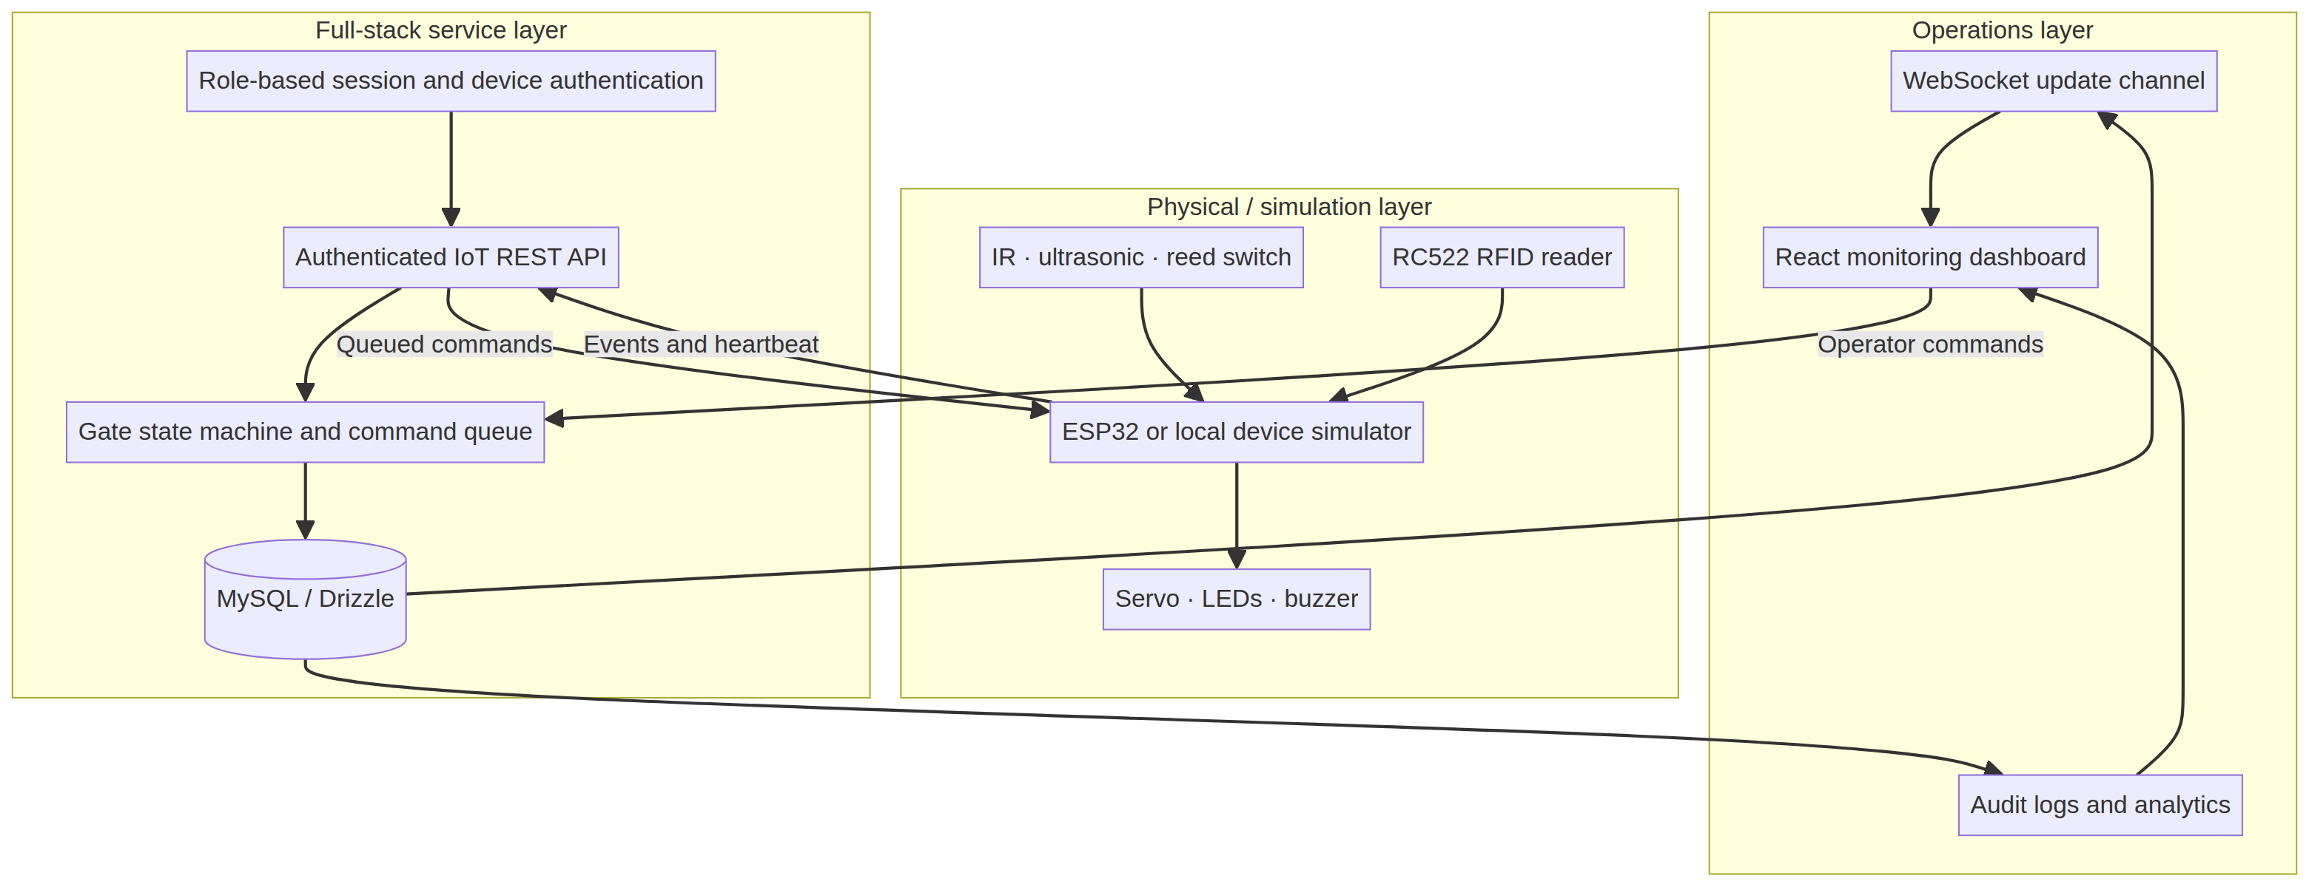
Figure 4.1: Overall System Architecture
4.2 Hardware Architecture
The hardware reference consists of an ESP32, an RC522 RFID reader, an IR input, a reed-switch input, a servo output, LEDs and a buzzer. The RFID reader is a contactless frontend with SPI capability; correct voltage and wiring conditions must be validated against the module and board documentation before connection [2]. Servo power must be isolated from sensitive logic supply where required by the physical assembly.
4.3 Software Architecture
The backend is organized into a schema layer, database helpers, a shared gate service, protected tRPC routers, device REST handlers, and live-update management. The shared gate service makes authorization and event processing independent of the caller. Consequently, a simulator cannot alter dashboard state without first passing through the same persistence and state-transition logic used by the device interface.
4.4 Data Flow Diagram
Figure 4.2 shows the access flow. A successful RFID request is not enough to state that the gate is open; the device must subsequently report a gate-position event. A denied scan produces a log and event without creating an open command.
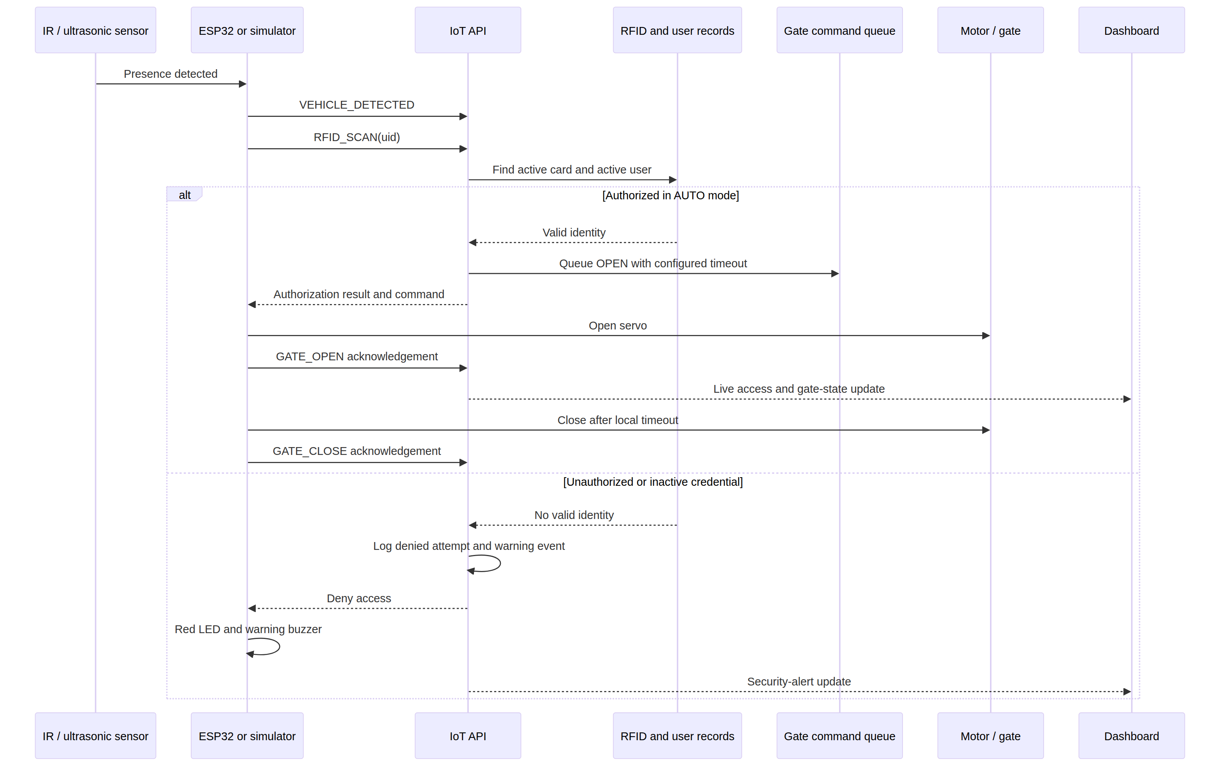
Figure 4.2: Authorized and Denied Access Event Sequence
4.5 Use Cases
The Admin role manages identities, RFID cards, device tokens and auto-close configuration. The Security Operator monitors live information, views logs and alerts, and queues manual OPEN, CLOSE and AUTO commands. The Registered User is an access identity to which an RFID card may be assigned. The ESP32/simulator submits events, polls commands and acknowledges execution.
4.6 Sequence Design
The authorized sequence is: presence detection, RFID scan, device API submission, user/card verification, log insertion, OPEN command queue, device movement, gate-open acknowledgement, local auto-close delay, and gate-close acknowledgement. The unauthorized sequence omits the OPEN command and emits a warning event. The forced-open sequence changes the state to ALERT and creates a critical event.
4.7 Database Design
Table 4.2 summarizes the persistent entities.
Entity | Purpose | Important fields
users | Human identities and roles | openId, role, status
rfid_cards | Credential assignment and revocation | rfidUid, userId, status
devices | Controller registry and heartbeat | deviceId, deviceTokenHash, status, lastSeenAt
access_logs | Append-only authorization outcomes | rfidUid, result, gateState, occurredAt
gate_events | Security and operations history | eventType, severity, resolved
sensor_readings | Device telemetry | sensorType, sensorValue, quality
gate_commands | Device command life cycle | commandId, commandType, status
gate_settings | Persisted current state and auto-close policy | gateMode, gateState, autoCloseTimeoutSeconds

4.8 Entity-Relationship Diagram
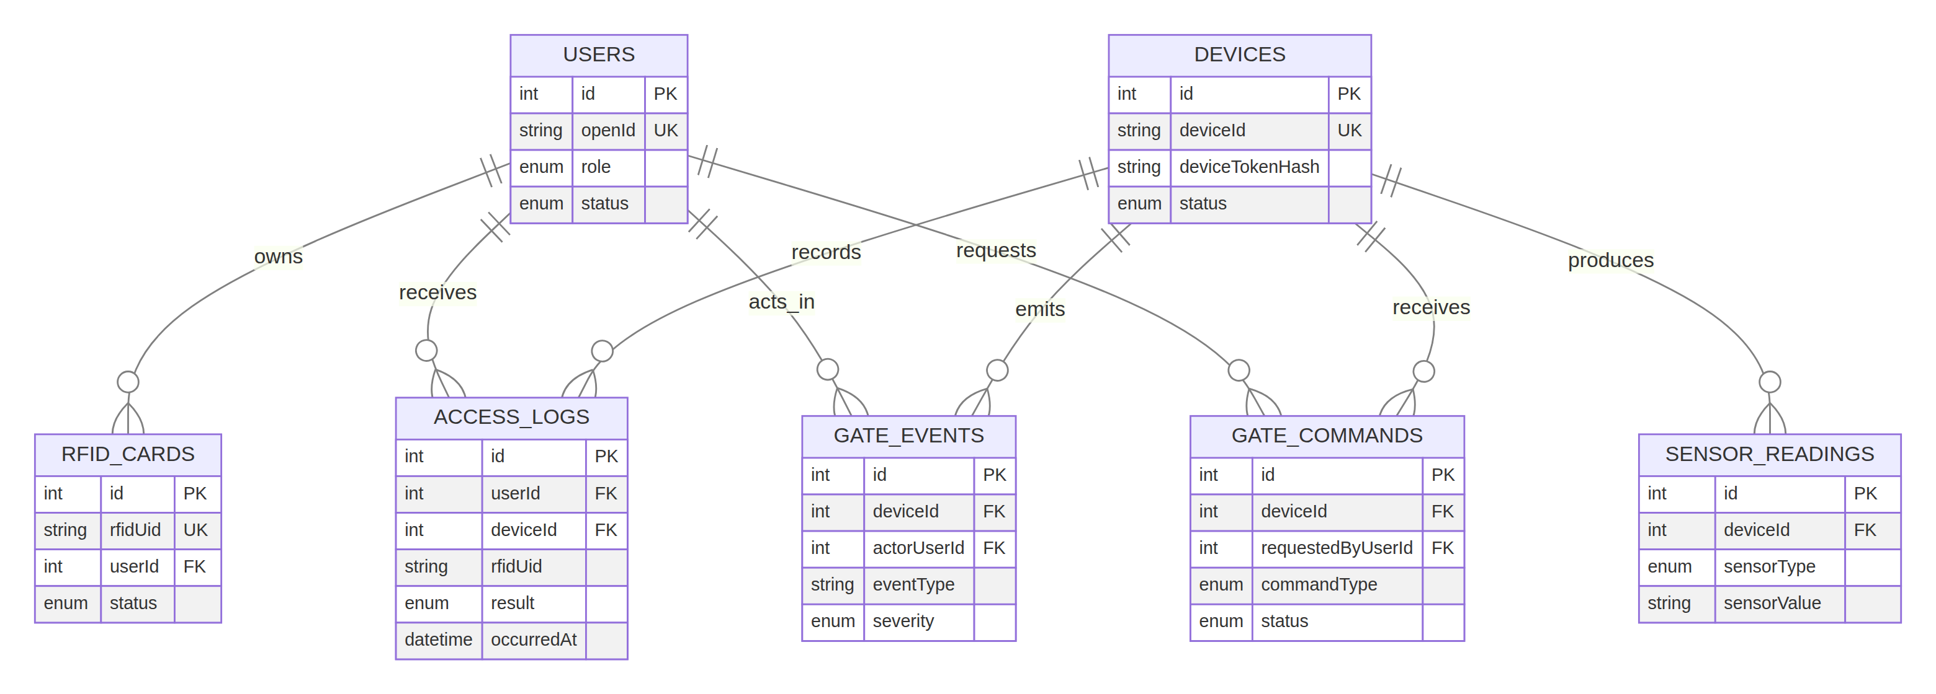
Figure 4.3: Entity-Relationship Model
4.9 API Architecture
Dashboard traffic uses protected typed procedures. Device traffic uses REST endpoints so an ESP32 does not need a browser session. Table 5.1 lists the device interface in Chapter 5. Device authentication uses request headers, and the backend compares a hash of the supplied token against a stored verifier. The token is generated only when an administrator rotates it.
4.10 Security Architecture
Table 4.3 relates important events to policy.
Event | Severity | Response
Unknown or inactive RFID | WARNING | Log denied attempt; do not queue OPEN; publish dashboard update.
Repeated denied RFID scans | CRITICAL | Create repeated-attempt event after the configured rule detects three denials in five minutes.
Forced gate open | CRITICAL | Set gate state to ALERT and suspend automatic opening.
Device offline | WARNING | Update device status and create communication-failure event.
Command failure | WARNING | Mark command failed and record event.
Manual operation | INFO | Queue the command with authenticated actor identity and create an audit event.

CHAPTER 5 — IMPLEMENTATION
5.1 ESP32 Firmware
The firmware reference in firmware/gate_controller.ino initializes Wi-Fi, SPI, RFID reader, servo, indicators and REST calls. It publishes VEHICLE_DETECTED, RFID_SCAN, GATE_OPEN, GATE_CLOSE and FORCED_GATE_OPEN events. It polls device commands and parses autoCloseTimeoutSeconds from the OPEN command payload, so the close delay is supplied by backend configuration rather than compiled as a fixed constant.
5.2 RFID Module and Sensor Module
The RFID code reads a UID from the RC522 and submits it to the API. The IR sensor creates a presence event; a reed switch is reserved for position consistency and forced-open detection. The NXP MFRC522 documentation describes a 13.56 MHz contactless reader/writer design and host interfaces including SPI, which supports this reference wiring approach [2]. UID-only access is suitable for a prototype but should be combined with stronger credential protections and threat modeling for a higher-security deployment.
5.3 Servo Gate Controller
The backend queues gate commands, while the device controls the servo and reports movement. The gate state changes to OPEN only after the device sends a GATE_OPEN event. Similarly, it changes to CLOSED only after the device reports GATE_CLOSE. This distinction prevents the dashboard from treating intent as a completed physical action.
5.4 Backend, Database and Authentication
The database schema uses normalized tables, foreign keys and time-oriented indexes for event and log retrieval. A platform-backed session is used for human users, while tRPC middleware enforces Admin or Admin/Operator procedures. Device clients use x-device-id and x-device-token headers. The server stores a SHA-256 verifier rather than the raw generated token. Input is validated with Zod schemas before device events and management actions are processed.
5.5 Real-Time Dashboard and Analytics
The dashboard uses an authenticated WebSocket upgrade endpoint to publish change notices. RFC 6455 describes WebSocket’s bidirectional communication model and browser-origin security relevance [3]. To retain a usable monitoring screen if that channel is unavailable, the dashboard also refetches its database snapshot every five seconds. Recharts renders daily access counts, authorization outcome mix, hourly traffic, security-event mix and current stored gate-open duration.
5.6 Alert System and Simulation Mode
The shared service creates gate_events with INFO, WARNING or CRITICAL severity. The browser simulator console provides repeatable scenario controls; the local Node.js simulator is the more faithful device demonstration because it uses the REST endpoints, polls commands, sends acknowledgements, and performs auto-close locally. Therefore the dashboard does not need to distinguish simulator data from ESP32 data.
5.7 Device API Endpoints
Table 5.1: Endpoint | Method | Purpose
/api/iot/heartbeat | POST | Validates device credentials and records online status.
/api/iot/events | POST | Accepts sensor, RFID, position and security events.
/api/iot/commands | GET | Returns pending commands for the authenticated device and marks delivery.
/api/iot/commands/:commandId/ack | POST | Records successful or failed command completion.

CHAPTER 6 — TESTING AND RESULTS
6.1 Testing Methodology
Testing was separated into backend unit/integration behavior, interface verification, device API contract checks and a future physical-validation plan. The implemented automated tests call the real gate service against the configured project database. The dashboard was visually inspected after its live query resolved, confirming presentation of populated metrics, a gate panel, manual controls, access rows and alerts.
6.2 Executed Automated Tests
The final executed test run completed on 19 August 2026. Vitest reported eleven passing tests across three files in approximately 23.87 seconds in the sandbox environment. This duration is a test-run observation, not a claim of production gate response time.
Table 6.1: Test Case ID | Test scenario | Expected result | Observed result | Status
TC-01 | Session logout | Session cookie is cleared and success is returned. | Existing template authentication test passed. | PASS
TC-02 | Registered RFID scan | An active card authorizes and queues OPEN in AUTO mode. | Authorization true; OPEN command returned. | PASS
TC-03 | Unknown RFID scan | Access is denied and no OPEN command is created. | Authorization false; command null. | PASS
TC-04 | Dashboard snapshot | Seeded device, settings and recent access rows are returned. | Snapshot contained simulator device, timeout and records. | PASS
TC-05 | Manual close command | An administrator request queues CLOSE in manual-closed mode. | CLOSE command and expected mode returned. | PASS
TC-06 | Forced-open event | A forced-open report changes the stored gate state to ALERT. | Dashboard snapshot reported ALERT. | PASS
TC-07 | Device-token rotation | Only a newly rotated token validates for the registered device. | Current token accepted; incorrect token rejected. | PASS
TC-08 | Registered User role | Registered User cannot issue a manual OPEN command. | Protected procedure returned FORBIDDEN. | PASS
TC-09 | Operator role | Security Operator cannot change Admin-only auto-close settings. | Protected procedure returned FORBIDDEN. | PASS
TC-10 | Administrator user CRUD | Admin creates, reads, updates and removes a managed identity. | Created record was returned, updated and removed successfully. | PASS
TC-11 | Simulator workflow | Unauthorized simulator scenario records a denied RFID attempt through the shared service. | Scenario completed and the denied record appeared in the snapshot. | PASS

6.3 Integration and System Testing
The device API was exercised with a valid simulator device identifier and token before source credential removal was completed, confirming a successful HTTP response path. The final design replaces that fixed development credential with administrator-controlled rotation. The command-centre dashboard was captured with populated stored data after its initial database query completed. The implementation also provides scenarios for authorized access, unauthorized access, forced gate open, device offline and command polling.
6.4 Results and Interpretation
The current evidence supports the following conclusion: the software system can persist authorization outcomes, issue and record commands, reflect device events, display stored operational data and run core service tests in simulation. It does not establish physical gate speed, RFID reading distance, Wi-Fi coverage, servo load capability, sensor accuracy, electrical safety, emergency override performance or real-world security resistance.
6.5 Physical Hardware Validation Plan
Table 6.2: Test ID | Physical validation scenario | Evidence to collect | Current status
HV-01 | RC522 card read at operating distance | UID read logs; tested distance; repeated trial counts | To be validated during physical deployment.
HV-02 | Presence sensor detection | Sensor state and environmental test notes | To be validated during physical deployment.
HV-03 | Servo open/close with prototype mechanism | Travel observations, power measurements, obstruction response | To be validated during physical deployment.
HV-04 | Reed-switch gate position | Reported versus observed position records | To be validated during physical deployment.
HV-05 | Network recovery | Device heartbeat and retry records after Wi-Fi interruption | To be validated during physical deployment.
HV-06 | Manual safety override | Documented operator procedure and safe actuation outcome | To be validated during physical deployment.

CHAPTER 7 — CONCLUSION AND FUTURE ENHANCEMENTS
7.1 Conclusion
This project delivers a full-stack, simulation-capable smart-gate system rather than a static dashboard. It combines role-aware human access, device-specific authentication, RFID authorization, persisted configuration, gate command queueing, device acknowledgements, alerts, monitoring, analytics and documentation. The command flow ensures that an interface request alone is not treated as completed gate movement. The simulator and ESP32 reference follow the same conceptual event and command contract, enabling end-to-end software demonstration without a physical prototype.
7.2 Contributions
The primary contributions are the normalized access-control data model, configurable auto-close policy, explicit gate state machine, device REST API, WebSocket/polling monitoring design, secure device-token rotation, responsive operations dashboard, local simulator, ESP32 reference, automated test cases and KGiSL-aligned report source.
7.3 Limitations
The current work is a prototype. The API and dashboard do not replace a safety-certified industrial gate controller. The reference firmware must be electrically and mechanically tested before use. The physical behavior of RFID readers, sensors, power supplies, servos and network links is not measured in this report. HTTPS transport, production secrets management, device provisioning, certificate management, firmware signing, camera integration, intrusion-resistant enclosures and formal security testing require additional deployment work.
7.4 Future Enhancements
Future work may add camera-supported face or number-plate verification, mobile alerts, secure remote update mechanisms, multi-gate tenancy, encrypted device certificates, camera-assisted incident evidence, edge anomaly detection, cloud reporting and formal safety controls. These are future enhancements, not features claimed as implemented by this project.

APPENDIX A — DEVICE API CONTRACT
All device calls require x-device-id and x-device-token headers. The device token is generated in the Admin Gate Device screen and should be placed in local firmware or simulator configuration, never in a repository.
POST /api/iot/events
{
"eventType": "RFID_SCAN",
"rfidUid": "RFID-ALPHA-001"
}
The permitted event vocabulary is RFID_SCAN, AUTHORIZED_ACCESS, UNAUTHORIZED_ACCESS, VEHICLE_DETECTED, GATE_OPEN, GATE_CLOSE, FORCED_GATE_OPEN, DEVICE_ONLINE, and DEVICE_OFFLINE. The backend may also create derived events such as UNAUTHORIZED_RFID, REPEATED_UNAUTHORIZED_ACCESS, COMMUNICATION_FAILURE and COMMAND_FAILURE.

APPENDIX B — HARDWARE INTEGRATION AND SIMULATOR GUIDE
For local simulation, an administrator rotates the simulator token in the dashboard, then exports it in the terminal before running node simulator/gate-device-simulator.mjs authorized. The simulator submits events to /api/iot/*, reads its command queue and reports actuator state. For physical integration, copy firmware/config.example.h to firmware/config.h, set deployment values, install ESP32Servo, MFRC522 and ArduinoJson, confirm wiring, and upload firmware/gate_controller.ino. Do not commit config.h.

REFERENCES
[1] Espressif Systems, “ESP-IDF Programming Guide,” *Espressif Documentation*. Available: <https://docs.espressif.com/projects/esp-idf/en/latest/esp32/>. Accessed: 19 August 2026.
[2] NXP Semiconductors, “MFRC522: Standard performance MIFARE and NTAG frontend,” *Product Data Sheet*, Rev. 3.9, 27 April 2016. Available: <https://www.nxp.com/docs/en/data-sheet/MFRC522.pdf>. Accessed: 19 August 2026.
[3] I. Fette and A. Melnikov, “The WebSocket Protocol,” *RFC 6455*, Internet Engineering Task Force, December 2011. Available: <https://www.rfc-editor.org/rfc/rfc6455>. Accessed: 19 August 2026.
[4] OWASP Foundation, “OWASP Internet of Things,” *OWASP*. Available: <https://owasp.org/www-project-internet-of-things/>. Accessed: 19 August 2026.

