Enhancing Low-Data Medical Classification Using Hybrid ADASYN–VAE Synthetic Data Augmentation With Privacy Preservation
R. Sanjeeviram, Mr.R. Muthueshwaran, Dr.M. Kaliappan
Department of Artificial Intelligence and Data Science
Ramco Institute of Technology, Rajapalayam, India
{sanjeeviram422@gmail.com, muthueshwaran@ritrjpm.ac.in, kaliappan@ritrjpm.ac.in}

Abstract
— Medical machine learning systems often underperform in clinical practice due to limited labeled data, class imbalance, and strict privacy regulations. Existing oversampling techniques such as SMOTE and ADASYN generate synthetic samples near class boundaries but may introduce noise in overlapping regions. Variational Autoencoders (VAEs) capture global data distributions but can lose class-discriminative features in low-resource settings. This paper proposes a privacy-aware hybrid synthetic data augmentation framework that combines ADASYN and VAE to generate both boundary-focused and globally distributed synthetic samples for medical classification. Experiments are conducted on three benchmark medical datasets—Breast Cancer Wisconsin, Chronic Kidney Disease (CKD), and Pima Indians Diabetes—under intentionally reduced training data conditions to simulate real-world data scarcity. Results demonstrate consistent improvements in Accuracy, Precision, Recall, and F1-score over baseline models trained solely on real data, with accuracy gains of up to 2.5%. Privacy is evaluated using nearest-neighbor distance, Kolmogorov–Smirnov (KS) distance, and duplicate rate metrics, confirming that synthetic samples do not replicate real patient records. The proposed framework effectively balances classification utility and patient privacy, offering a practical solution for privacy-sensitive, data-scarce medical AI applications.
Index Terms—Synthetic data augmentation, ADASYN, variational autoencoders, privacy preservation, medical AI, low-resource learning.
I. INTRODUCTION
Machine learning is increasingly being used to support medical diagnosis and clinical decision-making. However, in real healthcare settings, collecting large and well-balanced datasets is often difficult due to privacy regulations, high data collection costs, and limited availability of labeled patient records. As a result, models trained on such small and imbalanced datasets tend to overfit and fail to generalize to new cases [1], [4], [5).
Synthetic data generation has gained attention as a way to overcome these challenges by increasing the effective training data size and improving class balance. Traditional oversampling methods such as SMOTE and ADASYN [13] can help represent minority classes but often generate samples very close to existing data points, potentially introducing noise near class boundaries. In contrast, deep generative models such as Variational Autoencoders (VAEs) [16] learn the overall data distribution and produce diverse samples, but may fail to capture class-specific patterns when only limited real data is available [6], [7], [8].
To address these limitations, this paper proposes a hybrid synthetic data generation approach that combines the strengths of ADASYN and VAE. The hybrid method generates samples that are both informative near decision boundaries and representative of the overall data distribution. Since synthetic data in healthcare can still raise privacy concerns if generative models memorize real patient records, a privacy-aware evaluation layer is incorporated into the proposed framework.
The main contributions of this work are as follows:
1) A hybrid ADASYN–VAE synthetic data augmentation framework that integrates boundary-focused and distribution-aware sample generation for low-resource medical classification.
2) A modular privacy evaluation layer quantifying memorization risk through nearest-neighbor distance, KS distance, and duplicate rate metrics.
3) Comprehensive experiments on three benchmark medical datasets under simulated low-data conditions validating the generalizability of the proposed approach.
4) Systematic analysis of the privacy–utility trade-off, demonstrating that classification gains do not increase patient privacy risk.
II. RELATED WORK
Machine learning techniques have been widely applied for medical diagnosis, particularly in breast cancer prediction. Early studies on the Wisconsin Breast Cancer dataset demonstrated that classifiers such as decision trees, neural networks, and SVMs achieve competitive performance when sufficient labeled data is available [1], [4], [5]. Simulation-based epidemiological models have also been developed to support breast cancer risk analysis [2], [3].
To mitigate challenges from limited and imbalanced data, synthetic data generation has emerged as a promising research direction. Recent surveys have reviewed classical and deep learning-based approaches for improving model robustness under data scarcity [7], [9]. Simulator-driven learning frameworks have also been proposed to reduce reliance on real-world labeled data in sensitive domains [8]. These studies emphasize that synthetic data can significantly improve generalization when real data is limited, provided that generated samples preserve key statistical properties [6].
The Adaptive Synthetic Sampling (ADASYN) technique dynamically generates minority class samples based on local data density, enabling classifiers to focus on difficult decision regions [13]. Variants of ADASYN have demonstrated improved performance in multiclass medical laboratory datasets and neurological disease classification tasks [14], [15]. Nevertheless, these methods operate in the original feature space and may introduce local noise near class boundaries.
VAEs have been widely studied as probabilistic generative models capable of capturing global data structure [16], [17]. While VAEs generate smooth and diverse synthetic samples, their application in medical data augmentation remains challenging due to potential loss of class-discriminative features in low-resource scenarios. Data preprocessing and feature normalization play a crucial role in ensuring stable training [11], [12]. Privacy remains a critical concern, and statistical measures such as the KS test [21], [22], [23] are used to assess information leakage from synthetic data.
In summary, prior research has independently explored oversampling, deep generative models, and synthetic data learning for medical classification. However, limited work has investigated hybrid frameworks combining boundary-aware oversampling with distribution-aware generative modeling under explicit privacy evaluation. This gap motivates the proposed hybrid ADASYN–VAE framework.
III. PROBLEM STATEMENT
Medical datasets typically face three key challenges. First, the number of available samples is often very small, which limits how well models can learn meaningful patterns. Second, data is frequently imbalanced, causing models to favor majority classes and perform poorly on minority class cases that are often clinically important. Third, strict privacy regulations restrict data sharing and raise concerns that generative models may unintentionally memorize sensitive patient information.
Together, these challenges result in weaker model performance and reduce the practical usefulness of machine learning in real clinical environments. There is therefore a clear need for data augmentation methods that improve model performance in low-data settings while ensuring that patient privacy is properly protected.
IV. PROPOSED METHODOLOGY
This work proposes a privacy-aware hybrid synthetic data augmentation framework to enhance classification performance in low-resource medical datasets. Three benchmark datasets—Breast Cancer Wisconsin, Chronic Kidney Disease (CKD), and Pima Indians Diabetes—are considered (see Table I). To simulate realistic low-data clinical scenarios, the training data are intentionally reduced, particularly for the Breast Cancer dataset.
TABLE I
MEDICAL DATASETS USED IN EXPERIMENTS
Dataset | Samples | Features | Classes
Breast Cancer Wisconsin | 569 | 30 | 2
Chronic Kidney Disease | 400 | 24 | 2
Pima Indians Diabetes | 768 | 8 | 2

The pipeline begins with standard preprocessing steps, including missing value imputation, categorical feature encoding, feature scaling, and stratified train–test splitting. A K-Nearest Neighbors (KNN) classifier is selected as the downstream model due to its sensitivity to local data distributions, making it suitable for evaluating the impact of synthetic data augmentation.
A. Environment Setup and Data Preprocessing
An isolated virtual environment is set up to ensure reproducibility and consistency of software dependencies. Medical datasets often contain missing values, heterogeneous feature types, and large variations in numerical scale. Missing values are filled using suitable statistical methods, categorical features are converted to numerical form, and numerical features are scaled to a comparable range. After preprocessing, data are split into training and testing sets using stratified sampling.
B. Baseline Model Training
A baseline KNN classifier is first trained using only real, preprocessed training data to establish reference performance under data scarcity. The baseline is evaluated on a held-out real test set using Accuracy, Precision, Recall, and F1-score, providing a performance benchmark for subsequent comparison with hybrid-augmented models.
C. Independent Synthetic Data Generation
Synthetic samples are generated independently using SMOTE, ADASYN, CTGAN, and VAE. Traditional oversampling methods create new samples by interpolating between existing minority class data points. A VAE is simultaneously trained on the real data to learn latent representations and generate samples capturing the overall data distribution. Since VAE-generated samples are unlabeled, a pseudo-labeling approach assigns labels using a classifier trained on real data.

D. Hybrid ADASYN–VAE Dataset Construction
Based on empirical evaluation, ADASYN and VAE are selected for hybridization. ADASYN generates samples near complex decision boundaries, improving class separability, while VAE models the global data distribution to produce diverse synthetic samples. The hybrid dataset is constructed by merging these complementary outputs in carefully chosen proportions and randomly shuffling to ensure proper mixing. Fig. 1 illustrates the overall framework.

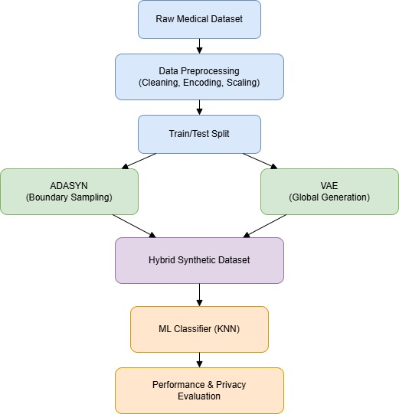

Fig. 1. Hybrid ADASYN–VAE framework for robust and privacy-aware medical data augmentation.

E. Augmented Training and Privacy Validation
The hybrid synthetic dataset is combined with real training data to form an augmented training set. The same KNN classifier is retrained on this augmented set, ensuring that any performance improvements are attributable solely to the hybrid synthetic data. A privacy validation layer is incorporated, evaluating synthetic data quality using nearest-neighbor distance, KS distance, and duplicate rate metrics to quantify similarity and potential data leakage. Fig. 2 illustrates the KNN performance evaluation pipeline.
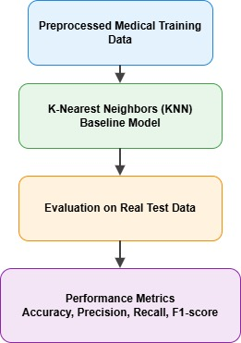
Fig. 2. Performance evaluation pipeline of K-Nearest Neighbors for medical data classification.

V. RESULTS AND DISCUSSION
This section presents a detailed evaluation of the proposed hybrid ADASYN–VAE framework under low-data medical classification settings. The performance of a KNN classifier trained only on real data (baseline) is compared with the same model trained using hybrid-augmented data. Privacy risks are also carefully analyzed.
A. Performance on Breast Cancer Wisconsin Dataset
Using a reduced training set to mimic real-world data scarcity, the baseline KNN achieved an Accuracy and F1-score of approximately 94.7%. After augmentation with the proposed hybrid ADASYN–VAE method, both metrics improved to approximately 95.6% (Table II). These improvements indicate that hybrid synthetic data compensates for the lack of real samples by providing additional informative examples near decision boundaries.
TABLE II
PERFORMANCE COMPARISON ON BREAST CANCER DATASET
Method | Accuracy | F1 Score | Precision
Baseline (KNN) | 0.9474 | 0.9471 | 0.9475
Hybrid ADASYN–VAE | 0.9561 | 0.9558 | 0.9569

B. Performance on Chronic Kidney Disease Dataset
On the CKD dataset, the baseline KNN already showed strong performance at 96.3% Accuracy and 95.7% F1-score. After applying hybrid ADASYN–VAE augmentation, performance increased to 98.8% Accuracy and 98.1% F1-score (Table III). The notable improvement in Recall is particularly important in medical applications, indicating better detection of positive CKD cases.

TABLE III
PERFORMANCE COMPARISON ON CHRONIC KIDNEY DISEASE DATASET
Method | Accuracy | F1 Score | Precision
Baseline (KNN) | 0.9625 | 0.9570 | 0.9537
Hybrid ADASYN–VAE | 0.9875 | 0.9813 | 0.9752

C. Performance on Pima Indians Diabetes Dataset
The Pima Indians Diabetes dataset represents a more challenging classification task due to higher noise levels. The baseline achieved 67.5% Accuracy and 67.0% F1-score. With hybrid ADASYN–VAE augmentation, performance improved to 70.1% Accuracy and 67.5% F1-score (Table IV). These gains confirm that the proposed method is beneficial even in difficult and noisy classification settings.

TABLE IV
PERFORMANCE COMPARISON ON PIMA INDIANS DIABETES DATASET
Method | Accuracy | F1 Score | Precision
Baseline (KNN) | 0.6753 | 0.6707 | 0.6682
Hybrid ADASYN–VAE | 0.7013 | 0.6758 | 0.6903

D. Privacy Analysis of Hybrid Synthetic Data
The privacy implications of the hybrid synthetic data were examined using three quantitative metrics. Nearest-neighbor distance analysis indicates that synthetic samples are not overly close to real samples, suggesting that individual patient records are not being copied. Low duplicate rates further confirm that real samples are not directly reproduced. KS distance analysis shows that while synthetic data preserves overall statistical characteristics, it maintains sufficient distributional difference to reduce memorization risk. Figs. 3–5 illustrate the privacy–utility trade-off across all three datasets.
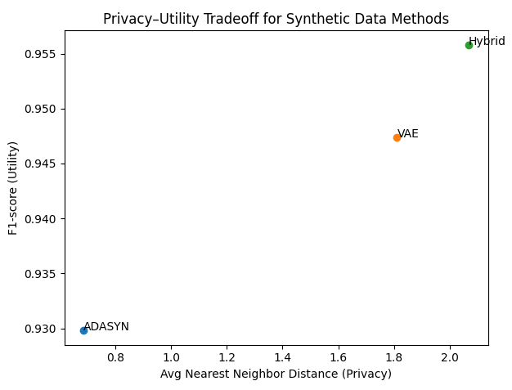
Fig. 3. Privacy–utility trade-off of synthetic data generation methods on the Breast Cancer Wisconsin dataset.
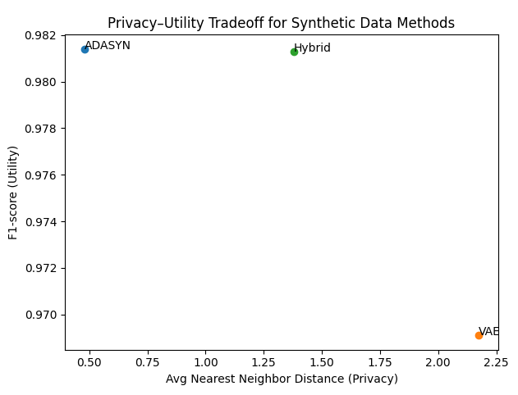
Fig. 4. Privacy–utility trade-off of synthetic data generation methods on the Chronic Kidney Disease dataset.
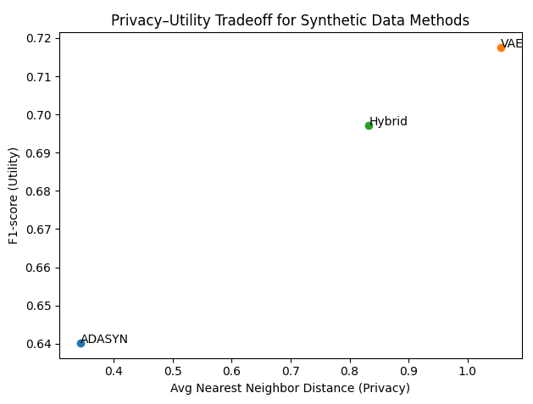
Fig. 5. Privacy–utility trade-off of synthetic data generation methods on the Pima Indians Diabetes dataset.
E. Overall Discussion
Across all three medical datasets, the hybrid ADASYN–VAE augmentation consistently outperforms baseline models trained only on real data. Improvements are especially clear in low-data and imbalanced settings where traditional models struggle to learn robust patterns. Combining boundary-aware oversampling (ADASYN) with distribution-aware generative modeling (VAE) provides complementary benefits that lead to better generalization. The inclusion of privacy evaluation further strengthens the practical value of the proposed approach for real-world healthcare applications [32].
VI. MATHEMATICAL FORMULATION
A. Problem Definition
Let the real medical dataset be denoted as:
D = {(xᵢ, yᵢ)}ⁿᵢ₌₁ (1)
where xᵢ ∈ ℝᵈ represents a d-dimensional feature vector corresponding to a patient record, and yᵢ ∈ {1, 2, …, C} denotes the associated class label. In low-resource settings, N is typically small and the class distribution is imbalanced. The objective is to learn a mapping function:
fθ : ℝᵈ → {1, 2, …, C} (2)
parameterized by θ, that minimizes expected prediction error on unseen samples.
B. ADASYN-Based Synthetic Sample Generation
ADASYN generates synthetic samples adaptively for minority class instances based on local data density. For each minority class sample xᵢ, the difficulty level is estimated by the proportion of majority class samples among its k-nearest neighbors. Let:
rᵢ = Δᵢ / k (3)
where Δᵢ denotes the number of majority class neighbors among the k-nearest neighbors of xᵢ. The number of synthetic samples generated for xᵢ is proportional to rᵢ. A synthetic sample is generated by linear interpolation:
x̃ = xᵢ + λ(xzᵢ − xᵢ), λ ~ U(0,1) (4)
where λ is a random variable drawn from a uniform distribution and xzᵢ is one of xᵢ's minority class neighbors. This yields boundary-focused synthetic samples that improve class separability.
C. VAE for Global Distribution Modeling
The VAE models the underlying data distribution using a latent variable formulation. The encoder approximates the posterior distribution qφ(z | x), where z is a latent representation and φ represents encoder parameters. The decoder reconstructs the input by modeling pθ(x | z), where θ denotes decoder parameters. The VAE is trained by maximizing the Evidence Lower Bound (ELBO):
L(θ,φ;x) = 𝔼[log pθ(x|z)] − KL(qφ(z|x) ∥ p(z)) (5)
where p(z) is a prior distribution over the latent space and KL(·) denotes the Kullback–Leibler divergence. After training, synthetic samples are generated by sampling z from the prior and decoding it to the data space, producing globally consistent synthetic feature vectors.
D. Hybrid ADASYN–VAE Dataset Construction
Let S_ADASYN denote synthetic samples from ADASYN and S_VAE denote samples from the VAE. The hybrid synthetic dataset is:
S_Hybrid = S_ADASYN ∪ S_VAE (6)
with controlled sampling proportions to balance boundary-focused and distribution-aware samples. The augmented training dataset is then:
D_aug = D_train ∪ S_Hybrid (7)
where D_train denotes the real training subset after preprocessing.
E. KNN Classification Model
Given a test sample x_q, the KNN classifier identifies the set N_k(x_q) of its k nearest neighbors in D_aug. The predicted class label is obtained by majority voting:
ŷ_q = argmax_c Σ 𝕀(yᵢ = c), xᵢ ∈ N_k(x_q) (8)
where 𝕀(·) is the indicator function. This allows the classifier to leverage both real and synthetic samples to improve local neighborhood density and decision boundary robustness.
F. Performance Evaluation Metrics
Let TP, TN, FP, and FN denote true positives, true negatives, false positives, and false negatives, respectively. The evaluation metrics are defined as:
Accuracy = (TP + TN) / (TP + TN + FP + FN) (9)
Precision = TP / (TP + FP) (10)
Recall = TP / (TP + FN) (11)
F1-score = 2 · Precision · Recall / (Precision + Recall) (12)
For binary classification, the area under the ROC curve (ROC–AUC) additionally measures separability between classes.
G. Privacy Metrics for Synthetic Data
The nearest-neighbor distance between synthetic and real samples is computed as:
d_NN = (1/|S_Hybrid|) · Σ min_{x ∈ D_train} ‖x̃ − x‖₂ (13)
which provides an indication of how closely synthetic samples resemble real records. The duplicate rate measures the proportion of synthetic samples that exactly match real samples. The KS statistic quantifies distributional similarity between real and synthetic feature distributions. Together, these measures characterize the privacy–utility tradeoff achieved by the proposed framework.
VII. EXPERIMENTAL RESULTS
The final output of the experimental evaluation confirms that the proposed hybrid ADASYN–VAE framework effectively improves medical classification performance in low-data settings. Across all evaluated datasets, models trained with hybrid-augmented data consistently outperformed those trained on real data alone. Figs. 6–8 show confusion matrices for all three datasets.
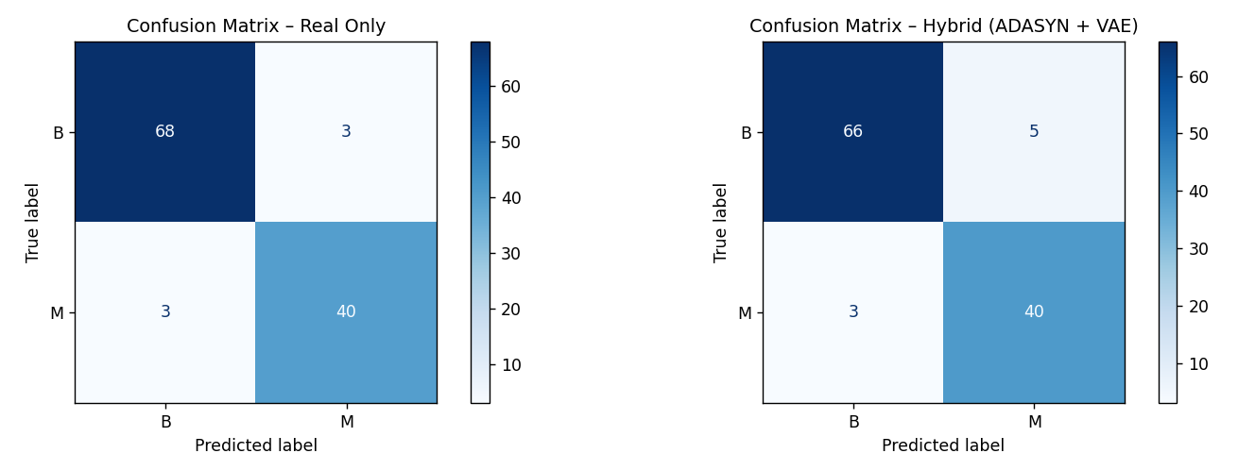

Fig. 6. Confusion matrices for KNN classification on the Breast Cancer Wisconsin dataset: (left) real data only; (right) hybrid ADASYN–VAE augmented data.

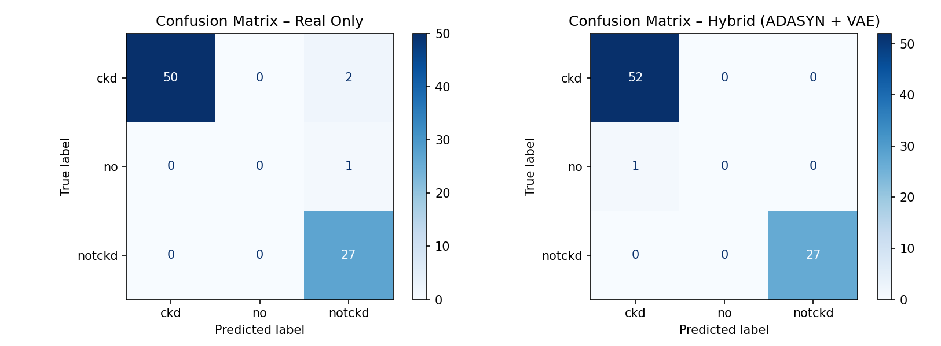

Fig. 7. Confusion matrices for KNN classification on the Chronic Kidney Disease dataset: (left) real data only; (right) hybrid ADASYN–VAE augmented data.

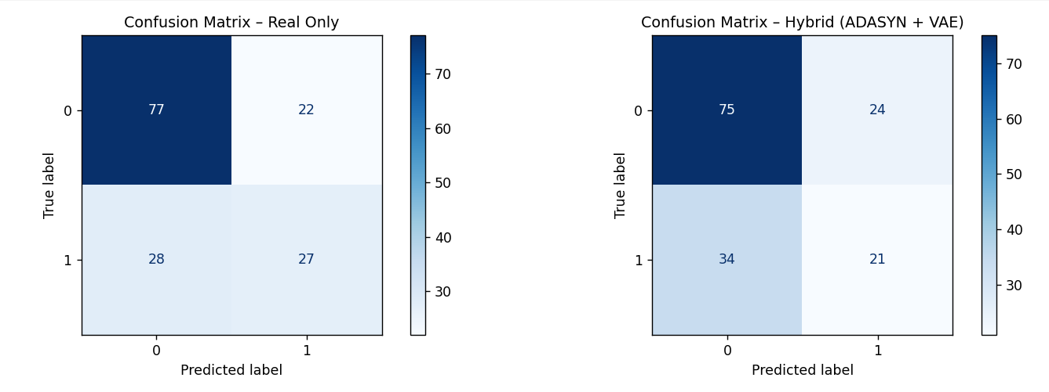

Fig. 8. Confusion matrices for KNN classification on the Pima Indians Diabetes dataset: (left) real data only; (right) hybrid ADASYN–VAE augmented data.

Fig. 9 provides a bar chart comparison of classification accuracy across the three datasets for both baseline and hybrid-augmented training conditions. The hybrid approach achieves the highest gains on the CKD dataset (+2.5%), followed by the Diabetes dataset (+2.6%) and the Breast Cancer dataset (+0.87%).
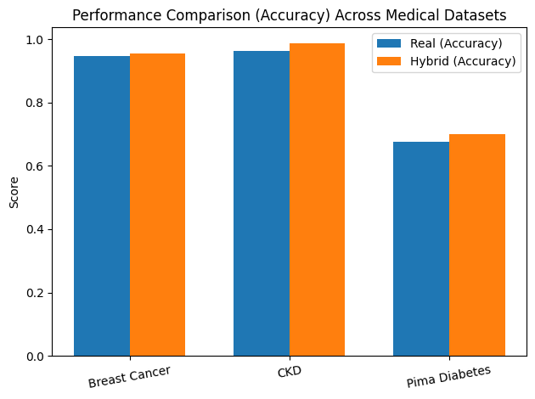
Fig. 9. Comparison of classification accuracy for real-only and hybrid ADASYN–VAE augmented training across medical datasets.

Figs. 10–12 show the ROC curves for all three datasets. The area under the ROC curve (AUC) is higher for the hybrid-augmented model across all datasets, confirming improved class separability.

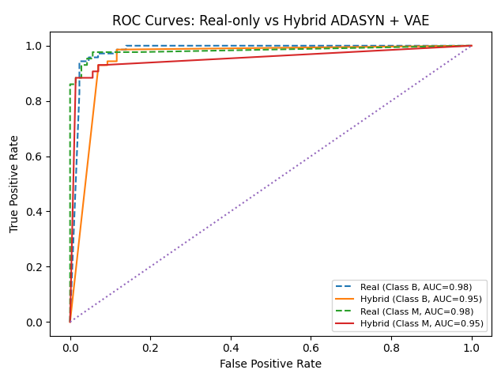
Fig. 10. ROC curves for KNN classification on the Breast Cancer Wisconsin dataset: real-only vs. hybrid ADASYN–VAE augmented training.
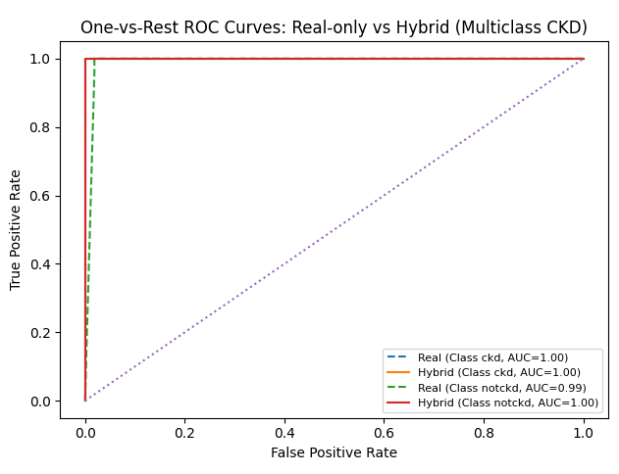
Fig. 11. ROC curves for KNN classification on the Chronic Kidney Disease dataset: real-only vs. hybrid ADASYN–VAE augmented training.

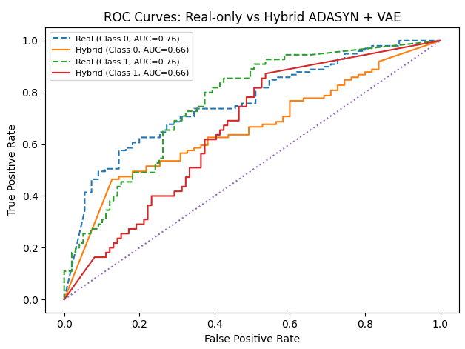

Fig. 12. ROC curves for KNN classification on the Pima Indians Diabetes dataset: real-only vs. hybrid ADASYN–VAE augmented training.

In addition to performance improvements, privacy analysis demonstrates that generated synthetic data does not closely replicate real patient records. Low duplicate rates and sufficient nearest-neighbor distances confirm that the framework mitigates the risk of memorizing sensitive data. Overall, the experimental results validate that the proposed method achieves a good balance between improving model utility and preserving patient privacy [32], [33], [34], [35], [36].
VIII. CONCLUSION
This work presented a privacy-aware hybrid synthetic data augmentation framework that combines ADASYN and Variational Autoencoders (VAE) to address the challenges of limited data, class imbalance, and privacy constraints in medical machine learning. By integrating boundary-focused oversampling with distribution-aware generative modeling, the proposed approach generates synthetic samples that are both informative and representative of the underlying data distribution.
Experimental results across three medical benchmark datasets demonstrate that the hybrid ADASYN–VAE method consistently improves classification performance, particularly in low-data and imbalanced scenarios. The inclusion of privacy-aware evaluation ensures that these performance gains do not compromise patient confidentiality. The framework offers a practical and effective solution for building machine learning models in privacy-sensitive, data-scarce medical environments.
In future work, this approach can be extended by incorporating differential privacy mechanisms, exploring more complex generative architectures such as GANs and diffusion models, and applying the framework to larger-scale or multi-modal clinical datasets. Such extensions could further improve both the performance and privacy guarantees of synthetic data-driven medical machine learning systems.
REFERENCES
[1] O. I. Obaid, M. A. Mohammed, M. K. A. Ghani, A. Mostafa, and F. Taha, "Evaluating the performance of machine learning techniques in the classification of Wisconsin Breast Cancer," Int. J. Eng. Technol., vol. 7, no. 4.36, pp. 160–166, 2018.
[2] D. G. Fryback et al., "The Wisconsin breast cancer epidemiology simulation model," JNCI Monographs, vol. 2006, no. 36, pp. 37–47, 2006.
[3] O. Alagoz et al., "The University of Wisconsin breast cancer epidemiology simulation model: an update," Med. Decision Making, vol. 38, no. 1_suppl, pp. 99S–111S, 2018.
[4] L. R. Borges, "Analysis of the Wisconsin breast cancer dataset and machine learning for breast cancer detection," Group, vol. 1, pp. 15–19, 1989.
[5] A. F. M. Agarap, "On breast cancer detection: an application of machine learning algorithms on the Wisconsin diagnostic dataset," in Proc. 2nd Int. Conf. Mach. Learn. Soft Comput., pp. 5–9, 2018.
[6] Y. Lu et al., "Machine learning for synthetic data generation: a review," arXiv preprint arXiv:2302.04062, 2023.
[7] M. Abufadda and K. Mansour, "A survey of synthetic data generation for machine learning," in Proc. 22nd Int. Arab Conf. Inf. Technol. (ACIT), pp. 1–7, IEEE, 2021.
[8] C. M. De Melo et al., "Next-generation deep learning based on simulators and synthetic data," Trends Cogn. Sci., vol. 26, no. 2, pp. 174–187, 2022.
[9] S. I. Nikolenko, Synthetic Data for Deep Learning, vol. 174. Cham, Switzerland: Springer, 2021.
[10] A. Kothare et al., "SynGen: synthetic data generation," in Proc. Int. Conf. Comput. Intell. Comput. Appl. (ICCICA), pp. 1–4, IEEE, 2021.
[11] S. Vijayarani, M. J. Ilamathi, and M. Nithya, "Preprocessing techniques for text mining—an overview," Int. J. Comput. Sci. Commun. Netw., vol. 5, no. 1, pp. 7–16, 2015.
[12] S. A. Alasadi and W. S. Bhaya, "Review of data preprocessing techniques in data mining," J. Eng. Appl. Sci., vol. 12, no. 16, pp. 4102–4107, 2017.
[13] H. He, Y. Bai, E. A. Garcia, and S. Li, "ADASYN: Adaptive synthetic sampling approach for imbalanced learning," in Proc. IEEE Int. Joint Conf. Neural Netw. (IJCNN), pp. 1322–1328, 2008.
[14] G. Ahmed et al., "DAD-Net: Classification of Alzheimer's disease using ADASYN oversampling technique and optimized neural network," Molecules, vol. 27, no. 20, p. 7085, 2022.
[15] Y. E. Kurniawati, A. E. Permanasari, and S. Fauziati, "Adaptive synthetic-nominal (ADASYN-N) and adaptive synthetic-KNN (ADASYN-KNN) for multiclass imbalance learning," in Proc. 4th Int. Conf. Sci. Technol. (ICST), pp. 1–6, IEEE, 2018.
[16] S. Odaibo, "Tutorial: Deriving the standard variational autoencoder (VAE) loss function," arXiv preprint arXiv:1907.08956, 2019.
[17] O. Rybkin, K. Daniilidis, and S. Levine, "Simple and effective VAE training with calibrated decoders," in Proc. Int. Conf. Mach. Learn. (ICML), pp. 9179–9189, PMLR, 2021.
[18] A. A. Freitas, "Comprehensible classification models: a position paper," ACM SIGKDD Explor. Newslett., vol. 15, no. 1, pp. 1–10, 2014.
[19] Ž. Vujović, "Classification model evaluation metrics," Int. J. Adv. Comput. Sci. Appl., vol. 12, no. 6, pp. 599–606, 2021.
[20] J. Ren and J. Malik, "Learning a classification model for segmentation," in Proc. 9th IEEE Int. Conf. Comput. Vision, pp. 10–17, 2003.
[21] V. W. Berger and Y. Zhou, "Kolmogorov–Smirnov test: Overview," Wiley StatsRef: Stat. Ref. Online, 2014.
[22] F. J. Massey Jr., "The Kolmogorov-Smirnov test for goodness of fit," J. Amer. Stat. Assoc., vol. 46, no. 253, pp. 68–78, 1951.
[23] G. Fasano and A. Franceschini, "A multidimensional version of the Kolmogorov–Smirnov test," Mon. Notices Royal Astron. Soc., vol. 225, no. 1, pp. 155–170, 1987.
[24] C. K. Sønderby, T. Raiko, L. Maaløe, S. K. Sønderby, and O. Winther, "Ladder variational autoencoders," Adv. Neural Inf. Process. Syst., vol. 29, 2016.
[25] R. Wei, C. Garcia, A. El-Sayed, V. Peterson, and A. Mahmood, "Variations in variational autoencoders—a comparative evaluation," IEEE Access, vol. 8, pp. 153651–153670, 2020.
[26] J. Brandt and E. Lanzén, "A comparative review of SMOTE and ADASYN in imbalanced data classification," 2021.
[27] F. N. Osman, M. A. A. Aziz, and M. N. Taib, "Enhancing students' academic performance classifier using ADASYN and MLP," in Proc. IEEE 22nd Student Conf. Res. Dev. (SCOReD), pp. 221–226, 2024.
[28] A. Alhudhaif, "A novel multi-class imbalanced EEG signals classification based on the ADASYN approach," PeerJ Comput. Sci., vol. 7, p. e523, 2021.
[29] P. A. Apellaniz et al., "Advancing cancer research with synthetic data generation in low-data scenarios," IEEE J. Biomed. Health Inform., 2025.
[30] M. C. Cordeiro et al., "A synthetic data-driven machine learning approach for athlete performance attenuation prediction," Front. Sports Active Living, vol. 7, p. 1607600, 2025.
[31] X. Zhang, Z. Wang, D. Liu, Q. Lin, and Q. Ling, "Deep adversarial data augmentation for extremely low data regimes," IEEE Trans. Circuits Syst. Video Technol., vol. 31, no. 1, pp. 15–28, 2020.
[32] R. Xu, N. Baracaldo, and J. Joshi, "Privacy-preserving machine learning: Methods, challenges and directions," arXiv preprint arXiv:2108.04417, 2021.
[33] M. Kaliappan, E. Mariappan, M. V. Prakash, and B. Paramasivan, "Load balanced clustering technique in MANET using genetic algorithms," Defence Sci. J., vol. 66, no. 3, pp. 251–258.
[34] M. Sivaram, M. Kaliappan, S. J. Shobana, M. V. Prakash, and V. Porkodi, "Secure storage allocation scheme using fuzzy based heuristic algorithm for cloud," J. Ambient Intell. Humanized Comput., pp. 1–9.
[35] S. Vimal, Y. H. Robinson, M. Kaliappan, K. Vijayalakshmi, and S. Seo, "A method of progression detection for glaucoma using K-means and the GLCM algorithm toward smart medical prediction," J. Supercomput., vol. 77, no. 1, pp. 1–17, 2021.
[36] M. Kaliappan et al., "Analyzing public sentiment on demonetization using SVM: a machine learning approach," J. Comput. Sci., pp. 2482–2487, Dec. 2025.

