NIP Project
Section 1 — Your Details
Full Name | Sanjeev Raj V
Email ID (registered on NIP) | sanjeevvssm@gmail.com
Phone Number | 6380090267
College Name | VSB Engineering College
Course (e.g. IT, CS) | CSE
State | Tamil Nadu
Project Chosen (Vehicle Service OR Movie Ticket Booking) | Movie Ticket Booking
Pega Application Name (e.g. NIP-VehicleService-YourName) | NIP-MovieTicket-Sanjeev Raj V
Case Type Name (exact) | Booking Request,Show Inquiry,Booking Execution,Booking Escalation
Pega Instance URL | https://grz7cg0x.pegaacademy.net/prweb/
Operator Name (created in Pega with your full name) | SanjeevRaj@movie

Section 2B — Movie Ticket Booking Management Application
US-001 — Submit Movie Ticket Request
Screenshot — paste your screenshot below this line:
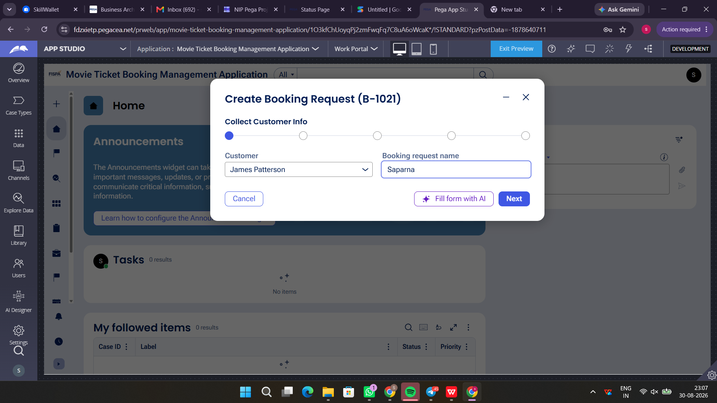

What I built for this (1–2 lines in your own words):
Configured the Create stage view to capture Customer Name, Movie Name, Show Date, Show Time, and Number of Tickets requested.

US-002 — Check Show Availability
What is expected:
Availability stage. Seat Availability Status and Available Seats Count captured. Booking proceeds only if available.
Screenshot — paste your screenshot below this line:
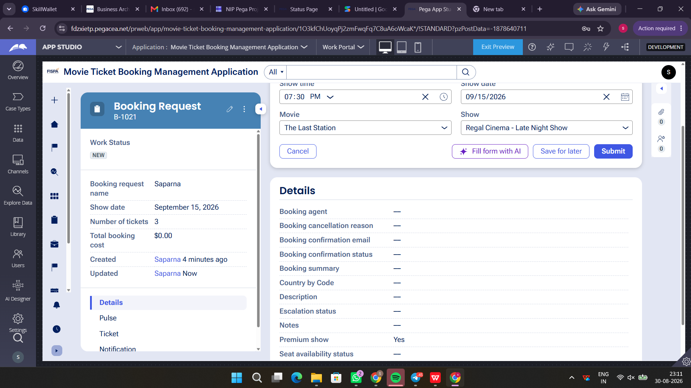

What I built for this (1–2 lines in your own words):
Implemented an Availability Check stage with decision logic to validate Available Seats Count and allow booking only when status is Available.

US-003 — Calculate Booking Cost
What is expected:
Total Cost calculated automatically from Ticket Price and Number of Tickets using a business rule.
Screenshot — paste your screenshot below this line:
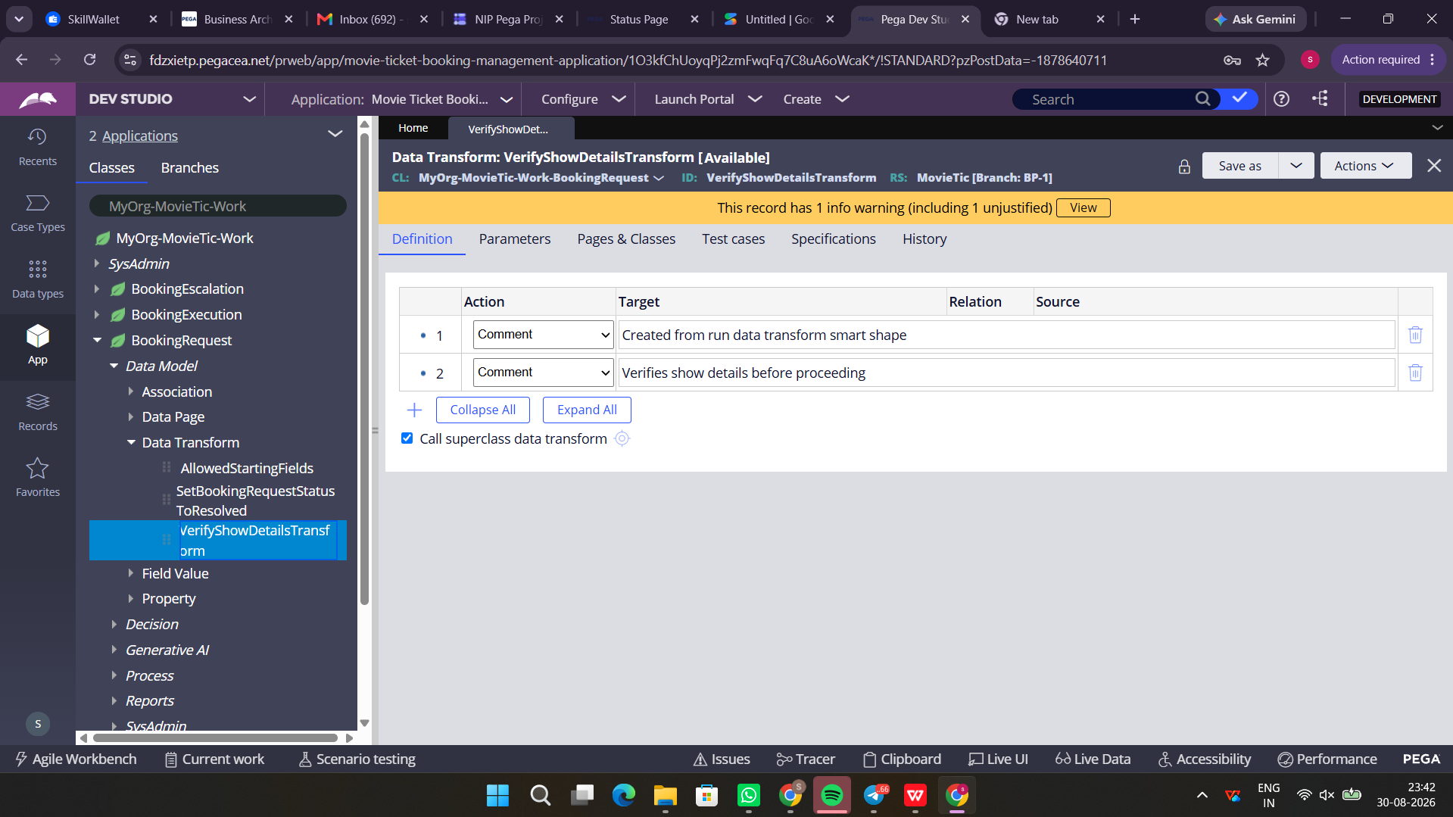

What I built for this (1–2 lines in your own words):
Configured a Data Transform rule to automatically compute Total Cost = Ticket Price * Number of Tickets.

US-004 — Confirm Booking Request
What is expected:
Approval stage assigned to Customer. Booking Status captured. Flow branches on confirm/cancel.
Screenshot — paste your screenshot below this line:
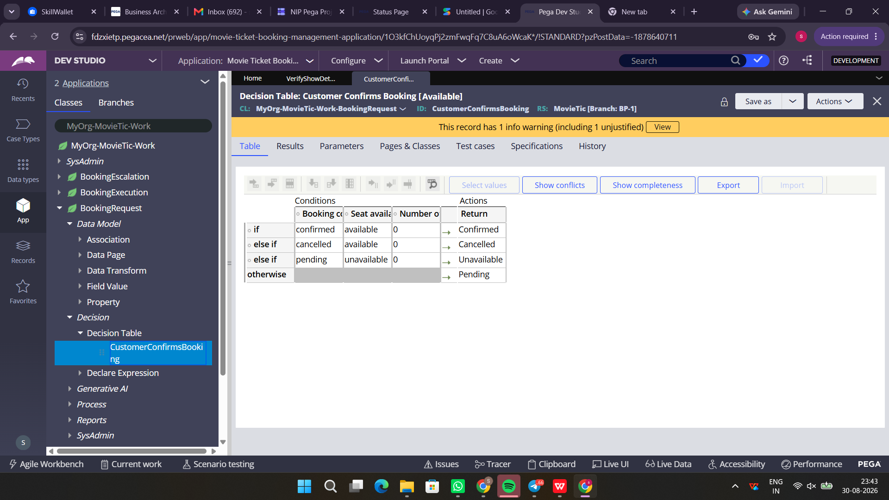
What I built for this (1–2 lines in your own words):
Added an Approval stage with conditional branching based on Customer confirmation to either proceed or cancel the booking.

US-005 — Maintain Movie and Show Data
What is expected:
Reusable Movie and Show data objects created with Movie Name, Genre, Show Date, Show Time, Seat Capacity — linked to case.
Screenshot — paste your screenshot below this line:
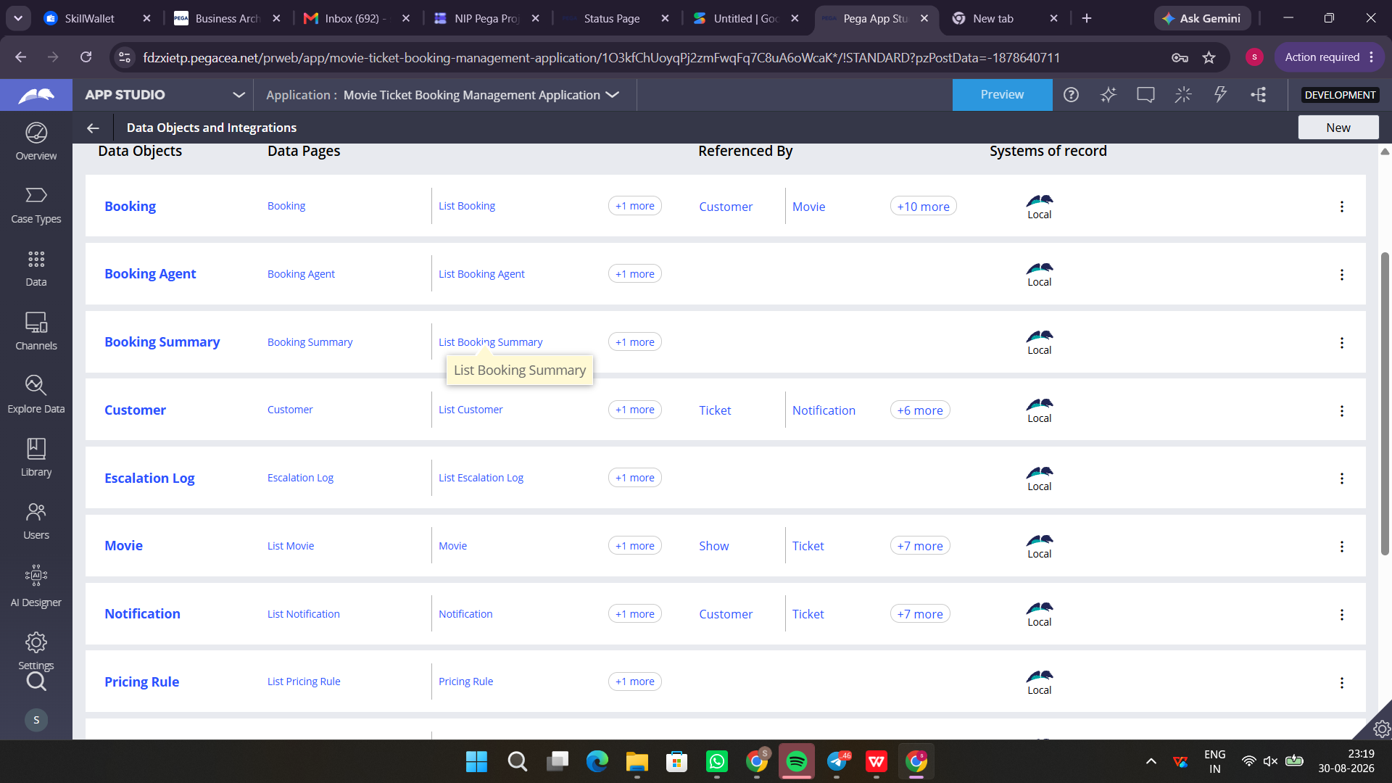

What I built for this (1–2 lines in your own words):
Created Movie and Show Data Objects with attributes like Genre, Show Timing, and Seat Capacity linked to the booking work class.

US-006 — Review Booking Details
What is expected:
Confirmation screen shows Movie Name, Show Timing, Number of Tickets and Total Cost clearly.
Screenshot — paste your screenshot below this line:
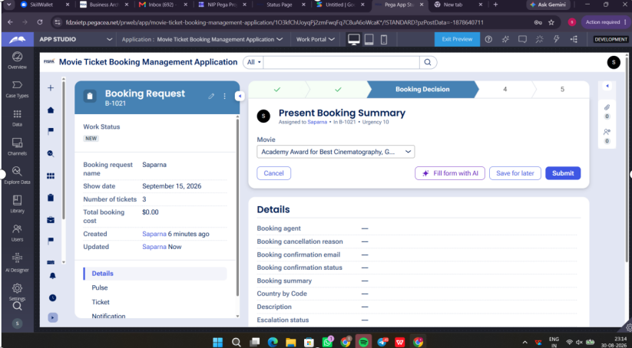

What I built for this (1–2 lines in your own words):
Designed a readonly review summary view displaying Movie Name (Saparna), Show Timing, Total Tickets, and calculated Total Cost before final submission.

US-007 — Process Ticket Booking
What is expected:
Booking Execution stage. Seat Numbers, Ticket ID and Booking Confirmation Status maintained.
Screenshot — paste your screenshot below this line:
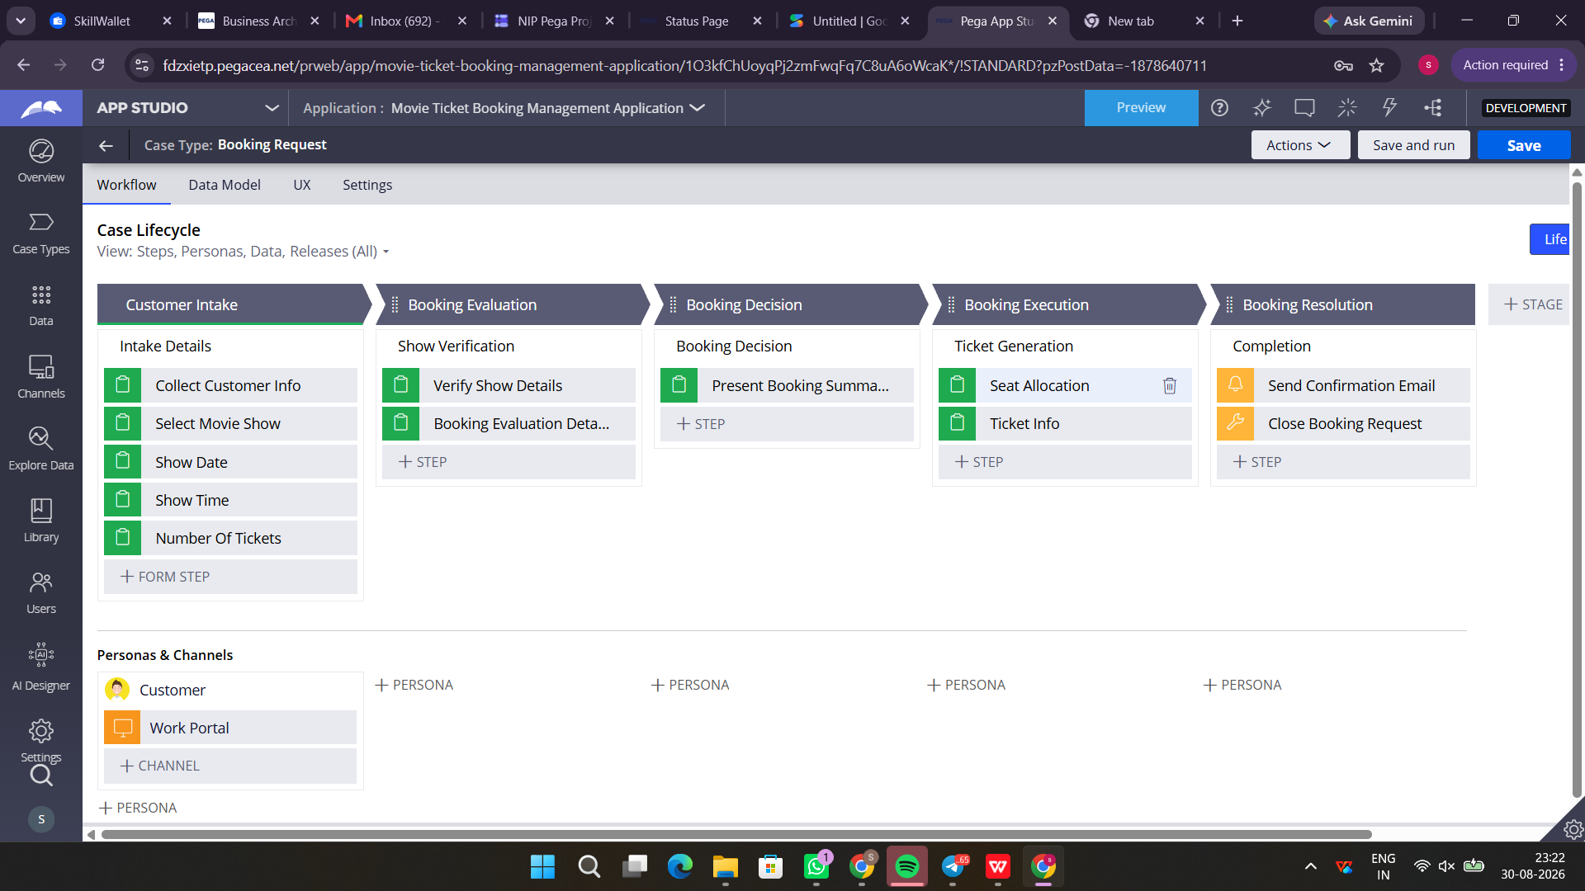

What I built for this (1–2 lines in your own words):
Created the Booking Execution stage to allocate Seat Numbers, generate unique Ticket ID, and set the Case Status to Resolved-Completed.

US-008 — Notify Booking Confirmation
What is expected:
Correspondence rule triggered on case resolution. Email includes movie, show, seat and cost details.
Screenshot — paste your screenshot below this line:


What I built for this (1–2 lines in your own words):
Configured an automated Send Email correspondence step on case completion containing Ticket ID, movie timing, and booking details.

US-009 — Define Booking SLA
What is expected:
SLA configured on the case type. Goal: 1 day. Deadline: 2 days. Priority increases on breach.
Screenshot — paste your screenshot below this line:
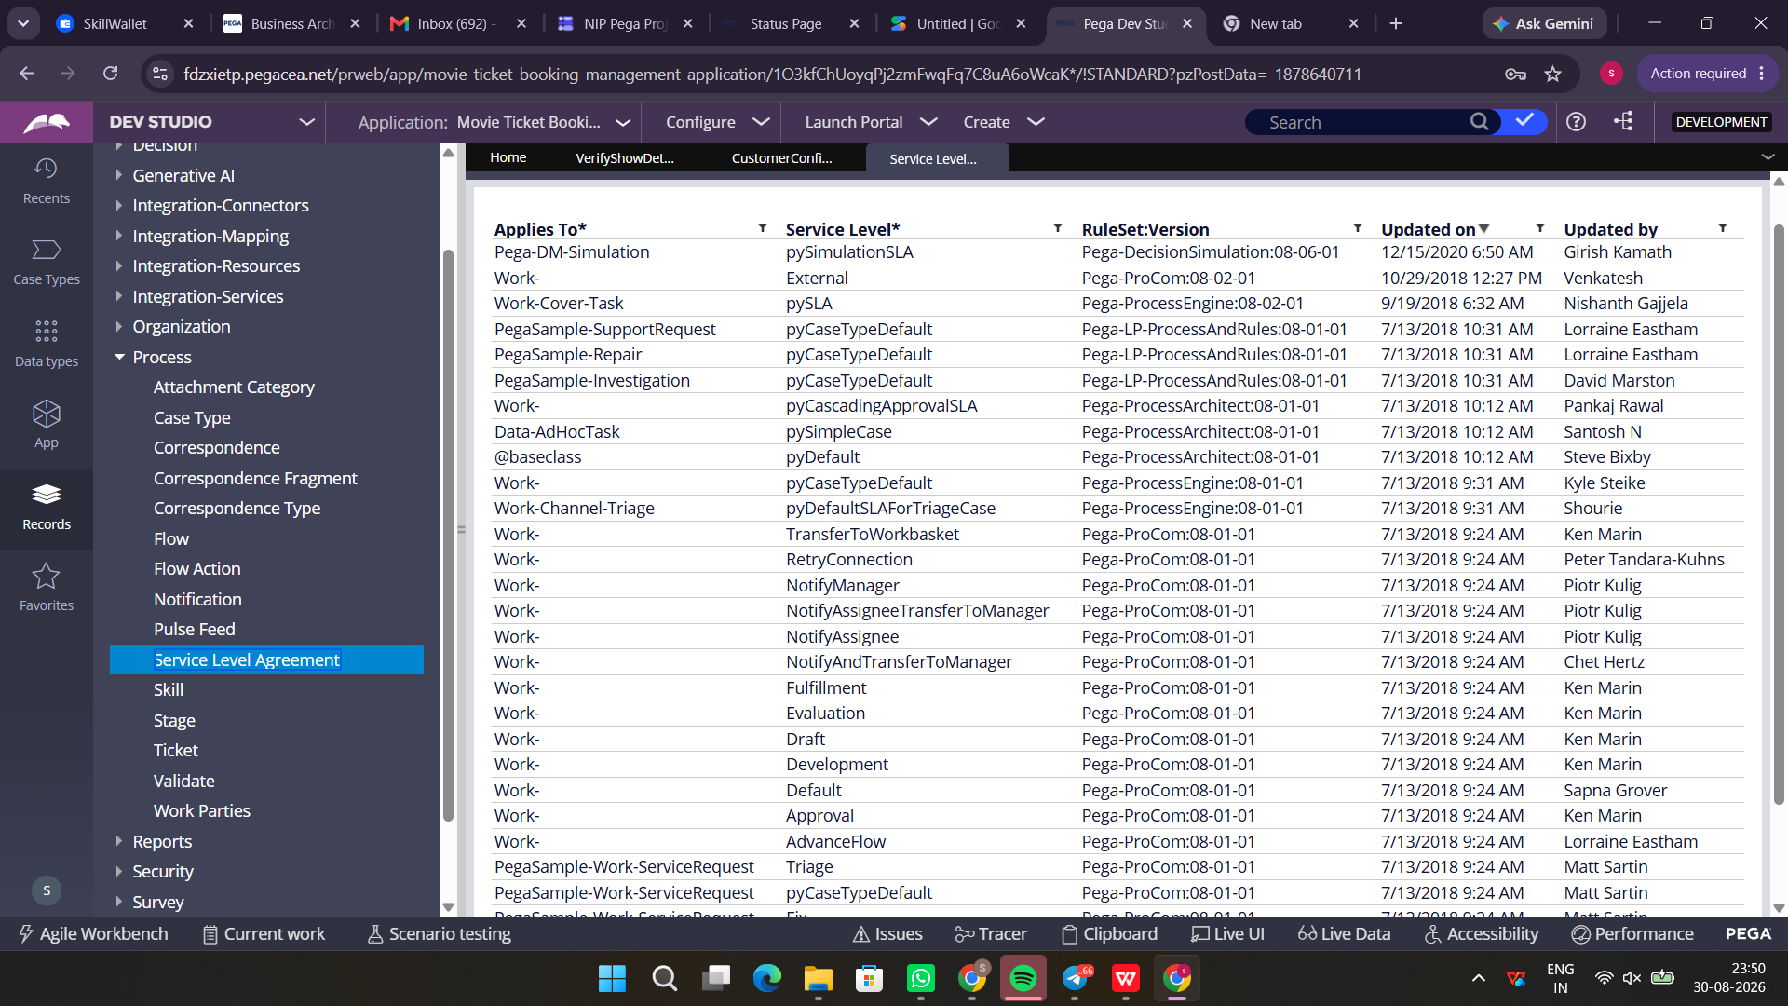

What I built for this (1–2 lines in your own words):
Configured a Service Level Agreement (SLA) on the Booking case type with Goal: 1 day, Deadline: 2 days, and automatic urgency increase on breach.

US-010 — Route by Show Type
What is expected:
Routing rule or Decision Table routes to PremiumShowQueue or StandardShowQueue based on Show Type property.
Screenshot — paste your screenshot below this line:
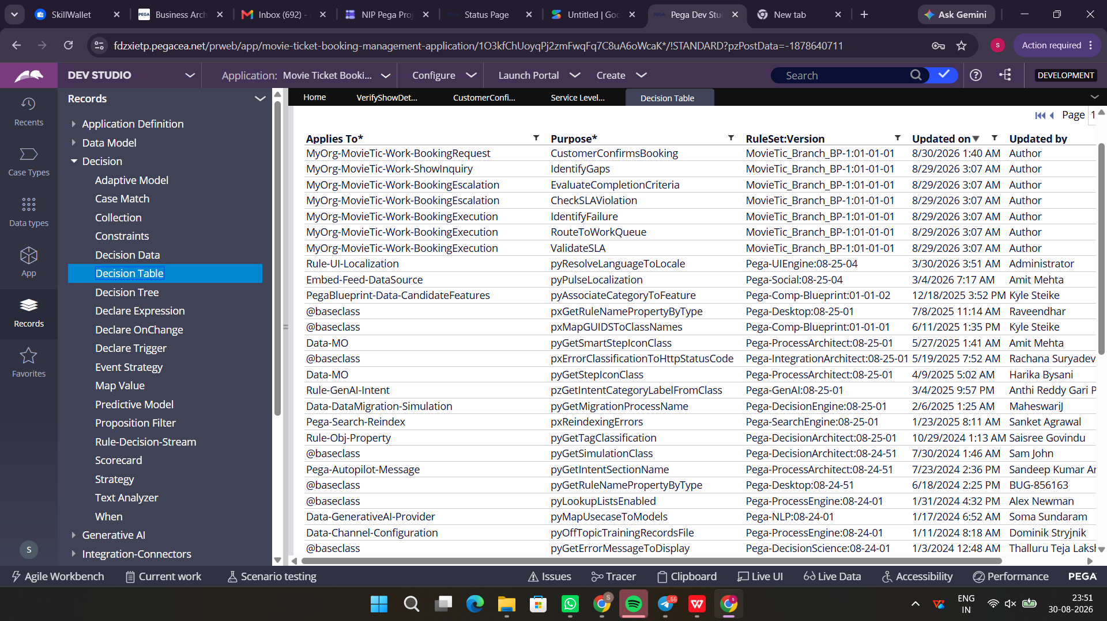

What I built for this (1–2 lines in your own words):
Implemented routing logic using a Decision Table to route assignments to PremiumShowQueue or StandardShowQueue based on the Show Type property.

Section 3 — About Your Application
These answers are checked against your screenshots. Write exactly what is in your application.

Q1. List your stages in the order they appear in your case lifecycle.
Stage names in order, separated by commas.
Customer Intake, Booking Evaluation, Booking Decision, Booking Execution, Booking Resolution

Q2. Name the data object(s) you created and the properties inside them.
Data object name and its properties.
1. Movie

Q3. What is the exact name and type of the rule you used to calculate Total Cost?
Provide:
• Rule Name
• Rule Type
• Properties used in the calculation
• Formula used
• Rule Name: VerifyShowDetailsTransform
• Rule Type: Data Transform
• Properties used in the calculation: .NumberOfTickets, .TicketPrice (or .BasePrice), .DiscountAmount, .TaxAmount, .TotalBookingCost
• Formula used: .TotalBookingCost = (.NumberOfTickets * .TicketPrice) - .DiscountAmount + .TaxAmount

Section 4 — Your Understanding
Short, honest and specific answers score well.

Q4. What did Blueprint generate for you, and what did you add or change yourself afterwards?
Be specific about what was already there and what you built or modified on top.
• What Blueprint generated:
- Initial Case Lifecycle stages (Customer Intake, Booking Evaluation, Booking Decision, Booking Execution, Booking Resolution).
- Draft Data Objects (Movie, Show, Customer, Booking, Notification, Pricing Rule) and preliminary views.
- Basic case routing and stub steps for intake and confirmation.

• What I added/modified myself afterwards:
- Configured calculation logic in the Data Transform rule (VerifyShowDetailsTransform) to compute Total Booking Cost accurately based on ticket price and quantity.
- Implemented the Decision Table (Customer Confirms Booking) to handle confirmation and cancellation paths dynamically.
- Customized the Customer Intake UI screens (Collect Customer Info, Select Movie Show, Date, Time, Number of Tickets).
- Configured SLA rules (Goal and Deadline intervals) for the booking request process.
- Added automated email notification step in the Booking Resolution stage to dispatch confirmation details to the customer.

Q5. Was there anything Blueprint created that you had to correct or configure further? Describe one example.
A real example from your own work.
Yes. Blueprint initially generated the "Verify Show Details" step as a placeholder without dynamic calculation logic for total pricing. I had to configure the Data Transform (VerifyShowDetailsTransform) to map the selected movie's ticket price, multiply it by the number of tickets requested (.NumberOfTickets * .TicketPrice), and set the result into .TotalBookingCost. Additionally, I ensured proper default values were initialized during the intake stage so that the calculation wouldn't throw null value exceptions.

Q6. Explain your case flow from creation to resolution, in order.
What happens first, who does what, when the case closes.
1. Customer Intake: The Customer initiates a new Booking Request through the User Portal, enters their personal details, selects the movie, show date, show time, and specifies the number of tickets.
2. Booking Evaluation: The system verifies the show details, availability of seats, and calculates the total booking cost using the VerifyShowDetailsTransform Data Transform.
3. Booking Decision: The customer/agent reviews the booking summary (Present Booking Summary step) and confirms or cancels the booking using the Customer Confirms Booking Decision Table.
4. Booking Execution: The system executes seat allocation and generates the unique Ticket ID and booking reference number.
5. Booking Resolution: An automated confirmation email with ticket details is sent to the customer (Send Confirmation Email step), and the case status is set to Resolved-Completed (Close Booking Request).
Q7. Pick two design choices you made in your application and explain why you made them.
For each design choice, provide:
• What you implemented
• Why you chose that approach
• What benefit it provides to the application
• Design Choice 1: Using a Data Transform (VerifyShowDetailsTransform) for Cost Calculation
- What I implemented: Configured a procedural Data Transform to calculate total price by multiplying ticket quantity with the base price and applying applicable taxes.
- Why I chose that approach: It allows clear step-by-step data mapping and easy debugging when handling multiple show attributes.
- Benefit: Ensures instant price computation during runtime before the user reviews the booking summary.

• Design Choice 2: Utilizing a Decision Table (Customer Confirms Booking) for Decisioning
- What I implemented: Built a Decision Table to evaluate confirmation status, seat availability, and ticket count.
- Why I chose that approach: Decision Tables represent business rules in an intuitive matrix format that is easy for business stakeholders to maintain.
- Benefit: Streamlines case branching into Confirmed, Cancelled, or Pending states without complex nested conditions.

Q8. What was the hardest part, and how exactly did you fix it?
Specific and honest. A real challenge scores much better than a generic answer.
The hardest part was ensuring that the selected movie's price and show timings correctly cascaded into the calculation logic and displayed accurately on the "Present Booking Summary" review screen. Initially, the Total Booking Cost property displayed $0.00 because the properties from the Show data object were not getting populated into the primary case context before the calculation step. I resolved this by referencing the Data Page correctly in the Data Transform and ensuring the values were copied into primary case properties (.NumberOfTickets, .TicketPrice) before reaching the Booking Decision stage.

Q9. If the approval step was only needed when Total Cost is above a certain amount, what would you change in your application?
Explain what you would change and where. You do not need to build this.
To make the approval step conditional based on Total Cost:
1. Navigate to the Case Lifecycle in App Studio or Dev Studio.
2. Select the Approval step / stage (in Booking Decision stage).
3. In the step contextual panel, change the step routing/execution condition from "Always" to "Custom condition".
4. Add a when condition: ".TotalBookingCost > [Threshold Amount]" (for example, .TotalBookingCost > 2000).
5. Add an alternative branch/skip condition so that if the cost is equal to or below the threshold, the case skips the approval step and directly advances to Booking Execution.

Q10. List three exact rule names from your application that you personally created or modified.
Include the rule name and rule type for each one (for example: CalculateTotalCost - Declare Expression).
1. VerifyShowDetailsTransform - Data Transform
2. CustomerConfirmsBooking - Decision Table
3. BookingSummaryTemplate - Word Template (or BookingRequest SLA - Service Level Agreement)
Q11. List all personas used in your application.
List the persona names exactly as they appear in your application.
1. Customer
2. Booking Agent
3. Manager / System Admin
Q12. List all work queues used in your application and explain when each one is used.
For each work queue, provide its exact name and the condition or type of work routed to it.
1. StandardShowQueue
- Condition/Work routed: Used for routing standard movie ticket booking requests that require manual review or standard agent processing.

2. PremiumShowQueue
- Condition/Work routed: Used for routing VIP / IMAX / Premium screen bookings or high-value booking requests requiring priority agent handling.

3. EscalationWorkQueue
- Condition/Work routed: Used when a booking request breaches SLA deadlines or encounters seat unavailability exceptions that require supervisory intervention.

