Iris Flower Data Analysis - Project

In this project, I am performing Exploratory Data Analysis on the Iris Flower Dataset.

The Iris Flower data set is also known as Fisher’s Iris data set. It is a multivariate data set introduced by the British statistician and biologist Ronald Fisher in 1936. It contains measurements of 150 iris plants, with 50 plants from every three species. Fisher measured the sepal length, sepal width, petal length, and petal width for each plant.

In this project, I am analysing data and trying to get some meaningful full visualization.

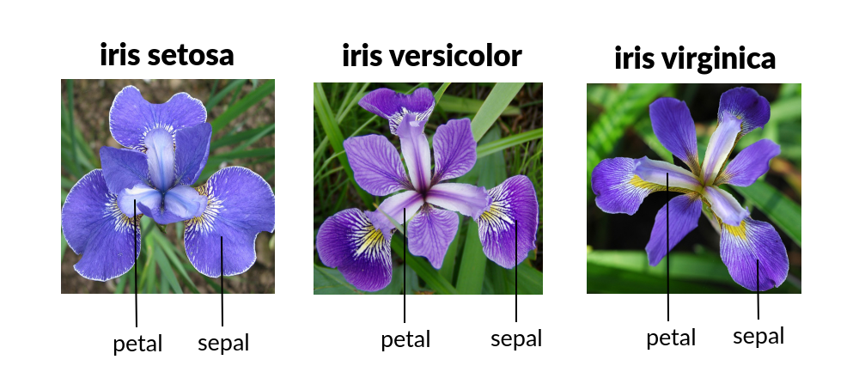

Tools used in this project –

1. Python
2. Power BI



[This Photo](https://ask.hellobi.com/article/9928) by Unknown Author is licensed under [CC BY-SA](https://creativecommons.org/licenses/by-sa/3.0/)



[This Photo](https://en.wikiversity.org/wiki/Python_Concepts) by Unknown Author is licensed under [CC BY-SA](https://creativecommons.org/licenses/by-sa/3.0/)

Our Findings –

1. Species Setosa has smaller petal length, petal width, and sepal length but larger sepal width.
2. Versicolor Species lies in the middle of the other two species.
3. Species Virginica has the largest of petal length, patel width, and sepal length but smaller sepal width.