**OUTPUT SCREENSHOT OF MY PORTFOLIO:**

**HOME PAGE:**

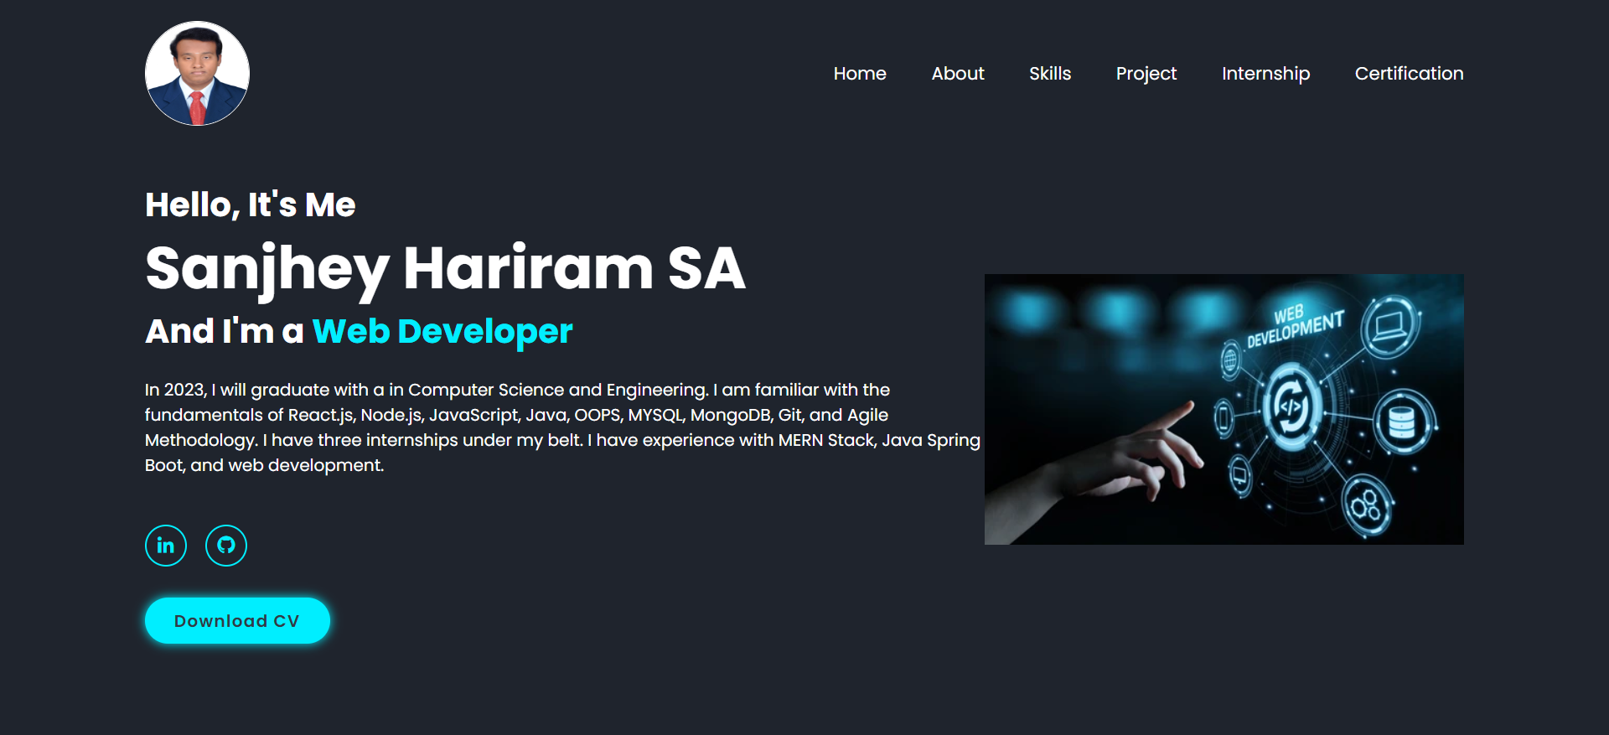

**ABOUT PAGE:**

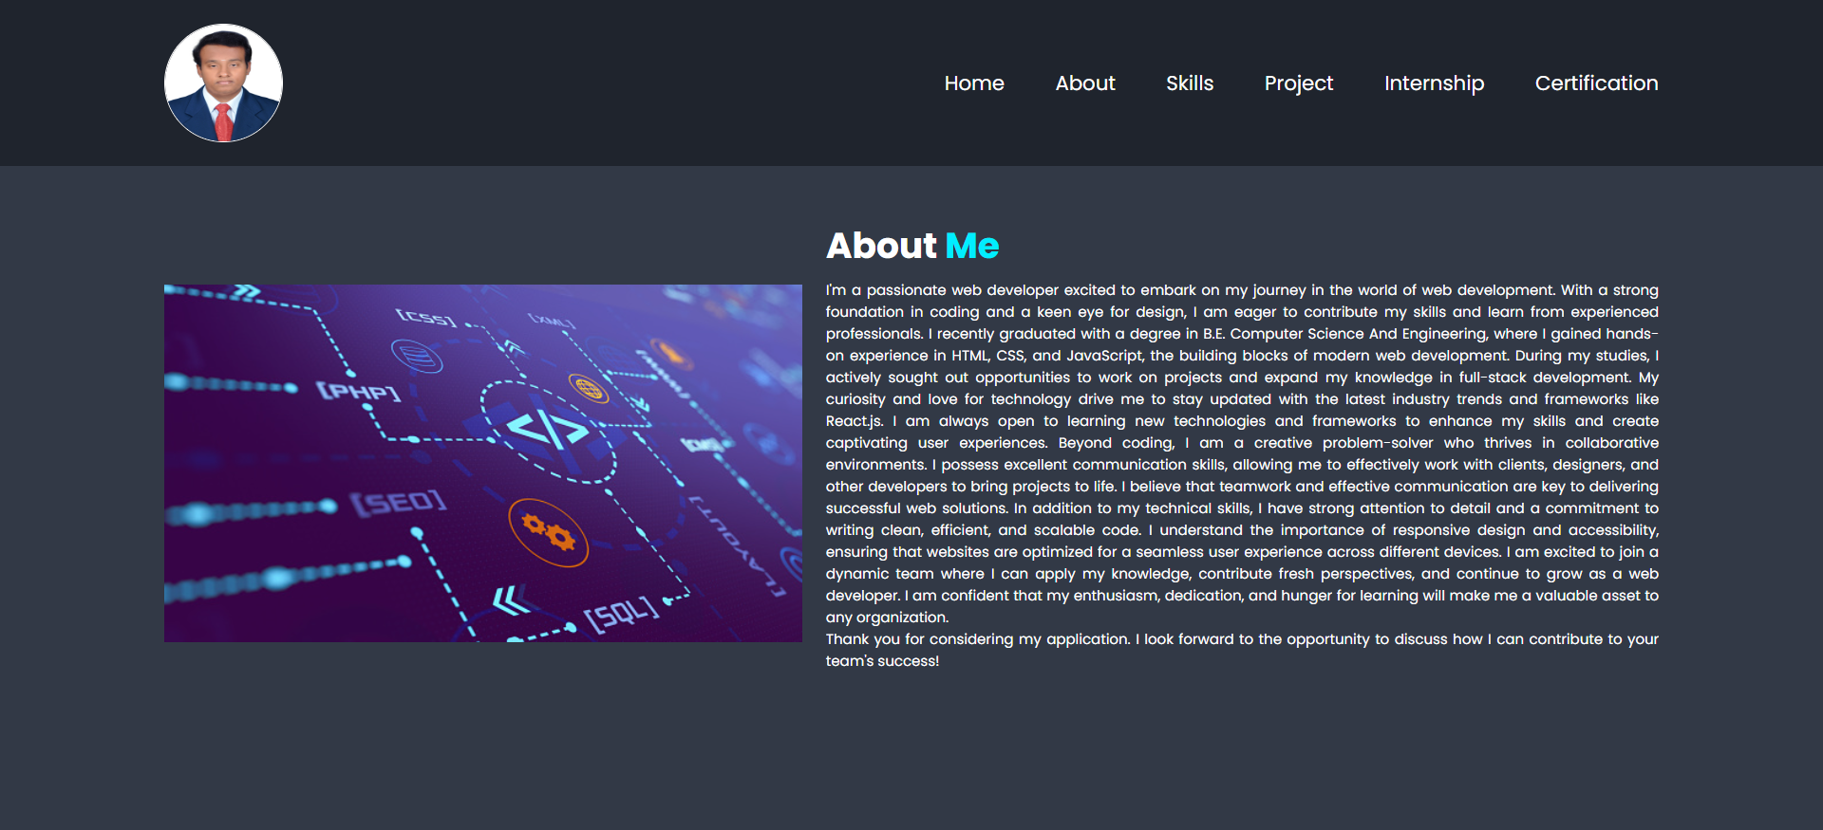

**SKILLS PAGE:**

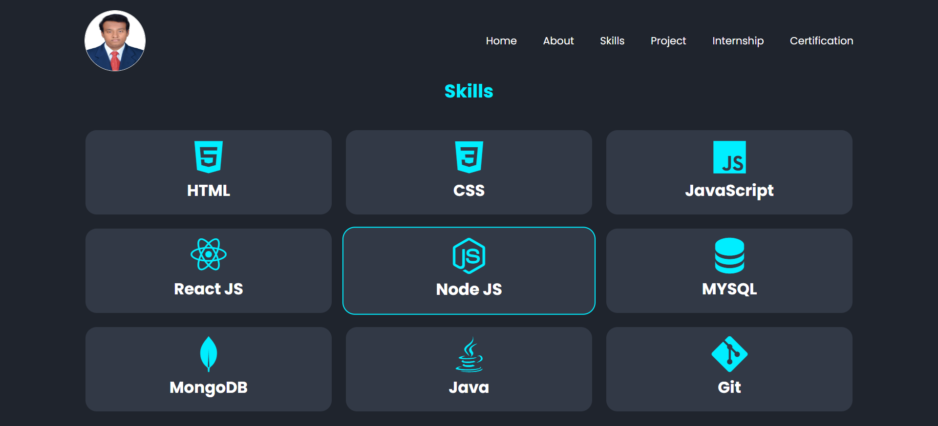

**PROJECT PAGE:**

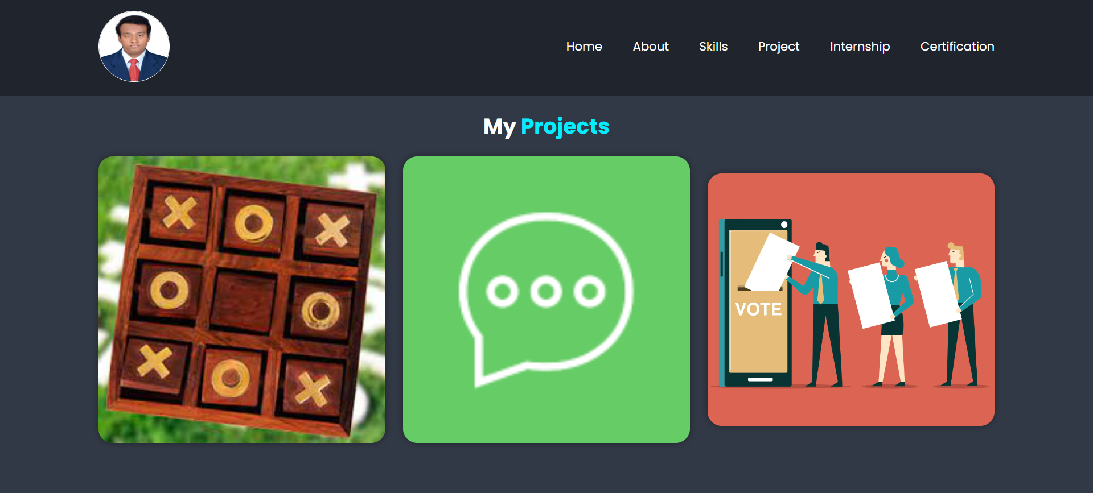

**INTERNSHIP PAGE:**



**CERTIFICATION PAGE:**

