

**Project Submission 1: SRS and Use Case Diagram**

**CSE 438**

**Smart Phone Application Development**

**Section: 01**

**Submitted to:**

**Shakib Mahmud Dipto**

**Submitted by:**

**Sanjib Biswas(193014012)**

**Khadiza Nasrin(191014042)**

**Sameya Haque(192014019)**

**Project name: Fashion Forward - Clothing store**

|  |  |
| --- | --- |
| 1. **Introduction** | **1.1 Purpose**: Fashion Forward - Clothing store is a mobile application developed using the Flutter framework that allows users to browse and purchase fashion products such as clothing, shoes, and accessories. User can using a dress modification tool developed in the Dart programming language, the system enables users to modify the chosen clothes.  **1.2 Scope:** Our application helps user to customize and modify dresses. Users will be able to design their own mind to create personalized outfits. |
| 1. **Functional Requirements** | **2.1 User Registration and Authentication :**   * Users can easily register for an account on the system by providing their email address or logging in using their social media accounts. This streamlined registration process ensures a hassle-free start to using the system. * To ensure secure access to the system, user authentication will be implemented using a standard username and password mechanism.   **2.2 Dress Modify**   * Users can modify the chosen dress using the system's dress modification tool. * Color, pattern, materials, sleeves, neckline, length, and other essential qualities will be customizable by users. * Users will be able to save and see their personalized outfit before purchasing it.   **2.3 Shop Ordering**   * Dresses will be added to users' shopping carts. * The system must figure out and show the combined cost of everything in the shopping cart. * The shopping cart should allow users to change the number or delete products.   **2.4 User Profile Management**   * Users needs to have access to their profile data and be able to edit it. * Users have to be able to control the personalized dress designs they've stored. * The ability for users to remove their accounts and related data should exist. |
| **3. Non-Functional Requirements** | **3.1 Performance :**   * The system have quick responses. * The clothing modification tool must deliver a responsive and pleasant user experience   **3.2 Security**   * User passwords is totally safe . * The system encrypt user accounts and sensitive data.   **3.3 Usability**   * The user interface is vary user-friendly . * The clothing customization tool must give detailed instructions.   **3.4 Scalability**   * The system should be capable of handling a larg number user. * To allow for future expansion, the system should be easily expandable. |
| **4. Constraints** | * It is a android application . * The system should be developed by Dart |

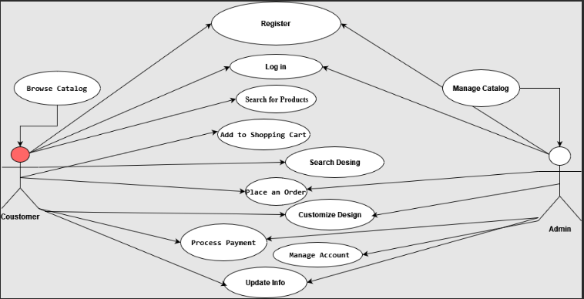

**Use Case Diagram**