**Step 1:**

First of all we need to set up the devices and routers as shown as the following picture.

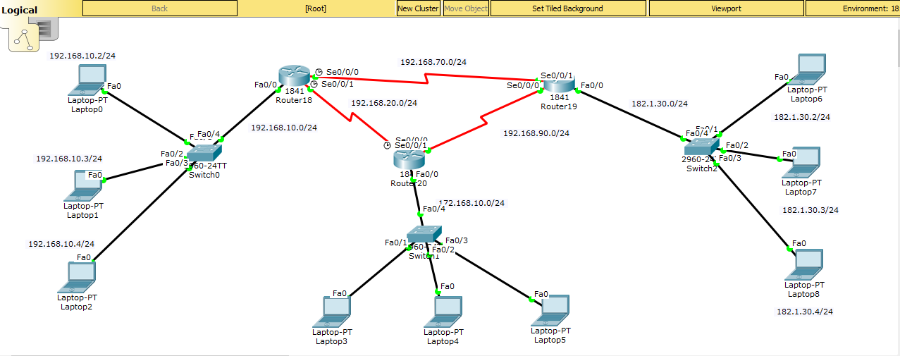

**Step-1:** We take three devices, a switch and router on the left, bottom and right. We connect the devices to switch by automatic wire.

**Step-2:** Click on each router> Physical> On physical device view tab turn off the power button> drag WIC-2T mode and drop into the right black portion of the physical device view tab.

**Step-3:** Now for every router to router connection, select the red wire with a clock in it and start connecting the routers. Select either s0/0/0 or s0/0/1 for the connections as shown in the above picture.

**Step-4:** Set the IP address for all computers. For set the IP address, Click on the desired device> Desktop> IP Configuration. Give the IP address as mention on the above picture. Set the default getaway 192.168.10.5 for laptop 0, 1 and 2 , 172.168.10.1 for laptop 3, 4, and 5 and 182.1.30.1 for laptop 6, 7 and 8.

**Step-5:** Click on router18> CLI> Run the following commands. (Hit enter after each)

enable

configure terminal

interface fastethernet 0/0

ip address 192.168.10.5 255.255.255.0

no shutdown

exit

interface serial 0/0/0

ip address 192.168.70.1 255.255.255.0

clock rate 64000

no shutdown

exit

interface serial 0/0/1

ip address 192.168.20.1 255.255.255.0

clock rate 64000

no shutdown

exit

Click on router19> CLI> Run the following commands. (Hit enter after each)

enable

configure terminal

interface fastethernet 0/0

ip address 182.1.30.1 255.255.255.0

no shutdown

exit

interface serial 0/0/1

ip address 192.168.70.2 255.255.255.0

no shutdown

exit

interface serial 0/0/0

ip address 192.168.90.1 255.255.255.0

no shutdown

exit

Click on router20> CLI> Run the following commands. (Hit enter after each)

enable

configure terminal

interface fastethernet 0/0

ip address 172.168.10.1 255.255.255.0

no shutdown

exit

interface serial 0/0/1

ip address 192.168.20.2 255.255.255.0

clock rate 64000

no shutdown

exit

interface serial 0/0/0

ip address 192.168.90.2 255.255.255.0

no shutdown

exit

**Step-6:**

Click on router18> CLI> Run the following commands. (Hit enter after each)

enable

configure terminal

ip route 182.1.30.0 255.255.255.0 192.168.70.2

ip route 172.168.10.0 255.255.255.0 192.168.20.2

Click on router19> CLI> Run the following commands. (Hit enter after each)

enable

configure terminal

ip route 192.168.10.0 255.255.255.0 192.168.70.1

ip route 172.168.10.0 255.255.255.0 192.168.90.1

Click on router20> CLI> Run the following commands. (Hit enter after each)

enable

configure terminal

ip route 192.168.10.0 255.255.255.0 192.168.70.1

ip route 182.1.30.0 255.255.255.0 192.168.90.2