There are two issues to solve.

1. The following links to the code for one of my pages.

For Mac and Windows the link works fine however on my web and ios version the link doesn’t work. I’m happy to use an “absolute link” – however this hasn’t worked for me.

The code in yellow is what isn’t working.

"content":"../sharedcontent/video/logo.mp4",

{

"data": {

"title":"",

"pdf":"../sharedcontent/lessonplans/Looptastic.pdf",

"autoplay":true,

"slides":[

{

"type":"video",

"duration":"00:09:10",

"content":"../sharedcontent/video/logo.mp4",

"voiceover":"",

"background-color":"white"

},

{

"type":"image",

"duration":"",

"content":"../sharedcontent/recap.jpg",

"voiceover":"",

"background-color":"black"

},

{

"type":"image",

"duration":"",

"content":"../sharedcontent/quiz.jpg",

"voiceover":"",

"background-color":"black"

},

{

"type":"image",

"duration":"",

"content":"quiz/2.jpg",

"voiceover":"",

"background-color":"black"

},

{

"type":"image",

"duration":"",

"content":"quiz/3.jpg",

"voiceover":"",

"background-color":"black"

},

{

"type":"image",

"duration":"",

"content":"quiz/4.jpg",

"voiceover":"",

"background-color":"black"

},

{

"type":"image",

"duration":"",

"content":"quiz/5.jpg",

"voiceover":"",

"background-color":"black"

},

{

"type":"image",

"duration":"",

"content":"quiz/6.jpg",

"voiceover":"",

"background-color":"black"

},

{

"type":"image",

"duration":"",

"content":"quiz/7.jpg",

"voiceover":"",

"background-color":"black"

},

{

"type":"image",

"duration":"",

"content":"quiz/8.jpg",

"voiceover":"",

"background-color":"black"

},

{

"type":"image",

"duration":"",

"content":"quiz/9.jpg",

"voiceover":"",

"background-color":"black"

},

{

"type":"video",

"duration":"00:07",

"content":"quiz/quiz.mp4",

"voiceover":"",

"background-color":"black"

},

{

"type":"image",

"duration":"",

"content":"quiz/12.jpg",

"voiceover":"",

"background-color":"black"

},

{

"type":"image",

"duration":"",

"content":"quiz/10.jpg",

"voiceover":"",

"background-color":"black"

},

{

"type":"image",

"duration":"",

"content":"quiz/11.jpg",

"voiceover":"",

"background-color":"black"

},

{

"type":"video",

"duration":"00:11:00",

"content":"media/vid.mp4",

"voiceover":"media/se.mp3",

"background-color":"#004aad"

},

{

"type":"image",

"duration":"",

"content":"coreslides/3.jpg",

"voiceover":"",

"background-color":"white"

},

{

"type":"image",

"duration":"",

"content":"coreslides/4.jpg",

"voiceover":"",

"background-color":"#004aad"

},

{

"type":"image",

"duration":"",

"content":"coreslides/5.jpg",

"voiceover":"media/groovepack.mp3",

"background-color":"#004aad"

},

{

"type":"image",

"duration":"",

"content":"coreslides//6.jpg",

"voiceover":"",

"background-color":"#004aad"

},

{

"type":"image",

"duration":"",

"content":"coreslides/7.jpg",

"voiceover":"",

"background-color":"#004aad"

},

{

"type":"image",

"duration":"",

"content":"coreslides/8.png",

}

}

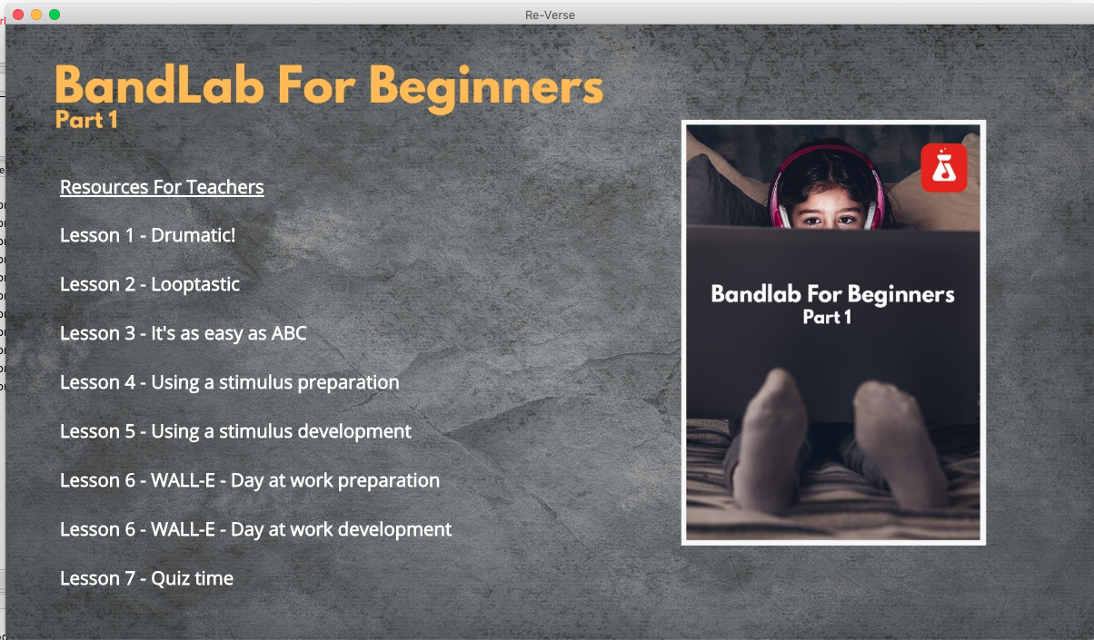

This is how my menu appears.

The resources for teachers link, at the top, need to be a hyperlink to :

https://rhythmstix.co.uk/getting-started-your-bandlab-classroom

This is the code in my software for that page currently:

[

{

"name":"<u>Resources For Teachers</u></b>",

"url":"guide",

"type":"slides"

},

{

"name":"Lesson 1 - Drumatic!",

"url":"1.drumatic",

"type":"slides"

},

{

"name":"Lesson 2 - Looptastic",

"url":"2.looptastic",

"type":"slides"

},

{

"name":"Lesson 3 - It's as easy as ABC",

"url":"3.abc",

"type":"slides"

},

{

"name":"Lesson 4 - Using a stimulus preparation",

"url":"4.stimulus",

"type":"slides"

},

{

"name":"Lesson 5 - Using a stimulus development",

"url":"4.stimulus",

"type":"slides"

},

{

"name":"Lesson 6 - WALL-E - Day at work preparation",

"url":"6.wall-e",

"type":"slides"

},

{

"name":"Lesson 6 - WALL-E - Day at work development",

"url":"6.wall-e",

"type":"slides"

},

{

"name":"Lesson 7 - Quiz time",

"url":"7.quiz",

"type":"slides"

}

]