Interactive Student Performance Tracking App
An online app for educational institutions that allows tracking student academic performance. The application provides users with access to interactive grading dashboards. Teachers can review such data as the overall curriculum progress, individual average grades, attendance, grade by subject, and others. Also, the app enables assessing the efficiency of the teaching staff.

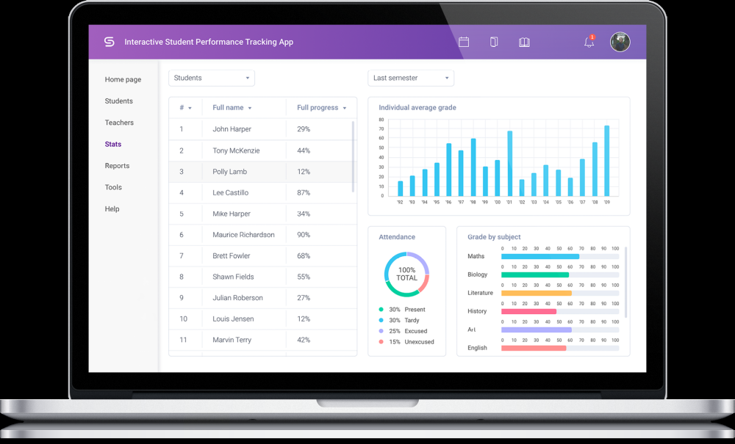

Business Challenge
To evaluate the effectiveness of the used teaching methodologies, educational institutions should regularly perform tracking of dozens of indicators related to the academic performance of their students. Considering the complex nature of modern education, it’s barely possible to complete such a task manually. Fortunately, assessment apps allow educational institutions to monitor, visualize, and analyze the efficiency of education with ease. An approach based on data tracking and analysis helps to define if there’s the need to change the used studying programs for reaching better academic results. Our company was asked to develop an online app for efficient tracking of student performance data. The app should allow reviewing and editing the list of students containing such info as name, contact info, and average grade. By request, users should get access to detailed stats of a particular learner, such as grade per specific subject. Also, the app should allow tracking the teachers’ their working hours, attendance by students, and other parameters.

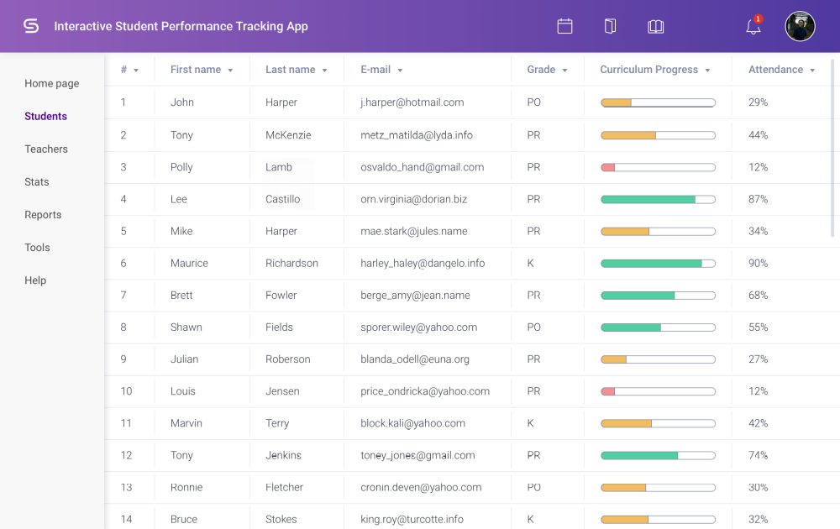

Solution
Our development team has built a full-featured online app for tracking performance data. Teachers can use this app to get access to the full list of students that provide such info as name, email address, average grade, curriculum progress, and attendance. The list can be sorted by any of these parameters. This feature of the app can be used to determine those learners that have the lowest grades. Then, such a student can be quickly contacted via email to find out the reasons for poor academic performance and schedule a consultation if needed. The app also provides access to the profile page of a particular student. This page contains such data as name, birth date, average grade, address, email, disciplines studied, and other records. All this info can be modified with a couple of clicks. The system allows getting access to data related to teachers as well. Users of the app can review the list of teaching staff that provides such info as name, email, department, and current status (busy or active). Each record can be edited and saved with a couple of mouse clicks. Our Webix development team has implemented data visualization features that allow representing info on students performance in the form of an interactive dashboard. Such an approach significantly improve the effectiveness of tracking student academic progress. Users of the app can select a particular student from the list and get instant access to such info as an individual average grade, attendance, grade by subject, and current curriculum progress. Besides, users can use this app for teachers efficiency tracking. In this mode, the application can visualize such data as working hours, attendance by students, and average test score. The app allows generating reports and exporting them to Excel, PDF, and other formats. Smart alerts and notifications allow being aware of important events. For example, you can configure the system to send you a warning if the average grade of a particular student falls below a given value. Mobile support enables the use of this tracking app on smartphones and tablets. Document upload and file sharing can simplify teamwork and provide teachers with the possibility to share and discuss their view on curriculum innovations. Progress evaluation and score system can help teachers to identify learners who demonstrate the best academic success and encourage them.

Applied Technologies
- Webix
- Node.js
- HTML
- CSS

Duration
1+ year
Estimated Working Hours
1500+ hours

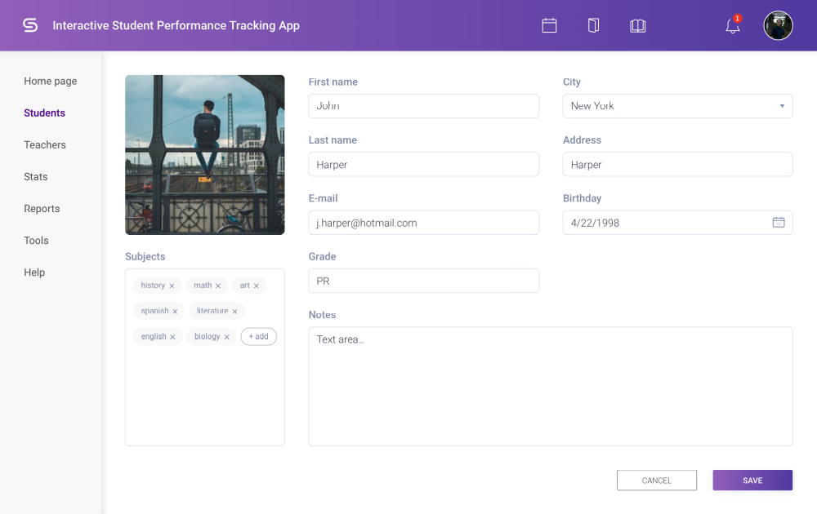

Our Role in the Client's Success
Our company has rich experience in Node JS development and other modern technologies. It allowed us to design and build an advanced online app for efficient tracking of students’ and teachers’ performance data. The app provides easy access to the list of students and teaching staff and allows editing this info with ease. Modern data visualization tools allowed our developers to create an interactive dashboard that represents complex data in an easy-to-understand way. With its help, users of the app can get a clear understanding of the current academic results of a specific student. Also, the dashboard allows tracking the performance of a particular teacher. To learn more about how a full-featured custom solution can help your organization, check our case studies in the education industry.

Developed student tracking app enables users to:
- review and edit the list of teachers and students
- get access to the dashboard for easy student progress tracking
- create and share reports via the web or mobile app

Customer
A large educational institution from the EU that wanted to replace legacy software for tracking data on students and teachers performance with a modern and full-featured app. To learn how custom-made apps can help your educational institution, you can receive a free consultation from our specialists.

