Date: 29 August 2022

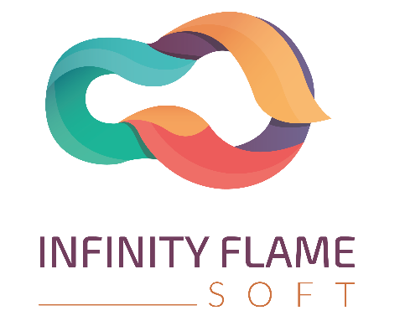



|  |  |
| --- | --- |
| WEBSITE PROPOSAL | **Infinity Flame**  5th Floor, Rangmohol Tower,  **Contact:** 01710-903032  **Email:** [faisal.lu.ac@gmail.com](mailto:faisal.lu.ac@gmail.com) [info@infinityflamesoft.com](mailto:info@infinityflamesoft.com)  **Website:** www.infinityflameso  Md Faisal  Managing Director |

Soft

## r,Bander Bazar,Sylhet

## Dear Sir

We are “Infinity Flame Soft” a well-established IT solution provider in Bangladesh and working in the field for the last 6 years. We provide several types of business, academic and corporate based solutions. We are happy to help our client with our best service but within the budget. We are happy to introduce to one of the finest websites & Software solutions for you.

Corporate-based

# FEATURE LIST

Basic website

Menu/Page

* Home
  + Principle/Chairmen
* About Us
  + Mission/Vision
  + Video And Text Review
  + Events
  + Board Of Trustees
* Academic
* Academic Policy
* Faculty Members
* Facilities
* Library
* Digital Class
* Class Routine
* Notice Board
* Academic Results
* Campus
* Campus Life
* Hostel Facilities
* Mukhtijuddha Chaottor
* Labs
* Computer Lab
* Physics Lab
* Biology lab
* Chemistry lab
* Math’s Lab
* Clubs
* Science Club
* Culture Club
* Computer Club
* Ranger Unit Club
* Gallery
* General Gallery
* Event Gallery
* Admission
* Instruction
* Form
* Fees Payment
* Apply Online
* Blog

# Estimation

|  |  |  |
| --- | --- | --- |
| **Item/Description** | **Development Time** | **Price** |
| **Website With Admin Panel (Dynamic)** | 30 Days | 35,000/- |
| **Domain With 20 GB Hosting for 1 year** |  | 5,000/- |
| **Static Website** | 15Days | 15,000/- |

**Note:** All price is calculated in BDT & Time are based on working days.

# Terms & Conditions

* 50% payment must be paid before the project starts. Another 50% payment will pay, after project completion.
* Client provides all the requirements before the project starts. Also, provide required documents if needed.
* 6-Moths free online/offline support. After that monthly 1000/- charge is applicable for next 3 years. After that service charge may negotiable. We must respond for service within 3 working days.
* Infinity Flame Soft will not be responsible for server/system crush or

**Md Faisal**

Managing Director