

**Ahsanullah University of Science & Technology**

**Department of Computer Science & Engineering**

**Course No. :** CSE 4108

**Course Name :** Artificial Intelligence Lab

**Assignment No. :** 05

**Submitted To :**

Md. Siam Ansary Mr. Ashek Seum

Department of CSE, AUST Department of CSE, AUST

**Submitted By:**

Name : Sanjida Akter Ishita

ID No. : 170204089

Session : Fall 2020

Section : B

Lab group : B2

**Date of Submission:** September 21, 2021

**QUESTION 01:** For the graph below, implement Greedy Best First Search Algorithm and A* Search Algorithm using Python.

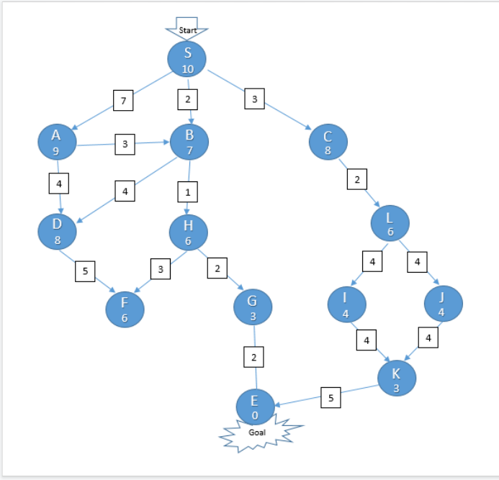

**Answer:** The two variants of Best First Search are **Greedy Best First Search** and **A* Best First Search**. The Greedy BFS algorithm selects the path which appears to be the best, it can be known as the combination of depth-first search and breadth-first search. Greedy BFS makes use of Heuristic function and search and allows us to take advantages of both algorithms.

**A**\* **Algorithm** in **Python** or in general is basically an artificial intelligence problem used for the path finding and the Graph traversals. This **algorithm** is flexible and can be used in a wide range of contexts.

The **A**\* **search** **algorithm** uses the heuristic path cost, the starting point’s cost, and the ending point.

**Implementation of Greedy Best First Search Algorithm using Python**

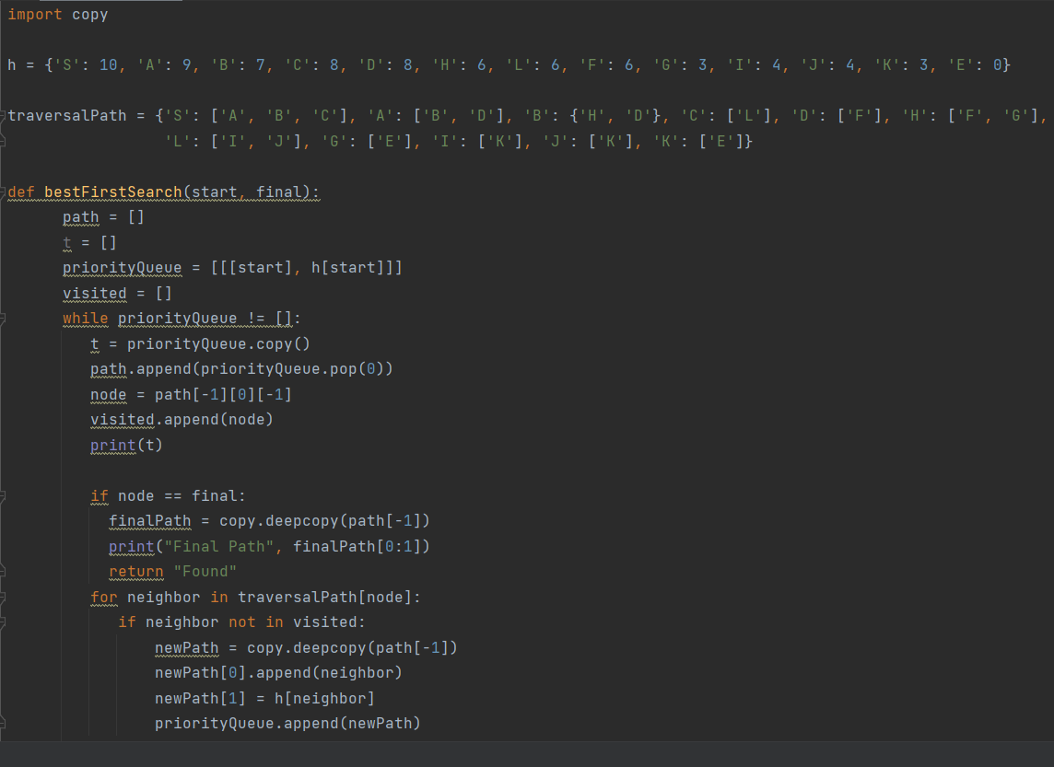

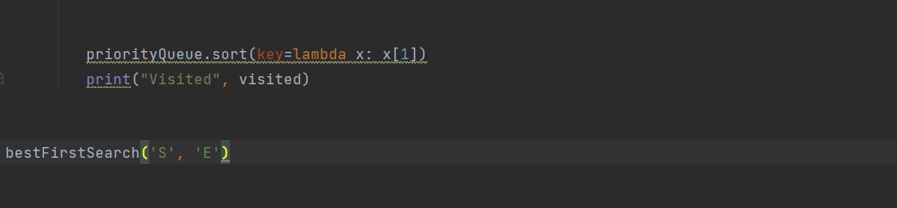

**Output:**

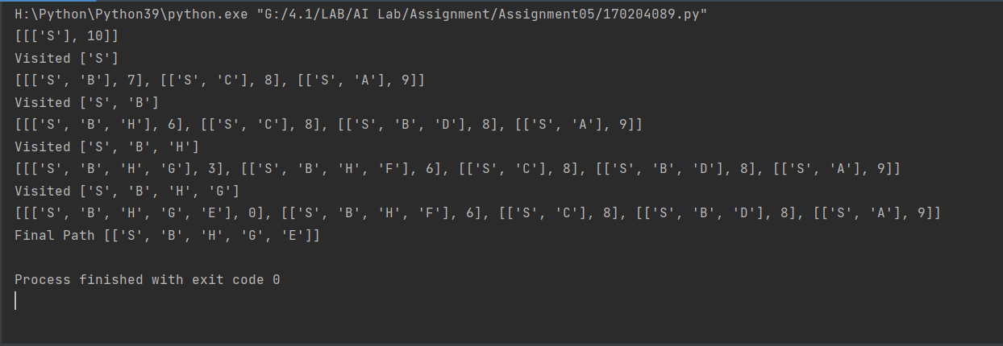

**Implementation of A* Search Algorithm using Python**

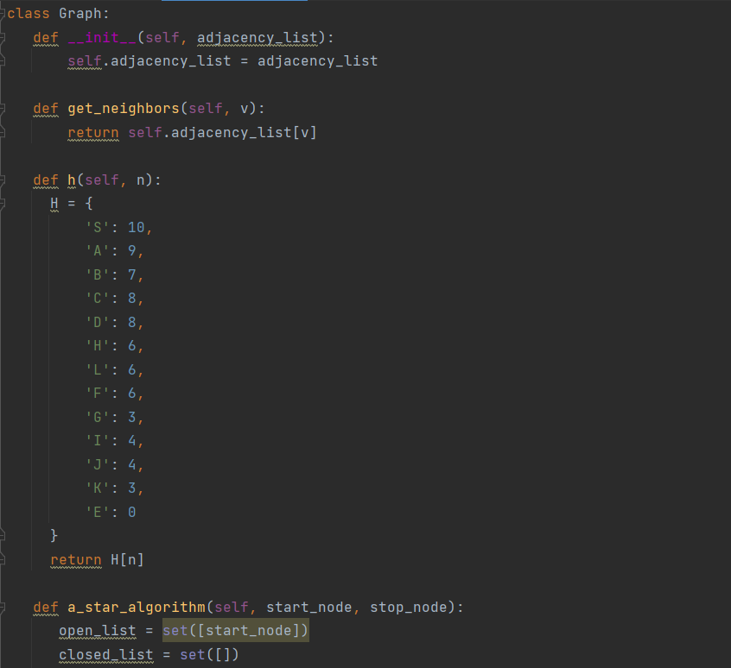

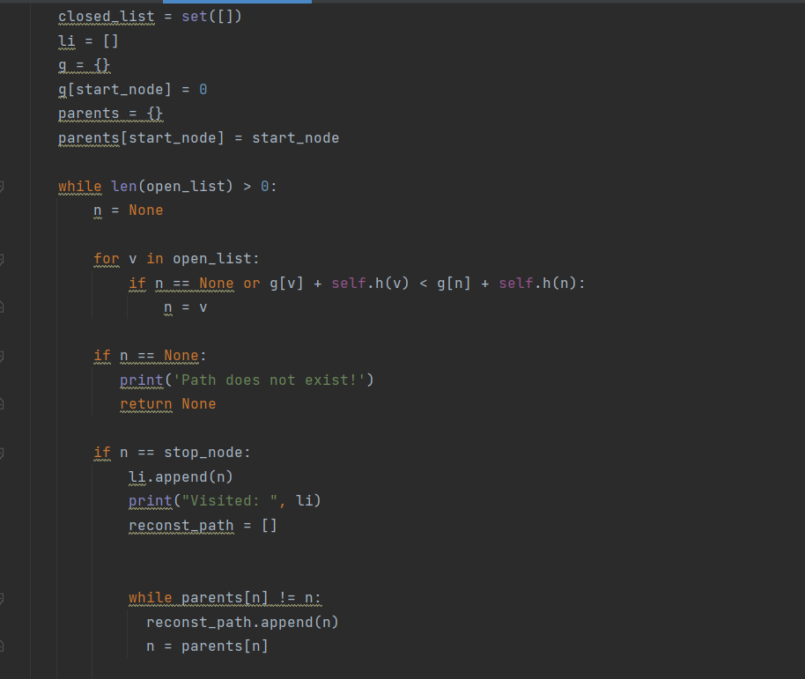

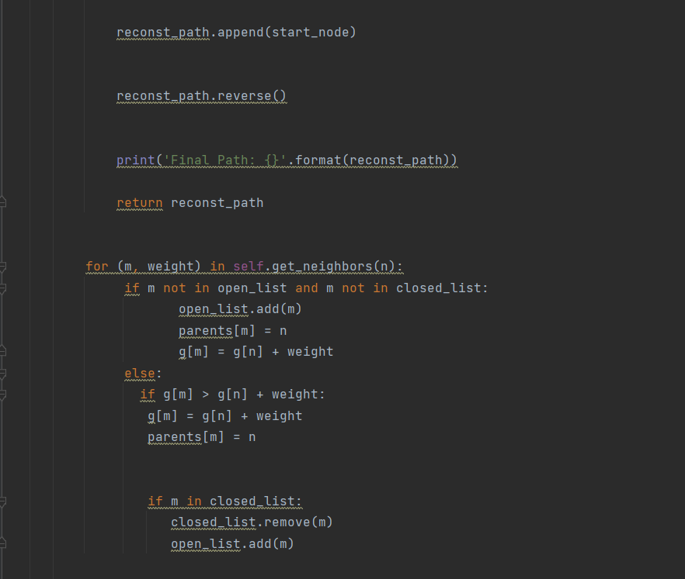

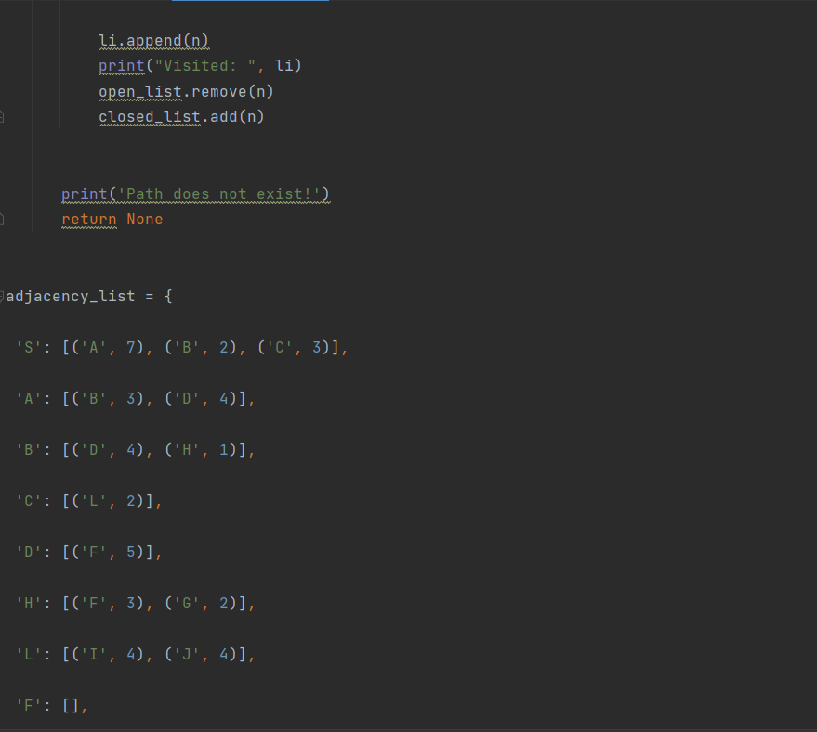

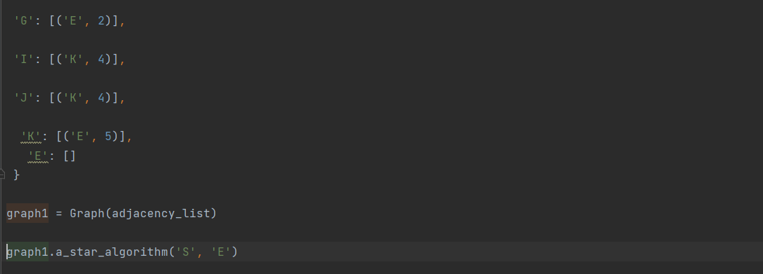

**Output:**

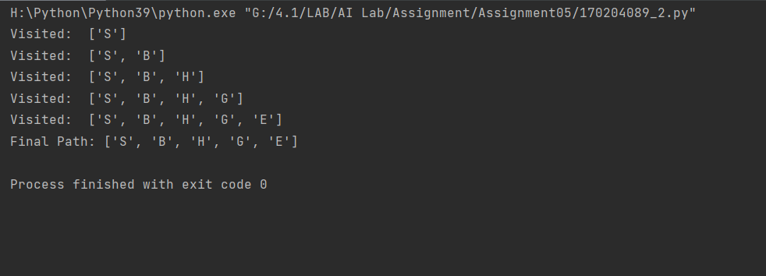

**Analyzing Code and Output:**

In greedy best first search, we used priority queue and sorted them according to the value of h(n) as f(n) = h(n). And for A* search, we took both the value of h(n) and g(n). The only difference between Greedy BFS and A* is in the evaluation function. For Greedy BFS the evaluation function is f(n) = h(n) while for A* the evaluation function is f(n) = g(n) + h(n).