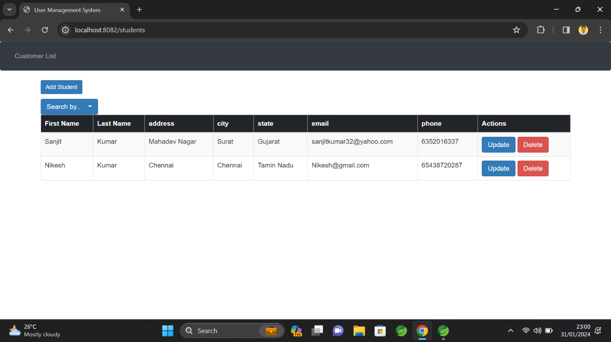

**For Authentication**

