Actual 3 tier architecture :

Front end backend DB
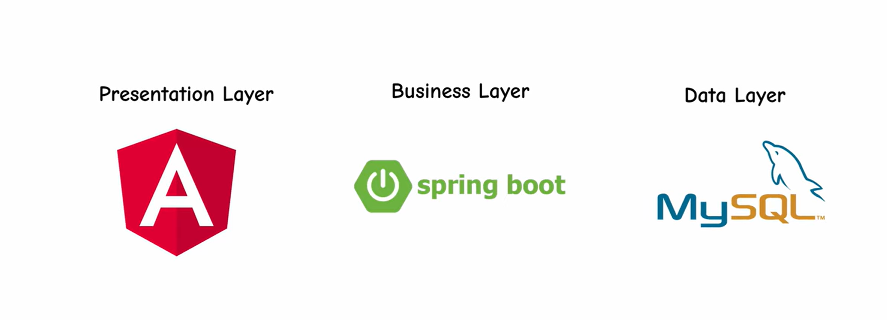
Actual flow of creation:
DB creation Backend Frontend
( DB pod should be created first, else if the backend pods starts it searches for DB pod to connect. If not there it crashes)

Needed yaml files :
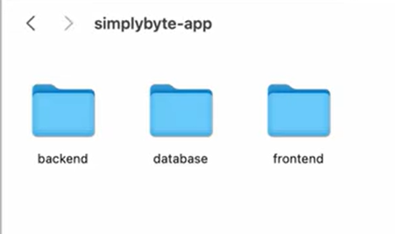
DB : headless-service.yml, secret.yml, stateful-set.yml
Backend : deployment.yml, service.yml
Frontend : config.yml, deployment.yml, service-nodeport.yml

Prerequisites:
- Docker
- Minikube — local single-node K8s cluster
- kubectl — CLI tool to talk to K8s cluster
Note : Before all, start minikube
# minikube start
It spins up a single-node K8s cluster on local machine using Docker as the driver. Then kubectl automatically connects to this cluster.
# kubectl get pods
Steps:
STEP 1 DB Creation
Starting with stateful-set.yml and secret.yml to create DB
( as DB is stateful application- that records the requests)
Note : We pass the credentials and DB_name as env variables in the stateful-set.yml , which the password is passed from secret.yml which should be written encoded shown below.
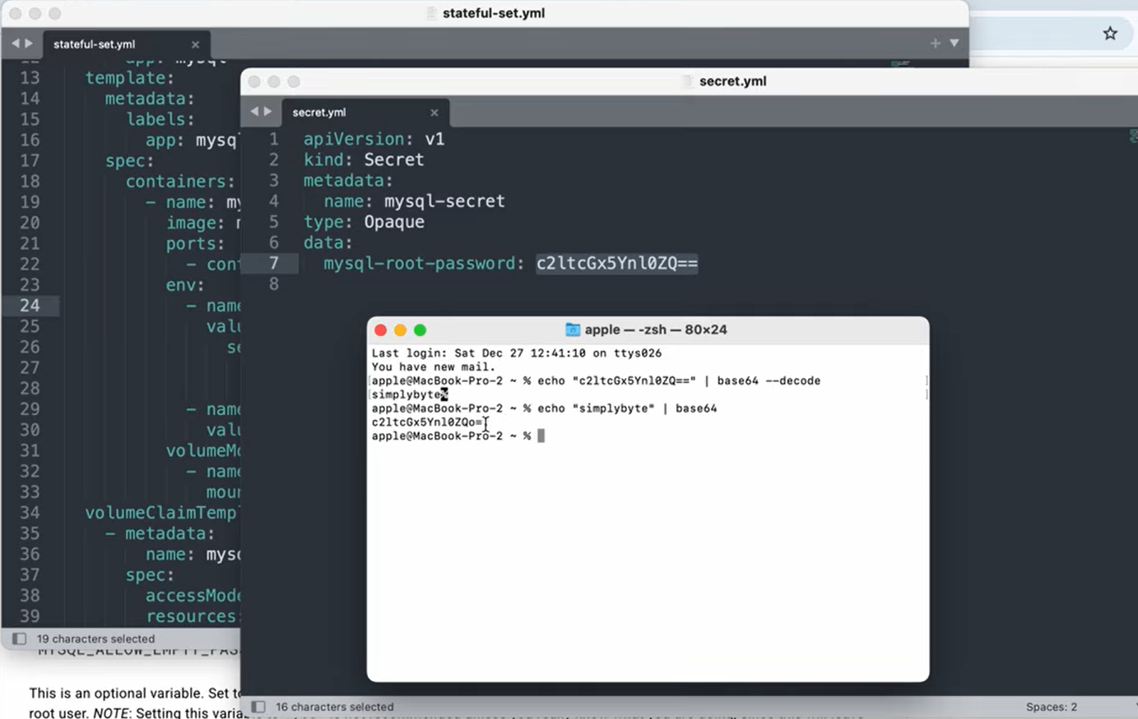

Question: 1. Why the stateful-set.yml needs DB credentials to be stored to create DB containers itself ?
DB Container starts
↓
MySQL process boots up
↓
Reads env variables from the container environment
↓
Uses MYSQL_ROOT_PASSWORD to set/verify root password
Uses MYSQL_DATABASE to create DB if not exists
↓
MySQL is ready
!! Allow your backend app to connect using those same credentials every time, so credentials in StatefulSet are more important for backend → MySQL connection than for MySQL's own startup after the first time !!
Environment variable = a value stored outside your program, that the program reads when it starts ( like while a container is launching it calls for the DB_creds which is stored as env variables outside the container )
ADV : No need of changing the dockerfile everytime the password is updated or changed. We easily configure the DB_creds outside without touching the code.
Need of headless-service.yml:
- Headless Service gives each DB pod its own DNS name so other pods can reach a specific DB pod directly and the backend can directly target to the specific DB pod.
- Normal cluster IP service randomly load balances to different pods leading to data inconsistency, it is fine if it is a stateless app.
- StatefulSet and Headless Service are designed to work together.
Feature | Who provides it
Stable pod names (mysql-0, mysql-1) | StatefulSet
Stable DNS for those pod names | Headless Service
Question : 2. The backend pods read password from where to connect to DB pod ??
The Secret file is the single source of truth for credentials — both MySQL and Backend get their values from the same place, which ensures they always match.
- Secret.yml -- start with secret file first
# kubectl apply -f secret.yml
- Before #apply secret.yml is just a file , apply stores the secret object inside cluster in etcd
- 1st Start reason : stateful-set searches for secret file to deploy. If no secret file pods will fail
- To verify :
# kubectl get secrets
- Headless-service.yml
#kubectl apply -f headless-service.yml
#kubectl get svc
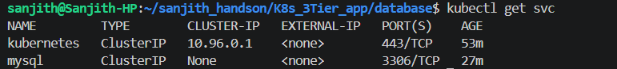
( clusterIP: None ) ensures that Don’t give me a virtual IP, just give me actual Pod IPs via DNS.

Note : After #minikube start the default Kubernetes API service
NAME TYPE CLUSTER-IP EXTERNAL-IP PORT(S) AGE
kubernetes ClusterIP 10.96.0.1 <none> 443/TCP 26m
(here the Cluster IP : none is not set, so it got a virtual IP and not POD IP)

- Statefulset.yml
#kubectl get sts
#kubectl get pods
DB POD is ready…

To acces the DB pod:
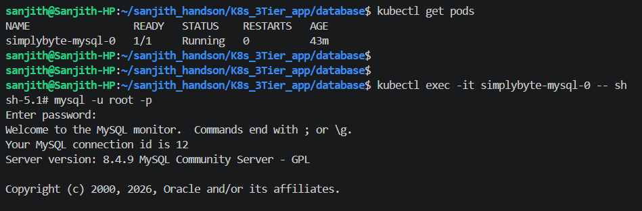
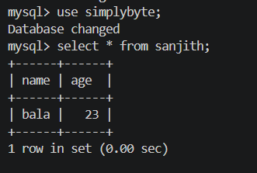

STEP 2 : Backend Creation

Deployment.yml
apiVersion: apps/v1
kind: Deployment
metadata:
name: simplybyte-backend
labels:
app: simplybyte-backend
spec:
replicas: 1
selector:
matchLabels:
app: simplybyte-backend
template:
metadata:
labels:
app: simplybyte-backend
spec:
containers:
- name: backend
image: simplybyte/simplybyte-backend:1.0 ----(pulls image from the public repo)
imagePullPolicy: Always ----(always pulls from repo)
ports:
- containerPort: 8090
env:
- name: SPRING_DATASOURCE_URL
value: "jdbc:mysql://simplybyte-mysql-0.mysql:3306/simplybyte"

( Here is where the backend finds the DB to connect )

jdbc:mysql:// simplybyte-mysql-0 . mysql : 3306 / simplybyte
───────────── ────────────────── ── ───── ── ──── ── ──────────
protocol pod name . headless port database
(Java DB URL) (StatefulSet pod name) service name

- name: SPRING_DATASOURCE_USERNAME
value: "root"
- name: SPRING_DATASOURCE_PASSWORD
valueFrom:
secretKeyRef:
name: mysql-secret
key: mysql-root-password

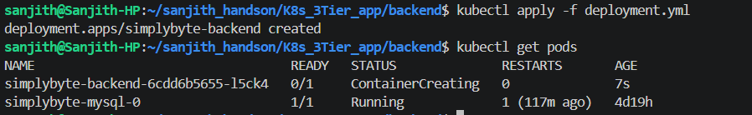
( see the exact difference of Pod_names, this shows the actual difference of creating pods using stateful-set gives proper DNS Name, whereas deployment gives random DNS Name)
Service.yml
apiVersion: v1
kind: Service
metadata:
name: simplybyte-backend
spec:
type: NodePort
selector:
app: simplybyte-backend
ports:
- port: 8090 ---> service port
targetPort: 8090 ----> container port
nodePort: 30080 -----> port to reach from outside the cluster
protocol: TCP

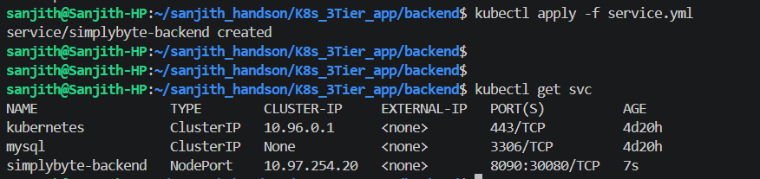

STEP 2 : Frontend Creation

- Starting with config.yml
The frontend config.yml stores the backend service URL as a plain text key-value pair. The frontend deployment injects this as an environment variable into the container — so the same Docker image can be deployed across dev, staging, and production just by changing the ConfigMap, without rebuilding the image. This is the K8s recommended pattern for managing non-sensitive configuration — sensitive values always go in Secrets, non-sensitive values go in ConfigMaps."
- Deployment.yml
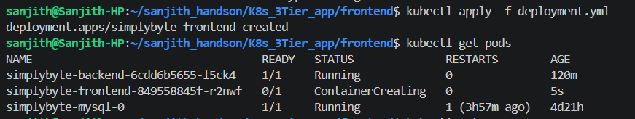

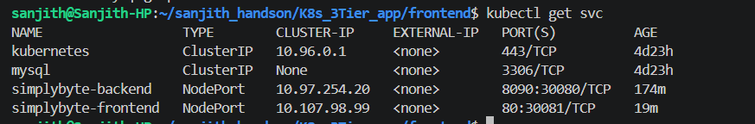

Output :
