**A Mini Project Report on**

### **IOT HOME SECURITY ALERT SYSTEM**

**Submitted to the Department of Computer Science & Engineering, GNITS in the partial fulfillment of the academic requirement for the award of B.Tech (CSE) under JNTU**

By

**B.Meghana(14251A0570)**

**Bobbala Kavya (14251A0571)**

**G.Sushrutha(14251A0575)**

**P.Sanjitha Reddy(14251A0598)**

under the guidance of

**Dr. K.Venugopala Rao**

**Professor**



**Department of Computer Science & Engineering**

**G. Narayanamma Institute of Technology & Science (for Women)**

**Accredited by NBA & NAAC &Affiliated to JNTUH**

**(ISO 9001 Certified Institution)**

**Hyderabad-500104, T.S, INDIA**

**2017**

Department of Computer Science & Engineering

**G. Narayanamma Institute of Technology & Science (for Women)**

**Accredited by NBA & NAAC &Affiliated to JNTUH**

**(ISO 9001 Certified Institution)**

**Hyderabad-500104,T.S,INDIA**

###### Certificate

This is to certify that the Mini Project report on “**IOT Home Security Alert System**” is a bonafide work carried out by **B.Meghana (14251A0570) ,Bobbala Kavya (14251A0571),G.Sushrutha(14251A0575) ,P.Sanjitha Reddy(14251A0571)** in the partial fulfillment for the award of B.Tech degree in Computer Science & Engineering, G. Narayanamma Institute of Technology & Science, Shaikpet, Hyderabad, affiliated to Jawaharlal Nehru Technological University, Hyderabad under our guidance and supervision.

The results embodied in the Mini Project have not been submitted to any other University or Institute for the award of any degree or diploma.

**Internal Guide Head of the Department**

**Dr. K.Venugopala Rao Dr.M.Seetha**

**Professor Professor and Head**

**Department of CSE**

**External Examiner**

###### Acknowledgements

We would like to express our sincere thanks to **Dr K. Ramesh Reddy, Principal** , GNITS, for providing the working facilities in the college.

Our sincere thanks and gratitude to **Dr. M.Seetha, Professor and HOD**, Dept. of CSE, GNITS for all the timely support and valuable suggestions during the period of our miniproject.

We are extremely thankful to **Mrs.D.V.Lalita Parameswari, Sr.Asst.Prof, Mrs.R.Mamatha, Asst.Prof , Mrs.M.Madhuri Latha, Asst.Prof** Dept. of CSE, GNITS, the miniproject coordinators **and Dr. N. Kalyani, , Professor,** Dept. of CSE, GNITS for their encouragement and support throughout the project.

We are extremely thankful and indebted to our internal guide, **Dr. K.Venugopala Rao, Professor ,** Dept. of CSE, GNITSforhis constant guidance, continuous advice, encouragement and moral support throughout the mini project.

Finally, we would also like to thank all the faculty and staff of CSE Department who helped us directly or indirectly, parents and friends for their cooperation in completing the mini project work.

**B.Meghana(14251A0570)**

**Bobbala Kavya (14251A0571)**

**G.Sushrutha(14251A0575)**

**P.Sanjitha Reddy(14251A0598)**

###### 

###### ABSTRACT

Safety is the most important requirement for people at any place either it may be home, office etc., With the development of technology, network and automatic control technology, an accident detection, security monitoring and alarming system becomes more and more practicable today. So that the accidents are detected at the early stages and can be handled before it causes serious damage.

In this project, a low-power consumption home security alarm system is developed by applying wireless sensor network (WSN) and global system for mobile communication (GSM) technology.

It can detect leaking of raw gas (like butane, propane), fire , motion and sends alert message remotely to the registered mobile number. The hardware of the system includes Arduino board, MQ2 (smoke and gas) sensor, Fire sensor, PIR sensor, GSM module for mobile alert message, LED lights. The hardware setup with sensors continuously reads the security issues of your house, if any mishap condition occurs it will sense and send a message to your mobile. The system is composed of the microcontroller like Arduino based wireless sensor network center node with GSM module, data collecting node, device control node and mobile phone. The wireless sensor network data collecting node module is connected with Flame sensor, MQ2 gas sensor, PIR Sensor. When the PIR finds that some people intrudes into the house or when the flame sensor detects too high indoor temperature, the data collecting node will send encoded alarm signal to the wireless sensor network center node through the wireless sensor network established in home. Once the Wireless sensor network center node receives alarm signal, it will send alarm short message to the users through the GSM module and GSM network immediately

**SYSTEM REQUIREMENTS:**

**Software Requirements:**

Platform -Windows

Development Tool -Arduino

**Hardware Requirements:**

Name of the Processor- i5 processor

Hard Disk Capacity -1 Tera Byte

RAM Capacity - 8GB

Hardware Parts -GSM Module, Arduino board, LED lights,

Bread board, Sensors, Jumper Wires.

**Contents**

**SL.No Topic PageNo**

ABSTRACT iv

1.INTRODUCTION 1

1.1 Motivation 1

1.2 Objective 2

1.3 Methodology 2

2.THEORETICAL ANALYSIS 3

2.1 Block Diagram of Security System 3

2.2 Software Used 4

2.2.1 Arduino IDE 4

2.2.2 Getting started with Arduino Software 4

2.2.3 The Integrated Development Environment (IDE) 4

2.3.3 Language used: 4

2.2.4 IDE Parts 4

2.3 Hardware Components 6

2.3.1 Arduino UNO 6

2.3.1.1 Architecture of Arduino UNO 6

2.3.1.2 Power -USB / Barrel Jack 7

2.3.1.3 Pins (5V, 3.3V, GND, Analog, Digital, PWM, AREF) 8

2.3.1.4 Features 8

2.3.2 GSM MODULE 9

2.3.3 Flame Sensor 11

2.3.4 MQ2 Gas Sensor 13

2.3.5 PIR Sensor 14

3.SYSTEM DESIGN AND ANALYSIS 17

3.1 Connections 17

3.1.1 Interfacing Arduino to Flame sensor 17

3.1.2 Interfacing MQ2 gas sensor with Arduino UNO 19

3.1.3 Interfacing PIR sensor to Arduino 21

3.1.4 Powering up the GSM Module: 22

3.2 Working 24

3.2.1 Procedure 24

3.2.2 Usecase Diagrams of the security alert system 26

4.Implementation 30

4.1 Inputs: 30

4.2 Outputs: 36

4.3 Source code: 37

5.CONCLUSION 41

6.REFERENCES 42

List of Figures:

Figure 1.1 Methodology of Home Security Alarm System

Figure 2.1 Block diagram of the project

Figure 2.2 Parts of Arduino IDE

Figure 2.3 Arduino UNO Board

Figure 2.4 Pins of GSM Module SIM900A

Figure 2.5 Flame Sensor

Figure 2.6 Flame sensor with its pin specifications

Figure 2.7 MQ2 Gas Sensor

Figure 2.8 MQ2 Gas Sensor with pin Specifications

Figure 2.9 PIR Sensor

Figure 2.10 Internal Working of PIR Sensor

Figure 3.1 Interfacing Flame sensor with Arduino

Figure 3.2 Working Mechanism of MQ2 sensor

Figure 3.3 Interfacing MQ2 sensor with Arduino

**Figure 3.4 Interfacing PIR sensor with Arduino**

Figure 3.5 Interfacing GSM Module with Arduino

Figure 3.6 Working Methodology

Figure 3.7 Connections of all sensors with Arduino

Figure 3.8 Use case Diagram of Home Security system

Figure 3.9 Use case Diagram of working

Figure 3.10 Sequence diagram of working

1.INTRODUCTION

Fire causes huge loss of lives and properties every year in Bangladesh. Analyzing past fire incidents, facts are revealed. Some of the main causes are insufficient fire defense materials, electric short circuit from faulty electrical wiring, presence of inflammable materials, violation of fire safety and lack of adequate awareness etc. Some factories and recent buildings have proper installation and fire safety arrangements such as fire alarm, fire extinguishers, water supply system etc. But the argument is these conventional fire extinguishing systems are not enough to take prompt action during fire and save life. Traditional manual system does not ensure 24/7 monitoring from fire protection. Moreover, existing fire protection system could spread panic inside the whole building since it does not announce the location of fire or intensity. It only raises alarm whenever fire is detected at any place. Frightened people could starts to run away haphazardly. As a result buildings full of workers in the factories women, children could be smashed by the outgoing pressure of the frightened crowd and injured severely.

On the contrary, Sometimes people does not realize the intensity of the fire and not willing to evacuate fire affected building quickly. It could lead a devastating result. In this project an alert system is presented that can minimize these hazard. Along with fire alarm this system able to detect severity. To prevent fire from spreading: some efforts are extremely important. Such as: breaking electric circuits of the affected area, releases fire extinguishing gas on the hazard spot, calling fire service, inform promptly building monitoring committee by text messages or telephone calls. Fire Alerts with GSM Module takes prompt attempt to accomplish these tasks.

SMS based Fire detection system using Smoke sensor has application in many areas like Industries, Companies, Offices, Shopping malls and even at our home. This project has a Smoke sensor to detect the fire. Fire detection system sends SMS to user when anyone these sensor crosses threshold value.

* 1. Motivation

Today, with advancement in science and technology, home automation has become oneof the fastest developing application-based technologies in the world. The idea of comfortable living in home has since changed for the past decade as digital, vision and wireless technologies are integrated into it. Intelligent homes, in simple terms, can be described as homes that are fully automated in terms of carrying out a predetermined task, providing feedback to the users, and responding accordingly to situations. In other words, it simply allows many aspects of the home system such as temperature and lighting control, network and communications, entertainment system, emergency response and security monitoring systems to be automated and controlled, both near and at a distance. Automated security systems play an important role of providing an extra layer of security through user authentication to prevent break-ins at entry points and also to track illegal intrusions or unsolicited activities within the vicinity of the home (indoors and outdoors).There has been much research done in the design of various types of automated security systems. Sensor-based systems that rely on contact or movement sensors or contact-based systems such as fingerprint and palm print scan or keypad activation that require substantial amount of contact with an input device.

Many security systems are based on only a single system. In an event of system failure or intrusion of the user authentication, there is no backup system to monitor the home continually. This shortcoming can be dealt with using multiple security systems (or multi-layered security systems). However, multi-system implementations will definitely be more demanding in terms of computational cost and organization.

* 1. Objective

Home security has been a major issue where crime is increasing and everybody wants to take proper measures to prevent intrusion. In addition, there is need to automate home such that the user can take the advantage of technological advancement. This project presents a model that will provide security to their home, office or cabin etc., via SMS using GSM technology. Keeping in view the rapid growth of wireless communication we are inspired to work on this project. The idea behind this project is to meet the upcoming challenges of the modern practical applications of wireless communication and control system. The applications of SMS/GSM Based security system are quite diverse. There are many real life situations that require control of different devices remotely and to provide security. There will be instances where a wired connection between a remote appliance/device and the control unit might not be feasible due to structural problems. In such cases a wireless connection is a better option. Basic Idea of our project is to provide GSM Based security even if the owner is away from the restricted areas. For this we adopted wireless mode of transmission using GSM. Besides this there are many methods of wireless communication but we selected GSM in our project because as compared to other techniques, this is an efficient and cheap solution also, we are much familiar with GSM technology and it is easily available.

* 1. Methodology

The hardware setup with sensors continuously reads the security issues of your house, if any mishap condition occurs it will sense and send a message to your mobile. The system is composed of the microcontroller like Arduino based wireless sensor network center node with GSM module, data collecting node, device control node and mobile phone. The wireless sensor network data collecting node module is connected with Flame sensor, MQ2 gas sensor, PIR Sensor. When the PIR finds that some people intrudes into the house or when the flame sensor detects too high indoor temperature, the data collecting node will send encoded alarm signal to the wireless sensor network center node through the wireless sensor network established in home. Once the Wireless sensor network center node receives alarm signal, it will send alarm short message to the users through the GSM module and GSM network immediately.

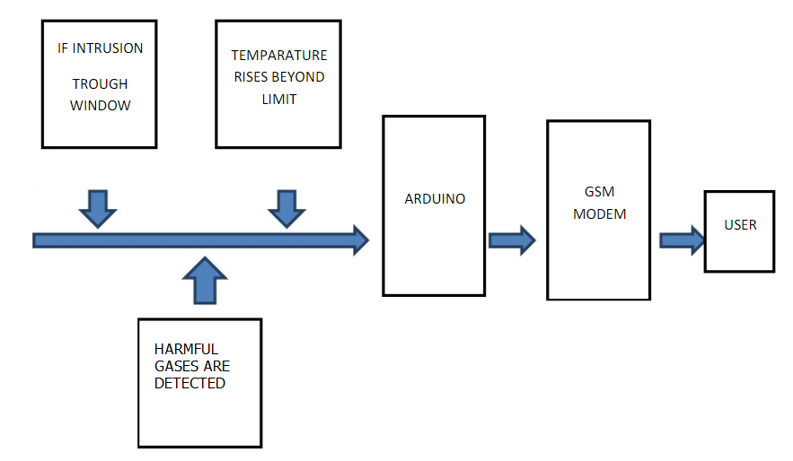

Methodology of Home Security Alarm System

2.THEORETICAL ANALYSIS

2.1 Block Diagram of Security System

The structure of the system has been shown in Figure 2.1

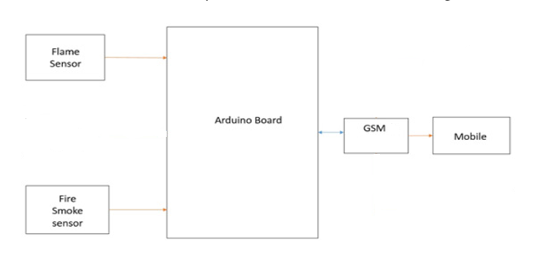

PIR

sensor

Figure Error! No text of specified style in document..2.1 Block diagram of the project

2.2 Software Used

2.2.1 Arduino IDE

Arduino is an open-source electronics prototyping platform based on flexible, easy-to-use hardware and software. Arduino is common term for a software company, project, and user community that designs and manufactures computer open-source hardware, open-source software, and microcontroller-based kits for building digital devices and interactive objects that can sense and control physical devices. Finally Arduino provides a standard form factor that breaks out the functions of the micro-controller into a more accessible Package. The Arduino software is free, the hardware boards are pretty cheap, and both the Software and hardware are easy to learn has led to a large community of users.

2.2.2 Getting started with Arduino Software

First download and install the Arduino for Mac, Linux or Windows from arduino.cc. Windows users also need to install a driver. Connect your board via USB, launch the Arduino application and select Arduino-Uno from the tools to board menu. Open the sketch File.

2.2.3 The Integrated Development **Environment** (IDE)

Every microcontroller needs software to be programmed. The Arduino board is not a case apart. It has its own integrated development environment (IDE).It is free and everyone can download it from its official website using either the Windows, Mac OS X or Linux platform. That allows Arduino Board to gain more users and it also helps it to grow.

2.3.3 Language used:

The major reason for using C in this project is the ease and the control, the language gives control over the system and interface to input and output modules. C is best suitable for system level programming for example a medium-level programming language to handle memory, I/O and peripheral devices. Android is used for user interface part in smart phones or tablets

2.2.4 IDE Parts

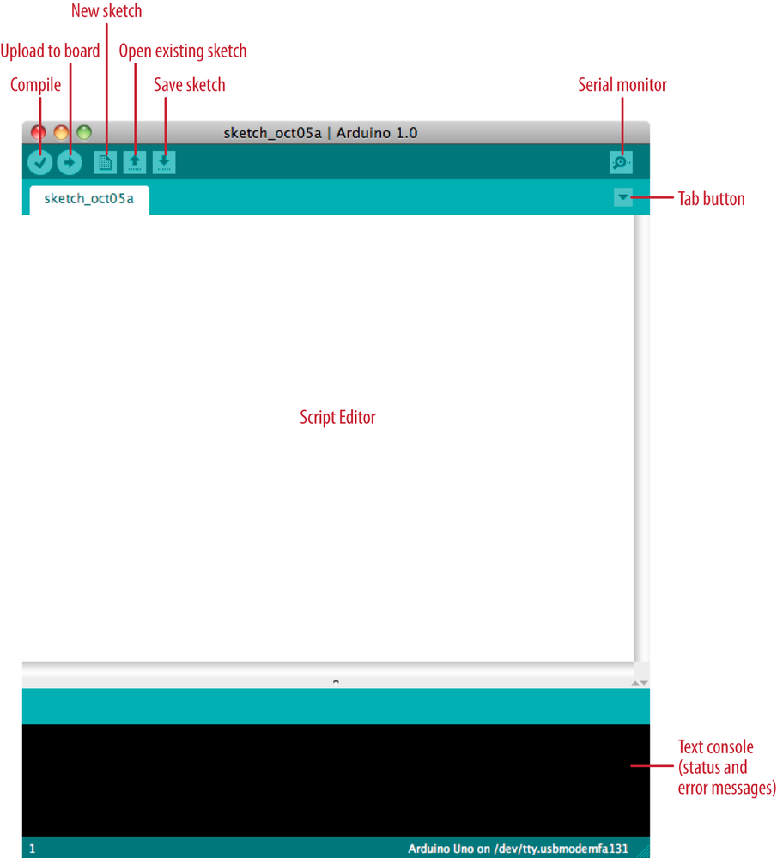

Parts of Arduino IDE

* **Compile**: Before program “code” can be sent to the board, it needs to be converted into instructions that the board understands. This process is called Compiling.
* **Stop**: This stops the compilation process.
* **Create new Sketch**: This opens a new window to create news ketch.
* **Open Existing Sketch**: This loads a sketch from a file on our computer.
* **Save Sketch**: This saves the changes to the sketch.
* **Upload to** Board: This compiles and then transmits over the USB cable to our board.
* **Serial Monitor**: Until this point when our programs (sketches) didn’t work, we just pulled out our hair and tried harder.
* **Tab Button**: This lets you create multiple files in your sketch. This is for more advanced programming than we will do in this class.
* **Sketch Editor**: This is where write or edit sketches
* **Text Console**: This shows you what the IDE is currently doing and is also where error messages display if make a mistake in typing program.
* **Line Number**: This shows what line number your cursor is on.

2.3 Hardware Components

**Components Required:**

1)Arduino Uno

2)Flame Sensor

3)MQ2 Smoke sensor

4)PIR Sensor

4)GSM Module

This project include Arduino Uno broad, GSM module, Flame sensor and MQ2 gas sensors. We connect the GSM module to an Arduino and the connections are done by using upper equipments

2.3.1 Arduino UNO

**2.3.1.1 Architecture of Arduino UNO**

Arduino is an open supply electronic device prototyping platform, dependent on variable electronics as well as applications. This Arduino is usually an easy yet advanced unit which is founded on At-mel’s ATmega microcontrollers. The Arduino board software program is usually backed by Windows family of Microsoft, OSX family of Macintosh and also various Linux systems like Red Hat, Kali etc, though almost all microcontrollers are restricted to Microsoft windows computer. Language programming depends on the high level programming language C and AVR can be appended through C ++ library sets. There exists a few types of microcontroller Arduino board12 you can find, such as Arduino sets and Arduino guards. Arduino One will be one of the boards made with a microcontroller ATmega328 the Atmel microcontroller, “UNO” in Italian. One board will be the last with a progression of USB, which is the Arduino board to be your own reference model on the Arduino stage. The Arduino Uno has the resonator 16 MHz ceramic, a USB association, power connector, a huge ICSP header and the reset catch, 6 analog inputs and 14-pin digital input/output (of which six to eight can be utilized as PWM output).

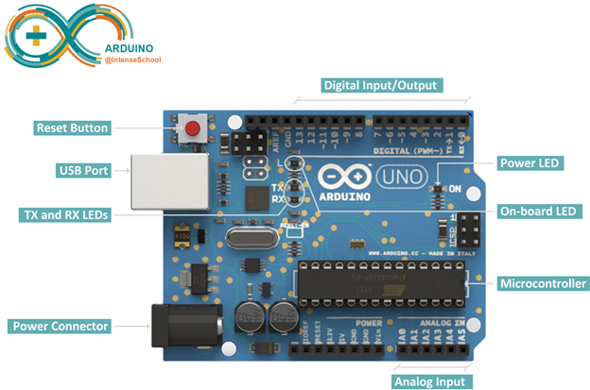

**Figure 2.3 Arduino UNO Board**

**2.3.1.2 Power -USB / Barrel Jack**

Our Arduino board needs a way to be connected to a power source. The Arduino UNO can be powered from a USB cable coming from your computer or a wall power supply that is terminated in a barrel jack. In the picture above the USB connection is labeled and the barrel jack is labeled .The USB connection is also how you will load code onto your Arduino board.

**Memory:** The Arduino has 32 KB (with 0.5 KB used for the boot loader). It also has 2 KB of SRAM and 1 KB of EEPROM.

**Input and Output:** Each of the 14 digital pins on the Uno can be used as an input or output, using pin mode,digital write, digital read functions. They operate at 5 volts. Each pin can provide or receive a maximum of 40 mA and has an internal pull-up resistor (disconnected bydefault) of 20-50 kOhms. In addition, some pins have specialized functions:

* **Serial: 0 (RX) and 1 (TX):**Used to receive (RX) and transmit (TX) TTL serial data. These pins are connected to the corresponding pins of the ATmega8U2USB-to-TTL Serial chip.
* **External Interrupts: 2 and 3:**These pins can be conFigured to trigger an interrupt on a low value, a rising or falling edge, or a change in value.
* **PWM: 3, 5, 6, 9, 10, and 11:**Provide 8-bit PWM output with the analog write function.
* **LED: 13:**There is a built-in LED connected to digital pin 13. When the pin is HIGH value, the LED is on, when the pin is LOW, it’s off.

The Uno has 6 analog inputs, labeled A0 through A5, each of which provide 10 bits of resolution (i.e. 1024 different values). By default they measure from ground to 5 volts, though is it possible to change the upper end of their range using the AREF pin and the analog reference function. There are couple of other pins on the board:

* **AREF:**Reference voltage for the analog inputs. Used with analog reference.
* **Reset:**Bring this line LOW to reset the microcontroller. Typically used to add areset button to shields which block the one on the board

**2.3.1.3 Pins (5V, 3.3V, GND, Analog, Digital, PWM, AREF)**

The pins of Arduino are the places where connect wires to construct a circuit. The Arduino has several different kinds of pins, each of which is labeled on the board and used for different functions.

* **5V**: The 5V pin supplies 5 volts of power. Most of the simple components used • Arduino run happily off of 5 or 3.3 volts.
* **GND**: Full name is Ground. There are several GND pins on the Arduino, any of which can be used to ground circuit.
* **Analog**: The area of pins under the ‘Analog In’ label (A0 through A5 on the UNO) is Analog In pins. These pins can read the signal from an analog sensor and convert it into a digital value that we can read.
* **Digital**: Across from the analog pins are the digital pins (0 through 13 on the UNO). These pins can be used for both digital input and digital output (like powering an LED).
* **PWM**: The digital pins (3, 5, 6, 9, 10, and 11) on the UNO are the PWM(~) pins. These pins act as normal digital pins, but can also be used for something called Pulse-Width Modulation (PWM).
* **AREF**: Stands for Analog Reference. It is sometimes used to set an external reference voltage (between 0 and 5 Volts) as the upper limit for the analog input pins.

2.3.1.4 Features

* Microcontroller: ATmega328
* Operating Voltage: 5V
* Input Voltage (recommended): 7-12V
* Input Voltage (limits): 6-20V
* Digital I/O Pins: 14 (of which 6 provide PWM output)
* Analog Input Pins: 6
* DC Current per I/O Pin: 40 mA
* DC Current for 3.3V Pin: 50 mA
* Flash Memory: 32 KB of which 0.5 KB used by bootloader
* SRAM: 2 KB (ATmega328)
* EEPROM: 1 KB (ATmega328)
* Clock Speed: 16 MHz

2.3.2 GSM MODULE

GSM means Global System for Mobile Communications. This subscription and mobile equipment are by and large isolated in the GSM, as opposed to in simple systems that point two or three being discharged. This record administration alongside keeping up another endorser smartcard might be SIM (Subscriber Identity Module) card, in spite of the fact that the air-called cellular equipment. In this manner, the mix of the SIM and cellular equipment is the mobile station. SMS is one of the inbuilt services of GSM, which gives a method for transmitting messages of restricted size and from the mobile stations. Dealing with the SMS is performed by the SMSC which is the task to be looked after by the employed GSM network for exchanging messages between the SMSC and the mobile stations.

Global system for mobile communication (GSM) is a globally accepted standard for digital cellular communication. GSM is the name of a standardization group established in 1982 to create a common European mobile telephone standard that would formulate specifications for a pan-European mobile cellular radio system operating at 900 MHz. A GSM modem is a wireless modem that works with a GSM wireless network. A wireless modem behaves like a dial-up modem. The main difference between them is that a dial-up modem sends and receives data through a fixed telephone line while a wireless modem sends and receives data through radio waves.

**Definition:**

GSM (Global System for Mobile communications) is an open, digital cellular technology used for transmitting mobile voice and data services. GSM differs from first generation wireless systems in that it uses digital technology and time division multiple access transmission methods. GSM is a circuit-switched system that divides each 200kHz channel into eight 25kHz time-slots. GSM operates in the 900MHz and 1.8GHz bands in Europe and the 1.9GHz and 850MHz bands in the US. The 850MHz band is also used for GSM and 3GSM in Australia, Canada and many South American countries. GSM supports data transfer speeds 9.6 kbit/s, allowing the transmission of basic data services such as SMS (Short Message Service). GSM satellite roaming has also extended service access to areas where terrestrial coverage is not available. The transmission power in the handset is limited to a maximum of 2 watts in GSM850/900 and 1 watt in GSM1800/1900.

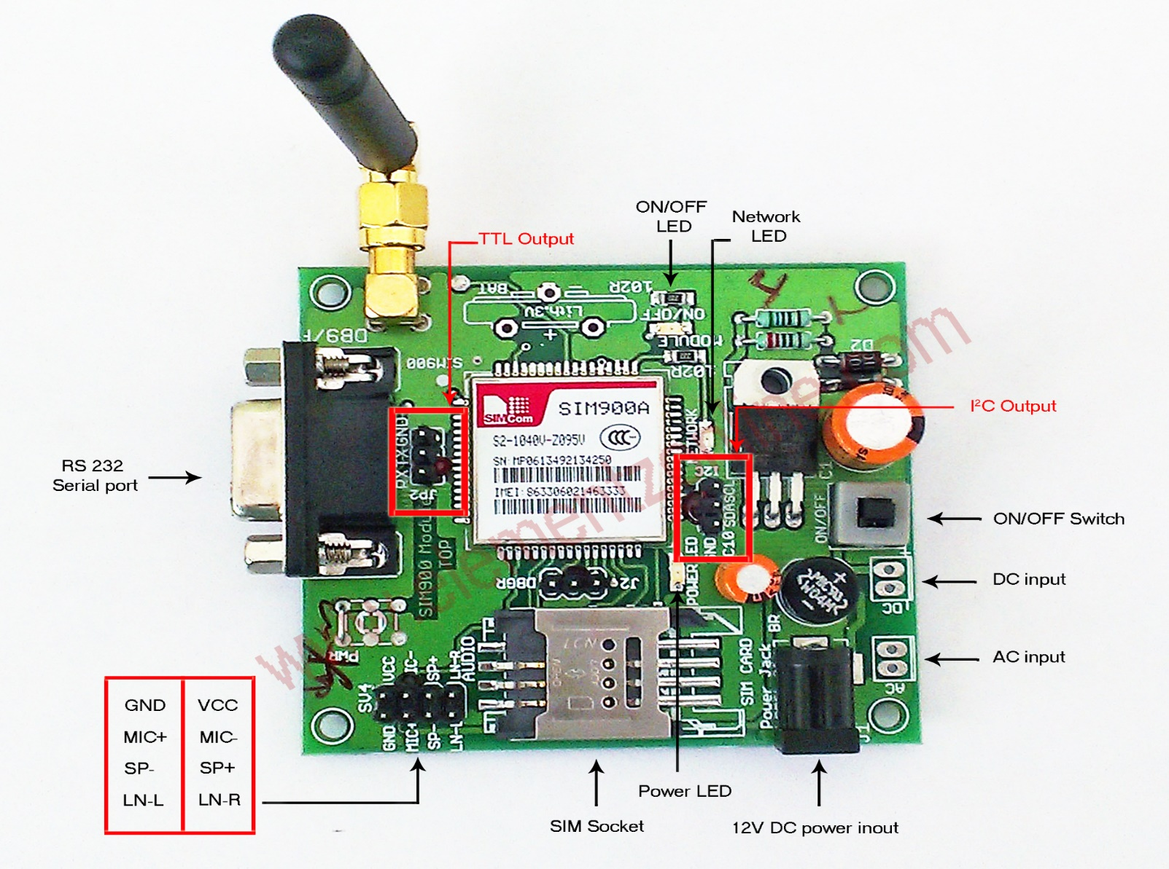

**Figure 2.4 Pins of GSM Module SIM900A**

It can communicate with controllers via AT commands (GSM 07.07, 07.05 and SIMCOM enhanced AT Commands). AT is the abbreviation for Attention. This module supports software power on and reset.A fixed number is used in system to apply different operations like Messaging and calling

For sending message, a GSM Module named SIMCOM900a is used.

Some useful AT Commands to program GSM

* **AT** - This command is used to check communication between the module and the computer.
* **AT +CMGF** - This command is used to set the SMS mode. Either text or PDU mode can be selected by assigning 1 or 0 in the command.
* **AT +CMGW** - This command is used to store message in the SIM.
* **AT+CMGS** - This command is used to send a SMS message to a phone number.
* **ATD** - This command is used to dial or call a number.
* **ATA** - This command is used to answer a call. An incoming call is indicated by a message “RING‟ which is repeated for every ring of the call. When the call ends “NO CARRIER” is displayed on the screen.
* **ATH** - This command is used to disconnect remote user link with the GSM module

**Gsm Characteristics**:

* TDMA over radio carriers (200 KHz carrier spacing).
* 8 full rate or 16 half rate TDMA channels per carrier.
* User or terminal authentication for fraud control.
* Encryption of speech and data transmission over the radio path.
* Low speed data services (up to 9.6 Kb/s).
* Support of short message service (SMS).

**Features:**

* Support wide range of frequencies (from 850 MHZ to 1900 MHZ) for differentclassification of GSM
* Supports integration with RS232 cable (serial cable,25 pins).
* Can be interfaced to system using USB cables.
* Input voltage varies from 5v to 30v.
* Very less weight in few grams.
* Provided with SIM holder and antenna connector.
* Programmable with AT commands.

**Advantages Of Gsm**:

* Capacity increases.
* Reduced RF transmission power and longer battery life.
* International roaming capability.
* Better security against fraud.
* Encryption capability for information security and privacy.
* Compatibility with ISDN, leading to wider range of services

2.3.3 Flame Sensor

This module is sensitive to the flame and radiation. It also can detect ordinary light source in the range of of a wavelength 760nm-1100 nm. The detection distance is up to 100 cm. The Flame sensor can output digital or analog signal. It can be used as a flame alarm or in fire fighting robots.

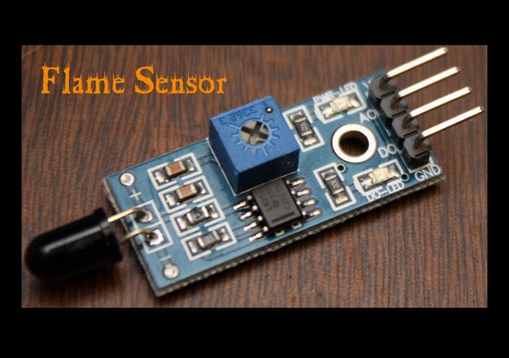

**Figure 2.5 Flame Sensor**

**Specifications:**

* Detects a flame or a light source of a wavelength in the range of 760nm-1100 nm
* Detection distance: 20cm (4.8V) ~ 100cm (1V)
* Detection angle about 60 degrees, it is sensitive to the flame spectrum.
* Comparator chip LM393 makes module readings stable.
* Adjustable detection range.
* Operating voltage 3.3V-5V
* Digital and Analog Output DO digital switch outputs (0 and 1) AO analog voltage output
* Power indicator and digital switch output indicator

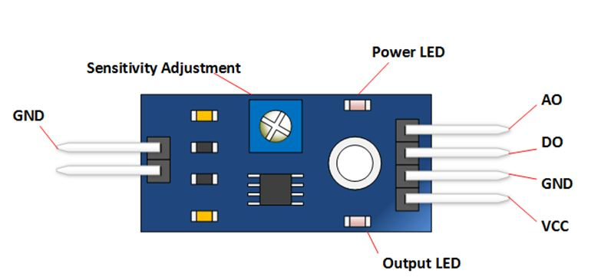

**Figure 2.6 Flame sensor with its pin specifications**

**Interface Description (4-wire)**

1) VCC -- 3.3V-5V voltage

2) GND -- GND

3) DO -- board digital output interface (0 and 1)

4) AO -- board analog output interface

2.3.4 MQ2 Gas Sensor

A smoke detector is a device that senses smoke, typically as an indicator of fire. Commercial security devices issue a signal to a fire alarm control panel as part of a fire alarm system, while household detectors, known as smoke alarms, generally issue a local audible or visual alarm from the detector itself. Smoke detectors are housed in plastic enclosures, typically shaped like a disk about 150 millimeters (6 in) in diameter and 25 millimeters (1 in) thick, but shape and size varies.

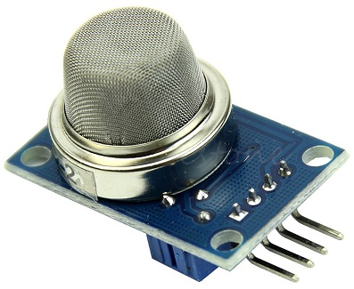

**Figure 2.7 MQ2 Gas Sensor**

Smoke can be detected either optically (photoelectric) or by physical process (ionization), detectors may use either, or both, methods. Sensitive alarms can be used to detect, and thus deter, smoking in areas where it is banned. Smoke detectors in large commercial, industrial, and residential buildings are usually powered by a central fire alarm system, which is powered by the building power with a battery backup. Domestic smoke detectors range from individual battery powered units, to several interlinked mains-powered units with battery backup; if any unit detects smoke, all trigger even in the absence of electricity

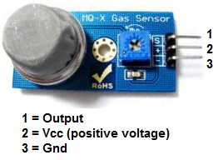

**Figure 2.8 MQ2 Gas Sensor with pin Specifications**

Sensitive material of MQ-2 gas sensor is SnO2, which with lower conductivity in clean air. When the target combustible gas exist, The sensor’s conductivity is more higher along with the gas concentration rising. Please use simple electro circuit, Convert change of conductivity to correspond output signal of gas concentration. MQ-2 gas sensor has high sensitivity to LPG, Propane and Hydrogen, also could be used to Methane and other combustible steam, it is with low cost and suitable for different application. **Character Configuration**

* Good sensitivity to Combustible gas in wide range
* High sensitivity to LPG, Propane and Hydrogen
* Long life and low cost
* Simple drive circuit

**Application**

* Domestic gas leakage detector
* Industrial Combustible gas detector
* Portable gas detector
* They are used in gas leakage detecting equipments in family and industry, and are suitable for detecting of LPG, i-butane, propane, methane ,alcohol, Hydrogen, smoke,etc

2.3.5 PIR Sensor

PIR sensors are more complicated than many of the other sensors explained in these tutorials (like photocells, FSRs and tilt switches) because there are multiple variables that affect the sensors input and output.

PIR sensors allow you to sense motion, almost always used to detect whether a human has moved in or out of the sensors range. They are small, inexpensive, low-power, easy to use and don't wear out. For that reason they are commonly found in appliances and gadgets used in homes or businesses. They are often referred to as PIR, "Passive Infrared", "Pyroelectric", or "IR motion" sensors.  
PIRs are basically made of a [pyroelectric sensor](http://en.wikipedia.org/wiki/Pyroelectric) (which you can see above as the round metal can with a rectangular crystal in the center), which can detect levels of infrared radiation. Everything emits some low level radiation, and the hotter something is, the more radiation is emitted. The sensor in a motion detector is actually split in two halves. The reason for that is that we are looking to detect motion (change) not average IR levels. The two halves are wired up so that they cancel each other out. If one half sees more or less IR radiation than the other, the output will swing high or low.  
Along with the pyroelectric sensor is a bunch of supporting circuitry, resistors and capacitors. It seems that most small hobbyist sensors use the [BISS0001 ("Micro Power PIR Motion Detector IC")](http://www.ladyada.net/media/sensors/BISS0001.pdf), undoubtedly a very inexpensive chip. This chip takes the output of the sensor and does some minor processing on it to emit a digital output pulse from the analog sensor.

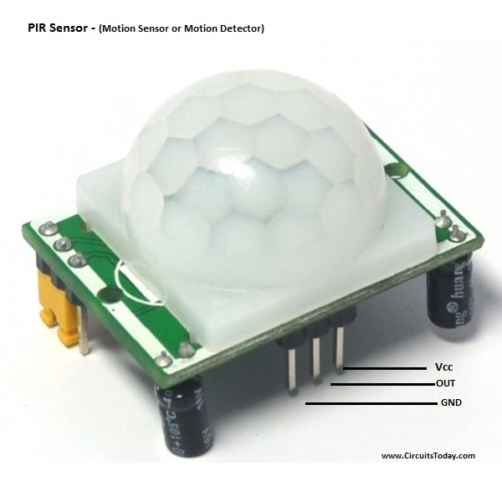

**Figure 2.9 PIR Sensor**

The PIR sensor itself has two slots in it, each slot is made of a special material that is sensitive to IR. The lens used here is not really doing much and so we see that the two slots can 'see' out past some distance (basically the sensitivity of the sensor). When the sensor is idle, both slots detect the same amount of IR, the ambient amount radiated from the room or walls or outdoors. When a warm body like a human or animal passes by, it first intercepts one half of the PIR sensor, which causes a positive differential change between the two halves. When the warm body leaves the sensing area, the reverse happens, whereby the sensor generates a negative differential change. These change pulses are what is detected.

[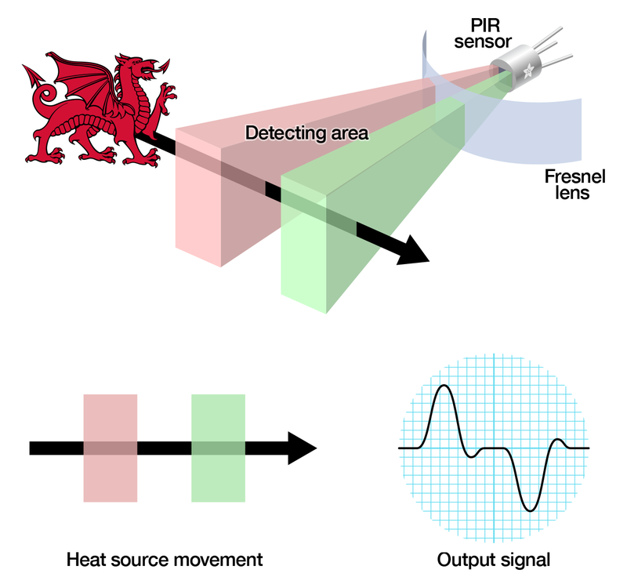](https://learn.adafruit.com/assets/35647)

**Figure 2.10 Internal Working of PIR Sensor**

The IR sensor itself is housed in a hermetically sealed metal can to improve noise/temperature/humidity immunity. There is a window made of IR-transmissive material (typically coated silicon since that is very easy to come by) that protects the sensing element. Behind the window are the two balanced sensors.

**Features**

* Complete with PIR, Motion Detection.
* Dual Element Sensor with Low Noise and High Sensitivity.
* Supply Voltage – 5V.
* Delay Time Adjustable.
* Standard TTL Output.

**Areas of Applications of PIR Sensors**

* PIR sensors possess a no of applications and due to their low cost and much advanced features they are the main focus of different projects being made now a days. Some of their features and practical applications are listed below as:
* They are able to sense the detection of people and other objects.
* PIR sensors are also used in automatic lightening systems. In these type of systems, when a person comes in the vicinity of the sensor then, the lights are automatically turned ON.
* They are used in outdoor lightening systems and also in some lift lobbies. You may have observed that when a person comes in front of the lift and if the doors are being closed then, the doors are opened again. This is all due to PIR sensors.
* They are widely used in underground car parking system. At every parking position a PIR sensor is installed and when that position is vacant then, a green light glows over that place which means you can park here. And if that position has been occupied then, a red light will glow, representing that this position is already occupied.
* PIR sensor is much compatible sensor and it has the ability to detect a particular motion and the output of this system is very sensitive and doesn’t have any kind of noise in it.
* All outdoor Lights
* Lift Lobby
* Multi Apartment Complexes
* Common staircases
* For Basement or Covered Parking Area
* Shopping Malls
* For garden lights

**3.SYSTEM DESIGN AND ANALYSIS**

3.1 Connections

3.1.1 Interfacing Arduino to Flame sensor

**Materials needed:**

* Flame Sensor (model with an analog out)
* Male to Female jumper wires
* An Arduino UNO.
* Bread board.
* Led lights.
* Lighter or another flame source for testing*.*

**Usage:**  
These types of sensors are used for short range fire detection and can be used to monitor projects or as a safety precaution to cut devices off / on.

**Range:**

This unit is mostly accurate up to about 3 feet.

**How it works:**

The flame sensor is very sensitive to IR wavelength at 760 nm ~ 1100 nm light.

**Analog output (A0**): Real-time output voltage signal on the thermal resistance.

**Digital output (D0)**: When the temperature reaches a certain threshold, the output high and low signal threshold adjustable via potentiometer.

**Pins:**

VCC...... Positive voltage input: 5v for analog 3.3v for Digital.

A0.......... Analog output

D0......... Digital output

GND..... Ground

**Testing:**  
To test the Flame Sensor and ensure that it is working correctly connect the VCC to a 5v power source and GND. Move a flame source within a foot of the front of the flame sensor and the D0-LED should light up. To wire the Flame Sensor to the Arduino simply connect the following as shown:

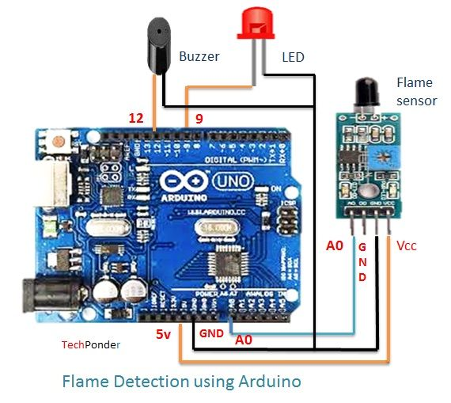

**Figure 3.1 Interfacing Flame sensor with Arduino**

**Arduino code execution:**

The following code maps and reads the analog values given by the flame sensor (0-1024). The stock flame sensor will have the following reaction with this code:

* If holding a flame within 1.5 feet in front of the sensor; "case 0" will be activated and " ** **Close Fire** ** " will be sent to the serial monitor.
* If holding a flame between 1.5 feet and 3 feet in front of the sensor; "case 1" will be activated and " \*\***Distant Fire**\*\*" will be sent to the serial monitor.
* If no flame is detected in front of the sensor; "case 2" will be activated and " **No Fire** " will be sent to the serial monitor.
* To view the output, point a serial monitor at your Arduino.

3.1.2 Interfacing MQ2 gas sensor with Arduino UNO

The MQ series of gas sensors use a small heater inside with an electro-chemical sensor. They are sensitive for a range of gasses and are used indoors at room temperature. The output is an analog signal and can be read with an analog input of the Arduino.

The MQ-2 Gas Sensor module is useful for gas leakage detecting in home and industry. It can detect LPG, i-butane, propane, methane, alcohol, hydrogen and smoke.

Some modules have a built-in variable resistor to adjust the sensitivity of the sensor.The MQ-2 smoke sensor is sensitive to smoke and to the following flammable gases:

* LPG
* Butane
* Propane
* Methane
* Alcohol
* Hydrogen

The resistance of the sensor is different depending on the type of the gas.The smoke sensor has a built-in potentiometer that allows you to adjust the sensor sensitivity according to how accurate you want to detect gas.

**How does it Work?**

The voltage that the sensor outputs changes accordingly to the smoke/gas level that exists in the atmosphere. The sensor outputs a voltage that is proportional to the concentration of smoke/gas.

In other words, the relationship between voltage and gas concentration is the following:

* **The greater** the gas concentration, **the greater** the output voltage
* **The lower** the gas concentration, **the lower** the output voltage

[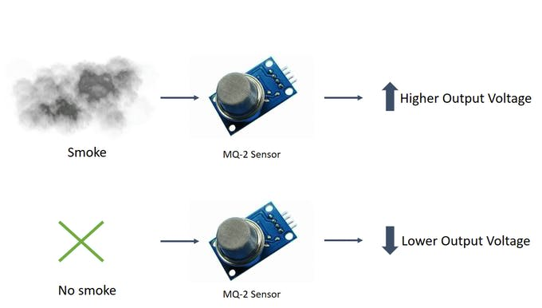](javascript:openLightBox('R1Gj',%200);)

**Figure 3.2 Working Mechanism of MQ2 sensor**

The output can be an analog signal (A0) that can be read with an analog input of the Arduino or a digital output (D0) that can be read with a digital input of the Arduino.

**Materials required:**

* Arduino UNO
* Breadboard
* MQ-2 Gas sensor module

**Pin Wiring**

The MQ-2 sensor has 4 pins.

Pin-------------------------------------Wiring to Arduino Uno

A0-------------------------------------Analog pins

D0-------------------------------------Digital pins

GND-----------------------------------GND

VCC------------------------------------5V

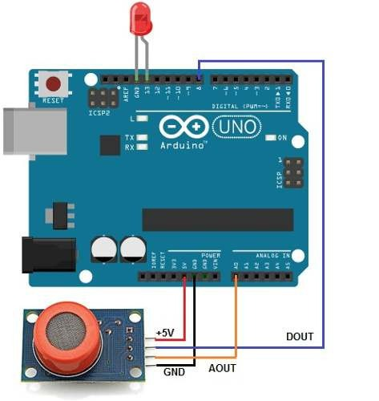

**Figure 3.3 Interfacing MQ2 sensor with Arduino**

**Execution:**

After dumping the code in Arduino IDE ,when there is smoke or any harmful gases surrounding the hardware setup ,then the MQ2 gas sensor detects it and adjusts its voltage through the potentiometer and sends the signal to the Arduino .This can be seen in the serial monitor of the Arduino IDE.

3.1.3 Interfacing PIR sensor to Arduino

The modern studies in the field of quantum physics tells us the fact each and every object when it is placed at a temperature above absolute zero, emits some energy in the form of heat and this heat energy is in fact the form of infrared radiations.  The name of PIR sensor is Passive Infrared Sensor, Passive elements are those elements that don’t generate their own voltages or energy. They just only measures things. So this sensor is a passive infrared sensor and it doesn’t generate anything by itself. It is only capable to measure the radiations emitted by other objects around it. It measures those radiations and do some desired calculations on them.

**Interfacing PIR sensor with Arduino UNO:**

PIR sensor have total 3 pins. The configuration of each pin is shown in the image given below:

1. Pin1 is of supply pin and it is used to connect +5 DC voltages.
2. Pin2 is of output pin and this pin is used to collect the output signal which is collected by PIR sensor.
3. Pin3 is marked as GND pin. This pin is used to provide ground to internal circuit of PIR sensor.

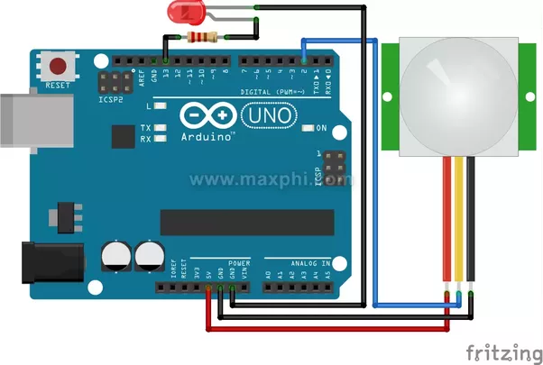

**Figure 3.4 Interfacing PIR sensor with Arduino**

****3.1.4 Powering up the GSM Module:****

**1.  Use SIM900 GSM Module** – This means the module supports communication in 900MHz band. We are from India and most of the mobile network providers in this country operate in the 900Mhz band. If you are from another country, you have to check the mobile network band in your area. A majority of United States mobile networks operate in 850Mhz band (the band is either 850Mhz or 1900Mhz). Canada operates primarily on 1900 Mhz band.

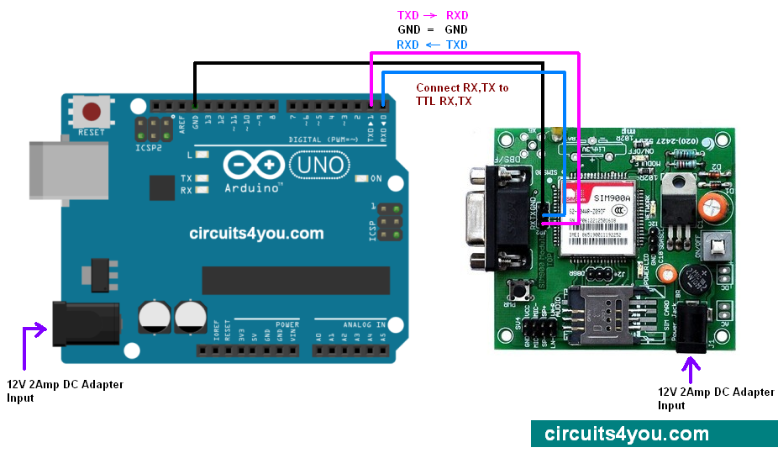

**Figure 3.5 Interfacing GSM Module with Arduino**

**2. Check the power requirements of GSM module**– GSM modules are manufactured by different companies. They all have different input power supply specs.GSM module requires a 12 volts input. Supply power to GSM module using a 12V,1A DC power supply

**Booting the GSM module:**

1. Insert the SIM card to module and lock it.

2. Connect the adapter to module and turn it ON!

3. Wait for some time (say 1 minute) and see the blinking rate of ‘status LED’ (GSM module will take some time to establish connection with mobile network)

4. Once the connection is established successfully, the status LED will blink continuously every 3 seconds.

**Making Connections**

Tx---------------pin 9 of Arduino

Rx---------------pin 10 of Arduino

GND------------GND of Arduino

There are two ways of connecting GSM module to Arduino. In any case, the communication between Arduino and GSM module is serial.Use serial pins of Arduino (Rx and Tx). Connect the Tx pin of GSM module to Rx pin of Arduino and Rx pin of GSM module to Tx pin of Arduino.

Connect the ground pin of Arduino to ground pin of gsm module, 3 connections and the wiring is over. Load different programs to communicate with gsm module and make it work. The problem with this connection is while programming. Arduino uses serial ports to load program from the Arduino IDE. If these pins are used in wiring, the program will not be loaded successfully to Arduino. So disconnect wiring in Rx and Tx each time you burn the program.

Once the program is loaded successfully, Reconnect the pins. To avoid this difficulty, Use an alternate method in which two digital pins of Arduino are used for serial communication.Choose pins 9 and 10 (which are PWM enabled pins). This method is made possible with the Software Serial Library of Arduino. Software Serial is a library of Arduino which enables serial data communication through other digital pins of Arduino. The library replicates hardware functions and handles the task of serial communication.

3.2 Working

**Programming** **Language used:**

The major reason for using C in this project is the ease and the control, the language gives control over the system and interface to input and output modules. C is best suitable for system level programming for example a medium-level programming language to handle memory, I/O and peripheral devices. Android is used for user interface part in smart phones or tablets.

3.2.1 Procedure

All the components should be interfaced to the Arduino and then the code should also be written by combining all the three interfaces so that when there is any flame then the sensor detects the signal and sends it to the Arduino through the connections .If there is any smoke or harmful gases or the leakage of the gases around the system hardware in the house or at the office then the MQ2 gas sensor detects the smoke and sends the signals to the Arduino .Then the Arduino shows the signals and read the input through Tx and Rx of the pins that are present on the board of the Arduino. Simultaneously the other side whenever the Arduino gets the signal from the Arduino it is sent to the GSM Module to send the SMS message to the respective phone number that is mentioned in the code that is dumped in the Arduino from the Arduino IDE.

This flammable gas and smoke sensor as shown in Figure detects the concentrations of combustible gas in the air and outputs its reading as an analogue voltage. When the target combustible gas exists, the sensors conductivity is more higher along with the gas concentration rising. The sensor can measure concentrations of flammable gas of 300 to 10,000 ppm.

The below Figure shows that the control unit is kept somewhere in the middle of the house or the office and the sensors are kept at the corners of the house respectively. When there is any fire accident or heavy and large amounts of smoke in the air then the sensors present at the corners detects the level of the fire and the smoke and sneds the signal to the Arduino of the control unit .Then the control unit sends the signal to the GSM module where the module searches for the network and sends the message that is written inside the code and alerts the respective person so that the respective action can be taken. 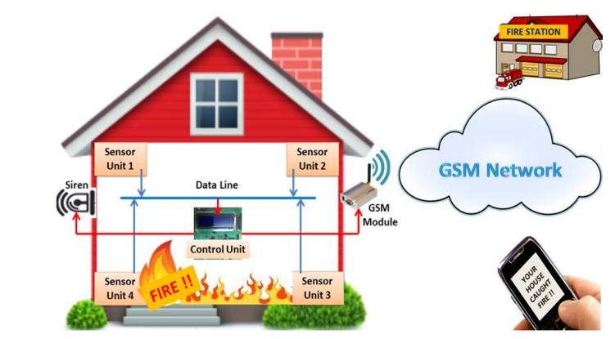

**Figure 3.6 Working Methodology**

The system is fully controlled by the microcontroller and the microcontrollers will continuously monitor the sensors, detector and GSM modem. If the voltage level of sensor input pins goes to zero then it will send the “AT + CMGS =”USER MOBILE NUMBER” to GSM modem through serial port. The GSM modems will response with the character “>”. After receiving “>” Character microcontroller again send the type of security problem SMS + CTRL Z to GSM Modem. GSM modem will send the type of problem to user.

For example if any moment is detected in security area at the time microcontroller pin number 39 goes to logical zero. Microcontroller sensed the change and immediately send AT + CMGS = ‟+xxxxxxxxx‟ to GSM modem, GSM modem give “>” character to microcontroller. After receiving “>” Character microcontroller again sends the “MOMENT DETECTED” SMS to GSM Modem. GSM modem sends the SMS to user.

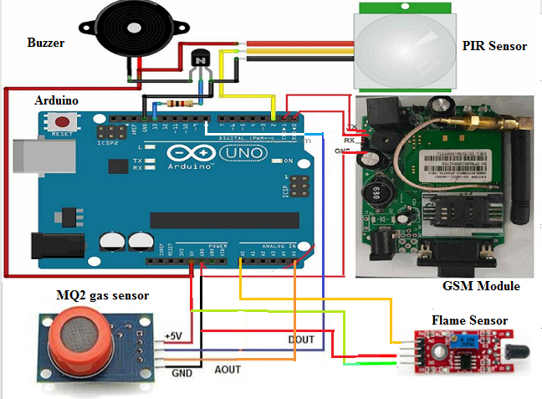

**Figure 3.7 Connections of all sensors with Arduino**

3.2.2 Usecase Diagrams of the security alert system

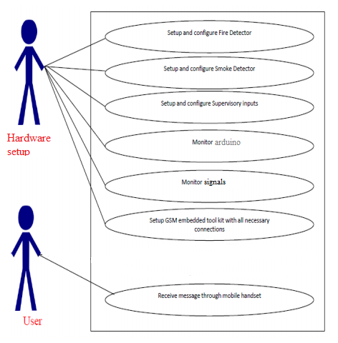

**Figure 3.8 Use case Diagram of Home Security system**

Use case diagram for GSM based mobile system. Figure 3 above depicts the Use Case diagram of GSM based mobile security system.

**Use case name:** GSM based mobile system

**Actor**: Hardware setup and User.

**Use cases**:

* Set up and conFigure Fire detectors.
* Set up and conFigure Smoke detectors.
* Set up and conFigure Supervisory inputs.
* Monitor arduino.
* Monitor signals.
* Set up GSM embedded module with all the necessary connections.
* Receive message through Mobile handset.

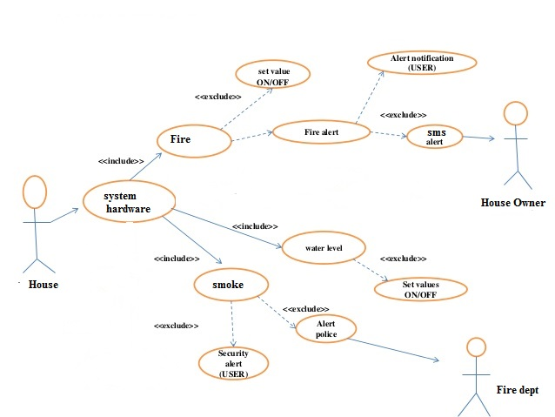

**Figure 3.9 Use case Diagram of working**

**Sequence Diagram:**

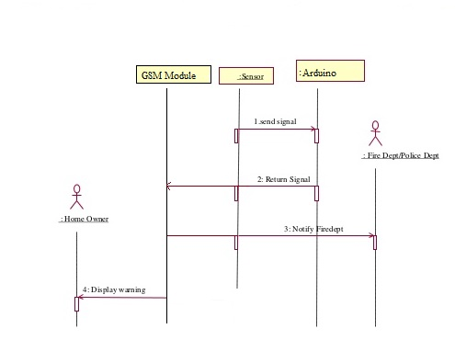

**Figure 3.10 Sequence diagram of working**

4.Implementation

4.1 Inputs:

**Step 1:** Open the Arduino IDE and go to tools ,set the board of arduino to Arduino UNO.

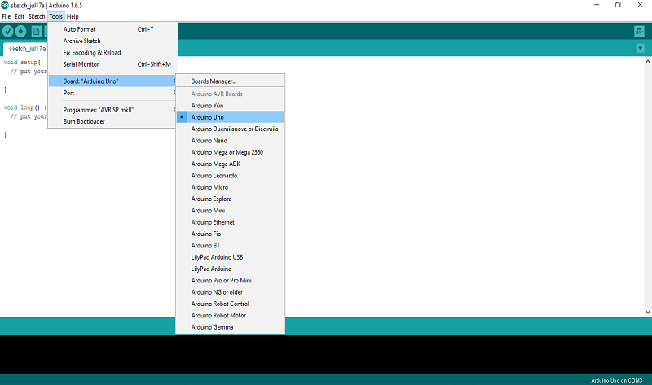

**Step 2:** Now open the tools and set port to **COM3** or **COM4** so that the arduino UNO gets connencted.

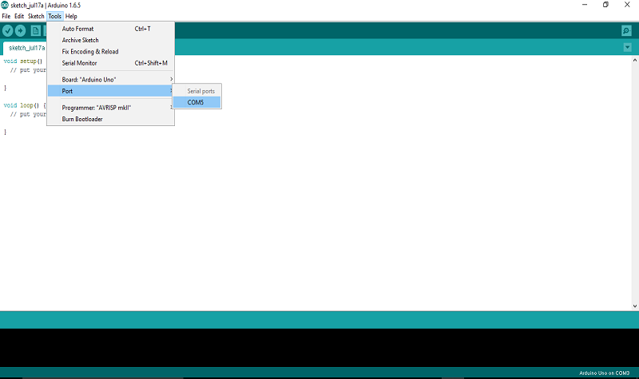

**Step 3:** Include all the libraries required for GSM Module such as SoftwareSerial

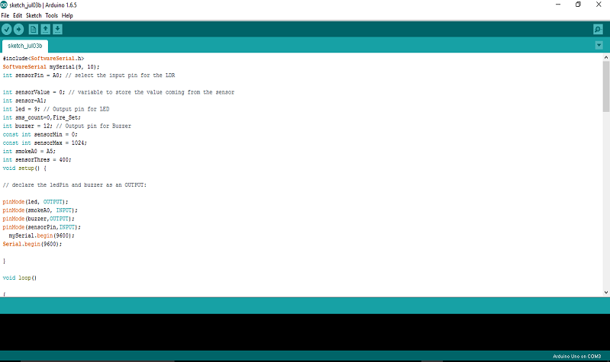

**Step 4:** Write the Initializations in the setup method and repeating conditions in the loop method

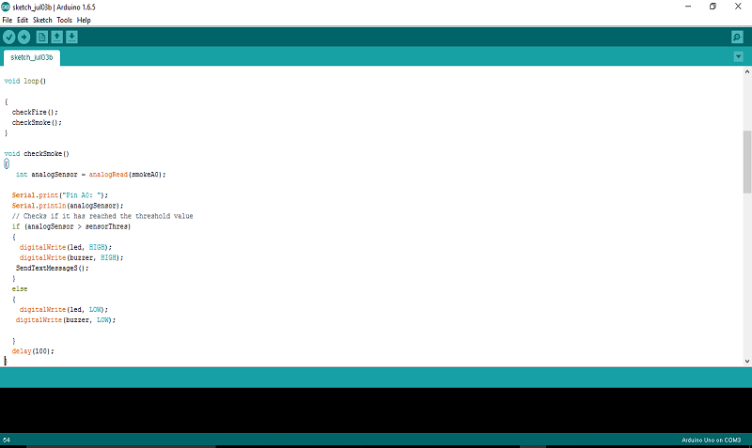

**Step 5:** In the loop method call the 3 functions checkFire() and checkSmoke() and checkMotion().

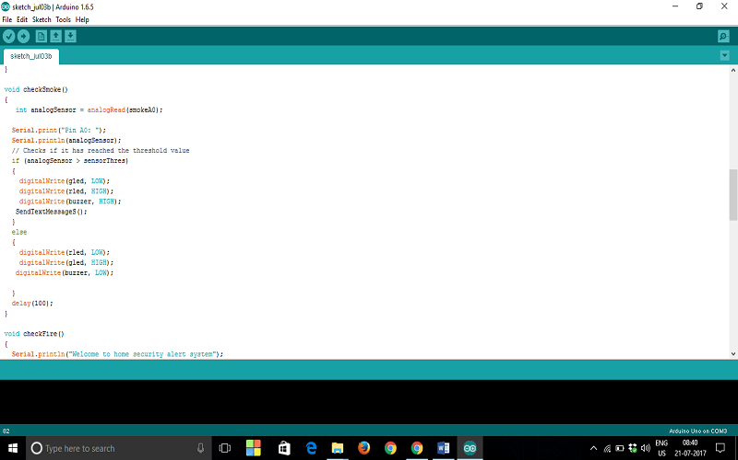

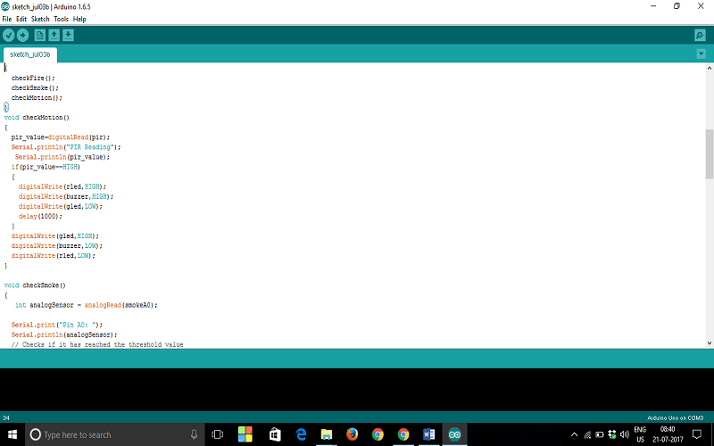

**Step 6:** Read the sensor pin value which is analog in to a variable and set its range from 0-3 so that the intensity of the fire ranges between those values and switch case is used to classify the intensity whether fire is distinct or close

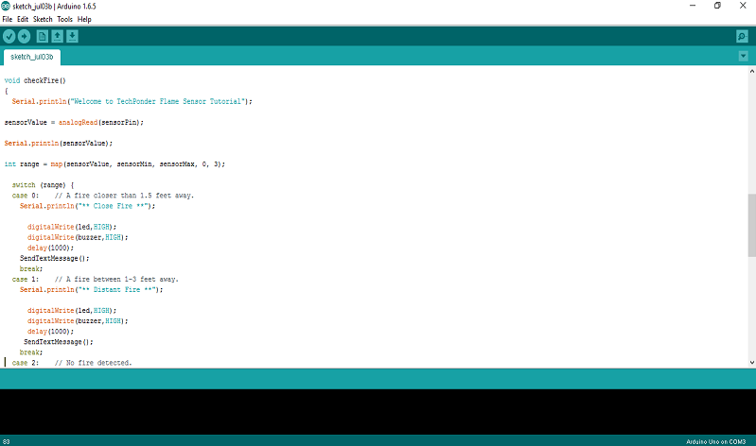

**Step 7 :** When the sensors detect the signal and send them to Arduino ,in turn Arduino sends it to GSM module where the numbers to which the SMS alert has to be sent are written through AT commands.

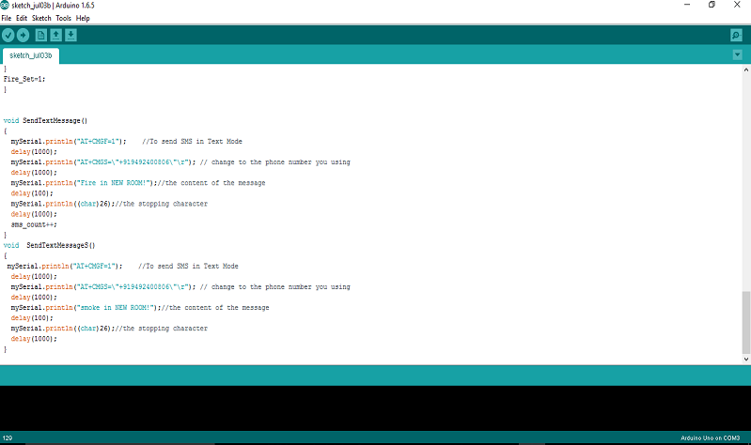

**Step 8 :** Click on **Verify** which is at the top left corner ,it verifies the code and checks for the errors.Status and errors in the code are shown at the bottom in the text console.

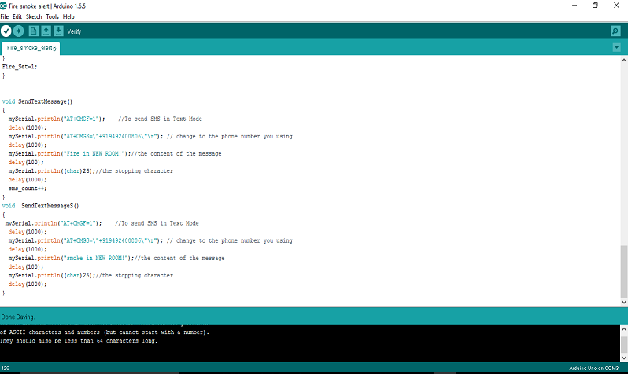

**Step 9:** Once the verify button is clicked the text console shows the status with progress of compiling.

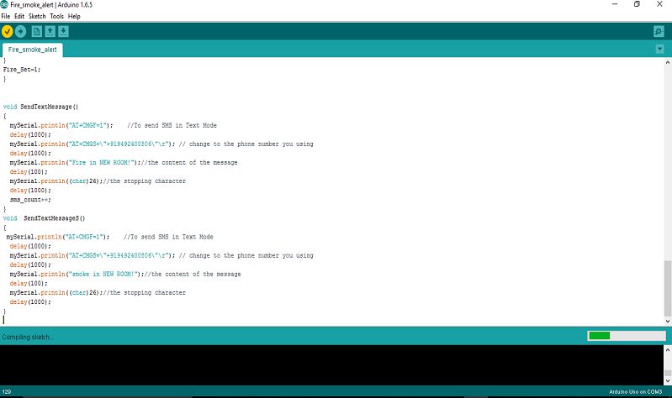

**Step 10:** Once the compiling is done without any errors then **Done Compiling** is shown in the status bar with the number of bytes of dynamic memory used for the global variables.

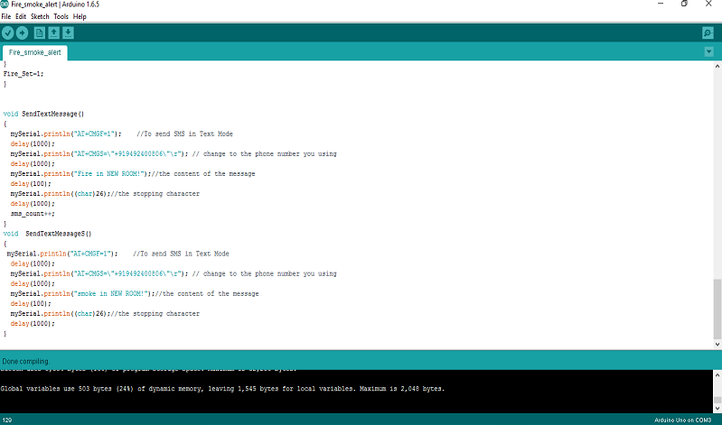

**Step 11:** After compiling the code it is dumped into the Arduino UNO through the cable that is connected to the hardware setup so that is acts as the programming instructions to receiving and detecting the signals.

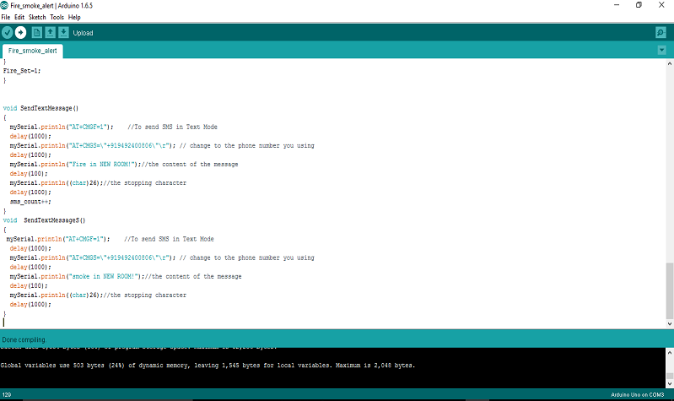

4.2 Outputs:

**1:**The Figure shows the PIR sensor digital reading when there is motion it shoes 1 else 0.

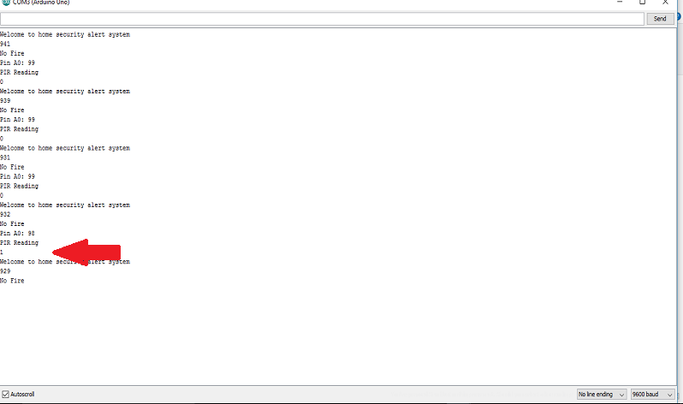

**2:** When there is fire it detects the intensity if it and displays in the serial monitor.

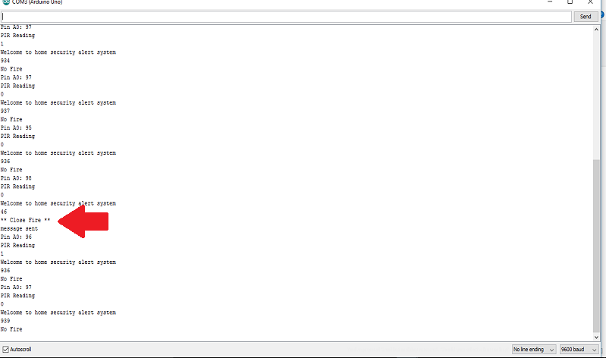

**3:** When the analog reading of the smoke exceeds the 400 level then it sends SMS alert.

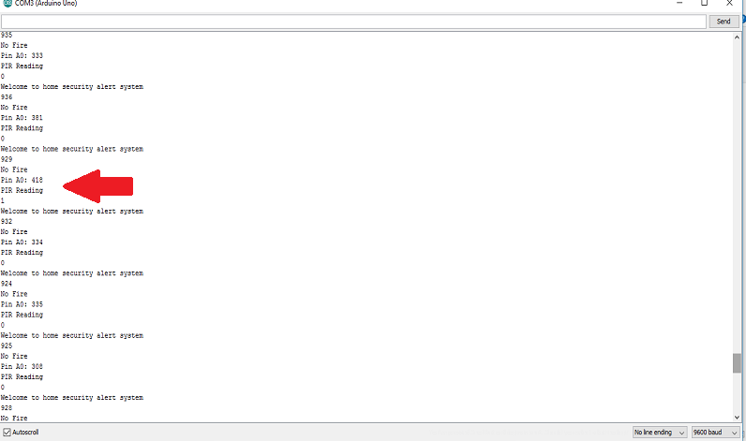

**4.Hardware**

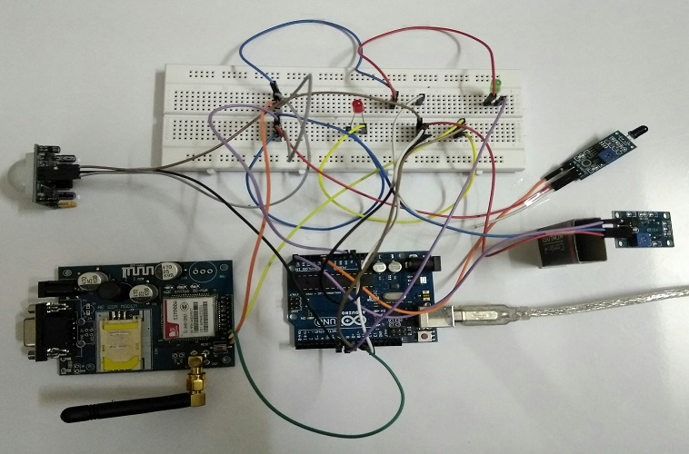

**5.Alert message to mobile**

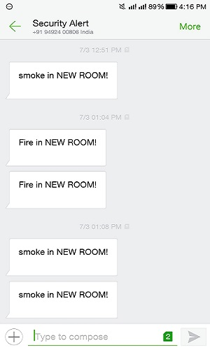

4.3 Source code:

#include<SoftwareSerial.h>

SoftwareSerial mySerial(9, 10);

int sensorPin = A0; // select the input pin for the LDR

int sensorValue = 0; // variable to store the value coming from the sensor

int sensor=A1;

int rled = 9;

int pir=7;

int pir_value;

int gled=8;// Output pin for LED

int sms_count=0;

int Fire_Set;

int buzzer = 12; // Output pin for Buzzer

const int sensorMin = 0;

const int sensorMax = 1024;

int smokeA0 = A5;

int sensorThres = 400;

void setup() {

// declare the ledPin and buzzer as an OUTPUT:

pinMode(rled, OUTPUT);

pinMode(gled, OUTPUT);

pinMode(pir,INPUT);

pinMode(smokeA0, INPUT);

pinMode(buzzer,OUTPUT);

pinMode(sensorPin,INPUT);

mySerial.begin(9600);

Serial.begin(9600);

}

void loop()

{

checkFire();

checkSmoke();

checkMotion();

}

void checkMotion()

{

pir_value=digitalRead(pir);

Serial.println("PIR Reading");

Serial.println(pir_value);

if(pir_value==HIGH)

{

digitalWrite(rled,HIGH);

digitalWrite(buzzer,HIGH);

digitalWrite(gled,LOW);

delay(1000);

}

digitalWrite(gled,HIGH);

digitalWrite(buzzer,LOW);

digitalWrite(rled,LOW);

}

void checkSmoke()

{

int analogSensor = analogRead(smokeA0);

Serial.print("Pin A0: ");

Serial.println(analogSensor);

// Checks if it has reached the threshold value

if (analogSensor > sensorThres)

{

digitalWrite(gled, LOW);

digitalWrite(rled, HIGH);

digitalWrite(buzzer, HIGH);

SendTextMessageS();

}

else

{

digitalWrite(rled, LOW);

digitalWrite(gled, HIGH);

digitalWrite(buzzer, LOW);

}

delay(100);

}

void checkFire()

{

Serial.println("Welcome to home security alert system");

sensorValue = analogRead(sensorPin);

Serial.println(sensorValue);

int range = map(sensorValue, sensorMin, sensorMax, 0, 3);

switch (range) {

case 0: // A fire closer than 1.5 feet away.

Serial.println("** Close Fire **");

digitalWrite(rled, HIGH);

digitalWrite(gled,LOW);

digitalWrite(buzzer,HIGH);

delay(1000);

SendTextMessage();

break;

case 1: // A fire between 1-3 feet away.

Serial.println("** Distant Fire **");

digitalWrite(rled, HIGH);

digitalWrite(gled,LOW);

digitalWrite(buzzer,HIGH);

delay(1000);

SendTextMessage();

break;

case 2: // No fire detected.

Serial.println("No Fire");

break;

}

digitalWrite(rled,LOW);

digitalWrite(gled, HIGH);

digitalWrite(buzzer,LOW);

delay(sensorValue);

}

void SetAlert()

{

while(sms_count<3) //Number of SMS Alerts to be sent

{

SendTextMessage(); // Function to send AT Commands to GSM module

}

Fire_Set=1;

}

void SendTextMessage()

{

mySerial.println("AT+CMGF=1"); //To send SMS in Text Mode

delay(1000);

mySerial.println("AT+CMGS=\"+919491922437\"\r"); // change to the phone number you using

delay(1000);

mySerial.println("Fire in NEW ROOM!");//the content of the message

delay(100);

Serial.println("message sent");

mySerial.println((char)26);//the stopping character

delay(1000);

sms_count++;

}

void SendTextMessageS()

{

mySerial.println("AT+CMGF=1"); //To send SMS in Text Mode

delay(1000);

mySerial.println("AT+CMGS=\"+919491922437\"\r"); // change to the phone number you using

delay(1000);

mySerial.println("smoke in NEW ROOM!");//the content of the message

delay(100);

Serial.println("message sent");

mySerial.println((char)26);//the stopping character

delay(1000);

}

5.CONCLUSION

The design and construction of a IOT Home Security Alert System was successfully carried out and tested effectively. The system did not pose extra-ordinary constraint and the components and materials used conform to engineering standard. The project we have undertaken has helped us gain a better perspective on various aspects related to our course of study as well as practical knowledge of electronic equipment and communication. We became familiar with software analysis, designing, implementation, testing and maintenance concerned with our project. The extensive capabilities of this system are what make it so interesting. From the convenience of a simple cell phone, a user is able to control and monitor virtually any electrical devices. This makes it possible for users to rest assured that their belongings are secure and that the television and other electrical appliances was not left running when they left the house to just list a few of the many uses of this system. The end product will have a simplistic design making it easy for users to interact with it. It’s a real time security purpose system developed with simple hardware which simplifies the possibility of error free security system. The system can be easily implemented with maximum reliability and the high security with the low cost is a special enhancement from the existing systems for home security.

**FUTURE SCOPE**

The future implications of the project are very great considering the amount of time and resources it saves. The project we have undertaken can be used as a reference or as a base for realizing a scheme to be implemented in other projects of greater level such as weather forecasting, temperature updates, device synchronization, etc. The project itself can be modified to achieve a complete Home security System which will then create a platform for the user to interface between himself and his household. The system is extensible and more levels can be further developed using automatic motion/glass breaking detectors so the solution can be integrated with these and other detection systems. In future the system will be small box combining the PC and GSM modem. The hardware will be protected and cannot be prone to electric failure. This appliance will have its own encapsulated UPS and charging system

6.REFERENCES

1.Al-Ali A. R., Rousan M. A., Mohandes M., “GSM-based Wireless Home Appliances Monitoring & Control

2.P.A. Patil, Prof. S. A. Naveed and Prof. M.A. Parjane, “Intelligent Security System for LPG Plant using GSM Protocol” International journal of Computer Engineering & Technology (IJCET), Volume 3.

3.J.A.Stankovic, T.F. Abdelzaher, C. Lu, L. Sha, and J.C.Hou. Realtime communication and coordination in embedded sensor networks

4.Luay Friwan,Khaldon Lweesy,Aya Bani-Salma,Nour Mani , “AWireless Home Safety Gas Leakage Detection System”, IEEE 2011

5.Rajkamal,”Embedded Systems: Architecture, Programming and Design”, Tata McGraw-Hill Education

6. [www.circuitstoday.com](http://www.circuitstoday.com)

7. [www.arduinouno.com](http://www.arduinouno.com)

8. [www.arduino.cc](http://www.arduino.cc)

9. [www.instructables.com](http://www.instructables.com)

10. [www.seminarprojects.com](http://www.seminarprojects.com)

11. http://blog.circuits4you.com/2015/06/gsm-based-fire-alarm-system.html

12. http://www.instructables.com/id/GSM-Based-Fire-Alarm-System/

13.http://ieeexplore.ieee.org/xpl/login.jsp?tp=&arnumber=6013128&url=http%3A%2F%2Fi eeexplore.ieee.org%2Fxpls%2Fabs_all.jsp%3Farnumber%3D6013128

14. http://link.springer.com/chapter/10.1007%2F978-3-642-31968-6_28

15. http://www.instructables.com/id/Fire-Alarm-System-GSM-based-using-Arduino/

16. http://duino4projects.com/gsm-based-sms-alert-fire-alarm-system-using-arduino/

17. http://www.electronicslovers.com/2015/04/sms-alert-fire-alarm-system-gsmbased.html

18. https://securitysnobs.com/LA-Mobeye-Portable-Quad-Band-Alarm_H2.html

19. https://www.youtube.com/watch?v=pxacoNbfLX0

20. http://www.compoundsecurity.co.uk/security-equipment-smoke-alarms-mobeye-gsmstand-alone-smoke-detector

21. http://www.instructables.com/id/Square-Smoke-GSM-Smoke-Detector/

22. http://www.instructables.com/id/Sending-sms-if-smoke-is-detected-ArduinoGSMSIM900/

23. https://www.isocketworld.com/en/Kit-2-ISKIT2/

24. https://makerfeed.net/article/gsm-based-sms-alert-fire-alarm-system-using-arduino

25. http://www.ijert.org/view-pdf/3166/design-of-gsm-based-smoke-detection-andtemperature-monitoring-system