AI Workflow Management – Deliverables Day 0

Feasibility
Technical Feasibility
The system is technically feasible using modern full-stack technologies and AI frameworks.
The implementation uses the following technology stack:
- Frontend: React
- Backend: Node.js
- Database: PostgreSQL
- Agent Framework: Claude Agent SDK
- Vector Storage: Milvus
- Queue System: Redis
React provides a dynamic user interface for configuring agents, tasks, and workflows.
Node.js serves as the backend orchestration layer responsible for managing workflow execution, scheduling, and communication with AI agents.
PostgreSQL stores system configuration data including agents, tasks, workflows, and execution logs.
Redis provides a reliable task queue and event streaming mechanism for asynchronous workflow execution.
Milvus supports vector-based memory and knowledge retrieval for advanced AI capabilities.
Claude Agent SDK supports multi-agent orchestration, tool use, and streaming out of the box. Agents are SDK agent instances, tools are registered tool definitions, and workflows are sequential or parallel agent invocations. The SDK handles context passing, tool call loops, and result aggregation which covers the heavy lifting for Pages 1, 3, and 4.

System Architecture
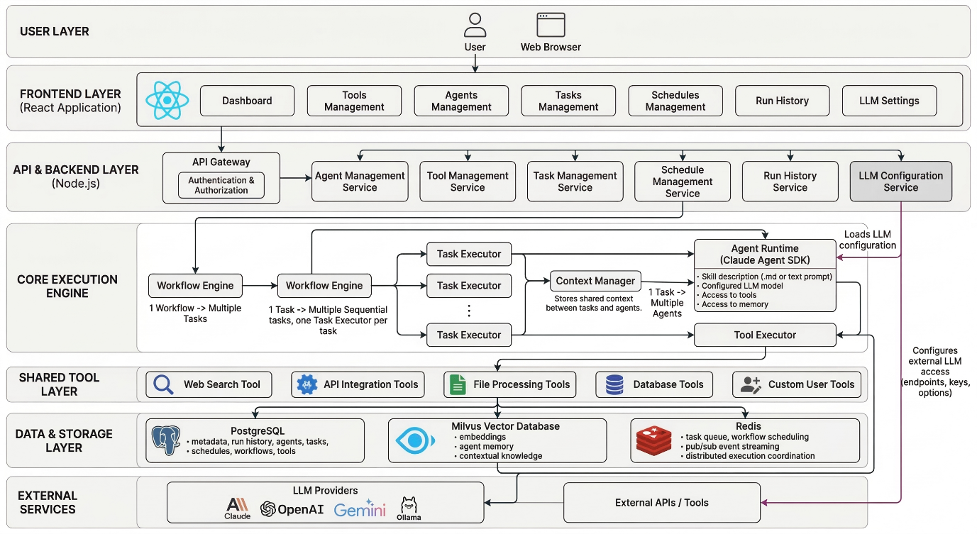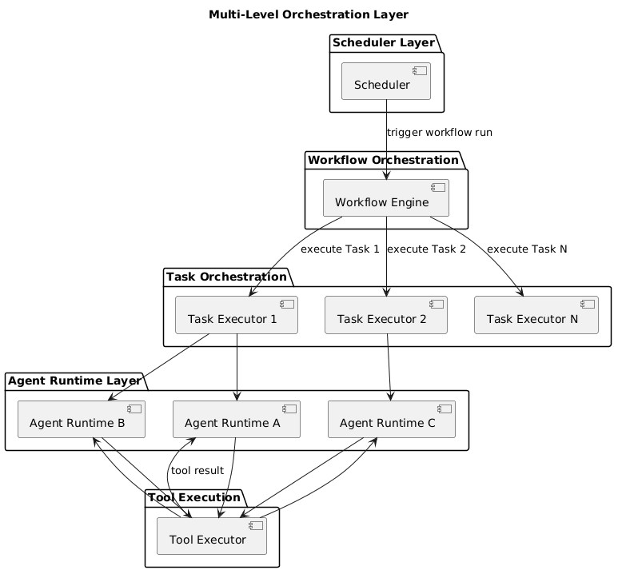

Timeline
Days | Focus | Tasks | Pages
1 | Foundation | Monorepo setup, Fastify + Prisma + PostgreSQL, React scaffold, BullMQ + Redis, Docker Compose, Prisma schema + migration, JWT auth | —
2–3 | LLM Settings | Provider Router interface, Anthropic + OpenAI + Gemini + Ollama adapters, API key encryption, CRUD endpoints, validate key, set default, Provider cards UI, status badge | Page 6
4–5 | Tools + Agents | Tool Registry CRUD, Agent CRUD, name availability check, agent instantiation logic, SSE dry run endpoint, Tool + Agent list UI, skill upload, LLM selector, tool multi-select, streaming dry run UI | Pages 1 & 2
6–7 | Tasks + Workflow Engine | Task CRUD, workflow generation endpoint, executeTask() with Claude Agent SDK, shared context object, Task list UI, agent multi-select, editable step list, drag reorder, task dry run UI | Page 3
8–9 | Scheduler + Worker | executeWorkflow() loop, two-layer orchestration, BullMQ job registration, webhook trigger, Execution Worker, dockerode integration, resume-on-failure, Schedule form UI, trigger selector, task order list | Page 4
10–11 | Run History + Streaming | Redis pub/sub → SSE pipeline, Docker log streaming, run history query + filter endpoints, session_id storage, History table UI, expandable rows, live status updates, filter bar | Page 5
12–13 | Integration + Bug Fix | Full E2E flow, context passing edge cases, SSE reconnection, Docker cleanup + timeouts, cost guard, failed agent handling, LLM key expiry mid-run, name uniqueness race condition | All
14–15 | Polish + Handoff | Empty states, loading skeletons, toasts, form validation, 3 full E2E workflow runs, env var docs, README, Docker Compose prod config | All

