**IOT Practicals**

**Rasberry Pi Pin Diagram**

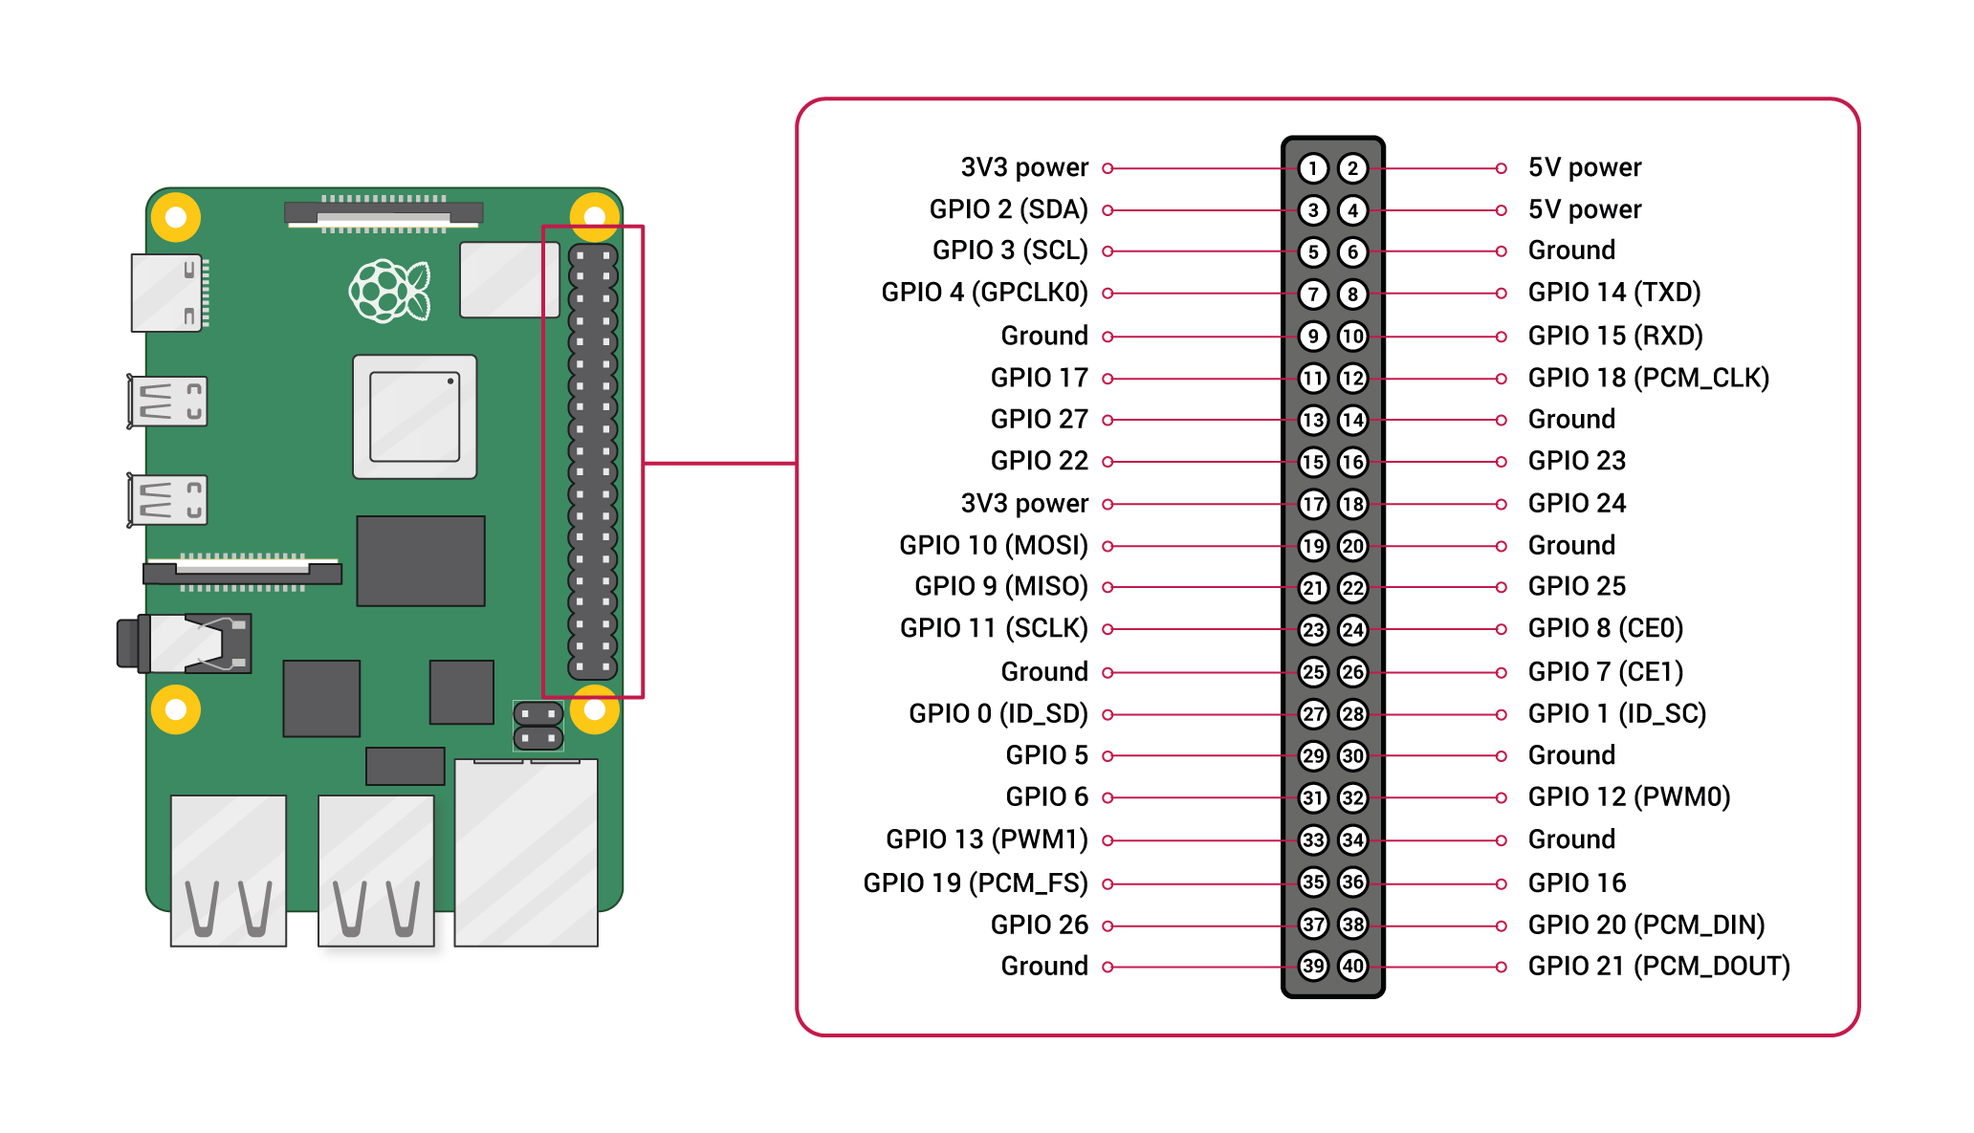

**NOTE :** To install modules use either pip3 or pip which is working

1. **Interfacing Raspberry Pi with RFID.**

**Modules :** mfrc522

**Imports :** mfrc522 => SimpleMFRC522

|  |  |
| --- | --- |
| **RFID** | **RPi Pin** |
| 3V3 | 1 |
| GND | 9 |
| SCK | 23 |
| SDA | 24 |
| MISO | 21 |
| MOSI | 19 |
| RST | 22 |

**Installation :**

1. pip install mfrc522
2. sudo raspi-config
3. Select the “Serial” option To access the login shell over serial communication, Select “No” option.

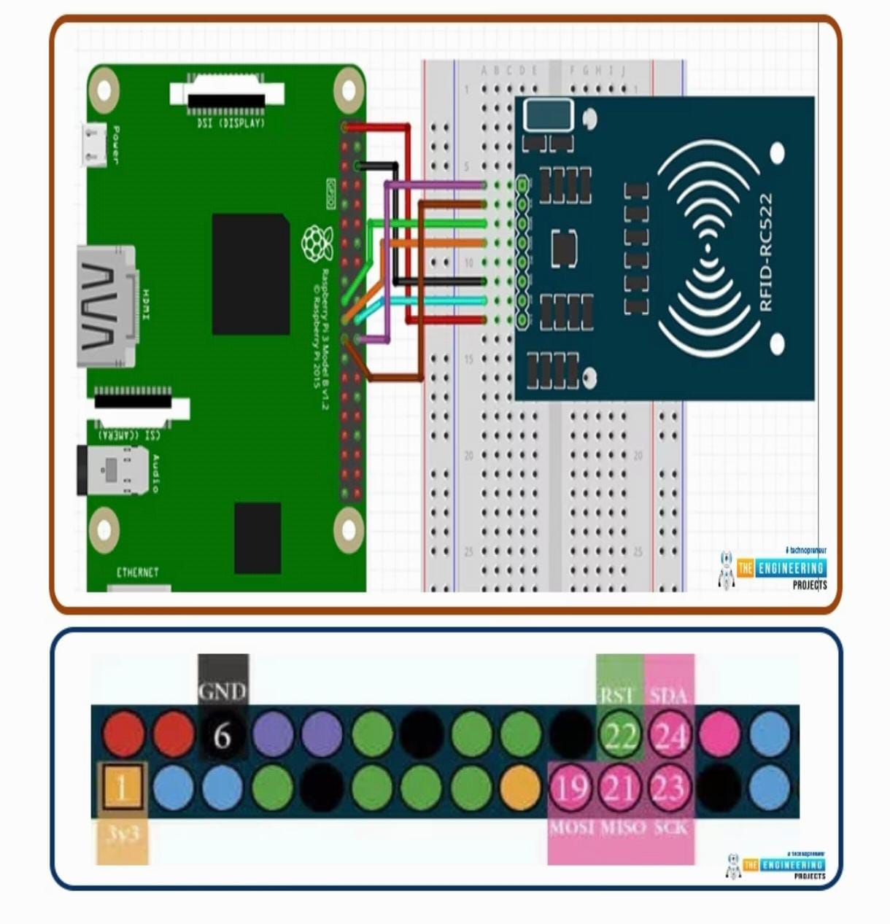

**Code :**

import RPi.GPIO as GPIO

from mfrc522 import SimpleMFRC522

GPIO.setwarnings(False)

reader = SimpleMFRC522()

while True:

try:

id, text = reader.read()

print(id)

print(text)

finally:

GPIO.cleanup()

**Tutorial :** https://www.youtube.com/watch?v=niaTCyYKI7w

1. **LED Blinking.**

**Connection:**

* In the raspberry Pi development board kit, there is an LED module.
* The LED Module has 7 male pins at the left hand side and 2male pins at the RHS.
* The LHS is the positive terminal and RHS is negative terminal.
* Connect the raspberry Pi to positive terminal and negative terminal

import RPi.GPIO as GPIO

from time import sleep

GPIO.setmode(GPIO.BOARD)

r= [3,15,8,11,13,26,29,22]

GPIO.setup(r, GPIO.OUT)

while True:

for i in r:

GPIO.output(i, GPIO.HIGH)

sleep (0.1)

GPIO.output(i, GPIO.LOW)

sleep (0.1)

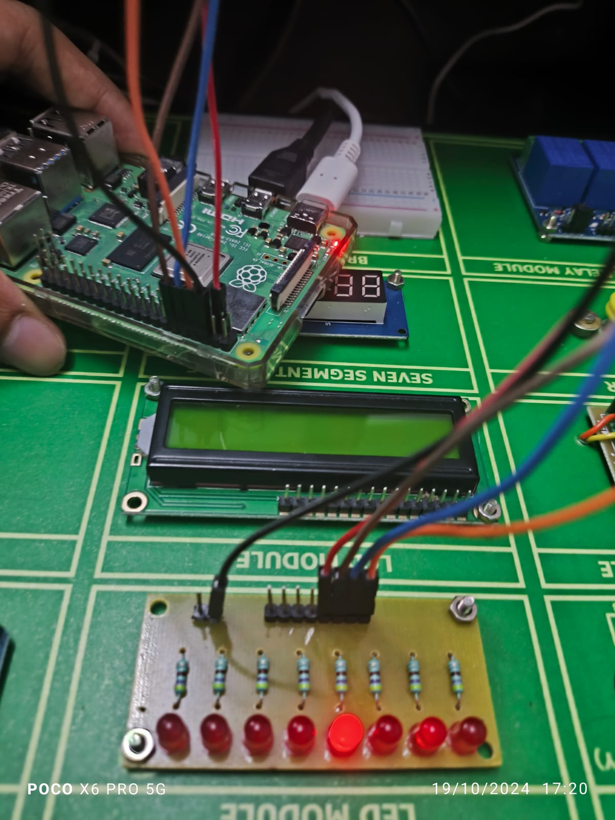

Ground (black wire) - 6

Led pins - 3,8,10,12

1. **Camera**

**Modules :** picamera

**Imports :** picamera => PiCamera

**Connection:**

* To connect the PiCamera, Insert the Ribbon cable of PiCamera into camera slot, slightly pull up the tabs of the connector at RPi board and insert the Ribbon cable into the slot, then gently push down the tabs again to fix the ribbon cable.

**Installation:**

1. pip install picamera

2. sudo apt-get install python3-picamera

3. sudo raspi-config

4. Select Enable camera and Enable it sudo reboot.

5. Check with raspistill -o test.

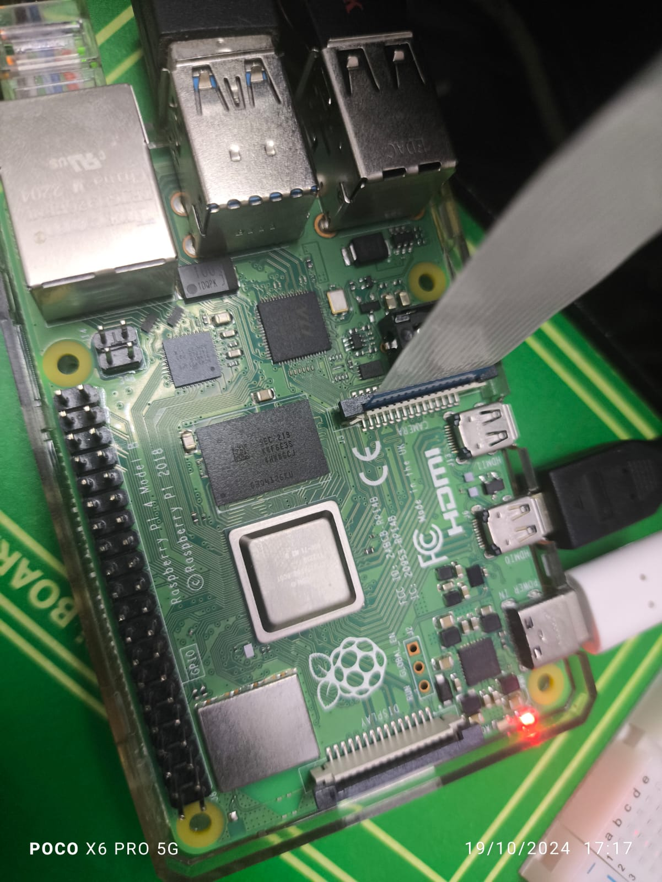

1. **Fingerprint**

**Modules :** board, busio, digitalio, adafruit-fingerprint

**Imports :** digitalio => DigitalInOut, Direction

|  |  |
| --- | --- |
| **Fingerprint Module** | **RPi Pin** |
| VCC | 2 |
| GND | 9 |
| TxD | 15 |
| RxD | 14 |

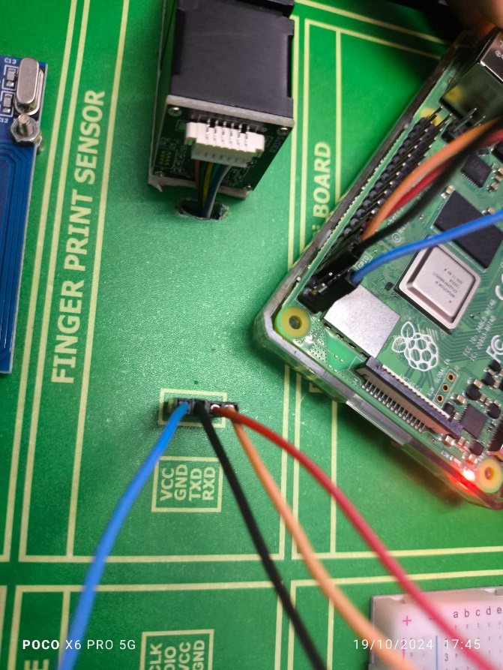

1. **Telegram Bot**

**Modules :** telepot (or pyTelegramBotAPI)

**Imports :** telepot.loop => MessageLoop

**Pins :**

* Blue – 7
* Yellow – 13
* Red – 11

1. **Displaying Time over 4-Digit 7-Segment Display using Raspberry Pi.**

**Modules :** raspberrypi-tm1637 => tm1637

|  |  |  |
| --- | --- | --- |
| **TM1637 Module** | **Function** | **RPi Pin** |
| GND | Ground | 14 |
| VCC | +5V power | 4 |
| DIO | Data In | 18 |
| CLK | Clock | 16 |

import tm1637

import time

from datetime import datetime

tm=tm1637.TM1637(clk=18, dio=17)

clear= [0,0,0,0]

tm.write(clear)

time.sleep(1)

s='This is pretty cool'

tm.scroll(s, delay=250)

time.sleep(0)

tm.write(clear)

time.sleep(0)

while True:

now=datetime.now()

hh=int(datetime.strftime(now,'%H'))

mm=int(datetime.strftime(now,'%M'))

tm.numbers(hh,mm,colon=True)

time.sleep(1000)

tm.write(clear)